
Approaches to innovation and organisational change
Management, Innovation and Sustainability (ACMA5007) Julian Edwards (2315607)

May 12, 2025
University of Wales Trinity Saint David

Executive Summary
This report makes use of two different analysis models to critically analyse the effectiveness of the change that is currently being carried out at TATA Steels Port Talbot site. The change centres around a transition into a more environmentally sustainable business, switching from blast furnaces to an electric arc furnace, this will also help to push the UK to its goal of a net zero carbon production. They are also currently reporting a loss of £1 million per day, insisting that this change will help to create a more financially stable business.
The first of the models applied, is Lewin’s Force Field Analysis, which helps to identify and evaluate driving and restraining forces that affect the change. While there were a few significant restraining forces such as job redundancies, need for external funding, and the need to source outside material while Port Talbot is unable to, the driving forces significantly outweigh the restraining forces. These driving forces include, more environmentally friendly steel, potential new customers, and being more financially beneficial. Though the change is largely beneficial, many in the community resisted the change by protesting and threatening industrial action, which was identified as a restraining force, however, it was also partly due to poor communication.
Kotter’s 8-Step Model then helped to identify this issue through analysing TATA Steel’s effectiveness by following each of the 8 steps. TATA Steel was effective at developing a sense of urgency, emphasising its financial struggles and need for reduced carbon emissions. They were also effective in achieving short-term successes such as securing funding and submitting planning applications, which were fully transparent and effectively communicated. However, it failed to effectively communicate about job redundancies and the opportunities to those in the business, such as financial support and training opportunities, to be better prepared if their job was at risk. They also failed to create short-term wins for individuals, it was clear the company had successes, but there was little for employees to see on a lower level.
Overall, TATA Steel has made significant progress in transitioning into a more financially and environmentally sustainable business. However, there are still some issues in communicating to employees and communities, particularly surrounding job redundancy and support available, which will need to be built upon to gain further support. TATA Steel must continue to improve its transparency, communication, and ability to produce short-term wins that are clear to see at an individual’s level. In conclusion, the success of this change will largely depend on the businesses ability to adapt, communicate, and rebuild trust withing the community and its workforce.

Table of Contents
Executive Summary 1
Introduction 3
Main Findings 4
Overview of the Change 4
Lewin’s Force Field Analysis 4
Kotter’s 8 Steps 6
Conclusion 9
Bibliography 10

Introduction
TATA Steel is ‘the largest steel producer in the UK’ (TATA Steel, 2025) with operations in 26 countries (TATA Steel, 2025). The primary steel plant within the United Kingdom is Port Talbot. It previously had its blast furnaces to produce its steel from slabs and process it on-site or send it to downstream processes to produce premium steel products. The UK business has been making severe financial losses, reporting a loss of ‘more than £4 billion after tax’ (TATA Steel, 2025) since 2007. This, and several other factors, has led TATA Steel to decide to reduce the carbon emissions in their UK business to promote a ‘green steel feature’ (TATA Steel, 2025).
Change can be essential to a business to ensure that it can adapt and survive, (Kotter, 2012) suggests that change can be both positive and negative to businesses and ‘is inevitable’ (Kotter, 2012). Management and leadership are key aspects that affect the process of change and can have a significant impact on the result. (Kotter, 2012) states that individual people ‘never have all the assets needed to overcome tradition’, suggesting that leadership is needed to combine individuals as a single entity to ensure all the ‘assets’ are available to ‘overcome tradition’. Management also plays a significant role in this, (Burns, 2017) suggests that there may be a relationship between more successful businesses and effective leadership and management. (Burns, 2017) also goes on to suggest that management and leadership have similar roles and can be difficult to distinguish the responsibilities and actions between leaders and managers but are both essential regardless.

Main Findings
(Cameron & Green, 2020), with reference to (Buchanan & Huczynski, 2023) states ‘Learning the process of acquiring knowledge through experience which leads to a lasting change in behaviour.’ (Buchanan & Huczynski, 2023). This suggests that change is a crucial result of learning, and can also be inferred from (Burns, 2017), which suggests that development is needed in order for organisations to effectively survive in an ‘increasingly hostile world’ (Burns, 2017). This can be used to further define change, in an organisation, as a process in which can be used by an organisation to adapt to survive a changing environment which has the ability to positively and negatively impact growth. From this, it can be suggested that better performing businesses are those who are more open to change and are constantly adapting. This is supported by (Akhatar, 2025), which states that the ‘highest performing organizations are, and will continue to be, those that create and nurture adaptability in a variety of ways’ and goes on to suggest that leadership is a larger contributor to this.

Overview of the Change
As previously mentioned, TATA Steel’s Port Talbot Steelworks in undergoing a significant change to decarbonise its products to promote a ‘green steel feature’ (TATA Steel, 2025). It involves the decommissioning of its blast furnaces that will later be replaced a by an electric arc furnace which will allow the company to significantly reduce its carbon emission. This change has, and will, have significant effects on the company itself, as well as the steel industry as a whole. There are both positive and negative effects of this change, which will have to effectively managed to ensure a smooth transition and beneficial result. One change management tool that can be used to help understand this change process is Lewin’s Force Field Analysis.

Lewin’s Force Field Analysis
Force field analysis characterises change as a ‘state of imbalance’ between ‘driving forces’ and ‘restraining forces’ (University of Cambridge, 2016), see figure 1.
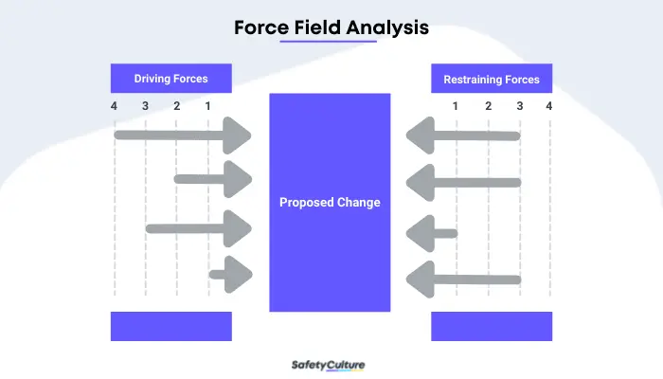
Figure 1 - Force Field Analysis (Reyes, 2024)
(Reyes, 2024) States that there are only 4 steps involved which including, stating and describing the change, identify driving and restraining forces as described by (University of Cambridge, 2016), applying a scoring scheme, and finally, analysing and applying methods to reduce restraining forces or increasing driving forces to help carry out the change as suggested by (University of Cambridge, 2016). Steps 2-4 can be applied to the change occurring at TATA Steel as below (See Table 1):
Table 1 - Force Field Analysis
Score | Driving Forces | Restraining Forces | Score
5 | Environmentally beneficial | Redundancy / Job Losses | 4
3 | Help to reduce customer turnover and potential new customers | Requires Funding from Government and parent company | 4
2 | Modernisation | Will require significant Research & Development even after the change | 4
4 | Financially beneficial in long term | No material production during interim | 4
5 | End of life for current assets
3 | Redundancies are beneficial to some
21 |  |  | 12

From Table 1, it is clear that there are several significant restraining forces, such as the job losses that have been produced, the funding that is required, and operational changes that they will face. However, these are outweighed by the driving forces that benefit both the company and environment, showing that the change is beneficial. This does not mean that the restraining forces do not affect the change, for example there were protests and ballets cast for industrial action due to the job losses proposed by the company. (Hoskin, 2024) stated that ‘Hundreds’ of people had joined in the protest and suggested that many members of the community have been let down by the company and UK politicians.
This shows that Lewin’s Force Field analysis has both benefits and drawbacks. It’s simple to use as explained by the four steps stated by (Reyes, 2024) which is supported by (Carnall & Todnem, 2014) which describes a similar four steps. Force field analysis also clearly highlights supporting and opposing factors which may have been missed when initially proposing the change and conveys their influence effectively when a scoring or priority system has been introduced. However, no method is perfect, there are flaws that need to be considered when carrying out force field analysis, such as being too simplistic on its own as suggested by (Burnes, 2004) stating that ‘When seen alongside the other elements of Lewin’s Planned approach, it becomes a much more robust approach to change’ (Burnes, 2004). Another drawback is that the list is just what were visible and appropriate at the time, there may be more resisting forces now, or less driving forces, or environment in which the change is taking place has changed which can be inferred from (Burns, 2017) which states that ‘No organisation’s culture is static’, and as organisation’s culture changes, so will the proposed force field analysis. For example there were protests when the job losses were proposed by TATA (Hoskin, 2024), and while there are some who are still not happy with the change, many people volunteered for redundancies, many of whom were happy to receive it so they could have an earlier retirement. Overall, Lewin’s force field analysis is a good tool to use when initially identifying driving and restraining forces, but as they change develops, it may be more appropriate to use another tool or combine it with one of the ‘other elements of Lewin’s Planned approach’ (Burnes, 2004).

Kotter’s 8 Steps
Another tool that can be used to understand and evaluate the effectiveness of the change at TATA Steel Port Talbot, is Kotter’s ‘8 Steps for Leading Change’ (Kotter, 2025). When the 8 steps are followed correctly and effectively, they can be used to produce, and implement, lasting change (Kotter, 2025). Each of the 8 steps are crucial when making a substantial change to any organisation, and are outlined below, in Figure 2.
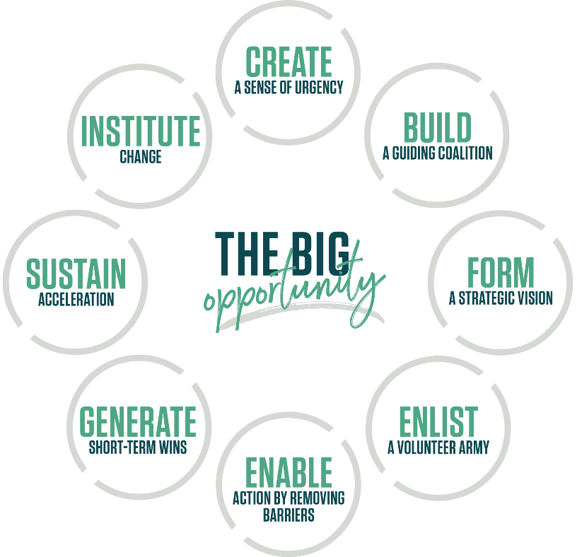
Figure 2 - Kotter's 8 Steps (Kotter, 2025)
According to (Kotter, 2012), the first step in implementing a change is creating a sense of urgency, which TATA executed flawlessly. TATA reported that the were losing £1 million each day with its blast furnaces being operated as stated by (Pigott & Thomas, 2024). It has also been stated that ‘Britain and its peers are rushing to clean up steel production’ (Taggart, 2024), clearly showing a need for modernising and reducing its effects on the environment as shown on their website (TATA Steel, 2025).
The second step in implementing an effective change is ‘Creating the Guiding Coalition’ (Kotter, 2012). (Kotter, 2012) emphasises the need for groups, rather than individuals, to effectively develop a vision, communicate it to others, and achieve the remaining steps. TATA Steel was only partially able to complete this step as shown by the UK Government’s financial commitment (Pigott & Thomas, 2024) as well as its support from TATA Steel’s leaders such as Rajesh Nair. However, they failed to gain the support of many workers and trade unions, leading to protests over their decisions, particularly surrounding job redundancy (Pigott & Thomas, 2024). While most issues surrounded job redundancy, there were also people who believed that the proposed execution of the change was poor and ill-conceived, (Hoskin, 2024) received a statement which suggested that while the change was being implemented, the Steel that would need to be imported would be more ‘dirty’ and ‘carbon intensive’ (Hoskin, 2024).
Step 3 of (Kotter, 2012)’s 8 steps is forming a vision and strategy, which TATA Steel managed to execute effectively. They clearly stated their goals, such as a ‘90% Reduction of direct CO₂ emissions’ and ‘2-2.5mt/y’ that they would be recycling (TATA Steel, 2025), they also made some of their planning documents publicly available so there is transparency in their ongoing actions. This demonstrates that they have effectively achieved step 3.
Step 4 of Kotter’s 8 steps is ‘Communication the Change Vision’ (Kotter, 2012), which has significant importance when implementing a change as it clearly demonstrates the goal that is being worked towards, avoiding confusion and possible providing confidence in the change. TATA Steel managed to succeed in this step, however, there was still room for improvement when communicating job redundancies and impact to the local area. They greatly emphasised the benefits the benefits to the environment (TATA Steel, 2025), and have reported the current financial losses (Pigott & Thomas, 2024) that they are making showing something needs to change immediately. They also very clearly stated the need for redundancies, claiming that are the ‘most viable’ proposal (Jolly, 2024), however, they failed to disclose opportunities to those who may be made redundant such as funded qualifications and re-training opportunities which was a major contributor to the discontent in the content and led to protests (Hoskin, 2024).
For the 5th step of Kotter’s 8 steps is ‘Empowering Employees’ (Kotter, 2012) to take action in helping to carry out the change, in which TATA managed to succeed in creating the tools and benefits for employees to be empowered to take action, but it was poorly communicated. For instance, TATA Steel, with assistance from Neath Port Talbot Council, started an ‘Employment and Skills Fund’ (Neath Port Talbot Council, n.d.), which was intended to empower employees by supporting them financially for training, exams, certificates, and more. They also offered voluntary redundancy, allowing those who wish to leave the business, and those who may be near retirement an opportunity to leave a bonus based on their service to the company. However, there are many who did not learn about these opportunities until much later, which contributed to the resistance to change.
This then leads on the Kotter’s 6th step, ‘Generating Short-Term Wins’ (Kotter, 2012), which is key when demonstrating the benefits of a change, if there are no tangible benefits to the employees or other parties involved, they will start to feel discouraged and lose faith in the change. This is another area where TATA only managed to partially succeed, with clear “wins” as a company, but no immediate short-term successes for the employees. One of TATA’s short-term successes, was the submission of the planning application (TATA Steel, 2024) which shows that they have met their first milestone, they have also managed to secure funding from the UK government (TATA Steel, 2025) which brings them closer to their goals. However, the “wins” so far have mostly impact just the business, and very few, if any, benefits have affected employees or stakeholders as individuals, which has caused some to feel unsure about the change and possibly be less supportive of the change.
This has also led to TATA barely succeeding in Kotter’s 7th step of ‘Consolidating Gains and Producing More Change’ (Kotter, 2012). As mentioned in the previous step, TATA was successful in generating some short-term successes, which is again seen when they mark ‘a major step in the UK steel industry's transition to green steelmaking’ (Tenova, 2024), by signing a contract with Tenova to supply the proposed electric arc furnace. While this holds no tangible benefits for individuals now, it can be seen as hope for the future, showing that the change is progressing, returning some of the lost confidence. The progress that TATA has made, must be continued with the same momentum to ensure that most parties involved are satisfied and confident that the change will be successful and guarantee them a future in the business.

The final step of Kotter’s 8 steps is ‘Anchoring New Approaches in the Culture’ (Kotter, 2012), which is a crucial step in ensuring TATA’s success in implementing such a large change. While the change has not been fully completed, the company has undergone a significant number of smaller changes such as job losses and the acquisition of steel from other sources while they are unable to produce their own. It is important for TATA to ‘Articulate the connections between new behaviors and organizational success’ (Kotter, 2025) as well as continuing to develop the new behaviours to improve upon the existing ones to promote positive change. It is difficult to say whether TATA has succeeded in achieving as there is a large shift in culture as suggested by (Pigott & Thomas, 2024), which states that traditional steelmaking has ended with his change. It can be seen as a failure as the business’s sudden cultural shift has led to some distain in the community, especially concerning job security, as many people saw TATA Steel as a ‘job for life’ (Pigott & Thomas, 2024) and the company had failed at effectively dealing with the concerns of both the community and employees. However, when looking at just the business, the change has been effective, with milestones being clearly visible and transparency surrounding planning (TATA Steel, 2024) and support being available surround some of their more difficult choices such as the job losses (Neath Port Talbot Council, n.d.). Overall, the change has been successful for the business so far, with room for improvement surrounding communication to employees as well as the need for more tangible short-term wins for individuals to gain more confidence in the change.

Conclusion
The change at TATA Steel’s Port Table site, marks an important moment in TATA Steel’s history. They are making a momentous change towards a more environmentally conscious future, as well as making a large sacrifice in hopes of a more financially stable future. It currently faces significant financial losses of £1 million per day (Pigott & Thomas, 2024) and have been receiving pressure to reduce their CO2 emissions to better align with the UK government's net zero target.
Lewin’s Forcefield Analysis highlighted both the driving and restraining forces of the change, showing that while there were significant restraining forces such as job losses and outsourcing of materials, the benefits to the company and environment far outweigh the negatives. Applying Kotter’s 8 steps then helps to evaluate the effectiveness of TATA Steel’s execution of the change. It shows that TATA effectively managed the ongoing changed in many ways, such as creating a good sense of urgency with regards to financial and environmental issues. It was also effective in creating and maintaining small wins such as receiving funding and submitting its planning applications. However, it helped to highlight clear communications issues when it came to redundancies and the available support when empowering employees.
Overall, TATA Steel’s momentous change has been relatively effective when focusing only on the business, with good transparency of planning and short-term wins, as well as providing support for employees who may face redundancy. However, it will need to focus on communication to its employees and the communities involved, providing more tangible successes that individuals can experience. It will also need to continue to build trust in the community to get over the initial lack of clarity in job security and options available to those who may be made redundant.

Bibliography
Akhatar, V., 2025. Outmaneuver Uncertainty: How Adaptable Organizations Win in the Long Run: Kotter. [Online]
Available at: https://www.kotterinc.com/outmaneuver-uncertainty-how-adaptable-organizations-win-in-the-long-run/
[Accessed 28 June 2025].
Buchanan, D. A. & Huczynski, A. A., 2023. Organizational Behaviour. 11th ed. Harlow: Pearson Education.
Burnes, B., 2004. Journal of management studies. Kurt Lewin and the Planned Approach to Change: A Re-appraisal, 41(6), pp. 977-1002.
Burns, B., 2017. Managing Change. 7th ed. Harlow: Pearson Education.
Cameron, E. & Green, M., 2020. Making sense of change management : a complete guide to the models, tools and techniques of organizational change. 5th ed. London: Kogan Page.
Carnall, C. A. & Todnem, R., 2014. Managing change in organizations. 6th ed. Harlow: Pearson Education.
Hoskin, R., 2024. Tata Steel workers protest over proposed job losses. BBC News, 17 February.
Jolly, J., 2024. Tata Steel rejects union plan to save jobs and keep Port Talbot furnace open. The Gaurdian, 25 April.
Kotter, 2025. The 8-Step Process. [Online]
Available at: https://www.kotterinc.com/methodology/8-steps/
[Accessed 27 June 2025].
Kotter, J. P., 2012. Leading Change. Boston, Massachusetts: Harvard Business Review Press.
Lines, R., 2004. Influence of participation in strategic change: resistance, organizational commitment and change goal achievement. Journal of change management, 4(3), pp. 193-215.
Neath Port Talbot Council, n.d. Employment and Skills Fund. [Online]
Available at: https://www.npt.gov.uk/tata-steel-transition-information-hub/support-for-people/employment-and-skills-fund
[Accessed 12 May 2025].
Pigott, P. & Thomas, H., 2024. Traditional steelmaking in Port Talbot ends. BBC News, 30 September.
Reyes, J., 2024. A Guide to Force Field Analysis. [Online]
Available at: https://safetyculture.com/topics/force-field-analysis/
[Accessed 27 June 2025].
Taggart, E., 2024. ‘Britain is playing catch-up’: inside the race for clean steel. The Times, 16 October.
TATA Steel, 2024. EAF planning and project information. [Online]
Available at: https://www.tatasteeluk.com/sites/default/files/application-forms---eaf---17-september-2024.pdf
[Accessed 12 May 2025].
TATA Steel, 2025. At a glance: TATA Steel. [Online]
Available at: https://www.tatasteeluk.com/about-us/at-a-glance
[Accessed 27 June 2025].
TATA Steel, 2025. Green Steel Future. [Online]
Available at: https://www.tatasteeluk.com/green-steel-future
[Accessed 27 June 2025].
Tenova, 2024. Tenova to supply High-Productivity Electric Arc Furnace for Tata Steel UK. [Online]
Available at: https://tenova.com/sites/default/files/files/press_releases/2024/20241021_PressRelease_Tenova_TataSteelUK.pdf
[Accessed 12 May 2025].
University of Cambridge, 2016. Force Field Analysis: IfM. [Online]
Available at: https://www.ifm.eng.cam.ac.uk/research/dstools/force-field-analysis/
[Accessed 27 June 2025].

