Application of Lean Techniques (M6X00466)
Alex Collier (1707158)
BEng Material Science
04/12/2020

Executive Summary
The term, lean refers to business improvement methodologies used to deliver products and services better, faster and at a lower cost (Laureani and Antony, 2019).
An exercise was carried out at a metal finishing organisation to reduce wastes within the effluent water treatment plant. A project team was assembled to firstly identify wastes within the process using the 7 mudas. Once identified, the team looked at ways of improving the waste following the DMAIC method. DMAIC is an acronym for Define, Measure, Analyse, Improve and Control (pronounced de-may-ic). It is a problem solving system which is a variation of Walter A Shewhart’s plan – do – check – act cycle, although, according to Harvey (2004), the DMAIC approach is more meticulous.

The project team, as the voice of the customer, decided that the focus of the improvements should be removing the nickel effluent from solution. This reduces hazardous waste produced from the treatment process, at the same time, generates revenue from the sale of nickel as metal.
Having considered several options for the removal of nickel from the effluent, preliminary laboratory trials were completed. From these trials, it was decided to undertake a larger pilot scale trial, with a removal method based on an electrocoagulation method. This involves passing the solution over a set of mild steel sacrificial anodes through which a current is passed. The results showed that 99% of nickel was removed from solution.
For the next stage of the project, a large capital expenditure is required.

Table of Contents
Executive Summary 1
1.0 Introduction 3
2.0 Consideration of the types of waste in the process 4
3.0 An analysis of the value from the customer’s perspective 6
4.0 An evaluation of how the process could be made leaner 7
4.1 Adsorption 7
4.2 Coagulation/ flocculation 7
4.3 Ion exchange 7
4.4 Electrochemical technology 8
4.5 Electrocoagulation 8
5.0 Improving the Process 10
5.1 Lab trials 10
5.2 Pilot trial 11
5.2.1 Treatment of 100ppm Nickel Effluent 13
5.2.2 Treatment of 500ppm Nickel Effluent 13
5.2.3 Treatment of 1000ppm Nickel Effluent 14
5.2.4 Sludge analysis 14
6.0 A consideration of potential problems, costs, and how problems could be overcome 15
6.1 Cost 15
6.2 Potential problems 15
6.3 Overcoming potential problems 16
7.0 Conclusion 17
8.0 References 18

Introduction (Define)
The authors employer is a top tier COMAH (control of major accidents and hazards) chemical plant within the manufacturing sector. The company has two nickel electroplating plants. ‘Electroplating is an electrolytic process for depositing a layer of metal upon a substrate, to enhance the appearance or properties of a component’ (Rose, 2014). According to Canning (1978), Electrodeposition occurs when the article to be electroplated is immersed in a solution usually referred to as electrolyte and connected to a negative lead of low current D.C supply, thus becoming a cathode. To complete the electrical circuit, anodes are immersed in the electrolyte and connected to a positive lead. The potential applied between anode and cathode is the driving force for the transfer of charge across the metal solution interface (Schlesinger, M).
The Effluent Water Treatment Plant (WTP), treats process waste solutions from the electroplating and other processes within the organisation. The water treatment process is common across multiple industries such as power plants, chemical plants, refineries etc. (Kroviddi et al, 2019).
The process removes metals and sulphates by systematic treatment of this waste solution with Aluminium Di Hydroxychloride, lime slurry and ultra-sonic energy. The insoluble metal hydroxides and calcium sulphates which result, are removed by coagulation, flocculation and clarification (settlement). Dewatering in a filter press then occurs.
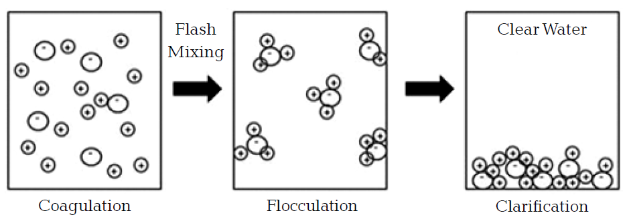
Figure 1 - Clari-Flocculation Process
The resultant filter cake is currently classed has hazardous due to the amount of nickel contained within it. In order to reduce the classification of the filter cake to non-hazardous, the nickel content of the incoming waste must be reduced and controlled.
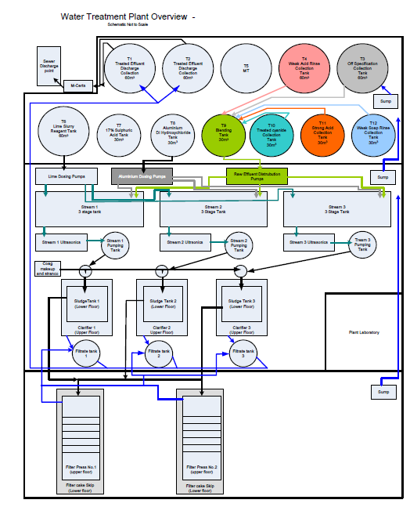

Figure 2 - Water Treatment Process Flow

Presently the WAC (waste acceptance criteria) of the filter cake limits the disposal options and results in high costs, reducing this from hazardous to non-hazardous, will offer a wide range of disposal options, including the opportunity to recover a revenue.

Consideration of the types of waste in the process (Measure)
To best consider the types of waste in a process, it is best to refer to the seven wastes of Muda. Muda is a Japanese term for futility or wastefulness (Miniardi, 2017). The seven wastes can be seen below:
- Transportation
- Inventory
- Motion
- Waiting
- Over processing
- Over production
- Defects
Both underutilisation of people and safety complications could also be considered types of waste (Woodward, 2011).
Waste in a process, can be defined as any activity that does not provide value to the customer (Nachiappan et al, 2009).
As the WTP is at the end of the process, transportation, over production and waiting cannot be improved. The WTP is a fully automated process and required little intervention of operators, therefore, motion is not considered.
Over processing – Over processing can occur if reagents are overdosed into the process. As this is automated, the only opportunity for this to occur is through failure of instruments. To mitigate against this, pH probe clean and calibrations occur twice per shift as standard work of the plant operator. The probes are also calibrated by an external verifier every 8 weeks as part of a maintenance schedule.
Defects - As plant solution analysis is carried out at each stage of the treatment process, defects occur rarely. In the case of a defective analysis, solution can be re-circulated to the appropriate stage to remove/ treat the contaminant. The occurrence of defects is usually down to an upstream process, sending a contaminant to the plant of which the WTP is not designed to treat (ammonia, cyanide, etc.)
Inventory – The main process re-agents are stored in both 30m³ and 60m³ silos. These are automatically dosed to the plant based on pH instruments placed within the plant. There is potential for a pH to go out of calibration, this could lead to over-dosing of re-agent. Process chemistries for the WTP are vendor managed inventory, this means the supplier has live telemetry readouts of tank levels. Thus, the decision to supply is taken by the suppliers, not the WTP as the customer. This ensures loads are maximised at the lowest cost (a discount is applied dependant on order quantity).
Large volumes of metals (as hydroxides) are disposed of via the waste sludge. This is disposed of via a third party total waste management organisation. Each month, approximately 1300kg of nickel is removed from the site, either in the filter cake, or by other method (tankers, IBC etc.). This has a large financial impact on the organisation, as the value of nickel is approximately £12000 per tonne.
Due to the large volume of nickel contained within the filter cake, the waste is labelled as hazardous. This limits disposal options for the filter cake, resulting in high costs.

An analysis of the value from the customer’s perspective
As the customer is the organisation where this exercise has taken place, a project team of internal stakeholders was assembled. The team can be seen in the table below.
Name | Title | Role
A Collier | WTP Manager | Process specialist/ Project requester
G Hibbert | Chemical engineer | Project engineer
S Clode | COMAH manager | Project sponsor
I Jones | BPROC production manager | Project Manager/ Chemist
L Matthews | Business Accountant | Finance
Table 1 - Project team
Belbin (1981) describes how individuals generally have team roles which are understood by the other team members. As all members within this team have worked together previously and in some cases, for a significant amount of time, relational attitudes had already been established. According to Suprapto et al (2015), relational attitudes are formed by a process in which team members create norms and structures governing their teams, in order to bring about mutually satisfactory project outcomes. When these norms are in place, productivity is maximised in a positive setting and ensures all members feel valued and respected.
From the point of view of the team, representing the customer, it was important that a waste was identified and an improvement to the process defined.
From the resultant brainstorm, the business accountant raised that a large amount of nickel was consolidated each month with the removal of the filter cake. Recovering nickel from the process was defined as the area to target for improvement. As this is a new process, many routes were researched and the feasibility of each was investigated by the project team.

An evaluation of how the process could be made leaner (Analyse)
Hemamalini et al (2018), state that there are various methods for the removal of nickel from solutions, these include adsorption, coagulation/ flocculation, electrochemical technology (EQ tech) and ion exchange. The type of method that should be used is dependent upon the concentration and nature of the effluent, percent removal required and the material to be removed (Dhokpande et al, 2013).

Adsorption
This method is a mass transfer process whereby the substances present in the effluent get accumulated on a suitable interface (Hemamalini et al, 2018). A study by Gowda (2012), used coconut leaves as the adsorbent for the removal of nickel from effluent. This was carried out at a range of parameters in a batch type process. The maximum removal efficiency of nickel was 93%, although, this process is not achievable at the volumes produced within the organisation. Two grams of coconut leaves were used for every fifty millilitres of effluent, with the optimum reaction time being four hours. 40kg of coconut leaf adsorbent would be required for 1m³.

Coagulation/ flocculation
This is the method currently used by the organisation. The treatment of metals is up to 99% efficient prior to discharge to the trade sewer. All metals react during the process and come out in the dried filter cake sludge in the form of metal hydroxides. The filtercake is expensive to remove from site as it is classified as hazardous, if treated and the metals were recovered, it could generate a revenue. Recovering the metals from sludge is quite promising from the point of view of nickel extraction according to Boshnyak et al (2018). However, further research will be required on flux and reducing agents for the specific sludge produced.

Ion exchange
Ion exchange processes are well established in the water treatment industry, particularly in water purification. Research by Dave et al (2010) investigated the removal of nickel from electroplating wastewater using the ion exchange process. The study was carried out using different resins at pH values between four and six. A batch method was implemented for this. The treatment was successful on batches with a nickel concentration of 5-30mg/L, above this, the exchange was unsuccessful. As this process is a batch process, it was determined that this process was not suitable.

Electrochemical technology
This process includes three different techniques; electrocoagulation (EC), electroxidation (EO), electroperoxi-coagulation (EP) (Kadbas et al, 2009). These work by applying an electric field between anodes and cathodes of specific materials, depending on the technique being applied. The electric current applied provides the electromotive force required to cause a series of chemical reactions such as:
- Molecular breakage
- Oxidation – reduction reactions
- Chemical and electrochemical absorption
- Separation and breakage of emulsions and oils
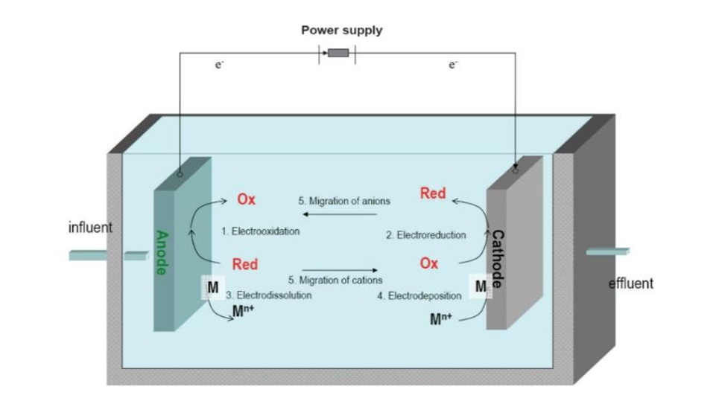
Figure 3 - Reactions in an electrolytic cell
These reactions destabilise the contaminant molecules, causing their precipitation and/or oxidising them to more biodegradable compounds. Electrocoagulation (EC) technique was utilised.

Electrocoagulation
In the EC process, ions/coagulants are generated in situ by an electric current through sacrificial anodes (Figure 3). During the same process, there are reactions of destabilisation, precipitation, emulsion breakdown, oxidation, reduction and molecular breakdown (Arslan-Alaton et al, 2008). EC reduces the amount of sludge generated (typically producing between 30% and 70% less sludge than other conventional physio-chemical treatments).
Chen (2004) says electrocoagulation process works with the basis of a conventional coagulation. Although, the main and most important difference is that the coagulant is generated in situ by the electrolytic oxidation of the anode which is sacrificed, therefore it is not necessary for the addition of chemicals. Thus, inventory consumption is reduced.
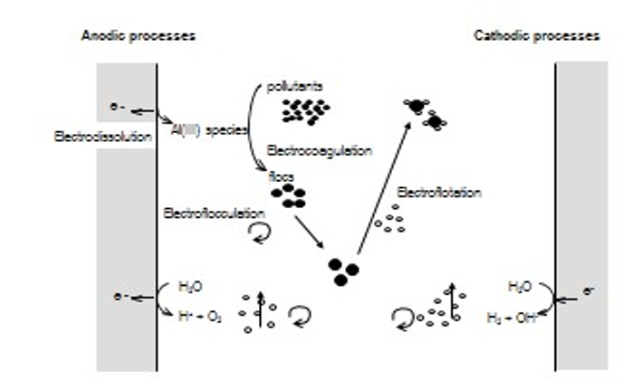
Figure 4 - Electrocoagulation in an electrolytic cell
EC can be used with aluminium or iron anodes (+) depending on the application. The cathodes (-) are always stainless steel. The anode is sacrificial and has to be replaced after a certain amount of time depending on the current and flow applied during the process.

EC targets specifically to the pollutants below:
• Suspended solids and colloids
• Heavy metals
• Organic compounds (COD / TOC)
• Absorbable nitrogen (TN)
• Oils, emulsions and total hydrocarbons
• Cyanides
• Bacteria, viruses and parasites

Improving the Process

Lab trials
Four samples were taken from different waste streams in the blank processing area. Three of them had varying nickel contents, and a finishing sample included different metals. The author’s employer currently produce approximately:
- 607 m³/week of Nickel rinse solution,
- 0.8 m³/week strong Nickel solution
- 2.5 m³/week of weak Nickel solution.
- 5.5m³/h of finishing sample
The test was run by combining all collected samples at the ratios indicated. The solution was treated at 0.3 Ah/l. It was considered that the effluent to be treated is approximately 10 m³/h assuming 80% utilisation of the plant capability. During the first treatment the sludge removal was initially done with a filter paper but part of the solids passed through the filter, therefore a second filtration was undertaken.
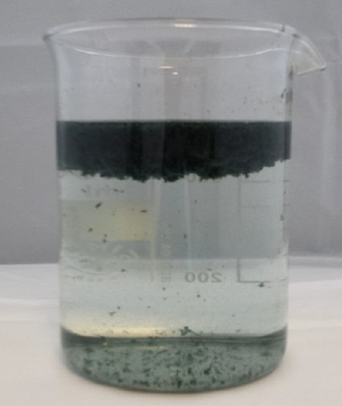
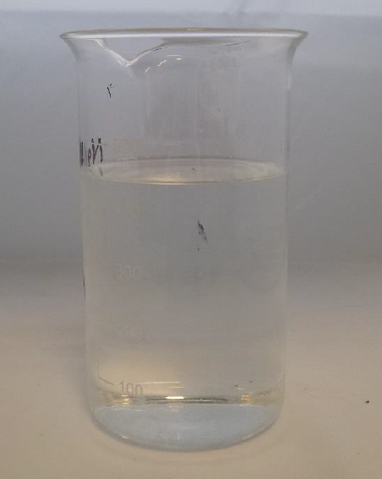

Figure 5 - Combined sample after electrocoagulation Figure 6 - Combined sample after EC and filtering

After the test was completed the sludge was removed and a clear sample was analysed. Figure 7 shows parameters defining the mixture made up and the results obtained after electrocoagulation treatment to the effluent mixture.
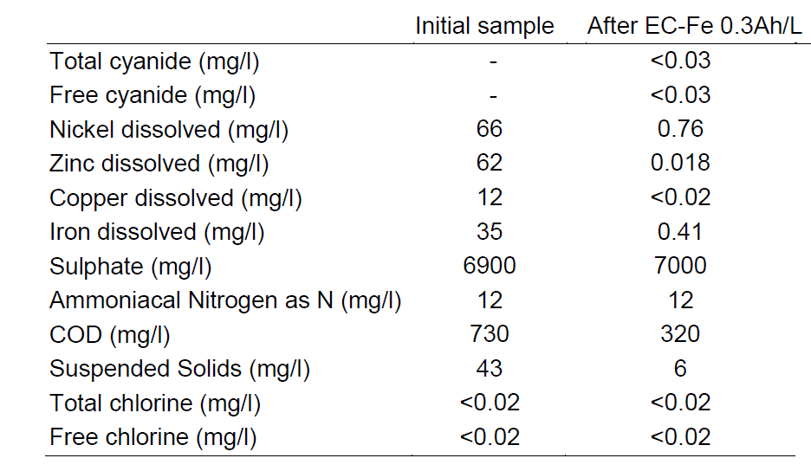
Figure 7 - Parameters analysed initially and after EC at 0.3Ah/l to the combination of Nickel solutions
This laboratory trial demonstrated that this technique is successful at removing nickel from process waste.

Pilot trial
As the results from the laboratory scale trials were successful, it was decided that a pilot rig should be trialled. This is to ensure process stability with larger volumes.
Figure 8 - Process flow of pilot rig trial

The treatment consisted of three main processes:
- Electrocoagulation (EC): the effluent was coagulated using this electrochemical technique. The EC reactor is shown in Figure 9.
- Anodes used in reactor: Iron
- Cathodes used in reactor: Inox 316 (austenitic stainless steel alloy)
2. Cross-flow ultrafiltration (UF) (Figure 9): separation of flocs produced during EC. The sludge generated in this stage was sent to the sludge filter press unit.
3. Filter press (FP): the sludge was passed through a filter press unit to generate a filter cake.

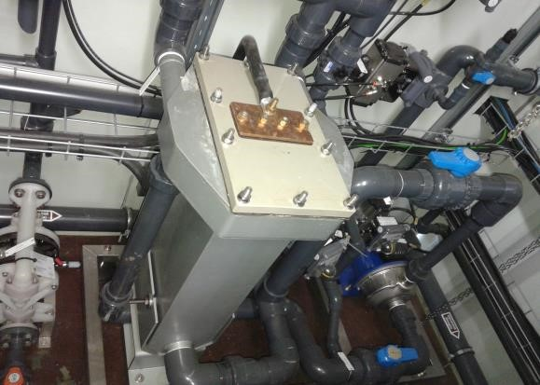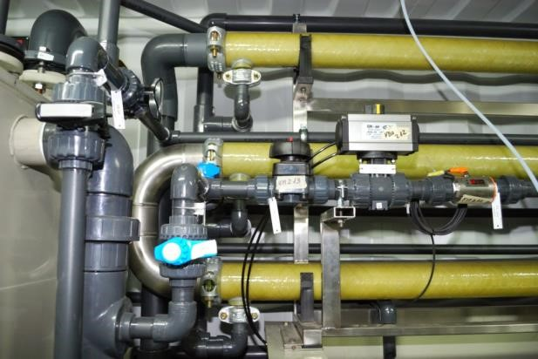

Figure 9- Left: Electrocoagulation reactor. Right: Ultrafiltration Membranes

Treatment of 100ppm Nickel Effluent
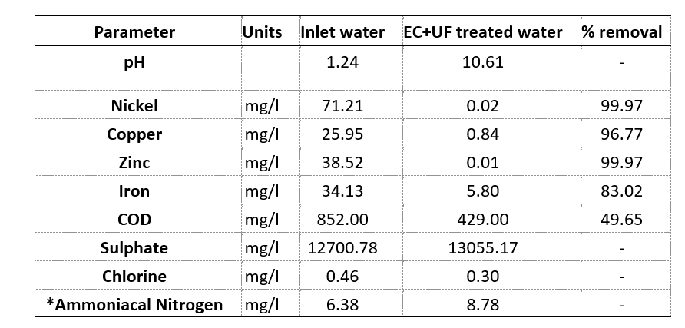
Table 2 - Average results of all the samples (IBC’s and samples taken in process checks) collected during the trial for the treatment of a 100 ppm Ni Effluent
*Ammoniacal nitrogen slightly increases due to the sampling method. When taking samples in process, at a certain time, the inlet water doesn’t match with the water being treated. The inlet water gets mixed with previous solutions in the next tanks before being treated. If the sample is taken from the homogenisation tank, the concentration remains the same or slightly decreases.

Treatment of 500ppm Nickel Effluent
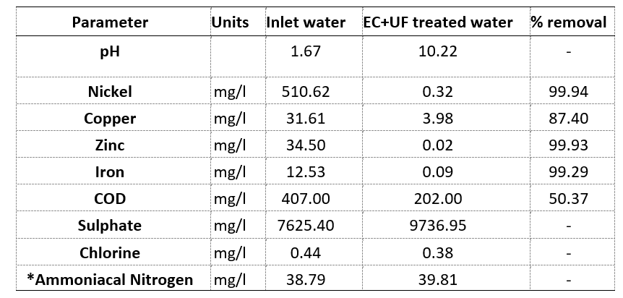
Table 3 - Average results of all the samples (IBC’s and samples taken in process checks) collected during the trial for the treatment of a 500 ppm Ni Effluent
*Ammoniacal nitrogen slightly increases due to the sampling method. When taking samples in process, at a certain time, the inlet water doesn’t match with the water being treated. The inlet water gets mixed with previous solutions in the next tanks before being treated. If the sample is taken from the homogenisation tank, the concentration remains the same or slightly decreases.

Treatment of 1000ppm Nickel Effluent
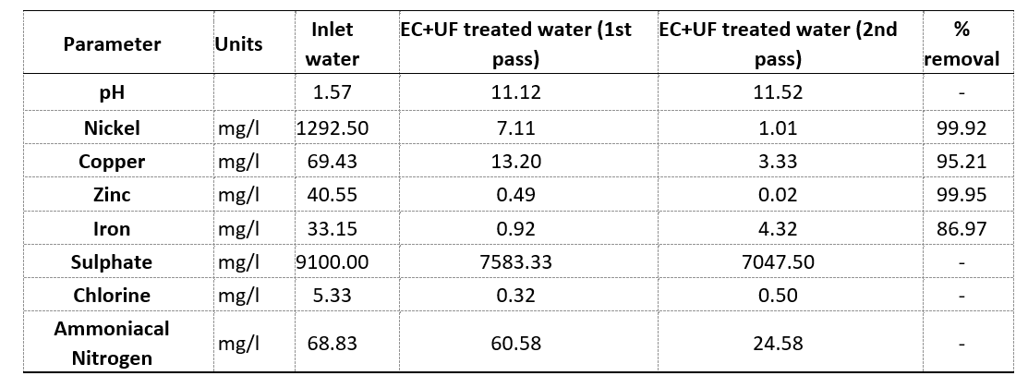
Table 4 - Average results of all the samples (IBC’s and samples taken in process checks) collected during the trial for the treatment of a 1000 ppm Ni Effluent.

Sludge analysis
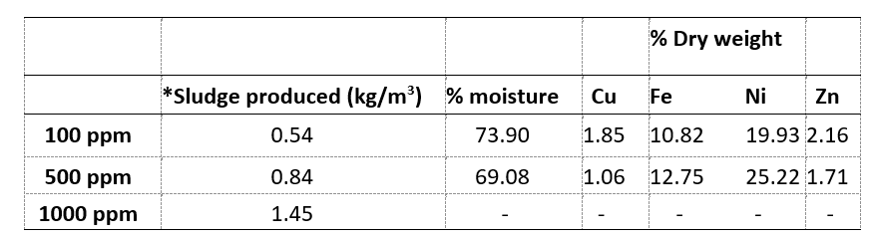
Table 5 - Sludge generated and average results of all the filter cake samples taken during the trial.
*The sludge produced is calculated weighing the suspended solids content of the samples taken just after the EC process.
An electrocoagulation treatment process using iron anodes was tested to assess the effectiveness of this technique to remove Nickel. Different strength solutions were tested during the pilot trial. The results of the recent study confirm that this technique efficiently removed suspended solids and heavy metals. Nickel was removed successfully (> 99%) in all the solutions tested covering a concentration range from 71 ppm to 1290 ppm. A second pass through the electrochemical reactor was required for the completed removal of Nickel for the highest concentration solution. Also the electrocoagulation enabled the removal of 50% of the COD, which represents the coagulable organic matter.
The sludge generated in the process was dried using a filter press. The filter cake obtained is rich in Nickel and Iron. Depending on the strength of the effluent treated the Nickel content varied between 20 and 25% of the dry weight and between 10 and 12% for Iron.

A consideration of potential problems, costs, and how problems could be overcome

Cost
- The annual operation cost would be approximately £5765 (£0.18/m3) in terms of electricity
- Approximately £12800 (£0.4/m3) for consumption of electrodes.
- The Electro-chemical treatment system and supporting process requirements result in an indicative cost of £136000
- An additional operator on each shift will be required to control the new equipment. 4 x £25043 + 48% shift allowance. Annual total £148254
- Civil work and pipework modifications will be required. This has been quoted at near £46000. The high cost is attributed to, building a new chemical resistant bund, hire of equipment (excavation, crane, high-lift etc.), modification to PIDs and site drawings, labour etc.
- CAPEX total will be in the region of £200000. Operational costs will increase by approximately £167000 (not including maintenance, downtime, quality issues etc.) annually.

Potential problems
- The process is energy intensive. The organisation is currently in a period whereby it wants to appear greener and more sustainable.
- Requesting £200000 capital expenditure (CAPEX) from the organisation will be challenging.
- Increasing revenue expenditure (REVEX) by £167000 annually will also be challenging
- Metal market prices often fluctuate, so any potential revenue from the selling of nickel could deplete and become negative.
- Coin market fluctuations. At present, there is a large demand for nickel plated steel, if this demand drops, any potential revenue from the selling of nickel metal could deplete and become negative.
- A small amount of nickel rich filter cake will still need to be disposed of as hazardous waste.

Overcoming potential problems
- The organisation can still appear green and sustainable by finding a new waste route for non-hazardous. Recycling of the filter cake is an option, as it contains calcium sulphate dihydrate which can be re-processed into gypsum, for use as plaster or fertilizer (Smith et al, 1984)
- Requesting CAPEX has a formal procedure, with the opportunity for the senior management board to review all data collected. If the CAPEX seems lucrative and is within the vision of the organisation, it should be approved. As the new process is expected to generate a revenue, some of the CAPEX can be offset.
- As with CAPEX, REVEX also has a defined procedure. As the process is expected to generate a revenue, some of the REVEX can be offset.
- Although metal markets fluctuate, any revenue generated is an advantage to the business
- Nickel plated steel is the main product produced at the organisation. This has been the case since an international change from non-ferrous to plated product. This demand is not expected to drop
- A small amount of hazardous waste will always be favourable over a large volume of hazardous waste. This means more non – hazardous waste will be generated, which should be suitable for recycling, reducing cost further.

Conclusion
- A waste was identified that could potentially generate a revenue for the organisation
- Both lab results and pilot results are satisfactory, removing 99% of the nickel in electroplating effluent.
- Metal markets currently make the investment lucrative. With nickel prices at £12000 per tonne, there is potential to recover approximately £185000 per year.
- A new recycling route for non-hazardous filter cake has been sourced. This is favourable to the business, as it makes the organisation appear more sustainable whilst reducing disposal costs.
- A capital expenditure enquiry will be raised by both the project requester and project sponsor
- Consumption of reagent chemicals can be reduced; this should be favourable when requesting CAPEX.

References
Arslan-Alaton, I, Kabdas¸ I, Hanbaba, D and Kuybu, E. (2008), Electrocoagulation of a real reactive dye bath effluent using aluminium and stainless steel electrodes, Journal of Hazardous Materials, 150:1, pp. 166–173.
Belbin, M. (1981), Management teams: Why they succeed or fail, (First Edition). Oxford: Butterworth-Heineman.
Boshnyak, M V, Galimianov, A R and Kolmachikhina, O B. (2018), Evaluation of the Processing Opportunity of Galvanic Production Sludges with Nickel Recovery, Solid State Phenomena, 284:1, pp. 790-794
Canning. (1978), Canning Handbook on Electroplating, (Twenty-second edition) Birmingham: W. Canning Limited.
Chen, G. (2004), Electrochemical technologies in wastewater treatment, Purifying Technology. 38:1, pp. 11–14.
Dave, R S, Dave, G B, and Mishra, VP. (2010), Removal of Nickel from electroplating Wastewater by Weekly Basic Chelating Anion Exchange Resins: Dowex 50x4, Dowex 50x2 and Dowex M-4195, Journal of Applied Sciences in Environmental Sanitation, 6:1, pp. 39 – 44.
Dhokpande, S R, Kaware, J P and Kulkarni, S J. (2013), Research for removal of nickel from wastewater: A Review. International Journal of Science, Engineering and Technology Research, 2:12, pp. 2162 – 2166
Gowda, R, Nataraj, A G and Manamohan Rao, N. (2012), Coconut leaves as a low cost adsorbent for the removal of Nickel from Electroplating effluents. International Journal of Scientific & Engineering Research, 2:1, pp. 1- 5
Harvey, J. (2004), Match the Change Vehicle and Method to the Job. Quality Progress. pp. 41 - 48.
Hemamalini, C G, Sruthi Meena, R, Sreevelan, M, Saravanan, G and Wilsha RW. (2018), Removal of Nickel from Wastewater using Natural Adsorbents through Regression Model, Bulletin of Pure and Applied Sciences. 37:2, pp. 221 – 228
Kabdas¸ I, Arslan, T, Ölmez-Hancı, T, Arslan-Alaton, I and Tünay, O. (2009), Complexing agent and heavy metal removals from metal plating effluent by electrocoagulation with stainless steel electrodes. Journal of Hazardous Materials. 165:1, pp. 838 - 845
Krovvidi, V B, Pinninti V R R and Dwivedula, D. (2019), A Six Sigma Case for Process Optimization in Water Treatment Plant, The IUP Journal of Operations Management, 18:3, pp. 37 – 48
Minardi, R. (2017), Muda: The 7 Deadly Wastes. LABTALK, pp. 16 – 21
Nachiappan, R M, Anatharaman, N and Muthukumar, N. (2009), Integrated Approach to Total Productive Lean Six Sigma (TPLSS) Implementation in a Manufacturing Industry, Journal of Operations Management. pp. 14 – 35
Rose, I and Whittington, C. (2014), Nickel Plating Handbook, (Second Edition) Brussels: Nickel Institute.
Schlesinger, M and Paunovic, M. (2000), Modern Electroplating, (Fourth Edition). New York: John Wiley and Sons Inc.
Smith, L L, Fortney, M L, Morris, C E, Wheelock, T D and Carrazza, J A. (1984), Resource Recovery from Wastewater Treatment Sludge Containing Gypsum, Chemical and Biological Engineering Conference Presentations and Proceedings, 19:1, pp. 441 – 450.
Suprapto, M, Bakker, H L M and Mooi, H G. (2015), Relational factors in owner–contractor collaboration. International Journal of Project Management, 33:1, pp. 1347 -1363
Woodward, K. (2011), Lean six sigma, Cary: North Carolina. https://www.slideshare.net/CKayeWoodard/lean-section-2 Accessed: 20/11/2020

