MODULE CODE: BMSK5003
UNDERSTANDING AND ENGAGING IN THE CUSTOMER EXPERIENCE
Module Lecturer’s Name: Tanja Nathan
STUDENT NAME: FIRON MIAH
STUDENT ID:1605305

Contents
Introduction 4
Critically analyzing the factors that impact on my organization’s ability to maximize customer value 5
Critically understanding of Aldi’s quality processes and its effectiveness in meeting customer requirements 11
Conclusion 17
References 18

Executive Summary
Customer value means the customers’ assessment of the difference between the perceived benefits from the products and the cost of the products. There is a close relation between customer value and customer satisfaction where the customer value affects the customer satisfaction level. When the perceived value of the customer is high, the customer satisfaction level increases. There are several factors that affect the customer value such as the price of the products, quality of the product and service, corporate reputation and brand value, product customization, fast delivery and after sale service. The business organization needs to focus on these factors and has to ensure that these factors increase customer value. The organization has to design the operational process in a way that facilitates the improvement of the customer value in terms of these factors. For example, the business organization has to implement total quality management process to increase products’ quality and thereby, the customer value. The business organization applies various processes for the management of quality such as Quality gap management model, six sigma and total quality management process. The business organization also needs to focus on the development of a good customer relation as it helps the company to make proper operational and strategic decision.

Introduction
For any business organization, the customer value and the customer satisfaction are the two crucial terms as they influence on the organizational operation and profitability level. When the customers hold a higher value to the products of the company, they purchase more products and they seem to be loyal to the company. The business organization takes attempts to increase the customer value and experience such as increasing quality of the products or ensuring a cheaper price for the products. The aim of this report is to explain the factors affecting customer value in terms of Aldi and the quality process of Aldi. Aldi is one of the leading retailers operating in more than 20 countries with more than 1,000 stores (Aldi.co.uk, 2018). The company offers foods, beverage and household goods to the customers.

Critically analyzing the factors that impact on my organization’s ability to maximize customer value
To a business organization, the importance of the customer value is very high as it holds impact on the overall profitability and market share of the business organization. Customer value can be defined as the benefit experienced by the customers through purchasing the products where the benefit outperforms the cost of the products. The customers evaluate the products’ value by measuring the difference between the perceived benefits and the cost of the products. It is needed to make a differentiation between customer satisfaction and customer value although both the terms are quite similar (Haney, Mazzola and Schroeder, 2015). Customer satisfaction means the attributes of the products that meet customer expectation properly. When the products and services meet customers’ expectation fully, the customers are satisfied and vice-versa. Thus, the customer satisfaction is related to the expectation regarding the products that they purchased. On the other hand, customer value is the perceived benefits over the purchasing cost of the products. But the customer value holds impact on the customer satisfaction where a higher customer value brings about a higher customer satisfaction.
The business organization like Aldi seeks ways to maximize customer value as it affects the competitiveness of the organization. The customers switch to other companies when they find higher customer value to these companies. Aldi is one of the leading retailers operating in more than 20 countries with more than 1,000 stores. The company offers foods, beverage and household goods to the customers. The profit level of the company is high that is € 53 billion in 2017 (Aldi.co.uk, 2018). Aldi puts importance on the customer satisfaction level and takes various strategic choices to increase customer value and satisfaction. But there are several factors that affect the customer value such as the quality level of the products affect the customer value and customer satisfaction level.
In case of Aldi, there are three major factors affecting customer value and the organizational ability to maximize customer value and customer satisfaction level. Here, by developing and applying a theoretical framework, the impact of these factors on the customer value has been explained in terms of Aldi.
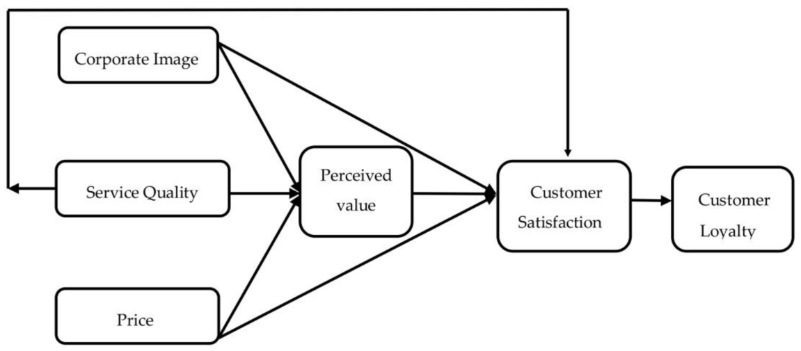
Figure 1: Theoretical Framework of factors affecting customer value
Source: (Haney, Mazzola and Schroeder, 2015)
First of all, the impact of corporate image on the customer has been demonstrated here. In this case, the corporate image means the reputation and brand value of the company which is trailed by the customer on the basis of the assessment of the company’s ethical and corporate social responsibilities practices in line of Aldi. The customer seems to get higher perceived value by consuming a product when the brand value and reputation of the company is high (Haney, Mazzola and Schroeder, 2015). This brand value and reputation brings about an intangible and intrinsic value for the products in the mind of the customers. For example, by purchasing a product of Aldi the customers get higher intrinsic value compared to the purchase of the product in the local retail shop because of the higher brand of Aldi. This brand value of the products adds higher utility from the consumption of the products. In this case, the ability of the company to maximize the customer value through ensuring a higher corporate image depends on two major factors such as the ability to adopt proper corporate social responsibility activities and the promotional activities. Here, the company needs to make budget for ensuring corporate social responsibility as it requires funding by the company. Aldi offers products to the community people at discount price and provides funds to the improvement of the quality lives of the community people. The company arranges promotional activities such as various discount offerings; 20% discount on the snacks items. All these factors affect the company’s ability to maximize customer value.

The quality of the service level along with the product influences the customer value and largely the satisfaction level of the customers. Quality of the products directly affects the utility of the products consumed by the customers and it builds perceived value in the mind of the customers (Schroeder and Kardoff, 2015). This quality can be stated in terms of two dimensions such as quality as excellence and quality as reliability. In this regard, Aldi puts emphasis on the both dimension to maximize the customer value. The reliability of the products means the actual performance of the products that meets the expectation of the customers and the promised performance of the products. Higher the reliability of the products is higher the customer value of the product. In this case, assimilation theory developed by Anderson (1973) can be linked to this statement of reliability of the product increasing customer value.
Under Assimilation theory, the customers develop an expectation regarding the products’ performance and attributes level. When the actual performance of the products fully meet the expectation such as the products are reliable, the customers are satisfied and their perceived value will be higher. But when the products’ actual performance fails to meet customers’ expectation, the perceived value along with the customer satisfaction will be lower and the customers reshape their expectation to minimize the discrepancy between expected and products’ real performance (Schroeder and Kardoff, 2015). But the contrast theory developed by Hovland, Harvey and Sherif (1987) states that the customers would not take action to minimize the discrepancy such as rebuilding the expectation rather they magnify their discrepancy level which adversely affects their value to the products. Thus, the reliable products of the company seem to increase customer value and satisfaction level. To ensure reliability of the products, the takes some actions such as applying total quality management technique and the six sigma approaches. These quality management processes of Aldi have been explained in the next section of this report. The ability of the company to maximize customer value depends on the ability of the company to properly implement these quality management processes and to ensure a reliability of the products.
The excellence dimension means the unique features of the products and the service of the company. The after sale service of the company increases customer value as it increases customers’ intrinsic utility of the consumption due to the confidence in the mind that any problem found of the product can be solved through the after sale service (Dessler, 2017). To maximize this facility, Aldi has installed online communication platform where the customers can get information from the company any time and they can put purchasing order through online. To ensure unique and excellent products offering Aldi emphasizes on the research and development section and the company encourages the employees and management to focus on more innovative product idea and production process.
Within the factors, the price of the products affects the customer value and satisfaction highly. The price of the products creates a difference between perceived value and cost of the products which is the basis of the customer value (Campling, 2015). The customers choose to purchase products on the basis of its price at the first hand as the quality or other attributes work after purchasing the products. In this sense, the setting of the price of the products is very important for the business organization to attain higher customer value and thereby, customer satisfaction and loyalty. To maximize customer value, Aldi needs to set a minimum and fair price of the products that is cheaper compared to other retail business organization like Tesco, ASDA and Morrison’s. It can be added that the price of the Aldi’s products is 30% cheaper than any other retailers in this industry sector (Aldi.co.uk, 2018). But the ability to set a lower price of the products depends on some factors such as the cost structure of the company and the price of the raw materials. To control the cost structure of the company with a view to setting a lower price, Aldi adopts some operational management tools such as lean production theory and just-in-time approach.
Under lean production approach, the company takes some strategic actions such as collecting raw materials from local suppliers which helps to reduce transportation cost and the application of progressed technological equipment in the production process and service offering section. Moreover, the company follows a time-based management where the company sets opening time of the stores related to the peak hour and in other time the company keeps closed the stores. This time-based management helps the company to control and reduce the cost of energy and the need of additional labour. The just-in-time approach is the process of setting purchase order of the products on the basis of the inventory in hand (Campling, 2015). The company sets purchase order only when the inventory is finished and this approach helps the company to reduce the cost of handing a large amount of inventory in hand.
The price of the raw materials affects the company’s ability to maximize customer value through setting lower price of the products. This price of raw materials depends on some factors such as the relationship with the suppliers, the economic and political situation of the country and the bargaining power of the suppliers. In this regard, Aldi focuses on the building of a good and long-term relationship with the suppliers which help the company to get a price concession on the raw materials. Moreover, the bargaining power of the supplier seems lower as they offer less-differentiated items and Aldi holds a strong position in the industry. The ability to collect raw materials at a lower price enables the company to set a lower price of the products and thereby, maximize the customer value.
There are other factors such as product customization, fast delivery of the products and the introduction of variety and variation in the products. Product customization means producing and offering the products to the customer based on their individual preference and demand. For example, Aldi offers diet food for the customer segment that is more health conscious. Customized product better satisfies the demand of the customers in a specific segment and it increases their utility level from the consumption of that product (Giuliani and Kurson, 2016). Product customization requires the company to increase market research and set a target customer segment. It requires more intensive customer survey and more production cost because the company does not get an economic scale from customized production.
Fast delivery of the products increase customer satisfaction level and this service feature can be stated as speed in terms of operational term. The customers want more technologically developed service that ensures fast delivery of service. For this Aldi introduces the use of information technology in its customer service section such as the customers can put purchasing order through online e.g. using Facebook or Twitter. The company then completes the transaction very fast and delivers the products using company’s special vehicles and staffs. Fast delivery saves time of the customers and it may increase utility of the consumption. The ability of the company to maximize this customer value depends on the availability of the technology and skilled human resources. Aldi hires employees with required expertise through its efficient recruitment and selection function. Moreover, the company arranges quality training for the staffs that increase employees’ productivity and the capability of the staffs to complete the transaction fast and effectively.
Developing and maintaining a good customer relation is very crucial for a business organization as it helps the organization to indentify customer demand and desire more accurately and to set proper strategic action such as proper advertisement channel for the customers (Giuliani and Kurson, 2016). Aldi takes several actions to develop a good customer relation such as the company maintains a communication with the customer through online facility where the customers can provide feedback of the products. Moreover, the company offers various special services to the customers such as premium membership to the customers who are loyal and purchase products from the company regularly. This premium membership facilitates the customers with more discounts on the products and gift from the company.
A good customer relation helps the company to identify the customers demand and then produce the products. It helps to produce more customized products for the customers that in turn increase customers’ satisfaction and loyalty level. A good customer relation helps Aldi to set strategy such as marketing and communicational strategy. The company arranges a facility in the Facebook to contact with the customers where the customers comment their preferences and suggestion for the company. It helps the company to focus on the specific section such as the company may need to improve the quality of home items which is pointed in the communication tool in the form of feedback from the customers (Kok and Graves, 2016). More importantly, a good customer relation helps the company to increase its market share as the customers themselves spread the company’s reputation and product’s information which works as a advertisement channel for the company.
But developing and maintaining a good customer relation posits some challenges for the company such as the company’s capability to indentify the customer group with whom the company needs to maintain a relation. The proper application of customer relationship management requires some costs for the company such as the company needs to develop online platform that needs maintenance and installment cost. Thus, the increase of the costs is one of the core challenges for the company though the benefits outperform the cost in this case.

Critically understanding of Aldi’s quality processes and its effectiveness in meeting customer requirements
Quality indicates the level of excellence of any product. That means more the product is flawless and less the variation of the product the product is more quality full. Quality is assured to fulfill the requirement of the customers. It can be described as the fulfillment of certain standers that is previously fixed or used to compare with other similar products (Kok and Graves, 2016). It is the total ability including the features and the characteristics of the product that can satisfy the customer needs. In business there are some aspects that indicate quality. Quality management depends on the aspects of quality and how they are being implemented throughout the organization. Some of the aspects applied in Aldi are:
Quality planning is related to the identification of the customer and their need, processes to fulfill those needs and how to implement those processes. It is related to the way of developing products and systems that will provide the customer expectations.
Quality assurance is the promise of a certain product or service that it will fulfill a certain level of expectation of the customers. This type of confidence is developed by proper quality control, scientific evaluation, and standard comparison. By proper monitoring and continuous development mistakes and defects are prevented to build the confidence of quality (Schroeder and Kardoff, 2015). QA is ensured based on two principles, one is, and the product should be for the fulfillment of the purpose that means it doesn’t matter if the product is premium quality if it doesn’t fulfill the purpose. And the second one is the prevention of the mistakes.
Quality control is the process that will ensure that the produced goods or the service will fulfill the determined quality standards. Total quality management and the six sigma are the two processes that Aldi follows to ensure the quality control.
Aldi uses TQM approach for maintaining quality process. It is the way that indicates the quality improvement from every aspect of the company and the improvement should be continuous in process. Here the manager of the company creates an organization culture where the employee and the staffs are responsible for the action they make and the quality improvement of the organization. To maintain the expected quality of service the management of the company arranges regular training for the employee where they are briefed about the quality control (Jones and Hill, 2017). The quality of the company is controlled by comparing the results with the predetermined standards. The most common cycle that is followed to ensure the TQM cycle is the PDCA cycle.
In the first stage the manager Plan for the quality control. That means they identify the target market and they identify the need of the customers, they identify the tools that will help to fulfill the need and the best way to implement those tools to achieve the quality of the standards. For example the company has decided to launch a new organic food product line. They have decided the target market will be the working class (Jones and Hill, 2017). They are trying to ensure the product quality by collecting the products directly from the firm and they will use their own experienced farmers to collect the products. For the transportation they are thinking they will use their own vehicles.
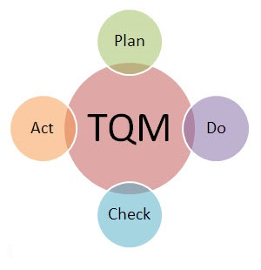
Figure 2: PDCA Cycle
Source: (Campling, 2015)
Now in the Do stage they have implemented the plan that is made before. Aldi has contacted the local farmers for the process. And the company made an annual agreement with the farmers for the supply of the products. The next stage is the Check stage here the quality control team will identify if the progress of the company is according to the plan. In this stage the team has found that the products that are delivered to the warehouse are not as fresh as it should be. The reason that has been found is due to the time difference of the harvesting and the Aldi’s transportation facility the products don’t remain fresh. So, to solve the problem, in the Act stage they have decided that before the harvesting day the transport will arrive in the local area to collect the products. It will kill some of the time but the product will remain very fresh for the customers and thus the total quality will be ensured. This cycle is simple but essential to ensure the quality.
Another approach that is followed by Aldi for the quality control is the six sigma. Six sigma is a way to control any quality related problems. In this process the quality is ensured by minimizing the mistakes and the defects in the production process. In this process the managers and the control team analyze the statistical data and the results to understand the production process and the problem with the process (Giuliani and Kurson, 2016). Aldi use this process to control the tolerable level of defects in the production. Here there is a maximum level of standard deviation that will be acceptable. But more than that will not be acceptable. To implement the six sigma managers use the DMAIC tool and the tool is described below:
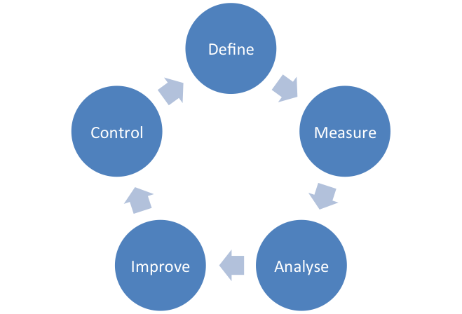
Figure 3: DMAIC Tool
Source :(Haney, Mazzola and Schroeder, 2015)
As the company follows this tool to implement the six sigma, in the first stage they define the problem related to the products or the service. For example the company has found out that the organic food quality is not as good as they have planned in the PDCA process. In the PDCA process they have decided that the accepted deviation for the products will be up-to 0.5%. There is presence of defect and products are not as much fresh as they have expected. Now in the second stage the deviation is measured that means how much the defect is and the level of mistakes that is happening in the process. They have measured that the deviation is 0.93% that is way high than the expected results.
In the third stage the reason of the problem is identified. There may be many problems for the deviation but in this stage the manager analyzes the problem to find out the root cause of the problem. In the next stage the manager improve the situation by solving the problem and developing the process. Manager of Aldi has taken decisions regarding the transportation and the harvesting to solve the problem mentioned above. The last stage is the control stage, here it is monitored that those type of problem does not happen again in the future and to implement the plan accordingly (Bisen and Srivastava, 2017). It is the responsibility of the manager and the leaders to train the employees and to motivate the employees so that they can participate in the total quality management and six sigma.
Quality is not a fixed standard. It mostly depends on the customer satisfaction. And customer satisfaction mostly depends on the customer experience of the organization. Aldi always tries to give the customer a better purchasing experience. For that reason Aldi has implemented the gap method for the better customer experience. The gap model helps to understand the gaps between the functions of the management process and helps to recover those gaps.
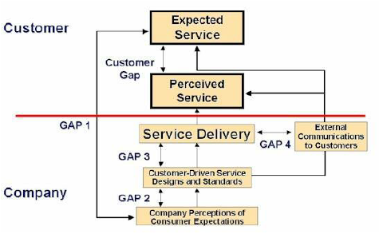
Figure 4: Gap Model of Quality
Source: (Haney, Mazzola and Schroeder, 2005)
In this model the first challenge is to identify the gap between the customer’s real expectations and the company perception about the customers’ expectations. This happens because the company is not able to identify the real expectation of the customers due to the changing nature of the business environment. For that reason Aldi have some contingency plan to meet this gap. They arrange annual survey about the customer consumption pattern and they have a research team who analyze the changes in the consumer market to understand the customer expectations. Aldi recently have found that the product preference of the average customer has been changed as the percentage of the baby boomers has been decreased and the number of young generations is increased. So they have decided to change the product preference. The 2nd gap is between the customer driven service designs and standards and the company perception of customer expectations. The gap can be minimized if there is consistency between the service process and the expectations. For example, customer wants cheap but quality product from Aldi. But it is not possible for them to provide cheap product if they don’t apply the lean production method and if they don’t control the waste management. Again it is not possible for them to provide quality product without applying the TQM method. The 3rd Gap is between the predetermined standards and the delivery of the service. That mean if the company has the ability to deliver the predetermined slandered. For this Aldi has a control team and they assure that the quality of the product is maintained properly. Communication is important to understand the need of the customers (Bisen and Srivastava, 2017). The 4th gap is related to the communication with the customers and the delivery of the product. The gap can be reduced by taking feedback from the customers and by developing them. Aldi has webpage and Facebook page for the feedback and they are monitored properly to understand the customers. Communicating with the customers also helps to generate new customer demands and new product or service ideas that will help to expand the business.
As a discount supermarket the main focus of the customers will be the price of the products. To fulfill the customer requirements the company has to understand the need of them. The target markets of Aldi want products at a cheap cost. They want product with high quality. They want better customer service and better shopping experience.
Now Aldi is fulfilling all the requirements of the customer by applying those process mentioned before. Due to the application of the six sigma the waste has been reduced and the cost related to this has been reduced. This leads to a cheaper price for the customer. A recent survey indicates that Aldi has managed to reduce the price 30% due to the successful implementation of six sigma. Due to the flawless production the company is able to reduce the operation cost and the raw material cost this also helps to reduce the price of the products.
The quality of the product is another vital customer requirement that is fulfilled by the TQM process. As in the TQM process the organization follows the PDCA cycle it tries to maintain the quality of the product from the production level to the delivery level (Dessler, 2017). To ensure the TQM process the organization gives training to the all level employees and staffs. For this reason there are limited chance for the mistakes and defect products and thus the quality is ensured.
In the customer service there are many factors related to the customer expectations. For example there is a predetermined expected service to the customer mind and the company has to fulfill the expectation. The communication to the customer is very important for the better service providing and the product development. Again the customer service quality depends on the response time of the company. All those problems and the factors are monitored and solved by Aldi with the help of Gap model. With the proper implementation of the model Aldi is now attracting the middle class shoppers. From a recent survey it is seen that 30% of the Aldi’s customers are low class and other 70% are the middle class consumers (Aldi.co.uk, 2018). It happens because of the better service quality of the company, the affordable price and the better quality of the products.
Aldi understands that the quality of the service is very important for discount shop like them and to fulfill the requirement of the customer successfully there is no alternative but using some of the quality control process. From a recent survey it is seen that the perception of the customer are being very positive (Dessler, 2017). There are many bloggers who wrote positive review about Aldi. The regular customers are giving positive review in the company webpage. Form a statistics it is seen that the market growth of the company has increased to 7.2%.

Conclusion
It can be concluded that the customer value is very important for the success of the business organization as the customer value affects customer satisfaction which in turn affects the profitability level of the company. To ensure higher customer value, the business organization like Aldi takes actions such as applying total quality management process and six sigma process to ensure higher quality of the product and thereby, higher customer value. The business organization also needs to focus on the development of a good customer relation as it helps the company to make proper operational and strategic decision. The organization also needs to consider some challenges such as higher cost at the time of developing good customer relation.

References
Aldi.co.uk. (2018). ALDI UK | Homepage. [online] Available at: https://www.aldi.co.uk/ [Accessed 3 Auguts. 2018].
Bisen, V. and Srivastava, S. (2017). Production & operation management. 1st ed. Lucknow, India: Word-Press.
Campling, J. (2015). Management. 1st ed. Milton, Qld.: John Wiley & Sons Australia.
Constable, C. (2016). Operation Management. USA: John Wiley Sons.
Daft, R. (2016). Leadership. 1st ed. [S.l.]: South Western Cengage learning.
Dessler, G. (2017). Human resource management. 1st ed. Place of publication not identified: Pearson Education Limited.
Giuliani, R. and Kurson, K. (2016). Leadership. 1st ed. New York: Hyperion.
Haney, V., Mazzola, L. and Schroeder, B. (2015). Management. 1st ed. Upper Saddle River, NJ: Pearson/Prentice Hall.
Jones, G. and Hill, C. (2017). Theory of strategic management. 1st ed. Australia: United Kingdom.
Kelly, S. (2015). Leadership Refrains: Patterns of Leadership. Leadership, 2(2), pp.181-201.
Kok, A. and Graves, S. (2016). Supply chain management. 1st ed. Amsterdam: Elsevier.
Schroeder, B. and Kardoff, A. (2015). Management. 1st ed. Upper Saddle River, N.J.: International Association of Administrative Professionals and Prentice Hall.
Sheldrake, J. (2016). Management theory. 1st ed. London: Thomson.

