Winfred Nakanjako Diane

1905864

Digital Skills and Research Methods

BMSW4003_LON

Joy Botu

The impact of Virtual Learning Environment (VLE)-Moodle on student’s learning experience at UWTSD London Campus
Research Report:
Introduction:
Virtual Learning environment it is an online portal/lesson for interaction, researching, providing material and information for student for their studies. Virtual learning environment has been the concern for many educators and researchers throughout the years since the learning environment is conducive of the respective learning outcome (Richardson and Swan, 2003).

Research Rationale:
virtual learning environment is now a very important source of learning as the lecture, if not more so, the internet (on line) have found a big part of learning at schools and used to demonstrate our ability to gather information and also helped in submission of assessments and so much more (Morgan, 2017). Such vast usage brings into question whether the learning experience gathered from using Virtual Learning Environment (VLE) for students in institutions are fruitful, how those effects their learning process and outcome and what can be done to maximise the positive outcomes. Palgrave (2014) wrote “Augmented education”. This book focused on research into learning in the “real world” that is augmented by use of virtual-and on learning in virtual environment, though some believed that these development have the potential to support new forms of inclusive and collaborative learning illustrate through practice. This research report delving right into these questions as is expected to help University of Wales’ teachers on their arrangement and application of the Virtual learning environment service- Moodle for obtaining the most effective impact on the students ‘learning and experience.

Research Title: The impact of Virtual Learning Environment (VLE) – Moodle on students’ learning experience in the University of Wales Trinity Saint David London Campus.

Background.
Learning is a result of your engagement with that information. (Morgan, 2017, p.94) wrote it’s also important to note that learning and assessment the feedback you get from assessment of one of the module or piece of work should get you think about what you did well and not so well and every occasion for assessing my work, is an occasion developing my work. Learning environment refers to the surrounding and resources available in that surroundings which is influential to learning as opposed to other activities. According to Scaramella (2006), effective knowledge building in any student learning environment requires the collaborative efforts among learning theories and styles, teaching approaches as well as use of technologies. The modern technology has helped with the virtual learning environment for students, thereafter, acknowledges the need for delving deep into the effective use of technology and thoughtful management support for arranging and applying such environment for obtaining better outcomes whether in terms of student learning or their experience while learning.

Student learning along with experience is a complex process with various factors of influence which needs to be considered and separately analysed, planned and arranged within a virtual learning platform. If failure to transmit the available information is identified, the platform is considered ineffective. Figlio (2010) henceforth, questions the effectiveness of online instructions since the clarity and effectiveness of understanding on this many outline effectiveness of online based virtual learning for students. The researchers point towards the reduced physical presence, constructive conversations and lesser opportunities in interactions in online classrooms as a major reason.
Henceforth, Richardson (2003) in his support poses a question whether the lack of social presence have any effects in virtual learning experiences. His findings suggest that while social presence might be complemented by a number of interventions and practices while letting them learn on the virtual learning environment, the student perceptions of the virtual learning environment holds much importance as marks the student satisfaction from the online learning experience. It is important for educators to consider these effects on student learning experience as issue much more influence on their learning outcome than can be regarded.
Kop (2011) expresses similar concerns since he found it challenging to connect to one another as possible in traditional classroom environments to the environment creating lacking on effective understanding of imparted knowledge and instructions. He also maintains that the student experience of learning and therefore positive outcomes from the experience relies much on different connectivity challenges and the teacher and students’ collaborative efforts’ effectiveness in countering those. So, one anonymously identified issue with student learning experience in virtual format is effective communication opportunities among entities present in the classroom (Yousef, 2014).
(Hron & Friedrich, 2003), fuelled by the belief that our ‘traditional’ classrooms are somehow
filled with the vital interactivity that online environments lack. He recognised as there is lack of interconnection in online education environment. Student who study with in the online environment lack the opportunity to experience the benefit of structure dialogue, intense requirement for self-discipline that is they always have deadlines for the assignment given by the lecturers but the organisation and time management skills really needed to stay on top of your work. And, also the sense of community that can be created in the tradition on site
Classes environment.Forexample, Robertson and Klotz (2002) suggest that the literature
provides evidence that online courses are often configured and delivered in a style more often associated with independent study and that, while this format might work in some
instances, it leaves what they term a ‘missing link’ in student learning.

Hence, Zaied (2007) argues to take timely and effective measures to ensure learning technologies to be effective in supporting positive student experience while going through regular learning process in the virtual medium. Similar supportive analysis is presented by John (2008) in his book ‘The Digital Classroom’. He emphasises that technology should be harnessed for their increased effectiveness with time to support digital classroom activities.Yousef (2014) also provided a number of analytical discussions on the reality of computer-based education as he ventured into analysing the possible ways that virtual learning assist student to upgrade in their studies and gain more experience. He also found several limitations of the virtual learning process. But, his perspective on the issue was that such limitations can be overcome with the advancement of technology and through planned support for Virtual Learning environment performance for effective student learning induced positive student learning experience in the process.

Aims and Objectives
The aim of this research is to find the various impacts of the Virtual Learning Environment (VLE)- Moodle on the students’ learning experience in UWTSD London Campus.
Accomplishing the set aim will require the following objectives to be attempted:
- By discovering the different ways, the virtual learning enviroment-moodle is using in regular student learning in UWTSD.
- To survey the student with the virtual learning environment and see how they are experienced.
- To find ways of improving the virtual learning environment for acquiring more positive outcomes and finding the impacts of the moodles service on student learning experience

Method:
The following methodological steps were taken for completing this research project-

Research Type:
There are two key types of research to be done on finding answers to complex issues. Primary research refers to data collected for specific research problems at hand, by using the policies that suits the research problems best. while Secondary research is done over second-hand data of where it is made by other researchers to be reused by the general research community. Hox, J & Boeije H (2005)
This research used both types of research presented the secondary research in the background discussion which allows the primary research in the later part to be informed on possible directions to take. Both being used creates synergy of collected data on reliable outcome definition (Leedy¸ 2005).

Research Strategy
Qualitative research strategy is where the collected data is quality based meaning, that the qualities of the topic is assessed also based on discussions opinions and descriptions, that is interpretive books, studies or text (journals) are of the kind, you tell the story as you see it, of how the themes are related to one another and how the characteristics of the speaker.(Bernard, 1996). Quantitative strategy marks numeric data for assessments and direct observation of behaviour, village census, time allocation studies and close-ended questions in surveys and collect relevant data. This research used both as helped efficiently conduct secondary and primary research, respectively.

Population and Sampling
Population of this research who were ccapable to enlighten me on the topic was huge as there are many students in UWTSD. However, collecting information from all of them is unrealistic and time consuming. So, I selected the students known to me and tried to recruit them for my survey. 15 respondents were recorded who answered in my survey based on convenience sampling meaning that they attempted the survey on their own convenient time and terms (Saunders, 2012).

Data collection and Analysis
Data collection for this research followed firstly a secondary qualitative data collection from books, journal articles, blogs, etc., while primary quantitative research required a questionnaire in a survey to collect the relevant data. The questionnaire included total 8 questions- mostly opinion-based, but also factual and behavioural questions were mixed to gather well-rounded evidences in a closed-question format. Although, I initially planned to handover hard copies of the survey to a larger sample frame, due to the COVID-19 scenario requiring social distancing and staying at home, I used the online platform by Survey Monkey to create the survey and collected the answers to the questionnaire from a much smaller group of 15 students. I dissipated the link of the survey to the sample group through WhatsApp and Email. The collected secondary data were thematically analysed, while primary data from the questionnaire has been analysed using digital analytical tools.

Results:
The results obtained from the responses to the distributed questionnaire in the survey will be presented in appropriate form below-
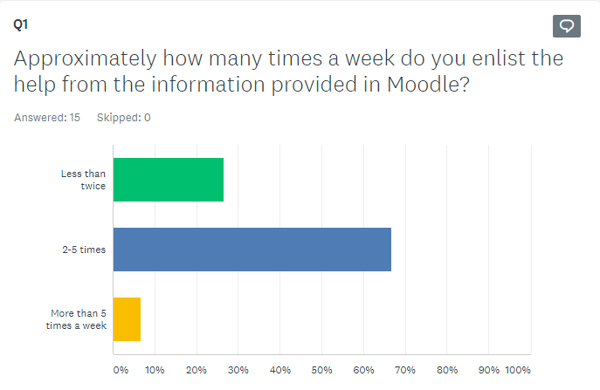
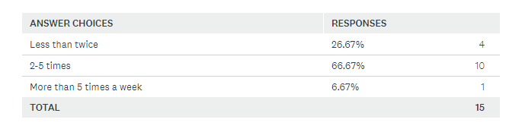With the first questions most student answered with the higher percentage because they use the Moodle service 2-5 times per week, while the lesser amount is also seen, only a few uses it more than that amount.

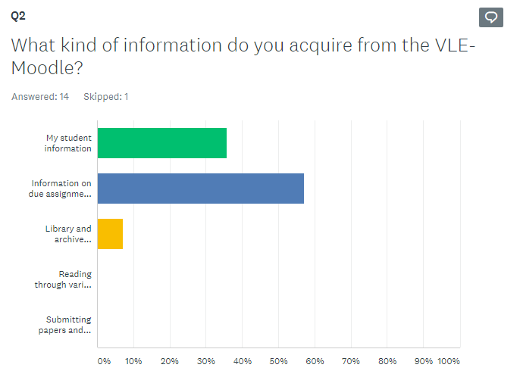
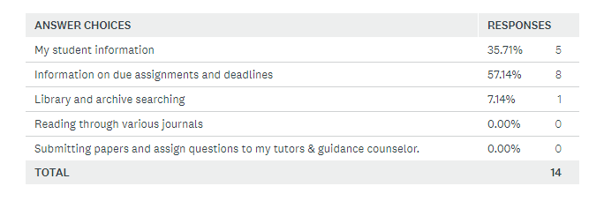With question 2. More students responded that they ask the virtual learning environment for tasks like checking on own information, submitting assignment, while the use of the resources available is alarmingly low.

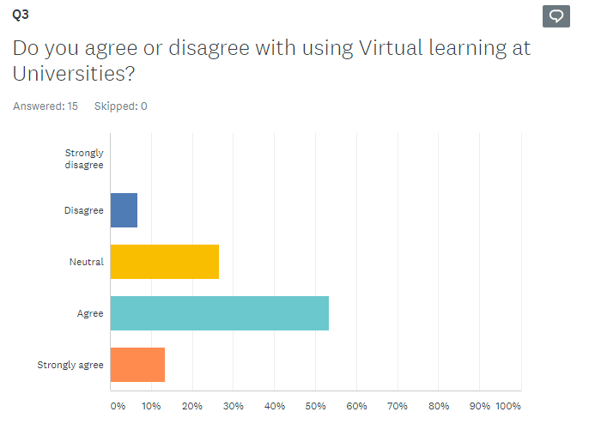
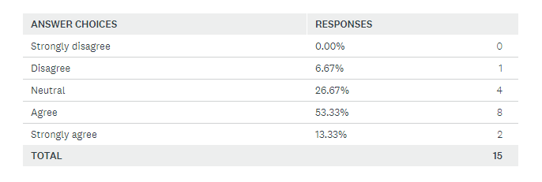Majority of students answered happily to the need of virtual learning environment for student learning in Universities with quite low negative opinion and moderate neutral ones.

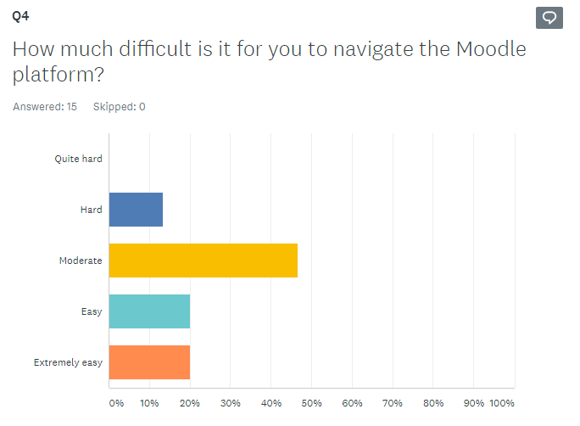
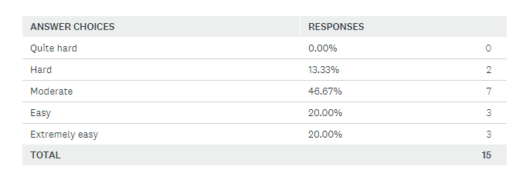Answering the fourth question there is far more indifferent opinion over the questionnaire and some positive ones suggesting the effectiveness of the service although with needs for improvements.

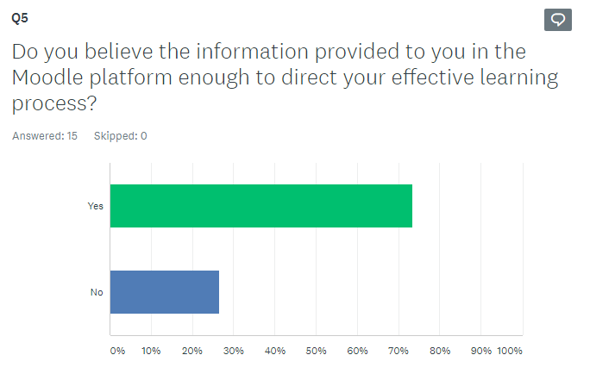
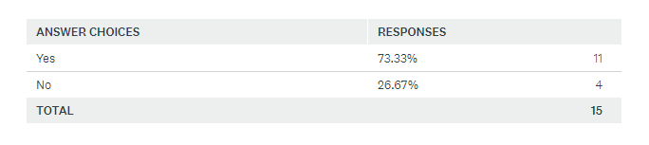Most students agree that the information in the VLE has been enough for their effective learning experience so far.

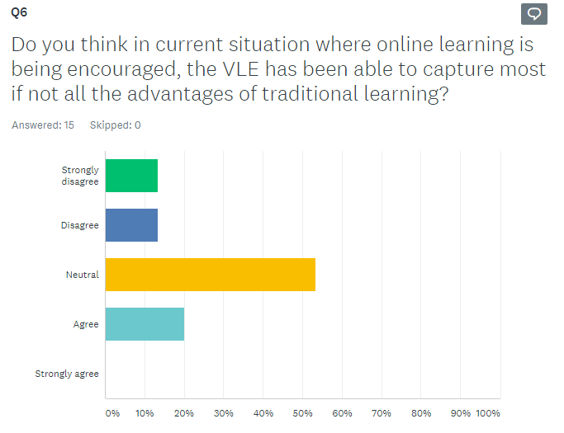
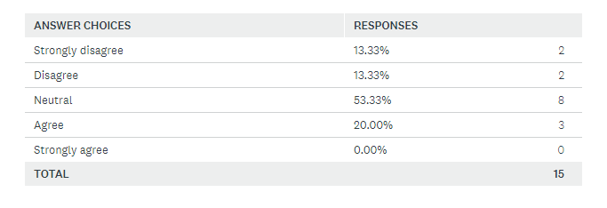For this question, the majority were neutral review with 4 disagreed views and only 3 agreements. It means that in the current situation where all learning, is online based in UWTSD, the virtual learning environment have not become able to help student learning experience as much as required while replacing traditional classroom.

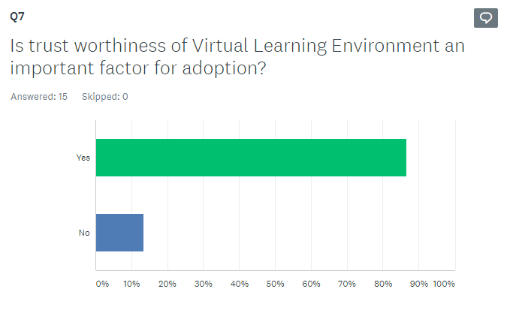
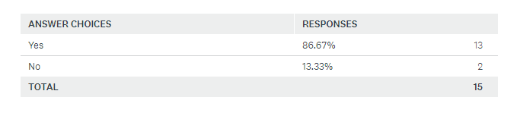Almost all student considers trustworthiness of the VLE- Moodle service a factor influencing their positive learning experience.

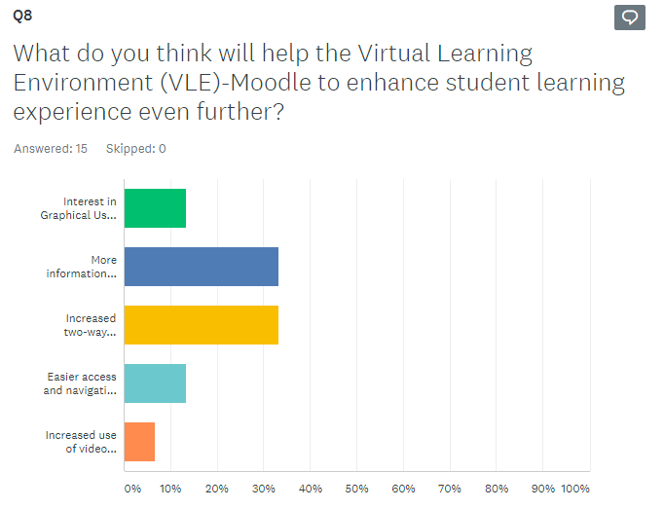
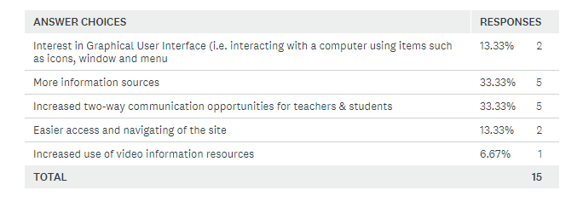This answer gathered various degrees of needs by students which they perceive will improve the learning experience using the VLE including increased resources for information, interactive communication opportunities using the VLE, etc.

Discussion
The obtained results from the survey questionnaire described that while the enlisting of help of the Moodle service by students in UWTSD is moderately high as they use it between 2 to 5 times a week, the usage is mostly limited to keeping track of own student information and for online submission of assignments. Only exceptional few ventures into the available information for further knowledge envelopment from library resources or form available journal articles. On the other hand, while some students were happy having the virtual learning environment service, as its helpful and even believes it effectiveness in guiding learning experience, some of them were not very satisfied with its usability. Furthermore, the student started to be suspicious that the Moodle alone is not helpful in replacing traditional classroom experience. The survey found them to outline trustworthiness of the platform in delivering information and effectuate two-way communication among teachers and students to be possible choices for enhancing student experience through Moodle service improvements.
These finds correspond with the findings from the secondary data analysis as various researchers found virtual Learning environment to be the future of positive student learning experience, although pointing out several areas of concern to finally accomplish the process. The findings also along with the claims of increased interactive guidance for students in online learning platform for improving student experience during the learning process (Richardson, 2003). However, the concern of trustworthiness of the platform casing positive or negative impact on the experience of students were not that much identified in those studies. VLE learning is a great process for expanding student learning experience in the digital world, as its confirmed from both set of data analysis but there are various concerns like successfully identifying student learning style preferences and accommodating for those through change in interface, easing the navigation tools, increase of useful and updated study resources, etc. (John, 2008).
According to these findings as collected from the research both in secondary data analysis of academic resources as well as from the primary data analysis in the survey, there are several improvements which can be made in the present virtual learning environment - Moodle for increased success with student learning and improved experience of these students in the process. The findings suggest that student understand the virtual learning environment worth their attention and positive experience if includes almost all relevant applications of traditional learning experience with increased resources. The easy navigation of the site as well as improved interactive communication between students and tutors is also found to have potential in improving student learning experience in the Moodle service.

Conclusion
This research meant to discuss on the possible impacts that virtual learning environment has on student experience in UWSTD. To find on this question, a methodological approach to data collection and analysis was put in place. Through collaboration of secondary and primary research using an online questionnaire, the research objectives were accomplished, and aim was fulfilled. The findings suggest that in modern world of technology-based communication, the Moodle service is increasingly effective in contributing to a fast-paced learning performance. However, thoughts should be put for making the platform more engaging and easier to use for inducing better student experience.

References:
Bernard, H. R. (2013) Social Research Method: Qualitative and Quantitative Approaches. 2nd Ed. California: Sage Publications.
David, N. Faglio, M. R. & Lu. Y. (2010) Is It live or Is it Internrt?Experimant Estimates of the Effects Of Online Instruction On Student Learning. Cambridge, MA: National Bureau of Economics Research.
Eraser, J. J. (2014) CSEDU 2014. Proceeding of the 6th International Conference On Computer Support Eduavtion. Barcelona, Spain : Education.
Gossman, J. & Baker, P. (2013) The Learning Impact of a Virtual. [Online]
Available at: https://core.ac.uk/download/pdf/29422368.pdf
[Accessed 06 05 2020].
Hox, J. & Boeije, H. (2005) Data Collection Primary vs Secondary. Encyclopedia of social measurement: Volume 1, pp. 593-599.
John, P. D. & Wheel, S. (2012) The digital Classroom; Harnessing Technology for the future of learning and teaching :Routledge.
Kevin, J. D. et al. (2016) Creating interaction in online learning: A case study, 15(3), pp. 202-215.
Kop, R. ( 2011) The Challenges to Connective Learning on Open Online Networks Learning Experiences during a Massive Open Online Course International Review of Research into Open; International Review Of Research in Open and Distance, 12 (3).
Leedy, P. & Ormnd, J. E. ( 2005) Practical Research ; planning and design. 8th Ed. Upper Saddle River, N.J : Merrill Prentice Hall.
Morgan, P. (2017) Business student's Guide to Study and Employability. London: Sage.
Palgrave, M. (2014) Bringing Real and Virtual Learning Together; Augmented Education .In: Sheehy, K. Ferguson, R. Clough, G (ed). NewYork: Palgrave Macmillan US, pp. 1X , 202.
Richardson, J. & Swan, K. (2003) An Examination Social Presence in online Courses in Relation to Student' Perceived Learning and Satisfaction; Journal of Asynchronous Learning Network, 7th March, p. 1.
Saunders, M. N. K.,Lewis, P. & Thornhil, A. (2012) Research Method for Business Student. 6th Ed. Harlow: Pearson.
Scardamalia, M. & Bereiter, C. (2006) Knowledge Building; Theory, Pedagogy, and Technology. In: K. Sawyer, (ed). Cambridge Handbook of learning Science. New York: Cambridge University Press, pp. 97-118.
Wilson, J. (2017) Certificate in Higher Education; Skills for the Workplace Student Year Book. In: Using Secondary Data. Londo: Sage, pp. 159-159.

Appendices:
Appendix 1. Questionnaire
Link to the survey questionnaire: https://www.surveymonkey.com/r/73R8WS6

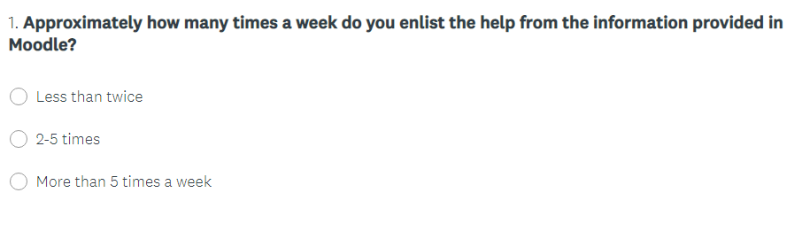
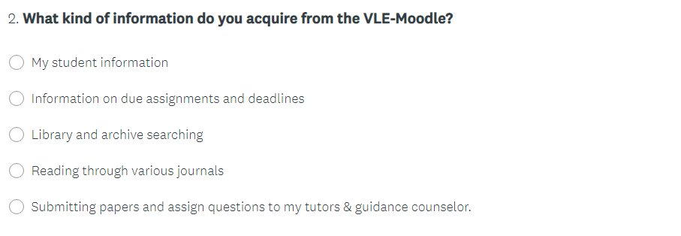
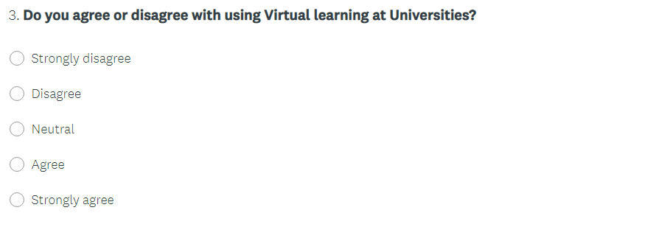
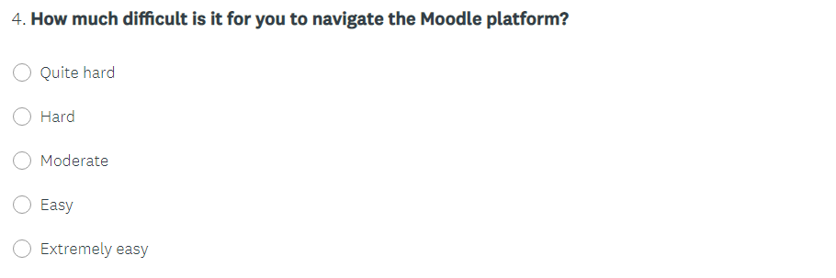
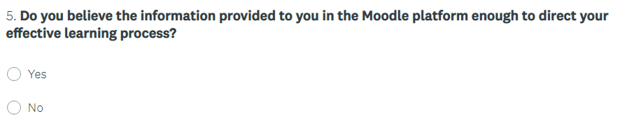
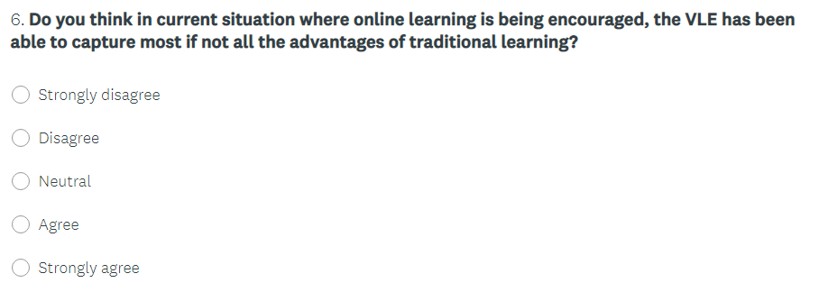
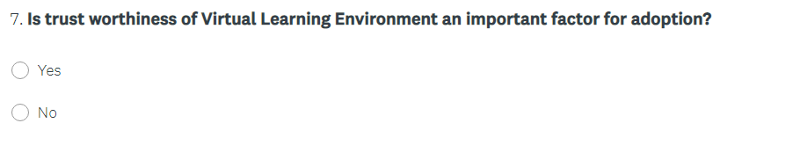
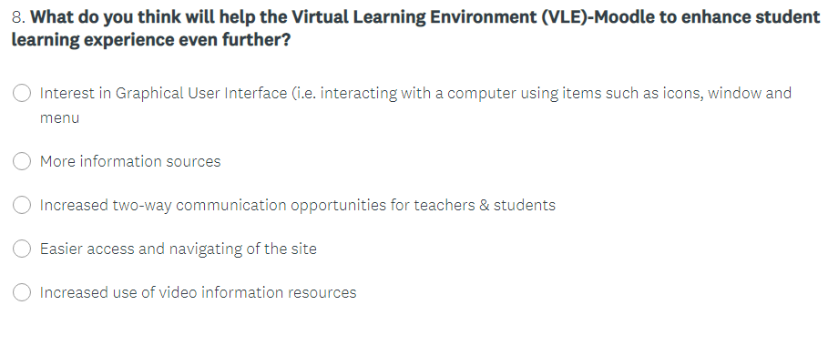

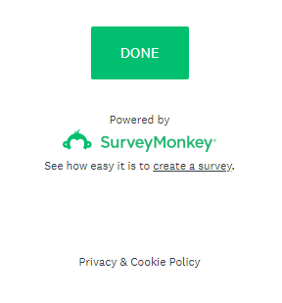

Appendix 2. Collected Data
Link to the survey results & collected data: https://www.surveymonkey.com/results/SM-PYSTHP5M7

