Blaenavon regeneration report

By Lucy Harratt
Tutors : Anthony Burns and Jessica Shore

Context

Part A:

- introduction
- Blaenafon’s historical development
- Changing fortunes
- Existing assets, structures and economic character
- Stake holders and interest groups
- Increasing tourism in the town

Part B:
- Our trip to Blaenavon
- Idea one
- Idea two
- Idea three
- References

Introduction
This report will demonstrate how the development of the mine increased the number of people in the town and how it grew throughout the years. It will also show the growth of tourism after the mine was shut, but also show how that is decreasing and the number of people visiting Blaenavon is getting lower every year. The report wil show research that shows the town is ‘outdated’ and in need of a modern touch in order to keep people interested. It will also explore 3 ideas for the regeneration process that could take place in Blaenavon. The ideas have stemmed from a visit to the town and seeing what the town needs and what the people of Blaenavon want. Asking residents of the town will give us a more clear opinion as they have the most experience with the town and could give a valid opinion on how to build Blaenavon up.

Blaenafon’s historical development
Blaenavon is an area located in the South Wales Valleys. This location is vastly known for its history of mining and ironworks. Blaenavon is home to ‘The Big Pit’, the national coal museum. ‘The big pit’ is popular due to it being one of the few remaining mining museums where you can physically descend into the pit via the lift used when the mine was still open and running. The tour comes with a guide who explains the life for miners working in the cold and dark conditions. There are also a number of surface exhibitions that are all located around the grounds of the mine. This attraction bring tourists to the town of Blaenavon as it is a free trip and offers a great opportunity to educate people on coal mining and the development of the town. It features the restored pitheads baths that are involved in the interactive exhibitions which allows visitors to walk through the exhibit and see, feel and touch the items of the miners, where they bathed and there lockers. There is also a section where there is a tunnel that is as small as the real tunnels that the children had to climb through, to give them an experience of the horrible conditions. It is a great opportunity to learn about Wales’ coal mining history and about the former people who worked and lived in coal mining communities. This bring in a lot of tourism from all over the UK, even globally. The industrial landscape of Blaenavon is a testament to the struggle and achievement of the iron workers and miners who worked there in the past. Blaenavon became an industrial landscape as a world heritage site due to the large part it had played in the development of iron and coal in the 19th century. when it was inscribed in 2000 as it says on the official page .Before the iron works, Blaenavon was a small area where farmers would work from remote homes and life in Blaenavon was overall, quiet. In the 1780’s ironworks was established. This lead to people all around the UK to travel to find work. This meant more and more people were moving to Blaenavon. The town then had a church, chapels and a school. There was also a working mens club for the miners. The page for Blaenavon is full of information that shows the development of the town and how it grew when the mine opened. They has said that “The arrival of the railways and the opening up of coal mines encouraged further expansion, resulting in the town you can explore today.” This is obvious as the town has changed so much from the time it relied on farming. Here is a map of Blaenavon and its main attractions.

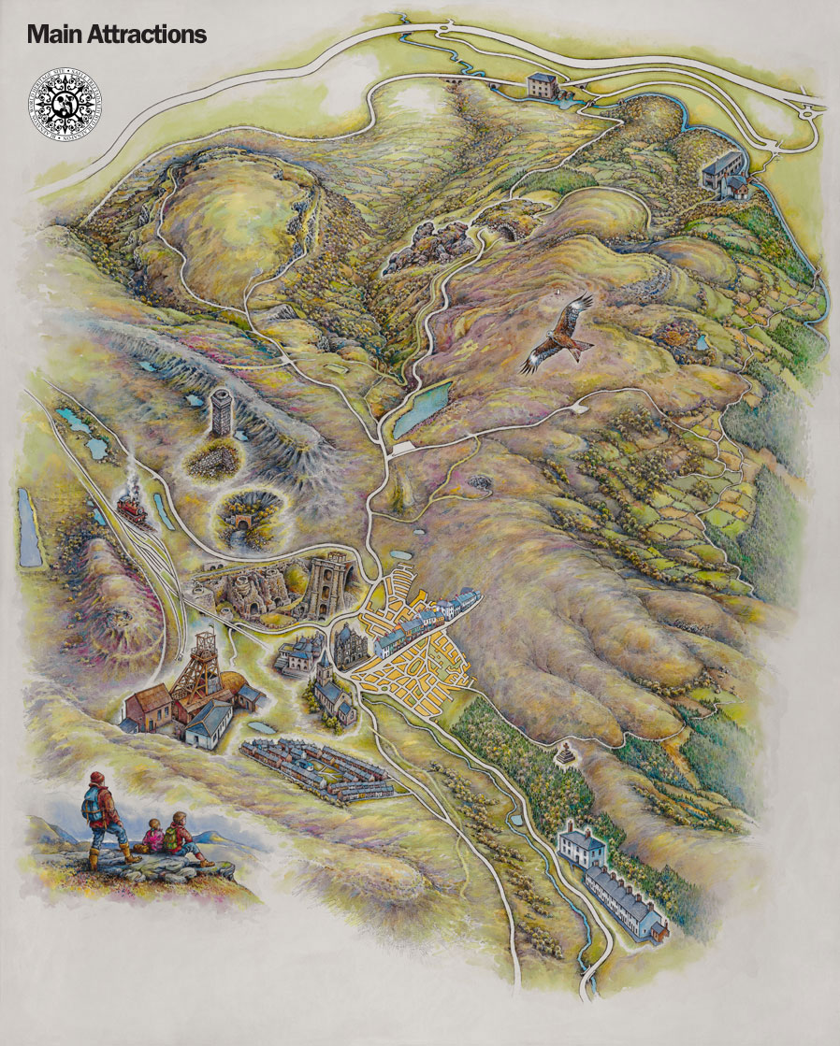

Changing fortunes
they became a world heritage site in 2000 December, Blaenavon is a human made landscape dating back to the early days of the industrial revolution. The town started to make more and more money and was increasing its number of buildings and people every year. The area of Blaenavon plaid a huge part in the industrial revolution. The town since the mine has shut stayed well populated with families and many small businesses in the town. The mine still has workers that worked the mine when it was open doing the guided tours into the mine. The town relies on the its reputation and tourism.

Existing assets, structures and economic character
The town has many events, attractions and activities all advertised o n the website. The website itself is modern, educational and very clear and easy to use. The main attraction is ‘Big Pit’, the museum and ironworks. In the town there is the Blaenavon heritage railway and the world heritage centre. These locations are all close together and only take a few minutes to drive to. The location itself is beautiful and that seems to attract people as they enjoy the view. The town is full of history, the struggle is getting people to go see it. The town features the Blaenavon world heritage centre based in former St Peter;s school founded in 1816. This school was used to educate the children of the iron workers. It now offers workshops in which they educate people on the world heritage of Blaenavon. They offer a number f indoor and outdoor activities for all ages. It holds a library with computers and even a small cafe that we found on our trip was widely popular, especially by the local residents. The big pit, bringing in tourisms and providing tours. Also has a gift ship that sells merchandise related to Blaenavon. It also features the iron works which is the main reason for Blaenafon's beautiful landscape. The Blaenavon website expressed that “you can view the extensive remains of the blast furnaces, cast houses and iconic water-balance tower, and gain a fascinating insight into the social history of the Industrial Revolution” After visiting Blaenavon, this was clear to see.

Key stakeholders and interest groups
Stakeholders include the towns county council who are trying to increase tourism and the amount of money the town have, they seem to be confident that there is enough in the town and are struggling on how to get people interested. Business and organisations are being held together by employees and volunteers. The town does offer transportation but not clearly and not regularly which may effect the town. The council could look into creating more transport for the public. The government could help with the financial status of the town. Providing money for a project with the promise of the return of the money. Press could be a huge influence on the town as the more publicity they have, the more chance of gaining tourists. The big pit gets a lot of attention, but the town itself seems to struggle. One of the recent reasons for the town of Blaenavon being in the press was the local award winning cheese shop.

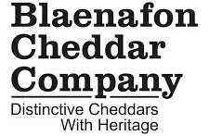

They were established in 2006 and have become widely popular. They pride themselves on Blaenafon's ‘heritage’. They describe their cheese as “ famous Pwll Mawr cheddar” They make this cheese “300ft below ground at the bottom of the mine shaft at Big Pit Mining museum in the World Heritage site ½ a mile away.” where is is aged for 2 weeks. The cheeses are matured in the big pit. In 2018 they won gold at the international cheese awards which got them plenty of publicity and customers. The shop was written about by many reporters and ultimately lead to it having more business as more people knew about it. The press is a great opportunity to gain publicity and gain more customers for all the small businesses that are struggling.
Blaenafon's society itself can help the town, less and less people are getting involved to help save the town. With the museum relying on volunteers, they are at risk of losing them as they are not forced to work there. They expressed to us that less people are volunteering due to there being less visitors. This however is going to just decline in the future and could lead to the closure of the museum. This could be avoided if they got the interest of maybe a local sponsor, or maybe an investor who could help with the buildings renovations to keep it safe and update the museum itself.

Increasing tourism in the town
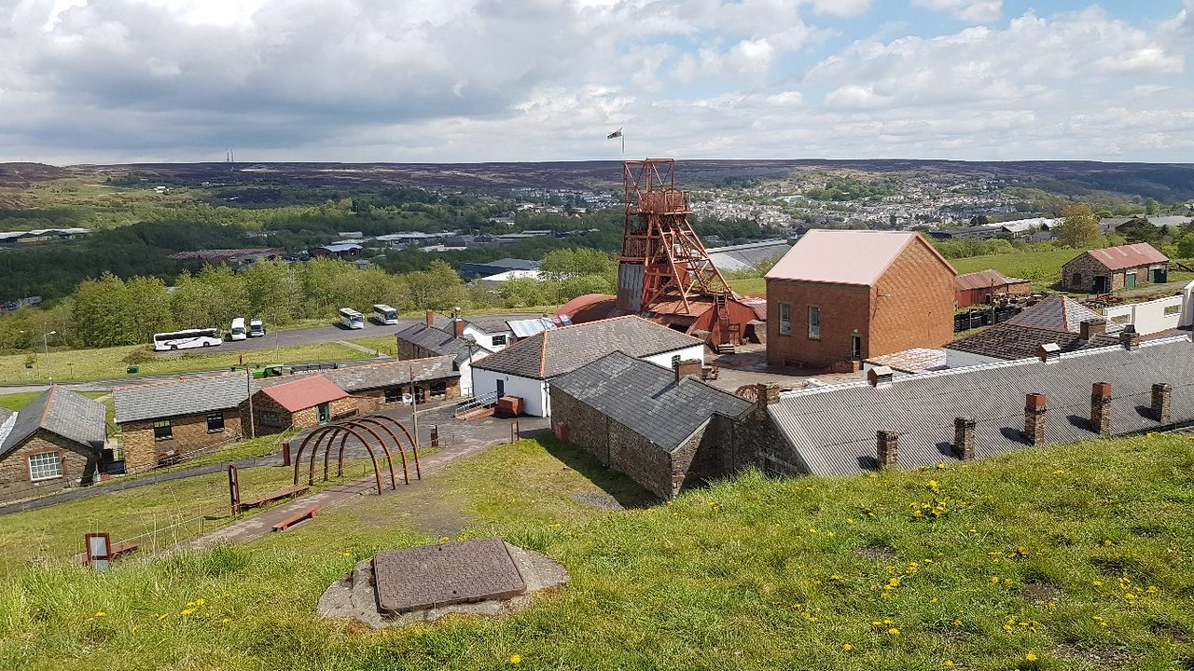
The town has been trying to attract more tourist and have modernised their technology in order to encourage more people. They have created a scheme where you can download an app called “Blaenavon Digital Passport” from the iTunes App Store. This allows the user to listen to an audio tour whilst wondering the streets of Blaenavon whilst it explains the heritage and the history of the town. The tour was done by Lewis Browning, a man who lived in the town in 1906. They also offer leaflets and maps and a PDF version available for download. The town hold many events in order to try and bring more people into the town. After talking to the people of the town, of which, a few people who had lived in the area for over 10 years said they had noticed a dramatic decline of the tourism in the town. After being asked what they felt the issue was, most believed it was because people may find the town a bit ‘outdated’ and ‘boring’. They believed something needed to be done in order to bring more people into the area. As for transportation and locations to stay in, the town offers this, but they are not heavily advertised in the town. On our trip to the town, one thing that became clear was the area was not well signed. The issue of getting lost meant there was less time to explore the town.
To be able to see what visitors really thought of the town, trip advisor was used to find ratings and comments left by the people. Here are some pictures of the town taken by previous visitors.

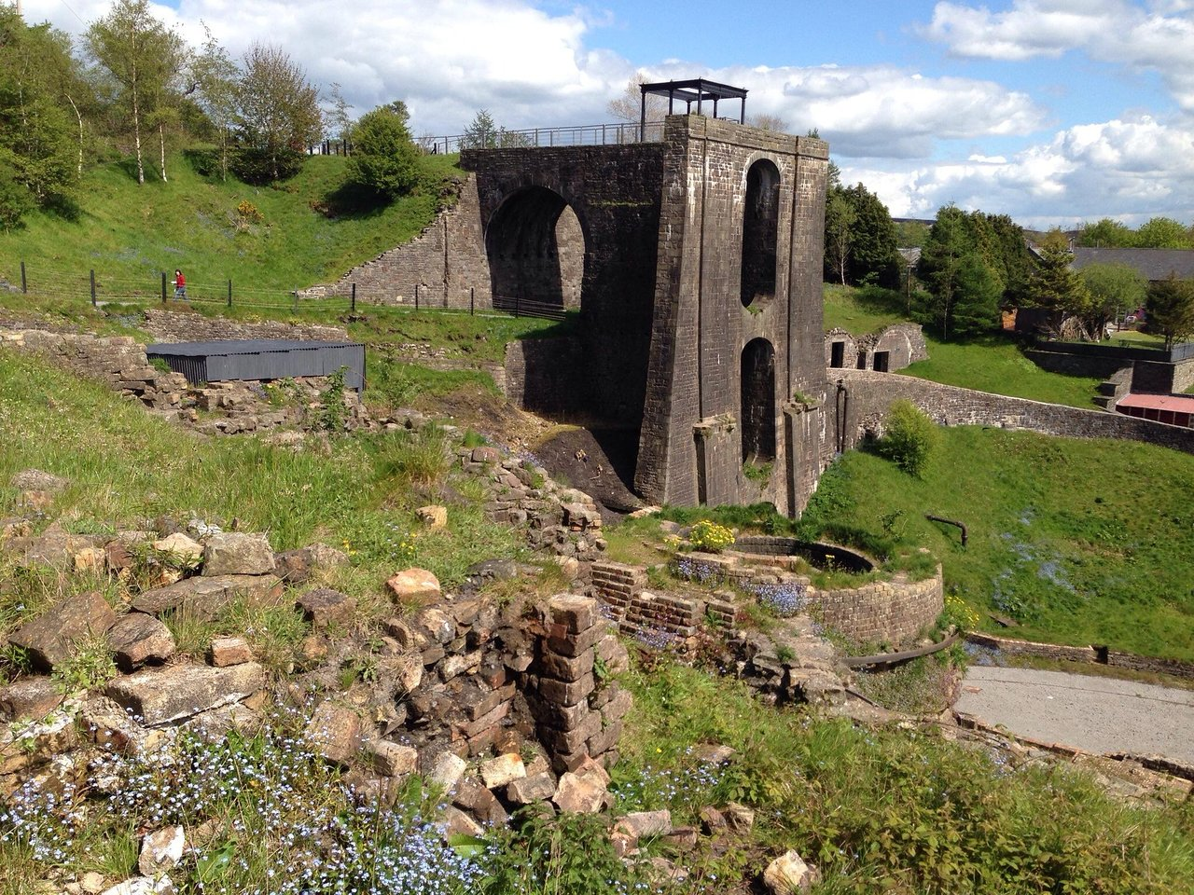
The customers seems to enjoy the Big Pit the most as it has 2,620 reviews and a 5 star rating. The people have said that it is a fun and educational day out for any ages. They even offer different tours for different age groups in order for it to be more understandable to younger children. It is a popular area for school trips, they have adapted their tours to suit larger groups. Only a certain amount of people are allowed into the pit at a time for safety reasons which is why they have a comfy waiting area for the visitors. The iron works seems to of been visited by less people with the rating of 4.5 stars. Not despised by visitors, some just found it to be closed when they said it would be open and some people found that the information was great, but it was nor given to them in a fun way. They found it to be outdated and in need or modern technology.

Our trip to Blaenavon
There were many businesses in the town, such as a cheese shop which had won many awards. This was good for the town as people were coming in to try the shop, which meant other shops were also getting attention. Many shops have opened and closed in the town of Blaenavon die to the lack of people there. There is however a new estate they are building which ill increase the number of residents and continue to build the town. There is lots of work in Blaenavon such as the school, shops and even the tourist attractions. The community itself is very close and people in the town all know each other. The community enjoys being close and some have expressed that growing the town may effect this. The older residents seemed to want to keep the town as it is but some of the younger believe there is room for improvement. We found that there was a sports centre that offered many different classes, but was not regularly used and is at risk of being shut down. Buildings like this need to be advertised and shown off more as they can become a credit to the community
There are many businesses still in Blaenavon, including the cheese shop, a Chinese, a chip shop and also a crafts store that features a post office. After visiting this store it became apparent that it was popular to the people of Blaenavon, yet it was not easy to find and was not well sign posted. Which is a shame because the store is a real asset to the town and would do well if it was advertised more on the local pages.

Idea one
There are many attractions in Blaenavon, but there is not much tourism in the town. The businesses are struggling, including the museum that asks a small fee when your enter. This is what they rely on to keep the building running. They also rely on volunteers, some of which worked in the mine. The museum is extremely important to the town and its people and they are keen to keep it running. They explained that ‘The Big Pit’ gets a lot of attraction but people are reluctant to go into the town. The volunteers at the museum were enthusiastic about their work and showed us all the unused space they have. There are so many more opportunities that the building have but can not due to the building needing renovation. They shared that the building itself is damp and has a lot of damage. The building has also had scaffolding for a number of years and has been looked over by the government as it seems “too expensive” and “time consuming”. this is heart breaking for them as they see so much potential in the building. The building holds a beautiful theatre that is unused as it is outdated and nobody knows about it. This room could be rented out for weddings and functions which could bring more money to the museum. The room itself is still intact but they are struggling with water damage in the rest of the museum. Although they are in the work of trying to find enough funding to fix this, a fund raiser could be held at the museum with the hopes to fix the building. The town of Blaenavon would love to get involved with this as it is something to do in the town and it also saves a crucial part of Blaenavon. If advertised well, this could also gain the attention of the following towns and previous visitors. The museum has many rooms they can not use due to the damage, but have lots more artefacts they could display, they simply do not have the room for them. Once renovated the museum would have more displays, a large function room, they even have a cinema they don’t open now due to the damage and lack of visitors. There is so much potential for the museum, the struggling Is financing the problems with the building.

Idea two
An idea that could possibly encourage more people to go to the town and visit the local business and tourist spots is a 2 day stay at a hotel in the town, followed by meals and a guided tour, for a limited price. A lot of the attractions in the area are free and although some visitors appreciate this, it does not help with the towns lack of money. The stay could cost a certain amount per person and offer a family or multi person price. This would increase the money the town earn and also give the town more tourists. The tour would also mean that all of the attractions are being seen as some seem to get neglected or out shined by others. The 2 days would give them the opportunity to visit the pit offering transportation, a chance to visit the iron works and the chance to have a meal in a restaurant or the cafe they have at the pit. The following day would include a tour of the town using the digital audio tour, the price would include a tour at t eh museum and a chance to see a show that they have on at the time. They would also have a chance to visit the towns shops and small businesses, and stop at the restaurants or pubs for refreshments throughout the day. The money made from this trip would be split between the attractions featured, with a percentage going to the the county council to maintain the town such as street hygiene and building maintenance.

Idea three
The people of Blaenavon complained about car parking. This could be fixed by finding small unused areas in the town and generated into parking spaces available to the public. These can be maintained by charging a small fee. More parking in the town would please the people of Blaenavon and encourage more visitors to explore the town itself. As there is not much parking, people may feel reluctant to look around at the worry of not finding a space to park. Another idea for this could be to set a car park somewhere slightly out of the centre to avoid traffic and provide a free shuttle bus paid for by the price of parking. This would ensure that the town would not be over run by cars and helps people to get in and out of the town. On the trip, the bus was parked at the ironworks where we proceeded to walk to the town, it was a far walk and was a struggle for some of the students. A bus would make the town more accessible and suitable for all people.

References

Blaenavon reviews, retrieved 2020, https://www.tripadvisor.co.uk/Attraction_Review-g1475934-d2092332-Reviews-Blaenavon_Ironworks-Blaenavon_Torfaen_South_Wales_Wales.html

Town centre attractions, retrieved 2020, https://www.visitblaenavon.co.uk/en/VisitBlaenavon/ExploreBlaenavonTown/Town-Centre-Attractions.aspx

Things to do in Blaenavon, retrieved 2020, https://www.tripadvisor.co.uk/Attractions-g1475934-Activities-Blaenavon_Torfaen_South_Wales_Wales.html

