Certificate of Higher Education in Skills for the Workplace

EMPL4011-Smart Technology for Workplace

Submitted
By

Student name: Ashik Ali

Student ID: 1604577

Table of Contents
Introduction 3
My experience 3
Teams and elements to build up an effective team 3
Belbin’s Team Roles theory 4
How my manager build up an effective team following Belbin’s Team Role Theory 5
My role and responsibility 7
My feeling and contribution 7
My experiences of team working 7
Task and Performance Behaviors 7
Socially Orientated Behaviors 8
Self-Orientated Behaviors 8
The difficulties we faced in team working 9
How we/our manager addressed these difficulties and improved team performance 9
Conclusion 10
Reference 11

Introduction

In this paper, I have discussed my job experience in my work place. My workplace was at McDonald’s. There I took participation in many team works. However, most of them were based on specific purpose at McDonald’s. Everyone had certain work. Every one worked for their personal and professional growth. Our works were segmented and distributed among us based on our skills and experience. This distribution was mainly done by our manager.

My experience

Teams and elements to build up an effective team
Robbins (2015) suggested that, team is defined as the set of people who work together with different skills and abilities to fulfill one common goal. Armstrong (2016) stated that, to form a proper and satisfactory team, various components are needed. Team members should have soothing relationship and communication. They should respect each others rights and share the responsibilities. They should take responsibilities for the group work. In addition, they should also carry out the activities together to achieve the one common goal of the team work.
Importance of teamwork in workplace
When doing teamwork collaboratively, they are working for common objectives or common goals. The total system of the work becomes more proficient (Wehbe, 2017). Another big advantage of working in team or working collaboratively is ideas and inspiration which may come from discussions of the team members. There are many opportunities for inspiration compare to working on the project by yourself rather than working collaboratively (Wehbe, 2017). On the other hand, when in the team has the brainstorming atmosphere, the idea of recommending unique and creative concepts are welcomed. Teamwork is significant for working place because it takes different backgrounds people together and their experiences level are different (Wehbe, 2017). Teamwork helps also the open discussion that permits every member of the team to be effectively informed about project. This is significant to keep in mind that a sense of belonging and helping in working place may give effectual job satisfaction (Parker, 2017). A well group atmosphere can perform as great support mechanism for members of the group. This is significant to remind that as staffs become experienced, their self-confidence enhances. This may support them to develop their attitude as well as raise their job satisfaction when working collaboratively (West, 2012).

Belbin’s Team Roles theory
According to Belbin’s team role theory, there are nine various activities that are needed to be understood by the team members. These activities are significant to achieve the success and efficiency of the team work. Therefore, the manager selects the team members according to their ability to perform all the nine activities and form an efficient and successful team. Belbin’s Team Roles theory involves three different behaviors. They are 1) action oriented 2) people oriented and 3) though oriented. There theory is given below:
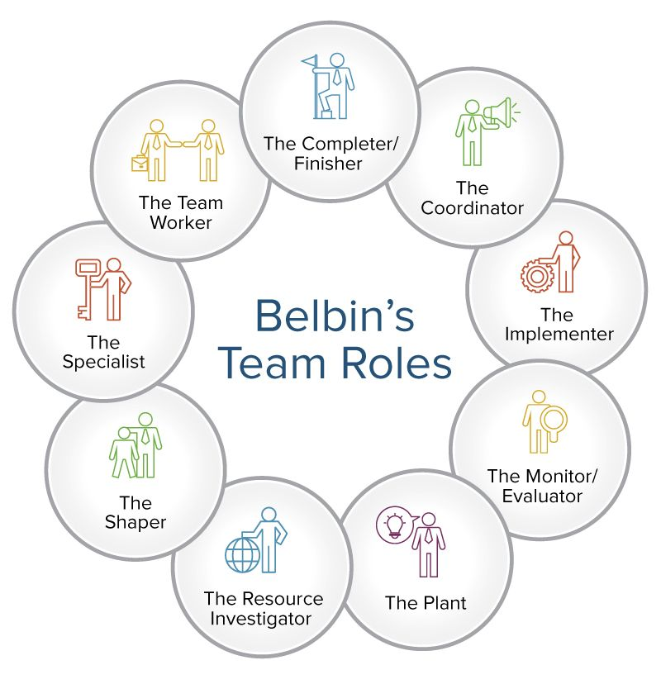
Diagram: Belbin’s team role theory Source: Smartsheet (2016)
Action oriented roles:
- Shaper: According to Smartsheet (2016), the shaper is mainly gives solution to the problem and difficulties.
- Completer: Smartsheet (2016) suggests that, the role of completer is to figure out the problems and faults in the reports submitted to the line managers regularly.
- Implementer: According to Smartsheet (2016), the role of the implementer to imply the creative and innovative ideas into practical activities to fulfill the goals and aims of the organization.
People oriented:
- Resource investigator: Smartsheet (2016) stated that, the role of the resource investigator is to figure out new resources for the organization. In addition, their role is to form relationship with the business.
- Co-coordinator: the role Co-coordinator is to assist the accomplishment of the organization’s goal. In addition, they also help other to accomplish their goals (Smartsheet, 2016).
- Team worker: following the statement of Smart sheet (2016), the role of team worker is to help others and form cooperation inside the team to accomplish the goal.

Thought oriented roles
- Plant Innovator: the role of the plant inventor is to deliver new creative and innovative ideas for the team work (Smartsheet, 2016).
- Monitor- evaluator: the role of the monitor –evaluator is to supervise and assess the activities of the team members. He also carries out the necessary initiatives as per need and submits the report to the line manager (Smartsheet, 2016).
- Specialist: the role of the specialist is to give devotion and take measure as necessary. In addition they also deliver the required information and data.

How my manager build up an effective team following Belbin’s Team Role Theory
According to the Belbin’s team role theory my manager formed an efficient team. The stages of the forming the team is given below:
- In the first stage, the manager evaluated the skills and weaknesses of the members of the team. Then he described the specific work responsibilities to the every member.
- In the second stage, manager evaluated the analytical skills, communication skills and behavior of the members towards the other team members.
- In the third stage, manager tried to determine the flaws and deficiencies of the team personnel. Then he tried to amend and improve their condition following the Belbin’s team role theory.
- Then, manager confirmed them all about their actions and accountabilities to all the team members.
- After that, manager evaluated the members’ performances and suggested them where they need to improve.
- Then the manager approved all the stages and actions of the team members so that they can improve their knowledge, skills and expertise.
According to Johnson et al. (2013), Maslow’s Hierarchy model is very efficient to motivate the team members. In this theory, five requirements of the human life have been mentioned. They are given below:
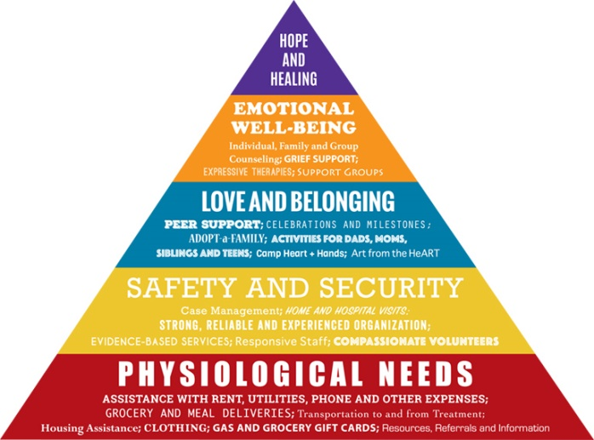
Diagram: Maslow’s Hierarchy model, Source: Slideshare (2016)
The five needs of Maslow’s Hierarchy model which motivates the team members are:
- Physiological needs: McLeod (2017) stated that, in the work place, the first and foremost requirement is physiological needs. Such as, food, water, home, treatment etc.
- Safety needs: According to McLeod (2017), when the physiological needs or the basic needs are fulfilled, then the people seek for safety needs. Such as, job security, health security, mortality, resources etc.
- Love/belonging needs: McLeod (2017) suggested that, since the safety needs are fulfilled, the people seek out for the love or belonging needs. Such as, friends, family, relatives, sexual life, etc.
- Esteem needs: Esteem needs refers to need for earn respects from others. People look for esteem needs subsequently once the love or belonging needs are fulfilled (McLeod, 2017).
- Self actualization needs: After the esteem needs are fulfilled people seek out for self actualization needs which are creation of new things, being supreme and gaining highest position in the workplace etc.

My role and responsibility
I was a resource investigator in my team work. My responsibility was to do probability research on the store affairs. My responsibility was also to figure out the reasons behind the poor sales and figuring out the solution of those causes. My job was also to study about the present market situations and opponents market positions. Then hand over the whole report to the manager and the other members of the team.

My feeling and contribution
My managers fulfilled his responsibilities properly according to my belief. My manager was successful to divide the works among the team members in an appropriate manner. All the team members, we worked together and solved all the problems and challenges faced during the team work. I was satisfies with job position and I tried my best to fulfill my responsibilities properly. I also appreciate my manager for his supports and help throughout the work.

My experiences of team working

Task and Performance Behaviors

Behavior | Impact on Group | My Reflections
Supporting | Supporting behavior of the team members maintains the peaceful environment. | All of our team members were very supporting towards each other. For this we could do our team very smoothly and effortlessly.
Bonding | A good bonding among the team members helps to earn the success and goal of the job very easily. | The bonding among our team was very strong. All of members maintained a good communication and shared their ideas and concepts to help each other.
Sharing of knowledge and information | To do the team work properly the members need to share their knowledge and information and help each other during difficulties. | All of the members of the team were very supportive to each other while sharing the knowledge and information. This behavior helped us to get our team work done very easily.
Communication | To earn the aim of the team work, the communication between the team members needs to be very strong and clear. | The team members maintained a clear and strong communication in the whole time.

Socially Orientated Behaviors

Behavior | Impact on Group | Our Reflections
Having respect towards others’ backgrounds | It very important to respect others religion, culture, race, gender to maintain smooth relationship in the team. | Our team was built with many persons with various backgrounds. However, all of them were very respectful towards each other.
Amiable behavior | To achieve the ultimate goal of the job, the team members must be amiable towards each other. | All the team members were very amiable towards each others during the work. There was no unfriendly situation during the work.
Giving presents | To make a friendly and supportive environment, the most tactful method is give presents to other group members. | During occasions and festivals, the members of my team bought each other presents and shared their happiness.

Self-Orientated Behaviors

Behavior | Impact on Group | Our Reflections
Concentration | Concentration is very necessary to achieve the ultimate goal of the team work. | The members were very concentrated towards their responsibilities and the team works.
Administration | Administration by any superior person is very important to carry out the activities effortlessly. | Our manager administrated us very carefully and supportively. He helped us in every step where we faced any difficulty.
Sorting out the problems | To get the job done appropriately, it is very important to sort out the problems and their solution. | The entire team worked very hard to sort out the problems and their solutions.

The difficulties we faced in team working
During the team work we encountered some challenges and difficulties. Some of them are,
- We faced difficulties to sort out the reasons behind the poor sale.
- We faced challenges to figure out the solution of the poor sales.
- There were some misconceptions and disputes between us due difference in the point of views. For this, we faced some unfriendly situations.

How we/our manager addressed these difficulties and improved team performance

To seek out the solutions of those problems that we faced, our manager utilized Tuckman’s team development theory. This theory has four stages. They are:
Forming: in the first stage the team members are very positive and courteous toward each other’s (Mindtools, 2017). For this, the leader of the team needs to be dominant in this stage to make the members understand their responsibility properly. Our manager firstly described us and made us understand our job properly.
Storming: in this stage, the members start to have disputes or conflicts due to differences in the point of views (Mindtools, 2017). When we had conflict our manager helped us to solve our problems by arranging discussion sessions between the disputed groups.
Norming: in this stage, people start to solve their conflicts as they socialize with each other (Mindtools, 2017). After the discussion sessions, we started to know each other and solved our problem. Our manger helped us to get through our disputes.
Performing: in this stage, the team members start to perform their activities (Mindtools, 2017). Our manager then helped us to do our duties properly. He also helped us to improve ourselves.
Adjourning: When the team earns their ultimate success they celebrate them selves in this stage (Mindtools, 2017). Our manager and we celebrated our success after we achieved our ultimate goal.
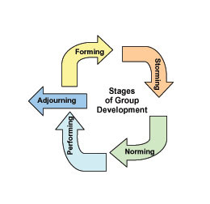
Diagram: Tuckman’s team development theory Source: Mindtools (2017)

Conclusion
Through this team work I learned many significant things. I learned about the team work, team management, socialization, to give respect to others and how to work together to earn the objective of the team. My interpersonal skills also got improved through this team work. My management skills, communication skills, decision making skills, leadership skills etc. got very improved through this team work. I believe that, these improvements and knowledge will aid me vastly in my job position and work place.

Reference
Robbins, S. P. (2015) Essentials of Organizational Behavior. 2nd Edition, London: Pearson Library
Armstrong, L. A. (2016) A Handbook of Human Resource Management Practice. 3rd Edition, New York: Oxford Publications.
Mullins, J. (2014) Organizational Behavior. 7th Ed. London: Pearson Education Ltd
Smartsheet (2016) How to Use Teamwork Roles to Build Winning Teams. Available at: https://www.smartsheet.com/how-to-use-team-roles-to-boost-performance [Accessed on 21 April 2018]
Johnson, G. Whittington, R, Scholes, K. Angwin, D. Regner, P. (2013) Exploring Strategies. 6 Ed. London: Persons Education Ltd.
McLeod, S. (2017) Maslow's Hierarchy of Needs. Available at: https://www.simplypsychology.org/maslow.html [Accessed on 21 April 2018]
Mindtools (2017) Forming, Storming, Norming, and Performing. Available at: https://www.mindtools.com/pages/article/newLDR_86.htm [Accessed on 21 April 2018]
Wehbe (2017) 5 important reasons why teamwork matters. Available at: https://www.potential.com/articles/5-important-reasons-why-teamwork-matters/ [Accessed on: 24 April, 2018]
Parker (2017) Team Players and Teamwork. 3rd Ed. London: Oxford University Press.
West (2012) Effective Teamwork: Practical Lessons from Organizational Research. 3rd Ed. London: Oxford University Press.

