IUBA5010 Changemakers: E-Portfolio Evidence of Learning
Student Name: GOH ZHE XIAN
Student ID: 2423907
Programme: IUMW Business Administration (Dual Award)
Module: Changemakers: Applying a Research Mindset
Module Code: IUBA5010
Lecturer: Emma Roberts
Submission Date: 11th September 2026

Contents
- : Outline a Problem (300 words)
- : Exploring the Problem with AI (500 words)
- : Research Question & Approach with AI (500 words)
- : Summary Research Proposal (700 words)
- : Video Presentation (5 mins) link will be provided
- : Reflective Piece – Gibbs Reflective Cycle (500 words)
- : Reference List

Task 1: Description of a problem. ( Outline a problem )

One of my major concerns with the places where I grew up–Kuala Lumpur, Malaysia–is that traditional small grocery businesses or kedai runcit find it difficult to compete with the booming chains of retail outlets such as 99 Speedmart, KK Mart and FamilyMart. Deli runcit in my neighbourhood has been operational for more than 20 years by my family, and I see a decrease in foot traffic and customers' loyalty to them over the past five years.

This problem is not anecdotal, in fact, it is widespread. According to data, traditional retail in Malaysia is simultaneously grappling with a number of structural issues – these include low price power, thin margins, inadequate digital adoption and susceptibility to a rise in prices from its immediate suppliers – fuel price hikes, rentals, wholesale prices, etc. Traditional retailers are doing mostly cash-based transactions without any real systems, whereas modern ones employ e-wallets, POS and CRM, and analytics. The digital transformation has also changed the way people shop, with 12.5% of retail sales in Malaysia transacted via non-store channels (less than 10% prior to the pandemic).

There are many facets to this problem. It's not only a price matter, it's also about shaping consumer behaviour and structural disadvantages. According to Rakuten Insight survey data, 77% of Malaysian respondents make online grocery shopping purchases, and 72% make them at least on a weekly basis. Plus, the number of e-money transactions using e-wallets in Malaysia has jumped by 25% year-on-year to 64% of the total volume of e-money transactions. As digital payments become more common among generations and payments through other forms less common, cash-only retailers are facing a disadvantage.

However, in many communities traditional kedai runcit remains relevant due to its convenience, accessibility and personal relationships. But if they are not adaptable, they are not able to exist in the long term. This reduction is not only a risk to my family's well-being but also has detrimental impacts on the quality and economic strength of neighbourhoods nationwide in Malaysia. Although typically viewed as a disruption of the retail structure, the cost for small independent business owners is massive and very real on a social level.

Task 2: Use AI to Explore the Problem

The task involved using Generative AI to find and understand academic works to develop a more specific problem definition.

1. The Prompts Used

To write a research problem about the local/traditional business (kedai runcit) problems and difficulties to compete with the local big business in Malaysia like 99 Speedmart and KK Mart during the era of modern

.Prompt 1: "I am an undergraduate with a business background and my research problem is about the problems and difficulties of local/traditional business (kedai runcit) in Malaysia to compete with local big business such as 99 speed mart and KK Mart in Malaysia now. Based on recent academic research (starting 2019), what concepts, terms and key academic findings do I have to this problem that I am aware of? Specifically indicate "Sources".

Prompt 2: " Previous answer good but not very specific, could you give me a more specific and evidence based definition of the underlying problem, with a focus on concepts around 'competitive disadvantage', 'consumer behaviour shift' and 'local business resilience'? Give specific citations to authors of scientific research cited earlier.

2. Best AI Outputs (in italics)

Based on the available info, this analysis was created:

From a review of the recent literature the problem can be comprehended the following main concepts:

Small and Medium Enterprises (SMEs) offer competitive disadvantage as they cannot compete with larger local chains and large multinational corporations (MNCs) in terms of economies of scale, marketing budgets and supply chain efficiencies as it is difficult for them to compete on brand loyalty recognition. The lack of formal credit and digital instruments adds to this structural disadvantage.

Consumer Behaviour Shift: It is noted that consumer behaviours have changed towards convenience, timeliness and the preference for electronic payments. Those are the three important factors that consumers care more about when shopping: ease-of-use of the platform (58%), discount vouchers (68%) and free shipping (76%). Less traversing to kedai runcit – especially for essential items due to the rising of GrabMart and PandaMart.

Inside-Research Perspective: Costley et al. (2010) argue that key insights into a problem a third party researcher may miss can be gained by studying it from the 'insider-researcher' perspective, or the perspective of some researcher who is intimately involved in the situation. For the insiders to be sensitive towards colleagues, ethics and the community of practice culture.

Local Business Resilience: This local research reveals that independent businesses need to be innovative, close to their community and accepting of their value proposition (cultural and unique, personal service, trust) to stay alive.

The most definitive problem statement of the AI is:

However, traditional, family-held kedai runcit in the neighbourhoods of Malaysian cities are losing market share to modern retail chains because of several factors: "the competition is skewed when the kedai runcit because of their inherent strengths—limited digitization, a lack of pricing power, and minimal systems—and also traditional kedai runcit have been combated by a changed consumer preference for convenience, digital payments, and online shopping.

3. Justification of Choice

The selection of this definition was based on my observations of my own family; it is concise and gives a clear definition of the problem. At a theoretical level, this is termed "competitive disadvantage," "consumer behaviour shift" and "local business resilience"-all of which succinctly describe this problem in practice.

To prevent AI fabrication and inaccuracies, I provided for a strict verification procedure:

Prompt Engineering: Asked for evidence and scholarly sources but also provided specific and challenging prompts.

Verification: I consulted key sources referred to by AI and in person checked them by searching Google Scholar and university databases and made sure they were genuine and accurate. The systematic review on AI and critical thinking also supports the need for verification of AI produced content; However the student must be critical and use their judgment to verify this content to check information is accurate. I declined any AI recommendations that I was unsure could be valid.

Task 3 : Using AI to develop a Research Question and Approach

1. The Prompts Used

Prompt 1: Given the problem definition that we have developed ("The central problem is that traditional, family-owned kedai runcit in Malaysian urban neighbourhoods are losing market share to modern retail chains due to their own competitive limitations and an overall consumer-change in retail habits..."), help me to formulate a focused, feasible research question for an undergraduate research project of my final year.

Prompt 2: 'Previous question was too general for our small study; please narrow it down to only consider 'consumer preferences' in a particular neighbourhood. Please develop a focused Research Question.

Prompt 3: "For the refined question, propose the most realistic and appropriate approach to the research, making note of the research philosophy, the method of data collection and the sampling strategy that one student could reasonably employ.

2. Best AI Outputs (in italics)

Based on this information, the AI generated the following Research Question:

What are the factors that contribute to the consumer choices of modern retail stores over kedai runcit in urban Malaysia? In terms of the research approach so that I can get the results I want, the AI recommendation was:

A good answer to this research question would be an interpretive philosophy of research and a feasible method for collecting data would be to interview 5-10 semi-structured interviews with neighborhood residents who have expressed a preference to shop at a chain store compared to your family's kedai. This is realistic because as an insider-researcher, you have access to the neighborhood and pre-existing relationships that enable data collection.

3. Justification of Research Question (RQ)
I decided to take the RQ because it is set, narrow and it is possible to achieve. The sharpened question zooms in on local consumers' preferences. If a small business wants to come up with a viable 'counter-strategy', it is essential to comprehend "why" consumers behave in their way. This RQ is directly related to the problem identified in Task 1 and the problems' simplicity means I will be able to bring it to the end of the final year project. Structured research is a vital part of understanding real world problems to prepare students for their career and entrepreneurial journey as proposed by Neeson & Billington (2022).

4. Justification of Research Approach examinations consist of two items.

I wished to choose the interpretive qualitative approach because it was the most appropriate to help me understand complex human behaviour of people. It enables me to explore people's emotional worlds and motivations, something a quantitative survey can't do. The semi-structured interview technique is appropriate since it combines a focused and flexible approach. In my own research the use of semi-structured interviews is a convenient and feasible approach in that I can use a tape recorder and transcribe and analyze the information without having to spend large sums of money or use coded software. The proposed purposive sampling strategy is also possible, as I have my own informal network in the local community from which to access the data, so that it is easy and attainable to obtain desired participants. This follows Costley et al. (2010) as the insider-researcher role is used in ways that give access and understanding that will be unique to the researcher's position.

Task 4: Summary Research Proposal :

1. Research Question

What are the critical factors that influence consumers' preference to modern retail chains over traditional kedai runcit in urban Malaysia?

2. Definitions

Modern retail chains are large, often, multinational, retail outlets with a standardised format which sell a wider range of products and are concerned with convenience, location and a longer shopping time. These include 99 Speedmart, KK Mart and FamilyMart (Saunders et al., 2019).

Independent, family-run small grocery stores, common among the Malaysian neighbourhoods, known as the Traditional Kedai Runcit. They usually carry a standard selection of dry goods and fresh produce, as well as other personal items, and are also a social centre for the community. The businesses are cash-based with very little systems in place and they are run through regular customers (Adu & Miles, 2024).

Consumer Preference: Consumer's subjective attitudes, beliefs, and behaviours that motivate the consumer to choose one product/service over another (Costley et al., 2010). This study is interested in how this preference is affected by certain factors.

3.1 Explanation and Justification of key terms.

The terms have been defined to ensure that there is a clear distinction between the two types of retail outlets studied. Modern retail chains differ from kedai runcit in that they are scalable, based on technology and directed towards consumers, while traditional kedai runcit are locally based, informal and focused on relationships (Saunders et al., 2019). I explain what is meant when I say ‘consumer preference' because I'm not talking about just sales figures, I'm talking about the psychological and behavioral components that are going into the consumer's preference. The phrase "key factors driving" implies more than one cause and many of the factors are likely to be interwoven, subsequently the word qualitative was used as it would provide the best explanation for the development of the selected variables.

4. Research Design

The study will be of a qualitative and interpretive nature based on the recommendations of Shani and Coghlan (2021) in the framework of a case study. The 'case' is to be the local community in KL – for which the competition between the kedai runcit and modern chains is very clear. This type of design will be suitable when attempting to delve into the complex, context-bound and subjective aspects of consumer decisions. My family's kedai runcit position us uniquely in case study mode to observe and understand this phenomenon (Costley et al., 2010).

5. Issues of Reliability and Validity

To ensure reliability (consistency of procedures), I will develop a semi-structured interview schedule that contains the same questions. This allows for key areas in each unit to be discussed with each participant, giving for the purposes of comparison systematic discussion of areas that are talked about (Saunders et al., 2019).

Triangulation is used to allow for the validity in measurement, that is to measure what I want to measure as I will use it to ensure validity. This is done by comparing the results of the semi-democratic interviews with my actual observations of the consumer behaviour in the local shops. This cross verification of data from various sources enhances the credibility of the findings (Saunders et al., 2019).

6. Suggested Research Methodologies and Data Collection

The main data collection tool I intend to use is semi-structured interview techniques with the local folks of 6-8 respondents. This sample size is reasonable and would yield rich data (Adu & Miles 2024). I would ask some open-ended questions such as:

- If you're looking to get groceries, what store do you typically go to?
- Which motivated you to go to the modern chain when you are choosing where to shop rather than the kedai runcit?
- If you were a customer of the traditional shop, what could it do in order to draw you in, what do you think?

Such interviews would be face-to-face, audio transcribed with participants' permission and analyzed thematically. This process would let me discover common concepts concerning consumer preference (Saunders et. al., 2019).

Proposed Data Collection and Access
Here, I'm just describing a feasible research collection process that I could follow; if I actually went about conducting this research:

Methods: I would make house-to-house visits and door-to-door visits in my own neighbourhood through a combination of door-knocking and WhatsApp/Facebook groups. In what became a 'snowballing' technique, starting participants would assist me in recruiting others.

Access: Being an insider-researcher within a family run kedai runcit within this community, I have established existing relationships and trust with the locals (Costley et al., 2010). This would facilitate access the researcher would have to participants much more readily than that an outside researcher would have.

Ethical Issues: I would make sure all participants are mature enough to be involved in study (18 years and older) and they fully understand what the study is about with anonymity offered and the right to drop out of the study at any point. The ethics of insider research given by Costley et al. (2010) - access, consent, anonymity and power would be considered and an appropriate consent form produced and a formal participant information sheet developed.

The proposed data collection time will be around 2-3 weeks, where the interviews can take place when the benefit is for the participants. This is achievable in the time period of an undergraduate's final year project.

Task 5: Video presentation (5 mins)

I have written a research proposal and compiled a 5 minute video presentation summarising it. The presentation is professional, at every moment I can be seen in the camera, and I don't read from a script, I speak into the camera.

Presentation video link : https://canva.link/4jx0mgsdcegng7y
Slides link : https://canva.link/aapfkxt0e2hcrff

TASK 6 – REFLECTIVE PIECE (GIBBS REFLECTIVE CYCLE).

I have employed a well-known structured reflection model, the Gibbs reflective cycle (1988) to give reflection on my learning journey to Tasks 1-5. This model works as it is logical, it describes, then analyses, then plans future action (Neeson & Billington, 2022).

The Gibbs Reflective Cycle is a cycle consisting of five stages.

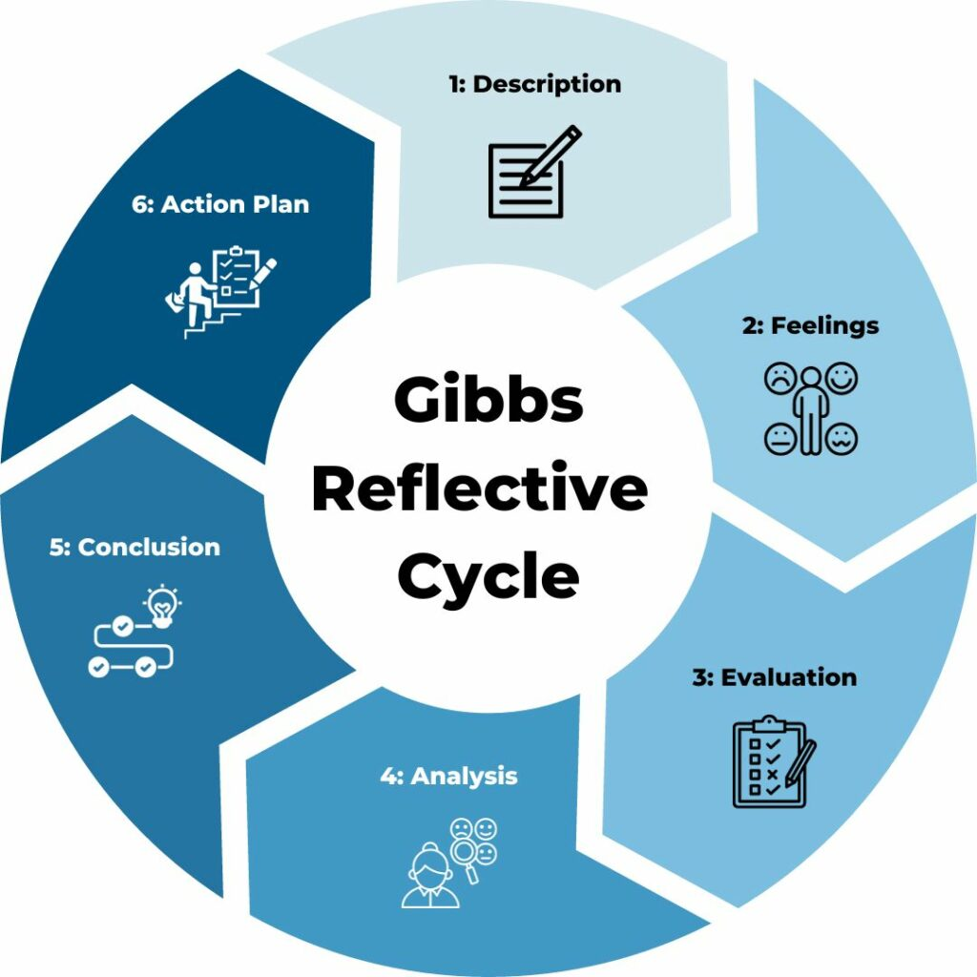

1. Description

My goal was to create a portfolio wherein I have first identified a problem within my community and then utilize the power of AI to help me structure it into a research proposal. It was a new kind of job that I had never interacted with AI in so meanly. The first step was to observe the problem. It's easy to observe the problem with my family's shop (Costley et al., 2010). I had some problems finding the right wording of prompts for the AI (Tasks 2 & 3) at first, though. The outputs generated by AI at times were helpful, but they were too generic and vague at times. The verification process was also a challenge—the AI directed me to all of the sources it recommended (Melisa et al., 2025).

2. Feelings

Toward the beginning, and up to the point where I had to leave the project, it was really exciting and motivating because the real world problem was of great interest (Neeson & Billington, 2022) The instant I had bad answers returned by AI, this was a huge disappointment. I was apprehensive that I might be using the tool unwisely. Upon receiving feedback and working on the prompts I felt much more confident. When I finally came up with the Research Question, I became very proud of what it felt like to have an actual challenge. When I checked out the sources that the AI had given me, it was great that they were not fake.

3. Evaluation

It was fantastic and exceedingly positive. I really liked the way that a personal messy observation (my family's problem) could be turned into a research proposal, using theory and an AI assistant to do the research for me (Saunders et al., 2019). It was also informative to verify information sources for AI; I want to bring to one's attention the necessity to be skeptical of information received (Aquije Ramirez et al., 2025). One negative reaction was the wasted effort during the first time investment on the weak AI yields. Could have done more research on and experimented with prompts before employed.

4. Analysis

I learned that artificial intelligence can be an awesome force, but it's not an oracular one. For me, the complexities of prompt writing mean that to get a good answer, you must deeply understand the problem and frame a good question: Martínez-Peláez et al., 2025). Moreover, the systematic review on AI and education reinforces that although AI can support students in accessing different viewpoints rapidly, excessive use may be detrimental for students to reflect on and critically assess their perspectives on learning (Melisa et al., 2025). For me, I had to validate the results of the AI using what I call “critical thinking” and “independent judgment.” As an insider-researcher, I gained other valuable lessons, such as the need to be sensitive to what colleagues with others are thinking and feeling, seeking consent, and unpacking power implications—not simply a theoretical understanding, but indeed moments where I needed to be sensitive to what others were thinking and feeling, sought consent, and addressed power implications (Costley et al., 2010).

5. Conclusion

This was a learning experience for me to appreciate the research process, responsible use of AI, and how to do good work-based research. It confirmed that "the inside" of the researcher point of view is at least a most valuable asset in understanding 'real world' issues (Costley et al., 2010). This has taught me that good questions for research must also be well verified and that there needs to be awareness of ethics. If I look back at AI and academic work, I should have done more research around prompt engineering.

6. Action Plan

If I were to do this project again it would be best if I did:

- Increase investment in prompt engineering; Research prompt writing, before beginning (Martínez-Peláez et al., 2025).
- Check the output of AI more systematically, e.g. a checklist for source checking (Melisa et al., 2025).
- Ask for feedback earlier – write a draft piece and hand this in to my tutor as outlined in week 8 of the module schedule.

Use the processes from this research and methodology to inform my final year project (refine this research question into my research question and method).

I would like to take it further within my final year research project and perform the semi-structured interviews to create a full dissertation. By developing this portfolio, I have been building my knowledge and understanding of how to develop research questions, design good methodology and have developed my ethical awareness, all of which is something that I will need (Neeson & Billington, 2022).

References
- Costley, C., Elliott, G., & Gibbs, P. (2010). Doing work based research: Approaches to enquiry for insider-researchers. SAGE.
- Martínez-Peláez, R., Mena, L. J., Toral-Cruz, H., Ochoa-Brust, A., Potes, A. G., Flores, V., Ostos, R., Pacheco, J. C. R., Félix, R. A., & Félix, V. G. (2025). Can Large Language Models foster critical thinking, teamwork, and problem-solving skills in higher education? A literature review. Systems, 13(11), 1013. https://doi.org/10.3390/systems13111013
- Melisa, R., Ashadi, A., Triastuti, A., Hidayati, S., Salido, A., Ero, P. E. L., Marlini, C., Zefrin, Z., & Al Fuad, Z. (2025). Critical thinking in the age of AI: A systematic review of AI's effects on higher education. Educational Process: International Journal, 14(1), 1-22. EJ1459623
- Saunders, M., Lewis, P., & Thornhill, A. (2019). Research methods for business students (8th ed.). Pearson.
- Adu, P., & Miles, D. A. (2024). Dissertation research methods: A step-by-step guide to writing up your research in the social sciences. Routledge.
- Neeson, R., & Billington, L. (2022). Entrepreneurship learning through a collaborative approach to student practical placement / internship. Journal of the International Council for Small Business, 3(1), 68-78.
- Shani, A. B. (Rami), & Coghlan, D. (2021). Action research in business and management: A reflective review. Action Research, 19(3), 518-541.
- Retail Group Malaysia. (2026, March 19). Retail associations warn of living cost spikes as Mideast tensions weigh on retail outlook. The Edge Malaysia. https://theedgemalaysia.com/node/796814
- Euromonitor International. (2026). Retail e-commerce in Malaysia. Passport Database
- Euromonitor International. (2026). Retail in Malaysia. Passport Database

