Jodie Sprake
P137910
the enquiring teacher research essay
Module code: ECPP7001

Contents
Pages

Introduction 2
Research Context 3
Literature Review 4 - 6
Lesson Study Design 7 - 10
Ethical Consideration 11
Lesson Study 1 and Analysis 12 - 13
Lesson Study 2 and Analysis 14 – 15
Discussion of research findings in relation to related literature and research
Conclusion
Recommendations
References
Appendices

Introduction
An area of interest for me was collaborative discussions during Think, Pair, Share within lessons. The ‘Think, Pair, Share’ collaborative model was originally created by Lyman (1981) and I felt this was a very important aspect of lesson which I had taught. By giving the children the opportunity to clarify tasks and ideas, to access prior knowledge and to develop prior knowledge with a partner seemed beneficial to the child as well as myself. It helped me to continue with the lesson after the introduction and identify any children who need additional support for the lesson or areas which need more discussion before continuing.
Within my school, Think, Pair, Share was used on a regular basis across the curriculum. When introducing a new topic or to activate prior knowledge, I would encourage children to have a two-minute discussion with their partner about the topic. By doing this, children are developing a variety of skills such as oracy and listening, as well as potentially developing their prior knowledge. A Think, Pair, Share opportunity would be given to the children during the lesson introduction as well as the plenary. By allowing a collaborative discussion within the plenary, I was able to identify more clearly who has a true understanding of today’s lesson, whether the success criteria were achieved, if the children need additional support and if the children need more sessions to achieve the success criteria.
My class is an upper key stage two class and the children have grasped the concept of Think, Pair, Share and collaborate well in pairs. However, attendance was an issue within my class. The poor attendance rates resulted in children without a collaborative partner during Think, Pair Share on a daily basis. I found myself having to organise the children into threes on a regular basis to overcome this issue.

Research Context
My class is within a large primary school within the city centre of Swansea. They are based within one of the most deprived areas of Swansea and have over 300 pupils attending the school. Within the school, 26.6% of pupils are free school meals children attending a green support category school (My Local School, 2018). My class is a mixed year 5 and 6 class consisting of 27 children. They are a mixed ability group and there are 9 children within the class with ALN. The children within the class contain the younger half of year 6.
My partner and I discussed whether collaborative talk is something used within their class. My partner explained children are allocated talk partners and have opportunities to discuss with their partner during the day. It is not as structured within my partners class as they are still trying to grasp the concept of collaborative discussion as they are first year key stage 2. We were discussing ideas surrounding the possibility of expanding and developing the Think, Pair, Share approach further. We discussed adding more members to the collaborative group but were unsure whether to put our groups into quads or trios.
We have developed our research question together which is as follows; Is Think, Trio, Share an effective strategy for accessing and developing prior knowledge within a Key Stage 2 setting?

For my class, this means that they will be changing collaborative discussion partners and becoming a trio. Children will be put into threes depending on where they are sitting.

Literature Review
I researched current literature using a variety of sources. I read books, journal articles, government documents and other on-line material. I first researched an appropriate definition for collaborative learning in context to my study.
Dillenbourg (1999, p.1) defines collaborative learning as “a situation in which two or more people learn or attempt to learn something together”. Chiu (2000) extends Dillenbourg’s (1999) definition by adding “unlike individual learning, people engaged in collaborative learning capitalize on one another's resources and skills” such as “asking one another for information, evaluating one another's ideas, monitoring one another's work, etc”.
Think, Pair, Share is a cooperative learning technique that is commonly used within the classroom. Cooperative learning has been extensively studied and many benefits for learners have been identified according to Cortright et al (2005). Rowe (1972) explains that using Think, Pair, Share for collaborative discussion, it allows more time for students to think, and encourages the pupils to get more involved in discussion and improve the quality of pupils’ responses during feedback. Think, Pair, Share is not just useful for pupils but is also very useful to teachers. This belief derives from research of Cooper and Robinson (2000) and they continue to explain they believe this because Think, Pair, Share can be used as a valuable form of formative assessment. Teachers can listen to the responses of the pupils during feedback, post discussion, and establish who has a true understanding of topic or task and where additional support is needed.
Cortright et al. (2005, p.108) state that “in order for meaningful learning to occur, students must interpret, relate, and incorporate new information with students’ existing knowledge and experiences”. Lujan & DiCarlo (2006, p.17) continue that “students must actively process information in order to learn. Direct instruction and other teacher to student interactions do not always allow students these opportunities”.
A study conducted by Cortright et al. (2005) used a technique similar to Think, Pair, Share which they called ‘Peer Instruction’. During the study, they divided a class into two groups, group A and group B. The two groups were presented with three presentations and after each, the students were given a short quiz about the presentation. Students in group A could discuss the questions within a small group of 2 to 3 other students and students in group B completed the quiz indivudally. Cortright et al. (2005) found that the quiz results and performances of the students was significantly greater for those who discussed with peers. During feedback, the students expressed that cooperation with peers facilitated their learning, they enjoyed peer instruction and peer instruction helped to develop positive relationships between students. Cortright et al. (2005, p.111) concluded that the cooperative learning technique of peer instruction led to transfer, allowing students to apply what they have learned to new contexts. Hence this cooperative learning technique led to meaningful learning.
There are numerous benefits to using a collaborative learning approach according to Pantiz (1999). Pantiz (1999) and Johnsons (1989) list over 50 benefits for using a collaborative learning approach. They organised them into four major categories; social, psychological, academic and assessment. Some of these examples include helps to develop a social support system for learners, cooperation reduces anxiety, promotes critical thinking skills and children are actively involved in the learning process (Johnson 1989; Pantiz 1999).
However, Brown and Lara (2011) identified multiple disadvantages to using a collaborative learning approach. They go on to explain that “there are three ways when individuals take action in relation to the actions of the others. One's actions may promote the success of others, obstruct the success of others, or not have any effect at all on the success or failure of others” Brown and Lara (2011, p.1). They acknowledge that by working together cooperatively, individuals can accomplish shared learning goals however, some individuals may work against each other or individually not considering the goals of the group.
In order for a collaborative learning method to be more productive than competitive or individualistic methods, according to Woods and Chen (2010) five conditions must be met. These include “considerable promotive interaction and clearly perceived individual accountability and personal responsibility to achieve the group’s goals, frequent use of the relevant interpersonal and small-group skills, and frequent and regular group processing of current functioning to improve the group’s future effectiveness” Woods and Chen (2010, p.2).
What this literature shows me is there has been research carried out in different academic contexts to test the effectiveness of collaborative discussions. The findings from these studies have found that collaborative discussions s very successful and beneficial to learners if it is considering the limitations to collaborative discussions and Woods and Chen (2010) five conditions are met. Therefore, all of this reading supported our research question ‘Is Think, Trio, Share an effective strategy for accessing and developing prior knowledge within a Key Stage 2 setting?’

Lesson Study Design
Lesson study research methodology is when research is conducted to investigate the effectiveness of lessons. Results are recorded based on whether the lessons and strategies used enhance the child’s learning and whether the teacher’s knowledge of pedagogy is reflected within teaching methods.
To ensure we were able to collect data for our study effectively, a variety of data collection methods were used. These methods of data collection include; non-participant observation, non-structured interview, field notes and a focus group.
I decided to use an observation research technique for a variety of different reasons. Observations are considered the most appropriate research method to use when you are researching behaviour as “generally, overt behaviour is all that can be measured” through field or observation studies, Hogg and Vaughan (2005, p.12). However, Hogg and Vaughan (2005, p.12) criticise an observation method as “it can difficult to obtain accurate measurements or measurements of subjective feelings” therefore observations benefits are limited as it is only appropriate when researching behaviour only. As our study was focusing on collaborative discussion, the behaviour of the group members within the trio, along with the context of the discussion needed to be observed to measure the success of the Think, Trio, Share. I used a non-participant observation method meaning “the observer is non-intrusive by not participating in the behaviour, and invisible by not having an effect on the ongoing behaviour”, Hogg and Vaughan (2005, p14). I felt this was necessary as I was needing to observe how the children interacted within their trios led by themselves, without an adult influence. The children needed to be leading their own learning and collaborative discussions to measure the success of Think, Trio, Share.
My field notes were hand written on a piece of paper which after the debriefing at the end of the study were destroyed. These field notes were taken in qualitive format and did not contain any confidential or personal information about any of the participants. Confidentiality is essential ethical issue in which I addressed, which resulted in me coming to the decision to destroy all notes taken once we have obtained the targeted information from the study. This conclusion is supported by Baez (2002) who explains how the convention of confidentiality is upheld in order to protect the privacy of all participants and to aid the researcher to build trust and rapport with their participants within the study. Baez (2002) also agrees with my ethical concerns in relation to confidentiality and emphasises the importance of maintaining ethical standards and the integrity of the research process. The field notes acknowledged the total number of children who gave assent, the total number of children present that lesson and the lesson time management i.e lesson introduction time, main activity time etc.
The non-participant observations were collected using an observation sheet. The observation sheet was designed by myself (see appendix 1) with a series of questions relating to what we aim to observe. These questions were focusing on the interaction of the group members and whether they were on task during the Think, Trio, Share. I was observing whether the children were and all communicating correctly i.e. waiting for their turn to talk, listening when others were talking. One question was asking whether they are accessing their prior knowledge and I observed this by listening to the content of the information children were sharing. I decided to use an observation sheet to record information from the study because it was quick to record notes, easy to follow and insured that the information gathered was focused on our question, and whether the Think, Trio, Share was successful and effective to enhance the children’s learning.
The focus group were chosen as a sample because they were the children who provided full consent in the form of a signed parental consent form. These children also gave assent before the study began. I used three children aged 10 and 11 years. I used an unstructured interview containing a mix of open and closed questions. Interviews are an ideal way for researchers to ask different types of questions which in turn generate a variety of answers. By using both closed and open questions allow people to express what they think in their own words about their closed answers. I designed a set of questions with my partner to create an interview schedule (see appendix 2). The questions were focused and aimed to find whether the children felt their learning experience using Think, Trio, Share was enhanced. I asked the same set of questions to each child in the same order. The questions were amended slightly in the both studies taking into consideration the interviewees. As I was interviewing children from an upper key stage 2 class and my partner was interviewing children from the lowest key stage 2 class, the wording of the questions differed slightly. We did this to ensure the children understood what we were asking however, both sets of questions had the same meaning just more advanced language for my children. The questions were short and to the point as our interviewees were children and according McLeod (2014) “children have a limited attention span and for this reason lengthy interviews should be avoided”. The interviews were informal, and I interviewed the children within my class and my partner interviewed her children as there is a strong rapport between the children and ourselves. This rapport was essential to our study as the children provided more in-depth and honest answers. I was able to obtain qualitative data from the children which I will be categorising during analysis. I will be categorising the responses from the two studies to have a clearer and more in-depth understanding of the children’s feeling about using Think, Trio, Share.
The first class we conducted research in was a year 3 class. My partner developed a lesson plan (see appendix 3) appropriate for her class. However, after receiving the lesson plan, I decided to develop it further by making my lesson more cross curricula (see appendix 4). My class was a year 5 and 6 mix and the work content needed to be amended to the ability of the children attending the upper key stage 2 class.
After the study was carried out, I decided to use Schön (1983) reflection-on-action method to reflect on the study after completion. ‘We reflect on action, thinking back on what we have done in order to discover how our knowing-in-action may have contributed to an unexpected outcome’ (Schön, 1983, p. 26). I find that during my teaching practise this was the most common form of reflection I used in the form of an ARC. I reflect on what I believe went well and the causes of this along with what areas I need to develop in or change and why I feel this is necessary. Our study focused on developing the current collaborative discussion strategy Think, Pair, Share (Lyman, 1988). I felt that attendance was an issue within my class which resulted in some children being without a discussion partner. Therefore, by adding an additional member of the group, the likelihood of a child being without a discussion partner during collaborative discussion would be ideally reduced. After placing the children into threes instead of pairs resulted in all children having someone to discuss with and I even had 2 groups of four due to absent children. There was a similar situation within my partner class also which resulted in two groups of four children. The children were placed in discussion groups they would not normally be a part of and in most of groups, the Think, Trio, Share was successful. Children were communicating correctly throughout and sharing their prior knowledge with each other. Children were also developing their knowledge from information shared by others. However, in the circumstances that the discussions were not flowing, and children were not communicating was due to the members within their groups. Feedback from the children informed me some of the children were with people they did not like or would not include them within the discussions therefore, they did not see any benefit from the discussion. I did during the Think, Trio, Share move one or two children as the groups were not discussing at all due to being placed with people they did not like. Brown and Lara (2011) identified this as a disadvantage to collaborative learning as some children would rather work individually disregarding the success of others and any obstructions they are causing for the other members of the group.
Overall, the collaborative discussions were successful and on task during our study within the introduction of the lesson however, children were less focused when it was used during the plenary. Also, the trios in future need to be carefully considered to ensure that all the children within the group would be included and benefit from the discussion. As I am still a student teacher without a permanent class, during my NQT year, I hope by knowing my children and by listening to feedback from other staff members about the children within my class, I would group them appropriately. During this study, we wanted to use the developed strategy twice to provide our results with higher validity.

Ethical Considerations
There are ethical considerations with doing research in a classroom which are consent, assent, confidentiality, anonymity and management to ensure there is no risk to the participants, researcher and the university.
An ethical issue which I have considered is any potential risk to participants who are involved in the research without giving their full consent. To overcome this issue, I will gain written consent from parents/guardians in relation to collecting data from their child. On the day of the research, I will collect signed consent forms from the class teacher to identify which children have been given parental/guardian consent and who I can obtain data from. Any child who did not obtain parental/guardian consent will not be chosen to partake within our focus group and no data will be collected from or about that child. I will also ask children for their assent to participate within the study. I will do this by asking the children for a thumbs-up after a brief explanation about what we will be doing. The children will be informed that they have the right to refuse to take part at any time, and do not have to take part if they feel it would be upsetting or distressing for them.
In order to overcome the issue of confidentiality, all participants will be given anonymity and be referred to as child A, B and C to protect their identity and data obtained. All data obtained will be destroyed after results have been analysed. Within the consent forms and during the verbal assent, I will emphasize all data obtained is anonymous and confidential.
The risk to the researcher is that I may be accused of unprofessional practice. I will manage the risk by adhering to the BERA guidelines and following my plan of ethical practice. I will always comply with ethical, legal and professional frameworks, obligations and standards as required by the statutory and regulatory authorities, as well as with the university’s Research Integrity and Ethics Code of Practice.
There should be no risk to the University if any risks for both participants and the researcher are managed correctly. The risks are mentioned above. I will conduct the research and all data collected will remain confidential and results will be recorded honestly.

Lesson study 1 and analysis
The lesson my partner chose to teach required the children to produce a poster of things to do when they visit the beach or a castle. During the lesson introduction, my partner presented a power-point to the children with information about today’s activities. The children were placed into trios and were asked to discuss what things there are to do at the beach or at castles and to share their experiences with each other. All observations were recorded using the observation form (see appendix 5) The children demonstrated fantastic communication skills during the discussion. One child spoke at a time and the other group members listened, ask questions and extended onto what they had heard. All children were on task during the discussion. All of the groups following the Think, Trio, Share provided feedback by nominating one member of the group to share. My partner then recorded the responses onto a flip chart to allow the children to refer to this when completing their class task. Children were given the choice to design a poster about a beach or castle and provided with paper information resources to assist them. Each child worked individually on their poster. During the plenary, my partner placed the children back into their trios to discuss what they had learnt from today’s lesson. The children then volunteered to show their posters to the class and discuss what things there are to do at the beach or whilst visiting a castle. (see appendix 6) The posters provided by the children achieved the lessons success criteria. During the focus group interviews, all the children answered the questions with ease. There was one question in which my partner and I had to simplify the question further as there was a little confusion (see appendix 7). However, after the amendment the children answered the question in the correct context.
If I were to teach my partners lesson again, I would make the lesson discussion broader. I would do this in order to generate more creative answers and in-depth discussions by providing the children with more than two possible ideas to discuss. In Wales there are national parks, fantastic museums to visit therefore, I would provide the children with more things to discuss within their Think, Trio, Share. I would have also provided the children with an example poster to refer to as they are lower key stage two to help keep them on task and strengthen their understanding of what is expected to meet the success criteria.
My partner was not consistent during the lesson and did not stick to our planned research strategies. The children did not complete a second Think, Trio, Share during their plenary which was essential to the research. My partner and I agreed that we needed to measure the effectiveness of collaborative learning on more than one occasion during the lesson. We decided this was essential to provide more validity for our results and to help us determine when using Think, Trio, Share is the most beneficial to the childrens’ learning. The questions used for the focus group could have been simplified in some circumstances along with providing a broader range of questions. Even though all the children answered all the questions, their answers seemed to be repeated and similar to their peers within the focus group (see appendix 7). I think using a focus group for this age group was appropriate as the children supported each other through the interview. The children are the youngest within key stage two and it is very unlikely they would have had to part take in an unstructured

Lesson study 2 and analysis
The lesson I chose to teach required the children to produce a tourism poster to encourage people to visit Swansea. During the lessons introduction I placed the word ‘tourism’ on the interactive white board followed by four questions. Once the children were placed into their trios they were asked to discuss the word ‘tourism’ taking into consideration the questions on display. Within their trios they were all sharing ideas, experience and knowledge with each other. My partner recorded finding using an observation form (see appendix 8). Children were talking one at a time and listening to the child speaking at each given time. On occasions, children would extend other children’s information that was shared and answer any questions asked by members of the group. The children remained on task throughout the discussion and focused on Swansea as a tourist attraction. They After their collaborative discussion, all the trios provided feedback and prior knowledge about the word ‘tourism’. I asked the children how they would define tourism and some examples of what activities tourist would take part in. I then asked for examples of tourist attractions in Swansea and introduced today’s task. The task required the children to use the information acquired from their discussions to produce a tourism poster for Swansea. The children had the option to work in pairs with their peers. All pairs provided a poster for the lesson plenary meeting the success criteria. The children were asked to return to their trios to discuss contents of their posters and why they used these features. The children then shared from their trios something they learned today and a feature of a tourism poster. The posters generated contained information discussed within their discussions such as activities in Swansea, travel information, costs of activities and colourful eye-catching presentation of posters (see appendix 9). Following the class activity, three children participated within an unstructured interview. The interview was conducted in a focus group and all the children provided answers for my questions. The questions were clear and focused and provided the children with the opportunity to extend their answers (see appendix 10). The children extended their answers on all occasions in the correct context.
If I were to teach this lesson again, I would either ask the children to produce their posters in their trios or individually. This would allow me to assess whether the children had a true understanding of today’s task, and whether they acquired any knowledge that aided them to produce a tourism poster. I would also teach this lesson over two sessions. I would use one session for children to discuss in their trios for a longer duration and use the remainder of the lesson to research content for their posters. The second session would be when the children produce their posters. This would allow them more time to be creative and to provide a more in-depth, better quality poster. By having more time to work on this activity, the children would have had to opportunity to develop their knowledge further.
From this experience I have acknowledged there a variety of ways I can improve my research technique. We used the same observation forms during the non-participant observation of Think, Trio, Share for both studies. Next time, I would still use an observation sheet however, I would include a variety of questions covering a broad area. The observer would be responsible for deciding whether the questions are relevant to the research being carried out. By having more questions, we would also be able to provide more data from observation as we are considering more factors. Within our research the lesson itself was not the focus of our research but the collaborative discussion. I think I chose a topic ‘tourism’ with some questions to consider. This topic is a broad and the children had plenty to discuss. Reflecting on this, I would ensure I use a broad topic that is going to generate discussion and the production of broad knowledge. However, when conducting our focus group interviews, some of the children were repeating answers provided by other participants. Therefore, answers provided may not be accurate and reflect the child’s true opinion. Next time, I will still use three children and they will be interviewed individually. This I hope would provide a more accurate reflection of the child’s experience as they are not influenced by other group members.

Discussion of research findings in relation to related literature and research
Feedback from the children provided me with the understanding that Think, Trio, Share is a collaborative discussion technique they enjoyed using. The children all felt that they benefitted from the additional person within the group. Child C’s response “with pairs, there’s only two brains and with one more person you have three brains. Three brains are better than two brains. You can get more ideas”, indicated to us that they were sharing ideas with the additional person to their trio which was an aim of research. Within out question we ask whether by using a Trio are children developing their knowledge and child C believed so. This is a strategy I would use again within this class as I previously mentioned attendance is an issue. However, child B mentioned that they did not like that after using Think, Trio, Share the children did not remain in their groups to complete the task and this is something they would have liked to have done. After taking this feedback into consideration, I will in future ensure that if the trios are collaborating well together, they will remain together to complete tasks unless it is essential that they are completed individually.

Conclusion
A major strength to our method was there was no cost implications for the school. Any minor costs included paper for the posters and paper to collect data and field notes which were covered between my partner and me.
By using a focus group enabled me to discover what the children thought and felt about using Think, Trio, Share and why. The ability to obtain detailed information about personal and group feelings, perceptions and opinions is one of the strengths of using focus groups. By interviewing the children together instead of individually saved time and provided us with the opportunity to seek clarification of answers. However, there are limitations to using a focus group. A major limitation is the responses given can be difficult to analyse if they are not in correlation to any other responses we have received. Another limitation, which I previously mentioned in relation to similar responses given by the children, is the children may find a focus group situation intimidating or off-putting. The responses they gave may agree with the dominant view as they felt under pressure or that their true response would be incorrect.
From our research we obtained a mix of both quantitative and qualitative data. The strengths of obtaining both that were able to obtain more detailed answers from our children. The children initially answer a yes or no question and were asked to explain their closed answer. However, due to the responses being the opinion of each individual child the data collection can be time consuming and findings cannot always be generalised. The data can also be more difficult to analyse as the responses may not fit into categories.
As we were observing behaviour during our collaborative discussion, and observation method was the most fitting method to use. A strength of observations is being “able to observe the flow of behaviour in its own setting studies have greater ecological validity” according to McLeod (2015). However, there are Limitations to using an observational method. McLeod (2015) explains that “observations are often conducted on a micro (small) scale and may lack a representative sample (biased in relation to age, gender, social class or ethnicity). This may result in the findings lacking the ability to be generalized to wider society”. Another is that Natural observations can cause reliability to reduce are there are uncontrollable variables causing researchers to not be able to repeat the study identically in future.
When discussing how and when we would record our data from the observations, we decided to use a variety of sampling techniques. These included event sampling, time sampling and instantaneous sampling which all to ensure we were collecting the appropriate data, what we are looking for was clear to the observer and by using a combination of these techniques, the data we collected was the at the highest standard.
Following the success of using Think, Trio, Share within the key stage two setting, I will be using this strategy for collaborative discussions within my introductions. I will in future even develop this strategy further once the children have grasped the concept of Think, Trio, Share and place children into larger groups.
As previously mentioned, if I were to teach this lesson again, I would amend two factors. I would either ask the children to produce their posters in their trios or individually. This would allow me to assess whether the children had a true understanding of today’s task, and whether they acquired any knowledge that aided them to produce a tourism poster. I would also teach this lesson over two sessions. I would use one session for children to discuss in their trios for a longer duration and use the remainder of the lesson to research content for their posters. The second session would be when the children produce their posters. This would allow them more time to be creative and to provide a more in-depth, better quality poster. By having more time to work on this activity, the children would have had to opportunity to develop their knowledge further.

Recommendations
After evaluating my results, I will during my future teaching practice be using Think, Trio, Share and other forms of collaborative learning. All the children mentioned they felt that by having the additional member within their groups they had the opportunity of having more help if needed and access to other children prior knowledge thus, developing their knowledge. More ideas were shared amongst the group and new ideas were developed during the discussions and the focus children interviewed felt they benefitted during the experience.
If I did lesson study research again I would change some aspects. I would provide a broad range of questions for the observer to refer to whilst carrying out their observation during the collaborative discussions. I hope this would provided us with more data from the research. The questions within the focus groups would vary slightly in the hope to obtain more information to generalise to other academic stages, such as the foundation phase, secondary school key stage 3 and 4. I would also conduction the research over two sessions as I felt an hour was not a sufficient amount of time to obtain high quality data. I would also consider having the children to complete the lesson task within their trios measure whether the standard of work produced by collaborative groups is greater than work produced by children working individually or with other partners after using Think, Trio, Share.
Sharing the good practice is something I believe an important aspect to a teacher career. Teachers are always striving to better their quality of teaching, teaching methods, pedagogy and develop and introduce learning strategies for children. The Think, Trio, Share worked well within key stage 2 and it is something I will use and offer to teachers I work with in the future.

References
Chiu, M., 2000. Group problem solving processes: Social interactions and individual actions.. The Theory of Social Behavior, pp. 30, 1, 600-631.
Chui, M., 2008. Flowing toward correct contributions during groups' mathematics problem solving: A statistical discourse analysis.. Journal of the Learning Sciences, pp. 415-463.
Cooper, J. L. &. R. P., 2002. Getting started: Informal small-group strategies in large classes.. New Directions for Teaching & Learning, pp. 81, 17.
Cortright, R. N. C. H. L. &. D. S. E., 2005. Peer instruction enhanced meaningful learning: Ability to solve novel problems.. Advances in Physiology Education, pp. 107-111.
Dillenbourg, P., 1999. Collaborative Learning: Cognitive and Computational Approaches. Advances in Learning and Instruction Series.. New York: Elsevier Science Inc.
Kaiser, K., 2010. Protecting Respondent Confidentiality in Qualitative Research. [Online]
Available at: https://www.ncbi.nlm.nih.gov/pmc/articles/PMC2805454/
[Accessed 02 04 2018].
Laal, M., 2011. Benefits of collaborative learning. Tehran: Elsevier Ltd.
Lujan, H. &. D. S. E., 2005. Too much teaching, not enough learning: what is the solution?. Advances in Physiology Education, pp. 17-22.
McLeod, S., 2014. The Interview Method. [Online]
Available at: https://www.simplypsychology.org/interviews.html
[Accessed 02 04 2018].
McLeod, S., 2018. Observation Methods. [Online]
Available at: https://www.simplypsychology.org/observation.html
[Accessed 03 04 2018].
N/A, 2018. Focus Group. [Online]
Available at: http://www.evalued.bcu.ac.uk/tutorial/4b.htm
[Accessed 02 04 2018].
N/A, 2018. Strengths and limitations. [Online]
Available at: http://betterthesis.dk/research-methods/lesson-1different-approaches-to-research/strengths-and-limitations
[Accessed 02 04 2018].
Rowe, M., 1972. Wait time and rewards as instructional variables: Their influence on language, logic, and fate control.

Sampsel, A., 2013. Scholar Works. [Online]
Available at: https://scholarworks.bgsu.edu/cgi/viewcontent.cgi?article=1029&context=honorsprojects
[Accessed 01 04 2018].
Schön, D., 1983. The Reflective Practitioner: How professionals think in action.. London: Temple Smith.
Vaughan, M. A. H. G. M., 2005. Social Psychology. 4th ed. Essex: Pearsons Education Limited.

Appendices

Appendix 1
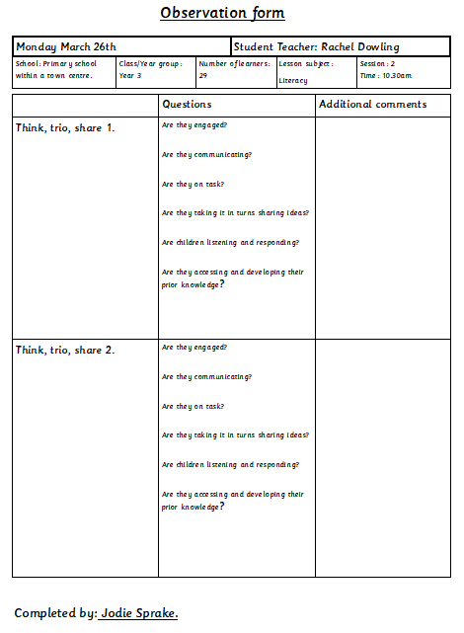
Appendix 2
Focus Group Interview Answers – Class 1
No. | Question | Answer
1. | Do you like using think, trio, share?
 | Why?
2. | Did you think it was beneficial having the additional person during think, trio, share?
 | Why?
3. | Do you feel like you learnt more from think, trio, share rather than individual thinking?
 | Why?
4. | Would you use think, trio, share again?
 | Why?

Appendix 3

Appendix 4

 |  |  |  |  |  |  |  |  |  |  | 1B

Session Plan – Key Stage 2
Name of trainee: |  | Jodie Sprake |  |  |  | Session ref: |  |  | 27/03/18
Personal target(s) in relation to QTS: |  |  |  | S1.3 S1.6 S2.5 S2.7 S3.1.3 S3.1.4 S3.3.7
Year group: | 5/6 |  | No. of learners:28 |  |  |  | ALN: 9
Additional Adults: |  |  | 1 teaching assistant.
Learning objective(s): To create a tourism poster to encourage people to visit Swansea. |  |  |  |  |  |  | Success criteria:  - Correct use of SPaG.  - Good communication skills.  - Create an eye-catching poster  - Include the things to do within Swansea.  - Include prices for things to do in Swansea and transport.
Links to previous learning: research topics using Ipads, Eisteddfod rap about Swansea.
Curriculum coverage (range, skills)
- Respond orally to a variety of stimuli and ideas.
- Speak and listen individually, in pairs, in groups and as members of a class.
- Use appropriate vocabulary suitable for the situation or purpose.
- Adapt writing style to suit the reader and purpose.
- Produce fluent and legible handwriting.
- Find information from a variety of sources for a defined purpose.
- Select suitable information and make simple judgements about sources of information.
- Make comparisons between prices and understand which is best value for money.
- Add and subtract totals less than £100 using correct notation, e.g. £28.18 + £33.45.
Literacy(LNF)  - Respond orally to a variety of stimuli and ideas.  - Speak and listen individually, in pairs, in groups and as members of a class.  - Use appropriate vocabulary suitable for the situation or purpose.  - Adapt writing style to suit the reader and purpose.  - Produce fluent and legible handwriting. |  |  |  |  |  | Numeracy (LNF)  • Make comparisons between prices and understand which is best value for money.  • Add and subtract totals less than £100 using correct notation, e.g. £28.18 + £33.45.
DCF  - Find information from a variety of sources for a defined purpose.  - Select suitable information and make simple judgements about sources of information. |  |  | Thinking  Decide in pairs how to make your poster eye-catching with all the appropriate information displayed. |  |  | ESDGC |  |  |  | YCC  Creating a poster to encourage tourist to visit Swansea.
Key vocabulary(English/Welsh):
Think, trio, share, discuss, ideas, tourism, Swansea, activities, individuals, families, fun, eye-catching, posters, communication, research, transport, cost, useful, helpful, tourists, Wales, dwylo I fyny, edrychwch arna I, da iawn, deg munud ar ol. Diolch.

Time | Session activities, organisation and management | Key questions & Assessment for Learning opportunities
5-10 mins | Introduction
5-10 mins | Using a Power point, I will place the word ‘tourism’ on the board and ask the children to discuss in their collaborative trios what they think is meant by the term, and for some examples.  We will share as a class their ideas to ensure that the children have a true understanding. I will then introduce today’s task. |  | Think, Trio, Share.
5-10 mins |  |  | Collaborative discussion.
5-10 mins |  |  | Questioning.
45-50 mins | Main activities  Introduce today’s task which is to create a tourism poster for Swansea.  Children will be working in pairs for the activity.  The children will be able to use Ipads to research information about Swansea.  The posters will be A4 size and the layout of the poster will be determined by the children. I will provide the children with an example poster that I will model on the power point. I will use this example to discuss what the poster needs to contain.  The children will need to list activities for people to do with their cost and provide some transport information and prices. The posters will need to accommodate individuals as well as families. |  | Modelling.  Questioning.
10-15 mins | Plenary
10-15 mins | I will gather all the posters and place them at the front of the class. The children will be asked to return to their seats and back into their collaborative trios. I will ask the children in their trios what information they included within their posters. I will also be asking them to discuss whether what they put in their poster is helpful for tourists and why.  We will share discussion outcomes as a class.  I will be having an in-class competition for the most eye-catching poster and the winner will be determined by votes. |  | Think, trio, share.
10-15 mins |  |  | Class discussion.  Questioning.

Appendix 5
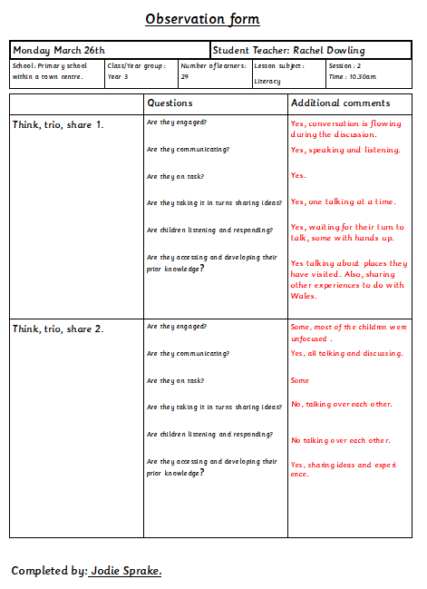

Appendix 6

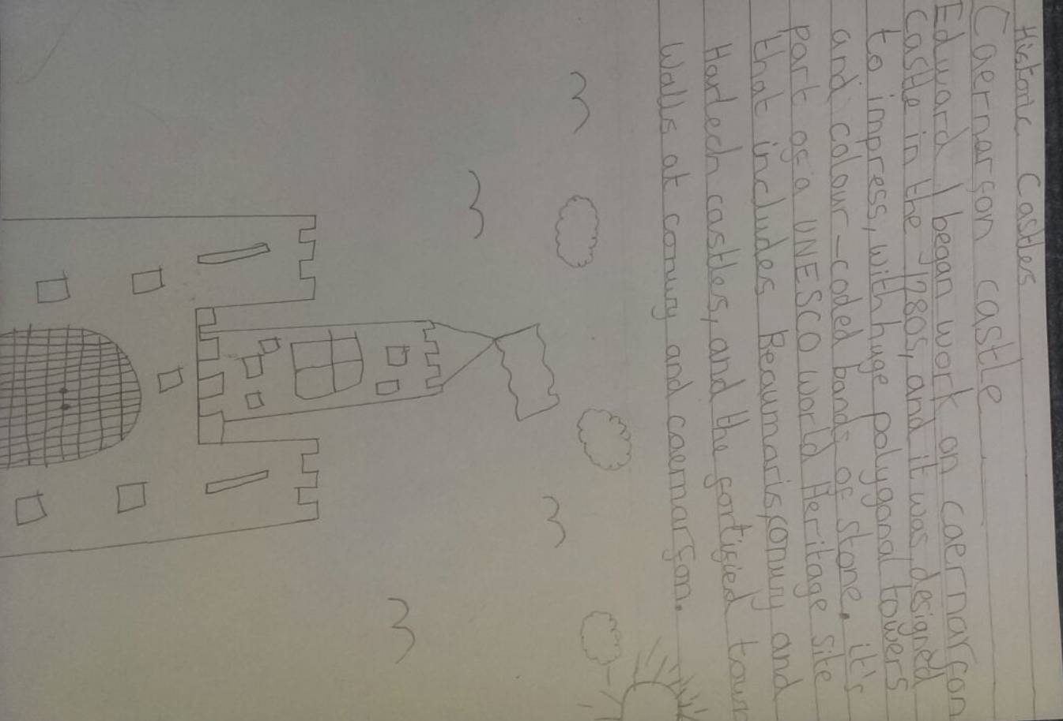
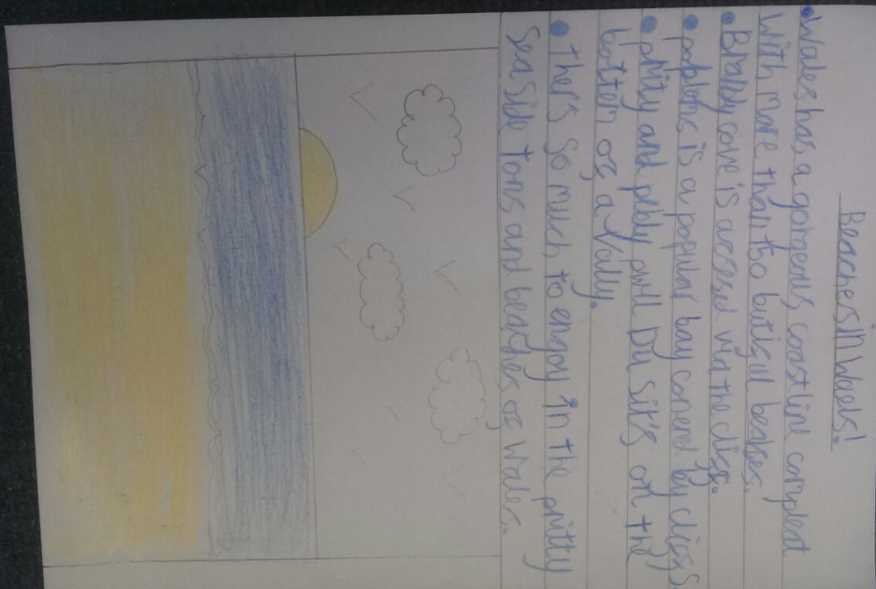
Appendix 7
Focus Group Interview Answers – Class 1
No. | Question | Answer
1. | Do you like using think, trio, share? | - Yes.  - Yes.  - Yes.
 | Why? | - It was really helpful, one more makes it better, it is more like working as a team than just with one other person.  - We were able to share new ideas as we were working with different people.  - Share ideas with each other.
2. | Did you think it was beneficial having the additional person during think, trio, share? | - Yes.  - Yes/no.  - Yes.
 | Why? | - See what other people think and what they know.  - No because I was working with X and he wouldn’t let me join in but with 3 people you get more ideas.  - My partner talks really quiet, so I struggle to hear them because of my hearing aids so it was nice to speak to someone else and be able to hear them.
3. | Do you feel like you learnt more from think, trio, share rather than individual thinking?  (reworded this question during interview to simplify for children) | - Yes.  - Yes.  - Yes.
 | Why? | - Help from others. If you don’t know the answer you can ask a friend for help.  - Faster to get answers as if you don’t know and someone in your group does then it’s quicker.  - If you don’t know the answer someone else may know.
4. | Would you use think, trio, share again? | - Yes.  - Yes.  - Yes.
 | Why? | - Helpful, if you don’t know the answer you can get help.  - Helps you more than just being in pairs.  - Helps you more in groups than being in pairs.

Appendix 8
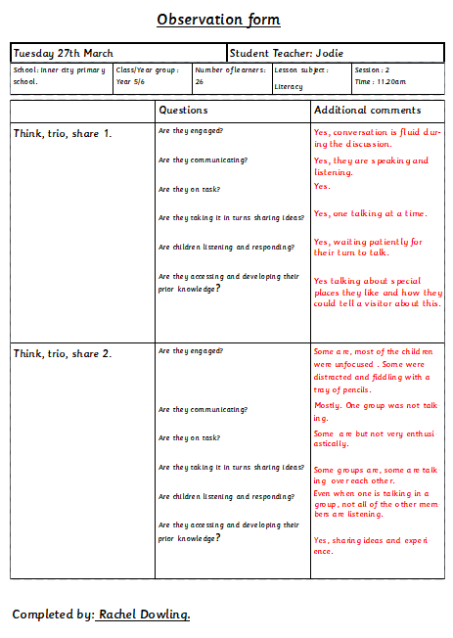

Appendix 9
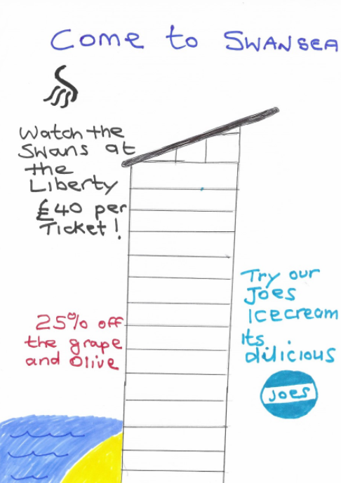

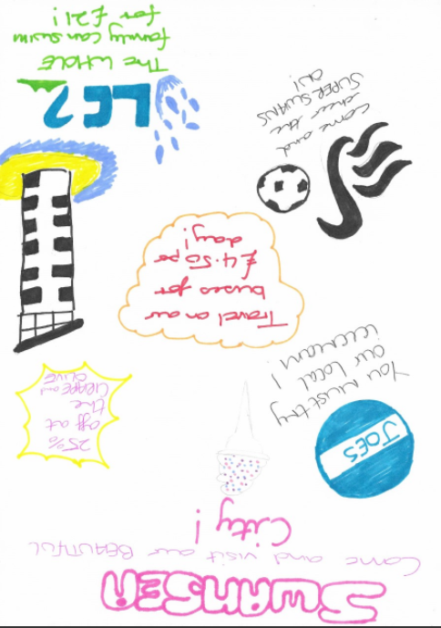
Appendix 10
Focus Group Interview Answers – Class 2
No. | Question | Answer
1. | Do you like using think, trio, share? | - Yes.  - No.  - Yes.
 | Why? | - It’s different from being in a pair. With more people in the group, there’s more to discuss.  - It feels weird. You have to talk to different people who you wouldn’t normally ask questions to.  - There’s more to chat about. You can learn more than working independently.
2. | Did you think it was beneficial having the additional person during think, trio, share? | - Yes.  - Yes.  - Yes.
 | Why? | - With more people, there’s more to discuss and more words to plan.  - It’s good to have more people.  - With pairs, there’s only two brains and with one more person you have three brains. Three brains are better than two brains. You can get more ideas.
3. | Do you feel like you learnt more from think, trio, share rather than individual thinking? | - Yes.  - Yes.  - Yes.
 | Why? | - We did because instead of thinking of your own ideas and getting stuck, there are more ideas working collaboratively.  - I found that if we’re in a group, even if it still feels a bit weird, there are more ideas and bigger ideas.  - If I think of an idea, if it’s only independently, you only have one idea. In a group, you might agree or disagree and you can agree as a group on the answer.
4. | Would you use think, trio, share again? | - Yes.  - Yes and No.  - Yes.
 | Why? | - It’s easier than a pair. There are more ideas to go into the final part. It develops our teamworking and thinking skills.  - Yes because it’s good to have other ideas and discuss. No because you have ideas but you still have to work independently.  - It’s good. It’s easier. If you have to work independently there’s only yourself, but in a group there are more ideas.

