DS2 Assignment
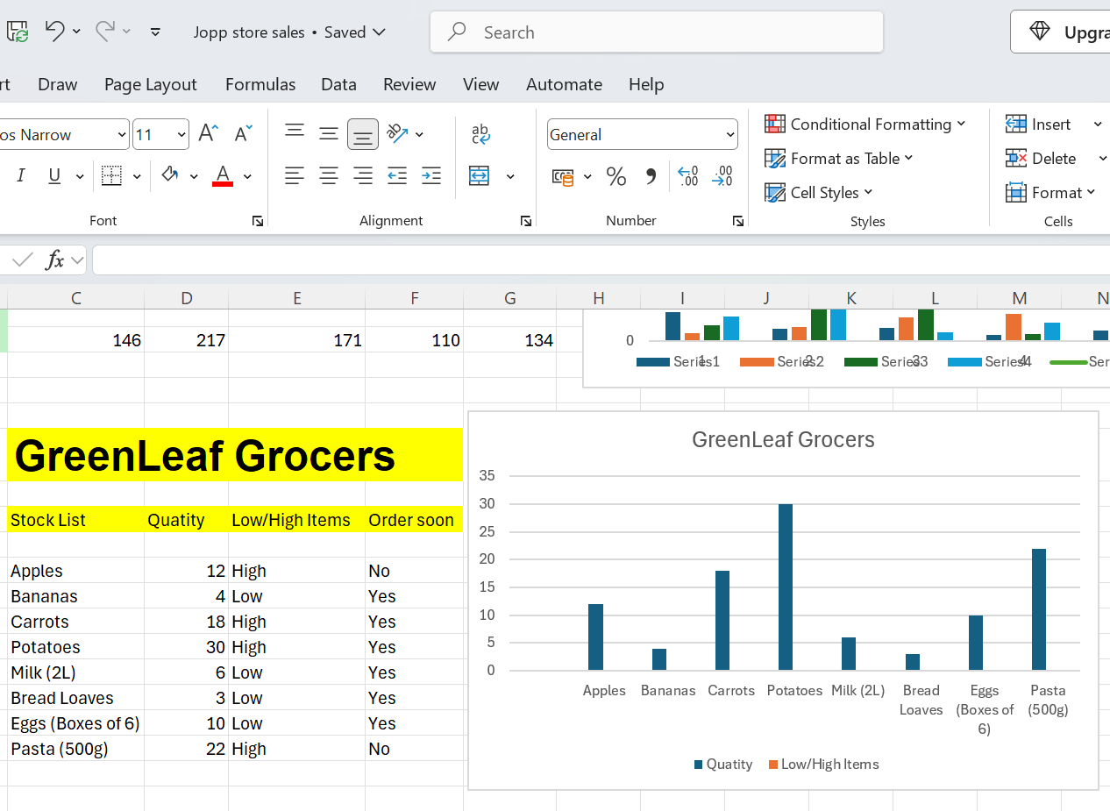

Reflection/Action Log:
I created a spreadsheet and graph to summarise the stock left at GreenLeaf Grocers. From the above information provided by the grocers, the following items are low: bananas, milk, bread loaves and eggs and will need to be reordered soon. The following items are high in stock: apples, carrots, potatoes and pasta and will not need to ordered.

