BMOE6003; Landscape and Sustainable Recreation.

Reflective fieldwork management plan for chosen recreational area.

A management plan for Dinefwr Park

Contents
1.1 Introduction……………………………………………………………………………...
1.2 Background………………………………………………………………………………
Conceptual Framework…………………………………………………………………….
2.1 Carrying Capacity…………...............................................................................................
2.2 Limits of acceptable change………………………………………………………………
2.3 Recreational opportunity spectrum….................................................................................
3.1 Conservation and Preservation………………………………………………………...
3.2 Visitor Experience and Interpretation……………………………………………………
3.3 Suggested management practice moving forward……………………………………….
4.1 Conclusion……………………………………………………………………………….
5.1 References………………………………………………………………………………..

  - Introduction
Engaging in outdoor recreation influences the surrounding environments (Huddart, and Stott., 2019). Outdoor recreation: Environmental impacts and management. Springer Nature. Because of this, it’s necessary to manage these habitats to minimize their negative consequences on the ecosystem, simultaneously however it’s within our best interest to provide and promote enjoyable recreational opportunities (Cole, 1993). Dinefwr Park, located in Llandilo, Carmarthenshire, offers visitors an opportunity to take in the natural beauty and cultural heritage of Wales. The site has several underlying barriers regarding sustainability and management, including but not limited to; depreciative attitude, influence of recreation and endangered animal populations (Dwyer, 2024). In an attempt to mange these issues for the benefit of both visitors and the environment, management recommendations and strategies have been developed with consideration from a number of conceptual frameworks as identified by Manning & Anderson (2012), these including; the recreation opportunity spectrum, carrying capacity, limits of acceptable change, and indicators of quality standards. Practice underpinning strategy identified including zoning, fees, fines, information, education, and enhancement of nearby locations. The objectives and goals of the below management plan will align with conservation, preservation and sustainable management practice.

1.2 Background:
For over two millennia, a country of strength and enchantment. in Welsh history, Dinefwr is a legendary location. There are two forts that attest to the Roman presence. At Dinefwr, the influential Lord Rhys conducted court and shaped Welsh policy. Newton House, a family residence for the descendants of Lord Rhys, the strong Prince of the Welsh Kingdom of the Deheubarth, stands proudly at the centre of the estate and has been for more than three centuries. From flower-rich meadows to dense historic woodland, the magnificent 18th-century landscape was created by visionaries George and Cecil Rice and is now protected as a parkland National Nature Reserve (National Trust, 2024a)

“If you take a handful of the soil of Dinefwr and squeeze it in your hand, the juice that will flow from your hands is the essence of Wales”.
(National Trust, 2024a).

Also onsite is Dinefwr Castle which is managed by CADW (cadw.gov.wales) and owned by the wildlife trust.

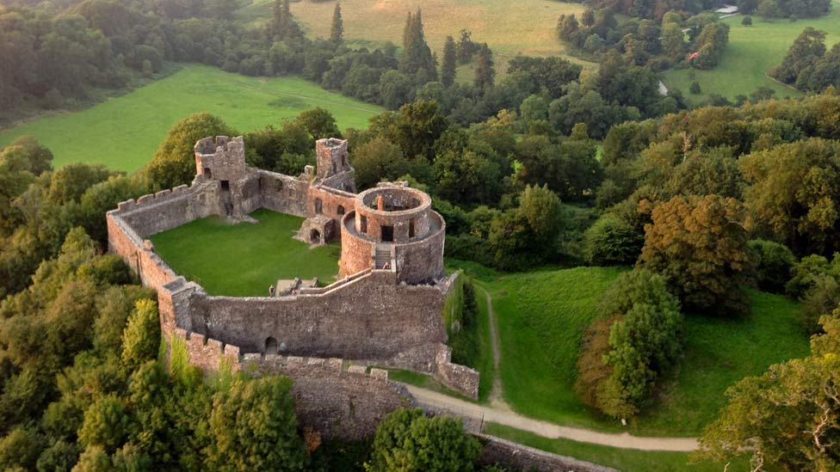
Figure 1: Dinefwr Castle birdseye image; (national Trust, 2024a)

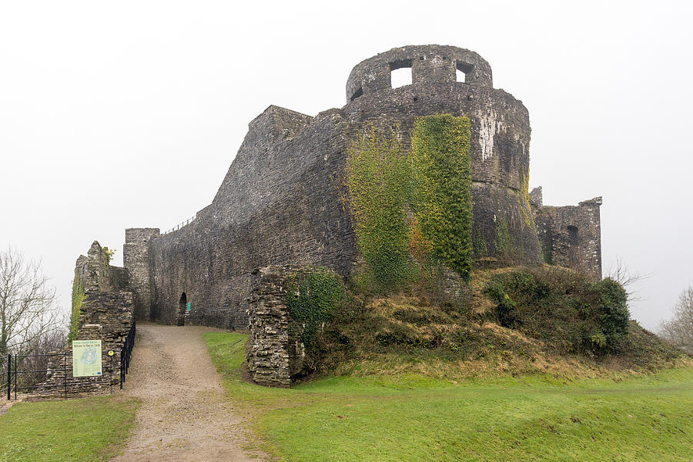
Figure 2: Dinefwr Castle from the ground; (national Trust, 2024a)

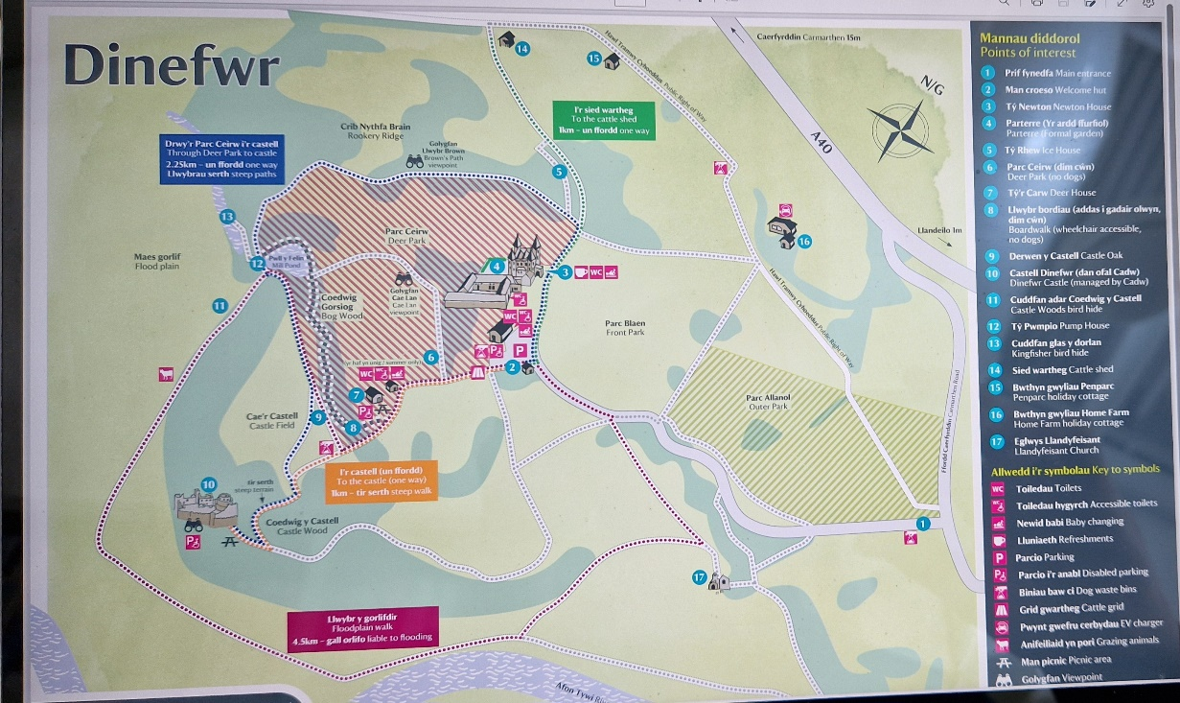
Figure 3: A map of the Dinefwr grounds; (national Trust, 2024a)

One benefit for the management plan of Dinefwr is that it is not totally dependent on making a profit to survive, as it sits under the umbrella of the National trust, which can make up any shortfall in revenue (Morgan, and Price, 2011). The National Trust has more than 5.37 million members (5.95 million in 2019–20). That is greater than Costa Rica's whole population (national Trust, 2024a).
“Our members' contribution enables us to safeguard more than 500 locations for the enjoyment of all people, both now and in the future. With more than 1,300 tenant farmers and approximately 250,000 hectares of land, we are the largest farm owner in the country. We're dedicated to farming such that plants and animals can flourish while also preserving the environment for food production”.
(national Trust, 2024a)
So, with this financial backing, there is no pressure On Dinefwr to have to get a certain amount of people through the gates to get a return on investment. On a recent research-based field study Dwyer (2024) elaborated on some of the issues faced by the site regarding sustainability. Regarding visitation, Dinefwr attracts 160,000 visitors a year to the park, with Newton house attracting 89,000 visitors. Post covid the number in outdoor visits has increased by 66%, with aims to attract more disabled and the ethnic minorities.
There is a strong emphasis on creating symbiotic relationships with humans and nature and developing a sense of place through rationale and education. So, the management plan is all about balance…. Between visitor numbers, access and experience verses managing and maintaining the wildlife habitat and the overall environment. The biggest challenge is managing the footfall through Newton House, with wear and tear of the flooring, dust, dirt etc. also protecting the artefacts (Dwyer, 2024).

Conceptual framework:
2.1 Carrying Capacity:
What is “carrying capacity”? For many years, the concept of "carrying capacity" has played a significant role in the management of natural resources and the environment. Its origins can be found in a work by (Malthus,1798). titled An Essay on the Principle of Population.
In the area of parks and outdoor recreation, carrying capacity—also referred to as "visitor capacity" at times—remains a significant yet difficult problem (Graefe et al., 1984; Shelby and Heberlein, 1986; Stankey and Manning, 1986; Manning, 2007, 2011; Whittaker et al., 2011). Several consequences of recreation on park resources and the standard of the visitor experience have been established by research on the application of carrying capacity to parks and outdoor recreation. So, managing visitor numbers is key to preservation and conservation at Dinefwr.
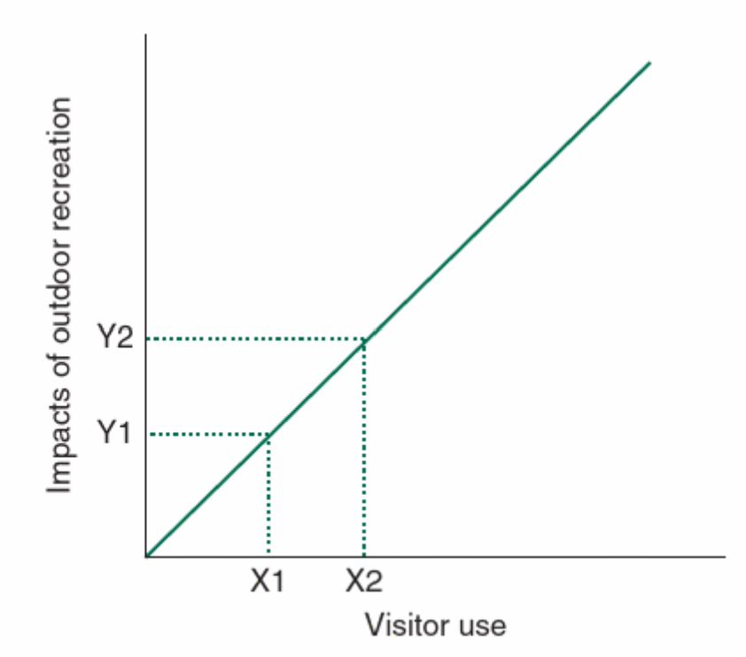
Figure 4 - Relation to visitor use and impact on environment; (Manning & Anderson, 2012)

It is vital to define acceptable degrees of change in order to manage parks and outdoor recreation. The management objectives cover the variety and quality of outdoor recreational options and the extent of resource conservation in parks, to improve biodiversity, safeguard native plants and animals, and encourage ecological resilience, create a habitat management plan for the National Nature Reserve (Manning, Anderson & Pettengill, 2017; Pigram & Jenkins, 2006).
2.2 Limits of acceptable change: Acceptable change thresholds in parks and outdoor recreation are mostly determined by management goals, related metrics, and quality standards. The term "management objectives" refers to statements regarding the intended uses of parks and outdoor recreation, including the degree of resource protection for parks as well as the kind and quality of recreational opportunities.

2.3 Recreational opportunity spectrum: A framework to assist and ensure diversity in parks and outdoor recreation is called the Recreation Opportunity Spectrum (ROS) (Driver and Brown, 1978; Brown et al., 1978, 1979; Clark and Stankey, 1979). In order to demonstrate a wide range of recreational activities, ROS applies quality indicators and criteria to each of the three elements of parks and outdoor recreation: experiences, management, and resources.

3.1 Conservation and Preservation (Managing and protecting the sites facilities).
- Conduct regular surveys and assessments of the natural and built heritage within the park and house to identify conservation needs and prioritize action plans. With current annual reviewing of management plan and rewriting every three years (Dwyer, 2024).
- Implement measures to protect and preserve the historical integrity of Historic Newton House, including maintenance of the building fabric, restoration of architectural features, and conservation of interior furnishings. This could be funded by charging an entry fee, entry fees enabled managers to conserve the environment (Pascoe, et al 2014).
- Develop a habitat management plan for the National Nature Reserve to enhance biodiversity, protect native flora and fauna, and promote ecological resilience.

This site has 800 acres of parkland with Site of Special Scientific Interest (SSSI) status and National Nature Reserve (Barton, and Buckley, 1983). This beautiful area of parkland has many very old trees, some of which are estimated to be over 700 years old, and which support numerous interesting lichens and insects. Already a SSSI, Dinefwr was designated as a National Nature Reserve in 2007, and it is the only area of parkland to receive such a designation in Wales (firstnature, 2024). The park has a few issues with its environment and fauna as well as with the experiences and attitude of its visitors. Dwyer (2024) mentioned that with the COVID-19 outbreak, there has been a rise in the number of visitors who disregard the fencing and do not follow the pathways. Visitors off-trail hiking/walking could put these species in danger (by making noise) and/or significantly modify their environment (breeding grounds/nests etc. as the location is designated as a Special Protection Area (SSSI) because of rare kinds of lichen ((Manning, Anderson & Pettengill, 2017). There are more than 300 trees that are more than 400 years old spread throughout the Park's several forest regions. Deadwood left on the ground throughout the park serves as a good home for insects and beetles in addition to the older trees themselves (Seibold, and Thorn, 2018). At Dinefwr, more than 25 different species of nationally rare insects have been identified. Autumn is one of the best seasons to visit, and decaying wood is great for fungi (Worrall, Anagnost, and Zabel, 1997). Many bracket fungi, such as the Beefsteak fungus (Fistulina hepatica), can be found growing on oak trees (Alexander, 1999). In the park, we have also discovered a variety of exquisite grassland mushrooms, such as Entoloma (pinkgills) and Hygrocybe (waxcap) species (FirstNature, 2024).
Dead wood invertebrates, who live in settings with decaying wood, are another reason why the area has been designated as an SSSI (Natural Resources Wales, 1999). Additional instances of depreciative behaviour from visitors were mentioned by Dwyer (2024), including stealing logs for firewood. The invertebrate species that rely on decaying lumber will suffer if such logs are stolen. There was also a focus on other deplorable behaviours, like graffiti, rock-throwing from the castle, and silverware theft from the manor house. According to Dwyer (2024), the popular White Park Cattle and Fallow Deer are presently afflicted with Bovine Tuberculosis (TB). She discussed the challenge of limiting visitor interaction with the animals due to their illness and attempting to be open and honest with them about the situation, which naturally negatively impacts the experiences of many visitors who come frequently to see these animals. The Deer area can be managed with zoning, keeping the public away from this section of the park implemented (Manning, Anderson & Pettengill, 2017).
The Twyi Valley is home to a variety of raptors, including the Red Kite (Milvus milvus) and Buzzard (Buteo buteo), both of which are fortunately abundant in this region of Wales. The sites lakes serve as a crucial wintering area for wildfowl. There, one can frequently see Tufted Ducks (Aythya fuligula), Common Teal (Anas crecca), and Wigeon (Anas penelope). Additionally, Dinefwr's pastureland is a great place for insects, which benefits the birds who eat them. So, with all this in mind, it is a very delicate balance of mixing people with such a fragile ecosystem. Outdoor recreation locations have a well-documented history of conflict between recreation organisations and individuals engaged in different activities (Manning, 2011). When one person or group's actions conflict with the objectives of another person or group, conflict may arise (Jacob and Schreyer, 1980).
Summarising, key issues include:
- Off-Trail hiking/walking, leading to deterioration of habitat. Even moderate levels of use can lead to notable degeneration in some situations (Marion and Reid, 2007).
- Conflicts between visitors
- Vandalism of site structures
- Noise pollution

A solution to this could be, moving the walkways away from the hides or regular warden patrols. Education has been demonstrated to have a significant role in parks, ecosystem services, and landscapes (Mocior & Kruse, 2016), in addition to having the potential to lessen impact (Fratz & Mayer, 2014). This is because education can affect visitors' sense of connection to nature. So, just simple sign posting, and education boards will help. If that fails, then we can use zoning and/or warden patrols.

3.2 Visitor Experience and Interpretation (crowd control):
- We can enhance visitor experience through interpretive signage, guided tours, educational programs, and interactive exhibits that showcase the rich history, cultural heritage, and natural beauty of Dinefwr Park and Historic Newton House (Grigg, 2015). Peak times are when tourist use is typically concentrated. If recreation use could be somewhat reallocated, this could help to alleviate issues like crowding. The usefulness of both time and space use redistribution in lowering contacts between recreational groups has been demonstrated in a number of research using computer-based simulation models. (Schechter and Lucas, 1978; Manning and Ciali, 1979; Manning and Potter, 1982, 1984; Potter and Manning, 1984; Underhill et al., 1986; Wang and Manning, 1999; Lawson and Manning, 2003a, b; Cole, 2005; Lawson et al., 2006; Gimblett and Skov-Peterson, 2008; Lawson et al., 2008). An earlier study, by Lime and Lucas, (1977) for instance, investigated the efficacy of informing visitors about present use patterns to modify future use patterns. This information can allow visitors to avoid the peak times (usually weekends and school holidays) and then visit at the off-peak times, so avoiding the congestion. Maybe discount ticket prices for off peak times to encourage visitors to visit at the less busy times. The use of rationing and allocation practices have been developed as they apply to river recreation (Whittaker and Shelby, 2008) and wilderness (Cable and Watson, 1998). By doing this it stops the pathways becoming overcrowded to managing deterioration and erosion of paths and the boardwalks. Other controls at busy, peak times could be different entry points or sending visitors along different paths, Krumpe, and Brown, (1982) say in opposite directions and/or zoning different areas and allowing set number of visitors into each zone for a period, then rotate the zones (e.g. maybe 2 hours in each zone). (Greist, 1975; Haas et al., 1987). The Recreation Opportunity Spectrum (ROS), which has been extensively used in parks and outdoor recreation, is based on the fundamental idea of zoning (Brown et al., 1978). “A recreation-related zoning system has also been applied to Mount Spil National Park, Turkey, based primarily on ecological considerations” (Hepcan, 2000).

3.3 Suggested management practice moving forward:
  - Provide visitor facilities such as information centres, rest areas, and accessible pathways to ensure a comfortable and enjoyable experience for visitors of all ages and abilities. Using information and education programs to influence recreation use were illustrated in a study in the Selway-Bitterroot Wilderness, Montana (Lucas, 1981).

  - Foster partnerships with local communities, schools, and cultural organizations to promote awareness, appreciation, and engagement with the park's heritage and environmental significance. Research has concentrated on depreciative behaviour, particularly littering, in order to examine the possible effectiveness of information and education as a management strategy. A person's experience of human history can be improved by connecting with it and developing a "sense of place," which can aid to evoke memories and feelings in these environments (Williams, 2019).

  - Visitors with less experience and expertise tend to respond better to information and education programmes. A particularly appealing target demographic could be younger visitors. Numerous studies have shown that different informational and educational messages, along with accompanying programmes, can effectively reduce the behaviour of littering and even clean up places that have been littered. (Burgess et al., 1971; Clark et al., 1971; Marler, 1971; Clark et al., 1972).

4.1 Conclusion:
In summary, Dinefwr Park/Newton house and all managed natural environments face a few challenges to both its protected habitats and visitor experience as it’s a constantly ‘moving target’. Both the “environmental resources and the quality of the recreational experience are impacted when more people visit a park or other outdoor recreation area. Using hypothetical correlations between rising use levels and visitor satisfaction, the consequences of increased use on leisure quality were highlighted”. There is a constant balance between (Management- environmental- visitors), trying to keep all three in equilibrium. Add in more complexity of the area being an SSSI, so extra protection needed for wildlife and fauna, with also a herd of Deer with tuberculosis (TB) that need isolating from humans and other animals. Luckily Dinefwr does not need unlimited amounts of visitors because it is not self-sustaining, so not driven by profit, so that it can manage and limit the number of visitors accordingly. If they were profit driven and had to let in unfettered amounts of visitors, then the balance of equilibrium would be harder to maintain. So, the need to establish monitoring and evaluation mechanisms to track progress towards achieving management plan objectives. Measure performance indicators, and adapt strategies as needed to address emerging challenges and opportunities. Also conduct periodic reviews and assessments of the management plan's effectiveness, soliciting feedback from stakeholders, visitors, and experts to inform future planning and decision-making processes. And finally, emphasize the importance of collaboration, community engagement, and stakeholder participation in achieving shared goals and objectives for Dinefwr Park and Historic Newton House.

Word count: 2679
5.1 References:

Alexander, K., 1999. Britain's wood pastures. British Wildlife.
Barton, P.M. and Buckley, G.P., 1983. The status and protection of notified sites of special scientific interest in South-East England. Biological conservation, 27(3), pp.213-242.
Brown, P., Driver, B. and McConnell, C. (1978) ‘The opportunity spectrum concept in outdoor recreation supply inventories’: Background and application. Proceedings of the Integrated Renewable Resource Inventories Workshop, USDA Forest Service General Technical Report RM-55, Fort Collins, Colorado, 73–84.
Burgess, R., Clark, R. and Hendee, J. (1971) ‘An experimental analysis of anti-litter procedures. Journal of Applied Behaviour Analysis 4, 71–75.
Cable, S. and Watson, A. (1998) ‘Recreation use allocation’: Alternative approaches for the Bob Marshall Wilderness Complex. USDA Forest Service Research Note RMRS-1, Missoula, Montana, 1–7.
cadw.gov.wales/visit/places-to-visit/castell-dinefwr
Clark, R., Burgess, R. and Hendee, J. (1972a) ‘The development of anti-litter behaviour in a forest campground’. Journal of Applied Behaviour Analysis 5, 71–75. Clark, R., Hendee, J. and Burgess, R. (1972b) ‘The experimental control of littering’. Journal of Environmental Education 4, 22–28
Cole, D.N., 1993. Minimizing conflict between recreation and nature conservation. Ecology of greenways: Design and function of linear conservation areas, pp.105-122.
Dwyer, H. (2024) Talk with OAE students at Dinefwr Park, 13 March.

Fratz, C.M. and Mayer, F.S. (2014) ‘The importance of connection to nature in assessing environmental education programs’, Studies in Educational Evaluation. 41, pp. 85-89.
firstNature (2024) Dinefwr National Nature Reserve, Llandeilo, Carmarthenshire, South Wales, Dinefwr National Nature Reserve, Llandeilo, Carmarthenshire, Southwest Wales. https://www.first-nature.com/waleswildlife/sw-nnr-dinefwr.php
Graefe, A., Vaske, J., and Kuss, F. (1984) ‘Social carrying capacity; an integration and synthesis of twenty years of research’. Leisure Sciences 6, 395–431.

Greist, D. (1975) ‘Risk zone management’: A recreation area management system and method of measuring carrying capacity. Journal of Forestry 73, 711–714.
Grigg, R., 2015. The Little Book of Carmarthenshire. The History Press.
Haas, G., Driver, B., Brown, P. and Lucas, R. (1987) ‘Wilderness management zoning’. Journal of Forestry 85, 17–22.
Hepcan, S. (2000) ‘A methodological approach for designating management zones in Mount Spil National Park, Turkey’. Environmental Management 26, 329–338.

Huddart, D. and Stott, T., 2019. Outdoor recreation: Environmental impacts and management. Springer Nature.
Jacob, G. and Schreyer, R. (1980) ‘Conflict in outdoor recreation’: A theoretical perspective. Journal of Leisure Research 12, 368–380.
Krumpe, E. and Brown, P. (1982) ‘Using information to disperse wilderness hikers. Journal of Forestry 80, 360–362.
Lime, D. and Lucas, R. (1977) ‘Good information improves the wilderness experience’. Naturalist 28, 18–20.
Lucas, R. (1981) ‘Redistributing wilderness use throughout information supplied to visitors. USDA Forest Service Research Paper INT-277, Ogden, Utah
Malthus, T. (1798) ‘An Essay on the Principle of Population’. W.W. Norton & Co., New York, New York

Manning, R. (2001) Experience and resource protection: ‘A framework for managing carrying capacity of National Parks’. Journal of Park and Recreation Administration 19, 93–108.
Manning, R. (2007) ‘Parks and Carrying Capacity’: Commons Without Tragedy. Island Press, Washington, DC.

Manning, R. and Ciali, C. (1979) ‘The computer hikes the Appalachian trail’. Appalachia 43, 75–85.

Manning, R. and Potter, F. (1982) ‘Wilderness encounters of the third kind’. Proceedings of the Third Annual Conference of the Wilderness Psychology Group. West Virginia University, Morgantown, West Virginia, 1–14.

Manning, R.E., Anderson, L.E. and Pettengill, P.R. (2017) ‘Managing outdoor recreation’: case studies in the national parks. Second edition. Boston: CAB International.
Marion, J. and Reid, S. (2007) Minimizing visitor impacts to protected areas: The efficacy of low impact education programs. Journal of Sustainable Tourism 15, 5–27.
Mocior, E. and Kruse, M. (2016) ‘Educational values and services of ecosystems and landscapes – An overview’, Ecological Indicators. 60, pp. 137-151.
Morgan, K.J. and Price, A., 2011. The collective entrepreneur: social enterprise and the smart state.
NationalTrust (2024a) Home, National Trust. Available at: https://www.nationaltrust.org.uk/

NationalTrust (2024b) Dinefwr: Carmarthenshire: Wales, National Trust Welcome to Dinefwr. Available at: https://www.nationaltrust.org.uk/visit/wales/dinefwr
NationalTrust (2024bc) Facts and figures, National Trust Dinefwr Facts and Figures. Available at: http://www.nationaltrust.org.uk/who-we-are/about-us/fascinating-facts-and-figures

Pigram, J.J. and Jenkins, J. (2006) Outdoor recreation management. 2nd ed. London: Routledge.
Schechter, M. and Lucas, R. (1978) ‘Simulation of Recreational Use for Park and Wilderness Management’. Johns Hopkins University Press, Baltimore, Maryland.
Shelby, B. and Heberlein, T. (1986) ‘Carrying Capacity in Recreation Settings’. Oregon State University Press, Corvallis, Oregon

Seibold, S. and Thorn, S., 2018. The importance of dead-wood amount for saproxylic insects and how it interacts with dead-wood diversity and other habitat factors. Saproxylic insects: Diversity, ecology and conservation, pp.607-637.

Stankey, G. and Manning, R. (1986) ‘Carrying capacity of recreation settings. A literature review: The President’s commission on Americans outdoors. U.S. Government Printing Office, M-47, M-57, Washington, DC.

Wagar, J. (1968) ‘The place of carrying capacity in the management of recreation lands. Third Annual Rocky Mountain-High Plains Park and Recreation Conference Proceedings, Colorado State University, Fort Collins, Colorado.

Wang, B. and Manning, R. (1999) ‘Computer simulation modeling for recreation management’: A study on carriage road use in Acadia National Park, Maine, USA. Environmental Management 23, 193–203.

Whittaker, D. and Shelby, B. (2008) Allocating River use: ‘A review of approaches and existing systems for river professionals. River Management Society, Missoula, Montana.

Whittaker, D., Shelby, B., Manning, R., Cole, D. and Haas, G. (2011) ‘Capacity reconsidered’: Finding consensus and clarifying differences. Journal of Park and Recreation Administration 29, 1–20.

Worrall, J.J., Anagnost, S.E. and Zabel, R.A., 1997. Comparison of wood decay among diverse lignicolous fungi. Mycologia, 89(2), pp.199-219.

Williams, A. (2019) ‘Place is special when we do a bit of homework’ HORIZONS Magazine No 82 p14-17.

