Cover page


LEVEL 7 ASSESSMENT SPECIFICATION

Student name: | WONG, Si Ming Kyle | Student ID number: | 1812211
Programme: | MBA
Module: | Financial Management
Module code: | SBMA7100 | Contribution to Overall Module Assessment (%): | 100%
Lecturer: | Dr Katherine Mo | Internal Verifier:
Assignment Title: | Assignment 1 | Word count (or equivalent): | 5000 words
Submission deadline: | 19 August 2019 ( 11:59pm Hong Kong time) | Return date of provisional marks & written feedback: | Within 20 days after submission
Submission method: | All written assessments, where practical and possible, must be submitted via Turnitin unless otherwise instructed by the Lecturer. (Please DO NOT put this assessment specification into Turnitin or it will match many similarities with other students’ submissions.)  Alternative submission method (if applicable):  Late submission of the assessment will result in a late penalty mark. Penalties for late submission: Up to one week late, maximum mark of 50%. Over one week late, 0%. Only the Extenuating Circumstances Panel may approve a change to submission dates.
Academic honesty / referencing: | Academic honesty is required. In the main body of your submission you must give credit to authors on whose research and ideas your work is based. Append to your submission a reference list that indicates the books, articles, etc. that you have used, cited or quoted in order to complete this assessment.

Financial Assessment
Of
Guangzhou Automobile Group Company Limited
( GAC Group)

Executive Summary

The automobiles sale in China has always on a positive growth for the past 20 years but started downturn in 2018. This sudden change has impact most of automobiles manufacturer including the Guangzhou automobile group company limited ( GAC 2019).
Mr. Zeng Qinghong who is Chairman of GAC and has put enormous effort and time under his management team but the net profit in 2018 has been negative growth since 2011. During this Financial Assessment, the author would complete an in-depth financial analysis by using both horizontal trend analysis and vertical analysis as well as two other similar sizes of the company in the same automobiles industry.
The investigation of the corporate governance assessment will be performed, new investment appraisals project proposed by using different of the capital budgeting decision calculation methods if the new project will be profitable.
In additional, Investment appraisals project of electric vehicles production line and Financing Management project will be evaluated and reviewed all the advantages and disadvantages of each option. An Audit plan will be included as well and keep track of the progress of each task to be implemented successfully.

Finally, a conclusion and recommendations will be provided to support the new investment of the fully automated electric vehicles production line and intelligently apply the one-time significant to succeed both projects engaged in the long term growth.

Table of Contents

Table of Contents
Cover page i
Executive Summary iii
Table of Contents iv
List of Tables v
List of Figures vi
Abbreviation table vii
Introduction 1
1 Company Background 2
2.1 Company business overview 2
2.3 Products and services 3
2 GAC Group & competitors Financial Analysis 4
2.1 Listed Company Bankrupcy Index 6
3.3 Operating Capacity 9
3.4 Profiability 11
3.5 Growth Capacity 12
3.7 Stock Market Propects Analysis 13
4 Corporate Governance Assessment 15
5 Investment Project Assessment 18
6 Financing and Capital Management 24
7 Audit Plan 26
8 Conclusion and Recommendations 28
References 30
Appendices A – The stock price at the last trading of the year of 2018,17 & 16 33
Appendices B – The exchange rate at the last trading of the year of 2018, 17 & 16 34
Appendices C – The closing price of August 9, 2019 36

List of Tables

Table 1 - Overall view summarize table of the 3 companies 12
Table 2 - Financial Analysis of three companies 13
Table 3 - Z-Score table 14
Table 4 - Financial Structure 15
Table 5 – Paying debt ability 16
Table 6 – Operating expenses 17
Table 7 - Assets Turnover 18
Table 8 – Profitability 19
Table 9 – Growth Capacity 20
Table 10 – Stock market prospect analysis 21
Table 11 – Stock Price earning power and dividend yield 22
Table 12 - ROA and ROE 23
Table 13 - New investment assessment data 25
Table 14 – Audit plan schedule for the next 4 quarters 33

List of Figures

Figure 1 - Employee Costs 17
Figure 2 - GAC Net Profit, Gross Profit & Net Profit 19
Figure 3 - HK Earning Per Share ( HK stock, in HKEX) 22
Figure 4 - ROA and ROE Chart 23
Figure 5 - Audit plan procedure 34

Abbreviation table

ARR | Accounting Rate of Return
CAAM | China association of automobile manufacturers
CN | China
GAC | Guangzhou automobile group company limited
Geely | Geely automobile holdings limited
Great wall | Great wall: Great wall motor company limited
HK | Hong Kong
HKEX | Hong Kong Stock exchange
IRR | Internal Rate of Return
NPV | Net present value
Payback | Payback period
SSE | Shanghai stock exchange

Introduction

According to the China association of automobile manufacturers (CAAM), the sale volume of the overall automobiles in China has always on a positive trend since 2011 to 2017 and sale volume has grown from approximately 18.5 million to 28.9 million. However, the positive trend has stopped and declined by 2.8 % with the sale volume in 2018. It would an interesting case to evaluate the impact of the automobile manufacturers from the financial prospective ( GAC, 2019; GAC 2018; GAC 2017).

The overall market declined has also lag GAC to the first negative profit grow rate of -1 % since 2012. This report will apply the in-depth financial assessment techniques to evaluate GAC past three year financial records as well as two other competitors of Geely and Great Motor from the same industry with similar sale volume.

The collected data and information are completed through study, review and observation methods. In additional, these related information was extracted from company financial statements, company public news, academic journals, books and newspapers. The company financial statements includes income statement, balance sheet and statement of cash flow.

Company Background

GAC is a well-known Chinese automobile manufacturer, subsidiary of Guangzhou automobile industry group, was established in June, 2005. It has been ranked among the Fortune Global 500 for six consecutive years and ranked 189th among the world's top 500 companies in 2019. Also, it is one of the top 6 local market leaders with 2.14 million sale volume in 2018 (GAC, 2019 and CAAM 2019).

GAC is first China automobile manufacturer company, was listed on both Hong Kong stock market (H stock is 2238) and China stock (A stock is 601238) markets. The listed on the Hong Kong stock exchange was Aug 30, 2010. The company hires approximately 94,000 employees in 2018. The major shareholder is Guangzhou automobile industry group ltd which is the parent company, Schroder Plc and BlackRock Inc. are the second and third largest shareholder (GAC, 2019).
Mr. Zeng Qinghong is the Chairman of both GAC and the parent company of Guangzhou automobile industry group since 2016.

1.1 Company business overview
GAC formed into two business operations, one under her own brand with end-to-end automobile manufacturing service which is from own design, manufacture and sale and the others operated with other international companies such as Honda, Toyota, Fiat Chrysler and Mitsubishi in China ( GAC 2019 ).
GAC operates in five key business units: 1) manufacture of vehicles, 2) parts & components, 3) research & development, 4) commercial services and 5) financial services. The company strategy is to provide full vertical integration from initial design to financial service of the vehicles ( GAC 2019 ).

1.2 Products and services

GAC offers both passenger & commercial vehicles and the most popular brand is consumer vehicle’s Trumpchi series, it has received more than 16 awards in 2018. In addition, the Sport Utility Vehicle under the brand name of Changfeng Motor and the newly developed lithium ion electric battery car under the brand name of Aion. The other Joint Venture brands with long history brand including the popular model of Honda’s accord, Toyota’s Camry, Mitsubishi’s outlander etc ( GAC 2019 )
The total sale volume of the whole vehicles are approximately 2.15 million units which including passenger vehicles, commercial vehicles and the new energy vehicle. The new energy vehicle sale volume has substantially increased from 5,246 to 20,006 in 2018 ( GAC 2019 ).

GAC Group & competitors Financial Analysis
The financial analysis will be including the company vertical analysis of the financial statement item in the same year. The horizontal analysis is to compare financial statement over time for the previous two years. In additional, there is another two similar size of competitor companies for relevant comparisons of profitability, market performance, liquidity, efficiency and capital structure. Refer to below table 1.

As shown on Table 1, the financial ratios are used to examine the company liquidity, profitability and debt. GAC, Geely and Great wall are similar in term of Market capitalization and Revenue range. However, GAC has better control on the gross profit margin, net profit margin which is difficult task to control.

Table 1 - Overall view summarize table of the 3 companies
 | Geely  Compare 1 |  |  | GAC Group  Main company |  |  | Great Wall  Compare 2
Industry | Automobile & Components |  |  | Automobile & Components |  |  | Automobile & Components
HK Stock Number | 0175 |  |  | 2238 |  |  | 2333
Year end period | Year end at Dec 31, 2018 |  |  | Year end at Dec 31, 2018 |  |  | Year end at Dec 31, 2018
Business nature | Automobile Manufacturer |  |  | Automobile Manufacturer |  |  | Automobile Manufacturer
Year | 2018 | 2017 | 2016 | 2018 | 2017 | 2016 | 2018 | 2017 | 2016
Market Capitalization | 108,729 | 213,258 | 57,139 | 94,629 | 113,840 | 83,530 | 45,966 | 92,383 | 86,357
Revenue ( RMB in million) | 106,595 | 92,761 | 53,722 | 72,380 | 71,575 | 49,418 | 99,230 | 101,169 | 99,230
Gross profit margin % | 25% | 24% | 22% | 19% | 22% | 18% | 21% | 23% | 33%
Net Profit margin % | 12% | 12% | 10% | 15% | 15% | 13% | 5% | 5% | 11%
Source: GAC (2019), GAC(2018), GAC(2017), Geely (2019), Geely(2018), Geely (2017) and Great wall (2019), Great wall (2018), Great wall (2017)

Financial Analysis
Among the three companies, GAC has the highest net current assets and total asset in 2018. The reason is that GAC is holding a large amount of Cash and Cash equivalents approximately 27.7 billion in 2018 and 37.2 billion in 2017. The total asset can be used to support generate revenue and facilitate the running business.
The all three companies have the similar amount of total liabilities including employee wages & benefits, taxes, debts, account payable, insurance etc. However, Geely and Great wall have higher revenue than GAC. The revenue refers to the sale indicating the earnings and the benefit for the shareholders ( GAC 2019, Geely 2019, Great Wall 2019)

Table 2 - Financial Analysis of three companies
Financial Analysis | Geely  Compare 1 |  |  | GAC Group  Main company |  |  | Great Wall  Compare 2
Years | 2018 | 2017 | 2016 | 2018 | 2017 | 2016 | 2018 | 2017 | 2016
Net current assets ( in million ) | (975) | 3,107 | 6,619 | 25,920 | 27,867 | 10,672 | 11,508 | 10,412 | 10,676
Total assets ( in millions ) | 91,461 | 84,981 | 67,583 | 132,174 | 119,656 | 82,146 | 111,800 | 110,547 | 92,309
Retained earnings | 44,780 | 34,303 | 24,275 | 39,491 | 33,801 | 25,555 | 43,398 | 40,006 | 38,167
EBIT | 15,073 | 12,936 | 6,319 | 12,321 | 12,840 | 8,001 | 6,971 | 6,371 | 12,622
Stock value (HKD) last trading day in Dec on HKSE | 13.80 | 27.10 | 7.14 | 7.81 | 13.23 | 6.70 | 4.49 | 8.95 | 7.24
RMB / HKD ex rate | 1.14 | 1.14 | 1.11 | 1.14 | 1.20 | 1.11 | 1.14 | 1.20 | 1.14
Number of H - stock, in million | 8,982 | 8,971 | 8,883 | 3,099 | 2,213 | 2,213 | 3,100 | 3,100 | 3,100
Stock value (RMB) last trading day in Dec at SSE | NA | NA | NA | 10.29 | 17.61 | 16.55 | 5.60 | 11.49 | 11.06
Number of A - stock, in million | NA | NA | NA | 7,133 | 5,079 | 4,240 | 6,028 | 6,028 | 6,028
Total liabilities | 46,086 | 50,170 | 42,897 | 54,199 | 49,188 | 37,253 | 59,111 | 61,289 | 44,956
Revenue | 106,595 | 92,761 | 53,722 | 72,380 | 71,575 | 49,418 | 99,230 | 101,169 | 98,616
Source: GAC (2019), GAC(2018), GAC(2017), Geely (2019), Geely(2018), Geely (2017) and Great wall (2019), Great wall (2018), Great wall (2017)

Listed Company Bankrupcy Index
Edward Altman's Z-Score Formula is a financial formula measuring a company financial health, exanimating and predicting the company's likelihood of bankruptcy. It is based on a large number of experiential investigations and analytical studies, the Z-Score model calculates a set of financial ratios and reflects the degree of financial crisis by the collected data from the financial reports (Altman, 1968).
Table 3 - Z-Score table
Z-score | Geely  Compare 1 |  |  | GAC Group  Main company |  |  | Great Wall  Compare 2
Year | 2018 | 2017 | 2016 | 2018 | 2017 | 2016 | 2018 | 2017 | 2016
A | -0.01 | 0.04 | 0.10 | 0.20 | 0.23 | 0.13 | 0.10 | 0.09 | 0.12
B | 0.49 | 0.40 | 0.36 | 0.30 | 0.28 | 0.31 | 0.39 | 0.36 | 0.41
C | 0.16 | 0.15 | 0.09 | 0.09 | 0.11 | 0.10 | 0.06 | 0.06 | 0.14
D | 2.36 | 4.25 | 1.33 | 1.75 | 2.31 | 2.24 | 0.78 | 1.51 | 1.92
E | 1.17 | 1.09 | 0.79 | 0.55 | 0.60 | 0.60 | 0.89 | 0.92 | 1.07
Z-score | 3.80 | 4.75 | 2.52 | 2.56 | 3.02 | 2.86 | 2.23 | 2.63 | 3.39

The calculation Z-score formula of the public manufacturers is Z = 1.2X₁ + 1.4X₂ + 3.3X₃ + 0.6X₄ + 0.99X₅ .
A = Working Capital/Total Assets ×1.2
B = Retained Earnings / Total Assets ×1.4
C = EBIT / Total Assets ×3.3
D = Market Value of Equity / Book Value of Total Liabilities ×0.6
E = Sales / Total Asset × 0.999
As Altman (1968) recommended that if the z-score is lower than 1.81, it indicates a high probability of bankruptcy; if the z-score is between 1.81 to 2.99 which is in a grey area; if the Z-score is larger than 2.99, it indicates a low probability of bankruptcy. Moreover, the higher the Z score, the less likely the company goes to bankrupt.
The calculated Z-score of the GAC is 2.56 in 2018 which is in a grey area between high and low bankruptcy score. However, the Z-score was better in 2017 and 2016 with result of 3.02 and 2.86 respectively.

Financial Structure
GAC has the lowest fixed asset to long term liability ratio than Geely and Great Wall, it measures the solvency of the company and indicates more difficulty in covering debts by fixed asset. The Current liability to Net asset ratio is to measure the reliance on the equity of payables, borrowing and tax. GAC has able to handle effectively and stability for the past three years because of the lowest current liability. The Current liability to stock ratio shows the reliance of the current inventory for payment controlled by GAC in 2018 as per shown on Table 4.

Table 4 - Financial Structure
 | Geely  Compare 1 |  |  | GAC Group  Main company |  |  | Great Wall  Compare 2
Year | 2018 | 2017 | 2016 | 2018 | 2017 | 2018 | 2018 | 2017 | 2016
Fixed Asset to Long term Liability Ratio | 0.50 | 0.39 | 0.43 | 0.19 | 0.17 | 0.21 | 0.53 | 0.59 | 0.52
Current Liability to Net Asset Ratio | 0.96 | 1.43 | 1.65 | 0.52 | 0.52 | 0.54 | 1.04 | 1.20 | 0.91
Current Liability to Stock Ratio | 10.68 | 8.28 | 13.25 | 5.99 | 10.94 | 9.73 | 12.29 | 10.56 | 7.14

Paying Debt Ability

The debt ratio analysis is a great way for stockholder to estimate company the debt control and measure the risk. The calculation of debt ratios would explain the ability to maintain its debt. The current ratio showing the financial strength of the company to pay off its debt in the next 12 month and GAC has been able to implement its short-term financing facilities efficiently than Geely and Great wall. The quick ratio is the ability of the company showing the quick asset to extinguish the current liabilities quickly and GAC has a better ratio than Geely and Great Wall. GAC has better cash ratio and total debt ratio but not that well on the debt/ equity ratio which shows a highly leveraged and risky investment compared to other 2 companies.

Table 5 – Paying debt ability
 | Geely  Compare 1 |  |  | GAC Group  Main company |  |  | Great Wall  Compare 2
Year | 2018 | 2017 | 2016 | 2018 | 2017 | 2016 | 2018 | 2017 | 2016
Current Ratio (%) | 98% | 106% | 116% | 164% | 176% | 144% | 121% | 118% | 125%
Quick Ratio (%) | 88% | 94% | 109% | 148% | 167% | 134% | 113% | 108% | 111%
Stock Credit Index | 1.24 | 0.48 | (1.16) | (2.85) | (7.33) | (3.28) | (1.59) | (0.87) | (0.76)
Cash Ratio (%) | 60% | 48% | 62% | 94% | 130% | 94% | 33% | 26% | 29%
Total Debt Ratio (%) | 50% | 59% | 63% | 41% | 41% | 45% | 53% | 55% | 49%
Debt / Equity Ratio (%) | 3% | 4% | 0% | 12% | 12% | 23% | 4% | 1% | 0%
Long Term Debt Ratio | 0.03 | 0.04 | 0.00 | 0.11 | 0.11 | 0.19 | 0.04 | 0.01 | 0.00
Total Debt / Fixed Asset Ratio | 1.97 | 3.57 | 4.03 | 3.31 | 3.67 | 3.14 | 2.04 | 2.21 | 1.82
Time interest cover ratio | 132.22 | 79.85 | 54.95 | 26.84 | 19.88 | 8.31 | 14.11 | 46.17 | 90.81
Cash coverage ratio | 153.39 | 91.81 | 69.33 | 33.48 | 23.49 | 10.58 | 14.41 | 47.57 | 63.11

Operating Capacity
The operating cost is one of the most important factors apart from revenue and profit. Having a well managing expenses can maximize the profit. GAC has a much higher employee cost due to the wages and salaries than Geely and Great Wall. The reason is because GAC has a joint venture with Honda, Toyota etc. and have to maintain skilled worker by offering attractive salary package. Refer to Table 6 and Figure 1
Table 6 – Operating expenses
Operating Expenses | Geely  Compare 1 |  |  | GAC Group  Main company |  |  | Great Wall  Compare 2
Year | 2018 | 2017 | 2016 | 2018 | 2017 | 2016 | 2018 | 2017 | 2016
employee costs | 6% | 5% | 5% | 12% | 9% | 9% | 1% | 1% | 1%
selling and distribution cost | 4% | 4% | 5% | 7% | 7% | 7% | 5% | 4% | 3%
admin cost | 4% | 3% | 5% | 6% | 6% | 6% | 2% | 2% | 5%
Depreciation and amortization | 2% | 2% | 3% | 4% | 3% | 4% | 0.2% | 0% | 0%
Rental expenses | 3.1% | 2.3% | 3.8% | 0.4% | 0.3% | 0.3% | 0.1% | 0.1% | 0.1%
Other expenses | 0% | 0% | 0% | 1% | 1% | 1% | 0% | 0% | 0%

Figure 1 - Employee Costs

The asset turnover ratio is to determine the efficiency of the assets to produce revenue. The asset turn ratio is to calculate the revenue as a percentage of the total asset. GAC has the lowest percentage than Geely and Great Wall and is not able to manage quality and utilization efficiency of all assets of the enterprise.

As for average collection period is a very critical measure, GAC has increased the number of days from 62 to 84 days from 2016 to 2018 and it has been weaker the liquidity of the account receivable. Also, GAC takes to turn its inventory by increasing from 22 days in 2016 and 40 days in 2018. The liquidity of inventory has been decreased showing the low consumption of the inventory.
The average collection period is 84 days and the payment days is 215 days in 2018.
It really enables GAC to benefit its capital operation efficiency and the stability of cash
flow.

Table 7 - Assets Turnover
 | Geely  Compare 1 |  |  | GAC Group  Main company |  |  | Great Wall  Compare 2
Year | 2018 | 2017 | 2016 | 2018 | 2017 | 2016 | 2018 | 2017 | 2016
Total Assets Turnover | 230% | 275% | 201% | 88% | 96% | 104% | 180% | 197% | 202%
Average Collection Period (days) | 78 | 132 | 197 | 84 | 54 | 62 | 184 | 180 | 149
Day's Sales in Inventory (days) | 18 | 29 | 26 | 40 | 21 | 22 | 20 | 25 | 30
Payment day (days) | 178 | 232 | 331 | 215 | 206 | 166 | 131 | 166 | 123

Profiability

Table 8 – Profitability
 | Geely  Compare 1 |  |  | GAC Group  Main company |  |  | Great Wall  Compare 2
Year | 2018 | 2017 | 2016 | 2018 | 2017 | 2016 | 2018 | 2017 | 2016
Net Profit ( in millions) | 12,674 | 10,735 | 5170 | 10,942 | 11,040 | 6295 | 5,248 | 5,043 | 10554
Net Profit growth | NA | 18% | 108% | NA | -1% | 75% | NA | 4% | -52%
Gross profit margin | 25% | 24% | 22% | 19% | 22% | 18% | 21% | 23% | 33%
Net Profit margin | 12% | 12% | 10% | 15% | 15% | 13% | 5% | 5% | 11%

In 2017, GAC has created its self-developed brand which has boosted the sales rapidly by selling over 500,000 units. There was a sudden increase in net profit by 75% between 2016 and 2017.
Although the gross profit margin of GAC shows the lowest rate compared to other two companies but its net profit is the highest one. It indicates the actual profit left over after deducting all the expenses. Net margin is the most common ratios showing the profitability of the company. In this case, GAC reports a 15% profit margin which means 15 cents for every dollar generated as shown on Figure 2
Figure 2 - GAC Net Profit, Gross Profit & Net Profit
2017
2016
2018

Growth Capacity
Table 9 – Growth Capacity
 | Geely  Compare 1 |  |  | GAC Group  Main company |  |  | Great Wall  Compare 2
 | 2018 | 2017 | 2016 | 2018 | 2017 | 2016 | 2018 | 2017 | 2016
Total Assets Turnover | 117% | 109% | 79% | 55% | 60% | 60% | 89% | 92% | 107%
Leverage ratio | 202% | 244% | 274% | 170% | 170% | 183% | 212% | 238% | 195%
Return on Equity (after tax) (%) | 28% | 31% | 21% | 14% | 16% | 14% | 10% | 11% | 22%
Retained yield (times) | 3.5 | 3.2 | 4.7 | 3.6 | 3.1 | 4.1 | 8.3 | 7.6 | 3.6
Self-sustainable Growth Ratio (%) | 99% | 99% | 98% | 51% | 48% | 57% | 82% | 86% | 81%

As for the growth capacity, GAC has the lowest total assets turnover among the three companies and is not able to generate highest sale by using its assets. The Leverage ratio refers to the measure of debt risk and has the lowest relative to its assets with better protective when the business declined. The Return on Equity is an important measure since it measures how well the company performed and the rate of return which the shareholder has invested.
The Self-sustainable Growth Ratio shows the company life cycles stage to make decisions on financing, strategy and dividend payout. GAC is the lowest one among three companies and on the downward trend. Refer to table 9.

3.7 Stock Market Propects Analysis

Table 10 – Stock market prospect analysis
 | Geely  Compare 1 |  |  | GAC Group  Main company |  |  | Great Wall  Compare 2
Year | 2018 | 2017 | 2016 | 2018 | 2017 | 2016 | 2018 | 2017 | 2016
HK & CN Market Capitalization ( in million) | 108,729 | 213258 | 57139 | 94,629 | 113840 | 83,530 | 45,966 | 92383 | 86,357
HK Market-to-book ratio | 2.40 | 6.13 | 2.31 | 0.27 | 0.35 | 0.30 | 0.23 | 0.50 | 0.42
HK & CN Enterprise Value (EV) in million | 138,127 | 251,040 | 82,898 | 116,802 | 121,533 | 105,569 | 95,059 | 146,857 | 127,506
HK & CN EBITDA | 17,486 | 14,874 | 7,973 | 15,369 | 15,176 | 10,184 | 7,121 | 6,564 | 12,822
HK & CN EV Multiple = EV / EBITDA | 7.9 | 16.9 | 10.4 | 7.6 | 8.0 | 10.4 | 13.3 | 22.4 | 10

Note: HK refer to HK listed stock market only, HK & CN refer to HK together with CN listed stock markets

As shown on Table 10, the market capitalization is one of the great measure of the company size because calculate issued stock multiple the stock price. Both GAC and Great wall are listed on both HKEX and SSH but Geely is listed on HKEX only. GAC has a similar market capitalization as Geely. The Market-to-book ratio is the perception of stock value and GAC has a low ratio which is the stock is undervalued than Geely and Great wall. The Enterprise Value is used to measure the company total value together with the debt and equity all included. GAC has scored an average result in Enterprise Value and EBITDA.
Enterprise Value Multiple is calculated by divided the enterprise value (EV) by the earnings before interest, taxes, depreciation, and amortization (EBITDA) and it has a better measure without affecting by the changes of the capital structure. GAC is scored the lowest Enterprise Value Multiple which it is cheaper the valuation for the past three years.

Table 11 – Stock Price earning power and dividend yield
 | Geely  Compare 1 |  |  | GAC Group  Main company |  |  | Great Wall  Compare 2
Year | 2018 | 2017 | 2016 | 2018 | 2017 | 2016 | 2018 | 2017 | 2016
HK Earning Per Share (HK$) | 1.41 | 1.20 | 0.58 | 3.53 | 4.99 | 2.84 | 1.69 | 1.63 | 3.40
HK Price-Earnings-Ratio (Times) P/E | 8.58 | 19.87 | 11.05 | 1.94 | 2.21 | 2.12 | 2.33 | 4.58 | 1.87
Dividend yield (%) (payout ratio) | 17% | 9% | 5% | 36% | 34% | 31% | 30% | 63% | 16%

GAC has strongest Earning-Per-Share of 3.53 and relatively low Price-Earnings-Ratio. It illustrates the GAC has high earning power but will be anticipating low growth in the future. Refer to Figure 3
Figure 3 - HK Earning Per Share (HK stock, in HKEX)

Moreover, GAC is the highest stable dividend yield among the two companies. As a result, it will attract those investors who usually seek for a company with low valuations of P/E and EV/EBITDA and solid dividend growth.

Table 12 - ROA and ROE
 | Geely  Compare 1 |  |  | GAC Group  Main company |  |  | Great Wall  Compare 2
 | 2018 | 2017 | 2016 | 2018 | 2017 | 2016 | 2018 | 2017 | 2016
ROA (after tax) (%) | 14% | 13% | 8% | 8% | 9% | 8% | 5% | 5% | 11%
ROE (after tax) (%) | 28% | 31% | 21% | 14% | 16% | 14% | 10% | 11% | 22%

As shown on Table 12 and Figure 4, these two ROA and ROE ratios are important to show the corporate performance with the effectiveness of company management and operations.
ROA determines how much profit earned for every dollar of its asset. The more the ROA, the more the company will earn on less investment. GAC can’t reach the highest rate indicating that they can’t generate the earnings from the asset effectively.

Figure 4 - ROA and ROE Chart

ROE shows how to determine the profit into investment and get better profit.
The higher the ratio, the better a company to invest in it. GAC can’t not reach the highest rate indicating that an ineffective investment of the company which could weaken the cash internally.

4 Corporate Governance Assessment

Corporate governance is the system of rules, procedure, practices that a company is controlled showing the person or group of person who has the authority, accountability and makes decisions. The most important function is to allow the management to operate the business effectively, achieve the objective with appropriate decision-making to benefit all of the stakeholders including shareholders, customers, suppliers, employees as well as the community. Moreover, the key point is the investors is expecting a capital investment return corresponding to their risk taking (Healy, 2003)
The GAC has received an excellent credit rating AAA from United Credit Ratings Co. Ltd since 2013. The Corporate governance section on the 2018 Annual report is well controlled by 10 sustainable systems including corporate culture management system, network security management system etc. and 23 rule systems including working rules of general manager, departmental responsibilities and employee performance appraisal measure etc.
GAC operates the corporate governance function by general meeting, the board and supervisors & supervisory committee, management, company secretary, appointment and remuneration of external auditor, investor relations and amendments to the articles of association.
During the 2017, Mr. Zeng Qinghong, the Chairman of GAC has participated both essential general meeting held in May & August 2018 and attended all the 25 general meetings either in person or by telecommunication. He has well-managed and kept track of the company latest direction.
However, we have found that Zeng Qinghong, director is the only person to complete the training on the corporate governance of listed companies, director duties and stock exchange or securities regulatory authorities in 2018. In case of any personal issue or resignation of Mr. Zeng, it would be risky as there is no one for replacement suddenly. Another person who should be well-trained as well for any sudden arrangement for supporting the daily operation.

5 New investment Project Assessment

The proposed new investment project is to build up a new fully automated electric vehicles production line. The objective is to align the China government new green energy vehicles policy announced in early 2018 and the sale volume has been estimated by increasing substantially from 1.1 million in 2018 to approximately 2 million by 2020 (Busch, 2018 ; Lee, 2018)
The project plan is to invest 5 % of the 2018 annual sale revenue with 5 years of net cash flow.

Given data:
Table 13 - New investment assessment data
Total Revenue in 2018 | 72.4 billion
Depreciation & amortisation in 2018 | 3 million
EBITDA of new project | 3.6 million ( 72.4 x 0.05)
Depreciation & amortisation of the new project | 0.72 million ( 3.6 / 5 ), use straight line depreciation
Machines cash payment | 0.72 million per year
Expenditure of Rental, R&D, Maintenance fee and Change of inventory & assembly process | The first year expenditure is calculated based on the 2018 data with proportional to the new estimated project sales
The sale grow rate | 8 %, from the ROA in 2018

Net Profile Calculation | Years | 1 | 2 | 3 | 4 | 5
Sales = Last year sales x (1+growth rate) | 8% | 17.3 | 18.7 | 20.2 | 21.8 | 23.5
Earnings before Interest, Tax, depreciation & amortization (EBITDA) | 21% | 3.6 | 3.9 | 4.2 | 4.6 | 4.9
Expenditure Machine¹ (depreciation ) | 5 year | (0.72) | (0.72) | (0.72) | (0.72) | (0.72)
Expenditure Machines² (cash payment) |  | (0.72) | (0.72) | (0.72) | 0.72) | (0.72)
Expenditure Rental³ | 10% | (0.63) | (0.69) | (0.76) | (0.84) | (0.92)
Expenditure R&D⁴ | 34% | (0.19) | (0.26) | (0.34) | (0.46) | (0.62)
Expenditure -maintenance fee⁵ | 10% | (0.12) | 0.13) | (0.15) | 0.16) | (0.18)
Expenditure -Change of inventory & assembly process⁶ | 10% | 0.58) | 0.64) | (0.70) | 0.77) | (0.85)
EBIT |  | 0.67 | 0.76 | 0.84 | 0.90 | 0.93
Tax expense (standard tax rate: 25%) | 25% | (0.17) | 0.19) | (0.21) | 0.23) | (0.23)
Profit ( in million) |  | 0.50 | 0.57 | 0.63 | 0.68 | 0.70
Note:
¹ The deprecation is a straight line method, it will be deprecated equally in 5 years
² The Cash payment will be divided equally in 5 years
³ The Rental is assemble line and testing areas
⁴ The R & D is the Research and Development of the energy vehicles
⁵ The additional maintenance fee of the assemble line
⁶ The Change of inventory & assembly process including the new battery storage system, quality testing and warehouse stock rearrangement

Free cash flow calculation | Years | 1 | 2 | 3 | 4 | 5
EBITDA |  | 3.6 | 3.9 | 4.2 | 4.6 | 4.9
Expenditure Machine (depreciation ) |  | (0.72) | (0.72) | (0.72) | 0.72) | (0.72)
Expenditure Rental | 10% | (0.63) | (0.69) | (0.76) | (0.84) | (0.92)
Expenditure R&D | 34% | (0.19) | (0.26) | (0.34) | (0.46) | (0.62)
Expenditure – maintenance fee | 10% | (0.12) | (0.13) | (0.15) | 0.16) | (0.18)
Expenditure -Change of inventory & assembly process | 10% | (0.58) | (0.64) | (0.70) | (0.77) | (0.85)
Tax expense (Std tax rate: 25%) | 25% | (0.17) | (0.19) | (0.21) | (0.23) | (0.23)
Free cash flow ( in million) |  | 1.22 | 1.29 | 1.35 | 1.40 | 1.42

The next step is to decide on the capital budgeting decision if the new project will be profitable. It could be determined by Net present value, internal rate of return, Payback period and Accounting rate of return. Each technique evaluates the new project from a different perspective and provides a different insight.

Net Present Value is widely used for investment appraisal and it is the sum of discounted future cash flow deducted from the initial investment at year zero.
Discount rate ( ROA in 2018) = 8%
Year | Cash flow | Present Value
0 | -3.6 | -3.6
1 | 1.22 | 1.13
2 | 1.29 | 1.11
3 | 1.35 | 1.07
4 | 1.40 | 1.03
5 | 1.42 | 0.97
NPV |  | 1.70

Since the NPV result is a positive 1.70, therefore, the project should be accepted.

Internal Rate of Return (IRR) is the rate of growth of a project is expected to be generated. It brings the discount future cash flow at per with the initial investment
Year | Cash flow
0 | -3.6
1 | 1.22
2 | 1.29
3 | 1.35
4 | 1.40
5 | 1.42
IRR | 24.10%

The IRR result is 24.10% which shows it worth’s investment. The project should be therefore go ahead as well.

Payback period is how long will the project be re-covered the cost of the project
Year | Cash Flow | Net Invested Cash
0 | NA | -3.6
1 | 1.22 | -2.38
2 | 1.29 | -1.09
3 | 1.35 | +0.26
4 | 1.4
5 | 1.42

Total = 2.44 years, approximately 2 year & 5 months.
The payback period will be 2.5 year which can be recovered the cost before the total investment of 5 years. However, the drawback of this method has ignored the time value of money and not considered anything happened after the payback point.

The Accounting Rate of Return is the net accounting profit arising from the capital investment in percentage.
The Accounting Rate of Return is an accounting calculation method to measure profit and it indicates the net accounting profit from capital investment.
ARR
Year | Cash flow | Depreciation | Net Profit
0 | -3.6
1 | 1.22 | 0.72 | 0.5
2 | 1.29 | 0.72 | 0.57
3 | 1.35 | 0.72 | 0.63
4 | 1.40 | 0.72 | 0.68
5 | 1.42 | 0.72 | 0.7
Total |  | 3.6 | 3.08
Average |  |  | 0.616
ARR |  |  | 17.1%

In summary, it shows profitable based on these four investment appraisal technique. The source of funding can be invested from the company available fund, borrowed a loan from a bank or external creditor.

- Company Fund – GAC has sufficient cash and cash equivalents of approximately 27.7 million and total equity is approximately 80 million in 2018 ( GAC, 2019 ) .GAC would be able to use the cash instantly without additional financial loan step required to avoid time consuming and interest payment for loan.

- Borrow a loan - since GAC has received an excellent credit rating of AAA and the current external lending rating is 5.125% as listed on HSBC ( Refer to Appendices C) Moreover, the borrowed loan rate will be lower than the company ROA of 8%.

6 Financing and Capital Management

The next project is to raise 1 time a cash equivalent of the 3% of the total asset. The 5 % of the total asset in 2018 is 3.97 million ( total asset is RMB 132.17 billion in 2018)
Here are the available fund raising options:
- Retained Earning – It is a part of the shareholder equity generated from profit of selling accumulated by the company over the periods of time. The fund can be used to reward shareholder by paying dividend or share buybacks. Since GAC has already been rewarding shareholder two times a year for the past three years, the available sufficient retained earning can be therefore used for this 1 time raise. GAC would be able to withdraw RMB 1.96 million from the
5 % of 39.49 billion retained earnings in 2018 ( GAC, 2019)
Also, it will decrease the Retained Yield & Self-sustainable grow rate but the impact will be minor due to the required funds.

- Debt Capital – GAC can either borrow loans from a bank or issue public debt corporate bonds to the interested investor in the public. The disadvantage will be interest payment involved and once GAC fails to payback, it may cause the possibility of bankruptcy. However, GAC has scored a good rate of 2.81 of the Altman's Z-score showing the minimum impact on the overall financial issue. Also, the interest payment is usually for tax deductible.

- Bond - It allows to access the capital faster by attracting investors in exchange of interest rate.

- Equity Capital – GAC can generate the fund by selling their ordinary shares to the public since their parent company of Guangzhou Automobile Industry Group Co. Ltd is the major shareholder holding over 53% of the total share capital in A ( Shanghai stock market) and H ( Hong Kong stock market). The negative side is that it will dilute the ownership percentage of the company and voting power. It would require 530,749 of stock to raise the necessary fund only and the final H stock holding will become 291,677,251.
Refer to equation below:
Required stock = Raising Fund / H stock share price¹
Required stock = 3.97 million / HKD $ 7.48
Required stock = 530,749
¹ see Appendices D, GAC stock price as of August 9, 2019

Final Holding Stocks = Currently Total – Required Stock
Final Holding Stocks = 292,208,000 – 530,749
Final Holding Stocks = 291,677,251

The author would recommend equity capital because it would be the less impact to the company financial issue. It enables the company to raise the required 3.97 million amount of capital without repayment to shareholders and strengthens its cash flow for the operation.
In additional, any losses can be equally shared among the company and the shareholders, it can minimize the loss for the company.

7 Audit Plan

A financial audit is an investigation of the business financial statements, documentation, and procedure performing by internal auditor or third party who is independent from the company. He or she will check and review the accounting records, internal quality policy and also requires to meet the requirement of the local register accounting and regulatory compliance standards.
This audit plan will be focused on the internal audit plan:

Table 14 – Audit plan schedule for the next 4 quarters
Time | Tasks
First Quarter | Overall view of the current operational, any major changes of the company top management, any non-conformance from last audit.
Second Quarter | Review the collected pervious year financial analysis and compare with newly collected data, any major financial changes
Third Quarter | Follow-up the corporate governance identified problem and resolve solutions  Check if any new upcoming corporate governance requirement or policy that need to be implemented next
Fourth Quarter | Review the new project status of fully automated electric vehicles production line, monitor closely if the latest actual result is align with the estimated profit and cash flow  Evaluated each of the rate of return method including NPV, IRR, payback period and ARR still on track

As recommend by Campbell and Riordan ( 2019 ), each internal audit procedure has identified on each quarter which should be performed by three major sequence phases namely 1) Preparation of work, 2) Field work and 3) Reporting. The detail work flow is shown at below Figure 5 – Audit plan procedure

Figure 5 - Audit plan procedure
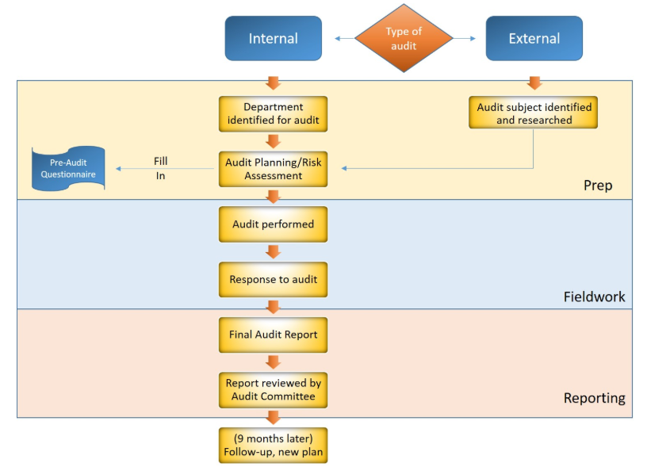
Source: Campbell and Riordan, 2019

8 Conclusion and Recommendations

As a conclusion, GAC is evaluated as positive signs of a financial health and profitable company as Maverick (2016) suggested it should be examined by measuring the four areas namely liquidity, solvency, profitability and operating efficiency. GAC has scored an above average mark on these areas.
However, GAC revenue growth has reached to a dreaded plateau and the net negative profit growth has been reported again in 2018 since 2011. The net profit is very important to the company because it can attract investors by showing the success of business and allow sufficient capital for operation.
Here are the recommendations for GAC:
- As proposed by China Government in 2018, the new energy vehicle mandate policy will be benefited the economic opportunity, energy security and clean air. The overall China sale of the energy vehicle market has been increasing dramatically from 50.7 in 2016, 77.7 in 2017 and 125.6 in 2018. Moreover, the projection of the sale market can be up to 2 million by 2020. (Busch, 2018; GAC presentation, 2019)

GAC should approve the new investment project of the Electric Vehicle Production Line in section 5 immediately in order to capture high quantity demand.

- Since GAC has a joint venture business with other oversee automobile company already, she should therefore propose them to continue investing on the available Electric Vehicle design or technologies in order to help speed up the product cycle from design to finish. Also, GAC should pay attention to the Production Capacity Utilization because GAC Mitsubishi, GAC FCA, Honda (China), GAC Hino and GAC BYD haven’t reached designed production capacity efficiency. It will eventually increase the cost of production and affect the labor management.

- With using the 3% of the total asset in section 6 – the financing and capital management project (Fund-raising ), we can use the raised capital and apply on further products / accessories / services like different types of wall charger system (Fast charging / regular charging), installation service by GAC technician and after-sale service support. With a well-trained our maintenance teams, we can provide professional service to our customers by offering a worry-free extended warranty services.

References
Altman, E. (1968) ‘Financial Ratios, Discriminant Analysis and the Prediction of Corporate Bankruptcy’, The Journal of Finance, 23(4), pp 589-609.

Barkenbud, J. (2019) ‘The electric vehicle revolution will come from China, not the US’, The Conversation.
Available at: http://theconversation.com/the-electric-vehicle-revolution-will-come-from-china-not-the-us-116102

Busch, C. (2018) ‘China's All In On Electric Vehicles, Here's How That Will Accelerate Sales In Other Nations’, Energy Innovation.
Available at: https://www.forbes.com/sites/energyinnovation/2018/05/30/chinas-all-in-on-electric-vehicles-heres-how-that-will-accelerate-sales-in-other-nations/#1fa81939e5c1

Campbell R. and Riordan R. (2019), ‘The Ultimate Survival Guide for Financial Audits’, Smartsheet.
Available at: https://www.smartsheet.com/financial-audit

China Association of Automobile Manufactures (2019) Sales ranking of the top ten manufacturers in 2018.
Available at: http://www.caam.org.cn/chn/4/cate_31/con_5221288.html

Geely automobile holdings limited (2017) Annual Report 2016.
Available at: http://geelyauto.com.hk/en/financial_statements.html
(Accessed: 28 July 2019)

Geely automobile holdings limited (2018) Annual Report 2017.
Available at: http://geelyauto.com.hk/en/financial_statements.html
(Accessed: 28 July 2019)

Geely automobile holdings limited (2019) Annual Report 2018.
Available at: http://geelyauto.com.hk/en/financial_statements.html
(Accessed: 28 July 2019)

Great wall motor company limited (2017) Annual Report 2016
Available at: http://www.gwm-global.com/investor-relations/report-by-year.html
(Accessed: 29 July 2019)

Great wall motor company limited (2018) Annual Report 2017
Available at: http://www.gwm-global.com/investor-relations/report-by-year.html
(Accessed: 29 July 2019)

Great wall motor company limited (2019) Annual Report 2018
Available at: http://www.gwm-global.com/investor-relations/report-by-year.html
(Accessed: 29 July 2019)

Guangzhou automobile group company limited (2019) homepage
Available at: http://www.gac-motor.com/
(Accessed: 29 July 2019)

Guangzhou automobile group company limited (2019) GAC Group 2018 Annual Results Presentation
Available at: https://www.gac.com.cn/data/cms/archive/201808(4)/17131/GAC%20Group%202018%20Annual%20Results%20Presentation.pdf
(Accessed: 27 July 2019).

Guangzhou automobile group company limited (2016) Annual Report 2015.
Available at: https://www.gac.com.cn/gw_en/tzzgx_en/index.shtml
(Accessed: 27 July 2019).

Guangzhou automobile group company limited (2017) Annual Report 2016.
Available at: https://www.gac.com.cn/gw_en/tzzgx_en/index.shtml
(Accessed: 27 July 2019).

Guangzhou automobile group company limited (2018) Annual Report 2017.
Available at: https://www.gac.com.cn/gw_en/tzzgx_en/index.shtml
(Accessed: 27 July 2019).

Guangzhou automobile group company limited (2019) Annual Report 2018.
Available at: https://www.gac.com.cn/gw_en/tzzgx_en/index.shtml
(Accessed: 27th July 2019)

Lee, A. (2018). ‘China’s electric car market is growing twice as fast as the US. Here’s why’, South China Morning Post.
Available at: https://www.scmp.com/business/companies/article/2143646/chinas-ev-market-growing-twice-fast-us-heres-why

Maverick, J ( 2016). ‘What Is the Best Measure of a Company's Financial Health?’, Investopedia.
Available at: https://www.investopedia.com/articles/investing/061916/what-best-measure-companys-financial-health.asp

Appendices A – The stock price at the last trading of the year of 2018,17 & 16

GAC Group
Date HK Closed Price (HKD)
2018/12/31 7.81
2017/12/29 13.23
2016/12/30 6.70
Source: https://www.hkex.com.hk/Market-Data/Securities-Prices/Equities/Equities-Quote?sym=2238&sc_lang=en

Date SH Closed Price (RMB)
2018/12/31 10.29
2017/12/29 17.61
2016/12/30 16.55
Source:https://finance.yahoo.com/quote/601238.SS/history?period1=1545321600&period2=1546185600&interval=1d&filter=history&frequency=1d

Geely
Date HK Closed Price (HKD)
2018/12/31 13.8
2017/12/29 27.1
2016/12/30 7.14
Source: https://www.hkex.com.hk/Market-Data/Securities-Prices/Equities/Equities-Quote?sym=175&sc_lang=en

Not listed on SH, China stock market

Great Wall
Date HK Closed Price (HKD)
2018/12/31 4.49
2017/12/29 8.95
2016/12/30 7.24
Source: https://www.hkex.com.hk/Market-Data/Securities-Prices/Equities/Equities-Quote?sym=2333&sc_lang=en

Date SH Closed Price (RMB)
2018/12/31 5.60
2017/12/29 11.49
2016/12/30 11.06

Source: https://finance.yahoo.com/quote/601633.SS/history?period1=1545321600&period2=1546185600&interval=1d&filter=history&frequency=1d

Appendices B – The exchange rate at the last trading of the year of 2018, 17 & 16
RMB/HKD exchange rate= 1.14 as last trading day on Dec 31, 2018
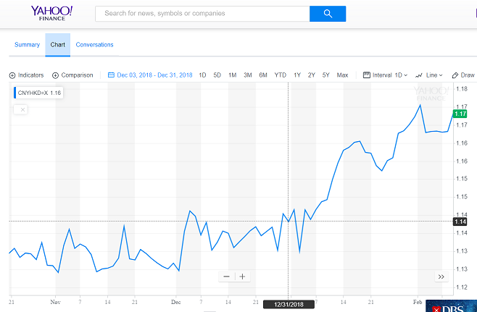
Source: https://finance.yahoo.com/quote/CNYHKD%3DX?p=CNYHKD%3DX

RMB/HKD exchange rate= 1.20 as on last trading day on Dec 29, 2017
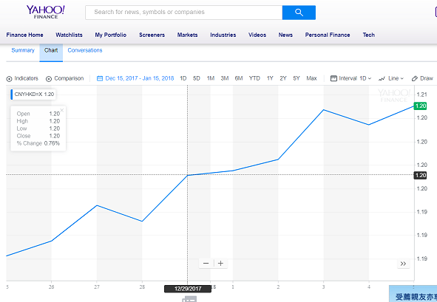
Source: https://finance.yahoo.com/quote/CNYHKD%3DX?p=CNYHKD%3DX
RMB/HKD exchange rate= 1.11 as on last trading day on Dec 29, 2016
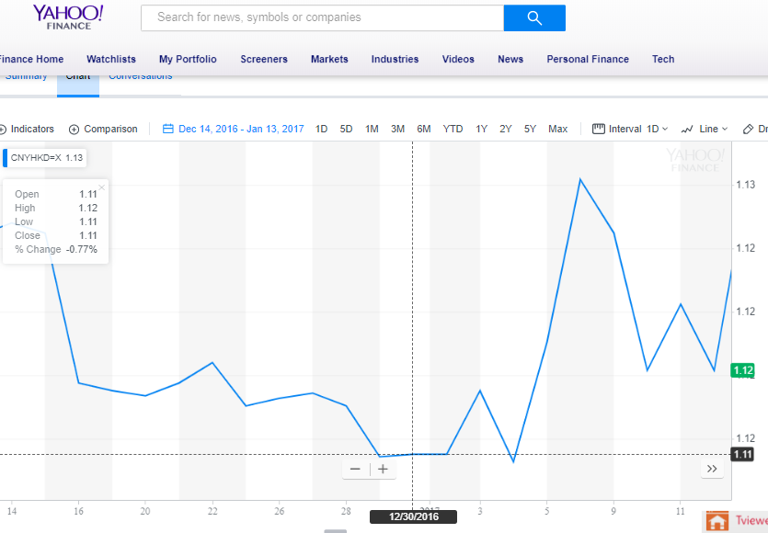
Source: https://finance.yahoo.com/quote/CNYHKD%3DX?p=CNYHKD%3DX

Appendices C – Bank Loan Rate
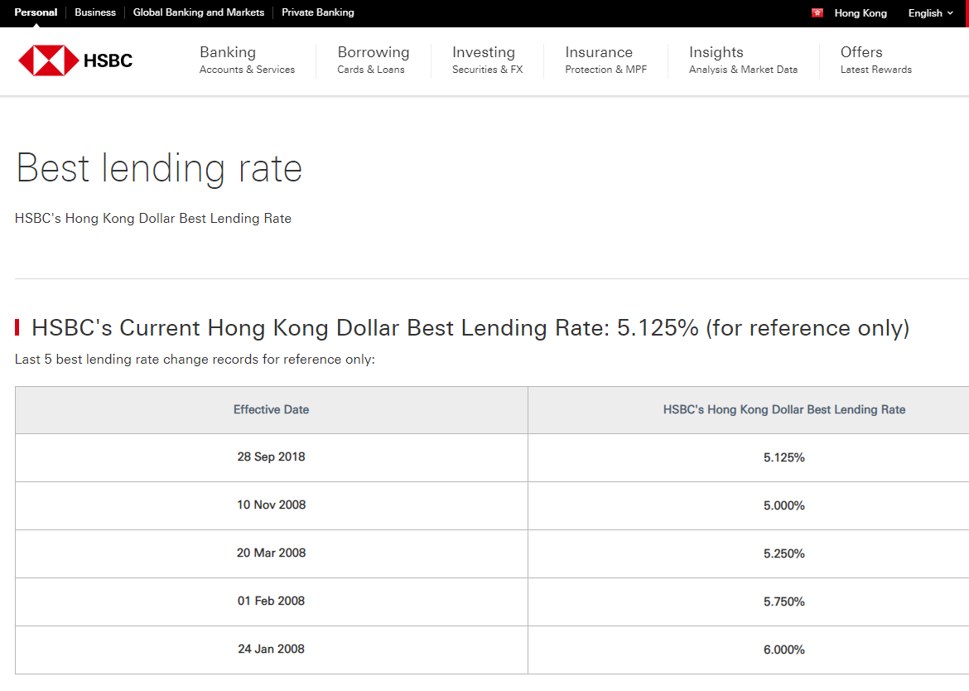

Appendices D – The closing price of August 9, 2019

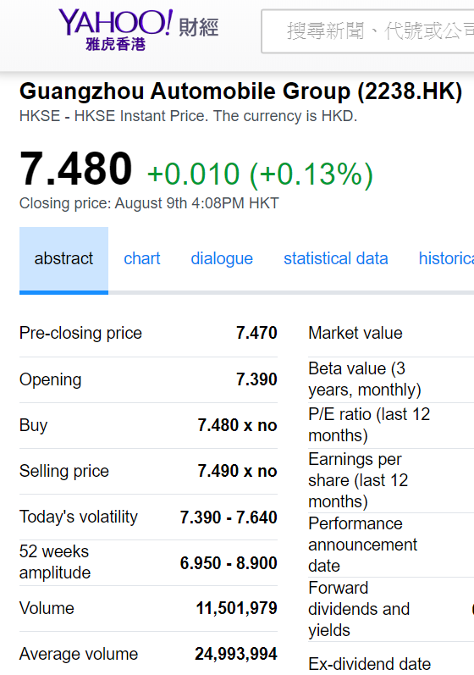

Student Self Evaluation Form
Student name: | Wong, Si Ming Kyle | Student number: | 1812211
Programme: | Marketing Management | Year of programme | 1.5 years
Assignment Title: | Financial Assessment Of Guangzhou Automobile Group Company Limited
This section repeats in brief the common assessment criteria detailed on previous pages. The extent to which these are demonstrated by you determines your mark. Using these criteria, tick the box that best indicates the level of achievement you feel you have achieved with regard to each of them.
Common Assessment Criteria Applied | Level of Achievement
Common Assessment Criteria Applied | REFER |  |  | PASS |  | DISTINCTION
 | FAIL | FAIL | MARGINAL FAIL | SATISFACTORY | GOOD to VERY GOOD | EXCELLENT | EXCEPTIONAL
1. Engagement with literature | 0-29% | 30-39% | 40-49% | 50-59% | 60-69% | 70-84% | 85-100%
1. Engagement with literature |  |  |  |  |  |  | √
2. Knowledge and Understanding | 0-29% | 30-39% | 40-49% | 50-59% | 60-69% | 70-84% | 85-100%
2. Knowledge and Understanding |  |  |  |  |  | √
3. Cognitive and intellectual skills | 0-29% | 30-39% | 40-49% | 50-59% | 60-69% | 70-84% | 85-100%
3. Cognitive and intellectual skills |  |  |  |  | √
4. Practical Skills | 0-29% | 30-39% | 40-49% | 50-59% | 60-69% | 70-84% | 85-100%
4. Practical Skills |  |  |  |  |  | √
5. Transferable Skills for Life and Professional Practice | 0-29% | 30-39% | 40-49% | 50-59% | 60-69% | 70-84% | 85-100%
5. Transferable Skills for Life and Professional Practice |  |  |  |  |  | √

PLEASE COMMENT ON AREAS IN WHICH YOU FEEL THAT YOU HAVE PERFORMED WELL |  | PLEASE COMMENT ON AREAS you feel that you need TO DEVELOP
Attended all the classes and be able to apply the Marketing Management skill at assignment |  | Still have a room to enhance my knowledge of market research, report preparation and time management.
Student’s Name | WONG, Si Ming Kyle |  | Date | Aug 10, 2019
Student’s Signature | Kyle Wong

