From the Couch to 5k: Can an App Really Improve Public Health
Population Health and Digital Health Promotion FitLife: A Smart Digital Health Promotion App to Combat Obesity
Module Code: LCHS7009
Module: Population Health and Digital Health Promotion
Assignment Title: Blogs
Lecturer’s Name: Dr Ping Wu
Student Name: Hetvibahen Chauhan
Student Id: 2522438

🏃 From the Couch to 5K: Can an App Really Improve Public Health?

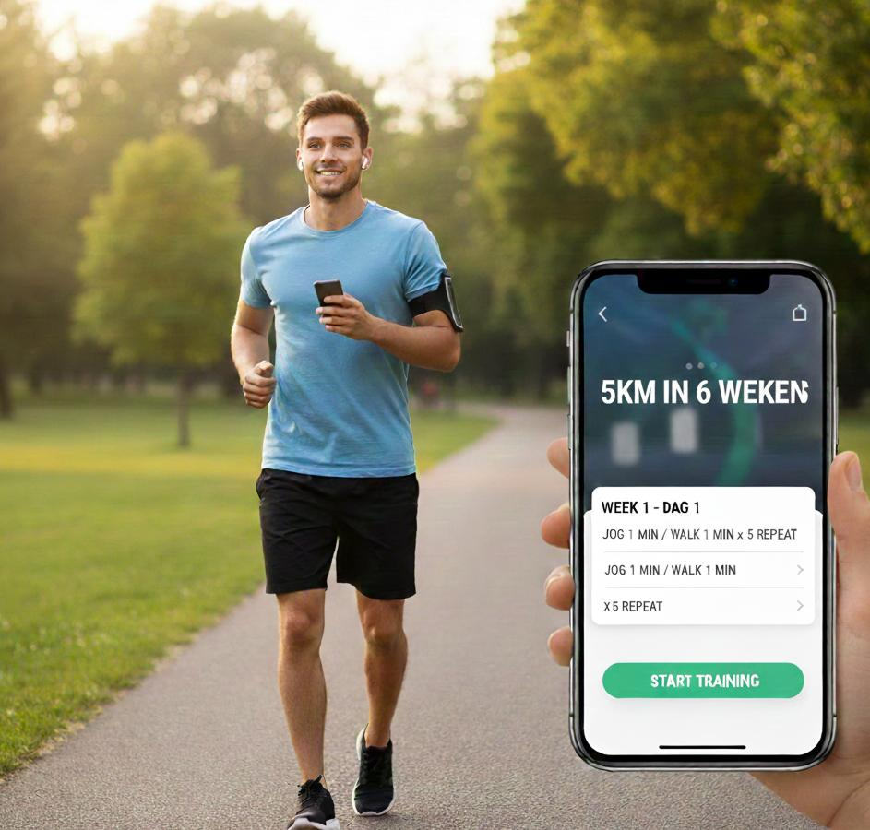

A beginner runner using the NHS Couch to 5K app during an outdoor run. The app supports users through a structured nine-week programme with audio coaching, progress tracking, and motivational guidance, helping inactive adults gradually become more physically active (NHS, 2024).

Why Physical Inactivity Matters
Physical inactivity is a major public health concern because it increases the risk of cardiovascular disease, type 2 diabetes, obesity, certain cancers, and poor mental health. The World Health Organization (WHO, 2024) estimates that 1.8 billion adults worldwide do not achieve the recommended levels of physical activity. In England, around one in four adults are physically inactive, placing a significant burden on the NHS and reducing quality of life (NHS England, 2023). Promoting regular physical activity is therefore essential for preventing chronic diseases and improving population health.

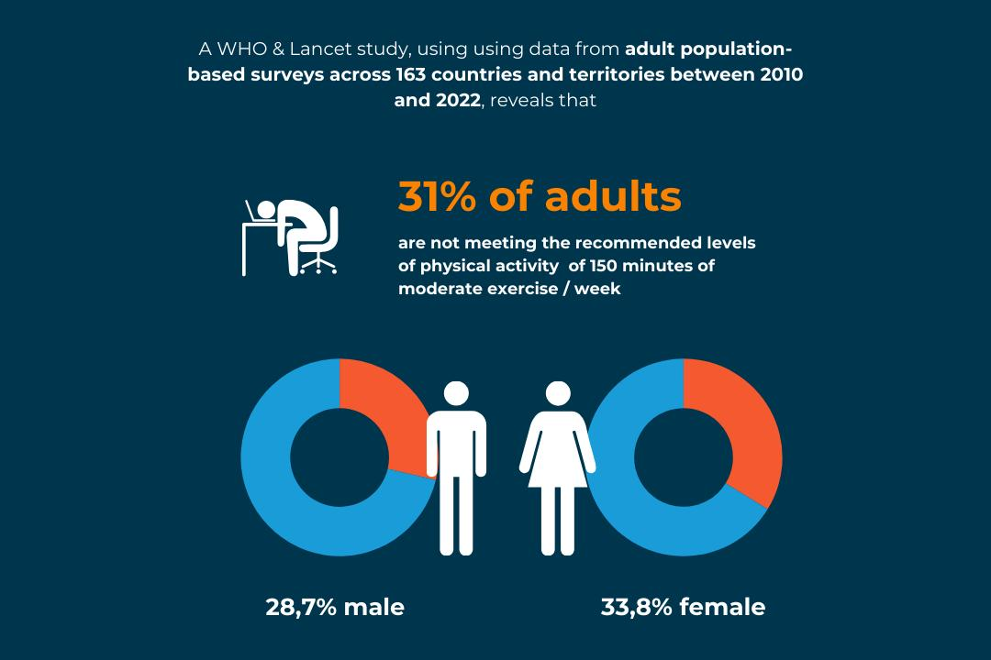
Physical inactivity is a major public health issue associated with an increased risk of cardiovascular disease, type 2 diabetes, obesity, some cancers, and poor mental health (WHO, 2024).

📱 How Does the NHS Couch to 5K App Promote Health?
The NHS Couch to 5K app is a free digital health promotion intervention designed to help beginners start running safely over 9 weeks.
✨ Key Features
- 🎧 Audio coaching
- 🎯 Personal goal setting
- 📈 Progress tracking
- 🔔 Motivation reminders
- 🏅 Achievement badges
These behaviour change techniques encourage users to become more active and develop long-term healthy habits (NHS, 2024).
🔄 How It Works

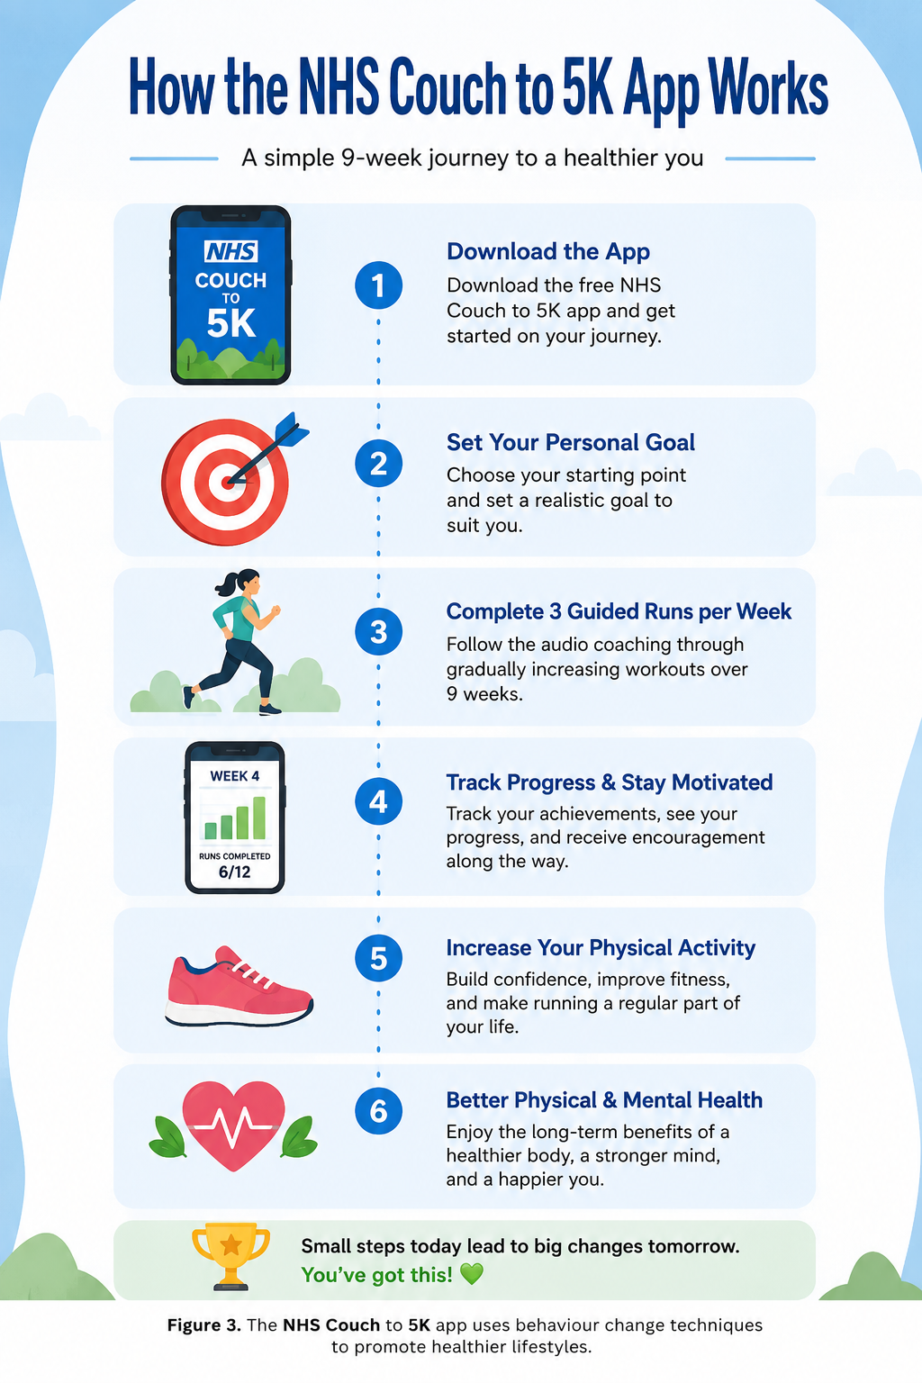
The NHS Couch to 5K app uses behaviour change techniques—including goal setting, guided coaching, self-monitoring, and motivational feedback—to help users increase physical activity and improve their physical and mental health (NHS, 2024).

⚖️ Benefits vs Challenges of the NHS Couch to 5K App
There are certain strengths of the NHS Couch to 5K app when it is used as an intervention tool in digital health. Firstly, the application is completely free and can be downloaded from anywhere. Secondly, the application is based on evidence-based behavioral change strategies such as goal setting, audio-based guidance, and tracking one’s progress towards improving one’s physical activity. This will motivate the user and improve his/her physical as well as psychological well-being. On the other hand, there are certain weaknesses of using this app that may develop due to its usage. First of all, its success depends on the motivation of users throughout nine weeks. Secondly, users need to have a smartphone with internet access to download the app.

References
- Direito, A., Carraça, E., Rawstorn, J., Whittaker, R., & Maddison, R. (2017). mHealth technologies to influence physical activity and sedentary behaviours: A systematic review and meta-analysis. British Journal of Sports Medicine, 51(16), 1206–1212. https://doi.org/10.1136/bjsports-2016-096907
- National Institute for Health and Care Excellence. (2022). Behaviour change: Digital and mobile health interventions.
- NHS. (2024). Couch to 5K. https://www.nhs.uk/live-well/exercise/get-running-with-couch-to-5k/
- NHS England. (2023). Physical activity.
- World Health Organization. (2024). Physical activity. https://www.who.int/news-room/fact-sheets/detail/physical-activity
- Bravata, D.M., Smith-Spangler, C., Sundaram, V., Gienger, A.L., Lin, N., Lewis, R., Stave, C.D., Olkin, I. and Sirard, J.R. (2007) 'Using pedometers to increase physical activity and improve health: A systematic review', JAMA, 298(19), pp. 2296–2304.
- Fanning, J., Mullen, S.P. and McAuley, E. (2012) 'Increasing physical activity with mobile devices: A meta-analysis', Journal of Medical Internet Research, 14(6), e161.
- Michie, S., van Stralen, M.M. and West, R. (2011) 'The behaviour change wheel: A new method for characterising and designing behaviour change interventions', Implementation Science, 6(42).
- National Institute for Health and Care Excellence (NICE) (2022) Behaviour change: Digital and mobile health interventions. London: NICE.
- National Institute for Health and Care Excellence (NICE) (2014) Behaviour change: Individual approaches (PH49). London: NICE.
- NHS (2024) Couch to 5K. Available at: https://www.nhs.uk/live-well/exercise/get-running-with-couch-to-5k/ (Accessed: 28 July 2026).
- NHS England (2023) Physical activity. Available at: https://www.england.nhs.uk (Accessed: 28 July 2026).
- Office for Health Improvement and Disparities (2023) Physical activity profile for England. London: OHID.
- Public Health England (2019) Everybody Active, Every Day. London: PHE.
- Public Health England (2021) Health matters: Physical activity. London: PHE.
- Sport England (2023) Active Lives Adult Survey. Available at: https://www.sportengland.org (Accessed: 28 July 2026).
- World Health Organization (2020) WHO guidelines on physical activity and sedentary behaviour. Geneva: WHO.
- World Health Organization (2024) Physical activity. Available at: https://www.who.int/news-room/fact-sheets/detail/physical-activity (Accessed: 28 July 2026).
- World Health Organization (2021) Global action plan on physical activity 2018–2030. Geneva: WHO.
- Biddle, S.J.H., García Bengoechea, E. and Wiesner, G. (2017) Sedentary behaviour and health. London: Routledge.
- Ekelund, U., Tarp, J., Steene-Johannessen, J., et al. (2019) 'Dose-response associations between accelerometry measured physical activity and sedentary time and all-cause mortality', BMJ, 366, l4570.
- Guthold, R., Stevens, G.A., Riley, L.M. and Bull, F.C. (2018) 'Worldwide trends in insufficient physical activity', The Lancet Global Health, 6(10), pp. e1077–e1086.
- Hallal, P.C., Andersen, L.B., Bull, F.C., Guthold, R., Haskell, W. and Ekelund, U. (2012) 'Global physical activity levels: Surveillance progress and prospects', The Lancet, 380(9838), pp. 247–257.
- Kahn, E.B., Ramsey, L.T., Brownson, R.C., et al. (2002) 'The effectiveness of interventions to increase physical activity', American Journal of Preventive Medicine, 22(4S), pp. 73–107.

Population Health and Digital Health Promotion FitLife : A Smart Digital Health Promotion App to Combat Obesity

🌍 Obesity: A Growing Public Health Challenge

Obesity has become one of the major health problems across the globe. This condition raises the chances of suffering from chronic illnesses like type 2 diabetes, heart diseases, hypertension, and even cancers. The WHO (2024) states that there are more than a billion individuals who suffer from obesity in the world. The causes of obesity are poor diet, lack of exercise, and sedentary behaviour.
This health problem has created a lot of pressure on health care systems and decreases the quality of life for those affected by it. Hence, digital health interventions are required in order to promote healthy behaviour.

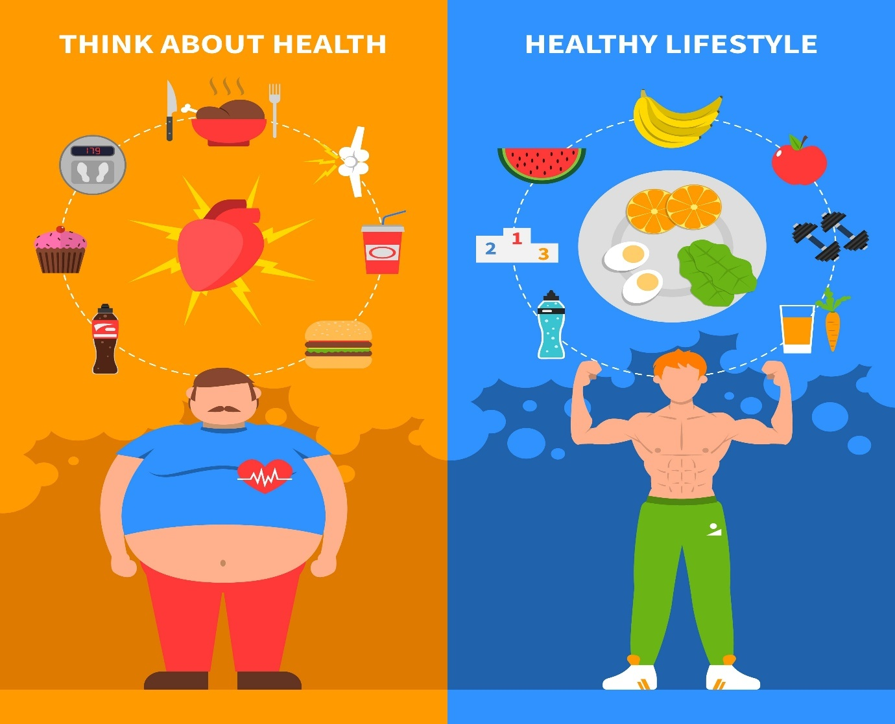
Global obesity is increasing rapidly across all age groups, making it one of the leading public health concerns worldwide. (World Health Organization [WHO], 2024)

📱 My Designed Digital Technology: FitLife+

FitLife+ is a digital health promotion mobile application designed to help adults reduce obesity through personalized lifestyle coaching.
The application includes:
- 🥗 AI-generated healthy meal plans
- 🚶 Daily step counter and activity tracker
- 💧 Water intake reminders
- 📊 BMI and weight progress dashboard
- 🎯 Weekly health challenges
- 👩‍⚕️ Online consultation with dietitians
- 🏆 Reward badges for achieving health goals
The app connects with smartwatches and fitness trackers to monitor users' physical activity in real time.

📈 How FitLife+ Promotes Health

FitLife+ encourages users to adopt healthier behaviours through personalized feedback, reminders, educational content, and goal setting. The app uses behavioural change techniques such as self-monitoring, motivation, and positive reinforcement to improve long-term lifestyle habits.

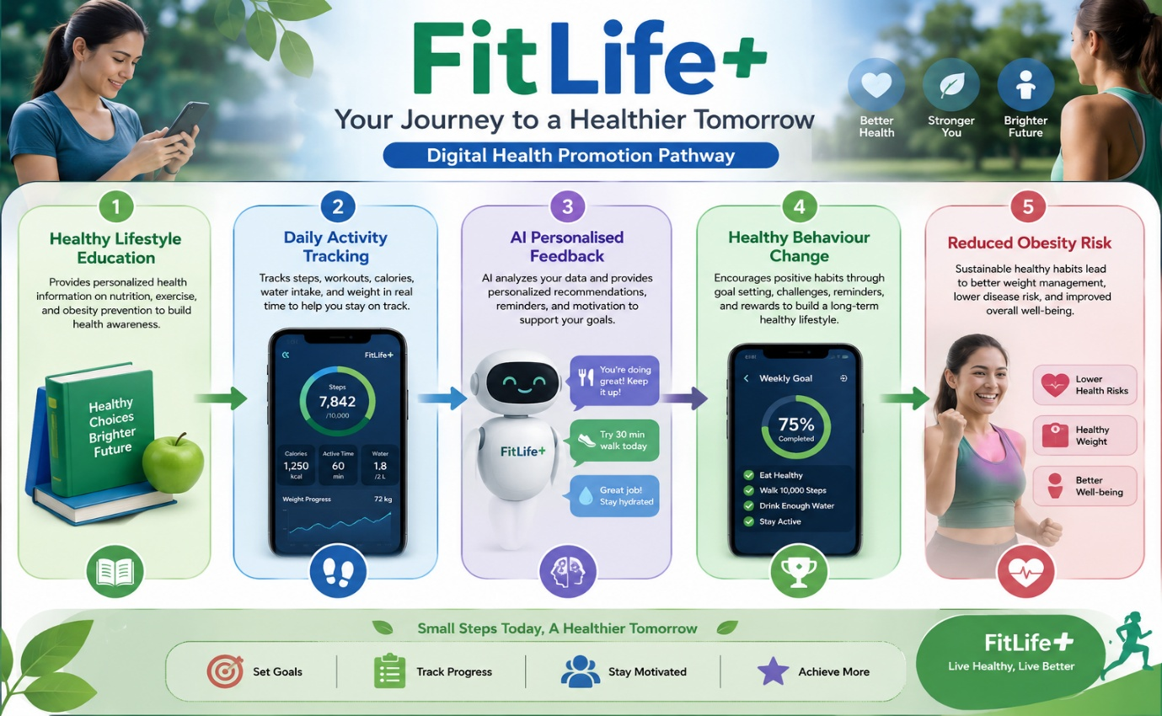

✅ Impact of FitLife+

Advantages
FitLife+ has several benefits:
- Promotes healthy eating and physical activity.
- Provides 24-hour access to health advice.
- Supports self-monitoring and behaviour change.
- Reduces healthcare costs through disease prevention.
- Can reach large populations regardless of location.
Research suggests that mobile health (mHealth) interventions can significantly improve weight management and physical activity levels (WHO, 2021).
Limitations
Despite its advantages, FitLife+ also has limitations:
- Some users may stop using the app after losing motivation.
- Older adults may have limited digital literacy.
- Personal health information may be vulnerable to cybersecurity threats.
- AI recommendations cannot replace professional medical advice.

References
- Auerbach, R. P., et al. (2018). WHO World Mental Health Surveys International College Student Project: Prevalence and distribution of mental disorders. Journal of Abnormal Psychology, 127(7), 623–638. https://doi.org/10.1037/abn0000362
- Lupton, D. (2018). Digital health: Critical and cross-disciplinary perspectives. Routledge.
- World Health Organization. (2021). Global strategy on digital health 2020–2025. https://www.who.int/publications/i/item/9789240020924
- World Health Organization. (2022). Mental disorders. https://www.who.int/news-room/fact-sheets/detail/mental-disorders
- World Health Organization (WHO), 2024. Obesity and overweight. Geneva: World Health Organization. Available at: https://www.who.int/news-room/fact-sheets/detail/obesity-and-overweight (Accessed: 27 July 2026).
- Ainsworth, B.E., Haskell, W.L., Herrmann, S.D., Meckes, N., Bassett, D.R., Tudor-Locke, C., Greer, J.L., Vezina, J., Whitt-Glover, M.C. and Leon, A.S., 2011. 2011 Compendium of Physical Activities. Medicine & Science in Sports & Exercise, 43(8), pp.1575–1581.
- Bandura, A., 1986. Social foundations of thought and action: A social cognitive theory. Englewood Cliffs: Prentice Hall.
- Bandura, A., 2004. Health promotion by social cognitive means. Health Education & Behavior, 31(2), pp.143–164.
- Free, C., Phillips, G., Watson, L., Galli, L., Felix, L., Edwards, P., Patel, V. and Haines, A., 2013. The effectiveness of mobile-health technologies to improve health care service delivery processes: A systematic review. PLoS Medicine, 10(1), e1001363.
- Krebs, P. and Duncan, D.T., 2015. Health app use among US mobile phone owners. JMIR mHealth and uHealth, 3(4), e101.
- Michie, S., van Stralen, M.M. and West, R., 2011. The behaviour change wheel: A new method for characterising and designing behaviour change interventions. Implementation Science, 6, p.42.
- Michie, S., Atkins, L. and West, R., 2014. The behaviour change wheel: A guide to designing interventions. London: Silverback Publishing.
- National Institute for Health and Care Excellence (NICE), 2022. Obesity: Identification, assessment and management (CG189). London: NICE.
- NHS England, 2023. Digital health and care. Available at: https://www.england.nhs.uk (Accessed: 28 July 2026).
- NHS, 2024. Obesity. Available at: https://www.nhs.uk/conditions/obesity/ (Accessed: 28 July 2026).
- O'Connor, S., Hanlon, P., O'Donnell, C.A., Garcia, S., Glanville, J. and Mair, F.S., 2016. Understanding factors affecting patient and public engagement with digital health interventions. BMC Health Services Research, 16, p.120.
- Public Health England, 2020. Health matters: Obesity and the food environment. London: PHE.
- Powell-Wiley, T.M., et al., 2021. Obesity and cardiovascular disease. Circulation Research, 128(11), pp.1612–1637.
- Rubin, R., 2022. Obesity prevention and digital technology. JAMA, 327(13), pp.1201–1203.
- Sallis, J.F., Owen, N. and Fisher, E.B., 2015. Ecological models of health behaviour. In: K. Glanz, B.K. Rimer and K. Viswanath, eds. Health behavior: Theory, research, and practice. 5th ed. San Francisco: Jossey-Bass.

