The article under critical review is titled, Conceptualising the role of adults within youth-adult partnerships: An example from practice was Received 29 March 2017; Received in revised form 24 July 2017; Accepted 25 July 2017
Available online 27 July 2017 at Corresponding author at: School of Social Work, University of Michigan, Ann Arbor, MI 48109, United States.

In this critical review Journal Article, the author will critically review the strengths, weaknesses, methodology and methods used in the above article. The exercise of critically reviewing the article will conclude by looking at the Ethics of the study and the importance of further research.

The authors of this piece of work sought to make a contribution and to add their voice to a growing scholarship interest which has been on the move for the last ten years on the subject of youth participation in civic engagement and community change. The article celebrated the efforts of other scholarship, notwithstanding it pointed out the need for more careful thought on some practicalities necessary to make the subject matter a reality when it stated, “However, to date the bulk of these scholarships has focused its attention on the specific activities of the work, the impact on the youth, or on conceptually understanding youth participation as a form of practice. As the field develops, it will be essential to turn attention to the process of youth participation, moving beyond “what it is” to what is needed to support, sustain, and facilitate these efforts” (Richards-Schustera & Timmermans, 2017).

The article also sought to move from the “what” to do, to the “how” to do it, (Richards-Schustera & Timmermans, 2017). The article continued to assert that even when a “how” had been settled on which in this case there was a “how”, it is about the concept of the role adult allies can play in the developing of youth participation efforts. The paper points out that even at that, there is still a deficiency in achieving the goal. The reason was attributed to the fact that the bulk of attention for a great outcome is mostly focused on what is not the core to developing the skills and quality of adult as allies, (Richards-Schustera & Timmermans, 2017).

The paper claims its aim is to fill this need deemed to be a deficiency in most literature by contributing to knowledge by examining the roles of adults, through the lens of the adults, within one example of a youth-adult partnership, (Richards-Schustera & Timmermans, 2017).

The contribution to knowledge as sated above was rooted in the author’s own experience as adult allies working with a team of young people in a multi-year youth participatory assessment project, (Richards-Schustera & Timmermans, 2017). Furthermore, their goal is to draw on their own reflections and a summary of their skills and lessons learned to add nuance and context to the youth-adult partnership literature. By providing examples, vignettes, and summaries of skills and practices from their own case study, they hope to help further conceptualise the roles of adults and add to understanding the complex interactions between youth and adults that emerge within youth participation efforts. They close their contribution by offering a practical framework for conceptualising the roles of adults for consideration based on their own perspectives and experience.

The Metropolitan Youth Policy Fellows case study: background and context

The work of the Metropolitan Youth Policy Fellows was a part of a large social justice initiative in a major metropolitan region. The region was said to be undergoing significant shifts and there was interest in engaging the voice of young people around important issues in the region,(Richards-Schustera & Timmermans, 2017).

The idea to recruit a group of youth based on their previous participation in an allied program was brilliant and should be considered as a strength in terms of considering the method of approaching the project.

A further strength to be noted is the fact Metropolitan Youth Policy Fellows (MYPF) team consisted of diverse individuals with representation across various social identities and crossing the boundaries between city and suburb, which leaves room for issues to be weighed from different perspectives. Sometimes our own perspectives, can blind us to the point we start to think the world is only what we see it to be as individuals. The opportunity to be in the same room with some body from another context can help us see things from a different viewpoint. As nicely illustrated by this example from the article; in a discussion it became very clear that youth coming from the suburbs and youth coming from the city had differing perspectives about what things contribute to safety. Young people from the city talked about how safety, for them, meant having street lights. The young people from the suburbs felt that street lights were of little importance. The youth from the city explained that they did not have street lights and they felt that this contributed to a lack of safety for them. These two youth groups made a significant impact on each other and contributed to shaping each other’s thinking by allowing each to see their respective worlds.

Furthermore, the inclusion of youth from Europe, African, Middle Eastern, participating in the project, was a strong message sent across on the subject of inclusion which clearly supported their theme of social justice. Without going unmentioned it is one of the five pillars of youth work in wales as well, (Youth Work in Wales, 2018).
(Richards-Schustera & Timmermans, 2017).

Launching a survey with the intension to hear from young people throughout the region in question on what issues they saw in their communities and their ideas for solutions bears the marking of qualitative research methods. Qualitative research methods is a good choice of method to use with young people. Youth work relies on the relationship between the young person, the face to face approach, to accomplish its purpose among young people. With this type of research method the researcher is closely involved, the researcher gains an insider's view of the field. This allows the researcher to find issues that are often missed, (Richards-Schustera & Timmermans, 2017). Also since the paper is aimed at improving youth-adult partnerships and collaborations, what kind of relationship can possible be forged without being closely involved?

Unlike the quantitative method of research, which do not take place in natural settings. In addition, the quantitative methods do not allow participants to explain their choices or the meaning that the questions may have for those participants, McLeod, S. A. (2019, July 30).
this would have not been a good method to use among young people. Young people are said to be experts of their own life (Richards-Schustera & Timmermans, 2017) and they like to weigh in on everything that concerns them.

To answer the question if the authors accomplished their goal which was to make a contribution and to add their voice to a growing scholarship on the subject of youth-adult partnerships and the role of adults within youth efforts. We will take a look at some of the results, considering, their argument has always been the inability of other scholarship in unpacking the specifics of the roles of adults, the skills needed.

The answer will be yes as the authors have succeeded to combine their learning added to the other literatures out there gleaning from the experience of other scholarships. They have been able to capitalise in what is not out there in other scholarships by offering us their suggestion as seen in figure 1 and table 1.

Figure 1 highlights the rules as it has been discussed in detail in the paper of what they deem as a requirement for a working model of an adult’s role in youth-adult partnership. While table 1 clearly stipulates the rules and skills of adults in a youth-adult partnership.

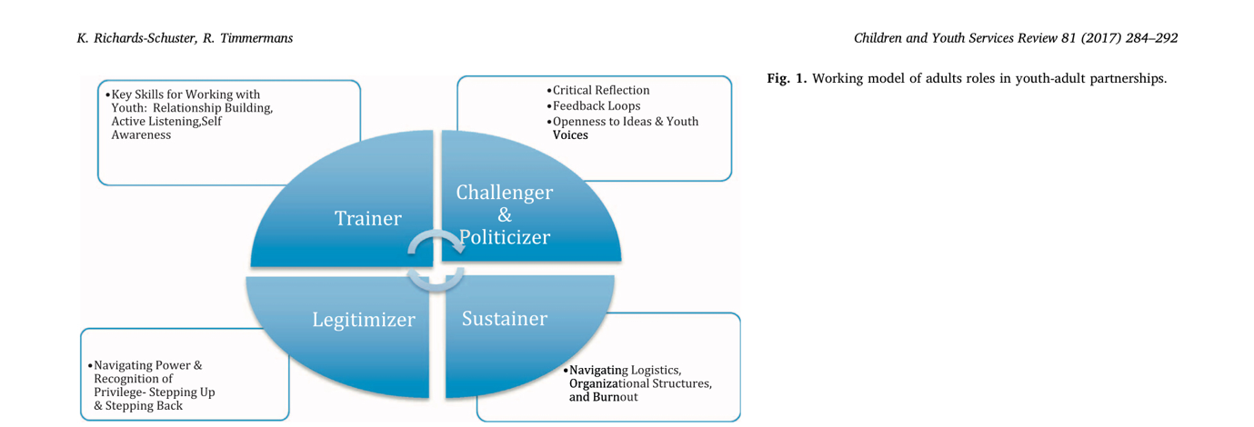

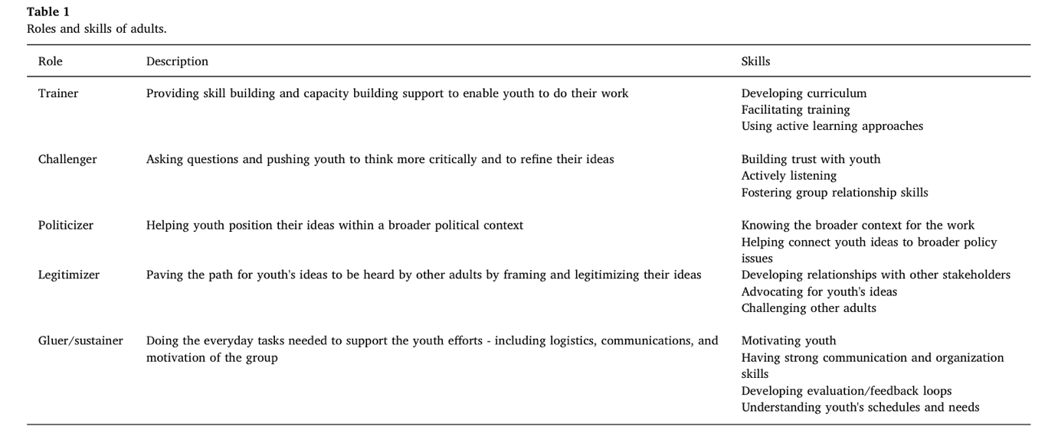

In figure 1 the adult roles in a youth-adult partnership are:
- Trainer, which entails key skills for working with youth, relationship building, active listening and self-awareness
- Challenger and Politicizer, which entails critical reflection, feedback loops, openness to ideas and youth voices.
- Legitimiser, which entails navigating power and recognition of privilege-stepping up and stepping back.
- Sustainer, which entails navigating logistics, organisational structures and burn out

The above are the working models in youth-adult partnership. For example the trainer sits in a room with a group of young people who are having a discussion amongst themselves and has the skill not to always interfere with the conversation, but at the same time has the ability to moderate the conversation in such a way that all sides are heard and every opinion is considered valuable.

The author of this critical review journal article intended to critically review the strengths, weaknesses, methodology and methods used in the article. The author also intended to look into the ethics of the study and the importance of further research.

So far, this critical review has highlighted some strengths of the paper. In terms of weaknesses, in the author’s opinion is that their research is based on subjectivity and it is a proposal which has not yet been tested.

Since the research went on for 4 years and the paper stated that some of the adult leaders left the project so their positions were filled by other adults; that is a weakness because the new adults leaders would have needed a period of adaptation to be able to get along with the young people and gain their trust. This is because it can take youths a while to trust and adult and to build relationships with an adult.

In conclusion, just like the authors said, they believe that this work will push the door open for new emphasis within social work and allied fields in our context; youth work in Wales. There is still a great amount of research that needs to be done to be able to embellish the concept they intend to put out there with more precise and adaptable principles and regulations which can better inform the practice of a youth worker.

Bibliography
Richards-Schustera, K., & Timmermans, R. (2017) 'Conceptualizing the role of adults within youth-adult partnerships: An example from practice'. Children and Youth Services Review N/A, 285-291.

Youth Work in Wales, YW (2018) Youth Work In Wales: Principles and Purposes . Wales: Youth Work in Wales Group.

McLeod, S. A. (2019, July 30). Qualitative vs. quantitative research. Simply Psychology. https://www.simplypsychology.org/qualitative-quantitative.html

