University of Wales Trinity Saint David

School of Engineering



Application of CAE Processes
Charlie Jones
2103718
BEng Motorsport Engineering
ACHA6011
Structural & Fluid Analysis
14th /21st December 2025
Word Count: 2963

AI Acknowledgement (Grammarly only)
I acknowledge the use of Grammarly (https://www.grammarly.com/) to proofread my own writing for grammar, spelling, syntax, and readability, including minor rephrasing suggestions to improve clarity while retaining my intended technical meaning. I used the prompt(s):
- "Please check the following text for readability, grammar and syntax."
- "Please identify and correct grammatical errors and improve sentence clarity without changing the technical meaning."

Abstract
This report applies a fully linked ANSYS Workbench CAE workflow to a piston–conrod assembly to demonstrate kinematics-derived loading, thermo-mechanical structural assessment, evidence-led optimisation, and a critical appraisal of model credibility. Operating loads were generated using an ANSYS Rigid Dynamics study under a prescribed crankshaft rotational velocity of 4000 rpm, with the peak joint reaction (2379.4 N) selected as the representative worst-case load case for subsequent static structural assessment. Thermal effects were incorporated via a steady-state convection-zoned thermal model mapped into Static Structural, with temperature-dependent material properties defined for a 6061-T6 aluminium piston.
Verification and validation were conducted before optimisation to bound numerical uncertainty. An analytical bimetallic-strip benchmark produced a 1.03% deformation error (7.049 mm analytical versus 7.1214 mm ANSYS), a mesh-independence study demonstrated negligible displacement variation across 1.00–0.25 mm element sizes, and a boundary-condition sensitivity study showed a 0.63% change in cantilever free-end deformation between two credible fixed-support definitions. The baseline piston exhibited a localised groove-root hotspot, with hotspot-region von Mises stress statistics of P95 = 1352.2 MPa and P99 = 1681.3 MPa. Fillet-driven optimisation reduced hotspot P95 to 927.5 MPa (Iteration 2B). At the same time, a subsequent skirt material reduction yielded the selected final design (Iteration 3), which retained a substantial hotspot improvement (P95 = 946.7 MPa, 29.99% reduction versus Baseline) while additionally reducing mass by 1.29% (to 252.47 g), representing the best balanced outcome against the combined structural and lightweighting objectives. The study concludes that CAE is most defensible for trend-based iteration and comparative decision-making, while absolute hotspot maxima remain sensitive to modelling idealisations, including constraints, discretisation, and load-path representation.

Contents
AI Acknowledgement (Grammarly only) 2
Abstract 2
Introduction 1
1.1 Background 1
1.2 Aim 1
1.3 Objectives 1
1.4 Report structure 2
2. Literature review and CAE context 2
2.1 CAE as an engineering design method 2
2.2 Known limitations relevant to the present studies 2
2.3 Design optimisation in CAE 3
3. Assembly and Simulation Methodology 3
3.1 Assembly description and modelling scope 3
3.2 Materials and Thermal Modelling 4
3.3 Joints, Constraints and Boundary-Condition Strategy 5
3.4 Kinematic Simulation and Load Transfer into the Structural Study 5
3.5 Meshing Strategy, Solver Settings, and Outputs Monitored 6
4. Verification and Validation 7
4.1 Analytical vs ANSYS validation case (Bimetallic Strip) 7
4.2 Mesh-independence study 9
4.3 Boundary-condition influence study (Cantilever) 10
5. Design iteration and Optimisation results 12
5.1 Baseline results for the selected component 12
5.2 Iteration plan and design targets 12
5.3 Iteration results and decision logic 12
5.4 Final design comparison and optimisation outcome 15
6. Critical discussion of CAE tools and limitations 16
6.1 Credibility of outputs and uncertainty 16
6.2 Sensitivity to modelling assumptions 16
6.3 Implications for engineering decision-making 17
7. Conclusions and recommendations 17
7.1 Conclusions 17
7.2 Recommendations 18
References 18
Appendix 20
Appendix A 20
Appendix B 21
21
Appendix C 21

Introduction

Background
Computer-Aided Engineering (CAE) is a standard enabling technology in modern mechanical design, supporting virtual testing, rapid iteration, and reduced reliance on physical prototypes. In industrial practice, its value lies in evaluating trends and comparing design alternatives under representative loading conditions rather than reporting single "true" values in isolation (Rifai et al., 1999) However, predictions remain conditional on modelling idealisations, including geometric simplification, discretisation error, contact representation, boundary-condition realism, and material-data fidelity; therefore, limitations must be evaluated before results justify engineering decisions.

This report applies an ANSYS Workbench workflow to a piston assembly case study, where kinematics-derived loads are transferred to a static structural assessment of a selected component. Thermo-mechanical effects are included because elevated temperature modifies stiffness and strength, introduces thermal strain, and affects durability-relevant response, consistent with powertrain practice where temperature-dependent properties and thermo-mechanical fatigue can be design-limiting (Luo et al., 2020). Verification and validation are treated as prerequisites, so optimisation is informed by evidence and bounded uncertainty.

Aim
To apply ANSYS-based CAE to a piston assembly to generate kinematics-derived loading, perform structural and thermo-mechanical assessment, implement evidence-led optimisation for structural performance and mass, and critically evaluate CAE capability and limitations for engineering decision-making.

Objectives
- Create a realistic assembly of at least five components suitable for simulation.
- Perform kinematic analysis in ANSYS to obtain representative operating loads.
- Conduct a static structural assessment of one selected component with justified boundary conditions, contacts, and material properties, including thermal effects and property degradation.
- Complete validation testing through analytical comparison, mesh independence, and boundary-condition influence studies.
- Use simulation evidence to drive iterative improvement while critically discussing uncertainty, assumptions, and CAE limitations.

Report structure
Section 2 reviews CAE limitations and thermo-mechanical durability. Section 3 defines the ANSYS methodology, including assembly definition, materials, contacts, meshing, and kinematics-to-structure load transfer. Section 4 presents evidence of verification and validation. Section 5 reports Baseline and optimised designs. Section 6 critiques CAE capability and limitations. Section 7 concludes against the aim and objectives.

2. Literature review and CAE context

2.1 CAE as an engineering design method
Computer-Aided Engineering (CAE) reduces reliance on physical prototyping by predicting structural, thermal, and dynamic response early in the design cycle, enabling faster iteration and evidence-led decisions. In automotive applications, Multiphysics simulation is often required because components experience coupled loading, including inertial excitation, constraint-driven load paths, and thermal gradients that alter stiffness and stress distributions (Thesing and Bishop, 2016).

Consequently, workflows commonly couple kinematic load generation with finite element analysis (FEA) and extend into durability assessment and optimisation to meet performance, mass, and packaging constraints.

However, credible CAE depends less on solver capability than on whether the numerical model is adequate for the engineering question. Verification and validation (V&V) distinguish validation, which assesses model representativeness, from verification, which assesses computational correctness(Wu, 2006). Without V&V, visually plausible results can remain unconverged or dominated by idealisations, driving optimisation by numerical artefact rather than physics.

2.2 Known limitations relevant to the present studies
A primary limitation is discretisation error. FEA replaces a continuum with a finite mesh and interpolated fields; results remain approximate and can be locally mesh-sensitive even when global trends appear stable (Wu, 2006). Practical meshes can distort peaks in regions of high curvature and steep gradients, motivating mesh-independence studies.

A second limitation is boundary-condition idealisation. Real load paths are rarely "perfectly fixed" or "perfectly free, and modest constraint changes can alter stiffness, reactions, and the resulting stress and deformation fields. Boundary conditions should be treated as modelling assumptions with uncertainty (Thesing and Bishop, 2016).

A third limitation is contact modelling and hotspot interpretation, where contact nonlinearity introduces steep gradients and acute sensitivity to formulation and discretisation (Lostado et al., 2016).

A fourth limitation is thermo-mechanical coupling. Elevated temperature modifies stiffness, strength, and fatigue resistance, and temperature–constraint interactions can drive mechanisms not captured by isothermal results; thermal boundary conditions and material data quality remain as influential as structural loads (Luo et al., 2020).

2.3 Design optimisation in CAE
Design optimisation within CAE should be treated as an iterative learning process rather than a purely numerical search for reduced peak stress. The assignment guidance emphasises using the case study to generate datasets that expose assumptions and limitations, then using trend-based comparisons to support judgment. Optimisation must manage trade-offs between mass, stress metrics, stiffness and durability, while recognising that weak verification and validation can allow model-form error to be "optimised into" the design. Dynamic topology optimisation commonly uses equivalence concepts to reduce computational cost, reinforcing that outputs are conditional on simplifying assumptions (Gupta and Tovar, 2024).

3. Assembly and Simulation Methodology

3.1 Assembly description and modelling scope
The modelling workflow was implemented in ANSYS Workbench to simulate a realistic multi-component system, generate operating loads via a kinematic (Rigid Dynamics) study, and assess a selected component under representative service conditions. The assembly represented a piston–conrod mechanism with five interfacing parts: piston (component of interest), connecting rod, gudgeon pin, crankshaft journal and a grounded reference to close the kinematic chain. Interfaces were retained to preserve pin–boss load transfer and skirt support effects that govern stress gradients and deformation modes. A fully linked Workbench workflow ensured consistent geometry and engineering data transfer across kinematic, thermal and structural stages (Figure 3.1).


3.2 Materials and Thermal Modelling
Figure 3.1: ANSYS Workbench project schematic showing the fully linked workflow used in this study, where rigid dynamics provides kinematics-derived loading and the steady-state thermal solution is mapped into the static structural analysis for thermo-mechanical assessment.
Thermal conditions and temperature-driven property degradation were represented using a coupled thermal–structural workflow (Figure 3.1). The piston material was defined as 6061-T6 aluminium using a custom Engineering Data entry, with temperature-dependent stiffness captured by tabulated Young's modulus values from 22–500°C (67 GPa at 22°C, reducing to 12 GPa at 500°C). Poisson's ratio was set as ν = 0.33 and thermal expansion coefficient as α = 2.36×10⁻⁵ 1/°C. Thermal conductivity (167 W/m·K) and specific heat capacity (0.896 J/g·°C) were included to support the steady-state thermal solution.

A steady-state thermal model used zonal convection boundary conditions (Figure 3.2), with piston surfaces partitioned into crown, crown-side, grooves, underside, and skirt zones, each assigned representative heat transfer coefficients and reference temperatures. The resulting temperature field was imported into Static Structural as a body temperature load for thermomechanical assessment (Figure 3.1). This approach supports comparative iteration studies, although piston thermal boundary conditions are transient and cycle dependent.
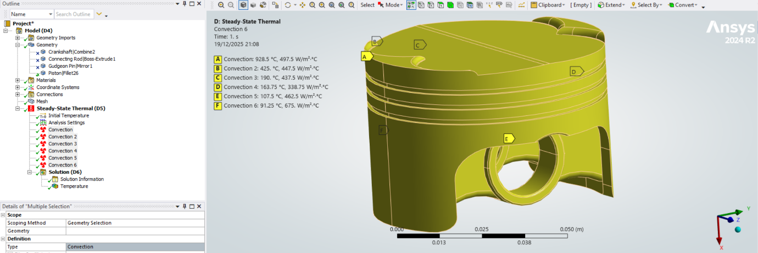
Figure 3.2: Steady-state thermal model boundary condition zoning on the piston, showing the applied convection regions (A–F) used to represent spatially varying heat transfer and temperature environments for the thermo-mechanical workflow.

3.3 Joints, Constraints and Boundary-Condition Strategy
In the rigid dynamics (kinematic) stage, interaction was modelled using joints rather than contact pairs (see Section 6.2) to generate inertial and reaction loads without introducing contact-compliance uncertainty. Within the fully linked workflow, auto-generated contacts were removed, and automatic connection generation was disabled to prevent re-creation on refresh, before defining joints to impose physically plausible degrees of freedom.

Constraints comprised: (i) revolute body-to-body joints at the crank–conrod, conrod–gudgeon pin and gudgeon pin–piston interfaces, (ii) a revolute body-to-ground joint at the crankshaft journal to fix the crankshaft in space while allowing rotation about the intended axis, and (iii) a general body-to-ground joint on the piston to permit translation along the cylinder axis while suppressing non-physical rigid-body freedoms.

For the static structural model, boundary conditions were selected to maintain a credible load path while avoiding over-constraint. A defined hotspot region (fixed face set) ensured repeatable iteration comparisons and reduced sensitivity to isolated numerical peaks from local transitions and constraint idealisation.

3.4 Kinematic Simulation and Load Transfer into the Structural Study
Operating loads were generated using an ANSYS Rigid Dynamics simulation under prescribed motion to obtain joint reactions representative of inertial and constraint effects. The driving input was a rotational velocity of 4000 rpm, applied through the revolute body-to-ground crankshaft joint, so motion followed the intended degree of freedom.

The joint reaction history was post-processed to define the governing design case. The maximum resultant reaction was 2379.4 N (Figure 3.3), selected as the representative worst-case operating load for subsequent structural assessment. Load transfer used the fully linked Workbench workflow, exporting motion loads into Static Structural so the corresponding remote forces and moments were applied to the flexible piston model (Figure 3.3).
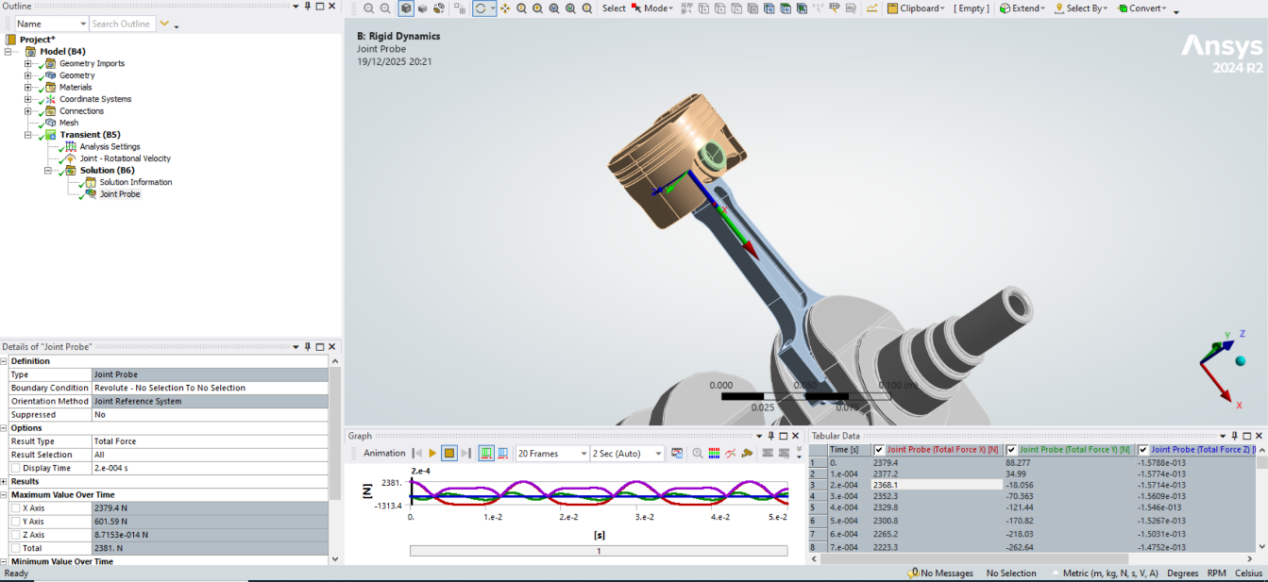
Figure 3.3: Rigid dynamics joint probe output used to define structural loading, with a prescribed rotational velocity of 4000 rpm and a peak joint reaction magnitude of 2379.4 N selected as the representative maximum load case for the subsequent static structural study.

3.5 Meshing Strategy, Solver Settings, and Outputs Monitored
A baseline mesh was established to support repeatable iteration-to-iteration comparisons, with local refinement applied where high stress gradients were expected. Mesh refinement and discretisation sensitivity were treated as controllable uncertainties and addressed explicitly through the mesh-independence verification study (Section 4.2). Solver settings followed standard Mechanical practice. Where unconstrained-region warnings arose due to realistic remote loading and constraint choices, stabilisation methods were applied cautiously and treated as a limitation influencing absolute magnitudes.

Monitored outputs were equivalent (von Mises) stress, equivalent elastic strain, and total deformation, extracted using maximum, mean, P95, and P99 statistics at both global and Hotspot scopes to support robust trend comparison (Table 3.1). Baseline node counts, mass, and the corresponding global and Hotspot response statistics are reported in Table 3.1. This dual-scope, percentile-based monitoring provides a defensible basis for optimisation by reducing reliance on single-node peaks while retaining sensitivity to high-stress behaviour.

Table 3.1: Baseline monitoring outputs for the piston structural assessment (global vs hotspot scopes), reported in base SI units and engineering units
Output (scope) | Nodes | Max | P95 | P99 | Mean
Equivalent (von Mises) stress, Global | 50,073 | 2.140900E+09 Pa (2140.9 MPa) | 5.728980E+08 Pa (572.898 MPa) | 1.016912E+09 Pa (1016.912 MPa) | 2.337962E+08 Pa (233.796 MPa)
Equivalent elastic strain, Global (–) | 50,073 | 3.83590E−02 | 1.18690E−02 | 2.25116E−02 | 4.63220E−03
Total deformation, Global | 50,073 | 3.43090E−04 m (0.34309 mm) | 3.01614E−04 m (0.30161 mm) | 3.29223E−04 m (0.32922 mm) | 1.58812E−04 m (0.15881 mm)
Equivalent (von Mises) stress, Hotspot | 3,307 | 2.140900E+09 Pa (2140.9 MPa) | 1.352250E+09 Pa (1352.25 MPa) | 1.681292E+09 Pa (1681.292 MPa) | 5.656284E+08 Pa (565.628 MPa)
Equivalent elastic strain, Hotspot (–) | 3,307 | 3.83590E−02 | 2.75261E−02 | 3.20586E−02 | 1.16483E−02
Total deformation, Hotspot | 3,307 | 1.04600E−04 m (0.10460 mm) | 1.00560E−04 m (0.10056 mm) | 1.03640E−04 m (0.10364 mm) | 7.06610E−05 m (0.070661 mm)

4. Verification and Validation

4.1 Analytical vs ANSYS validation case (Bimetallic Strip)
This verification case validated the thermo-mechanical capability of the ANSYS Static Structural workflow before interpreting piston-assembly results. A bonded bimetallic strip (Invar and copper) was modelled with one end fixed and the other free, with self-weight neglected. The analytical benchmark specifies the geometry, linear-elastic isotropic properties, and a uniform temperature rise that generates differential thermal strain, curvature, and free-end deflection (Figure 4.1).

In ANSYS, the same geometry and material parameters were applied, and the interface was treated as perfectly bonded to reproduce composite action (Table 4.1). Thermal strain was defined relative to an environmental temperature of 22 °C; a uniform applied body temperature of 122 °C was used to give ΔT = 100 °C.

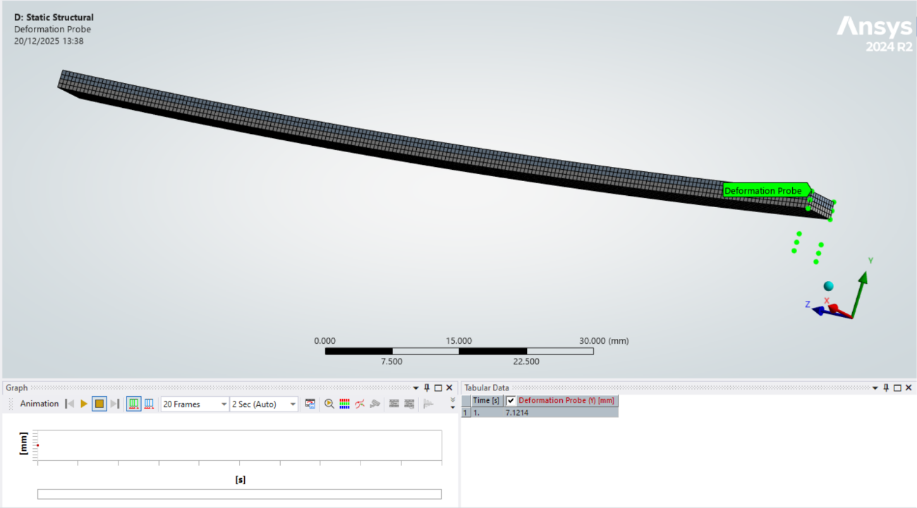
Figure 4.1: ANSYS bimetallic strip verification model showing the free-end deformation probe used to extract $u_{z,max⁡}$under a uniform thermal rise $ΔT=100 K$
The analytical solution predicts a free-end deflection of 7.049 mm, and ANSYS returned 7.1214 mm, yielding an absolute error of 0.0724 mm (1.03%) (Figure 4.1). This agreement is sufficient to validate the thermomechanical setup for subsequent use, with residual discrepancy consistent with discretisation and implementation detail.

Table 4.1: Key thermal-reference definition and material properties used to reproduce the analytical bimetallic strip benchmark in ANSYS. Values are reported in both SI base units and the entry units used in Workbench to demonstrate unit consistency and traceability of the thermo-mechanical setup.
Category | Parameter | Symbol | Value (SI base) | Value used in ANSYS setup
Thermal reference | Environment (reference) temperature | $$T_{ref}$$ | 295.15K | 22°C
Thermal loading | Applied uniform body temperature | $$T_{applied}$$ | 395.15K | 122°C
Thermal loading | Effective temperature rise | $$Δ T$$ | 100K | 100°C
Invar (linear elastic) | Young’s modulus | $$E_{i}$$ | $1.37×{10}^{11}$Pa | 137000 MPa
Invar (linear elastic) | Poisson's ratio | $$ν_{i}$$ | 0.280 | 0.280
Invar (thermal) | Coefficient of thermal expansion | $$α_{i}$$ | $1.2×{10}^{-6}$K⁻¹ | $1.2×{10}^{-6}$°C⁻¹
Copper (linear elastic) | Young's modulus | E_{c} | $1.30×{10}^{11}$Pa | 130000 MPa
Copper (linear elastic) | Poisson's ratio | $$ν_{c}$$ | 0.354 | 0.354
Copper (thermal) | Coefficient of thermal expansion | $$α_{c}$$ | $2.0×{10}^{-5}$K⁻¹ | $2.0×{10}^{-5}$°C⁻¹

4.2 Mesh-independence study
A mesh-independence study verified that discretisation did not materially affect the bimetallic-strip validation response and justified a mesh choice balancing fidelity with computational cost. The monitored output was the maximum free-end vertical deformation at the strip tip, (u_{z​, max,} (mm)). Geometry, material assignment, thermal loading, boundary conditions, and probe definition were held constant between runs; therefore, mesh size was the only intentional change (Figure 4.2; Table 4.2).

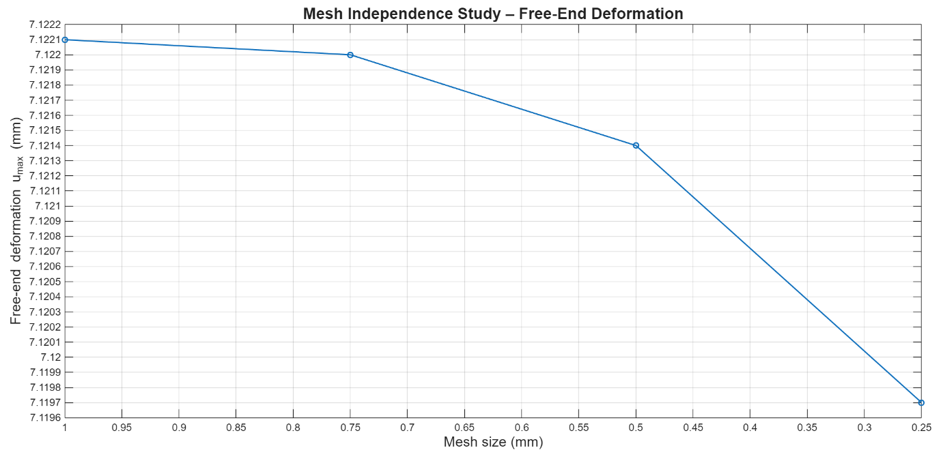
Figure 4.2: Mesh-independence study for the bimetallic strip validation model, showing maximum free-end vertical deformation, $u_{z,max⁡}$, as a function of global element size. The response exhibits negligible variation across the tested refinement range (1.00–0.25 mm), supporting the mesh-independence conclusion; corresponding element and node counts and successive percentage changes are reported in Table 4.2.
Four global element sizes (1.00, 0.75, 0.50, and 0.25 mm) were evaluated, with element and node counts recorded. Convergence was assessed using the percentage change in u_{z​, max}​ between successive refinements. Successive deformation changes were negligible and well below the typical <1% displacement threshold; therefore, the response is mesh-independent over the tested range (Table 4.2). Accordingly, 0.50 mm was selected as a cost-effective mesh that is essentially indistinguishable from 0.25 mm while avoiding the disproportionate increase in element and node count (Figure 4.2; Table 4.2).

Table 4.2: Mesh refinement study for the bimetallic strip validation model, reporting maximum free-end vertical deformation $u_{z, max⁡}$From a tip deformation probe for four global element sizes, the percentage change is reported between successive refinements (coarser → finer).
Global element size, (h) (mm) [m] | Elements (–) | Nodes (–) | Tip deformation, $\left(u_{z, max}\right)$ (mm) [m] | % change vs previous refinement (coarser → finer)
1.00 $\left[1.00×{10}^{-3}\right]$ | 1,000 | 8,056 | 7.1221 $[7.1221×{10}^{-3}]$ | –
0.75 $\left[7.50×{10}^{-4}\right]$ | 3,752 | 22,902 | 7.1220 $[7.1220×{10}^{-3}]$ | 0.0014%
0.50 $\left[5.00×{10}^{-4}\right]$ | 8,000 | 47,370 | 7.1214 $[7.1214×{10}^{-3}]$ | 0.0084%
0.25 $[2.50×{10}^{-4}]$ | 64,000 | 315,778 | 7.1197 $[7.1197×{10}^{-3}]$ | 0.0239%

4.3 Boundary-condition influence study (Cantilever)
To assess the sensitivity of structural response to boundary-condition (BC) definition, a cantilever plate under uniform pressure was analysed using two credible fixed-support implementations. The benchmark geometry and loading follow the published verification case: length $L=1.0 m$, width $=0.05 m$, thickness $t=0.005 m$, applied pressure $p=2750 Pa$, with linear-elastic small-deformation assumptions (Figure 4.3; Table 4.3).

Case A applied a Fixed Support to the end faces of the clamped boundary, whereas Case B applied a Fixed Support to the end edges only. In both cases, the monitored output was the maximum free-end vertical displacement magnitude ∣, uv, max∣, extracted using an identical deformation-probe definition at the free end; any output variation is attributable to BC scoping rather than post-processing choice (Figure 4.3). The signed displacement is negative under downward deflection; the comparison is performed on the displacement magnitude.

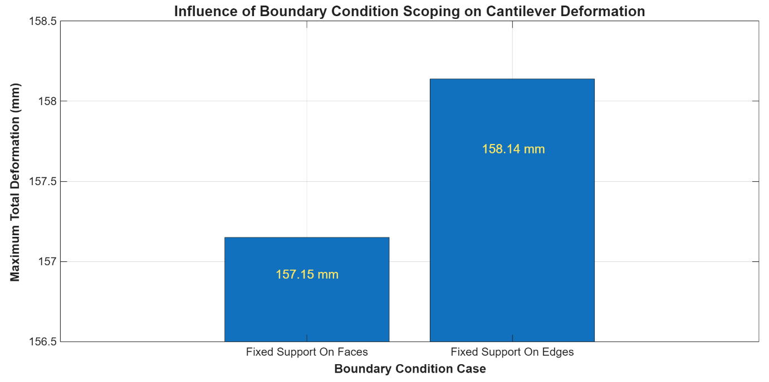
Figure 4.3: Free-end displacement magnitude, |u_{z,max}|, for fixed support applied to the clamped end faces (Case A) and clamped end edges (Case B); all other model inputs were held constant.
The predicted free-end deformation magnitudes were 157.15 mm (Case A) and 158.14 mm (Case B), yielding an absolute difference of 0.99 mm and a relative change of 0.63% relative to Case A (Figure 4.3; Table 4.3). Therefore, for this bending-dominated problem, displacement is weakly sensitive to fixed-support scoping across two reasonable BC definitions. However, BC specification remains a non-trivial modelling decision that should be justified and applied consistently, because even sub-1% compliance changes can influence stress distributions and margin assessment in more complex geometries.

Table 4.3: Boundary-condition sensitivity study for a cantilever plate under uniform pressure loading, comparing fixed support applied to the clamped end faces (Case A) versus the clamped end edges (Case B). Reported values are the free-end vertical displacement magnitude from an identical deformation probe, with all other modelling inputs held constant.
Case | Fixed support implementation | Free-end displacement magnitude (m) | Free-end displacement magnitude (mm) | Difference vs Case A (mm) | Difference vs Case A (%)
A | Fixed support on end faces | 0.15715 | 157.15 | 0.00 | 0.00
B | Fixed support on end edges | 0.15814 | 158.14 | 0.99 | 0.63

5. Design iteration and Optimisation results

5.1 Baseline results for the selected component
The baseline piston design exhibited a localised hotspot associated with groove-root geometry, and hotspot-region stress statistics were adopted as the primary driver for subsequent iterations. Baseline mass and the corresponding hotspot von Mises stress metrics (P95, P99, and max) are reported in Table 5.2. Global deformation remained small, indicating that stiffness and deflection were not the limiting constraint under the applied load case (Table 5.2).

5.2 Iteration plan and design targets
The optimisation strategy followed the coursework intent to improve structural performance while optimising mass, using consistent outputs between iterations so changes were attributable to geometry updates rather than post-processing differences. The principal targets adopted were:

- Hotspot stress reduction, using hotspot-region P95 von Mises stress as the primary robust indicator.
- Tail-risk monitoring, retaining Hotspot P99 and max to monitor peak sensitivity.
- Mass control, maintaining or reducing piston mass using skirt material removal as the optimisation lever.
- Deformation check, confirming global and Hotspot deformation remained stable to avoid unintended compliance increase.

All outputs use the exact hotspot-region post-processing definition and are collated in Table 5.2 for like-for-like comparison.

5.3 Iteration results and decision logic
Fillet-driven iterations (Iterations 1 to 2B). Groove filleting was selected because the baseline hotspot indicates a groove-root stress concentration, and an increased radius is expected to reduce gradients and redistribute load. Iteration 1D (0.60 mm fillets on the oil groove) delivered substantial reductions in Hotspot P95/P99 with negligible mass change and was retained as the best fillet-only improvement (Figure 5.1; Table 5.2).

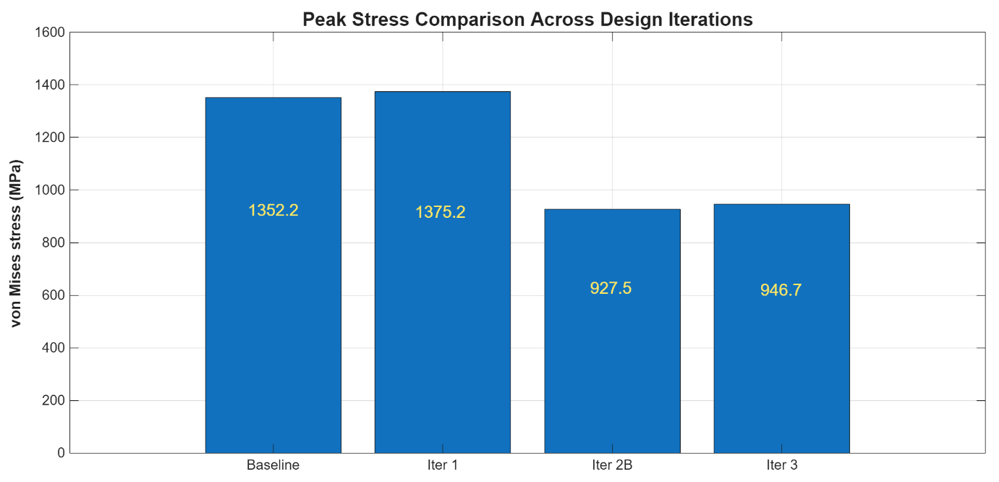
Figure 5.1: Peak (maximum) von Mises stress comparison across the baseline and key design iterations (Baseline, Iteration 1, Iteration 2B, and Iteration 3), extracted from the same hotspot-region post-processing definition to support consistent iteration-to-iteration comparison.
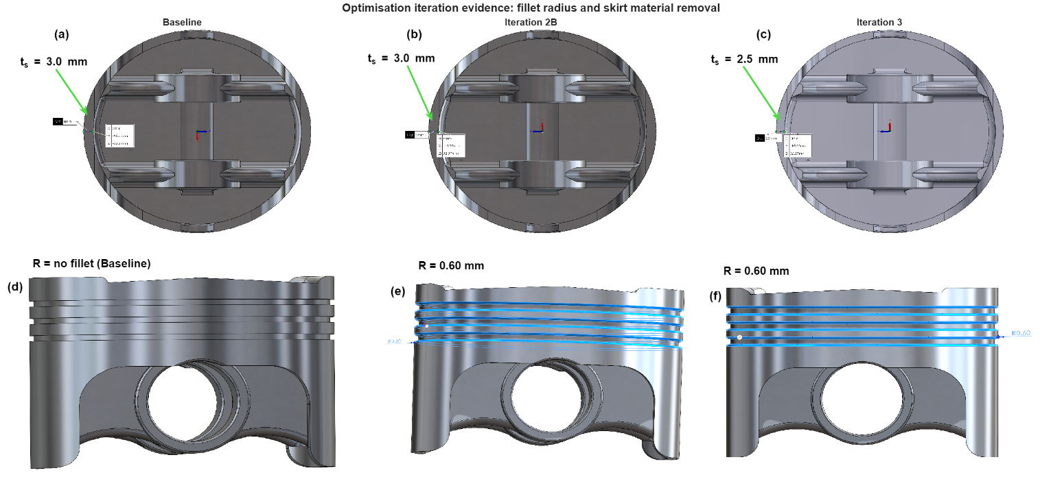
Extending fillets to all grooves produced Iteration 2B (Figure 5.2e), which delivered the lowest hotspot P95 (Table 5.2). However, P99 reduced less strongly than Iteration 1D, and hotspot max increased, indicating improved bulk response but persistent local peak sensitivity. Iteration 2B was therefore retained under the primary P95 objective, with interpretation guided by P99 and max.
Figure 5.2: Optimisation iteration evidence, fillet radius and skirt material removal (SolidWorks screenshots).

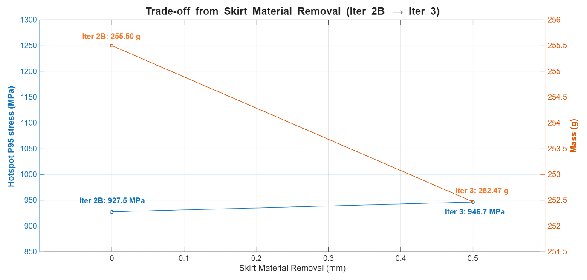
Mass-removal iterations (Iterations 3 and 3B). Iteration 3 applied 0.5 mm skirt removal to Iteration 2B (Figure 5.2a–c), achieving mass reduction while preserving most P95 benefit, therefore representing the preferred trade-off (Table 5.2). Iteration 3B applied the same removal to the Baseline and returned P95 to baseline levels, demonstrating that removal alone does not address the governing stress concentration and should be rejected (Table 5.2). Global deformation remained broadly stable, consistent with primarily local stress redistribution.
Figure 5.3: Stress–mass trade-off for the skirt material removal step (Iteration 2B to Iteration 3), showing the change in hotspot P95 von Mises stress alongside piston mass versus skirt removal depth (0.0 to 0.5 mm).

Fatigue-life screening (S–N). A screening indicator used the 6061-T6 S–N curve for R=0R (Figure 5.4) with Hotspot mean stress as a proxy due to fatigue-solver limitations. Table 5.1 shows that filleting provides the dominant durability improvement, and that post-fillet skirt removal preserves most of the benefit, whereas baseline removal does not.

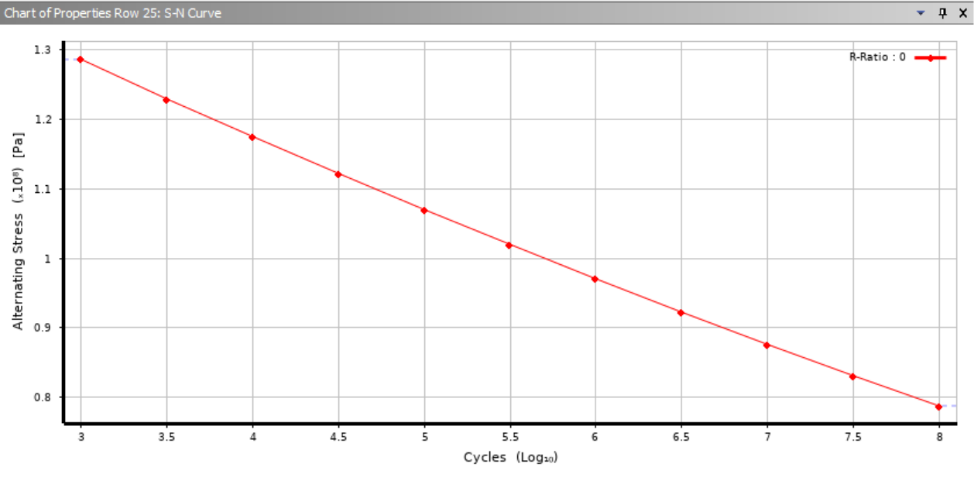
Table 5.1: Manual fatigue screening using 6061-T6 S–N curve (R = 0) and Hotspot mean von Mises stress
Figure 5.4; Aluminium 6061-T6 stress-life (S–N) curve defined in ANSYS Engineering Data, showing alternating stress as a function of cycles for $R=0$(pulsating loading), used as the fatigue input data for the screening assessment described in Section 5.3.
Design state | Hotspot mean stress, $(σ_{eq,;mean}$ (Pa) [MPa] | (SF_{SN}) at $(N={10}^{7})$ (–) | $(Δ{SF}_{SN} )$ vs Baseline (%)
Baseline | $(5.656×{10}^{8})$ [565.6] | 0.155 | 0.0
Iteration 1D | $(4.973×{10}^{8})$ [497.3] | 0.176 | +13.7
Iteration 2B | $(4.460×{10}^{8})$ [446.0] | 0.196 | +26.8
Iteration 3 | $(4.533×{10}^{8})$ [453.3] | 0.193 | +24.8
Iteration 3B | ($5.702×{10}^{8})$ [570.2] | 0.154 | −0.8

5.4 Final design comparison and optimisation outcome
The selected final design is Iteration 3 (Iteration 2B + 0.5 mm skirt removal). Relative to Baseline, it achieved a substantial reduction in Hotspot P95 stress, along with a measurable mass reduction as it best meets the targets (Table 5.2). Although hotspot P99 and max did not reduce proportionally, the primary objective of improving the bulk hotspot stress field while reducing mass was achieved, and retaining P99 and max reporting provides transparency regarding peak-stress sensitivity and CAE limitations when interpreting absolute maxima (Figure 5.4).

Considering hotspot stress reduction, mass optimisation, and durability screening, Iteration 3 was selected because it preserves most of the structural benefit from fillet optimisation while achieving mass reduction and maintaining an improved S–N screening margin relative to Baseline (Table 5.1).
Table 5.2: Summary of piston design iterations showing mass and hotspot-region von Mises stress statistics in base units (kg, Pa) and engineering units (g, MPa). The primary optimisation metric is hotspot $P95$, with $P99$ and max retained indicating peak sensitivity; percentage changes are reported versus Baseline and, where stated, versus the previous retained design step.
Design state | Geometry change | Mass (kg) [g] | Hotspot stress (P95) (Pa) | Hotspot stress (P95) (MPa) | $(Δ P95)$ vs BL (%) | $(Δ P95)$ vs previous (%) | Hotspot stress (P99) (Pa) [MPa] | $(Δ P99)$ vs BL (%) | Hotspot stress (max) (Pa) [MPa] | $(Δ max)$ vs BL (%) | Decision
Baseline | As modelled | 0.25577  [255.77] | 1.35225E+09 | 1352.2 | 0.00 | – | 1.68129E+09  [1681.3] | 0.00 | 2.14090E+09  [2140.9] | 0.00 | Reference
Iteration 1D | 0.60 mm fillets, top and bottom of oil groove | 0.25568  [255.68] | 1.01795E+09 | 1017.9 | −24.72 | −24.72 | 1.26387E+09  [1263.9] | −24.83 | 2.11460E+09  [2114.6] | −1.23 | Keep (best fillet-only stability)
Iteration 2B | 0.60 mm fillets, top and bottom of all 3 grooves | 0.25550  [255.50] | 9.27480E+08 | 927.5 | −31.41 | −8.89 | 1.40368E+09  [1403.7] | −16.51 | 3.26330E+09  [3263.3] | +52.43 | Keep (lowest (P95), monitor peaks)
Iteration 3 | Iteration 2B + 0.5 mm skirt material removal | 0.25247  [252.47] | 9.46718E+08 | 946.7 | −29.99 | +2.07 | 1.47605E+09  [1476.0] | −12.21 | 2.50570E+09  [2505.7] | +17.04 | Select (final trade-off)
Iteration 3B | Baseline + 0.5 mm skirt material removal | 0.25274  [252.74] | 1.35272E+09 | 1352.7 | +0.03 | +42.87 | 1.71715E+09  [1717.1] | +2.13 | 2.21650E+09  [2216.5] | +3.53 | Reject

6. Critical discussion of CAE tools and limitations

6.1 Credibility of outputs and uncertainty
This project demonstrates how CAE can enable rapid, evidence-led design iteration, although the credibility of absolute outputs remains bounded by verification, validation, and modelling uncertainty. Section 4 provides baseline confidence that the ANSYS workflow functions correctly at the solver level through analytical agreement for a simplified thermo-mechanical bending case (Section 4.1, Figure 4.1; Table 4.1) and evidence of mesh independence for the monitored displacement (Section 4.2, Figure 4.2; Table 4.2). However, the piston assembly study (Sections 3 and 5) introduces additional uncertainty from contact idealisation, kinematics-to-structure load transfer assumptions, and temperature-dependent property modelling. Consequently, results are most defensible as comparative iteration trends rather than calibrated life predictions.

6.2 Sensitivity to modelling assumptions
The boundary-condition influence study (Section 4.3, Figure 4.3; Table 4.3) confirms that constraint scoping is an engineering assumption affecting stiffness and load transfer rather than a purely numerical setting. This sensitivity generalises to assemblies, where joint, contact, and constraint choices can dominate local stress fields and generate non-physical hotspots if the load path is over-constrained or the contact state is simplified. Discretisation adds uncertainty because stress concentrations and contact-pressure peaks can remain mesh-dependent; convergence logic and region-based statistics are preferable to isolated maxima (Barbič and Sifakis, 2022). Thermo-mechanical modelling adds further sensitivity via thermal boundary conditions and temperature-dependent properties, but coupling and calibration are common where gradients and cycling govern durability (Luo et al., 2020; Ghasemi et al., 2013).

6.3 Implications for engineering decision-making
Consequently, CAE is fit-for-purpose here as a virtual prototyping tool for ranking design iterations and justifying geometry changes using consistent metrics and cross-referenced evidence (Section 5; Table 5.2; Figures 5.1–5.2). However, it is not fit-for-purpose for claiming an absolute life-safety factor or peak-stress truth without experimental correlation or more advanced modelling of contacts, material behaviour and thermal loading cycles (Thesing and Bishop, 2016). Credibility could be strengthened by correlating the rigid-dynamics load case with representative operating conditions, improving contact realism, extending thermal inputs to cover representative transients where cycling governs durability, and bracketing key outputs across plausible BC and mesh variations to explicitly report uncertainty (Luo et al., 2020).

7. Conclusions and recommendations

7.1 Conclusions
This project implemented a CAE-led workflow for a piston assembly, from assembly definition and kinematics-derived loading to thermo-mechanical structural assessment, verification and validation (V&V), and evidence-led iteration. The structural load case was defined from the rigid-dynamics peak joint reaction of 2379.4 N at 4000 rpm, enabling consistent iteration comparison under an operating-relevant condition.

Baseline mass and the corresponding global and Hotspot stress statistics confirm a strongly localised hotspot response; optimisation is most appropriately driven using region-based metrics (P95/P99) rather than isolated maxima (Table 3.1; Table 5.2).

Section 4 provides verification evidence through analytical agreement for a thermo-mechanical benchmark, mesh-independent displacement over the tested range, and modest BC sensitivity (Tables 4.1–4.3). Nevertheless, absolute hotspot stresses remain sensitive to contact, constraint, and thermal idealisation; therefore, the results are most defensible for comparative trend-based decisions rather than calibrated life prediction.

7.2 Recommendations
- Correlate kinematics-derived loading to representative operating conditions and report load uncertainty bands.
- Quantify hotspot uncertainty using structured sensitivity checks on contact parameters and constraint scoping, reporting bounded P95/P99 trends.
- Apply local refinement or sub-modelling at the Hotspot to improve stress-gradient resolution without excessive global mesh cost.
- If durability claims are required, extend fatigue assessment to representative load histories and thermal cycling, supported by experimental correlation where feasible.

References
Barbič, J. and Sifakis, E. (2022) Finite Element Method Simulation of 3D Deformable Solids. 1st edn. Springer Nature.
Ghasemi, A., Dong, M., Meda, L. and Romzek, M. (2013) CAE Dynamic Durability Simulation of Exhaust System. 1SAE International. Available at: https://doi.org/10.4271/2013-01-0510 .
Gupta, A. and Tovar, A. , (2024) 'Topology Optimization of Multibody Systems Undergoing Dynamic Loading Using an Equivalent Static Displacement Method', American Society of Mechanical Engineers , Available at: https://asmedigitalcollection.asme.org/IDETC-CIE/proceedings/IDETC-CIE2024/88377/V03BT03A016/1208893.
Lostado, R., Villanueva Roldán, P., Fernandez Martinez, R. and Mac Donald, B.J. (2016) 'Design and optimisation of an electromagnetic servo braking system combining finite element analysis and weight-based multi-objective genetic algorithms', Journal of Mechanical Science and Technology, 30(8), pp. 3591–3605. Available at: https://doi.org/10.1007/s12206-016-0720-6.
Luo, X., Zou, P., Zeng, X., Yuan, X., Li, B., Teng, H. and Xu, Y. (2020) Failure Prediction and Design Optimisation of Exhaust Manifold based on CFD and FEM Analysis. 1SAE International. Available at: https://doi.org/10.4271/2020-01-1166 .
Rifai, S.M., Buell, J.C., Johan, Z. and Landers, J.M. , (1999) 'Automotive Engineering Applications of Multiphysics Simulation', Available at: https://www.proquest.com/docview/29080050.
Thesing, T. and Bishop, N. (2016) Modern Methods for Random Fatigue of Automotive Parts. Available at: https://doi.org/10.4271/2016-01-0372 .
Wu, S.R. (2006) 'Convergence Study On Explicit Finite Element for Crashworthiness Analysis', Available at: https://www.proquest.com/docview/28951507.

Appendix

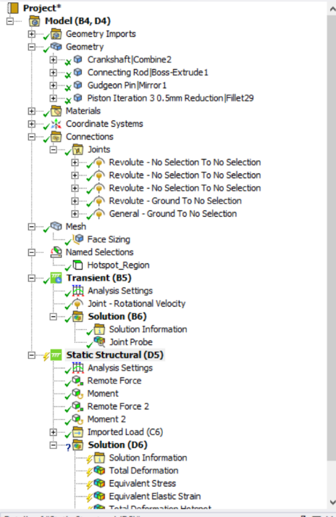
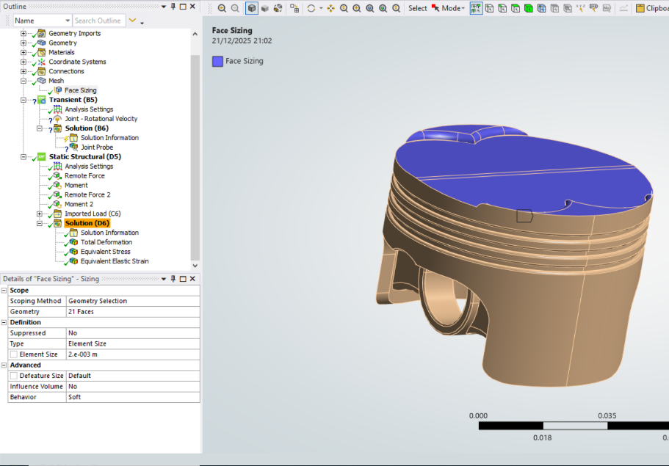
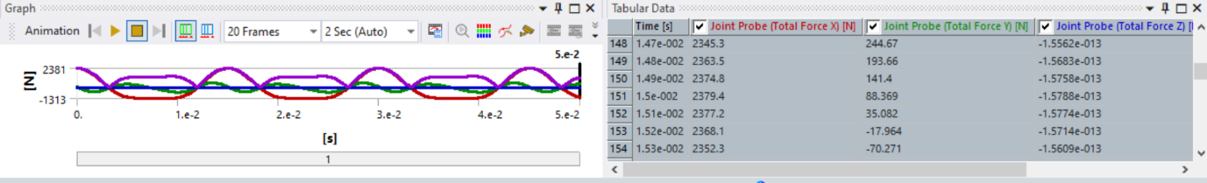
Appendix A
Appendix A3: joints, contacts, named selections, fixed supports, and where loads are applied (the figure plan items you already identified as “appendix methodology figures”).
Appendix A2: element type, sizing controls, local refinement regions, and any relevance settings that justify why your hotspot is refined.
Appendix A1: how the peak joint reaction load case is extracted from Rigid Dynamics and transferred into Static Structural (screenshots of the load probe and the applied load object scoping).

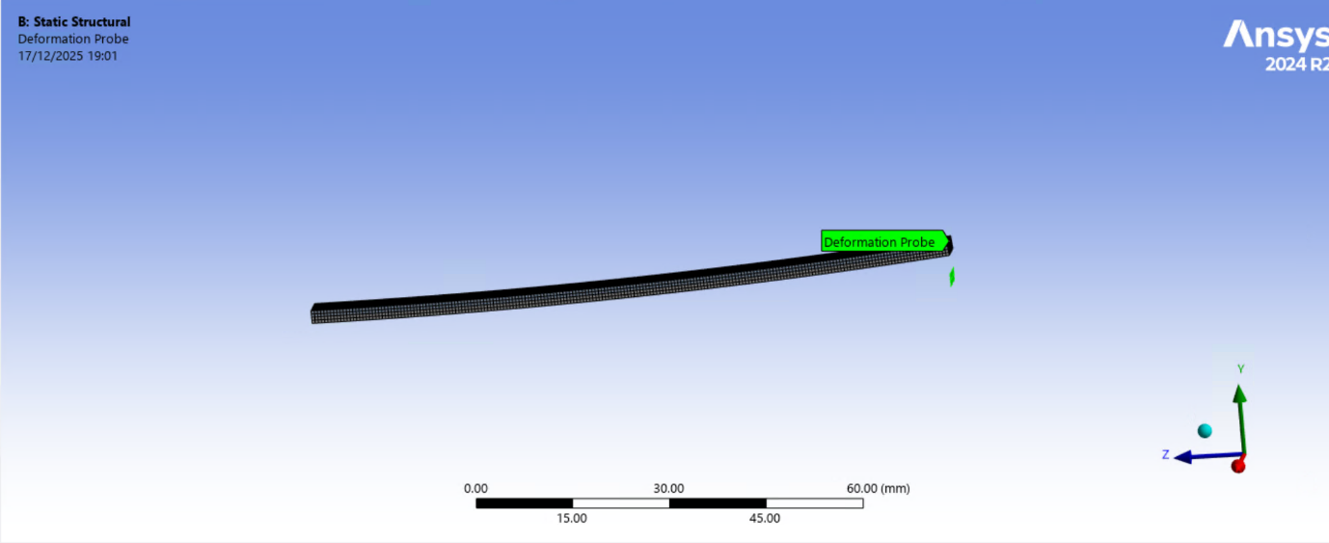
Appendix B
Appendix B1: Deformation of the Bimetallic Strip
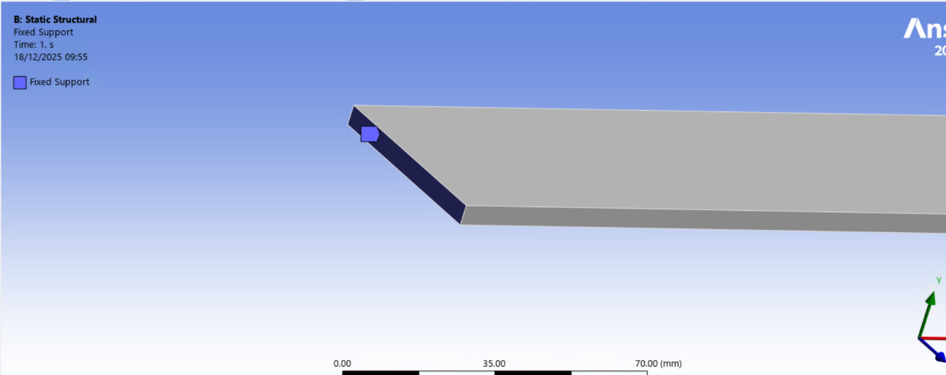
Appendix B2: The Fixed Support for Case A for Boundary Conditions Influence

Appendix C
Global Stress For Each Iteration
Iteration | Mass (g) | n (nodes) | Max (Pa) | Max (MPa) | P95 (Pa) | P95 (MPa) | P99 (Pa) | P99 (MPa) | Mean (Pa) | Mean (MPa) | %Δ Max vs BL | %Δ P95 vs BL | %Δ P99 vs BL | %Δ Mean vs BL
Baseline | 255.77 | 50,073 | 2.140900E+09 | 2140.9 | 5.728980E+08 | 572.898 | 1.016912E+09 | 1016.912 | 2.337962E+08 | 233.796 | 0.00% | 0.00% | 0.00% | 0.00%
Iteration 1 | 255.75 | 71,429 | 3.912700E+09 | 3912.7 | 8.427860E+08 | 842.786 | 1.448032E+09 | 1448.032 | 3.034773E+08 | 303.477 | +82.76% | +47.11% | +42.40% | +29.80%
Iteration 1B | 255.76 | 62,182 | 3.239300E+09 | 3239.3 | 8.777890E+08 | 877.789 | 1.432733E+09 | 1432.733 | 3.027146E+08 | 302.715 | +51.31% | +53.22% | +40.89% | +29.48%
Iteration 1C | 255.73 | 53,284 | 3.992900E+09 | 3992.9 | 6.822870E+08 | 682.287 | 1.026419E+09 | 1026.419 | 2.543175E+08 | 254.317 | +86.51% | +19.09% | +0.93% | +8.78%
Iteration 1D | 255.68 | 37,258 | 2.114600E+09 | 2114.6 | 7.155530E+08 | 715.553 | 9.664700E+08 | 966.470 | 2.207331E+08 | 220.733 | −1.23% | +24.90% | −4.96% | −5.59%
Iteration 2 | 255.70 | 91,506 | 6.168800E+09 | 6168.8 | 6.691350E+08 | 669.135 | 1.232115E+09 | 1232.115 | 2.500715E+08 | 250.072 | +188.14% | +16.80% | +21.16% | +6.96%
Iteration 2B | 255.50 | 66,990 | 3.263300E+09 | 3263.3 | 6.069830E+08 | 606.983 | 9.698344E+08 | 969.834 | 2.202854E+08 | 220.285 | +52.43% | +5.95% | −4.63% | −5.78%
Iteration 3 | 252.47 | 65,588 | 2.505700E+09 | 2505.7 | 6.242540E+08 | 624.254 | 9.943865E+08 | 994.387 | 2.201848E+08 | 220.185 | +17.04% | +8.96% | −2.22% | −5.82%
Iteration 3B | 252.74 | 48,855 | 2.216500E+09 | 2216.5 | 5.715940E+08 | 571.594 | 1.029498E+09 | 1029.498 | 2.319467E+08 | 231.947 | +3.53% | −0.23% | +1.24% | −0.79%
Appendix C1: Full Log Iteration Table for Global Stress for Task 3 Improvements of Piston

Hotspot Stress For Each Iteration
Iteration | n (nodes) | Max (Pa) | Max (MPa) | P95 (Pa) | P95 (MPa) | P99 (Pa) | P99 (MPa) | Mean (Pa) | Mean (MPa) | %Δ Max vs BL | %Δ P95 vs BL | %Δ P99 vs BL | %Δ Mean vs BL
Baseline | 3,307 | 2.140900E+09 | 2140.9 | 1.352250E+09 | 1352.2 | 1.681292E+09 | 1681.3 | 5.656284E+08 | 565.6 | +0.00% | +0.00% | +0.00% | +0.00%
Iteration 1 | 10,812 | 3.912700E+09 | 3912.7 | 1.375225E+09 | 1375.2 | 2.250631E+09 | 2250.6 | 5.413579E+08 | 541.4 | +82.76% | +1.70% | +33.86% | −4.29%
Iteration 1B | 7,808 | 3.239300E+09 | 3239.3 | 1.466630E+09 | 1466.6 | 2.321521E+09 | 2321.5 | 6.406511E+08 | 640.7 | +51.31% | +8.46% | +38.08% | +13.26%
Iteration 1C | 4,876 | 3.992900E+09 | 3992.9 | 1.071675E+09 | 1071.7 | 1.515775E+09 | 1515.8 | 5.287771E+08 | 528.8 | +86.51% | −20.75% | −9.84% | −6.52%
Iteration 1D | 3,288 | 2.114600E+09 | 2114.6 | 1.017950E+09 | 1017.9 | 1.263869E+09 | 1263.9 | 4.973296E+08 | 497.3 | −1.23% | −24.72% | −24.83% | −12.07%
Iteration 2 | 11,682 | 6.168800E+09 | 6168.8 | 1.250500E+09 | 1250.5 | 2.033528E+09 | 2033.5 | 5.132527E+08 | 513.3 | +188.14% | −7.52% | +20.95% | −9.26%
Iteration 2B | 6,031 | 3.263300E+09 | 3263.3 | 9.274800E+08 | 927.5 | 1.403680E+09 | 1403.7 | 4.459731E+08 | 446.0 | +52.43% | −31.41% | −16.51% | −21.15%
Iteration 3 | 5,956 | 2.505700E+09 | 2505.7 | 9.467175E+08 | 946.7 | 1.476045E+09 | 1476.0 | 4.533356E+08 | 453.3 | +17.04% | −29.99% | −12.21% | −19.85%
Iteration 3B | 3,272 | 2.216500E+09 | 2216.5 | 1.352715E+09 | 1352.7 | 1.717148E+09 | 1717.1 | 5.701619E+08 | 570.2 | +3.53% | +0.03% | +2.13% | +0.80%
Appendix C2: Full Log Iteration Table for Hotspot Stress for Task 3 Improvements of Piston

Global Total Deformation for Each Iteration
Iteration | n (nodes) | Max (m) | Max (mm) | P95 (m) | P95 (mm) | P99 (m) | P99 (mm) | Mean (m) | Mean (mm) | %Δ Max vs BL | %Δ P95 vs BL | %Δ P99 vs BL | %Δ Mean vs BL
Baseline | 50,073 | 3.43090E-04 | 0.34309 | 3.01614E-04 | 0.30161 | 3.29223E-04 | 0.32922 | 1.58812E-04 | 0.15881 | 0.00% | 0.00% | 0.00% | 0.00%
Iteration 1 | 71,429 | 3.54400E-04 | 0.35440 | 3.03610E-04 | 0.30361 | 3.35487E-04 | 0.33549 | 1.44721E-04 | 0.14472 | +3.30% | +0.66% | +1.90% | −8.87%
Iteration 1B | 62,182 | 3.41960E-04 | 0.34196 | 2.97520E-04 | 0.29752 | 3.25318E-04 | 0.32532 | 1.43928E-04 | 0.14393 | −0.33% | −1.36% | −1.19% | −9.37%
Iteration 1C | 53,284 | 3.39630E-04 | 0.33963 | 2.99710E-04 | 0.29971 | 3.25692E-04 | 0.32569 | 1.53019E-04 | 0.15302 | −1.01% | −0.63% | −1.07% | −3.65%
Iteration 1D | 37,258 | 3.39900E-04 | 0.33990 | 3.05820E-04 | 0.30582 | 3.29024E-04 | 0.32902 | 1.70041E-04 | 0.17004 | −0.93% | +1.39% | −0.06% | +7.07%
Iteration 2 | 91,506 | 3.41230E-04 | 0.34123 | 2.88420E-04 | 0.28842 | 3.20179E-04 | 0.32018 | 1.46308E-04 | 0.14631 | −0.54% | −4.37% | −2.75% | −7.87%
Iteration 2B | 66,990 | 3.38980E-04 | 0.33898 | 2.94790E-04 | 0.29479 | 3.22432E-04 | 0.32243 | 1.57233E-04 | 0.15723 | −1.20% | −2.26% | −2.06% | −0.99%
Iteration 3 | 65,588 | 3.39460E-04 | 0.33946 | 2.94223E-04 | 0.29422 | 3.23281E-04 | 0.32328 | 1.58470E-04 | 0.15847 | −1.06% | −2.45% | −1.80% | −0.21%
Iteration 3B | 48,855 | 3.41660E-04 | 0.34166 | 2.98943E-04 | 0.29894 | 3.27609E-04 | 0.32761 | 1.59315E-04 | 0.15932 | −0.42% | −0.89% | −0.49% | +0.32%
Appendix C3: Full Log Iteration Table for Global Total Deformation for Task 3 Improvements of Piston

Note: temperature differences are numerically identical in K and °C, therefore $ΔT=100 K={100}^{∘}C$

