University of Wales Trinity Saint David

Certificate in Higher Education Business Skills for the Workplace
Module: LCLM4006 Enterprise and Entrepreneurship
Assignment: Task 1 – Individual Written Business Plan
Student name: | Nicolae-Daniel Toma
Student ID: | 2514774
Lecturer: | Simon Chatterton

POLONICUL BISTRO

Executive Summary
My name is Nicolae-Daniel Toma, and I plan to open Polonicul Bistro, a hot food takeaway bistro, on Lowesmoor, Worcester, in January 2029. The menu combines Eastern European home-style dishes, such as grilled skinless sausages, stuffed cabbage rolls and a homemade soup of the day, with popular international street food such as smashed burgers, chicken shawarma and wraps.
The bistro is for customers of all nationalities, especially working adults aged 25–44, Worcester's Eastern European community and students. My unique selling point (USP) is home-made food, cooked freshly every day, at fair prices.
I will run the business as a sole trader and employ one local part-time assistant. I will buy ingredients from local suppliers and reduce waste through compostable packaging, food-waste recycling and food bank donations. I will promote the bistro through social media, Google, delivery apps and a loyalty card.
I need £22,000, which I will fund entirely from my personal savings, so the business starts with no debt. First-month sales are forecast at £8,775 (excluding VAT) against total out-flows of £26,271, which include one-off start-up costs. This leaves £4,504 in the bank at the end of January 2029.

Table of Contents
1. Overview of the Business Idea 1
1.1 The business idea and products 1
1.2 Unique selling point (USP) 1
1.3 Environmental sustainability and community support 1
1.4 Legal format and management structure 1
2. Market Research 1
2.1 PESTEL analysis 1
2.2 Competition 1
2.3 SWOT analysis 1
3. Marketing Communications 1
3.1 Target customers and location 1
3.2 Marketing strategy 1
4. Financials 1
4.1 Funding required and source 1
4.2 Start-up expenses in the first month 1
4.3 Cash flow forecast (Month 1) 1
Reference List 1

1. Overview of the Business Idea

1.1 The business idea and products
Polonicul Bistro will be a hot food takeaway bistro on Lowesmoor, Worcester, in January 2029. The name means "the ladle" in Romanian, my home language, and reflects my love of home cooking. The bistro will have around ten seats. It will offer counter service, phone and click-and-collect orders, and delivery through Just Eat and Uber Eats, Monday to Saturday from 10:00 to 18:00.
Every dish will be cooked fresh to order. The menu combines two styles. The first is Eastern European home cooking, such as grilled skinless beef and pork sausages, stuffed cabbage rolls and a different homemade soup every day. The second is popular street food, such as smashed burgers, chicken shawarma, wraps and hand-cut chips. Table 1 shows my planned prices.

Menu item (examples) | Price incl. VAT
Smashed burger with bacon and cheese | £12.50
Chicken and bacon burger | £10.50
Chicken shawarma wrap with chips | £12.50
Grilled skinless sausages with chips and mustard | £15.00
Homemade soup of the day with bread | £7.00
Table 1: Planned menu prices for 2029, including VAT (author's own)
This is a large market. The UK takeaway and delivery sector is worth around £23.6 billion and includes 50,078 businesses (Whitmore, 2026). Worcester itself has 103,872 residents and a mixed population: 6.6% describe themselves as "Other White", a group that includes many Eastern Europeans, and 5.6% are Asian or Asian British (Office for National Statistics, 2022). This gives a local customer base for both parts of the menu.
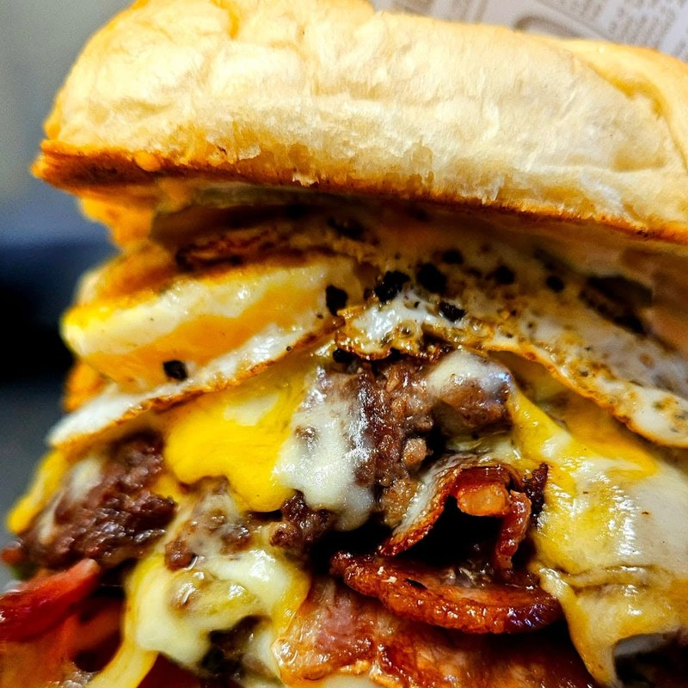 | 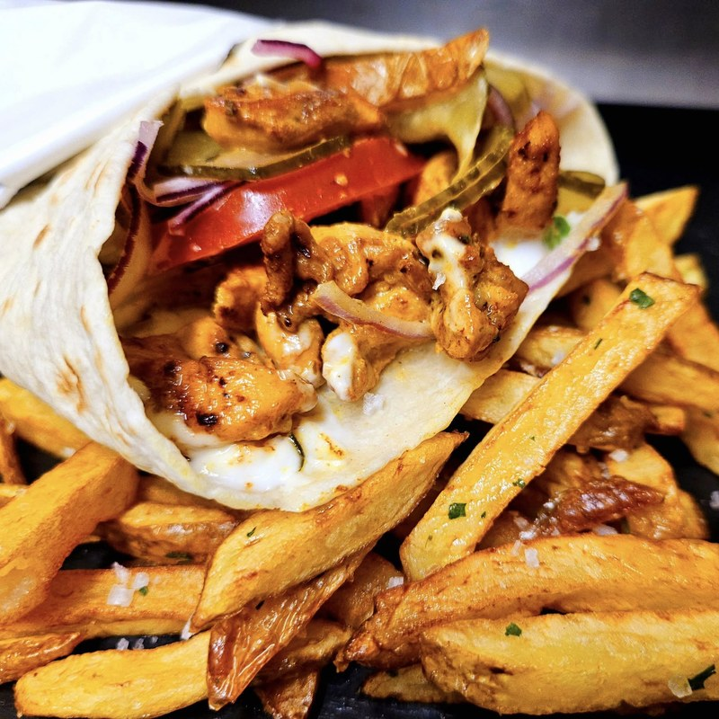 | 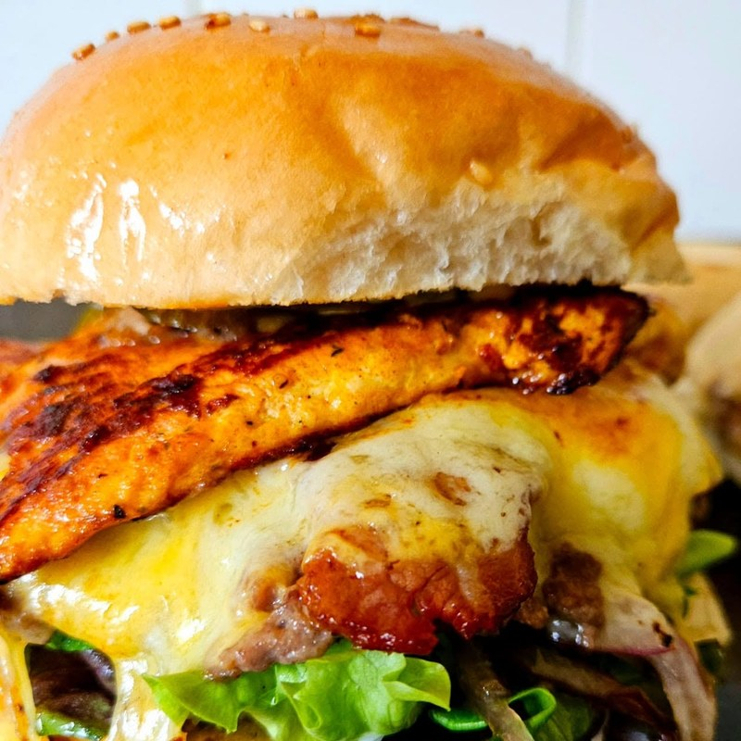
Double smashed burger | Chicken shawarma wrap with chips | Beef and chicken burger
Figure 1: Street food made fresh to order (Source: author's own photographs, 2025)1.2 Unique selling point (USP)
The unique selling point is home-made food, cooked fresh every day at fair prices, that customers cannot easily find elsewhere in Worcester. Many takeaways reheat ready-made kebab meat or use frozen burgers. Polonicul Bistro will make its own burger patties, sausages, sauces and hand-cut chips every day. For Eastern European customers, my food offers the taste of home. For British and other customers, it offers new flavours in familiar forms, such as the beef and pork sausage burger. Combining both styles also reduces the risk of depending on a single community.
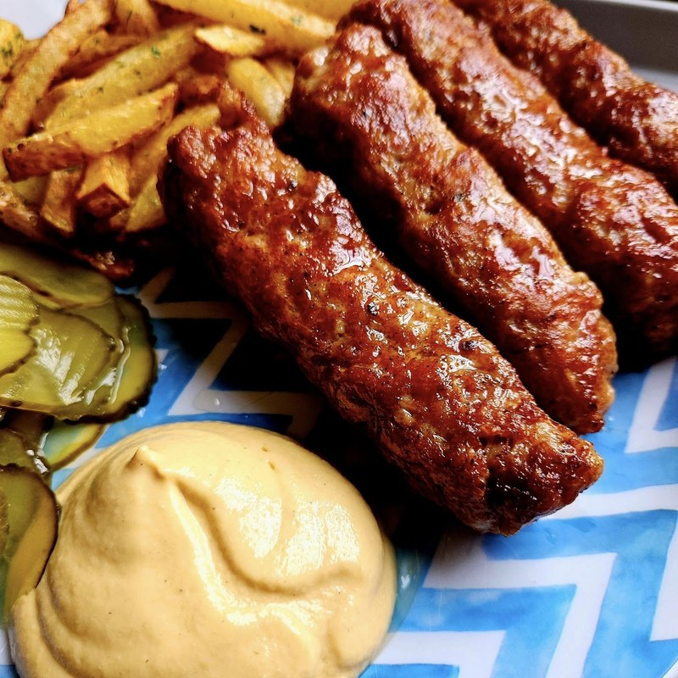 | 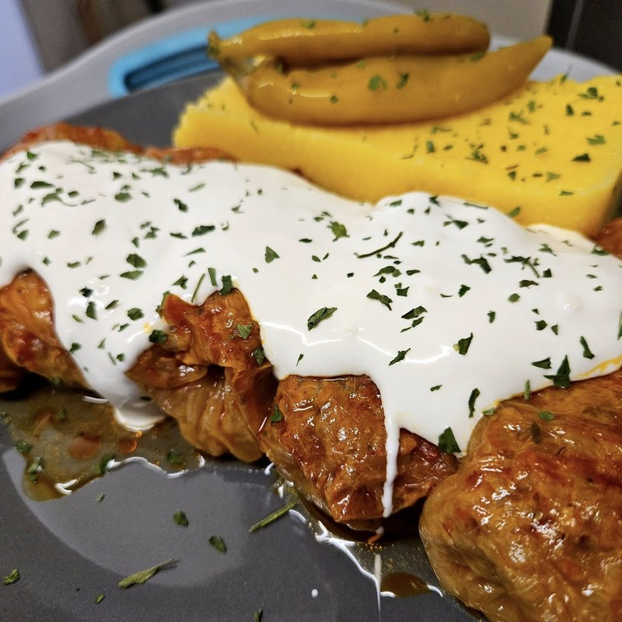 | 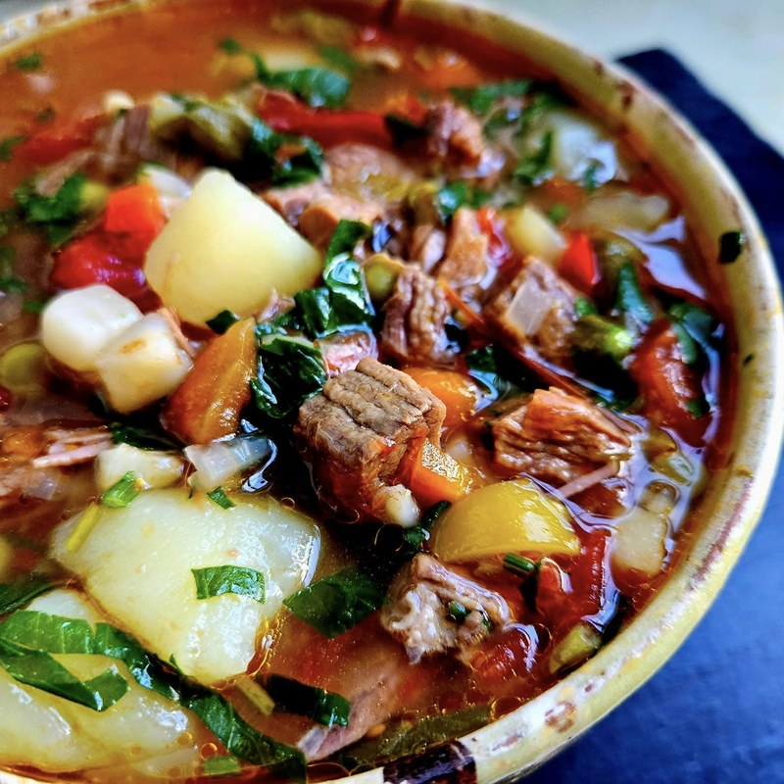
Grilled skinless sausages with chips | Stuffed cabbage rolls | Beef and vegetable soup
Figure 2: Eastern European home-style dishes (Source: author's own photographs, 2025)

1.3 Environmental sustainability and community support
Investors increasingly favour responsible businesses, so I have built sustainability and community support into my plan:
- Local sourcing: Meat will be bought from a Worcestershire butcher and seasonal vegetables from Vale of Evesham growers. This reduces food miles and supports local firms.
- Less waste: Only compostable or recyclable packaging will be used and customers who bring their own container will receive 10% off. Food waste and dry recycling will be separated which Simpler Recycling rules require from all businesses, including micro-firms from March 2027 (Royal Borough of Greenwich, n.d.).
- Community: Leftover vegetables will be used in the daily soup, unsold food will be donated to a local food bank and the bistro will create a local part-time job.

1.4 Legal format and management structure
The business will trade as a sole trader. A sole trader owns and runs the business alone, keeps all the profits and is personally liable for its debts (Mariotti and Glackin, 2017). I chose this format because it is quick and cheap to set up. I only need to register with HMRC for Self Assessment, and I keep full control of decisions. The main disadvantage is unlimited liability. Barrow and Brown (2012) explain that careful planning and suitable insurance reduce this risk, so public and employers' liability insurance has been included in the budget. Because the business will not borrow any money, the risk is lower. Becoming a limited company is considered once profits grow.
As owner and head chef, I will manage the cooking, purchasing, staff and finances. I hold a Level 2 Food Hygiene certificate. Since 2017 I have worked in warehouse operations at DHL Supply Chain, where I learned stock control, health and safety and teamwork. I will employ one local part-time kitchen and counter assistant for 25 hours a week. An external accountant will handle bookkeeping and VAT returns.
Figure 3: Management structure of Polonicul Bistro (author's own)
Owner and Head Chef
Nicolae-Daniel Toma (sole trader, full-time)
Menu and cooking · purchasing and stock control
Food safety and allergens · staff · marketing · finances
Kitchen and Counter Assistant
Part-time employee, 25 hours a week
Food preparation · serving · orders · cleaning
External support (contracted, not employed)
External Accountant
Bookkeeping, VAT returns
and Self-Assessment
Local Suppliers
Worcestershire butcher and
Vale of Evesham growers
Delivery Partners
Just Eat and Uber Eats
(delivery orders)
Solid line: employed and reports to the owner Dashed line: external support, not employed

2. Market Research

2.1 PESTEL analysis
A PESTEL analysis was used to examine the external factors that will affect my bistro. Each factor is explained below and summarised in Figure 3.
Political: From April 2026, small retail, hospitality and leisure properties pay business rates at a lower multiplier of 38.2p, and small businesses can still receive rate relief (Camden Council, 2026). As the unit will be small, the bistro is expected to pay little or no business rates, which reduces fixed costs.
Economic: The National Living Wage rose by 4.1% to £12.71 an hour in April 2026 (ACS, 2025). Wages will be one of my biggest costs, so the bistro will start with only one part-time employee and budget £13.50 an hour to allow for future rises. On the positive side, food inflation slowed to 1.7% in June 2026 (Thakadu, 2026), which should help keep menu prices stable.
Social: Worcester's diverse population (Office for National Statistics, 2022) and the trend towards convenience food support a menu that mixes cultures. However, customers are price-conscious, so the portions and prices must offer good value.
Technological: Delivery apps handle around 50–70% of UK takeaway orders but charge between 14% and 30% commission (Whitmore, 2026). The bistro will use them to reach new customers but encourage direct orders to protect my profit margin.
Environmental: Under Simpler Recycling, businesses must arrange separate collections for food waste and recycling (Royal Borough of Greenwich, n.d.). The bistro will comply from opening day and promote this approach to customers.
Legal: A food business must register with the local city council at least 28 days before trading, receives a food hygiene rating and must provide information on the 14 allergens (Small Business Guide, n.d.). The bistro will register in November 2028 and aim for a 5-star hygiene rating.
P  Political | Business rates – small hospitality units pay a lower 38.2p multiplier (Camden Council, 2026).  Rate relief – small premises may pay little or no business rates.
E  Economic | Rising wages – National Living Wage up 4.1% to £12.71 (ACS, 2025).  Food inflation – slowed to 1.7%, helping stable prices (Thakadu, 2026).
S  Social | Diverse population – 6.6% "Other White", 5.6% Asian (Office for National Statistics, 2022).  Convenience – busy workers want quick, hot meals.
T  Technological | Delivery apps – 50–70% of orders, 14–30% commission (Whitmore, 2026).  Social media – low-cost promotion through short videos.
E  Environmental | Simpler Recycling – food waste and recycling collected separately (Royal Borough of Greenwich, n.d.).  Packaging – compostable packaging may cost more.
L  Legal | Registration – register with the council 28 days before trading (Small Business Guide, n.d.).  Allergens – the 14 allergens must be declared.
Figure 3: PESTEL analysis for Polonicul Bistro (author's own)

2.2 Competition
Worcester's takeaway market has many outlets selling similar, but not identical, food. Nearby competitors were compared using their Deliveroo menus (Table 2). German Doner Kebab is a national chain that charges £9.79 for a kebab. Lowesmoor Fish Bar competes on low prices, with kebabs from £6.40. Polonicul Bistro will not compete on the lowest price. Instead, it will compete on freshness, home-made recipes and generous portions. Indirect competitors include nearby Indian and Asian restaurants and supermarket meal deals. Against these, the bistro offers a hot, freshly cooked meal at a fair price.
Competitor | Type | Example price | My advantage
German Doner Kebab | Direct (chain) | Kebab £9.79 | Home-made, fresh
Lowesmoor Fish Bar | Direct (budget) | Kebab £6.40 | Quality, portions
Purbani / Noodle Hut | Indirect | Mid-price | Different cuisine
Supermarket meal deals | Indirect | Cold lunch | Hot, cooked to order
Table 2: Key competitors (author's own research using Deliveroo, October 2026)

2.3 SWOT analysis
A SWOT analysis compares a business's internal strengths and weaknesses with its external opportunities and threats (Barrow and Brown, 2012). Figure 4 shows the SWOT analysis for Polonicul Bistro.
Strengths | Weaknesses | Opportunities | Threats
▪ Home-made food, cooked to order  ▪ Unique mix of Eastern European and street food  ▪ Food hygiene and stock-control skills  ▪ Self-funded, no debt | ▪ New brand with no customers yet  ▪ Limited savings for unexpected costs  ▪ Small team and premises  ▪ Reliance on the owner | ▪ Diverse local population  ▪ Growth of delivery and online orders  ▪ Lower business rates for small units  ▪ Local partnerships and events | ▪ Chains and cheap takeaways  ▪ Rising wage costs  ▪ High delivery app commission  ▪ Changes in food prices
Figure 4: SWOT analysis for Polonicul Bistro (author's own)
The main strength, fresh home-made food, matches the opportunity of Worcester's diverse population. Because the brand is new, the marketing focuses on building awareness quickly, and rising costs will be managed by starting with one employee.

3. Marketing Communications

3.1 Target customers and location
The bistro will target three groups. The first is working adults aged 25–44 within three miles of the shop, looking for lunch or an evening meal. The second is Worcester's Eastern European community, who want familiar home-style food. The third is students and young people who want good-value hot food. The food social media page already reaches this audience: 74.7% of its followers are aged 25–44, and half live in Worcester (Figure 5).
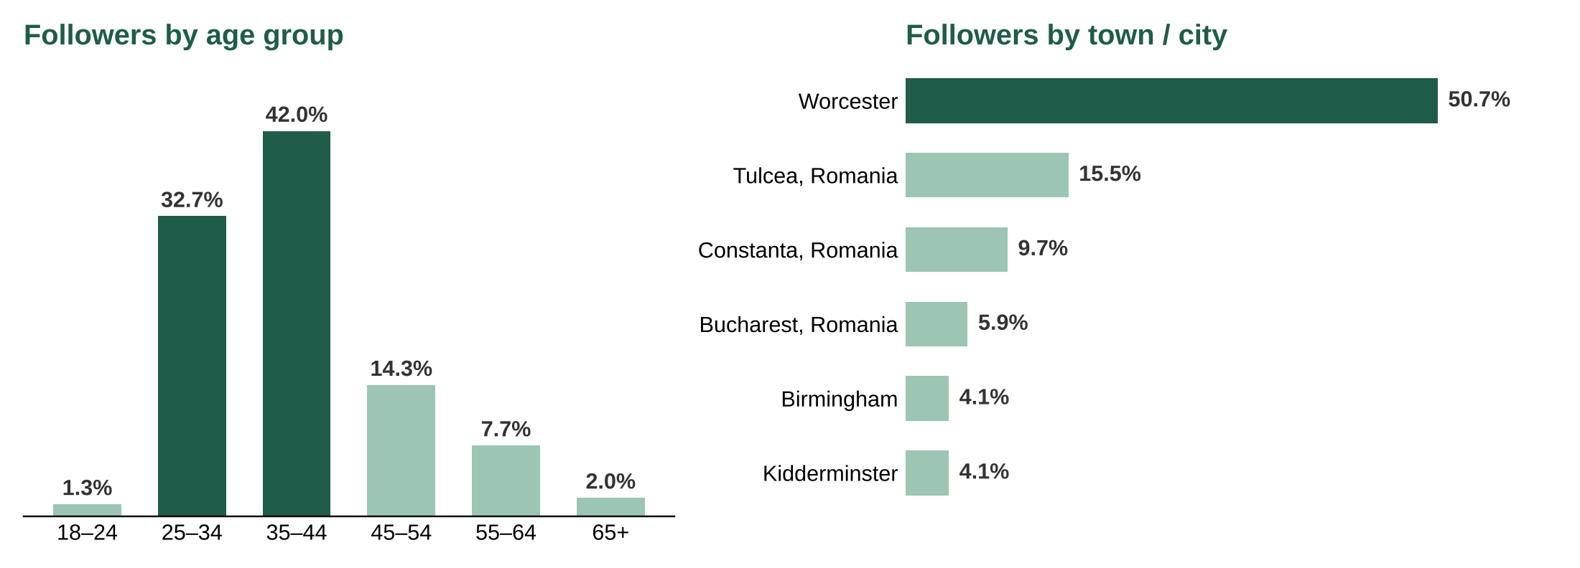
Figure 5: Age and location of the followers of my food social media page (Source: author's own Facebook Insights data, 2026)
Location is critical for a takeaway, so Lowesmoor has been chosen. It is a busy road on the edge of the city centre, near a large Asda superstore, offices and bus routes, which brings steady walk-in footfall. Worcester's high street is also performing well. Footfall rose by 0.3% in a year when visitor numbers in other cities fell by 3.2% on average, and it peaked at nearly 2.4 million visitors in December (The Business Magazine, n.d.).

3.2 Marketing strategy
Before opening, Facebook, Instagram and TikTok pages will be created to share short videos of dishes being cooked. After opening, a "menu of the day" every evening to bring customers back. A small paid Facebook advertising budget will target people aged 25–44 in Worcester. A Google Business Profile with photos and opening hours will help the bistro appear in "takeaway near me" searches, and satisfied customers will be asked to leave reviews.
The bistro will be listed on Just Eat and Uber Eats to reach customers who prefer delivery. Because of the high commission these apps charge (Whitmore, 2026), the app prices will be about 10% higher. Each delivery bag will contain a leaflet offering a discount for ordering directly next time.
For the launch, a free tasting evening will be held for local residents and businesses and offer 20% off in the opening week. Leaflets will be delivered to nearby offices and student houses. A loyalty card (tenth meal free) will encourage repeat visits, and links will be build with local Eastern European shops and community groups.

4. Financials

4.1 Funding required and source
The business needs £22,000 to open and run Polonicul Bistro for the first month. I will fund it entirely from my personal savings, built up from my job at DHL. Personal funding means that entrepreneurs invest their own money in the business (Mariotti and Glackin, 2017). I chose this option for three reasons:
- There are no loan repayments or interest charges, so all profit stays in the business.
- I keep 100% ownership and control. With business angels, I would have to give away a share of the business.
- Investing my own money shows my commitment to suppliers, the landlord and customers.
The disadvantage is that I risk my own savings. To manage this, about £4,500 will be kept in the bank after the first month as a safety buffer.

4.2 Start-up expenses in the first month
The main start-up expenses in January 2029 are refurbished kitchen equipment (£8,500), the rent deposit and first month's rent (£5,200), and shop fit-out and signage (£2,500). Running costs include food and packaging (about 34% of sales, plus opening stock), one part-time employee (£1,500) and launch marketing (£750). Sales are forecast at around 30 meals a day over 26 trading days, at an average of £11.25 excluding VAT, which gives first-month sales of £8,775. The business will register for VAT because yearly turnover is expected to pass the current £90,000 threshold. The cash flow forecast for the first month is shown in Section 4.3. Out-flows are higher than sales because most start-up costs are paid only once, so the business will finish the month with £4,504 in the bank.

4.3 Cash flow forecast (Month 1)
CASH FLOW – January 2029
 | MONTH (£)
Cash in | 1
Personal savings – start-up capital | £22,000
Sales (total sales of product and/or services) | £8,775
Other | £0
Total cash in-flows (A) | £30,775
 | MONTH (£)
Cash out-expenses | 1
Rent or premises costs (3-month deposit + January rent) | £5,200
Business rates for your business premises | £0
Utilities (gas, electricity, water) | £700
Insurance | £100
Telephone and internet | £50
Marketing and advertising expenses | £750
Vehicle running costs | £100
Equipment purchase or leasing | £8,500
Postage, printing, stationery | £150
Transport and delivery | £0
Professional fees (legal, accounting etc.) | £800
Cost of sales (Cost of product) | £3,784
Wages your own | £1,200
Staff wages | £1,500
Shop fit-out and signage | £2,500
Delivery app and card fees, waste and cleaning | £937
Total cash out-flows (B) | £26,271
Your net cash flow (A-B) | £4,504
Table 3: First-month cash flow forecast, sales excluding VAT (author's own).

Reference List
ACS (2025) National living wage rise to £12.71 in April 2026. Available at: https://www.acs.org.uk/news/national-living-wage-rise-ps1271-april-2026 (Accessed: 21 October 2026).
Barrow, P. and Brown, R. (2012) The business plan workbook. 7th edn. London: Kogan Page.
Camden Council (2026) Business rates explained 2026 to 2027. Available at: https://www.camden.gov.uk/business-rates-multiplier-2026-to-2027 (Accessed: 21 October 2026).
Mariotti, S. and Glackin, C. (2017) Entrepreneurship: starting and operating a small business. 4th edn. Harlow: Pearson.
Office for National Statistics (2022) Census 2021: ethnic group (TS021) – Worcester. Available at: https://censusdata.uk/e07000237-worcester/ts021-ethnic-group (Accessed: 21 October 2026).
Royal Borough of Greenwich (n.d.) New waste requirements for businesses: Simpler Recycling rules. Available at: https://www.royalgreenwich.gov.uk/info/200171/recycling_and_rubbish/2593/new_waste_requirements_for_businesses_simpler_recycling_rules (Accessed: 21 October 2026).
Small Business Guide (n.d.) How to start a food business. Available at: https://www.smallbusinessguide.co.uk/starting-up/how-to-start-food-business (Accessed: 21 October 2026).
Thakadu, A. (2026) 'Food and drink inflation slows down in June', Grocery Gazette, 22 July. Available at: https://www.grocerygazette.co.uk/2026/07/22/food-and-drink-inflation-slows-down-in-june/ (Accessed: 21 October 2026).
The Business Magazine (n.d.) Worcester's high street success despite national decline in retail footfall. Available at: https://thebusinessmagazine.co.uk/companies/worcesters-high-street-success-despite-national-decline-in-retail-footfall/ (Accessed: 21 October 2026).
Whitmore, J. (2026) UK takeaway marketing data. Whito. Available at: https://whito.co.uk/research/uk-takeaway-marketing-data/ (Accessed: 21 October 2026).

