

Student name: Sarolta Beri
Student ID: 2314149

Module name: Psychopathological Classifications and Provisions
Module code: (BMHP6029_LON)

Understanding Chronic Insomnia
Sarolta Beri
Introduction  Classification:  Sleep-wake disorders  Around 1 in 10 adults (≈10%) meet the criteria for chronic insomnia disorder, meaning their sleep problems occur at least three nights per week for three months or more, with associated daytime symptoms such as fatigue, poor concentration, irritability (Rosenberg et at., 2021).  - Short-term insomnia symptoms affect roughly 30–35% of adults at any given time (Mutchler, 2024). 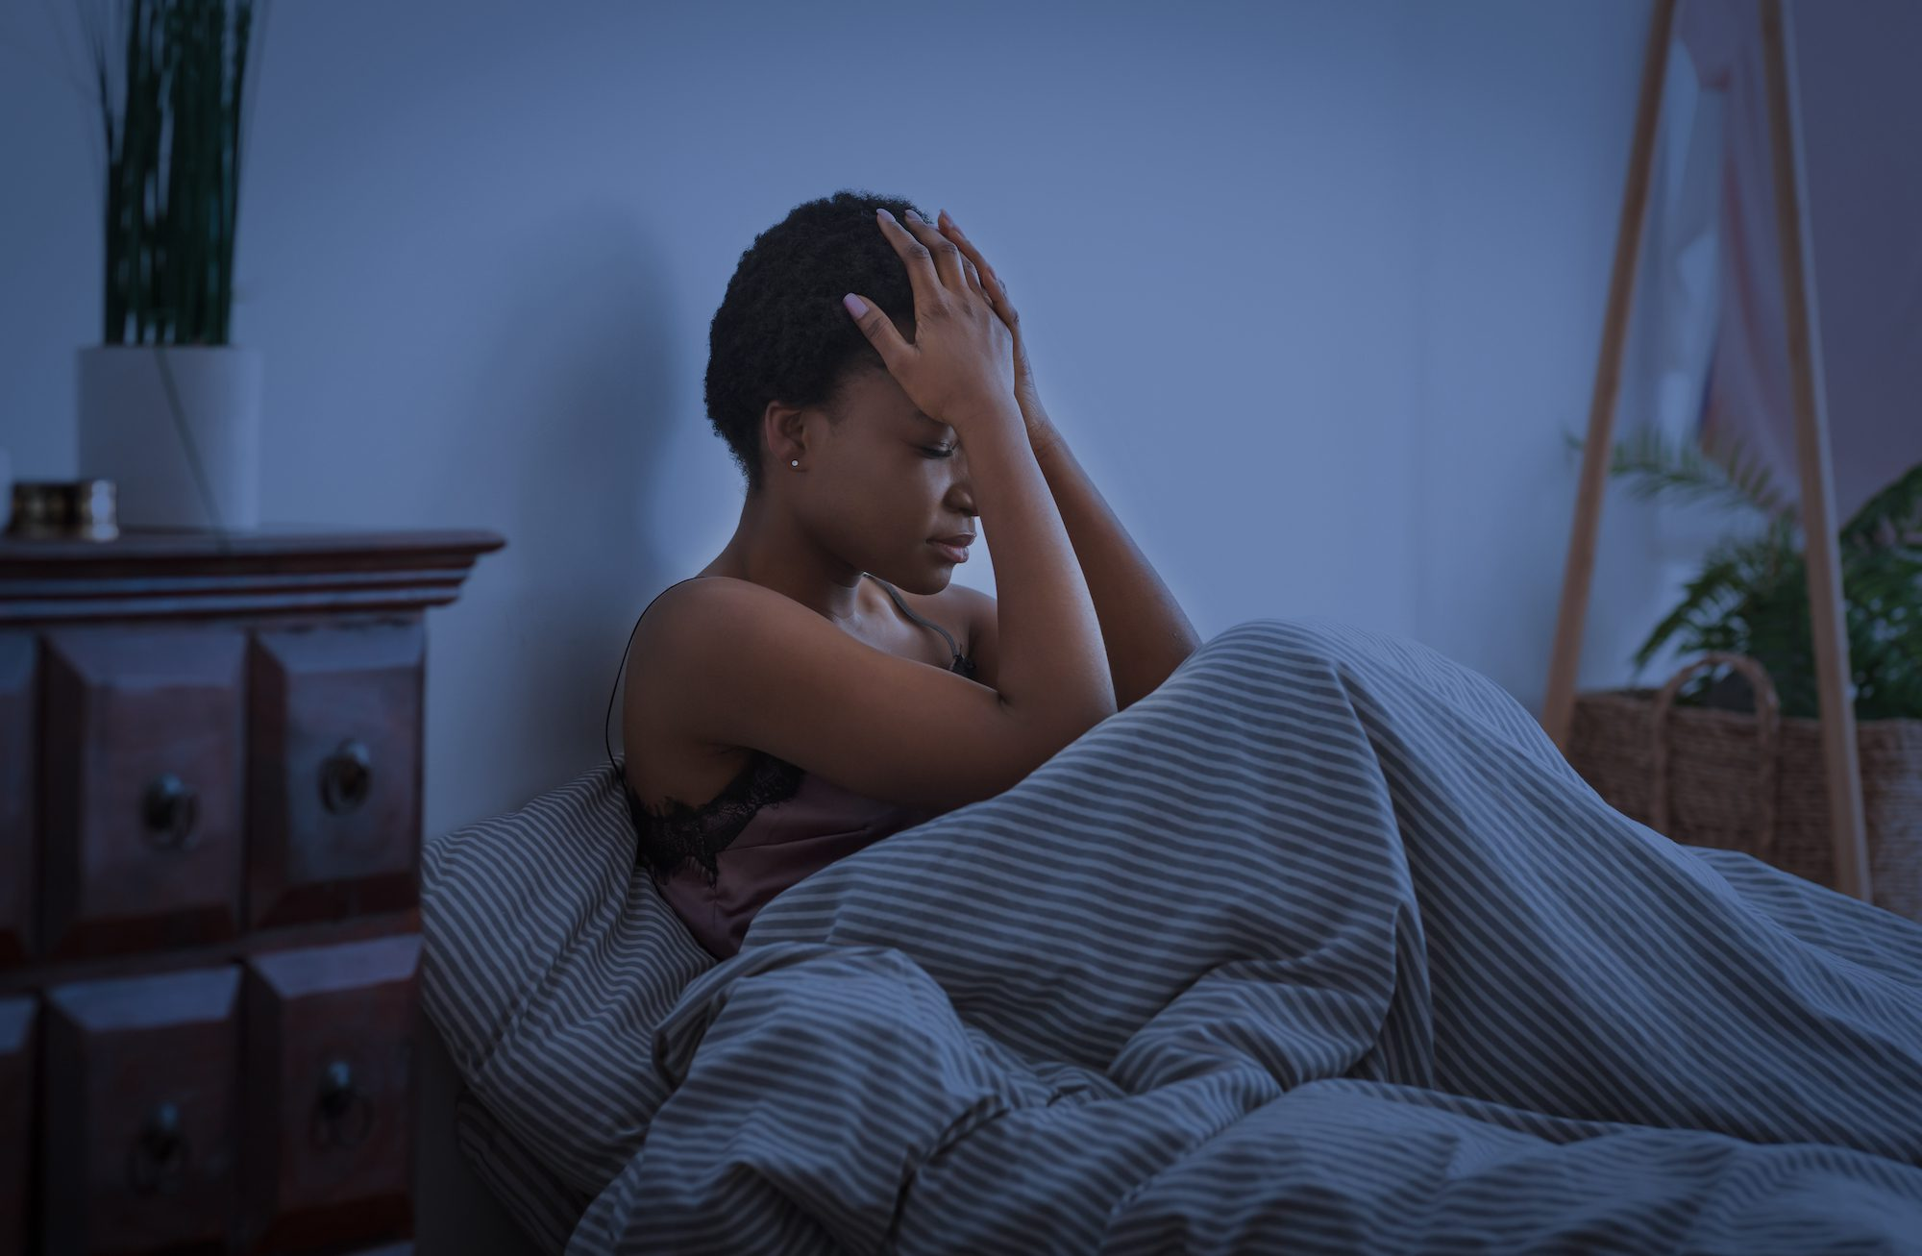  (Summer, 2022).  Historical perspectives and treatments    (Eloisa, 2025)  Before the 19th century, people commonly slept in two segments, so waking in the middle of the night wasn’t seen as insomnia. The term, first noted in Thomas Elyot’s Bibliotheca Eliotae (1542), became common only after this biphasic pattern faded, suggesting that modern middle-of-the-night insomnia may be a remnant of earlier sleep habits (Eloisa, 2025). |  | Chronic Insomnia  (Pixabay, 2025)  Definition  Persistent difficulty in sleeping for at least three nights per week (Libman, H. et al.,2022).  Causes  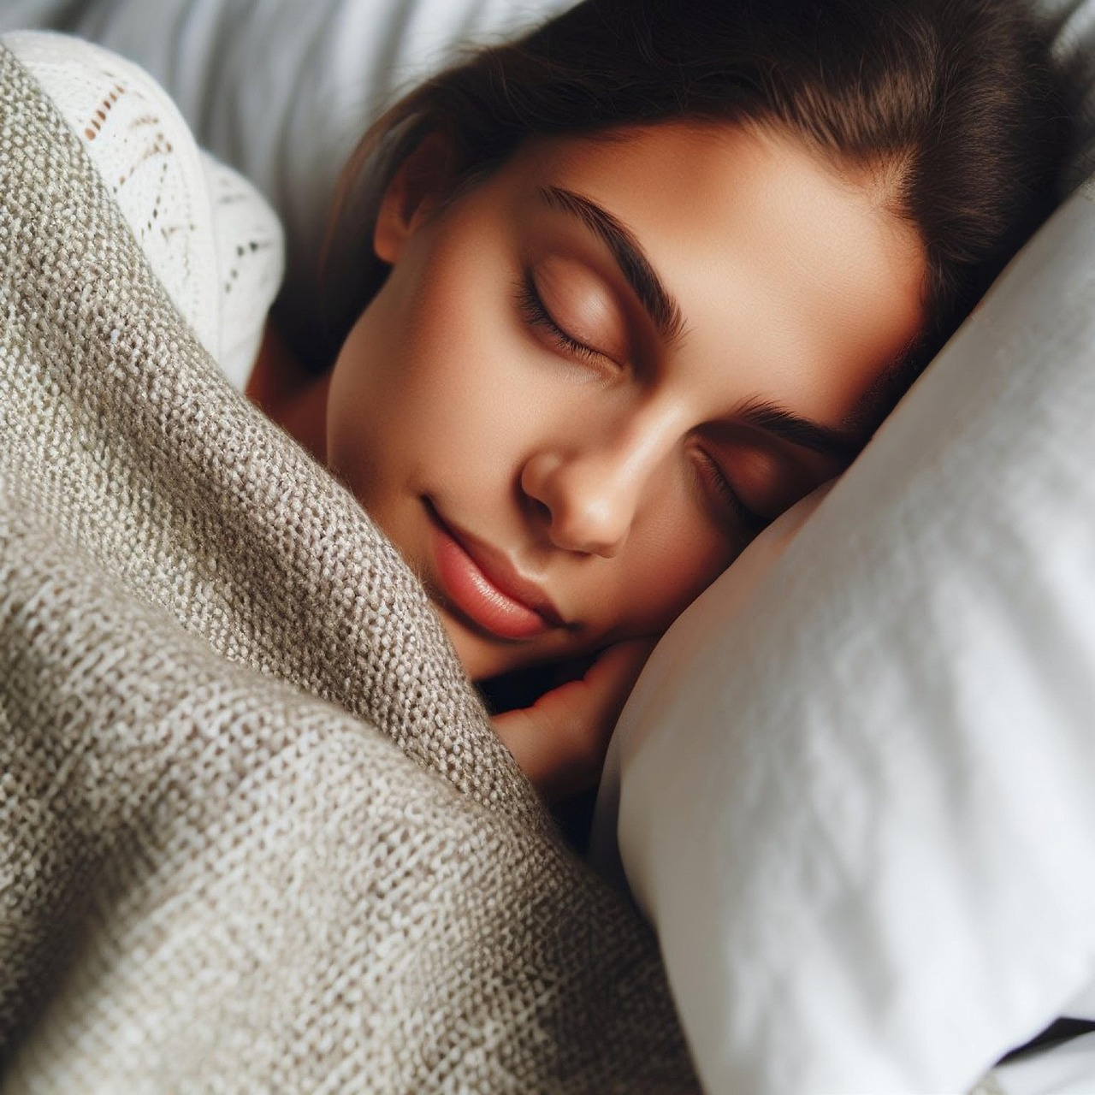  Psychological conditions such as anxiety, depression, and stress are commonly associated with insomnia, with stress identified as a precipitating factor through cognitive, endocrine, neurological, and behavioral pathways indicative of hyperarousal (Drake et al., 2003).  Diagnosis  - A detailed sleep history (patterns, duration, quality, and routines).  - Assessment of daytime functioning and impact on daily life.  - Review of medical, psychiatric, and medication history.  - Use of sleep diaries or questionnaires (e.g., Insomnia Severity Index).  - Occasionally, polysomnography or actigraphy if another sleep disorder is suspected  (Lauren, 2025). |  | Symptoms  - Have trouble falling asleep  - Wake up multiple times throughout the night  - Spend long periods lying awake  - Wake up too early and can’t fall back asleep  - Feel unrefreshed or exhausted in the morning  - Struggle to nap during the day despite feeling worn out  - Feel fatigued and easily irritated during the day  - Have difficulty focusing because of tiredness  (NHS, 2024).  Current services and treatments  Therapy for Insomnia (CBT-I)  Sleep hygiene education  Relaxation techniques  - Stimulus control therapy  - Sleep restriction therapy  - Pharmacological treatments  - Online and digital CBT-I programs  - Specialist sleep clinics  - Lifestyle and complementary approaches  Cognitive Behavioural  (Hood et al., 2014).  Recommendations  It is recommended that individuals with persistent insomnia seek professional evaluation and evidence-based treatment such as CBT-I to improve sleep and reduce associated health risks (Samajdar, S.S. et al., 2025).  Conclusions  In conclusion, insomnia is a common yet treatable condition, and early recognition with appropriate management can significantly improve overall health and quality of life.

References
Benz, F. et al. (2023) ‘Insomnia symptoms as risk factor for somatic disorders: An umbrella review of systematic reviews and meta‐analyses’, Journal of sleep research, 32(6), pp. e13984-n/a. Available at: https://doi.org/10.1111/jsr.13984. (Accessed 5 November 2025).
Drake, C.L., Roehrs, T. and Roth, T. (2003) ‘Insomnia causes, consequences, and therapeutics: An overview’, Depression and anxiety, 18(4), pp. 163–176. Available at: https://doi.org/10.1002/da.10151. (Accessed: 05 November 2025).
Eloisa Ocando Thomas (2025). History of sleep. [online] Available at: https://warwick.ac.uk/fac/arts/history/students/research_opportunities/cabinets_of_curiosity/history_of_sleep (Accessed 5 November 2025).
Hood, H.K., Rogojanski, J. and Moss, T.G. (2014) ‘Cognitive-Behavioral Therapy for Chronic Insomnia’, Current treatment options in neurology, 16(12). Available at: https://doi.org/10.1007/s11940-014-0321-6. (Accessed 5 November 2025).
Lauren Fountain (2025) Diagnosing Insomnia. Available: Diagnosing Insomnia | Sleep Foundation (Accessed 5 November 2025).
Libman, H. et al. (2022) ‘How Would You Manage This Patient With Chronic Insomnia?: Grand Rounds Discussion From Beth Israel Deaconess Medical Center’, Annals of internal medicine, 175(12), pp. 1746–1753. Available at: https://doi.org/10.7326/M22-2817. (Accessed: 02 November 2025).
Mutchler, C. (2024). Insomnia Facts and Statistics: What You Need to Know. [online] Verywell Health. Available at: https://www.verywellhealth.com/insomnia-facts-and-statistics-5498718. (Accessed 5 November 2025).
NHS (2024). Insomnia. [online] NHS. Available at: https://www.nhs.uk/conditions/insomnia/. ((Accessed: 23 November 2025).
Rosenberg, R., Citrome, L. and Drake, C.L. (2021) ‘Advances in the Treatment of Chronic Insomnia: A Narrative Review of New Nonpharmacologic and Pharmacologic Therapies’, Neuropsychiatric disease and treatment, 17, pp. 2549–2566. Available at: https://doi.org/10.2147/NDT.S297504. (Accessed: 02 November 2025).
Samajdar, S.S. et al. (2025) ‘A Comprehensive Approach to Diagnosis and Management of Insomnia: An Integrative Review with a Focus on Healthcare Perspectives’, Journal of Association of Pulmonologist of Tamil Nadu. 2nd edn, 8(2), pp. 65–71. Available at: https://doi.org/10.4103/japt.japt_4_25. (Accessed 5 November 2025).
Summer, J. (2022). Irregular Sleep-Wake Rhythm Disorder. [online] Sleep Foundation. Available at: https://www.sleepfoundation.org/circadian-rhythm-sleep-disorders/irregular-sleep-wake-rhythm-disorder. (Accessed: 18 November 2025).
woman sleeping. Available: Download Woman, Sleep, Bed. Royalty-Free Stock Illustration Image - Pixabay (Accessed 5 November 2025).
Pixabay (2025)

