BEng (Hons) Engineering Portfolio
L4 – Quality & Business Improvements
Process Improvement Methodologies
Student number: 1902951

Contents
Introduction
Description of “Lean” Manufacturing:
Description of “six sigma”:
What it means for lean and six sigma.
Elements of DMAIC
Define – Tools used.
Measure – Tools used.
analyse – Tools used
Improve – tools used
Control – tools used.
Principles of “Lean” implementations.
Conclusion:
Introduction:
This report presents a detailed analyses of the methodologies, “lean” and “six Sigma” that Plant operations and other marketing operations use for process improvement. This paper will investigate the elements that six sigma technique uses and how to implement them. Discussions will be made around the advantages the provider can gain from these techniques. This report will go in depth around the principles of “Lean” implementations and how a company can optimise operational performances.
Description of “Lean” Manufacturing:
Lean is a systematic approach in the reduction of waste or elimination of a process that does not add value to manufacture procedure. In 1908 Henry Ford (1863-1947), the famous car manufacturer and founder of the Ford Motor Company, introduces the “Model T”. A revolutionary vehicle that brought mass-production methods, interchangeable parts and large production plants, which featured the world’s first moving assembly line. This innovation created a solution to overwhelming demand of products and is still used in today’s manufacturing companies. The novelty of this process was the back bone behind industry’s production process and is a classic example of the improvement of a flow process of a product. Lean is about making processes less complicated, faster and easier to complete by doing more with less. Through-out the 1960’s the “TOYOTA” motor company gradually developed a management system called the Toyota Production System (TPS) which focused on the term “Muda”. The history behind Lean manufacturing was key for its development in the manufacturing industry, where by companies can cut their costs by reducing their waste.

Description of “six sigma”:
Six sigma is a business management strategy that seeks to improve the quality of a process output by identifying and eliminating the roots of any defects. The methodology focuses on manufacturing products with a 3.4 defects per million products with a success rate of 99.9997%, this is the use of minimizing inconsistency in manufacturing and business processes. The practices that Six sigma uses emphasizes the removal of wasteful steps in a process and exploiting the systems advantages. Six sigma was developed by Mikel Harry and Bill Smith at Motorola in the late 1980s which has roots back to William Deming with the principles of the PDCA (Plan, Do, Check, Act) cycle and total quality management. The use of Six Sigma is the reduction of the variations between the quality of goods which will achieve a lesser average that the quality is defected by, this method is based around being consistent. Following the initiation of Motorola’s efforts by using six sigma the company achieved a 200 fold improvement. This is a clear example by using Six sigma’s statistical quality assurance methods it will ensure excellence within the organization
What it means for lean and six sigma.
The meaning of “lean six sigma” is having multiple business improvement techniques that will increase profits, better customer satisfaction and improve production flow. The objective that management have to take into consideration is choosing the precise method for the right system. “DMAIC” is one of “lean six sigma” business improvement techniques that consists of five phases Define, Measure, Analyse, Improve and Control. DMAIC steams from Mikel Harry and Bill Smith six sigma projects that was later developed by the likes of GE (General Electric) in 1997, who added the Define stage to the process. The reasoning behind effectiveness of DMAIC B.ReVelle (2001) states (chapter 14.2.2.1 six sigma DMAIC) “DMAIC, originated as an approach to rectify quality problems on the manufacturing floor. It has also proven effective in addressing quality problems throughout an organization, including transactional and design issues.” . Under this bases DMAIC is a key improvement technique that a company will benefit from its practice by following the 5 elements.

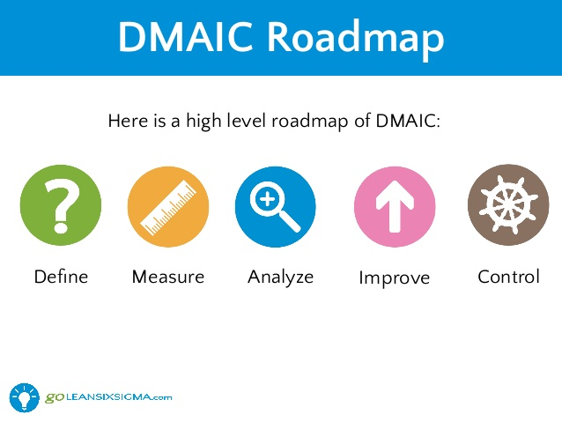
(https://www.slideshare.net/goleansixsigma/free-lean-six-sigma-white-belt-training-goleansixsigmacom, n.d.)

Elements of DMAIC
Define.
The first phase in the Lean six sigma methodology is the defining process, this process is the start of any project that would scope out the perimeters of the projects topic and what would it involve. It is important to note the capabilities of the systems performances before the effects this process will implement. The define phase is seeking a goal for the project to achieve, mainly targeting the customer requests. The number of techniques that this phase can implement is listed below:
- Project charter.
- Cost of poor quality (COPQ).
- Product, process performance metrices.
- Critical to Matrix (CT).
- High-level process map (SIPOC).
- Pareto Chart.
- Voice of the customer.
- Kano Analysis.
- Survey Design.
High-level process map (SIPOC) is a process map that depicts the operations with in a system that the project is focusing on. The output and customers requires are listed to set targets for the project. Using SIPOC the Inputs can be targeted for improvement to provide a better quality of product. Below is an example of a high-level process map in SIPOC.
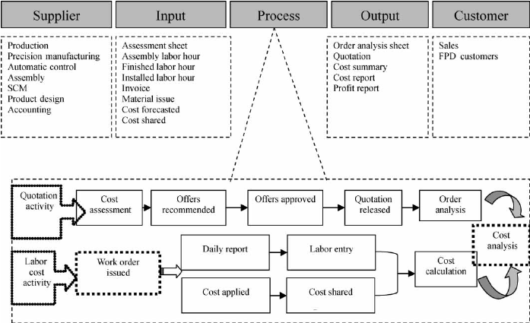
(https://www.researchgate.net/figure/The-high-level-process-map-with-project-scope_fig2_254348426, Jan 2011)
Measure
The measure phase of DMAIC is to establish the input and output variables and priorities of the current state accordingly with the estimated improvement targets. It is important at this stage that the Data is collected for the system and identifications of waste opportunities are made. In the measurement phase processes should be the numerical organisation of the project, which follows from define, for example the VOC (voice of customer) could identify a faults in the products design, then a CTQ (Critical To Quality) would target “on average how many faults occur in final product”. The number of techniques that this phase can implement is listed below:
- Critical To Quality (CTQ)
- Stakeholder analysis.
- Process Mapping.
- Spaghetti Chart.
- Check Sheet.
- 5s Analysis.
- Pareto Diagram.
- Measurement Systems Analysis (MSA).
- Process capability Analysis.
A good example of a measuring tool would be to have the data collected in The Pareto chart this will determine the most frequent problematic data. By narrowing down 20% of issues that should be concentrated on terminating, a success rate of 80% is to be suspected in the performance of the system. The example below shows the total number of defects in a product and has highlighted the most effective method of elimination by focusing on surface finish and blow holes to expect results.

(Quality Tools and Root Cause Analysis 20/05/2019)

Analyse:
Analyse Phase is the elimination of the variabilities with in the projects improvement methods, by identifying the root causes. At this stage management will analyse the metrices collected in the previous phase and what the data measured can improved. Below is the tools that can be use in the third phase of DMAIC:
- Ishikawa Diagram (fish bone Diagram).
- Cause and effect Matrix.
- Failure Mode and Effects Analysis (FMEA).
- Multi-Vari Chart.
- Correlation and Regression.
- Hypothesis testing.
- Design of experiment (DOE) Screening.
One of the key tools used in the Analyse phase is Ishikawa Diagram (fish bone Diagram) which will identify the estimated failures in the system. A Fish bone diagram is an insight to the possible defects associated with the system using primary and secondary causes. An example of a fish bone diagram is below and narrows down the “Blow hole” defects in a product.

(Quality Tools and Root Cause Analysis 20/05/2019)

Improve
The Improve phase of the DMAIC methodology will identify, prioritize and implement the improvements for the critical inputs found during the analyse phase. An action plan can come from the analysis an FMEA can provide, these list out what need to change in order to improve the process. The improvement phase requires the process to be updated or changed all together, visual management techniques are used to suggest the best areas in which to focus on. The site standard should be considered to help the production process of the system. Listed below are the techniques this phase concentrates on :
- Design of experiment (DOE).
- Mistake Proofing.
- Regression Analysis.
- 5s and Visual Management.
- KANBAN – Pull systems.
- Kaizen events waste elimination.
- Failure Mode and Effects Analysis (FMEA).
- Hypothesis Testing.
For a Simple example where these methods works is the improvement tool of a KANBAN system, it is the recording of stock levels or “to do tasks” and the replacement of them. It is a key tool for the improvement phase as it can be inspected visually, limits “Work in Progress” and manages operational flow. From research find in manufacturing handbooks, B.ReVelle (2001) Quotes “Kanban The theory of constraints was developed separately from lean, but the approaches are quite compatible. The primary focus is on maximizing how efficiently the organization’s resources deliver output. Defect reduction is a means to achieve this end.” Below is a brief diagram of a KANBAN system:
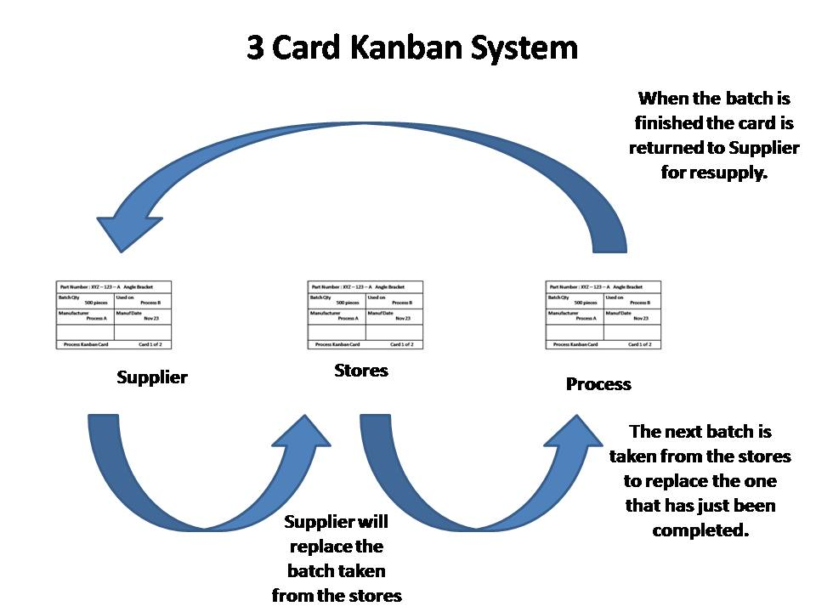
(http://leanmanufacturingtools.org/kanban/ n.d.)
Control.
This final stage of the DMAIC methodology is the control phase, this focuses on sustaining the improvements previously made in the DMAIC phases. Controlling process improvements need to be monitored and maintained, this can be proven through statistical data that the improvements are sustained. The operations are successful through the communications of this process, tools used are as follows:
- Control Plan.
- Control Chart.
- Audit plans.
- Mistake proofing established.
- Visual Management established.
- Total preventative Maintenance (TPM).
- Procedures/work instructions.
- Process Capability.
- Standardized operations procedures .
- FMEA.
The Standard operating procedures (SOP) is a document that utilizes the training and reference for all parties involved. This is a Step-by-step set of instructions that may assist a new standard of operation procedures. SOP’s would normally relate to a compliancy document or a competency folder, here is a simple example of a SOP :
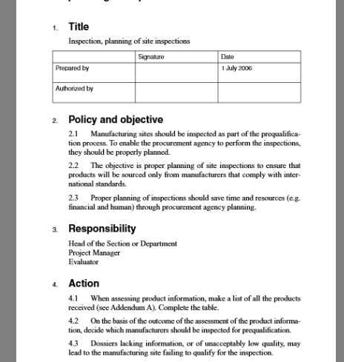

(https://www.pdffiller.com/jsfillerdesk14/?projectId=298763175&expId=5010&expBranch=3#e372229ffcb3426e93d72bb116134bb5 n.d)

Principles of “Lean” implementations.
Lean Implementation consists of communication from the management teams to input a lean system, this will be done by training all members of the organization on lean principles. The lean principles of MUDA identifies and tackles waste in a working environment these waste elements are:
- Overproduction
- Inventory
- Waiting
- Motion
- Transportation
- Rework / defects
- Over Processing
Overproduction can be overcome by implementing lean systems, by reducing the amount of parts wasted as a rework, reject or a spare can be recognised by using the DMAIC principles. Inventory is also part of the visual management systems, that if areas of inventory were to be investigated waste factors become visible, the implementation of this would be to reduce inventory and organise stocks and processes which will better opportunities that need addressing. Waiting can be a bottleneck in the production processes and relates to machine breakdowns, operation run times or even poor layout. An implementation of incorporating lean systems in this area would be to train operators in other tasks to fill this time and change the processes before it comes to this bottleneck. Motion can be a wasteful task in the workforce and can be down to poor housekeeping, work station layout and fatigue. A great method of overcoming this problem is to give work stations a shadow board for the tools to be in order for the operation, working standards can be displayed as a document to better the up keep of the working environment. Transportation can be down to poor use of space, this procedure has no value to its motion with an outcome that can damage parts with excessive movements. Transportation can be minimalized by the organisation of the plant and the inventory that is waste, stock check should be carried out and spare parts should be recycled. Rework/ defects can be time and cost effective, communication is key for implementing lean systems in this area as SOP’s will cover any unforeseen problem. G. Bralla has a great solution to ordering the correct material if the rework was down to graded metals: “for other processes, try to use materials that are formulated for easy processability. For example, for stamping or other formed metal parts, use metal alloys or grades that are specifically intended for easy formability , e.g., centain grades of brass that bend and flow eaily without problems. The brass maybe more expensive per unit weight or unit volume than mild steel, but when quantities are low, the added materials cost may be negligible in comparison with the overhead costs that can be saved.” Over processing is the lack of training or standards and overall affect the production procedures, if a bottle neck was to appear in the system it needs to be identified and updated.

Conclusion:
From these business management strategy that exploit the current systems with in a process or plant, it is world changing and effective enough to be a globally known. Companies such as Tata steel can utilize these methodologies by creating more storage arounds for the “Hot charged” Slabs, evidence shows below that the Hot connect process is a massive profit income, if the process was to incorporate a lean system by increasing space from a derelict part or the plant then the percentages will be much greater and the improvement techniques would have worked. To summaries this report the techniques that have been developed though the history of manufacturing and marketing systems have been very affective in their projects. The Impact that this project have upon a company can inspire new generation to create and develop new systems.
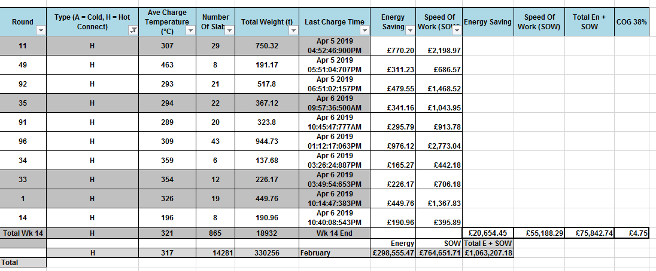
Plant flow diagram, Analysis & Poster. 20/05/2019

Bibliography
Jack B.ReVelle. (2001) “The manufacturing handbook of best practices” 1st edition (chapter14.2.2.1 six sigma DMAIC), 08/05/2019.

Linked in slide share, n.d, Free Lean six sigma training. https://www.slideshare.net/goleansixsigma/free-lean-six-sigma-white-belt-training-goleansixsigmacom, 20/05/2019.
ResearchGate, Jan 2011 Application of Lean Six Sigma to a panel equipment manufacturer. https://www.researchgate.net/figure/The-high-level-process-map-with-project-scope_fig2_254348426, 20/05/2019
(Quality Tools and Root Cause Analysis 20/05/2019)

(Quality Tools and Root Cause Analysis 20/05/2019)

Jack B.ReVelle (2001) “The manufacturing handbook of best practices” 1st edition edited (“Kanban (“pull”system production and just-in-time inventory), 20/05/2019
Lean Manufacturing tools, n.d. How Does a Kanban Card System Work. http://leanmanufacturingtools.org/wp-content/uploads/2016/10/Slide5.jpg 20/05/2019
Pdffiller,n.dhttps://www.pdffiller.com/jsfillerdesk14/?projectId=298763175&expId=5010&expBranch=3#e372229ffcb3426e93d72bb116134bb5 20/05/2019

Design for manufacturability handbook edited by james G. Bralla (n.d) second edition (Chapter DFM for low quantity production 9.9 ) 08/05/2019

(Plant flow diagram, Analysis & Poster. 20/05/2019)

