LCBB4001 Accounting Fundamentals

Student Name: Elitsa Yankova
Student ID:2030401

Table of Contents
1. (a) Profit and Loss statement – Kedison PLC 3
Statement of Financial Position – Kedison PLC 5
1. (b) Explanations of Position of Financial Statement being balanced in both sides 7
2 (a) Ratio Calculation 8
2. (b) Analysis of Chocco plc and interpretation of its ratios 11

1. (a) Profit and Loss statement – Kedison PLC
From the given data of Kedison PLC, a Statement of Profit and Loss is presented below to highlight their financial performance in the period of 2020.
Statement of Profit and Loss
Eccles plc
For the year ended 31 December 2018
 |  | (£) | (£)
Revenue | W1 |  | 827,630
(-) Cost of Sales |  |  | (578,650)
Gross Margin |  |  | 248,980
(-) Operating costs:
Administration costs
Directors remuneration 5,000
Other Admin. Costs 30,000 |  | 35,000
Sales and distribution costs:
Sales Commission 3,000
Distribution costs 28,000 |  | 31,000
Total Operating Costs |  |  | 66,000
Operating Income |  |  | 182,980
(-) Interest expense | W2 |  | 4,000
Income before tax |  |  | 178,980
(-) Corporate Income Tax |  |  | 68,000
Net Margin |  |  | 110,980

Workings:
1. Revenue
Sales of £980 were delivered to customers but did not recorded. So, this is credit sales for the company. So, total sales –
Revenue | 826,650
(+) Credit Sales | 980
Net Revenue |  | £827,630
2. Interest expense
Interest expense in 2020  [100,000 * 4%] | £4000
(-) Interest Paid during the year 2020 | (2000)
Interest Due |  | £2000

Statement of Financial Position – Kedison PLC
From the given data of Kedison PLC, a Statement of Financial Position is presented below to highlight their financial performance in the period of 2020.
Statement of Financial Position
Eccles plc
For the year ended 31 December 2018
 |  | (£) | (£)
Assets
Fixed Assets:
Plant and equipment |  |  | 632,730
Current Assets:
Stock (31 December 2020) |  | 330,600
Cash and bank |  | 12,900
Debtors | W1 | 171,105 | 514,605
Total Assets |  |  | 1,147,335
Equity and Liabilities
Equity:
Ordinary shares |  | 310,000
Preference shares |  | 300,000
Retained Profits:
Retained profits (1 January 2020) 132,000
(+) Net Margin 110,980
242,980
(-) Ordinary dividend paid (20,000)
Preference dividend paid (30,000) |  | 192,980
Total Equity |  |  | 802,980
Non-Current Liabilities:
Debentures |  |  | 100,000
Current Liabilities:
Trade Creditors |  | 171,355
Tax Payable |  | 68,000
Interest Due | W2 | 2,000
Accrued Sales Commission |  | 3,000 | 244,355
Total Equity and Liabilities |  |  | 1,147,335

Workings:
1. Debtor
Debtors | £ 170,125
(+) Credit Sales | 980 | £ 171,105
2. Interest expense
Interest expense in 2020  [100,000 * 4%] | £4000
(-) Interest Paid during the year 2020 | (2000)
Interest Due |  | £2000

1. (b) Explanations of Position of Financial Statement being balanced in both sides
The statement of financial status contains the balances of all accounts. The debit side of this sheet represents all assets, while the credit side represents all obligations and equity. Such remark is made in light of the fundamental accounting equation A= L + OE. Consequently, A denotes all assets, L denotes all liabilities, and OE denotes all owner's equity (Smith, 2018). Shareholders' equity is represented in a limited company's shareholders' equity. Revenues build equity, whereas expenditures and withdrawals decrease equity.
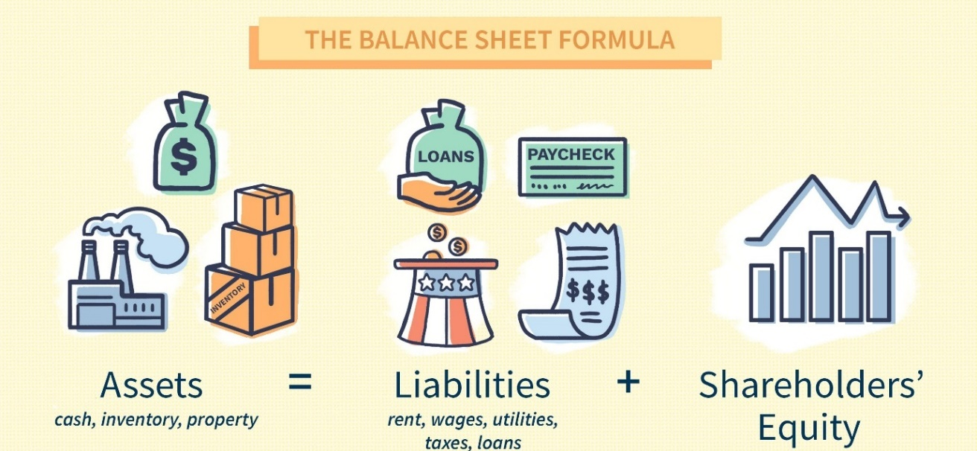
Figure 1: Balance Sheet formula (Warfield et al., 2017)
The balance sheet is always equal on both sides since it is prepared using a dual entry method. Due to the dual entry mechanism, each transaction has both debit and credit implications. Each transaction is assigned a debit and a credit entry (Broadbent and Laughlin, 2013). Occasionally, one account is debited and credited simultaneously, and occasionally, two or more accounts are debited and credited simultaneously. Due to the fact that this dual entry method maintains a balance on both sides, it simplifies the financial statement.
Utilizing a single-entry system may result in systemic instability and imbalance. A single-entry method is inconvenient and makes it difficult to maintain track of all transactions (Drury, 2013). Thus, when the dual entry method is employed to prepare a financial statement, all assets equal the total of the liabilities and the equity. The primary reason for this equality is that all assets and resources are obtained via debts and ownership.

2 (a) Ratio Calculation
Here all the required ratios have been calculated for the year of 2019 and 2020 –
1- ROCE = $\frac{Net income after tax}{Capital Employed } ×100$
2019 | 2020
$\frac{366}{2,912+ 4,129}$ ×100  = 5.20% | $\frac{431}{3,088+ 4,137}$ ×100  = 5.97%
2- ROE = $\frac{Net income after tax}{Equity } ×100$
2019 | 2020
$\frac{ £431}{ £3,088}$ ×100  = 12.57% | $\frac{ £366}{ £2,912}$ ×100  = 13.96%
3- Earnings per share = $\frac{Net Income After Tax}{No of Equity Shares}$
2019 | 2020
$$\frac{366}{600}$$  = 0.61 | $$\frac{431}{600}$$  = 0.72

4- Net profit margin = $\frac{Net Income After Tax}{Net Sales Turnover} ×100$
2019 | 2020
$\frac{366}{6,441}$ $×100$  = 5.68% | $\frac{431}{6,738}$ $×100$  = 6.40%
5- Asset turnover = $\frac{Net Sales Turnover}{Total Asset} ×100$
2019 | 2020
$$\frac{6,441}{ £10,087}$$  = 0.64 times | $$\frac{6,738}{ £9,736}$$  = 0.69 times
6- Stock holding days = $\frac{Inventory}{Cost of Sales} ×365$
2019 | 2020
$\frac{659}{ £3096}$ $×365$  = 77.69 days  or 78 days | $$\frac{708}{ £3235}×365$$  = 79.88 days  or 80 days
7- Debtors collection period = $\frac{Days in a years }{Debtors Turnover Ratio}$
2019 | 2020
$$\frac{365}{5}$$  = 73 days | $$\frac{365}{5.39}$$  = 68 days
8- Current ratio = $\frac{Current Assets}{Current Liabilities}$
2019 | 2020
$$\frac{2,355}{3,046}$$  = 0.77: 1 | $$\frac{2,303}{2,511}$$  = 0.92: 1
9- Gearing ratio = $\frac{Non-current Debt}{Capital Employed } ×100$
2019 | 2020
$\frac{4,129}{2,912+ 4,129}$ ×100  = 58.64% | $\frac{4,137}{3,088+ 4,137}$ ×100  = 57.26%
10- Invertor cover = $\frac{Operating profit}{Interest Expense} ×100$
2019 | 2020
$$\frac{720}{181}$$  = 3.98 times | $$\frac{846}{226}$$  = 3.74 times

2. (b) Analysis of Chocco plc and interpretation of its ratios
This section analyzes the ratios calculated before for Chocco plc. The ratios have been used to evaluate the business's financial performance and condition.
ROCE:
The ROCE, or Return on Capital Employed, ratio of Chocco plc. In 2019, 5.20% will increase to 5.97%, and in 2020, 5.97% will increase to 5.20%. The Return on Capital Invested (ROCE) ratio indicates the profit margin earned on each pound of capital employed (Anil, 2019). It should be observed that the ratio decreased somewhat from the previous year, although not significantly. The result found from ROCE analysis is satisfactory and the reason behind this satisfactory outcome is that the revenue of Chocco plc. was increased to 6,738 million from 6,441 million in 2019.

ROE:
The phrase "Return on Equity," or ROE, refers to the profit earned by shareholders in a particular year (Demski, 2018). Chocco plc. now has a return on equity of 12.57%, which will be increased to 13.96% in 2020. The result found from the ROE analysis of Chocco plc. was satisfactory because the ROE of Chocco plc. Got increased by 1.39%. it is mainly because the equity in 2020 got decreased to 2,912 million from 3,088 million.

EPS
EPS- Earnings per share which is a profitability metric of net profit to total shares (Richwood and Thomas, 2018). Chocco plc's earnings per share (EPS) were 0.61 in 2019 and 0.72 in 2020. As a consequence, it has been increased. The EPS of Chocco plc. Was satisfactory as the net income after tax was increased to 431 million from 366 million in 2019.

Net Profit Margin
Net profit margin of Chocco plc would increase to 5.68% in 2019 and 6.40% in 2020. This indicates that the net profit margin as percentage of sales rose between 2019 to 2020. Net profit margin was also satisfactory for Chocco plc as both the revenue and net income got increased in 2020. In 2019, the revenue and the net income after tax was 6441 million and 366 million respectively and then it increased to 6738 million and 431 million respectively.

Asset Turnover
Asset turnover ratio is such a ratio that indicates how efficiently a company converts its total assets to sales (Davies and Crawford, 2011). The asset turnover ratio of Chocco plc. It was 0.64 times in 2019, and has slightly risen to 0.69 times in 2020. This shows that the company is managing its assets efficiently and turning them to revenue, although their productivity does not improve much over the preceding year (Mills et al., 2012). Asset turnover of Chocco plc is also satisfactory as in 2020, the asset got decreased from 10,087 million to 9,736 million. At the same time, the revenue increases also helped in increasing the asset turnover.

Stock Holding Days
Stock holding days of Chocco plc were 77.69 days in 2019 and 79.88 days in 2020, respectively. This means that the company converted inventory to revenue in 77.69 days in 2019, compared to 79.88 days in 2020. Stock holding days for Chocco plc is not satisfactory as the amount of inventory got increased from 659 million to 708 million.

Debtor Collection Time
The debtor collection time is the number of days required by a company to collect on a bill (Cole, 2011). Chocco s.r.l. Chocco s.r.l. They need 77.69 days in 2019 to collect customer bills, compared to 0.77 days in 2020. Debtor collection period of Chocco plc. Is satisfactory as the debtor turnover ratio of Chocco plc has increased from 5 to 5.39.

Current Ratio
In 2019, current ratio of Chocco plc was 0.77, and in 2020, it was 0.92. The current ratio is calculated as the difference between current assets and current liabilities. It illustrates a business's liquidity position (Marriott et al, 2011). In 2019, the company's current assets were £0.77, compared to its current liabilities, which stood at £1. By 2020, current assets, on the other hand, will equal £0.92 for every £1 in current liabilities. As a consequence, the company's liquidity position has strengthened. Current ratio of Chocco plc. Is satisfactory as the amount of current liabilities in 2020 got decreased from 3,046 million to 2,511 million.

Gearing Ratio
Chocco plc's gearing ratio was 58.64% in 2019 and 57.26% in 2020. While the ratio has decreased somewhat, it remains very high. As a consequence, the business's debt burden is much more than its equity capital. Gearing ratio is satisfactory for Chocco plc. as the capital employed got increased from 7,041 million to 7,225 million.

Interest Coverage Ratio
The interest coverage ratio shows how much interest is deducted from operating income by a company (Phillips et al., 2011). In 2019, the ratio was 3.98, but was decreased to 3.74 in 2020. These ratios are rather constant. Thus, the company's interest coverage position stays unchanged. Interest coverage ratio of Chocco plc. Was not satisfactory in 2020 as the interest expanse got increased from 181 million to 226 million.

References
Anil, C. (2019) Fundamentals of Accounting and Financial Analysis (For UPTU). Pearson Education India.
Broadbent, J. and Laughlin, R. (2013). Accounting control and controlling accounting: Interdisciplinary and critical perspectives. Emerald Group Publishing.
Cole, W.M. (2011). The fundamentals of accounting. Houghton Mifflin.
Davies, T. and Crawford, I.P. (2011). Business accounting and finance. Financial Times Prentice Hall.
Demski, J.S. (2018). Managerial uses of accounting information (Vol. 2). New York: Springer.
Drury, C.M. (2013). Management and cost accounting. Springer.
Marriott, P., Edwards, J.R. and Mellett, H.J. (2011). Introduction to accounting. Sage.
Mills, R.W., Robertson, J., Davies, T., Boczko, T. and Drury, C. (2016). Fundamentals of managerial accounting and finance. Mars.
Phillips, F., Libby, R. and Libby, P.A. (2011). Fundamentals of Financial Accounting. New York, NY: McGraw-Hill Irwin.
Richwood, C. and Thomas, A. (2018). An Introduction to Financial Accounting. London: McGraw-Hill Book Company.
Smith, M. (2018). Luca Pacioli: The father of accounting. Available at SSRN 2320658.
Warfield, T.D., Weygandt, J.J. and Kieso, D.E. (2017). Intermediate Accounting: Principles and Analysis. John Wiley & Sons.

