  - DSP & Communications
Jenkins, Christopher :1910560
ACDA5008
March 20, 2021
Table of Contents
1. Abstract 2
2. Introduction 2
3. Method 3
4. Results 8
5. Discussion 11
6. Conclusions 12
References 13

Abstract
  - This report has been created to critically compare the performances of Amplitude Shift Keying (ASK), Phase Shift Keying (PSK) and Quadrature Phase Shift Keying (QPSK) when noise is introduced into the systems at increasing levels in the form of a white Gaussian noise.
  - The different systems will be simulated using Simulink software with the results documented and analysed in stages along with the systems being described.
  - Comparison of the results of the simulations will take place allowing discussions and conclusions to be formed.
  - The completed article detailed in this report is not for manufacture and is only intended to demonstrate the theoretical knowledge gained during the duration of the DSP and Communications module.

Introduction
  - Before digital, signal processing was carried out on analogue signals by utilising variable capacitors to dial into a broadcast station and tuning the received signal with the aid of resistors, vacuum tubes and capacitors to amplify and/or attenuate the frequency of the signal. Some examples of these are the old television sets and wireless radios where the channels could only be changed by physically turning a dial.
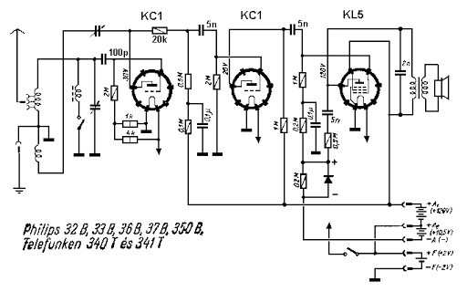
Figure 1 – Schematic for 1936 Philips 32B 3 tube radio [1]
  - As technology advanced digital signal processing has become widely used throughout the world, advances in mass production techniques have resulted in costs being decreased significantly opening the market to near enough anyone.
  - The present-day world uses DSP in normal day to day electronic systems and devices for example modern televisions, set top boxes, central heating thermostats and mobile phones.
  - Analogue systems are analogue throughout (input signal, processing circuit and output signal), digital systems require signals in digital form to process them. If the signal is not already in digital form, then an analogue to digital converter needs to be employed to transform the signal. Similarly, if the output from the system is required to be analogue a digital to analogue converter is required [2].
  - For this report purely digital input signals are being used with the input signal being provided by a random signal generator. With the performances of ASK, PSK and QPSK modulation methods being assessed using a bit error rate calculation (BER).
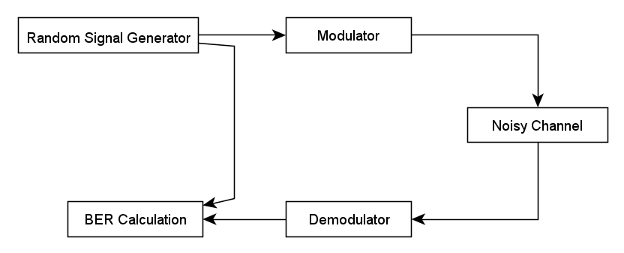
Figure 2 – Basic circuit showing BER calculation. [3]
  - BER is the percentage of bits that have errors relative to the total number of bits received in a transmission [4].
$$BER=\frac{Number of error bits present}{Number of bits transmitted}$$
  - Digital modulation techniques are in more demand than analogue modulation techniques as the have a capacity to transmit much larger amounts of data, they also offer:
- Higher data security
- Quicker system availability
- Greater quality communication [5]
There are many types of digital modulation techniques which can also be combined depending on the need. The prominent ones are:
- ASK – Amplitude Shift Keying, where the output amplitude depends on the input data levels.
- FSK – Frequency Shift Keying, where the output signal frequency will be either high or low, depending upon the input data applied.
- PSK – Phase Shift Keying, where the phase of the output signal is shifted depending on the input.
- QPSK – Quadrature Phase Shift Keying, as PSK but 2 bits are modulated at once.
  - This report will only investigate ASK, PSK and QPSK modulation techniques.

Method
  - ASK
    - ASK modulation sees the amplitude of the carrier wave being changed between distinct levels, usually two, in reaction to the digital data present at that moment.
    - When the binary data is set to a 0 the carrier wave has no amplitude and when the binary data is a 1 the carrier wave will have an amplitude. An example of ASK modulation can be seen in figure 3.
    - The combination of possible states for a given modulation type can be represented in a constellation diagram, an example of an ASK constellation diagram can be seen in figure 4.
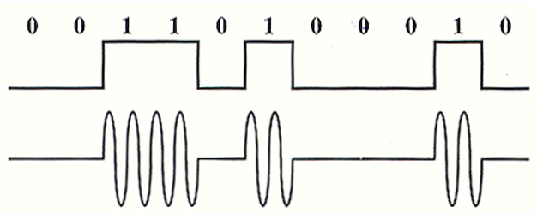
Figure 3 – Example of ASK modulation [6]
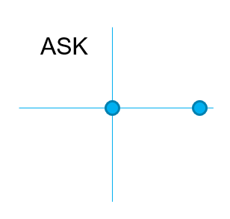
Figure 4 – Example of an ASK constellation diagram [7]
    - The ASK system was constructed and simulated in Simulink as seen in figure 5.
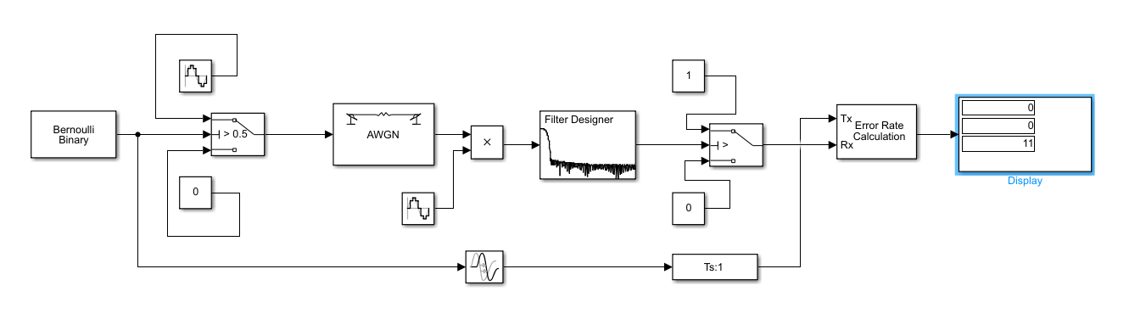
Figure 5 – ASK system showing result from S:R ratio of 0.
    - The simulation was run a total of 10 times at each of the signal to noise ratio with gradually increasing. An average of the 10 simulations was taken and recorded as the BER percentage at that level of noise.
    - The S:R ratio was increased in the settings of the AWGN component in -2dB increments from 0dB to -50dB.
    - A BER level of 40% was selected for this assignment as the point where the number of errors present exceeds our ability to use the received data. In modern real-world applications this figure is much smaller with telecommunications system designers often considering a BER of 10⁻⁹ being the minimum acceptable. [8]
    - The excel spreadsheet containing the results can be seen in figure 6.
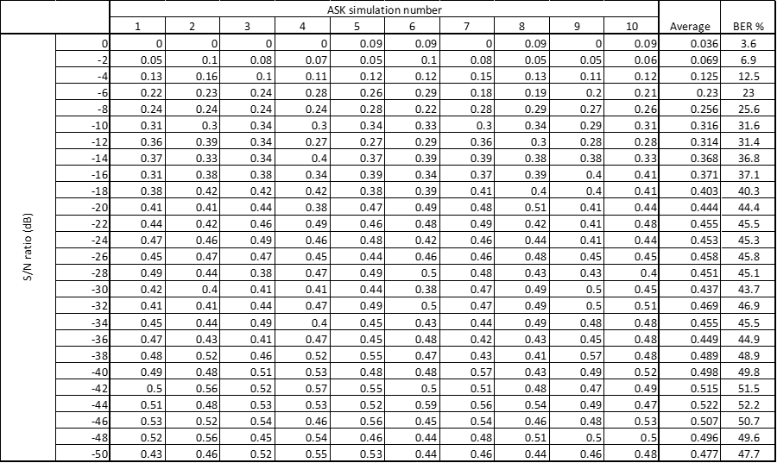
Figure 6 – ASK simulation results.
    - The simulation showed that a BER of 40% was reached when the Signal to Noise ratio reached -18dB.
  - PSK
    - PSK modulation sees the Phase of the carrier wave changing between distinct values in reaction to the digital data present at that moment.
    - In the example seen in figure 7 the phase of the carrier wave changes when the binary data is a 1, when the binary data is at 0 no change to the carrier wave takes place.
    - The combination of possible states for a given modulation type can be represented in a constellation diagram, an example of a PSK constellation diagram can be seen in figure 8.
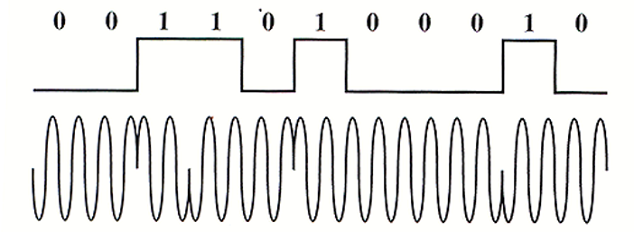
Figure 7 – Example of PSK modulation [6]
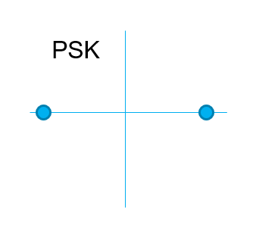
Figure 8 – Example of an PSK constellation diagram [7]
    - The PSK system was constructed and simulated in Simulink as seen in figure 9.
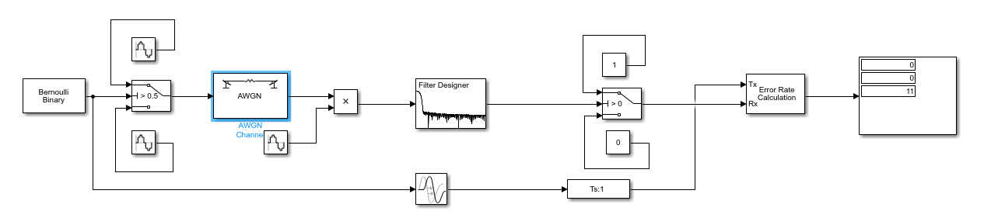
Figure 9 - PSK system showing result from S:R ratio of 0.
    - The PSK simulation was run for the same number of times and with the same steps in the S:R ratio as the ASK simulations as detailed in sections 3.1.4 to 3.1.6
    - The excel spreadsheet containing the results can be seen in figure 10.
Figure 10 – PSK Simulation results.
    - The simulation showed that a BER of 40% was reached when the Signal to Noise ratio reached -22dB.
  - QPSK
    - QPSK modulation sees two bits of data modulated at the same time with one of four carrier phase shifts being selected, these being at 0°, 90°, 180° or 270°.
    - This allows double the amount of information to be carried when compared to PSK modulation.
    - An example of QPSK showing the modulating value of 2 bits can be seen in figure 11.
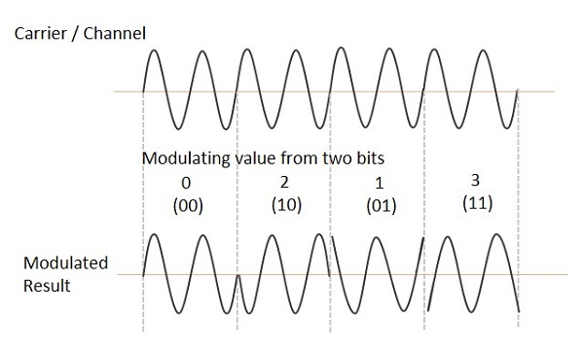
Figure 11 – Example of QPSK modulation [9]
    - The combination of possible states for a given modulation type can be represented in a constellation diagram, an example of a PSK constellation diagram can be seen in figure 12.
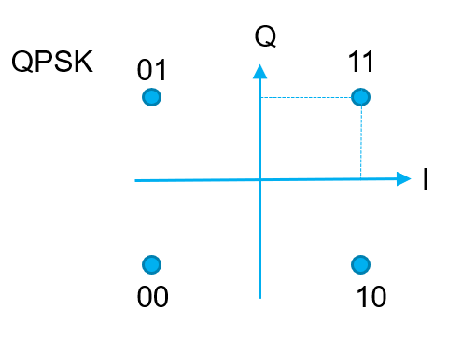
Figure 12 – Example of a QPSK constellation diagram [7]
    - The QPSK simulation was run for the same number of times and with the same steps in the S:R ratio as the ASK simulations as detailed in sections 3.1.4 to 3.1.6
    - The QPSK system was constructed and simulated in Simulink as seen in figure 13.
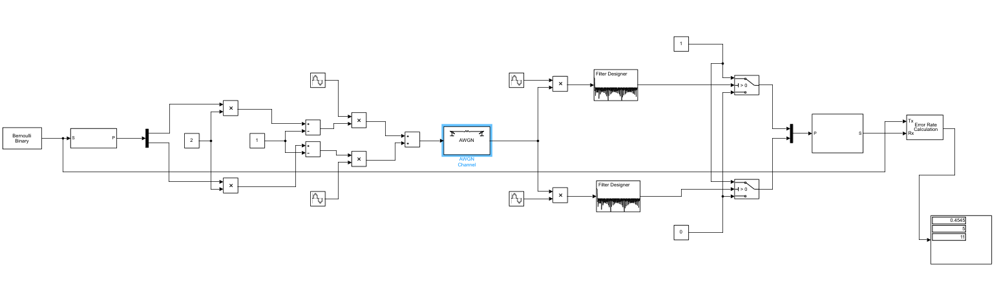
Figure 13 - PSK system showing result from S:R ratio of 0.
    - The excel spreadsheet containing the results can be seen in figure 14.
Figure 14 – QPSK Simulation results.
    - The simulation showed that a BER of 40% was reached when the Signal to Noise ratio reached -6dB.

Results
  - ASK
    - The results of the simulations conducted to assess the ASK system as detailed in figure 6 were used to create the graph shown in figure 15. The graph shows the percentage of bits that have errors increasing as the level of noise increases.
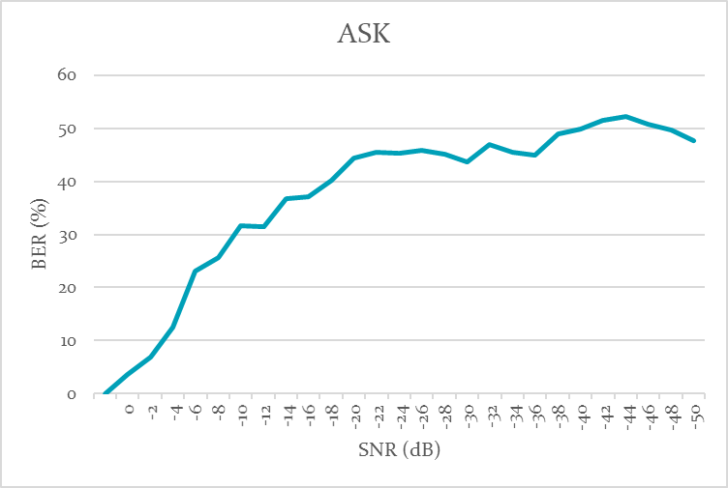
Figure 15 – Graph showing ASK simulation results.
    - The results show a non-linear increase in the BER as the S:R ratio is increased with the stipulated failure level of 40% being reached when the WGN is at -18dB.
    - At the -22dB the rate of failure appears to level off with a BER of approximately 45% as the S:R increases to -50dB only slight increases in the BER percentage were seen.
  - PSK
    - The results of the simulations conducted to assess the PSK system as detailed in figure 10 were used to create the graph shown in figure 16. The graph shows that at low levels of noise the percentage of bits that have errors remain low with errors only being recorded as the S:R ratio reaches -6dB.

Figure 16 – Graph showing PSK simulation results.
    - As previously seen with the ASK simulation the results show a non-linear increase in the BER as the S:R ratio is increased with the stipulated failure level of 40% being reached when the WGN is at -22dB.
    - Also as previously seen with the ASK simulation the BER percentage increase from the -22dB point to the -50dB level is minimal compared to the rate of increase between -6dB and -22dB.
  - QPSK
    - The results of the simulations conducted to assess the QPSK system as detailed in figure 14 were used to create the graph shown in figure 17. The graph shows that even at a noise level of zero 13% of bits received have errors.

Figure 17 – Graph showing QPSK simulation results.
    - The QPSK simulation the results show a non-linear increase in the BER as the S:R ratio is increased with the stipulated failure level of 40% being surpassed when the WGN is at -6dB.
    - Also as previously seen with the ASK and PSK simulations the BER percentage increase from the -22dB point to the -50dB level is minimal showing a BER increase of only 10% compared to the rate of increase between 0dB and -18dB where almost a BER 60% was measured.

Discussion
  - When comparing the results of all three modulation techniques covered in this report by including them on a single graph, as seen in figure 18, it can be said that phase key shifting allowed for a higher noise level to be present within the system before the stipulated threshold for acceptable bit error rate is exceeded.
  - It can also be said that when very low levels of noise are present in the system the simulation showed that PSK modulation had a 0% bit error rate while with ASK and QPSK a bit error was present.
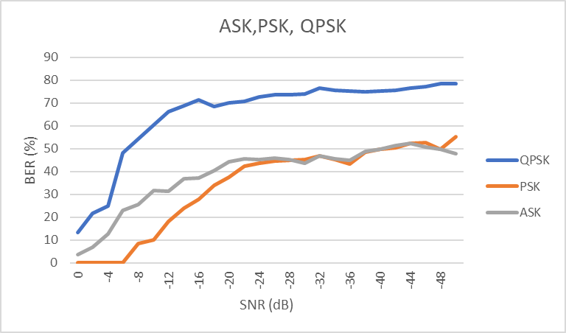
Figure 18 - Graph showing ASK, PSK and QPSK simulation results.
  - However, it must be noted that while QPSK does have a higher BER at all S:R ratios it offers the system the advantage of sending and receiving two bits at a time where ASK and PSK systems only use one bit at a time.
  - In real life applications all three systems lend themselves well to the processing of smaller data transfers, with QPSK being able to send double the data for the same bandwidth its uses may be far more suited to data rich transmissions.
  - Another method of modulation not simulated for this report is Quadrature amplitude modulation (QAM), This method of modulation allows for a greater number of bits to be transmitted simultaneously. The quantity of bits depends on the type of QAM used:
- 4-QAM – Similar to QPSK conveys 2 bits.
- 8-QAM – Conveys 3 bits.
- 16-QAM – Conveys 4 bits.
- 32-QAM – Conveys 5 bits
And so on.
  - The error rate for QAM is much higher than QPSK due to its spectral width being narrower, as the type of QAM increases in number the narrower it becomes increasing the bit error rate. [10]

Conclusions
  - ASK and PSK are better suited to smaller data transfers due to them only conveying a single bit at a time, PSK suffers a lesser BER when low level noise is introduced to the system when compared to ASK and QPSK.
  - While QPSK is more likely to suffer from a higher BER its ability to handle 2 bits for every 1 that ASK or PSK handle makes it a valid choice for system designers particularly when available bandwidth is at a premium.
  - While the results gained during running the simulations were somewhat expected they do not accurately represent the results a system designer would get if they were to physically build the systems using real components this is due to:
- Possible errors made in the building of the simulation.
- A lack of experience or understanding by the modeller creating the simulation.
- The rounding or approximation of results.
- Limited number of times a simulation was run.
- Simulations being from built in noise found in cables, connections etc.
  - Simulations are however a just method of modelling that can help down select components and systems during the design phase which could help reduce time, effort and costs.

References

[1] | K. Nagy, “RADIOTECHNICS-1936 RADIO,” 01 01 2015. [Online]. Available: http://www.oddmix.com/tech/r36_philips_32b_2.html. [Accessed 08 Mar 2021].
[2] | M. Parker, Digital Signal Processing 101 : Everything you need to know to get started, Burlington MA: ELSEVIER, 2010.
[3] | D. S. Mosey, L5 Assessment specification DSP & Communictions, Swansea: UWTSD, 2021.
[4] | W. E. K. Y. G. Robert J. Shimonski, Sniffer Pro Network Optimization and Troubleshooting Handbook, Elsevier, 2002.
[5] | tutorialspoint, “Digital Modulation Techniques,” tutorialspoint, 2021. [Online]. Available: https://www.tutorialspoint.com/digital_communication/digital_communication_digital_modulation_techniques.htm. [Accessed 10 Mar 2021].
[6] | D. S. Mosey, Digital Modulation, Swansea: UWTSD, 2021.
[7] | D. S. Mosey, Advanced Modulation 1, Swansea: UWTSD, 2021.
[8] | FOSCO, “What is BER and BERT,” FOSCO, 07 12 2010. [Online]. Available: https://www.fiberoptics4sale.com/blogs/archive-posts/95047174-what-is-ber-bit-error-ratio-and-bert-bit-error-ratio-tester. [Accessed 15 03 2021].
[9] | J. H. G. K, “Quadrature Phase Shift Keying (QPSK) Constellation,” Mathworks MATLAB, 2020.
[10] | TechDifferences, “Difference between QAM and QPSK,” TechDifferences, 2021. [Online]. Available: https://techdifferences.com/difference-between-qam-and-qpsk.html. [Accessed 16 03 2021].

