

Assessment 1 – Reading Task Template
PART 1: Upload your photo of your A3 in-class notes here:
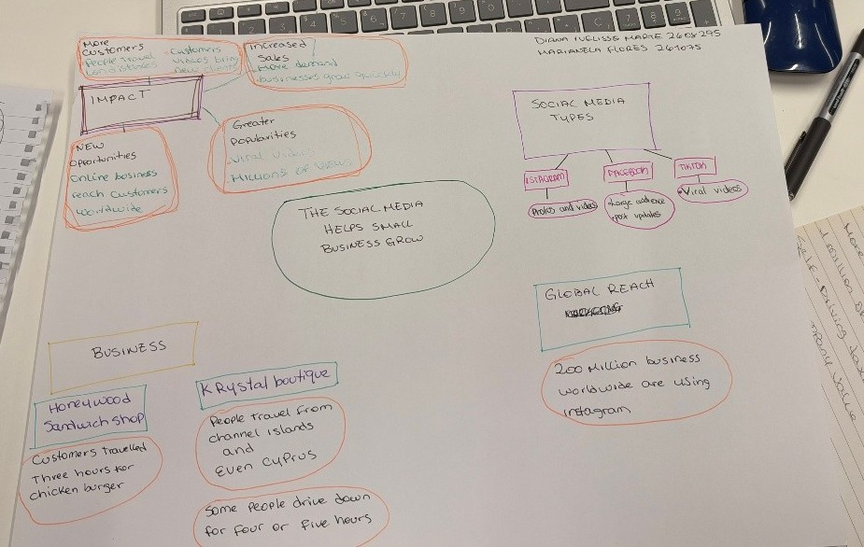

PART 2:
- Answer every question below in 1-3 full sentences.
- Use your own words. Do not use generative AI to answer these questions.
- Include a specific detail from the text when asked.
REMINDER
- The main idea is the overall message of the whole text.
- A key point helps to explain the main idea.
- A specific detail or example from the text shows that the key point is true.

- What is the main idea of the whole text?
Social media helped small businesses attract more customers and grow.

- What is one key point that supports the main idea, and which specific example from the text shows this?
Viral videos on social media can attract customers even from far away
For example: in Honywood Sandwich Shop, customers travelled for three hours to try a chicken burger after seeing videos on TikTok.

- What is a different key point that supports the main idea, and which specific example from the text shows this?
Social media change how a business operates. Lindy Loo´s Boutique at first sold clothes at local markets and moved to selling online and is now an online business.

- Which part of the text do you think is most important, and why?
Lindy Loo´s story, I think, is the most important because it shows how effective social media can be for small businesses.

Reflection:
- What did you find difficult in this task (including in-class components), and why was it difficult?
The language barrier was challenging for me because English is not my first language; I find it hard to express my answers as clearly as I can in Spanish. I need more time to understand what I am reading, process the information, and organise my ideas.

- What helped you with this difficulty, and how did it help you?
Working with my classmate helped me. She contributed ideas that I had missed, and vice versa, we complemented each other.

