A critical evaluation and the identification of next teaching and learning steps focusing on a case study of an individual learner or a group of learners, based on an observed critical incident



ECAD6007- Who am I teaching?
Pwy ydw i’n ei addysgu?

Student Number- 1900339

Word Count- 4373

Introduction
This essay intends to focus upon and evaluate an observed critical incident and identify the subsequent teaching and learning steps. It is vital to acquire an understanding of what a ‘critical incident’ is. When ‘critical’ and ‘incident’ are separated, negative connotations appear to exist. Both words are defined in a negative light where something ‘critical’ may be perceived as ‘serious, uncertain, or possibly dangerous’ (Oxford Advanced Learner’s Dictionary, no date). Additionally, an ‘incident’ is often understood as a ‘serious or violent event’ or something that occurs which is ‘unusual or unpleasant’ (Oxford Advanced Learner’s Dictionary, no date). This, in fact, fails to epitomise the definition of what it is. Whilst some incidents may indeed be negative, it is defined as a personal encounter which highlights a specific situation that may be of interest to the observer, usually within a professional environment (Davies and Kinloch, 2000). Following the identification of such event, analysis subsequently takes place where the observer reflects upon what has been done and learns lessons from what did, or did not work (Rich and Parker, 1995). Within an educational context, this can inform future teaching practice where practitioners make improved professional judgements (Tripp, 2011). The use of critical incidents within the context of reflective practice is thus evident for it holds immense importance for improving pedagogy and within the identification of next learning and teaching steps.

The role of critical reflection
The existence within an ever-changing world creates various implications for those within all professions, and particularly those within the educational sphere. As society evolves, curriculum changes and new standards for teaching and learning will be introduced (Hsu and Malkin, 2011). Consequently, teachers are required to utilise reflective, critical thinking skills in attempt to keep up with these reforms (Dillon and Maguire, 2001). Reflective thought can be defined as an active process of paying attention to one’s own experience (Amulya, 2004). Other scholars elaborate to highlight how this process can be used by educational practitioners to improve their practice. It appears that this is one of the most important purposes of reflection as it subjects teachers to engage in critical thought, resulting in a positive alteration of practice (Korthagen, 2001). This is made possible as critical reflection is a process of learning from experiences, analysing previous knowledge considering these experiences, and then incorporating this new knowledge to inform and alter future pedagogy (Rosser et al., 2013).
The process of critical reflection is a widely researched phenomena where various scholars like Graham Gibbs have provided their input on how this type of reflection should be undertaken. Figure 1 provides a framework for this. This is comprised of six stages to ensure a holistic approach to reflection is taken. Deep critical thought about an experience is encouraged as evidenced by the reflector needing to consider their feelings and make sense out of the experience. Thus, Gibbs’s model is effective in guiding the reflective process and focuses heavily on the participant learning from the experience (Gibbs, 1998; Markkanen et al., 2019), consolidating the idea that critical reflection is purposeful for learning and improvement.
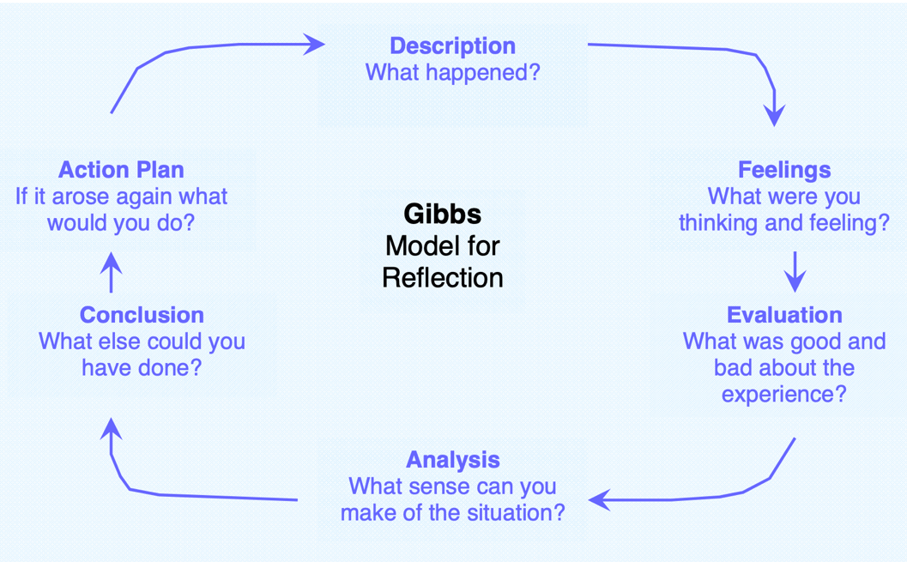
Figure 1- Gibbs’s Reflective Cycle

Stephen Brookfield, however, provides a guide to further this critical thought by encouraging the reflector to observe an experience through four different lenses. These include the Self, Students, Colleagues, and Theoretical. This allows for deeper critical thought as it enables the reflector to observe a situation from other perspectives. Thus, we are alerted to wrong or incomplete aspects of our assumptions that may need further consideration or investigation (Brookfield, 1998). Following my reflection on Brookfield’s idea, I would recommend for additional lenses to be considered such as the Parental/Carer perspective, especially when reflecting upon a child’s learning as useful recommendations for support can be provided by these individuals.
The importance of educational practitioners engaging within critical reflection is also reflected within the documentation for the Professional Standards for Teaching and Learning (PSTL). Importantly, the idea that practitioners are required to engage in continuous learning is found within the Professional Learning strand that states that teachers should have a desire for professional learning and growth which has positive impact upon pedagogy (Welsh Government, 2019). The Pedagogy component also highlights the importance of critical reflection upon practice as this is critical to refining teaching. Refining teaching includes the act of listening to learners where practitioners need to evaluate the learning of their students and act upon this where possible (Welsh Government, 2019). The mentioned models of reflection provide clear guidance on how the reflective process should be undertaken and when. If teachers utilise these guides appropriately then these two areas of the Professional Standards can be developed effectively.
Figure 2 presents the four key purposes that the current curriculum in Wales is built upon. Teachers hold the responsibility to ensure that their students are working towards the achievement of these. They must assess what teaching methods need to be used in consideration of the purposes, along with the needs and developmental stages of the pupils as good teaching encourages effective learning (Donaldson, 2015). Consequently, the discussed reflective processes must consistently be utilised by practitioners to ensure effective pedagogy is being implemented, reinforcing their importance. The reflective process is not only immensely effective in informing and improving pedagogy but is vital in the facilitation of effective learning.
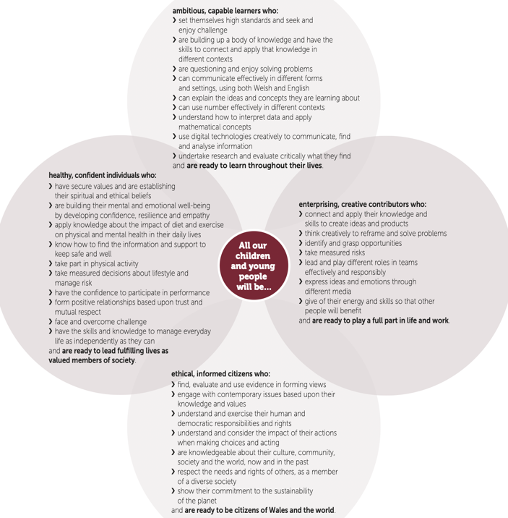

Figure 2- The Four Purposes

Observation: School and Class context
In adherence to the British Educational Research Association (BERA) ethical guidelines (2018), all information that may lead to the identification of the participants and school involved within the critical incident will be anonymised throughout. This is crucial as participants within educational research should be accorded to their rights of confidentiality and anonymity, for this is considered the norm (BERA, 2018).
The observed critical incident took place in an English medium community school, located on the outskirts of an urban area in South Wales. The school caters for pupils aged 3-11 and around 500 students are on role. There are 18 teachers with an additional 18 learning support officers who aim to nurture, inspire, and challenge their pupils so that their full potential can be met.
The critical incident that has been observed and analysed took place on a Monday morning in a literacy lesson for Year 6 pupils at around 10.30am. The task had been explained by the teacher whereby the students understood that they had to complete an activity called ‘Book on Book’. This required the children to find a partner and peer assess each other’s stories that they had written on the previous Friday. When the activity was to take place, they had to determine whether their stories met the success criteria that was created prior to the task. The environment was calm and children appeared ready and willing to engage within this activity.

Critical Incident linked to Donaldson’s Four Purposes
The observed critical incident focuses upon the interaction between one teacher and a pupil who will be referred to as: Teacher A and Student X. This will subsequently be explained, however, detail of the incident can also be found within Appendix A. Whilst the incident predominantly involves Teacher A and Student X, engagement with other individuals within the class also occurs.
Teacher A noticed that Student X did not have a partner to work with during the ‘Book on Book’ activity and so took on the role of a pupil. As the activity continued, Teacher A paused the session and encouraged Student X to share the technique that they had been using to mark their stories with the other class members. Teacher A described Student X’s technique as ‘valuable’ and ‘an excellent way of completing the task’. Student X then shared their technique with the rest of their peers with confidence. Teacher A then immediately encouraged the other pupils to try this strategy as it could be ‘very useful and beneficial’ for their learning too. Following this, Teacher A praised Student X by saying ‘Well done, thank you for sharing that with us!’. Therefore, the critical incident observed was the action of Teacher A rewarding Student X for their use of an effective strategy and encouraging them to share this with the other class members.
The first of Donaldson’s purposes that this critical incident links to is ambitious, capable learners. Importantly, a learner may demonstrate that they have, or are building up a ‘body of knowledge and have the skills to apply that knowledge in different contexts’ (Donaldson, 2015, p. 29). Student X demonstrates the qualities of this type of learner as they have used previously learnt assessment techniques to mark their work. The incident highlights how Student X has acquired the knowledge of a skill prior to this peer activity and has effectively applied this knowledge within a different context. Student X also demonstrates how they are working to become an ambitious, capable learner as the activity required the pupils to be critical of the work that they were reading. This type of learner demonstrates that they can effectively ‘evaluate critically what they find’ (Donaldson, 2015, p. 29); something Student X was doing successfully which was identifiable by Teacher A’s praise.
The second of the purposes that Student X appears to demonstrate is that of an enterprising, creative contributor. Importantly, Student X was willing to ‘give of their energy and skills so that other people will benefit’ (Donaldson, 2015, p. 29). Despite needing prompt from Teacher A, Student X took on the role of the MKO (More Knowledgeable Other) to guide and inspire the other pupils. They shared their effective technique with the intention of encouraging their peers to use this too, clearly indicating that they wanted their class members to benefit from utilising this technique.
Whilst Student X demonstrated the previous traits independently, Teacher A appeared to encourage the student to develop traits of a healthy, confident individual by boosting the student’s confidence and supporting their well-being. This purpose presents how this type of learner will be ‘building their mental and emotional well-being by developing confidence, resilience, and empathy’ (Donaldson, 2015, p. 30). Teacher A’s use of positive language and praise identifies how they are facilitating Student X in becoming this type of learner as they are not simply supporting their learning alone, but their well-being too.

The Literature Review
Subsequent to the analysis of the critical incident, two key areas for further research have been identified. These are ‘Learning from others’ and ‘Well-being’.
Learning from others, or social learning is a vital way to support a child’s holistic development. Importantly, Welsh Government (2015) epitomise the importance of social interaction from an early age within their framework for Foundation Learning. Play is one of the first ways that young individuals learn socially for they are enabled to explore different concepts freely, whilst practicing and consolidating their learning via risk taking and problem solving in both small and large groups (Welsh Government, 2015). This inevitably encourages young children to utilise a plethora of skills that will support their holistic growth as they develop linguistically, physically, culturally, socially, intellectually, behaviourally, and emotionally (WJEC, 2019).
My critical incident, however, specifically focuses upon older children which highlights how social learning is a continual process. This idea is consolidated by the work of Lev Vygotsky who emphasises how new knowledge is consistently constructed via social interaction. Importantly, humans are actively involved within the development of their own learning where social contributions are vital to support this (McLeod, 2022). This idea is reiterated within increasingly reliable peer-reviewed articles that state that Vygotsky’s social constructivist theory provides an effective way of teaching that all students, of all ages can benefit from (Kalina and Powell, 2009). This way of teaching heavily focuses upon the active role of the child within the learning process and views them as competent (Prince, 2004). Whilst this is important, the MKO, which is defined as someone who has an increased understanding of the concept or one with a higher ability level than the learner (McLeod, 2022) is needed to challenge them. The abstract zone where an individual is needing to be guided is known as the Zone of Proximal Development (ZPD) and this is where the learning occurs. This is a commonly accepted idea that features within many academic texts. Importantly, it features within the work of Dootlittle (1991), Mahn and John-Steiner (2012), and Erbil (2020) where it is collectively agreed that this can be identified as the gap between what an individual can do with the aid of a MKO and what they can do independently.
The work of Albert Bandura adds to the idea that social interaction is vital for learning. However, he introduces the idea that children learn from imitating modelled behaviour (Bandura, 1986; Lyons and Berge, 2012). The work of Lyons and Berge (2012), an increasingly contemporary source, expands further and stipulates that this theory best takes place within social contexts where various behaviours can be modelled, observed, and re-enacted. The earlier work of Bandura suggests however that some individuals need a reason to imitate the behaviour. For example, one may be motivated by the praise that they receive if they imitate a positive behaviour; something that has been observed within the critical incident of focus. For some, the absence of this praise may be a determiner in why some individuals would not have reason, or make the effort to reproduce a specific behaviour (Bandura, 1977).
Negatively, it may be suggested that the content of the literature is outdated, for these theories generalise the learning process as they fail to consider all types of learners. Inclusive education is a key theme found across various, increasingly contemporary literature sources. Black-Hawkins (2017), Florian and Beaton (2018) and Slee (2019) distinguish that an inclusive environment should support the learning of every pupil effectively and prioritise the creation of a safe environment where students experience a sense of belonging. However, the literature encompassing social learning contains a gap as it does not consider those with additional learning needs (ALN). Specifically, learners with autistic spectrum disorder (ASD) may struggle with this type of learning as this developmental disorder is characterised by social communication issues, behavioural rigidity, and repetitive sensory-motor behaviours (Kanner, 1943; Lord et al., 2018). Further contemporary articles extend what this can mean for these learners if they are placed in a social situation where they may feel uncomfortable. For example, sensitivity to specific situations may be experienced where challenging and non-compliant behaviour can be expressed (Reichow et al., 2012; O’Nions et al., 2018). This, in turn, may lead to children with autism being excluded from school. Evidence has shown that this has risen by 60% within the United Kingdom in recent years, despite the attempt by campaigns like ‘Ruled Out’ trying to raise awareness and combat the issue (Ambitious About Autism, 2014; Ambitious About Autism, 2018). The statistics provided by reputable organisations like the World Health Organisation reiterate how this issue is vast as about one in 100 children within the United Kingdom have autism and experience troubles within school (World Health Organisation, 2022). Consequently, schools must alter their pedagogy and implement the correct provision to ensure the needs of all learners are met, for everyone is entitled to overcome barriers within their learning experience and achieve their full potential (Welsh Government, 2018). Thus, the ideas highlighted within social learning theories may be invalid for some individuals and educators must assess whether these approaches will best support the learning of their pupils.
The second theme for research is well-being. This can be understood as a dynamic concept that can be enhanced when individuals are enabled to fulfil their emotional, social, and personal goals which may include developing the ability to understand and manage their emotions in ways that are helpful to them and those around them (Weare, 2004; Statham and Chase, 2010). When well-being is placed in the educational context, research elicits how the maintenance of a positive well-being is crucial to achievement. Importantly, Coombes et al. (2013) highlight how this concept does not only impact upon the mind, but it can affect physical health too; all of which determine how successful a child will be in school. Well-being may also be impacted upon negatively. The experience of an adverse childhood experience (ACE), social deprivation, a negative home background, or disability or illness are all influences that may be detrimental to the maintenance of a positive well-being (WJEC, 2019) and present danger to one’s educational success.
In response to the criticality of needing to promote positive well-being, contemporary Welsh curriculum reform has introduced an Area of Learning and Experience (AoLE) called Health and Well-being in attempt to educate children and provide a holistic structure for understanding health and well-being (Welsh Government, 2020). As a result, they should acquire knowledge about the interconnected nature of the components of health and well-being and recognise that staying healthy mentally and physically is vital to successful learning (Welsh Government, 2020). Specifically, the ‘What Matters Statements’ highlight the different areas that will be covered during the teaching of this AoLE. In particular, ‘Developing physical health and well-being has lifelong benefits’ and ‘How we process and respond to our experiences affects our mental health and emotional well-being’ (Welsh Government, 2022) demonstrate how the topics of Health and Well-being are vital in promoting the pupils to achieve the 4 purposes, especially to become ‘Healthy, confident individuals’ and ‘ethically informed citizens’ (Donaldson, 2015).

Theories based around well-being provide can provide further guidance for educators. Maslow’s Hierarchy of Needs (See Appendix D) demonstrates how the achievement of prime well-being is a process. For example, individuals must satisfy lower-level needs like receiving food and water before they can progress to meet higher level needs like achieving self-actualisation and their full potential (Maslow, 1943; Maslow, 1987). Additionally, Seligman’s increasingly contemporary theory supports this idea as he elicits how certain elements need to be experienced before one can totally flourish in terms of their well-being. He proposes the pneumonic of ‘PERMA’ to express that positive emotions, engagement, relationships, meaning, and accomplishment must be experienced before a prime level of well-being can be achieved (Seligman, 2011). It is imperative that teachers are aware of these ideas as it better informs their practice and thus their ability to support their learners.
As it can be seen, pupil well-being is of prime focus. However, the literature appears to ignore the significance of teacher well-being. The duty of the teacher is to be a role model and effectively support children to meet both their academic and non-academic needs (Hoffman and Miller, 2020). Role modelling different behaviours and values is considered an immensely powerful teaching tool (Cruess et al., 2008), however further contemporary literature stipulates that this profession is one with a high prevalence of work-related stress which can lead to physical and mental illness (Fisher, 2011; Chirico et al., 2020). Consequently, educators may be unable to conceal these difficulties within the educational environment. As mentioned previously, children observe modelled behaviour and may imitate this. Findings demonstrate how poor teacher well-being may be detrimental to the success and well-being of the pupils if this behaviour, or these feelings are reproduced. This idea is reiterated within contemporary articles where it is highlighted how associations have been found between teacher and student psychological distress and depression, which may be explained by teachers attending school when physically or mentally unwell (Harding et al., 2019). However, this issue may continue to prevail due to the stigma attached to mental illness. This stigma, unfortunately, may create barriers for those with ill health to access treatment which in turn, also compromises their ability to care for their physical health (World Health Organisation, 2017). Despite the attempt to eradicate this issue by the prevalence of mental health charities that are committed to normalising mental illness like ‘Chasing the Stigma’ (Chasing the Stigma, no date.), it still exists and results in a plethora of negative outcomes (Hatzenbuehler et al., 2013). If students’ mental states are to be protected, an increased level of support is required to be given to educators and further attempt is needed to reduce the stigma around mental health.

Reflection/ Evaluation & Next Steps
This component of the text will focus upon reflecting, evaluating, and analysing the critical incident of attention. The use of Gibbs’s Reflective Cycle (1998) encourages the participants to holistically evaluate a situation and assess what could be done if it arose again (See Figure 1). His model of reflection is useful for this evaluation as it encourages me to reflect upon the critical incident in depth, whilst providing guidance to what the subsequent teaching and learning steps will be. This is particularly evidenced by the ‘Evaluation’, ‘Analysis’ and ‘Action Plan’ elements of the model (Gibbs, 1998). Throughout this part of the assignment however, all steps demonstrated within Figure 1 will be considered.
As highlighted within the literature review, social learning is accessible to the majority of learners (Kalina and Powell, 2009). In particular, the role of the MKO is vital during the construction of knowledge as they can help a learner to grasp a new concept that may be challenging for them (Dootlittle, 1991; Mahn and John-Steiner 2012; Erbil, 2020). Within the observed critical incident, Student X was provided with the opportunity to act as the MKO by sharing their higher-level strategy with the other members of the class. Following further research of this idea, I now appreciate the role that Student X took on more as they were able to support and extend the development of learning for their peers. Subsequent to this, Teacher A praised them for taking on this role. It is possible to suggest that this may lead to Student X in reproducing this positive behaviour as Bandura’s theory suggests that children can require some sort of motivation to act in a specific way (Bandura, 1977). However, I now understand that not every learner may be willing to act as an MKO, especially those with ASD. During this critical incident, this was not an issue. However, when considering the ‘Conclusion’ and ‘Action Plan’ components of Gibbs’s cycle, I would ensure that the learner is comfortable with sharing the advice and that they are not placed in a situation considered daunting. This will benefit my future practice and support my professional development as I will aim to recognise and meet the needs of every pupil (Welsh Government, 2019) which meets the ‘Refining Teaching- Differentiation’ strand within the ‘Pedagogy’ area of the PSTL. Although, if a pupil demonstrates the same confidence as Student X, then I will promote the act of sharing knowledge as it encourages children to give their time to help others; something which aids them towards becoming enterprising, creative contributors (See Figure 2) (Donaldson, 2015). Thus, supporting my pupils to reach their potentials within a safe environment will be imperative within my practice.
The idea of creating a safe environment is also paramount to promoting positive well-being; something which is also vital for achievement (Coombes et al., 2013). Following the research into this area, I value the approach that Teacher A took to praise Student X as it was an effective way to meet the basic and psychological needs proposed by Maslow within his hierarchy. To meet the highest level of well-being, feelings of accomplishment and positive emotions and relationships must be experienced (Maslow, 1943; Seligman, 2011). Thus, Teacher A’s positive language demonstrates how this was a useful approach in ensuring that Student X felt proud and valued, and that their well-being was enhanced. I now have a greater awareness of the process of how prime well-being can be achieved. Not only this, but the impact that teacher well-being can have upon the emotional state of pupils does not go unrecognised. Consequently, I will aim to present myself as a positive role model to my pupils by attempting to stay physically and mentally healthy as this is appears to be a subtle, but effective tool in supporting their well-being. When considering the ‘Conclusion’ and ‘Action Plan’ elements, I would not change the approach within the critical incident as it was effective, although I will aim to consistently use praise and ensure my students experience a sense of accomplishment. This will ensure that students are encouraged to become healthy, confident individuals as they are strengthening their emotional and mental well-being whilst developing confidence (Donaldson, 2015). Again, my professional development will continue as I will be meeting the ‘Advancing learning’ strand within the ‘Pedagogy’ area of the PSTL. It is important that educators have the knowledge and understanding of the purposes and ensure that they are the focus of the pupils’ educational experiences (Welsh Government, 2019). As a result, they will be at the heart of my planning and preparation and pedagogical approaches will work to support the pupils in certifying that they achieve them.

Conclusion
Overall, it has been understood that the analysis of a critical incident is useful in reflective practice, allowing for educational practitioners to improve their pedagogy and identify next teaching and learning steps. The analysis of the observed critical incident has allowed me to uncover two pertinent themes existent within the educational environment. The first, social learning has uncovered how activities that require students to communicate are useful for both extending and supporting knowledge. However, practitioners should acknowledge that such approach may not be as beneficial and difficult for some learners. In relation to this, educators should be aware that the needs of all learners should be met as this is critical for supporting the multifaceted concept of well-being. Additionally, it has been understood that this is a significant determiner of educational outcomes and teachers must take on the imperative role of modelling positive well-being and promoting this which may be done via the effective implementation of the Health and Well-being AoLE. Positive use of, and promotion of social learning and well-being is thus pertinent to support the holistic development of young individuals and teachers should consistently reflect upon their practice and assess where improvements can be made. This not only ensures that that the PSTL are met like the ‘Advancing learning’ and ‘Differentiation’ strands within the Pedagogy area, but the educational context is experiencing improvements through supporting the needs of all learners and teachers encouraging their students to work towards the achievement of the four core purposes.

References

Ambitious About Autism (2014) Ruled out report. Available at: https://www. ambitiousaboutautism.org.uk/sites/default/files/Ruled_Out_Report.pdf (Accessed: 10 October 2022).
Ambitious About Autism (2018) We need an Education Report. Available at: https://www.ambitiousaboutautism.org.uk/sites/default/files/resources-and-downloads/files/we-need-an-education-exclusions-report.pdf (Accessed: 10 October 2022).
Amulya, J. (2004) What is Reflective Practice? Available at: https://www.careinnovations.org/wp-content/uploads/what-is-reflective-practice65.pdf (Accessed: 25 October 2022).
Bandura, A. (1977) Social learning theory. New York: General Learning Press.

Bandura, A. (1986) Social foundations of thought and action: A social cognitive theory. New Jersey: Prentice- Hall, Inc.

Black-Hawkins, K. (2017) ‘Understanding inclusive pedagogy: learning with and from teachers’, in Plows, V. and Whitburn, B. (eds.) Inclusive Education: making sense of everyday practice. Rotterdam: Sense Publishers.

British Educational Research Association [BERA]. (2018) Ethical Guidelines for Educational Research: Fourth edition. https://www.bera.ac.uk/researchers-resources/publications/ethical- guidelines-for-educational-research-2018 (Accessed: 10 October 2022).

Brookfield, S. (1998) ‘Critically Reflective Practice’, Journal of Continuing Education in the Health Professions, 18(4), pp. 197-205.

Chasing the Stigma. (No date) About us- Who We Are. Available at: https://www.chasingthestigma.co.uk/about/ (Accessed: 12 October 2022).

Chirico, F., Sharma, M., Zaffina, S. and Magnavita, N. (2020) ‘Spirituality and prayer on teacher stress and burnout in an Italian cohort: A pilot, before-after controlled study’, Frontiers in Psychology, 10, p. 2933.

Coombes, L., Appleton, J.V., Allen, D. and Yerrell, P. (2013) ‘Emotional Health and Well‐being in Schools: Involving young people’, Children & Society, 27(3), pp.220-232.

Cruess, S.R., Cruess, R.L. and Steinert, Y. (2008) ‘Role modelling—making the most of a powerful teaching strategy’, British Medical Journal, 336(7646), pp. 718-721.

Davies, H., & Kinloch, H. (2000) ‘Critical incident analysis: facilitating reflection and transfer of learning’, in Cree, V. E. and Macaulay, C. (eds.) Transfer of Learning in Professional and Vocational Education. London: Routledge.

Dillon, J. and Maguire, M. (2001) Becoming a Teacher: Issues in Secondary Teaching. 2nd edn. Berkshire: Open University Press.
Donaldson, G. (2015) Successful Futures. Available at: https://gov.wales/sites/default/files/publications/2018-03/successful-futures.pdf (Accessed: 3 October 2022).
Doolittle, P.E. (1991) Vygotsky and the Socialization of Literacy. Available at: https://files.eric.ed.gov/fulltext/ED377473.pdf (Accessed: 25 October 2022).

Erbil, D. G. (2020) ‘A review of flipped classroom and cooperative learning method within the context of Vygotsky theory’, Frontiers in Psychology, 11. p. 1157.

Fisher, M. H. (2011) ‘Factors influencing stress, burnout, and retention of secondary teachers’, Current issues in education, 14(1), pp. 1-37.

Florian, L. and Beaton, M. (2018) ‘Inclusive pedagogy in action: getting it right for every child’, International Journal of Inclusive Education, 22(8), pp. 870-884.

Gibbs, G. (1998) Learning by Doing: A Guide to Teaching and Learning Methods. Oxford: Further Education Unit, Oxford Polytechnic

Harding, S., Morris, R., Gunnell, D., Ford, T., Hollingworth, W., Tilling, K., Evans, R., Bell, S., Grey, J., Brockman, R. and Campbell, R. (2019) ‘Is teachers’ mental health and wellbeing associated with students’ mental health and wellbeing?’, Journal of affective disorders, 242, pp.180-187.

Hatzenbuehler, M. L., Phelan, J. C., and Link, B. G. (2013) ‘Stigma as a fundamental cause of population health inequalities’, American Journal of Public Health, 103, pp. 813–82.

Hoffman, J. A. and Miller, E. A. (2020) ‘Addressing the consequences of school closure due to COVID‐19 on children's physical and mental well‐being’, World medical & health policy, 12(3), pp. 300-310.

Hsu, A., and Malkin, F. (2011) ‘Shifting The Focus From Teaching To Learning: Rethinking The Role Of The Teacher Educator’, Contemporary Issues in Education Research (CIER), 4(12), pp. 43–50.

Kalina, C. and Powell, K. C. (2009) ‘Cognitive and social constructivism: Developing tools for an effective classroom’, Education, 130(2), pp.241-250.

Kanner, L. (1943) ‘Autistic disturbances of affective contact’, Nervous child, 2(3), pp. 217-250.

Korthagen, F. (2001) ‘A reflection on reflection’, in Korthagen, F., Kessels, J., Koster, B., Lagerwerf, B., and Wubbels, T. (eds.) Linking practice and theory. New York: Routledge.

Lord, C., Elsabbagh, M., Baird, G. and Veenstra-Vanderweele, J. (2018) ‘Autism spectrum disorder’, The Lancet, 392(10146), pp.508-520.

Lyons, S.D. and Berge, Z.L. (2012) Social learning theory. Available at: https://mdsoar.org/bitstream/handle/11603/16519/Bandura_%20SLT_Lyons_Berge_28mar11%20(1).pdf?sequence=1 (Accessed 25 October 2022).

Mahn, H., and John‐Steiner, V. (2012) ‘Vygotsky and sociocultural approaches to teaching and learning’, in Weiner, I. B., Reynolds, W. M., and Miller, G. E. (eds.) Handbook of Psychology: Educational Psychology. New Jersey: John Wiley & Sons.

Markkanen, P., Välimäki, M., Anttila, M. and Kuuskorpi, M. (2020) ‘A reflective cycle: Understanding challenging situations in a school setting’, Educational Research, 62(1), pp. 46-62.

Maslow, A. H. (1943) ‘A theory of human motivation’, Psychological Review, 50(4), pp. 370-396.

Maslow, A. H. (1987) Motivation and personality. 3rd edn. Delhi: Pearson Education.

McLeod, S. (2018) Maslow’s Hierarchy of Needs. Available at: https://canadacollege.edu/dreamers/docs/Maslows-Hierarchy-of-Needs.pdf (Accessed 11 October 2022).

McLeod, S. (2022) Vygotsky’s Sociocultural Theory of Cognitive Development. Available at: https://www.simplypsychology.org/vygotsky.html (Accessed 7 October 2022).

O’Nions, E., Happé, F., Evers, K., Boonen, H. and Noens, I. (2018) ‘How do parents manage irritability, challenging behaviour, non-compliance and anxiety in children with autism spectrum disorders? A meta-synthesis’, Journal of autism and developmental disorders, 48(4), pp.1272-1286.
Oxford Advanced Learner’s Dictionary. (No date) Definition of critical adjective from the Oxford Advanced Learner’s Dictionary. Available at: https://www.oxfordlearnersdictionaries.com/definition/english/critical?q=critical (Accessed: 6 October 2022).
Oxford Advanced Learner’s Dictionary. (No date) Definition of incident noun from the Oxford Advanced Learner’s Dictionary. Available at: https://www.oxfordlearnersdictionaries.com/definition/english/incident_1?q=incident (Accessed: 6 October 2022).

Prince, M. (2004) ‘Does active learning work? A review of the research’, Journal of Engineering Education, 93(3), pp. 223-231.

Reichow, B., Steiner, A.M. and Volkmar, F. (2012) ‘Social skills groups for people aged 6 to 21 with autism spectrum disorders (ASD)’, Campbell Systematic Reviews, 8(1), pp. 1-76.

Rich, A., and Parker, D.L. (1995) ‘Reflection and critical incident analysis: ethical and moral implications of their use within nursing and midwifery education’, Journal of advanced nursing, 22(6), pp.1050-1057.

Rosser, M., Mooney, G. P. and Jasper, M. (2013) Professional development, reflection and decision-making in nursing and healthcare. Chichester: Wiley-Blackwell.

Seligman, M. (2011) Flourish: A New Understanding of Happiness and Well-being- and How to Achieve Them. London: Nicholas Brealey Publishing.

Slee, R. (2019) ‘Belonging in an age of exclusion’, International Journal of Inclusive Education, 23(9), pp. 909-922.

Statham, J. and Chase, E. (2010) Childhood wellbeing: A brief overview. Loughborough: Childhood Wellbeing Research Centre.

Tripp, D. (2011) Critical Incidents in Teaching (Classic Edition): Developing Professional Judgement. London: Routledge.

Weare, K. (2004) Developing the emotionally literate school. London: Paul Chapman.

Welsh Government. (2015) Curriculum for Wales- Foundation Phase Framework. Available at: https://hwb.gov.wales/storage/d5d8e39c-b534-40cb-a3f5-7e2e126d8077/foundation-phase-framework.pdf (Accessed 10 October 2022).

Welsh Government. (2018) Additonal learning needs (ALN) transformation programme. Available at: https://gov.wales/sites/default/files/publications/2018-09/additional-learning-needs-aln-transformation-programme-v2.pdf (Accessed 11 October 2022).

Welsh Government. (2019) Professional Standards for Teaching and Leadership. Available at: https://hwb.gov.wales/api/storage/19bc948b-8a3f-41e0-944a-7bf2cadf7d18/professional-standards-for-teaching-and-leadership-interactive-pdf-for-pc.pdf (Accessed: 3 October 2022)

Welsh Government. (2020) Area of Learning and Experience: Health and Well-being. Available at: https://hwb.gov.wales/curriculum-for-wales/health-and-well-being (Accessed 11 October 2022).

Welsh Government. (2022) Health and Well-being- 2. Statements of what matters. Available at: https://hwb.gov.wales/curriculum-for-wales/health-and-well-being/statements-of-what-matters/ (Accessed 11 October 2022).

WJEC. (2019) Factors affecting well-being. Available at: http://resource.download.wjec.co.uk.s3.amazonaws.com/vtc/2018-19/HSC18-19_2-3/_multi-lang/unit01/2-factors-affecting-well-being.html (Accessed 12 October 2022).

WJEC. (2019) Health, Well-being, Learning and Development. Available at: http://resource.download.wjec.co.uk.s3.amazonaws.com/vtc/2018-19/hsc18-19_3-2/_multi-lang/unit03/02-the-importance-of-play-and-holistic-development.html (Accessed 10 October 2022).

World Health Organisation (WHO). (2017) Mental health action plan 2013–2020. Geneva: World Health Organisation.

World Health Organisation (WHO). (2022) Autism. Available at: https://www.who.int/news-room/fact-sheets/detail/autism-spectrum-disorders (Accessed 10 October 2022).

Appendices

Appendix A: Critical Incident 1 (included within essay)

Date and time, year group: 26/09/22, 10.30am, Year 6.

Where and When: Context of the observation – subject/AOLE, general classroom context

This observation was observed in the morning session on a Monday (26th September). The activity of focus took place at 10.30am. The subject/AOLE was Literacy for Year 6. The children appeared lethargic after the weekend. Teacher A prepared for this and responded by encouraging the children to engage within a group activity called ‘Book on Book’. Here, the children peer-assessed each other’s stories that were written on the Friday (23rd September). They used a success criteria which aided them in their marking.

What happened: a detailed description of the critical incident(the more detail the better to refer to in your later work)
Teacher A instructed that the children needed to complete this activity in pairs. They noticed that Student X did not have a partner and so completed the activity with them. I observed Teacher A providing lots of praise to Student X throughout. However, approximately 5-10 minutes into the activity, Teacher A requested the attention of all of the students and encouraged Student X to share the technique that they had been using to assess the work which they did with confidence. Teacher A described this as a significantly good way to complete the task and explained that the other pupils should try the technique too. Student X appeared happy and proud following this praise. Teacher A then praised Student X again and thanked them for sharing their strategy with the class.

Areas of possible exploration: what you think could be” under the hood” in these incidents? What avenues of research could you consider?

The nature of the activity meant that social learning was occurring. In particular, the significance of Student X taking on the role of the more knowledgeable other (MKO) to support the learning and development of their peers could be explored. Not only this, but the motivation behind this and the importance of praise could be considered to offer further explanations. Student X also displayed feelings of happiness following this praise, revealing how their well-being was supported. This is an important concept that features within the contemporary Welsh curriculum, for example, displaying how well-being could be a key theme for exploration. Teacher A’s role in this support may also demonstrate how they are meeting the pedagogical standard of managing the learning environment where positive learning habits and behaviours are promoted to encourage students to meet the four purposes of the Welsh curriculum.

Notes: any details you can note (is it a busy environment, is it after lunch, are there lots of distractions, are directions made explicit - the more you can refer to the better here)

- Clear instructions provided by teachers,
- Pupils aware of what was expected of them,
- The last take before break time,
- All students focused and willing to engage with the task,
- Controlled environment,
- Safe and positive environment.

Appendix B: Critical Incident 2

Date and time, year group: 26/09/22, 2pm, Year 1

Where and When: Context of the observation – subject/AOLE, general classroom context

This observation took place after lunch during an afternoon P.E session for Year 1 pupils. Two teachers oversaw the children. During this lesson, students were using different equipment like a multi-coloured parachute. Originally, the weather was dry and sunny, but changed to rain mid-way through the session. The teachers instructed the children to go under the parachute and sit down in a circle.

What happened: a detailed description of the critical incident(the more detail the better to refer to in your later work)

When both teachers and all pupils were sat under the parachute, a mindfulness session began. Firstly, the teachers told the pupils to ‘pass a smile’ around the circle. Following this, the children were asked ‘What are you most looking forward to this week?’. Each child then received the opportunity to share any news or positive thoughts with the teachers and their peers. All participants were required to be silent and respectful when somebody else was talking. There was dedicated time for questions after everyone had shared their news.

Areas of possible exploration: what you think could be” under the hood” in these incidents? What avenues of research could you consider?

The contemporary Welsh curriculum demonstrates how supporting and promoting well-being is vital to pupil’s emotional and academic development. This is particularly evidenced by the existence of the Health and Well-being AoLE and two of the four purposes being to create ‘ethical, informed citizens’ and ‘healthy, confident individuals’. Teachers are also required to create authentic and meaningful learning experiences where mindfulness sessions could be beneficial for this. This is an important theme that could be explored. From this, various well-being theories could be researched like Maslow’s hierarchy of needs and Seligman’s ‘PERMA’. Importantly, the nature of these sessions could be useful in meeting the basic and psychological needs of Maslow’s theory, providing understanding of how well-being has different levels that need to be met before prime well-being can be achieved. This knowledge could be vital in aiding educators in supporting their pupils to the best of their ability.

Notes: any details you can note (is it a busy environment, is it after lunch, are there lots of distractions, are directions made explicit - the more you can refer to the better here)

- One child not listening to instructions but not presenting themselves as a distraction,
- Outside environment,
- Clear instructions given by teachers,
- Rules to be followed expressed by teachers,
- The session was a little long due to the number of children involved, meaning that some pupils became restless.

Appendix C: Critical Incident 3

Date and time, year group: 27/09/22, 11am, Year 5.

Where and When: Context of the observation – subject/AOLE, general classroom context

This observation took place after playtime at approximately 10.55/11am on Tuesday 27th of September. Guided reading was the activity that needed to be completed. Before the children came in from play, a lot of screaming and erratic behaviour was observed. However, when they entered the classroom, they were very calm and happy to engage within the independent activity. The children had been grouped prior to my observation. The teacher spun the activity wheel and whatever activity that group landed on, they would need to complete. The activity that I chose to observe was a group reading activity. This was the teacher’s focus group and they also read along the passage with them.

What happened: a detailed description of the critical incident(the more detail the better to refer to in your later work)

The teacher listened to the children read one page of the book each. When necessary, she intervened and helped them with their pronunciation of certain unfamiliar words. Some of these included ‘aniseed’ and ‘tentatively’. She then explained what these words meant and linked the explanation to concepts that they already knew. For example, she explained that aniseed was a flavour that was similar to liquorice; a flavour the children were already familiar with. Additionally, ‘ravenous’ was a new word that they had come across which the teacher explained this as ‘a good ‘wow’ word for hungry’.

Areas of possible exploration: what you think could be” under the hood” in these incidents? What avenues of research could you consider?

This interaction highlighted the role of the teacher in extending and supporting the learning of their students. Due to this, it would be useful to explore Vygotsky’s social learning theory relating to the the importance and role of the more knowledgable other (MKO). It could be useful to understand why this individual is important for the construction of new knowledge and how this can be achieved. The significance of the book being challenging enough for the students could also be explored. Here, Vygotsky’s social learning theory could be used for explanation as learning occurs when an indivdual enters the zone of proximal development (ZPD). This is a zone where they need support from the MKO to achieve understanding or mastery of a concept. Another area of exploration could be Piaget’s constructvist theory of the concept of the schema as the teacher encouraged the students to add diferent meanings of words to this. As a result, they may be able to articulate themselves within their work in a more sophisticated manner. Thus, the teacher is also meeting the pedagogical standard of supporting the learners’ outcomes and well-being as they are aware that high-quality work leads to improved learning, followed by improved well-being. The four purposes of the contemporary Welsh curriculum will be met subsequently, highlighting the significance of this critical incident again.

Notes: any details you can note (is it a busy environment, is it after lunch, are there lots of distractions, are directions made explicit - the more you can refer to the better here)

- Calm,
- Focused,
- Safe environment, students did not fear making mistakes,
- 20-25 minute task meaning that children were engaged at all times.

Appendix D: Maslow’s Hierarchy of Needs
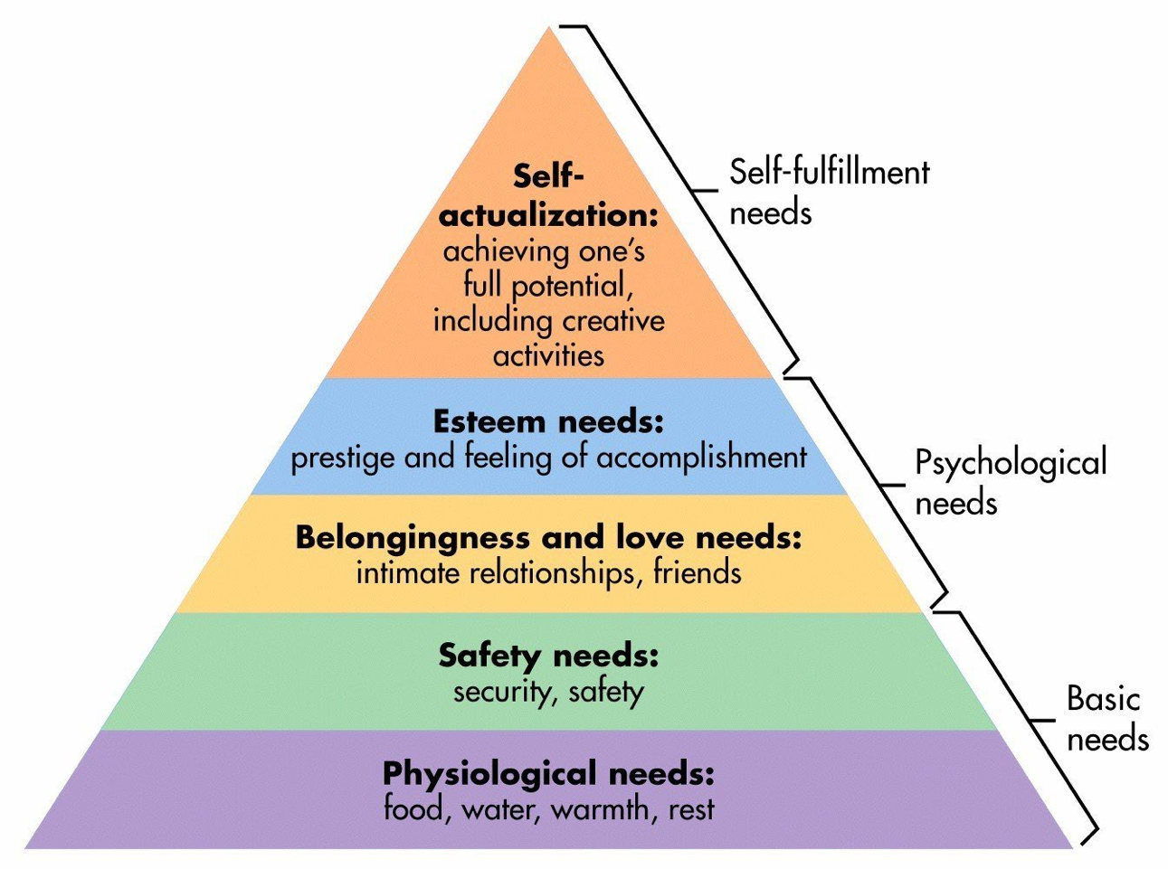

McLeod, S. (2018) Maslow’s Hierarchy of Needs. Available at: https://canadacollege.edu/dreamers/docs/Maslows-Hierarchy-of-Needs.pdf (Accessed 11 October 2022).

