Essay (HPHP 4006)
(Narantsatsralt Ganbaatar 2124049)
The Bible has been one of the biggest influences for modern human beings and its all sorts of behaviours. The myth-like stories of the Bible are to be found as answers to many human curiosity. One of such is Genesis 2:15-3:7, describing the creation of woman from man and their first sin with its punishment. Therefore, in this essay, I will attempt to analyse Genesis 2:15-3:7 in its full term and we are going to discuss as many as possible, ways to interpret it.
Genesis Chapter 1 focuses primarily on the physical part of the creation. Whereas, Genesis chapter 2 focuses almost entirely on the humans for whom the earth was created. In so doing, it adds a number of details to expand upon Chapter 1. It clarifies the purpose to be served by the earth and the creatures on it, helping us to see that everything here was created for mankind. While chapter 1 is written in strictly chronological order, I think, chapter 2 follows no particular order. It brings in various details only as necessary when they refer to humans. In addition to this, chapter 2 expands hugely on a single verse in chapter 1. In Genesis Chapter 1 verse 27 “So God created mankind in his own image, in the image of God he created them; male and female he created them.” This verse is very concise. Chapter 2, in discussing this verse, expands upon it tremendously:
(Genesis 2:5-25) “⁵ when no plant of the field was yet in the earth and no vegetation of the field had yet sprung up—for the Lord God had not caused it to rain upon the earth, and there was no one to till the ground, ⁶ but a stream would rise from the earth and water the whole face of the ground— ⁷ then the Lord God formed man from the dust of the ground and breathed into his nostrils the breath of life, and the man became a living being. ⁸ And the Lord God planted a garden in Eden, in the east, and there he put the man whom he had formed. ⁹ Out of the ground the Lord God made to grow every tree that is pleasant to the sight and good for food, the tree of life also in the midst of the garden, and the tree of the knowledge of good and evil.
¹⁰ A river flows out of Eden to water the garden, and from there it divides and becomes four branches. ¹¹ The name of the first is Pishon; it is the one that flows around the whole land of Havilah, where there is gold, ¹² and the gold of that land is good; bdellium and onyx stone are there. ¹³ The name of the second river is Gihon; it is the one that flows around the whole land of Cush. ¹⁴ The name of the third river is Tigris, which flows east of Assyria. And the fourth river is the Euphrates.
¹⁵ The Lord God took the man and put him in the garden of Eden to till it and keep it. ¹⁶ And the Lord God commanded the man, “You may freely eat of every tree of the garden, ¹⁷ but of the tree of the knowledge of good and evil you shall not eat, for in the day that you eat of it you shall die.”
¹⁸ Then the Lord God said, “It is not good that the man should be alone; I will make him a helper as his partner.” ¹⁹ So out of the ground the Lord God formed every animal of the field and every bird of the air and brought them to the man to see what he would call them, and whatever the man called every living creature, that was its name. ²⁰ The man gave names to all cattle and to the birds of the air and to every animal of the field, but for the man there was not found a helper as his partner. ²¹ So the Lord God caused a deep sleep to fall upon the man, and he slept; then he took one of his ribs and closed up its place with flesh. ²² And the rib that the Lord God had taken from the man he made into a woman and brought her to the man. ²³ Then the man said,
“This at last is bone of my bones
and flesh of my flesh;
this one shall be called Woman,
for out of Man this one was taken.”
²⁴ Therefore a man leaves his father and his mother and clings to his wife, and they become one flesh. ²⁵ And the man and his wife were both naked and were not ashamed.” (BibleGateway, 2024).
We read in verse 7 that Adam was created. Then there is a brief explanation regarding an important aspect of his education. He was taught about God's laws first, that there would be consequences for disobedience. In verses 19 and 20 his education went on to include having to examine each type of animal in order to give it a suitable name. This would have taken a long time, probably decades. And only after this is the need for a mate finally mentioned. Then, finally, in verses 21 and 22 we read of Eve’s creation and the first simple wedding ceremony of mankind along with more instruction regarding the type of bond that should exist between a husband and a wife. So the events described in a single verse in chapter 1, when described in more detail, took 21 verses in chapter 2. It is all about the people, not the things.
On the other hand, in ancient Hebrew, the word for Holy Spirit is Feminine, “Ruach” (Hebrew for Christians, 2024). According to this source, the word for Spirit is written as follows; (רוח) (ruach), (which is used in the Hebrew Bible, as is the feminine word "shekhinah" in rabbinic literature, to indicate the presence of God). The Hebrew language phrase ruach ha-kodesh (Hebrew: רוח הקודש, "holy spirit" also transliterated ruacḥ ha-qodesh) is a term used in the Hebrew Bible and Jewish writings to refer to the spirit of YHWH (רוח יהוה). If we notice it, Adam does refer to a mother, but we must point out Adam was not born but formed, made from dust. Nevertheless, we can get another Glimpse of the female Holy Spirit, the Spirit of God's Wisdom.
Genesis 3 reveals that God created numerous invisible spirit creatures, or angels, long before He created humans. A disobedient angel in Eden, later to be called Satan the Devil, cunningly attempted to lure Eve into eating the fruit of the one tree that God had forbidden. Using a snake as a mouthpiece, Satan hinted that God was keeping something desired from the woman and her husband from the very beginning of chapter 3. Eve was informed by the angel that if she and her husband ate the forbidden fruit, they would not perish. Thus, Satan charged that God had lied to His creation, the humans. The Deceiver portrayed disobedience to God as a desirable path that would result in liberation and enlightenment. All of this, however, was a falsehood—the first untruth ever spoken on Earth, in fact. The true question at hand concerned God's sovereignty, or supreme rulership: whether God has the right to rule and whether he does so in a way that is morally just and beneficial to his people. (Jehovah’s Witnesses, 2024).
In other words, Eve fell for the deceit of Satan. She started to crave the fruit and eventually swallowed some of it. Subsequently, she shared some with her spouse, who also consumed it. They thus turned into sinners. That seemingly insignificant deed was a sign of disobedience. Adam and Eve consciously rejected the authority of the Creator, who had given them everything, including a wonderful life, by choosing to defy God's order. The rebels were summoned by God to answer for their deeds. He predicted the arrival of the Seed, or Deliverer, who would bring about the destruction of Satan, the figure symbolised by the snake. God showed kindness to Adam and Eve's unborn children by postponing the execution of their death sentence for a while. The One that God would send would rectify the devastating effects that the rebellion in Eden had set in action, giving those children reason to hope. As the Bible was written, more and more details about how God intended for this coming Saviour to be fulfilled and who the sent-forth One would be became clear.
The serpent was now more crafty than any animal that the Lord God had created in the field.
And he said to the woman, “Has God indeed said, ‘You shall not eat of every tree of the garden’?” And the woman said to the serpent, “We may eat the fruit of the trees of the garden; but of the fruit of the tree which is in the midst of the garden, God has said, ‘You shall not eat it, nor shall you touch it, lest you die.’ ” Then the serpent said to the woman, “You will not surely die. For God knows that in the day you eat of it, your eyes will be opened, and you will be like God, knowing good and evil.” (BibleGateway, 2024).
In Genesis 2:14-17 God told Adam he's free to eat of every tree of the garden except that of the tree of knowledge of good and evil. Comparing the above scriptures we will find the depth of Satan's deception. No wonder he's described as very cunning.
However, Satan didn't come out straight to lie against God. He started with a question to see the level of emotional involvement Eve attached to the tree, I think. Hearing her exaggerated answer which is a lie, (nor shall you touch it) and not part of God's command, Satan knew, he could step up by telling her some half-truths. The part about them knowing good and evil was true, but that they would not die was an outright lie. Death is a separation and they immediately get separated from God. They could no longer see God. But God is good so they could still perceive his Presence. After Genesis 3:7-8, it is shown that their, Adam and Eve, spiritual covering was gone, and they saw themselves naked. They now knew good and evil and with that knowledge came the sorrow of separation from God, shame, hiding from God's Presence, decay, sickness and eventual physical death too.
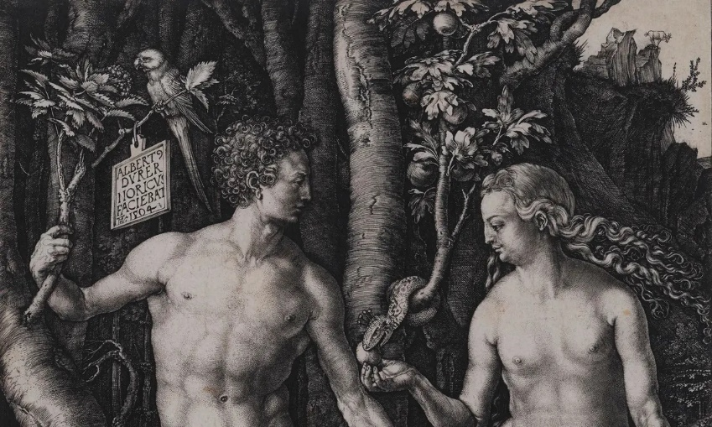(Albrecht Dürer’s ‘Adam and Eve’)
The only thing the serpent who is called Satan knows best to do is to look for ways to kill man, steal from man and destroy man as is written; the thief cometh not, but for to steal, and to kill, and to destroy. (John 10:10a) That thief is Satan who entered the serpent. No Spirit enters the physical world except through the tacit approval of some man.
Satan still lies to man today in many ways. For example, one lie he always tells man is that man is master of himself and does not need God which is still a half-truth and a half lie just like he did in Genesis 3. He continually feeds on the ignorance of man. Because God has given man freedom of choice and also knowledge, man is deceived into believing that he does not need God. But wait until that same man faces eternal judgment, he immediately would know that this world has an owner who demands obedience from his Creation. Furthermore, man has the ‘DNA’ of sin inherited from Adam and cannot do anything about it. The only solution for a man to get back to righteousness with God is for someone without sin to pay the sacrifice for sin. Jesus came, not through the polluted seed of man but by the power of the Holy Spirit to redeem man more than 2000 years ago. “Those who believe in him are not condemned, but those who do not believe are condemned already because they have not believed in the name of the only Son of God.” (John 3:18)
It is later claimed that God expelled Adam and Eve from Paradise. To make a living outside of the Garden of Eden would take labour and sweat. Cain was Adam and Eve's first child, born when Eve fell pregnant. Abel and Seth, Noah's ancestor, were among the couple's other sons and daughters. (Britannica, 2024).
In the conclusion, we have analysed the basis of Genesis chapter 2 and the first sin with its punishment. I have attempted to elaborate on Adam and Eve’s birth, their affair with god and their sin. We have seen the reason why they were expelled from Eden. And it seems, from that very beginning humans have been trying to get back to Eden by behaving unsinful. We can easily see that this seek has many influences on nowadays daily life, especially in the ‘western world’. At the end, I would like to end this essay by stating that biblical myths and stories have been shaping people’s perspectives from ‘how to behave’ to ‘what to do’.

Bibliography
Britannica, 2024. Britannica. [Online]
Available at: https://www.britannica.com/biography/Adam-and-Eve-biblical-literary-figures
[Accessed 10 March 2024].
Hebrew for Christians., 2024. Hebrew for Christians. [Online]
Available at: https://www.hebrew4christians.com/Names_of_G-d/Spirit_of_God/spirit_of_god.html
[Accessed 10 March 2024].
BibleGateway., 2024. Bible Gateway. [Online]
Available at: https://www.biblegateway.com/passage/?search=Genesis%202%3A15-3%3A7&version=NRSVUE
[Accessed 06 March 2024].
Biblical Scholarship., 2024. Commentary on Genesis 2:4-25. [Online]
Available at: https://biblicalscholarship.wordpress.com/2008/12/08/commentary-on-genesis-24-25/
[Accessed 7 March 2024].
Jehovah's Witnesses., 2024. Jehovah’s Witnesses. [Online]
Available at: https://www.jw.org/en/library/books/bible-teach/what-is-gods-kingdom/
[Accessed 10 March 2024].

Gn 2:5-25 (New Revised Standard Version)
Gn 3:1-5 (New Revised Standard Version)

