Assignment 1
Network Operating Systems & Security
Joshua Longhurst
2205415@student.uwtsd.ac.uk
School of Applied Computing
DDA Cybersecurity & Computer Networks
Contents
Task 1 2
Hypervisor 2
IP Addressing 2
Routing 3
Network Services 3
Task 2 4
Hypervisor 4
Operating System ISO’s 5
Download/Setup 7
Windows Server 7
Debian Server CLI 8
Windows 11 Client 9
Debian Client GUI 10
Configuration of IP’s 11
Windows Server 2022 11
Windows 11 Client 12
Debian Client GUI 13
Debian Server CLI 13
Testing/Troubleshooting 15
Windows 11 Client 15
Windows Server 2022 15
Debian Client GUI 16
Debian Server CLI 16
Windows Server 2022 to Debian Server Ping test 17
Debian Server CLI to Windows Server Ping test 17
Task 3 18
Reflection 18
Bibliography 18

Task 1

Hypervisor
Hypervisors are sets of software that creates, runs and manages virtual machines. This permits multiple operating systems to run on one singular physical hardware platform. Industry separates between Type 1 and Type 2 hypervisors with Type 1 operating on bare metal, it offers improved stronger performance and improved scalability. These main attributes make Type 1 Hypervisors the preferred option in enterprise environments where workload management and security is critical. An example of a type 1 hypervisor is VMware ESXI. Type 2 Hypervisors run directly on top of a host operating system. Type 2 Hypervisors are less efficient but provide excellent accessibility, low hardware requirements and effective in educational, testing and small operation-based environments. An example of type 2 hypervisors is Oracle VirtualBox. [1]
The hypervisor that fits the topology requirements set in the assignment brief, shows that whilst type 1 would be the best option due to scalability and performance. A type 2 hypervisor is suitable as well. As it meets the usage criteria of small labs in a controlled environment. [2]
Upon considering the topology, the hypervisor of choice for the assignment will be a Type 2 hypervisor using Oracle VirtualBox. I have chosen this because it aligns with the scale, purpose and hardware requirements of the domain. The SWANSEA.ACCA domain will consist of a limited number of machines. It will allow for a controlled environment in which Windows Server 2022, Debian Server and 2 clients to run on a single workstation without the need for a dedicated machine.

IP Addressing
Data gets transferred from one computer to another through 1 or more interconnected networks. Networks are made up of IP addresses which are unique identifiers for devices, which can be divided down to make smaller networks using subnetting. Without IP addresses routers would not have the ability to determine destinations of packets. Data is transferred using packets. [3]
IPV4 is a 32-bit decimal value represented by dotted decimals. IPv4 suffers from overuse and the need for subnetting has increased. IPV6 a 128-bit hexadecimal value allowing for a larger address selection. IPv6 supports improved routing and hierarchical addressing. Whilst IPv6 offers scalability due to its complexity, IPv4 still has industry dominance with most enterprise networks adopting dual-stack deployment. The topology design set in the assignment aligns with the use of IPv4 addressing. [4]
Routers and switches operate at different layers of the OSI, layer 2 for switches and layer 3 for routers. However, you can have a switch that operates on both layer 2 and 3 of the OSI. They enable the flow of data. [5]
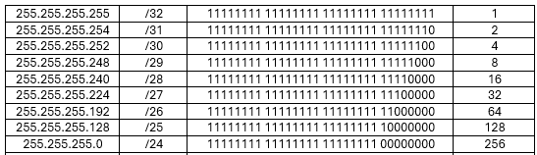
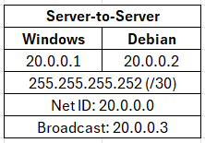

The diagrams illustrate the use of subnetting and the effect on IPv4 networks. The use of /30 network used in point-to-point networks prevents the waste of IPv4 addresses by subnetting it down to 2 usable IP’s. The subnet table displays the binary network sizes and demonstrates the CIDR notation against the subnet mask and useable IP’s in the subnet. They both reinforce the practical IP allocation and use of subnetting to segment a network.

Routing
Routing is the process of transporting data from one network to another. Routing can be set out by 2 different types static or dynamic. Static routing is manually configured, and the route doesn’t change unless told to by a configuration change usually carried out by an administrator. Static routing can be secure and suitable, but it doesn’t consider network failures or topology changes. Static routing reduces the risk of spoofing and malicious routes. Dynamic routing uses protocols such as RIP, OSPF and EIGRP to learn and update routes. It can adjust paths when network topology changes or when network failures occur. This makes dynamic routing scalable and resilient. Dynamic routing requires additional security to protect against routes being intercepted or manipulated. [6] [7]
To meet the requirements of the assignment the most suitable routing style is static routing. The network is small and stable which allows static routing to be implemented. It also allows for routing to be secure, simple and have full administrative control. If dynamic routing was implemented, it would introduce security concerns which are not required into the topology. The Debian server will work by forwarding DHCP requests to the subnets rather than providing dynamic routes making static routing suitable. Whilst the Windows server will provide domain controller services such as DNS, DHCP, Active Directory. As the routing paths are fixed and unlikely to change with the 2 subnets connected via 1 single point, static routing is able to work effectively within the network design.

Network Services
VPN’s or Virtual Private Networks are essential in many scenarios and are relatively cheap and easy to setup. They can provide encrypted remote access through the use of VPN Tunnels but can also act as entry points for cybercriminals to access protected networks. Victoria Walsh a Security Specialist at BT said, “VPN’s can be a great tool for improving your business security without having to invest a lot of money”. [8]
DHCP is considered essential in modern networking. Specialists argue in industry that it doesn’t just automate the assignment of IP addresses but allows for resilience and control. It allows for failover configurations, scope design and avoids the duplication of IP addresses within a network. Industry engineers recommend avoiding installing DHCP Roles on to a domain controller to reduce a potential attack surface. [9]
Active Directory Domain Services are high worth targets in the security world for cybercriminals. AD is dominant and essential technology for identity and access management used by 90% of organisations worldwide. Microsoft advises to avoid granting excessive privileges, keep DC’s secure and to use MFA for administrators carrying out administrative tasks in AD. [10]
Certificate authorities are one of the most sensitive components in security architecture. If the root CA is comprised, every certificate beneath it becomes untrustworthy. The best practice in industry is offline root CA’s with have minimal exposure and are tightly controlled. CA authenticates an entity such as devices or users by issuing a digital signed certificate. [11]

Task 2

Hypervisor
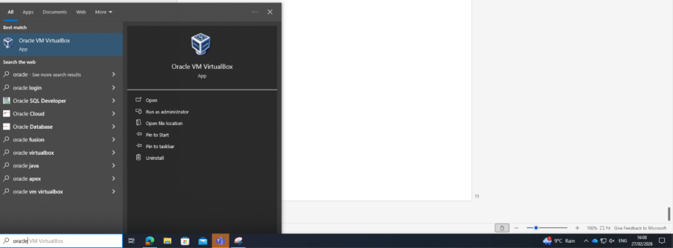
For the assignment I chose to use Oracle VirtualBox a type 2 hypervisor. The hypervisor will run 4 different Virtual Machines, One Windows Server, One Windows Client, 1 Debian CLI server and one Debian GUI client. I chose to use Oracle VirtualBox due to its flexibility, low hardware requirements with the need for dedicated hardware removed compared to type 1 hypervisors. Type 2 hypervisors are perfect for small controlled lab environments, educational settings and testing environments. [12]

Operating System ISO’s
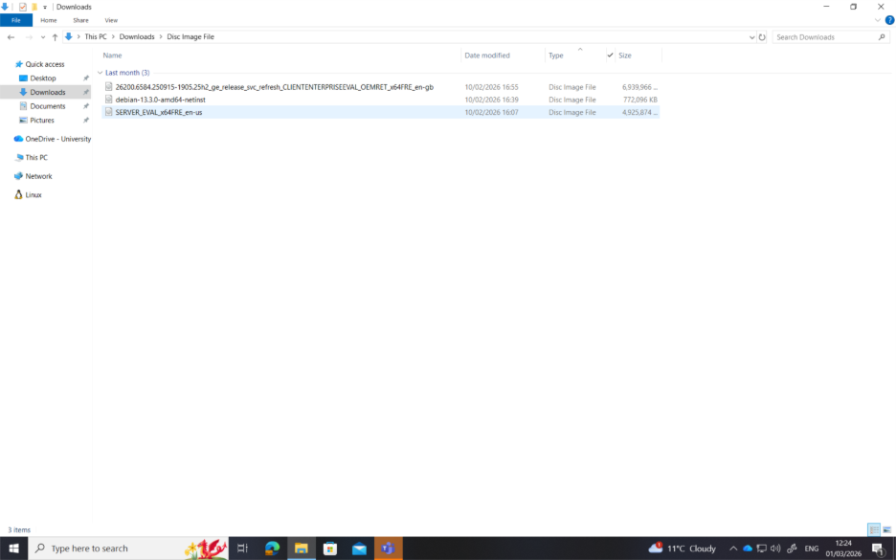
Here is the file explorer page from my machine I am running the type 2 hypervisor on. I gathered one Windows 11 Evaluation ISO, one Windows Server 2022 Evaluation ISO and one Debian ISO as you can use the same ISO for the CLI and GUI operating system interfaces.
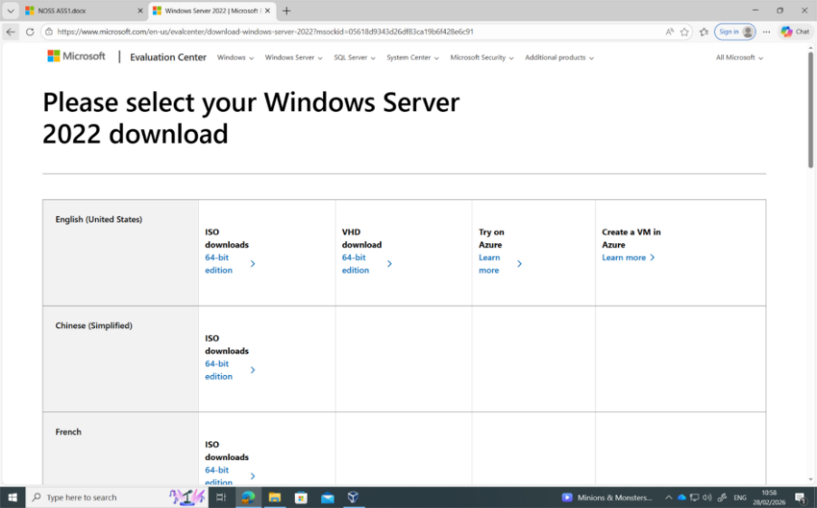
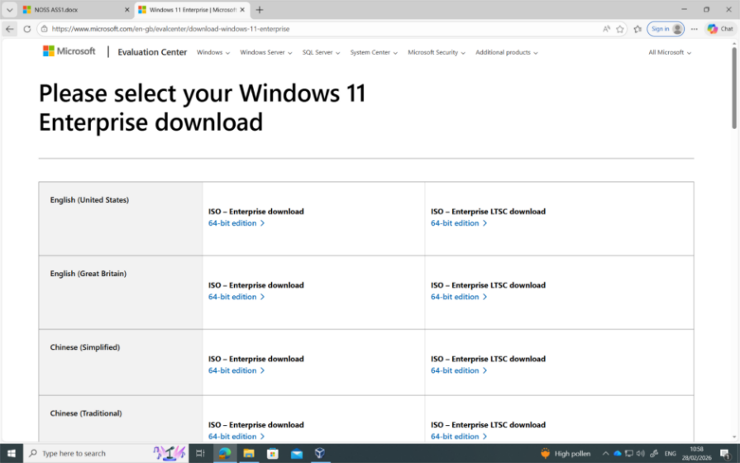
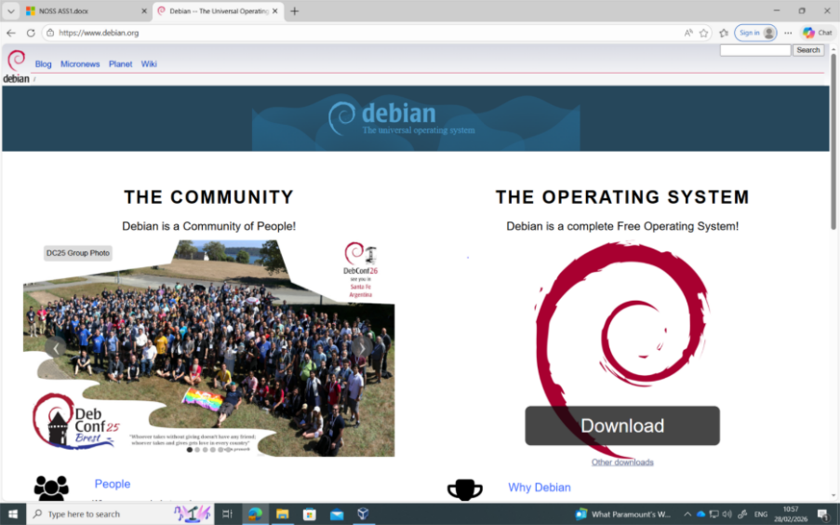

Here I show the websites and URL’s of where I decided to download the ISOs. I decided to install from the Windows Evaluation Centre for the Windows ISOs as the Microsoft website is a trusted official website and source of the ISOs and it features the padlock in the URL indicating that the website has a secure, encrypted HTTPs connection. I also decided to install the Debian OS from the Debian.org site as it features the same encrypted HTTPs connection and is the official home and source of Debian. [13]

Download/Setup

Windows Server
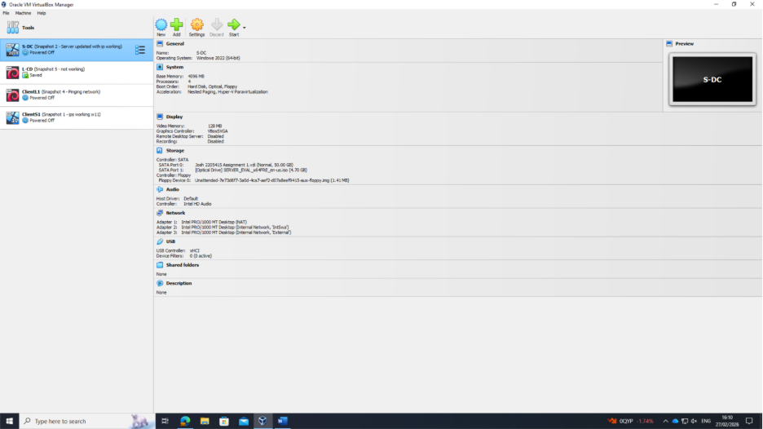
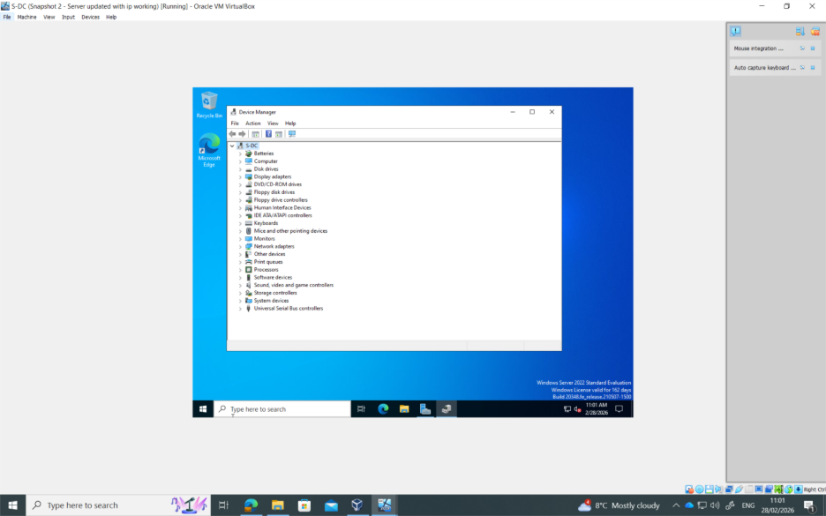
The above Screenshots show system settings of the Windows Server 2022 which is named S-DC as it will run as a domain controller. 3 network adapters are set, one as a NAT for internet access, one for the server-to-server network called External and then the LAN facing IP being IntSwa.

Debian Server CLI
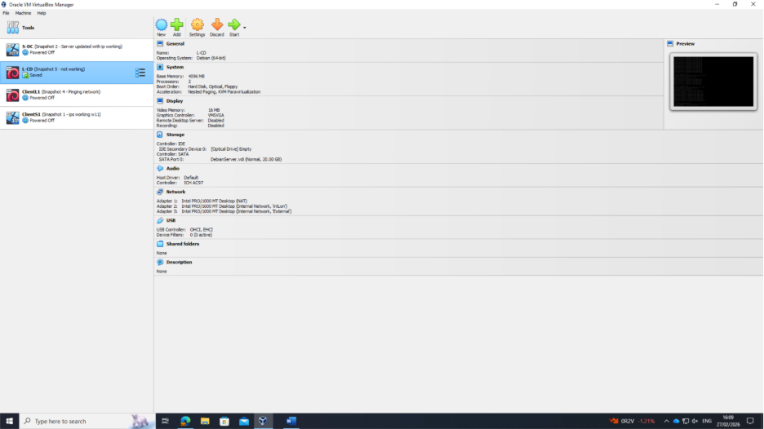
This screenshot shows the system configuration for the Debian Server which will run as a domain member. It follows the same network design as the Windows Server with one to see out to the internet, One for the Server-to-Server connection and the London LAN facing adapter called IntLon.
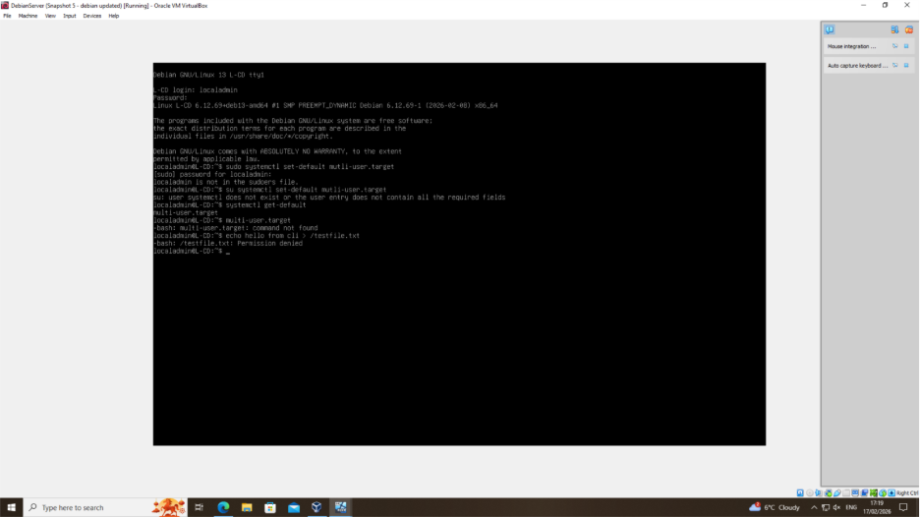
Here I show the Debian Server setup as a CLI in line with the requirements of the assignment brief. I chose to use localadmin as the username for ease of remembering and also to differentiate in future between potential user accounts and generic accounts.

Windows 11 Client
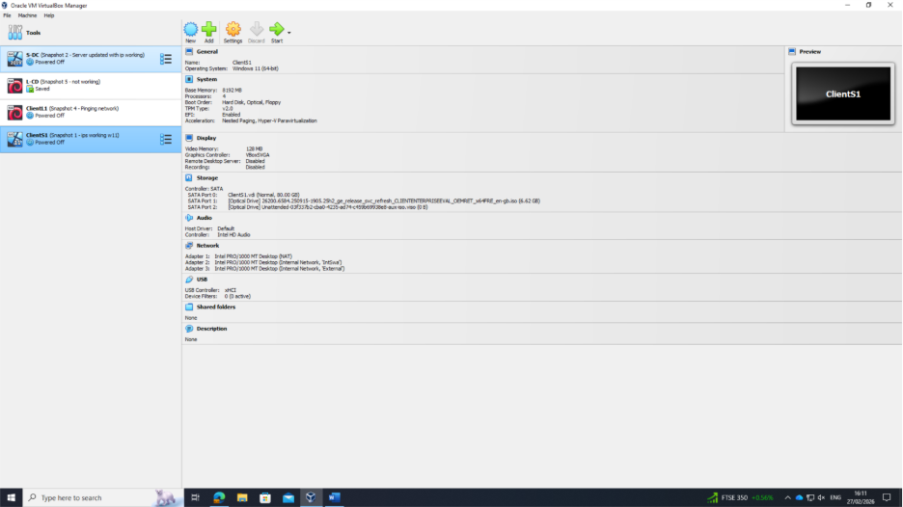
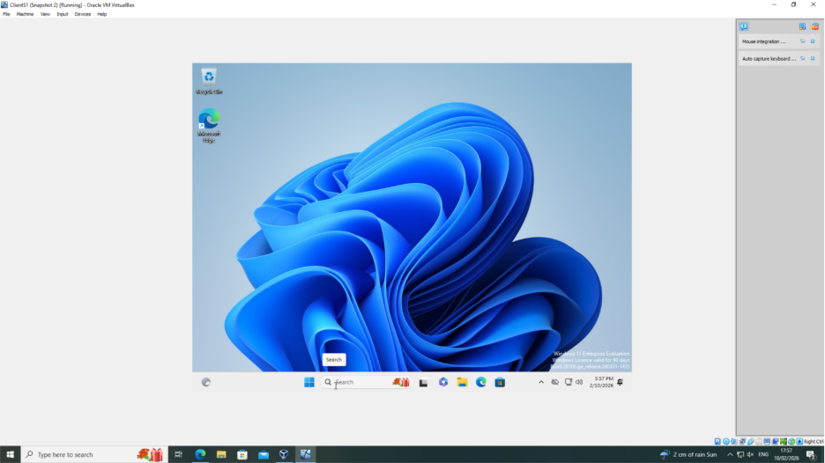
The above screen captures show the Windows 11 machine installed. Which will work as the Windows client in the SWANSEA.ACCA domain. Whilst the assignment brief requested Windows 10, due to end of support from Microsoft for Windows 10, they no longer provide the ISO in the evaluation Centre. This meant only Windows 11 was available from the evaluation centre. However, for long term security having Windows 11 already installed puts me in a better position than Windows 10.

Debian Client GUI
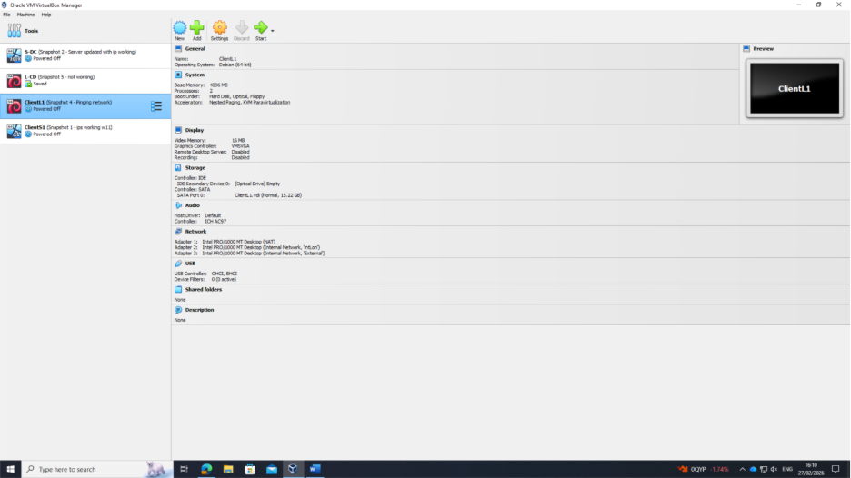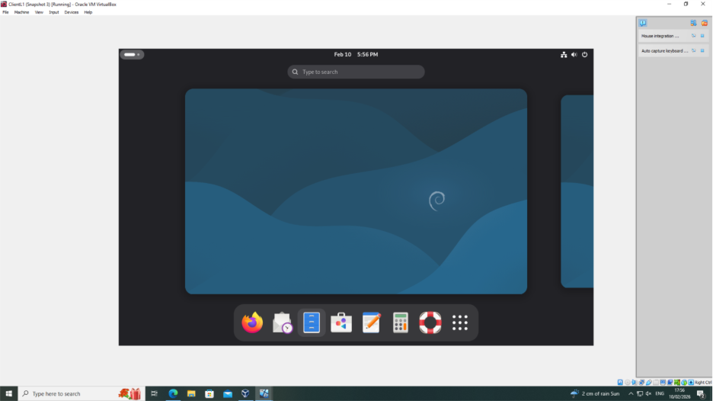
The above screen captures show the Debian machine installed. Which will work as a client in the SWANSEA.ACCA domain.

Configuration of IP’s

Windows Server 2022
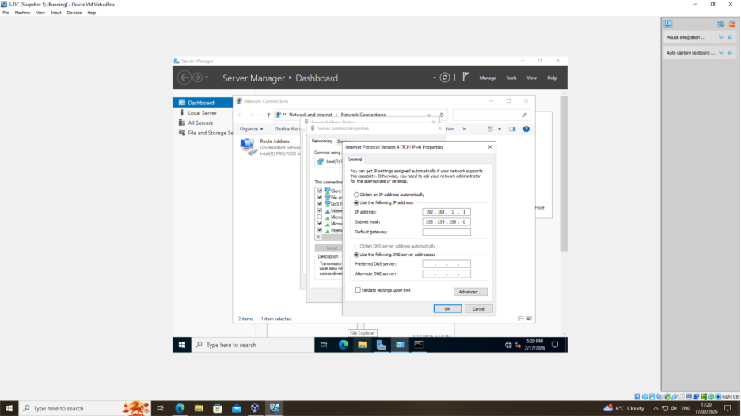
The screenshot above shows the Swansea LAN facing IP address assigned on the Windows Server Operating System. The subnet used means this network has 256 available IP addresses.
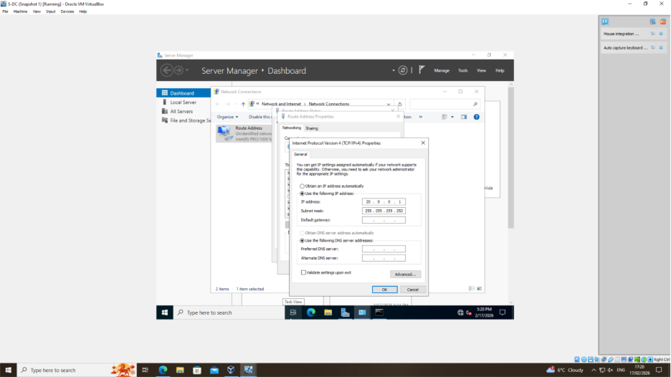
The above screenshot shows the Server to Server IP address used on the Windows Server. In this case 20.0.0.1 will be used on the Windows Server and 20.0.0.2 will be used on the Debian Server using the subnet of 255.255.255.252 as the subnet’s range is for 2 usable IP’s.
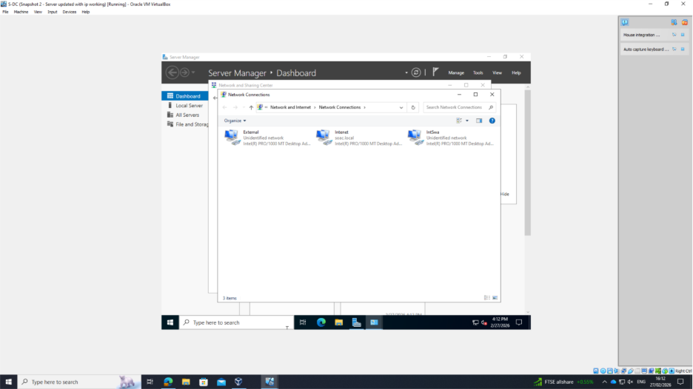
The 3 Network adapters are assigned as External, IntSwa and Internet as shown here on the Windows Server.

Windows 11 Client
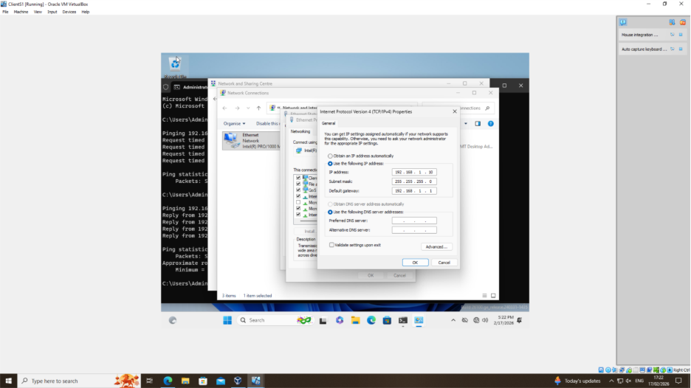
This screenshot shows the IPV4 Configuration for Windows client. The client is connected to the Windows Server using the IP of 192.168.1.10.

Debian Client GUI
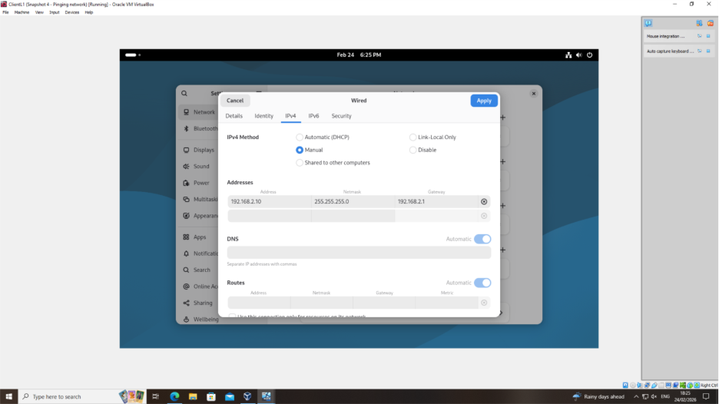
The screenshot above outlines the configuration of the Debian client using the 192.168.2.10 address in the London LAN.

Debian Server CLI
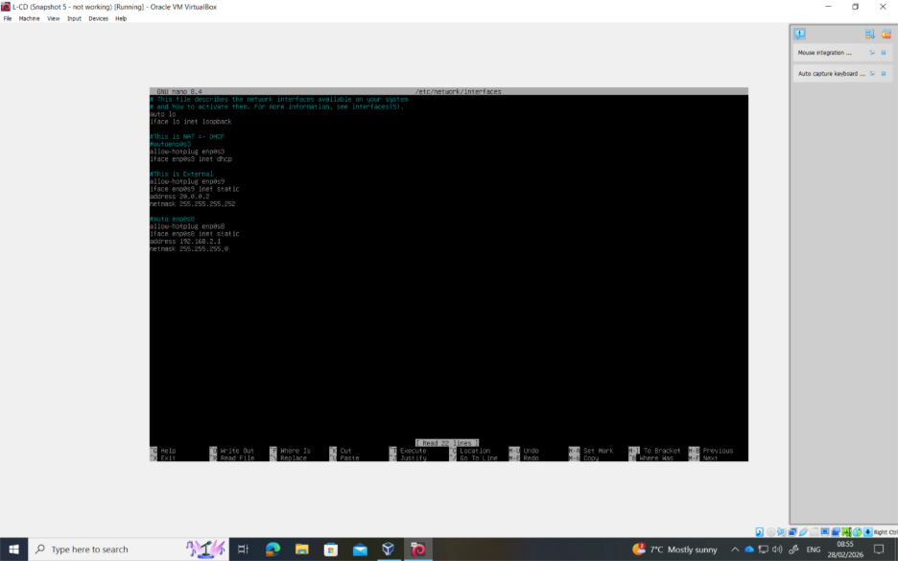
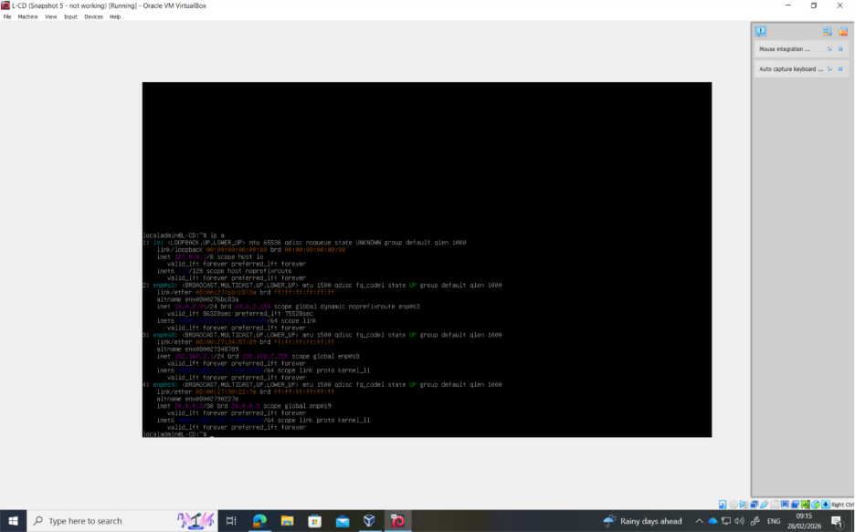
The above screenshots show the Debian Server using the CLI, the assigned IP addresses including the Server-to-Server address using the .252 subnet allowing for 2 usable addresses. It also shows the London LAN facing IP address of 192.168.2.1
It also shows the automatically assigned loopback address, Debian CLI’s have loopback addresses assigned as part of OS installation. Default loopback address is assigned as 127.0.0.1.

Testing/Troubleshooting

Windows 11 Client
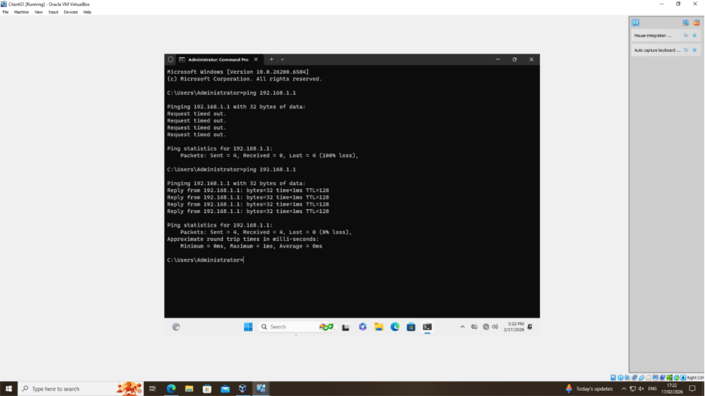
In the 1st instance I had an issue with pinging the Windows Server LAN facing IPV4 address. As seen in the screenshot, this was because I had missed turning off the Firewall. Upon carrying out a change on the firewall, the ping test was successful.

Windows Server 2022
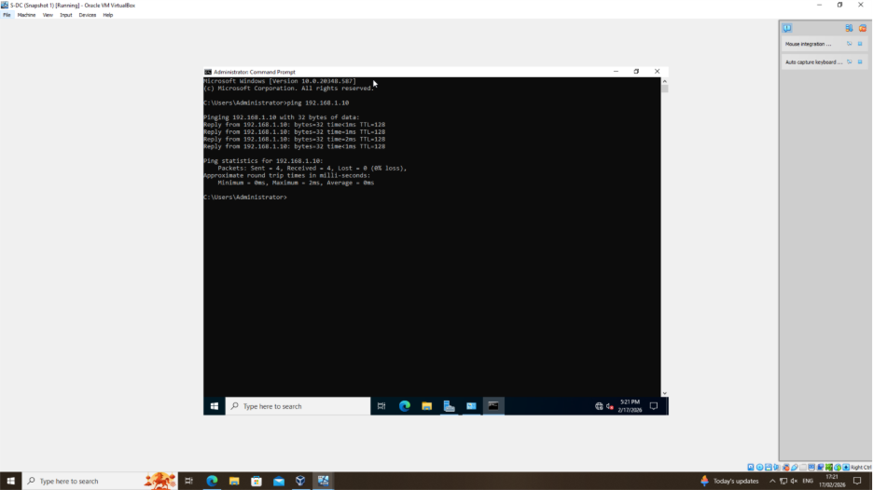
The screenshot above shows the PING test on the Windows server to ping the Windows Client on the IPV4 address of 192.168.1.10

Debian Client GUI
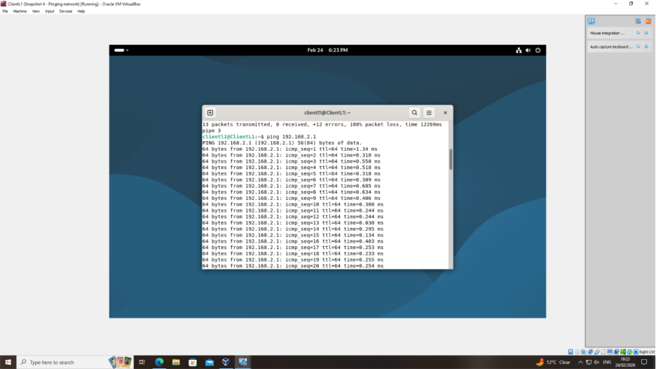
Here I have demonstrated the successful ping test from the Debian Client to the Debian Server using the address of 192.168.2.1

Debian Server CLI
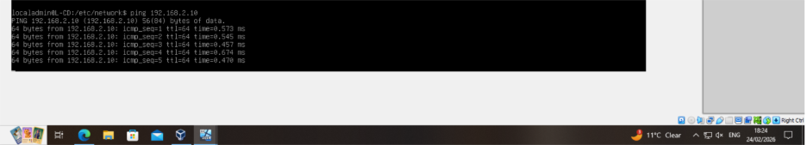
Whilst here I am demonstrating the successful ping test from the Debian server to the Debian Client using the IP address of 192.168.2.10

Windows Server 2022 to Debian Server Ping test
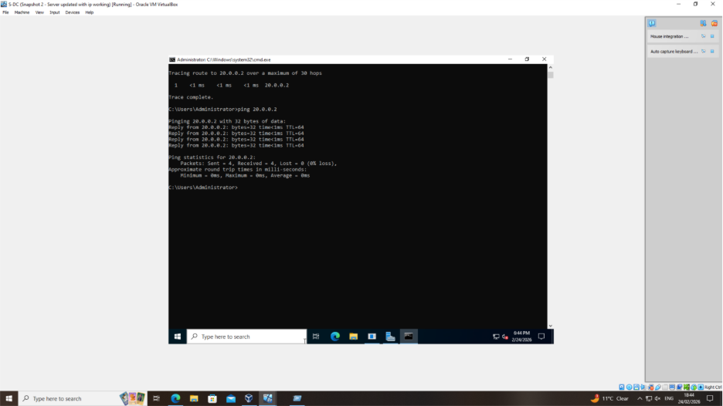
I tested the connection of the 255.255.255.252 subnet used on the server-to-server connection via a ping test. The above screenshot shows the connection, by the Windows Server successfully pinging the Debian Server.

Debian Server CLI to Windows Server Ping test
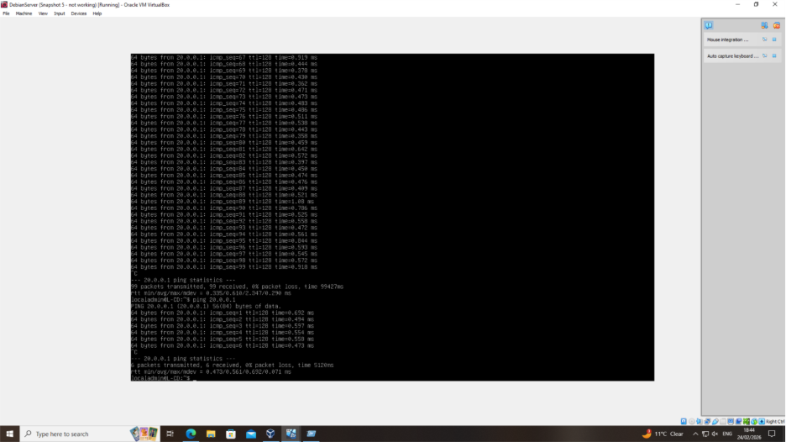
The connection between the Debian server and the windows server was also tested. As shown above the ping test being performed on the Debian Server to ping the windows server.

Task 3

Reflection
Upon reflection, technical and personal areas could be improved. Issues occurred during the Ping test, due to firewall configuration. This was spotted when I attempted to ping the Windows Server LAN IP address from the Windows Client, the test displayed the Request Timed Out message. To fault find this I introduced the OSI 7-layer Model. I firstly checked layer 1 by seeing if the Windows Server was powered. I then moved onto Layer 3 by checking if the Server had the correct IP address and Subnet assigned. On the information I had at this point, I checked layer 4 of the OSI. Checking if the packets were being blocked, where I noticed the Firewall as being on. To test I turned the Firewalls off, and the ping tests were successful. Whilst I recognise firewalls are critically important in industry networks and I strongly do not recommend turning the Firewalls off, in this controlled educational environment where the configurations are isolated in Virtual Machines, it is acceptable to turn the firewalls off for testing and troubleshooting. For future use of this Virtual Network, Firewalls will be implemented and tested.
On a personal level, during the assignment I was invited to meet the royal family which understandably caused temporary backlog. Upon returning to university I focused on catching up and ensured that deliverables were completed by expected deadlines. Although I met the required timeline, I recognise with improved time management before my departure the catch-up process would be more efficient and effective.

Bibliography

[1] | S. S. +. I. Smalley, “IBM,” IBM, [Online]. Available: https://www.ibm.com/think/topics/hypervisors. [Accessed 27 01 26].
[2] | AWS, “AWS,” Amazon Web Services, [Online]. Available: https://aws.amazon.com/compare/the-difference-between-type-1-and-type-2-hypervisors/. [Accessed 27 01 2026].
[3] | Cloudflare, “Cloudflare,” Cloudflare, [Online]. Available: https://www.cloudflare.com/learning/network-layer/internet-protocol/. [Accessed 27 01 26].
[4] | IBM, “IPv6 Addressing,” IBM, 27 02 2021. [Online]. Available: https://www.ibm.com/docs/en/zvm/7.2.0?topic=addressing-ipv6. [Accessed 01 03 2026].
[5] | “Cisco,” Cisco, [Online]. Available: https://www.cisco.com/c/en_uk/solutions/small-business/resource-center/networking/what-is-a-router.html. [Accessed 27 01 26].
[6] | Juniper Networks, “Static Routes,” HPE Juniper Networks, [Online]. Available: https://www.juniper.net/documentation/us/en/software/junos/static-routing/topics/topic-map/config_static-routes.html. [Accessed 14 02 2026].
[7] | ruijie, “dynamic route vs static route,” ruijie Networks, [Online]. Available: https://www.ruijie.com/en-global/support/faq/dynamic-route-vs-static-route. [Accessed 14 02 2026].
[8] | V. Walsh, Interviewee, Security Advisory Specialist. [Interview]. 27 10 2025.
[9] | Microsoft, “Microsoft Learn,” Turn off or remove the Dynamic Host Configuration Protocol (DHCP) Server service installed on any of the domain controllers, no. https://learn.microsoft.com/en-us/services-hub/unified/health/remediation-steps-ad/disable-or-remove-the-dhcp-server-service-installed-on-any-domain-controllers, p. 1.
[10] | Microsoft, “Microsoft Learn,” Best practices for securing Active Directory, p. 1.
[11] | Microsoft, “Microsoft Learn,” What is the Certification Authority Role Service?, p. 1.
[12] | E. Mendelson, “PCMag,” 06 01 2025. [Online]. Available: https://uk.pcmag.com/system-performance/18779/oracle-vm-virtualbox-for-mac. [Accessed 27 02 2026].
[13] | Microsoft, “Evaluation Centre,” Microsoft, [Online]. Available: https://www.microsoft.com/en-gb/evalcenter. [Accessed 02 2026].

