Game Design & Asset Creation
Assignment Two
Thomas Nurse

Game Overview
Name: Cyber Sleuth
Genre: 3rd Person Narrative
Structure: 4 Levels (1 per person)
Story Outline: Player is a detective that has been tasked with investigating a murder that has taken place in a dark alley in the city. As the player goes through and finds evidence at the crime scene, they find an ID card for a scientist that used to work at a lab that specialized in controlling creature’s minds before they were fired. On investigating the home of the scientist, the player discovers a secret lab that has been used by the scientist to continue their experiments in secret. The scientist will be nowhere to be found as the player will discover that the scientist has been killed by one of the creatures they were trying to control when it escaped. Game ends while the creature is still on the loose.
Target Audience
The target audience for the game would be a more mature audience with light elements of gore and implied bodily harm but with none shown directly on screen. Cyber Sleuth is primarily targeted at audiences that enjoy narrative games and secondarily audiences that enjoy crime shows and media. Some examples of similar titles would be:
- Life is Strange [1]

- Detroit Become Human [2]
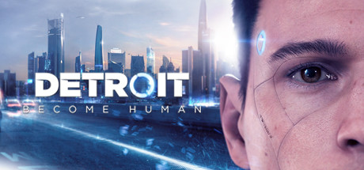
Design / Theming
The initial inspiration for the Cyber Sleuth was old black and white detective movies. This idea quickly evolved into a sci-fi game that focused on having 1920s styled environments adapted into the sci-fi aesthetic. This contrast between the old and the future is a core design principle that was used when designing most elements of our environments. In particular we wanted to focus on sci-fi elements such as holograms and hovering objects; all of which would emit their own light with their engines and projections while still integrating with the objects that were being designed as if they had not developed any further than the technology of the 1920s.

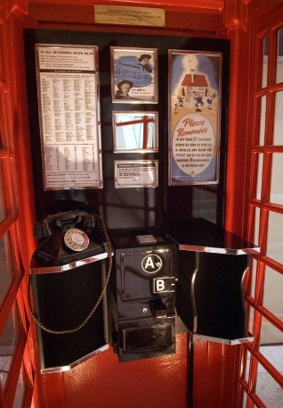
I used this image of an old British telephone box when designing my public phone asset. The main things I was looking for when researching for this asset was an unobstructed view of the interior of the phone box so I could draw inspiration from the general layout of the interior.
[3]

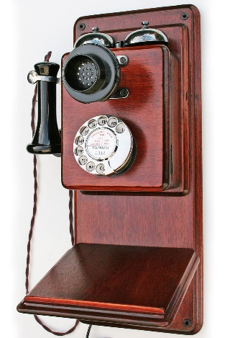
[4]
I used this image when designing the phone part of the public phone asset. I was looking for the older type of rotary phone where the person that used the phone would only pick up the earpiece part and speak into the microphone on the main body of the phone.

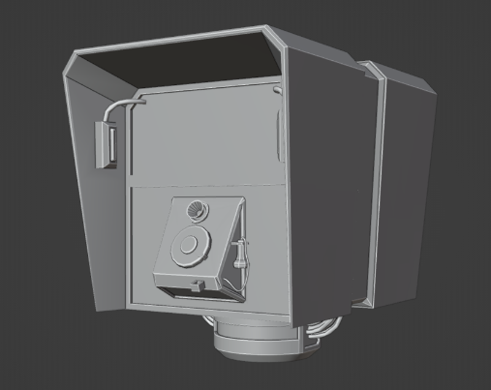
Using these reference images as inspiration, I drew from elements of each image to create my final public phone asset that was used in the game.

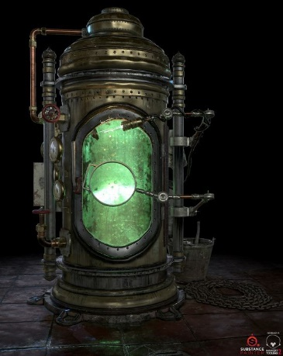
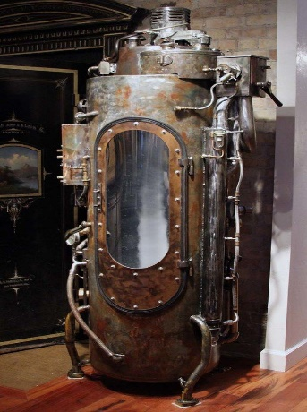
I used both of these images as references for my incubator asset. The reason I used these images is because I wanted do try to lean more into the older looking technology combined with the general atmosphere of the mad scientist’s lab. Following this idea, I ended up looking into more steampunk looking objects as I felt they worked better for my lab environment idea with it being dark and dirty rather than leaning into the more clean and sharp sci-fi aesthetic. The use of more raw looking metals such as copper was directly inspired by these references.
[6]
[5]

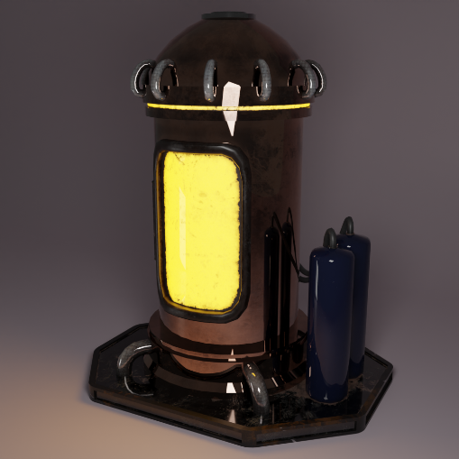
While inspiration can clearly be seen from my reference images I still wanted to try and make incubator asset more of my own, this resulted elements such as the tanks on the side connecting to the incubator as well as the emissive ring at the top of the model. I decided to make this asset highly emissive as I intended for the lab environment to be primarily lit by the objects inside of it and the incubators was always going to be the largest of these objects with a pair of incubators standing tall in the corner of the lab.

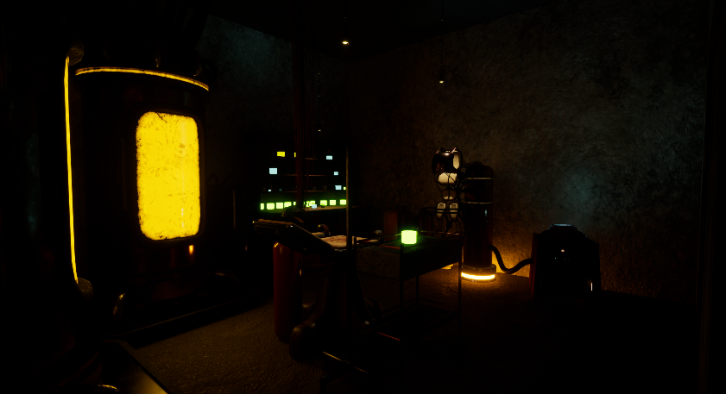
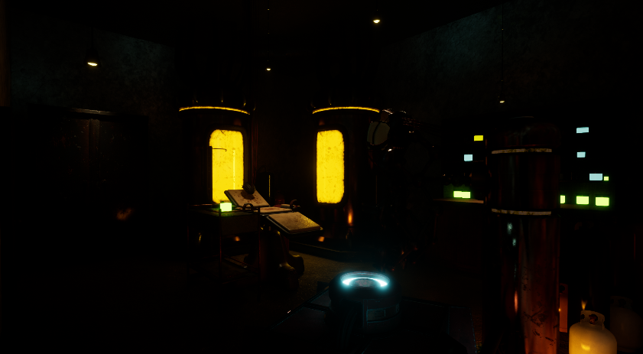
For the Lab environment I focused on keeping the room dark and utilising both spotlights and emissive lighting to highlight the assets in the environment. I did this to focus on my environment looking as if it was in a dark and dirty basement. I believe that this decision improved the environment as a whole as I think it looks more like a secret laboratory thrown together quickly by the scientist rather than a more official lab.

Research
Blender
At the beginning of the project, I had no experience with 3D asset creation in any capacity. Due to this I made the decision to learn Blender rather than Maya as I knew it would be easier for me to do my own independent research on Blender due to the much larger number of community resources for learning how to use the software. Before I started to create my own assets for the project, I spent time learning the basics in Blender by following some tutorials.
The first tutorial series I followed was the “Blender Beginner Donut Tutorial” series by the Youtube Channel “Blender Guru” ^{[7]}. I only followed the first few videos of this series as it covered the main areas of Blender that I needed to learn so that I could apply that knowledge to my assets for the project later on. Some of the main lessons that I learned from this tutorial series are:
- General navigation of the software,
- How to edit and manipulate meshes to create assets,
- How to use the modifiers system (Subdividing, Mirroring, smoothing, etc)
After I had learned the basics, I began modelling my first assets for the project, at this point my research consisted more of looking into specific aspects of what I was trying to achieve so I can learn how to do them in the best way possible rather than still learning the software in general.
When I had created my first asset, I wasn’t aware that a model could consist of multiple objects that were all contained in the single fbx file. This meant that I spent a lot of time merging my objects into a single piece of geometry rather than leaving them as child objects to the main object. While I was experimenting with Blender in my own time, I discovered that it wasn’t required to have only a single piece of geometry but instead an asset could be made of many intersecting objects packed together.
Though I did not initially intend of researching the topic of Boolean Techniques in modelling I found a video titled “Blender Secrets – 6 Minutes of Boolean Basics” by the channel “Blender Secrets” on YouTube ^{[8]}. This video introduced me to the technique of using Booleans in my modelling workflow to allow for quick cuts and unions of my objects to create specific designs very efficiently. However, when using Boolean cuts, I quickly began to find that things such as shading was beginning to break on my mesh around where cuts were made. After some research I found out that this was happening due to the Boolean cuts creating Ngons. From here I followed advise from the video “Ngons to SubD is easier than you think! (Blender Tutorial)” from the YouTube channel “Josh Gambrell” ^{[9]}. From this video I learned the importance of having clean topology in my assets and how to clean up areas of messy topology caused by my Boolean cuts. This knowledge allowed me to further improve my assets as I was able to convert Ngons throughout my models to mostly quads and some tris where quads were not feasible. After I had learned about using the Boolean techniques and how to tackle the problems that using them in my workflow created, I began using Booleans in many of my later assets and found the techniques to be very valuable as I found more places where it created efficiency improvements throughout.
When creating my incubator asset, I wanted there to be tubes connecting two points near the top all the way around the whole asset. Due to this I researched using the Array modifier to surround the main cylindrical body with the pipes. For this I found a video by the YouTube channel “Markom3D” titled “How to use the Rotate Array Modifier in Blender” ^{[10]}. From this I learned the technique of assigning the first pipe’s array modifier to an empty object and by rotating that object, it in turn manipulates the pipe array to rotate around the empty object. This technique worked perfectly for what I was trying to achieve with the pipes surrounding the top of the incubator while also being very efficient.

I knew that for some of my assets I wanted to make heavy use of cables in them for detailing. Due to this I researched how to make large amounts of cables quickly and easily. However, the methods I found were quite slow as you had to use curve objects and move them into place one at a time to create each cable. While I was looking into this, I found a plugin for Blender called “Cablerator.” ^{[11]} I decided to use this plugin as it turned the long process of creating single cables into a 3 click process. While the output object was exactly the same as if I had done it manually myself, it provided a massive efficiency boost which I really needed since I intended to have dozens of cables on some of my assets. Another feature of the plugin that I used on my scientist controls asset was a function that makes a group of cables between a set of faces. While it is just as simple to use as creating a single cable I could create a bundle of as many cables as I wanted in the same amount of time.
Another plugin I found allowed for much quicker and easier uses of Boolean operations. This plugin is called “Box Cutter.”^{[12]} Using this plugin, I can very easily create specific cuts by clicking and dragging a “cutter” over my mesh, this cutter works in the same way as a standard Boolean operation, however it is much faster to use. Using this addon in my workflow created significant efficiency improvements.
When creating my holographic police tape asset, I knew I wanted it to be fully 3D rather than just a texture on a flat plane. Because of this I started researching how to make a physical hologram in Blender. I found a tutorial made by the YouTube channel “Blender Guru” named “How to make a Hologram in Blender in 15 minutes.”^{[13]} From this tutorial I learned about how to use the geometry nodes system in Blender to fill an object with a 3D grid of points to create the holographic effect. This system can be applied to any mesh with just needing to change a couple of parameters to adapt the detail level to be suitable for both performance but also readability since my asset was going to have text on it.
When exporting my assets from Blender into Substance Painter, I wanted to clearly define areas where different textures should be applied. I knew that I could assign these areas using different materials, however this creates multiple ‘texture sets’ in Substance Painter which are exported as separate texture files which would create a lot of unnecessary work with assigning all of the extra textures in Unreal Engine. Because of this I began looking for a solution that did not have this drawback. I found a YouTube Tutorial on the channel “Azarath” titled “Blender to Substance: Using Vertex Colors to Create ID Mask” ^{[14]} From this tutorial I learned about using vertex painting in Blender to assign the areas for different textures. This means I just need to assign the areas with different colours of vertex paint to define the regions.
Substance Painter
Since I had never used Substance Painter before, I had to learn how to use the software from scratch. I started by following a YouTube tutorial for beginners to Substance Painter on the “Adobe Substance 3D” channel titled “Substance 3D Painter First Steps: 01 - Creating a Project, Materials & Masking” ^{[15]}. From this tutorial I learned the very basics of how to use Substance Painter to texture my assets. Some of the main things I learned from this tutorial series were:
- How to navigate the interface
- How to Bake Mesh Maps
- How to apply materials to the model
- How to use masking on materials
Using what I had learned in the tutorial I followed on vertex painting in Blender, ^{[14]} I was able to use my vertex colours with a simple colour mask after Baking the Mesh Maps with the “Color Source” option set to “Vertex Color” rather than “Material Color”. This meant that I could work with as few as a single export texture set while still being able to easily drag and drop materials onto specific areas of my model without it influencing any other areas.
Following a tutorial on the YouTube channel “Tutor” called “Substance Glass Shader”^{[16]} I learned how to make realistic looking glass in Substance Painter that is actually translucent. From this I learned that you could use the Opacity channel on textures if the shader is changed from “pbr-metal-rough” to “pbr-metal-rough-with-alpha-blending.”
Unreal Engine
I have used Unreal Engine before starting this project, this meant that I was already familiar with the interface and how to do many things in the engine. However, I still did research on specific areas of using Unreal Engine that I had not explored before.
Since I had never worked with Substance Painter before I had never imported any textures into Unreal Engine before. Following a tutorial on the YouTube channel “3DWolf” named “Substance Painter to Unreal Engine 5 Workflow Tutorial | Exporting Textures from Substance to UE5.” ^{[17]} I learned about exporting from Substance Painter using the “Unreal Engine 4 (Packed)” template. When exported this would give 3 or 4 texture files per texture set depending on if that set has any emissive areas. When importing textures into Unreal Engine, they need to be assigned to a material and following this tutorial I learned that the third texture file that is exported named “OcclusionRoughnessMetalic” uses the RGB channels separately to connect to the corresponding fields on the material node in Unreal Engine. Following this, I connected all the nodes correctly and my textures in Unreal Engine looked the same as they did in Substance Painter.
When making the project, I found that I wanted to make a system that I named “Conditional Doors”. The idea for this system was that by viewing the Journal Entries that the player had, the level transition actors would either be locked or unlocked. This was important as it prevented the player from just immediately moving on to the next level while missing some context that they didn’t interact with inside the current level. I eventually succeeded in making this system work after using trial and error in understanding how the core systems worked for handling things like the level doors and the journal system. After many failed attempts I was able to get the system to function where the door has a variable that contains the Journal Entry required to unlock it and whenever the player attempts to use the door, the door will compare the player’s current Journal entries to see if any of them match the required entry. If a match is found then the door will unlock and work as normal, however if there is no match found a message will be shown stating that “There is something else I need to do here” instead.

Research Methods
I used many different research methods throughout the project, some of which were used more often than others, or were only used in specific parts of the project. During the modelling stage, I mostly used methods such as searching websites like Google Images and Pinterest for inspiration, YouTube tutorials for learning about new concepts to expand my knowledge on Blender as a whole and searching forum posts for specific issues that I would have while creating my assets that I cannot find the solution for myself. Since I used Blender rather than Maya for this stage, I ended up isolating myself when it comes to sharing knowledge on modelling with my group since most things are not directly transferable between the programs; While I don’t think this hindered my ability to create my assets, it did cause issues when I was trying to explain concepts that I didn’t realise were handled in very different ways in Maya in comparison to Blender.
When texturing, the main research methods that I used were following Youtube Tutorials, sharing knowledge and ideas between group members, peers and myself or simply using trial and error to understand something on my own.
In Unreal Engine, my research mostly consisted of following YouTube tutorials, reverse engineering systems in the template to use them the way I wanted to, as well as sharing my pre-existing knowledge of using Unreal Engine to group members and peers.
Overall, I believe that my research has been overwhelmingly useful in my part of the project as I have learned both Blender and Substance Painter from scratch, and even expanded my knowledge of how to do things in Unreal Engine too. Without my research I doubt I would have created more than a few assets and they would not have anywhere near the quality that they have.
In the future I believe that expanding the amount of reference images that I gather would be greatly beneficial to the quality of my work as a whole as for many of my assets, they mostly are inspired by one or two references if any at all, this in turn means that I could’ve had many other great elements incorporated in some way that never materialised simply due to a lack of inspiration.
Another research method I would like to employ in the future would be getting feedback on my assets while I am still in the early stages of creating them. On multiple occasions throughout this project, after I had already finalised an asset to the point that editing it in many ways would be a very large ordeal, only to receive a great idea that I would have loved to incorporate in some way if it was given to me at an earlier time.
Better communication as a team as a whole also would have been beneficial, while overall I think our communication has been very good with constant activity the whole time, there were instances where one member had been doing a task in the wrong way without realising which caused very large problems later on when they added their assets to the Unreal Engine project file. They were doing this without realising the issues it would cause but since they never asked if they were doing it correctly, they were never shown the way the task should have been handled. This could’ve been solved significantly earlier when I had been asked about the right way to complete the task by a different member of the team, if I had stated the correct method to the group as a whole rather than to just a single member the issue would’ve been avoided entirely.

Collaboration
For collaborating we decided to use GitHub to store our Unreal Engine Project files on. Overall, this system worked really well as even though I managed the Unreal Engine Project as a whole, everyone did their own levels individually, this meant we needed to use a system that allowed us to easily share the project files, so each person was able to implement their changes easily.
This system was not perfect however, since GitHub has a 100MB file size limit for individual files, it mostly worked fine, however on occasion the autosaves folder would contain some files that were larger than this limit which caused the member to not be able to upload their files to the shared repository. The solution was to simply delete the contents of the autosaves folder since all changes would have been manually saved on exit of Unreal Engine anyway, but this extra friction did cause frustration on more than one occasion.
Another issue with using this system was that we were not able to reserve the project files so nobody else could edit them while we worked on them. This meant that we needed to manually communicate to each other exactly when we were going on and off Unreal Engine as we couldn’t afford for two people to use the files at the same time since their edits would create two different versions of the project, and while this would’ve been fixable later on, it was not worth the hassle of allowing it.

References
[1] DONTNOD Entertainment, “Life is Strange – Episode 1,” Steam, Jan. 30, 2015. [Online]. Available: https://store.steampowered.com/app/319630/Life_is_Strange__Episode_1/ [Accessed Dec. 9, 2022]
[2] Quantic Dream, “Detriot: Become Human,” Steam, Jun. 18, 2020. [Online] Available: https://store.steampowered.com/app/1222140/Detroit_Become_Human/ [Accessed Dec. 9, 2022]
[3] unicornkiosks, “Red Telephone Box Sale & Restorations,” Pinterest. [Online]. Available: https://www.pinterest.co.uk/pin/541135711448581451/ [Accessed Oct. 28, 2022]
[4] Antique Telephones, “Genuine GPO 121L wooden wall telephone 1920s” Antique Telephones. [Online]. Available: https://www.antiquetelephones.co.uk/contents/en-uk/p1297_Genuine_GPO_121L_wooden_wall_telephone_1920s.html [Accessed Oct 29, 2022]
[5] flickr, “Tornado 3.0 (wide right),” Pinterest. [Online]. Available: https://www.pinterest.co.uk/pin/26106872833045581/ [Accessed Nov. 10, 2022]
[6] Artstation, “Steampunk Incubator, Raphael Jean” Pinterest, [Online]. Available: https://www.pinterest.co.uk/pin/907334656151341570/ [Accessed Nov. 10, 2022]
[7] Blender Guru, “Blender Beginner Donut Tutorial,” YouTube, Dec. 03, 2021. [Online]. Available: https://www.youtube.com/playlist?list=PLjEaoINr3zgFX8ZsChQVQsuDSjEqdWMAD [Accessed Oct. 11, 2022]
[8] Blender Secrets, “Blender Secrets – 6 Minutes of Boolean Basics,” YouTube, Jul. 19, 2022. [Online]. Available: https://www.youtube.com/watch?v=_S3D8djM5bE [Accessed Oct. 22, 2022]
[9] Josh Gambrell, “Ngons to SubD is easier than you think! (Blender Tutorial),” YouTube, Aug. 23, 2021. [Online]. Available: https://www.youtube.com/watch?v=AuY_kHUya9A [Accessed Oct. 23, 2022]
[10] Markom3D, “How to use the Rotate Array Modifier in Blender,” YouTube, Mar. 26, 2020. [Online]. Available: https://www.youtube.com/watch?v=BVGW3fyOkEc [Accessed Nov. 23, 2022]
[11] Sergey Kritskiy, “Cablerator,” Blender Market. [Online]. Available: https://blendermarket.com/products/cbl [Accessed Oct. 24, 2022]
[12] TeamC, “Boxcutter,” Blender Market. [Online]. Available: https://blendermarket.com/products/boxcutter [Accessed Oct. 24, 2022]
[13] Blender Guru, “How to make a Hologram in Blender in 15 minutes,” YouTube, Sep. 30, 2022. [Online]. Available: https://www.youtube.com/watch?v=0OsgS2JpM8k [Accessed Oct. 22, 2022]
[14] Azarath, “Blender to Substance: Using Vertex Colors to Create ID Mask,” YouTube, Apr. 16, 2021. [Online]. Available: https://www.youtube.com/watch?v=q6Ojnv0vR7k [Accessed Oct. 27, 2022]
[15] Adobe Substance 3D, “First Steps: Substance 3D Painter,” YouTube, Jun. 23, 2021. [Online]. Available: https://www.youtube.com/playlist?list=PLB0wXHrWAmCw90iSI7Gj8XWnEN6NHt6kx [Accessed Oct. 21, 2022]
[16] Tutor, “Substance Glass Shader,” YouTube, Mar. 28, 2020. [Online]. Available: https://www.youtube.com/watch?v=lfufwfE1rA0 [Accessed Nov. 26, 2022]
[17] 3DWolf, “Substance Painter to Unreal Engine 5 Workflow Tutorial | Exporting Textures from Substance to UE5,” YouTube, Jun. 26, 2021. [Online]. Available: https://www.youtube.com/watch?v=vxVd0Zk8ECg [Accessed Oct. 18, 2022]

