  Component One:  What are the key skills required when working in the housekeeping team? 750 words (+/- 10%)  Contribution to Overall Module Assessment: 25% | Student No: | 2121888
 | Module Title: | Operating Hotel Facilities
 | Module Code: | 4006
 | Lecturer: | Laurence Blake
This topic relates to the skills required to be an effective member of a hotel’s housekeeping team.

Setupmyhotel.com (2012) describes the housekeeping department as the one that ensures the cleanliness, maintenance, and aesthetic appeal of all rooms and public areas. The first impression of how a hotel will treat its guests is often made by its appearance.

Jones (2008) expresses the views of many that even in a industry that is considered poorly paid, “housekeeping employees are among the lowest paid….the housekeeping department has traditionally attracted individuals who possess minimal levels of education, skills and esteem.” This probably because there is very little academic knowledge required. The key skills relate to manual labour such as lifting, cleaning, sweeping, mopping, scrubbing and dusting. Basic literacy to be able to read and write, and to pass simple messages to the front desk and/or maintenance departments is often the only requirement.

Despite the perception above I have found that housekeepers are expected to have a skillset that goes beyond the basic ability to vacuum, mop, scrub and dust. Housekeepers are the only staff in a hotel that see the guests up close and personal. This requires a high level of soft skills like honesty, tact and diplomacy around guests. As a liaison with the front desk and maintenance, housekeepers need to have good communication skills too. As smartphones become the norm, and with more and more hotels are using applications such as Breezeway.io to ensure the successful completion of tasks, across multiple rooms and within strict timelines, the ability to use apps and effective time management is another important skill that is required.

If I could compare a hotel to a car the housekeeping department would be the engine, mostly hidden under the bonnet often dirty and greasy but nevertheless working smoothly. The only time it would be recognised is during a breakdown. Having working as a trainee housekeeper I have realised that there is major disconnect between the importance of the role with the usual type of personality that applies for the position.

A recent job advertisement on Indeed.com for what Marriott Stanton Beach in Miami, Florida describes a housekeeper as “Guest Environment Expert” that empowers them to handle guest requests as well as the more familiar roles. With a focus more on the experiences I have seen that the roles of housekeepers are now blurring – not only cleaners but also as brand ambassadors that can and must enhance the guest’s experience. The wording from this job post simply reaffirms my view that today’s housekeepers are more customer service agents with additional responsibility to ensure cleanliness.

In 2020, much of the housekeeper’s role and skills changed. The pandemic has helped make the housekeeping function no longer about being “flawless and invisible”. “The era of cleaning happening behind the closed door is passe and efforts are required to take cleaning and sanitization centre stage in communication and guest experience.” Sharma and Kaushik (2021)

Following the pandemic, housekeepers have had to take a more prominent front stage role as star performers in Thompson’s (2020) “Hygiene Theatre”. When before the housekeeper worked behind the scenes, now they are very much centre stage vigorously spraying and polishing in full view of the public to reassure guests that their hotel is very much a safe and “germ free” place to stay. In so doing more and more non housekeeping staff are getting in on the act; such as front desk agents regularly seen to be cleaning their counter tops.

It is very important for the hotel industry to expect and demand the right skills from a housekeeper, and recruitment for housekeepers in many modern hotel chains reflect this. There may be nomenclature changes such as the above guest environment expert shows but the core skills that are required to successfully execute the duties required remain. An aesthetically pleasing hotel that has a clean lobby and clean rooms is an essential pre-requisite to attract guests in the first place.

Beyond aesthetics, a hotel that fails to maintain proper cleaning standards can face the type of unwanted scrutiny that harms its brand, and hence its profits. Inside Edition (2021) highlighted some hotels that failed to properly clean and replace sheets or pillow cases. As a manager, it is essential that staff adhere to the protocols established.

REFERENCES:

Indeed.com 2023 Available at: indeed.com/view/job?jk=570e650055572273&tk=1gqktsg98itms800&from=serp&vjs=3 Accessed: 3rd March 2023

Inside Edition Sheets Weren’t Changed at Some Hotels During COVD-19 [youtube video] Available at: https://www.youtube.com/watch?v=ltBrCJC5BNI Accessed: 7th March 2023
Jones, TJA, ED Professional Management of Housekeeping Operations 5th edition John Wiley & Sons pg

Setupmyhotel.com 2012 Available at: https://setupmyhotel.com/train-my-hotel-staff/hk/789-housekeeping.html Accessed: 6th March 2012

Sharma, S. and Kaushik, T., 2021. Aesthetically clean to clinically clean – A study on new housekeeping practices in Delhi hotels beyond COVID-19 pandemic. Worldwide Hospitality and Tourism Themes, 13(5), pp. 646-659.

Thompson, D. (2020) Hygiene Theatre is a Huge Waste of Time The Atlantic July 27th 2020 Available at: https://www.theatlantic.com/ideas/archive/2020/07/scourge-hygiene-theater/614599/ Accessed: 6th March 2023

Word Count | 717

Component Two:
Contribution to Overall Module Assessment: 25%
In this scenario – You have just been promoted to team leader for a floor within the hotel. A guest complains that on their arrival, their room had not been properly cleaned. Create an action plan and answer the following questions.

Problem | Why did it happen? | What are you going to do? | How will you prevent this from happening in the future? | What measures would you introduce to improve team effectiveness?
- Guest reported room not properly cleaned.  - Guest had been allowed an early check in into their favourite room. | - There had been a full house the day before, and there had been several late checkouts agreed.  - There is also a near full house checking in  - Due to high staff turnover, team member assigned that room was new and had only started working the day before.  - He was already struggling to make up his rooms quota for the day, and he was behind schedule.  - He admitted that he had to skip some areas. | - The first thing is to meet with the guest and apologise for the inconvenience.  - Subject to room availability and in conjunction with the Front Office Manager I will offer the guest a room change (preferably an upgrade)  - If this is not possible due to a full house I will offer the guest a complimentary drink or meal while I work with the housekeeper to bring the room up to standard.  - I will have towel art arranged in the room and will have some complimentary cake or wine in the room.  - Hopefully we as a hotel would be able to rectify the mistake and exceed the guest’s expectation in making a service recovery. | - I will be working closely with the Front Office team to stress the importance of checking with the housekeeping team before late checkouts or early check in requests by guests are agreed.  - I will meet with my housekeeping team to offer support should they need it and then stress the importance for them to be share their concerns.  - I will also stress that team members follow the strict tasks that are expected to be undertaken in each room, and to tick them off as they complete each task. | - A staffing roster that clearly defines the room assignments.  - Have daily 10 at 10 meeting to discuss the key assignments/special events/special requests and VIP guests arriving each day  - Attend regular meetings with other departments to ensure that there is proper communication and liaison between each other  - Suggest inter department placements so that each department team members can see how the entire operation requires everyone to work together.  - Arrange a staff training session
 |  |  | - I would look into the possibility of using housekeeping apps such as breezeway.io to simply and ensure that all tasks are completed and monitored by myself and the housekeeping manager.

Reference: Therefore, service providers endeavor at ‘doing the service very right the second time’
CHIHYUNG OK KI-JOON BACK CAROL W. SHANKLIN and quoted from MIXED FINDINGS ON SERVICE RECOVERY PARADOX: AN ILLUSTRATION FROM AN EXPERIMENTAL STUDY (Berry and Parasuraman, 1991, p34).

Component Three:
Contribution to Overall Module Assessment: 50%
Your task is to create and prepare a presentation following the detailed scenario provided below.

As the floor housekeeping manager and given the recent guest complaints you need to put together a basic training presentation for your colleagues within the housekeeping team to get the best out of them, ensure that brand standard is being achieved and that Health and Safety procedures are also being followed.

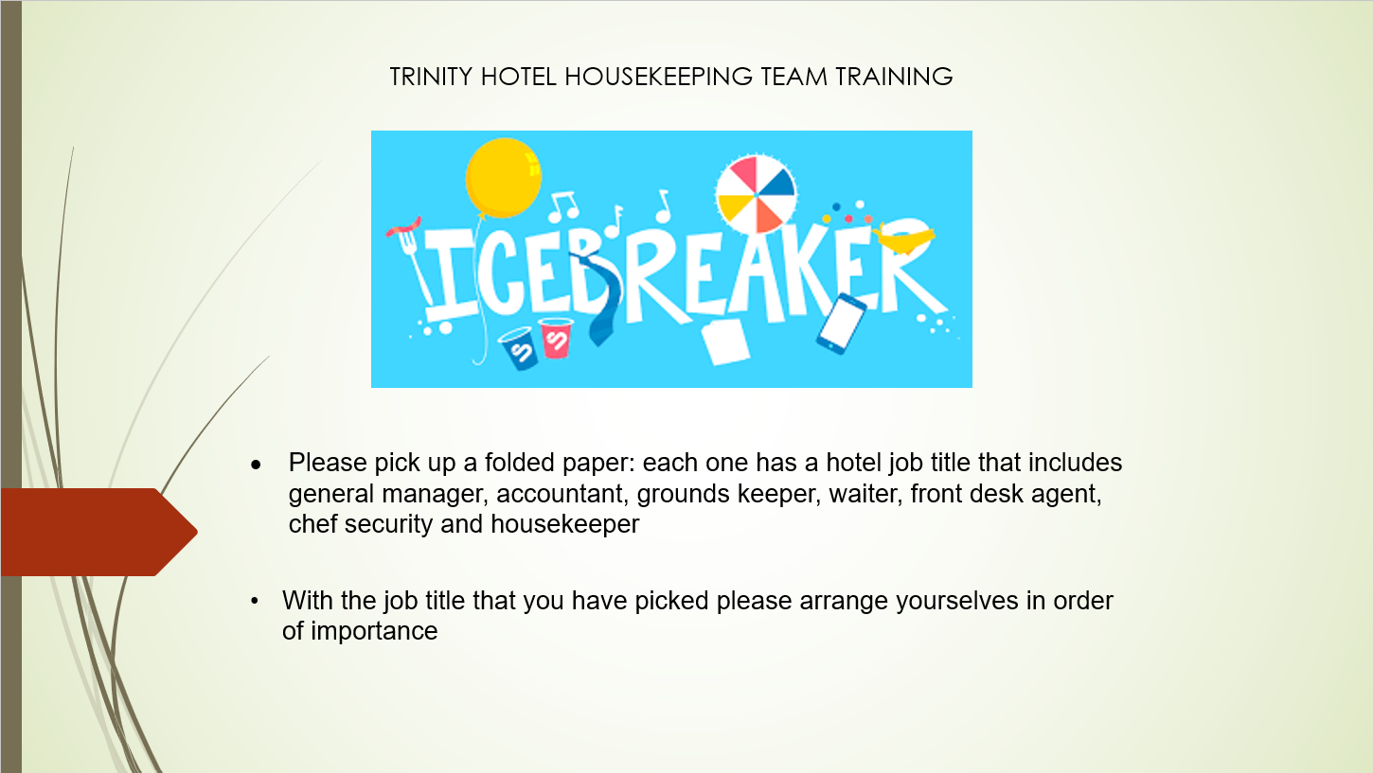

Training Notes:

The aim is that the group form a circle rather than a line. Jones, Thomas and Jones (2007a) has acknowledged that many see housekeeping as a job that lacks esteem despite its essential role in the hospitality business. The circle represents the fact that housekeeping is an integral part of the chain to provide excellent customer service.

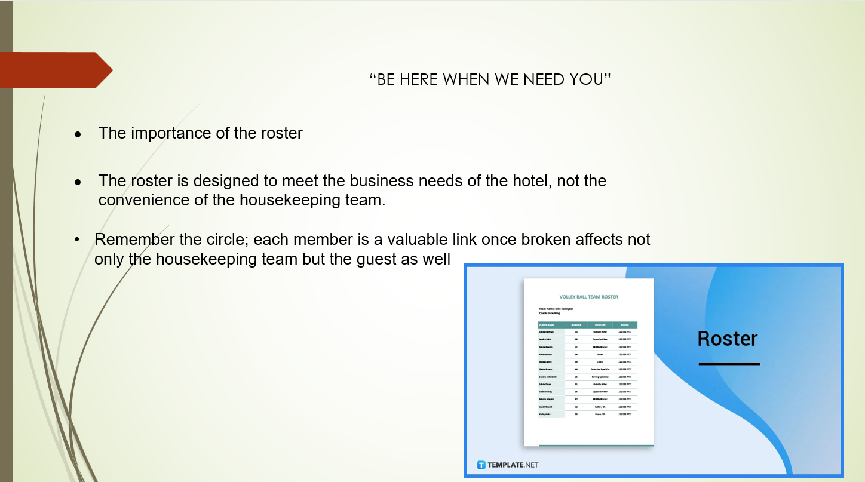

Training Notes:
Important to stress that obviously guests is the priority. Also necessary to stress that the department, and the employees are all equally as important as each other when it comes to scheduling. The understanding of the compliance to schedule, and the expectation of compliance to schedule. “Be here when we need you”

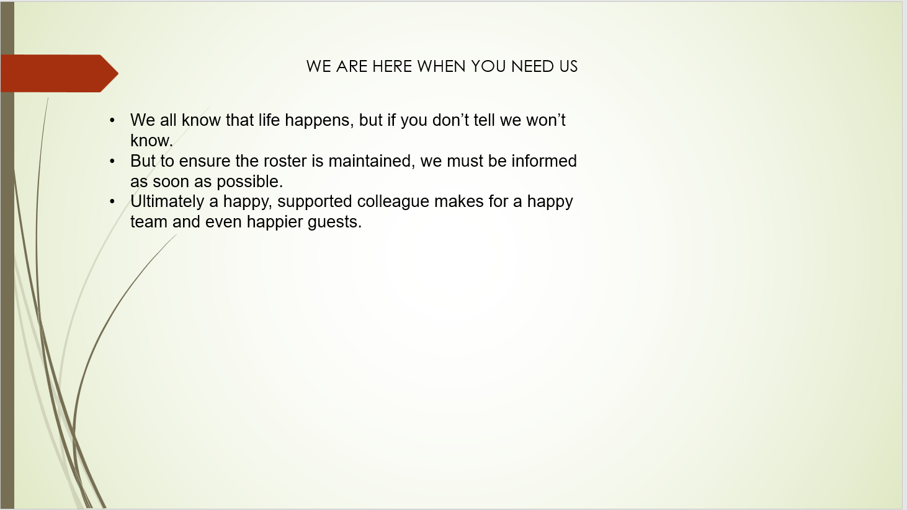

Training Notes: It is important to let the team know that managers are also interested in the well being of the team, because without them there is no department. So far as special needs and special requests does not affect the departments operations and harmony requests may be considered.

There is also the need to ensure that as much as possible absences are reported in good time. (Housekeeping Rehab)

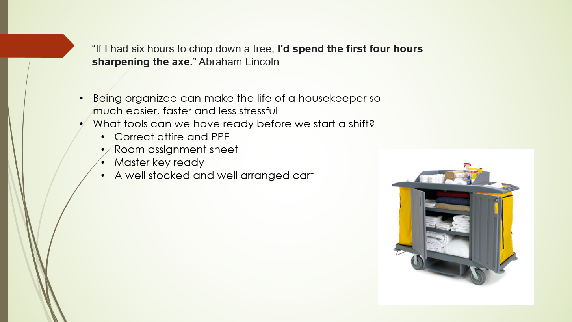

Training Notes:
The importance of being organised cannot be over emphasised. A housekeeper that is well organised is efficient and will get more done and will complete tasks sooner. (RP-E Learning). Have all your linen and amenities and cleaning materials on the cart ready enough to cover your number of rooms to save time and make you more efficient.

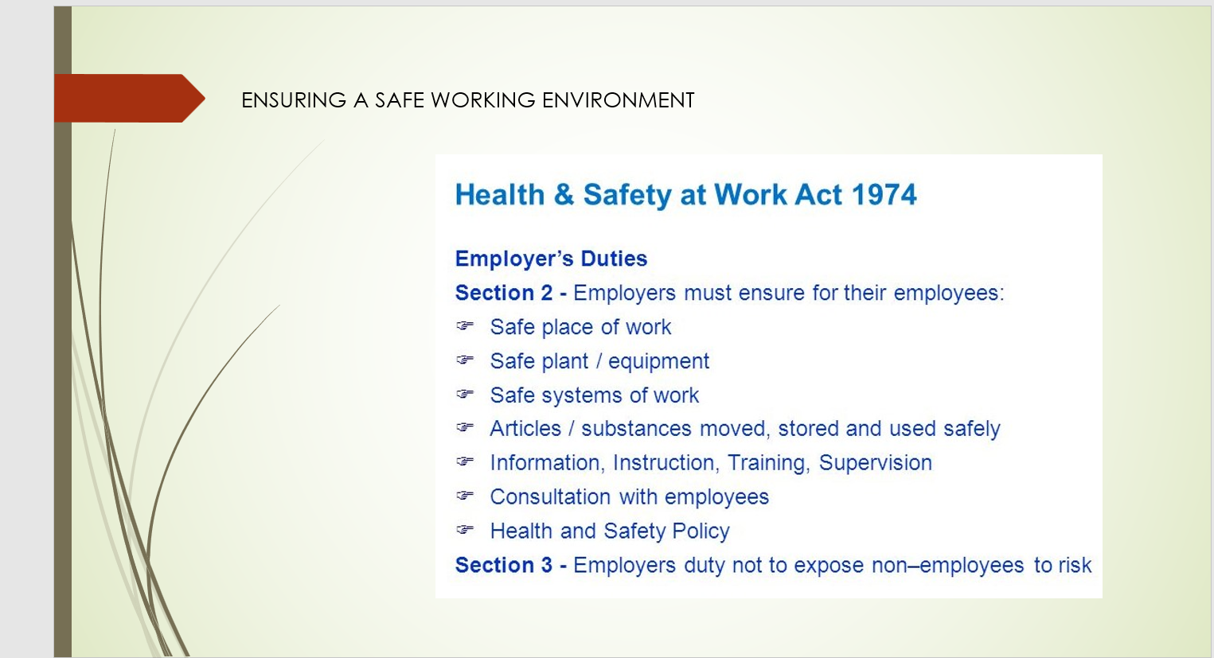

Training Notes:

Refer to parts of the legislation that is particularly relevant to housekeepers
- Manual handling
- Working at heights using step ladders
- Control of Substances Hazardous to Health and the use of cleaning materials, solvents, and polishes.

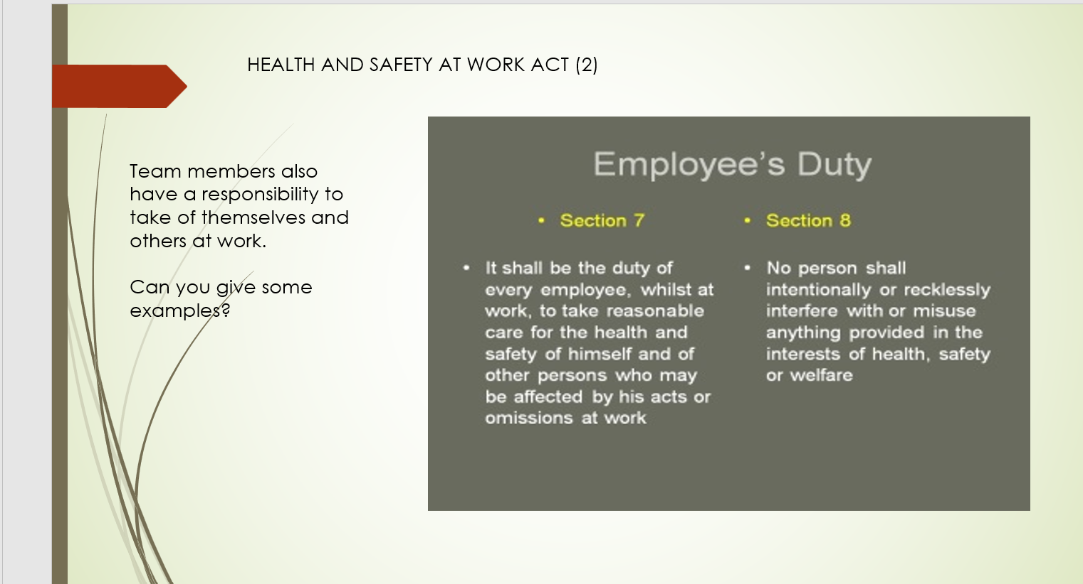

Training Notes: Examples

- Ensuring that you use the PPE provided, especially gloves? Holsinger ( year) notes the proliferation of microbial contaminants in high touch points such as door knobs, phones, remotes.
- Another example is ensuring that staff lift using the correct posture.
- All these are important to keep the team fit and healthy to deliver quality service.

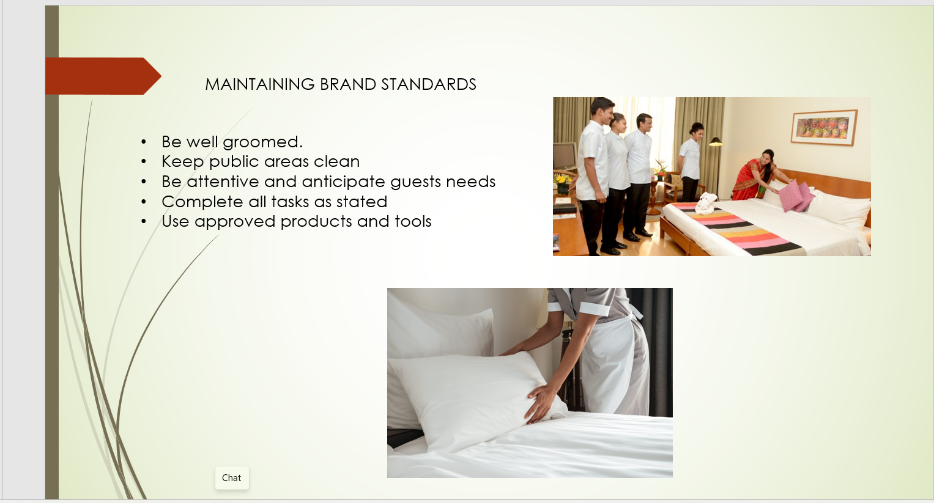

Training Notes:
Remember that you ARE the brand in the eyes of the guest. “Promises matter. If the brand doesn’t deliver what it promises then the brand will cease to matter to the very people it is trying to engage.” Hospitality and Catering (2016)

Make sure that the department sticks to its mission statement, spends time to continuously train and retrain.

Create an entrance that exudes cleanliness, and carry that through to the guest rooms and the amenities in the room. Above all stick to the checklist. (Hotelcleaningservices.com)

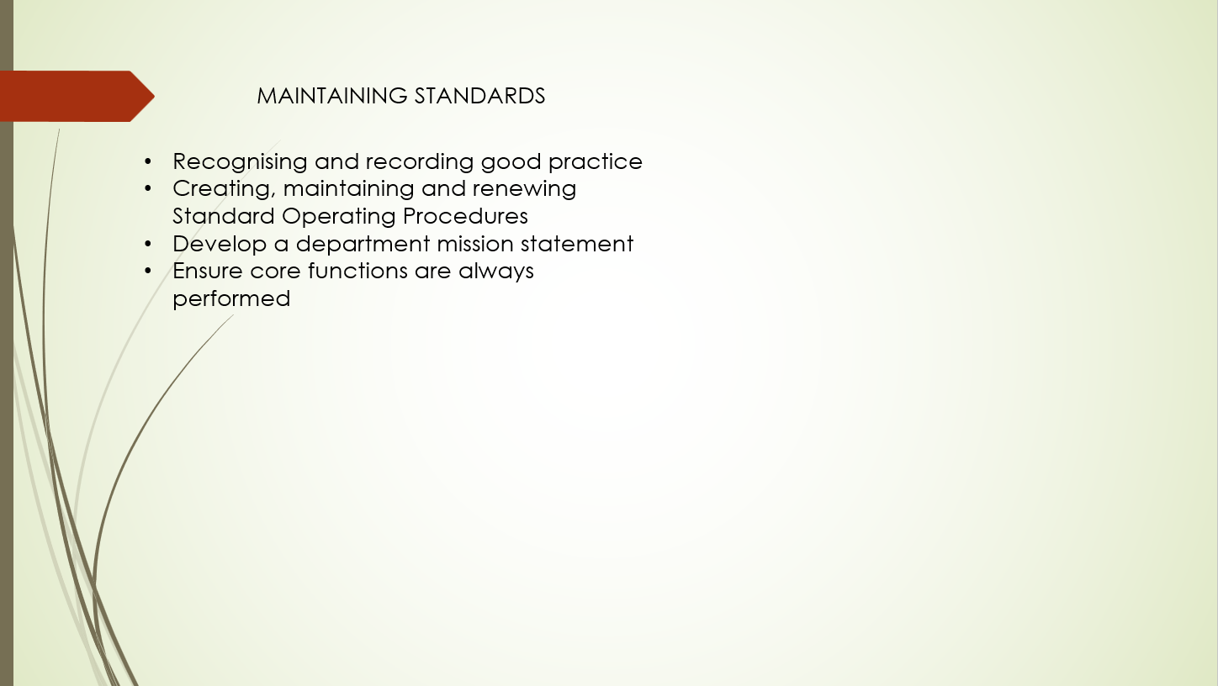

Training Notes: As well as the corporate brand standards, it is important that the housekeeping department continues to maintain SOP’s and department standards, especially as it can be seen as a high staff turnover department (Jones, Thomas and Jones (2007b).

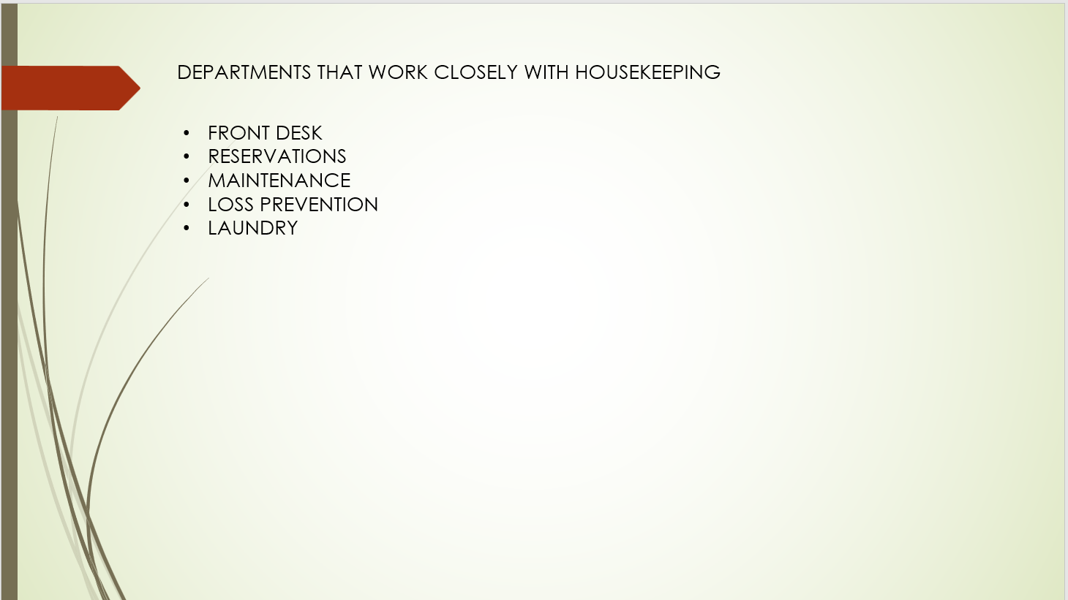

Training notes:
Housekeepers are “first line” for maintenance issues and a good housekeeper will prevent guests from having that dubious role of reporting issues.
There will also be among the first to report suspicious activity within a room. This re-emphasises the importance of the role of housekeepers.

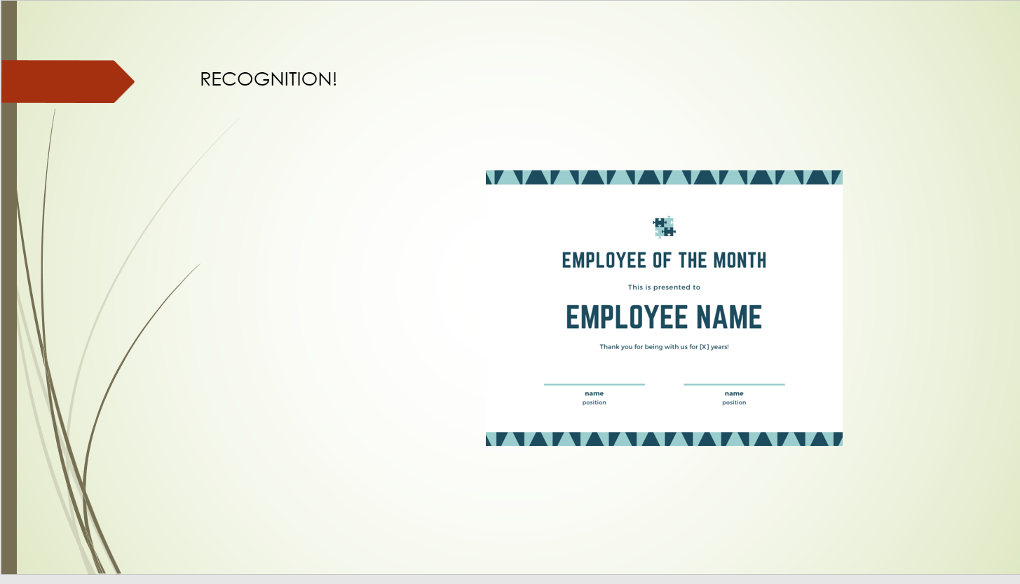

Training Notes:

Stress the importance to recognise and reward excellence! Have Fun

References

Health and Safety at Work Act 1974
(Housekeeping Rehab – How to organise Housekeeping Schedules Youtube Video Available at: (https://www.youtube.com/watch?v=Sboq6qAUlPE) Accessed:27th February 2023
Hospitality and Catering News “The importance of aligning guest experience with brand promise” Available at: https://www.hospitalityandcateringnews.com/2014/09/the-importance-of-aligning-guest-experience-with-brand-promise/ Accessed 2nd March 2023
Jones, Thomas J. A., Professional Management of Housekeeping Operations, John Wiley & Sons, Inc., 2007. ProQuest Ebook Central, https://ebookcentral.proquest.com/lib/trinity/detail.action?docID=315165. Accessed: 27 February 2023
Magnify School - Hotel Housekeeping - Cleaning Tips Youtube video Available at: (https://www.youtube.com/watch?v=KP7pYMssAcU) Accessed: 28th February 2023

RP E-Learning Housekeeping - Level 3 - SERVICING THE GUEST ROOM Training Notes: Check your PPE, Rooming List, Type of clean. Vacant? Check in? Or stay over? https://www.youtube.com/watch?v=hoZhEY9fZ8k

Holsinger Two Steps to a safe work environment Chap 13 pg 288 Housekeeping in other venues Professional Management of Housekeeping Operations ed Thomas J. A. Jones (2007)

https://hotelcleaningservices.com/how-to-improve-hotel-housekeeping-service-standards-checklist/ Accessed: 1st March 2023

