University of Wales Trinity Saint David
School of Engineering
Heat Exchanger Laboratory Analysis
James Gregory
P148409
Mechanical Engineering
12/04/2019
Thermofluid Mechanics
M5X00406


Contents
Table of figures 3
1 Introduction 4
2 Literature review 5
2.1 Heat transfer 5
2.2 Heat exchanger 6
2.2.1 What is a heat exchanger? 6
2.2.2 Types of flow arrangements in a heat exchanger? 6
2.2.3 Types of heat exchangers? 7
3 Methodology 9
3.1 Operation of the TD1007 heat exchanger 9
3.2 Learning outcomes 10
3.3 Experiment one 11
3.3.1 Aim 11
3.3.2 Procedure 11
3.3.3 Results and analysis 12
3.4 Experiment two 15
3.4.1 Aim 15
3.4.2 Procedure 15
3.4.3 Results and analysis 16
3.5 Experiment three 19
3.5.1 Aim 19
3.5.2 Procedure 19
3.5.3 Results and analysis 20
4 Conclusion 24
5 Evaluation 25
5.1 How the laboratory experiment was carried out? 25
5.2 Why the laboratory was carried out? 25
5.3 If you were performing the experiment again, what would you do different and why? 25
6 References 27

Table of figures
Figure 1: TD1007 water to air heat exchanger 4
Figure 2: Diagram of three modes of heat transfer, from left to right: conduction, convection and radiation (Alfa Laval, 2004) 5
Figure 3: Schematic diagram of three common flow arrangements, from left to right: parallel flow, counter flow and crossflow (Brogan, 2011) 6
Figure 4: Shell and tube heat exchanger (Thermofin, 2018) 7
Figure 5: Gasket plate heat exchanger (Alfa Laval, 2019) 8
Figure 6: Labelled TD1007 heat exchanger (TecQuipment Ltd, 2014) 9
Figure 7: Results for heat emitted vs. heat absorbed (experiment one) 12
Figure 8: Results for air, water and mean temperature efficiencies (experiment one) 13
Figure 9: Results for heat transfer coefficient (experiment one) 14
Figure 10: Results for heat emitted vs heat absorbed (experiment two) 16
Figure 11: Results for air, water and mean temperature efficiency (experiment two) 17
Figure 12: Results for heat transfer coefficient (experiment two) 18
Figure 13: Results for heat emitted vs heat absorbed (experiment three) 20
Figure 14: Comparison of water powers (experiment three) 21
Figure 15: Results for air, water and mean temperature efficiencies (experiment three) 22
Figure 16: Results for heat transfer coefficient (experiment three) 23

Introduction
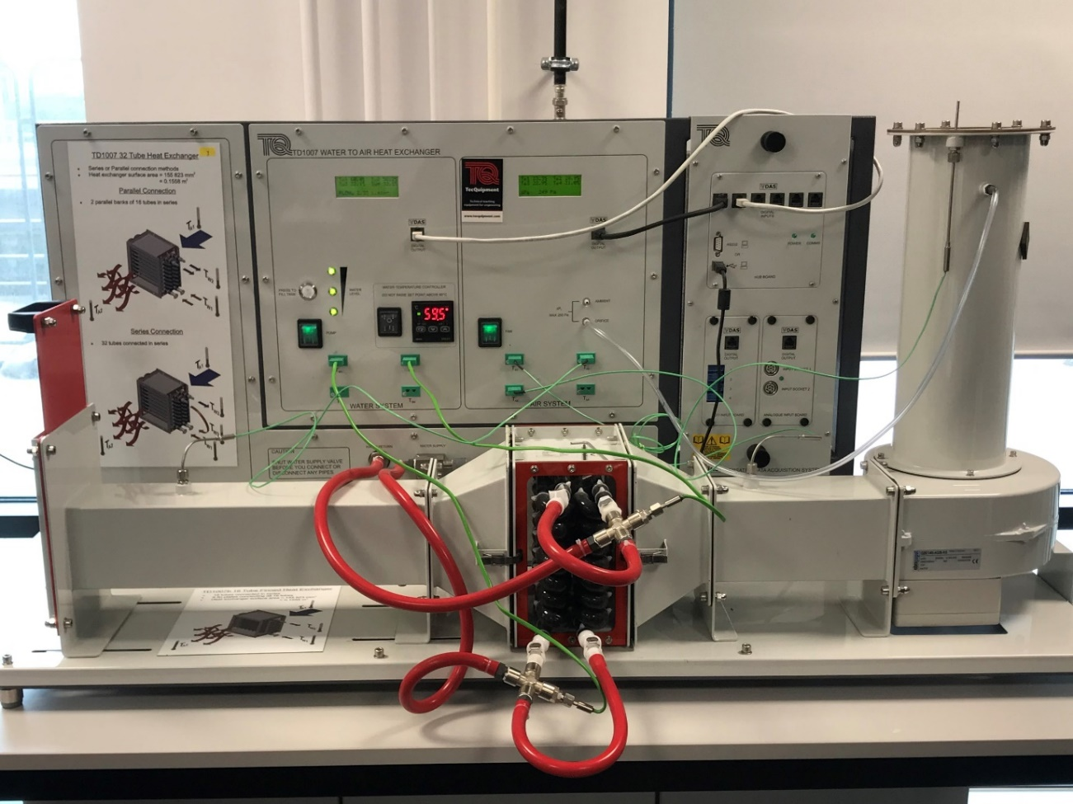
The aim of this report was to conduct three experiments in a standard 32 tube crossflow heat exchanger as shown in figure one; looking at the effects of variation in water flow rate, air flow rate and temperature. The experiments were conducted on the 19/02/2019 as a group laboratory session. The results gathered will be used to show how different water and air flow rates and temperatures affect the performance of the heat exchanger for a given fixed variable. This will be done by performing a series of calculations in Microsoft Excel and illustrated by graphs which will be explained further on in the report. The report structure will consist of a literature review into heat transfer and heat exchangers: their functions and types and the relevance of it in this report. A methodology into the operation of the heat exchanger, learning outcomes and explaining the aim, procedure, the results and analysis for the three experiments. A conclusion, looking back at the results and determining what they mean and finally, an evaluation into how and why the experiment was carried out and areas in which the experiment could be improved.
Figure 1: TD1007 water to air heat exchanger

Literature review

Heat transfer
In short context, heat transfer is a discipline of thermal energy, which is concerned with the exchange and/or conversion of energy between material bodies as a result of a temperature difference. There are three modes of heat transfer which can occur, these are: conduction, convection and radiation and are each shown in figure two below (Holman, 2010). In a bit more detail, conduction is the process whereby heat will flow from a hot to cold region if there is a temperature difference present between one or more mediums (Rogers & Mayhew, 1992). Convection, which can be natural or forced, occurs when fluid transfers heat from one location to another (Alfa Laval, 2004). Finally, radiation, is the process whereby heat transfer takes place in the form of electromagnetic waves (Doyle, 2019).
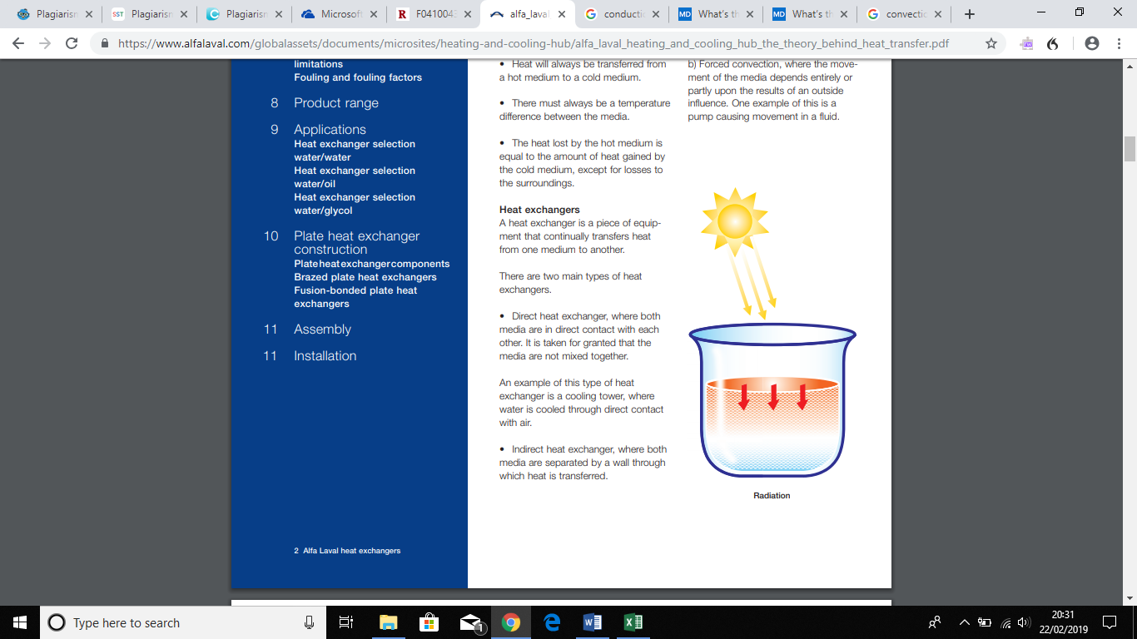
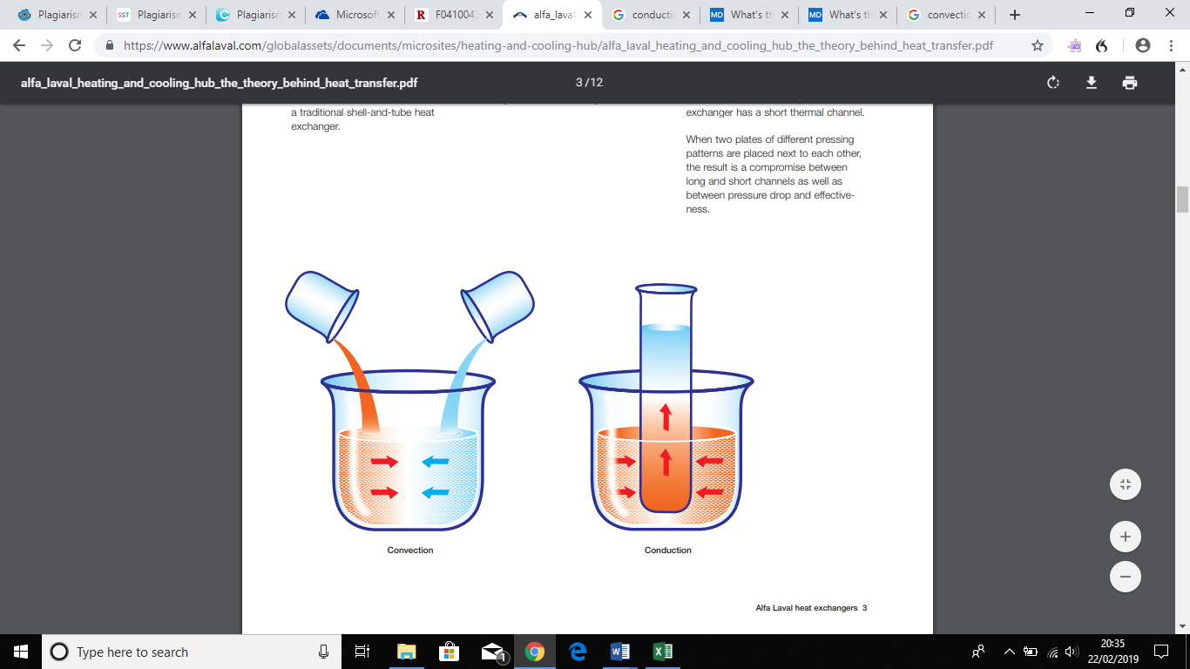
Figure 2: Diagram of three modes of heat transfer, from left to right: conduction, convection and radiation (Alfa Laval, 2004)

Heat exchanger

What is a heat exchanger?
A heat exchanger is a device used to exchange heat between two fluids that are at different temperatures while preventing them from intermixing. The fluid could be a liquid, such as water or oil, or moving air. Heat exchangers are commonly used in an array of industries and applications, such as: HVAC, power generation, refrigeration, pharmaceuticals, petrochemical, manufacturing and food and beverage processing (Baskharone, 2012).

Types of flow arrangements in a heat exchanger?
Heat exchangers are classified based on the arrangement of flow which occurs within the system, there are three main types of flow arrangements, these are: crossflow, parallel flow and counter flow, as shown in figure three (Huang, et al., 2019). A crossflow arrangement consists of two fluids flowing perpendicular to one another, for instance, one fluid will flow through a tube while the second fluid passes around the tube at 90° (Hofmann, 2000). A parallel flow arrangement consists of two fluids flowing independently but in the same direction, one fluid flows through the tube side and the other through the shell side (Li & Qing-qing, 2013). A counter flow arrangement consists of fluids flowing parallel to each other, but in opposite directions within the system. It is considered to be the most efficient of the three arrangements because it provides better thermal conductivity but allowing a larger change in temperature between both fluids (Vijay & Snehalatha, 2016).
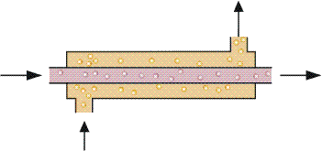
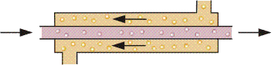
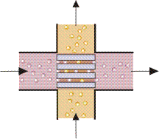
Figure 3: Schematic diagram of three common flow arrangements, from left to right: parallel flow, counter flow and crossflow (Brogan, 2011)

Types of heat exchangers?
There are many types of heat exchangers available, each coming in different shapes and sizes depending on the application they are used for and the needs of the customer. However, the construction of most heat exchangers falls into two categories: shell and tube, or plate. Each built with a purpose of providing efficient heat transfer, but as in all mechanical devices, they both have their advantages and disadvantages.

Shell and tube heat exchanger
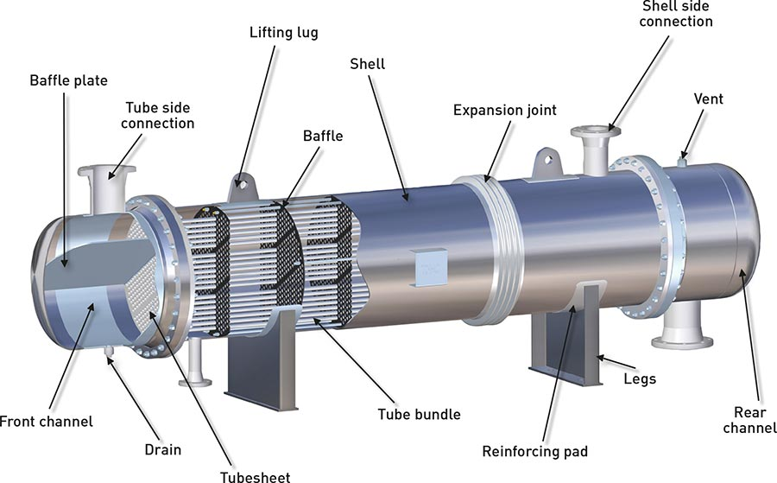
Shell and tube heat exchangers are one of the most common types of exchangers used in industrial processing, for example, petrochemical plants. This exchanger consists of a vessel which contains a bundle of tubes inside and heat transfer occurs within these tubes and along the shell side of the vessel; therefore, categorising the flow arrangement as either parallel or cross/counter flow. The rate of heat transfer is dependent on several factors such as: shell diameter, tube geometry, number of tubes, feed temperature and pressure, baffle spacing and cutting spacing (Abd, et al., 2018). Some advantages of using this exchanger are: it can operate at higher temperatures and pressures, less expensive to install and can be repaired more easily and it is easier to detect and locate leaks (ScottTech, 2015).
Figure 4: Shell and tube heat exchanger (Thermofin, 2018)

Plate heat exchangers (PHEs)
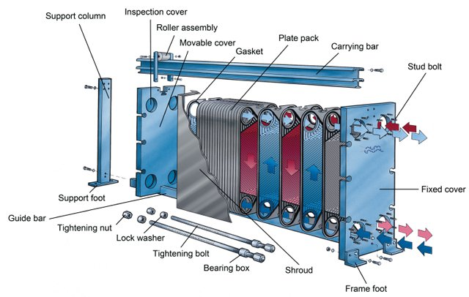
In many industries today, plate type heat exchangers are becoming more widespread because of their low cost, flexibility, easy maintenance and high thermal efficiency. A PHE is a counter flow exchanger which consists of corrugated plates fastened together between a fixed frame plate and a moveable pressure plate. The ‘plate pack’ produces turbulent flow when fluid runs along them as a result of the surface pattern used on the plate, thus producing high thermal efficiency (Elmaaty, et al., 2016).
Figure 5: Gasket plate heat exchanger (Alfa Laval, 2019)

Methodology

Operation of the TD1007 heat exchanger
Figure 6: Labelled TD1007 heat exchanger (TecQuipment Ltd, 2014)
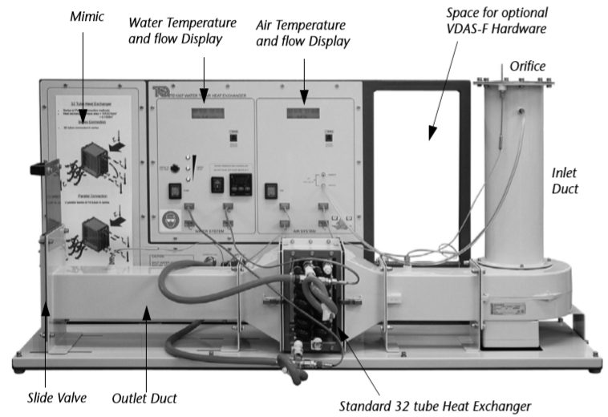
The operation of the heat exchanger shown above involves an electrically operated valve which opens to allow the tank to fill up with clean, cold water. The tank has a system in place to protect it from low water level, overfilling and high temperatures. The water flow rate is controlled by a precision needle valve and a flow meter. Cool air passes through a vertical cylindrical inlet duct containing an orifice plate which connects to a differential pressure transducer. The air then travels and passes through a fixed speed centrifugal fan, where the fan accelerates the flow of air and changes the direction of flow 90° and forces it along the horizontal rectangular section of the duct. The air travels through the heat exchanger and exists through a hand operated slide-valve. The orifice located at the top of inlet duct works with an air pressure senor to measure and control air flow rate. Thermocouples used along the air duct to measure the ambient air temperature at the inlet and before and after the heat exchanger (TecQuipment Ltd, 2014).

Learning outcomes
At the end of this experiment, the following learning outcomes should be achieved:
- An understanding of heat transfer between fluids through a solid wall.
- An understanding of energy balance and efficiency.
- Finding the heat transfer coefficient and Logarithmic Mean Temperature Difference (LMTD) at each water flow rate and air pressure.
- An understanding of the effect of water temperature (the ‘driving force’).
- Comparing the actual midpoint temperature with the average based on overall inlet and outlet temperatures.

Experiment one

Aim
To show how different water flow rates affect the performance of the heat exchanger for a given fixed air flow and water temperature.

Procedure
- Before commencing with the experiment make sure the heat exchanger has cooled down, if it has been used beforehand.
- Begin by connecting and setting up the heat exchanger in a parallel flow arrangement and set a heater tank temperature of 60°C. As a result of the flow arrangement, water will enter the bottom of the heat exchanger and exit at the top.
- Note the ambient (atmospheric) air pressure.
- Inspect the top of the inlet duct, where the orifice is located, there will be a value stamped on the surface indicating the orifice diameter (in mm).
- Turn on the fan and use the hand operated side valve to adjust an airflow which will produce an orifice drop of 250 Pa (+/- 5 Pa tolerance).
- Turn on the pump and use the hand operated water supply valve to adjust the water flow to 2.25 L/minute (+/- 0.01 L/minute tolerance).
- Allow at least five minutes for the heat exchanger temperatures to stabilize and then record all readings.
- Repeat the procedure for flow rates 1.75, 1.25, 0.75 and 0.25 L/minute.

Results and analysis
Figure 7: Results for heat emitted vs. heat absorbed (experiment one)

Heat energy (power) results for the standard heat exchanger. Figure seven shows the heat emitted by water vs the heat absorbed by air, the results plotted demonstrate that both air and water power increase with water flow. This is as a result of a gradual increase of water mass being heated (at 60°C), therefore, gradually increasing the energy emitted, and thus the flow of air absorbing the heat. This can be proven by the similar values between water and air power in the graph, showing a good energy balance coefficient which varies from 0.97 to 1.06. However, as the slope increases there is a sudden change in water power as it increases from 634.40 W to 692.29 W indicating a possible anomaly which could have occurred due to a sudden increase in water flow or external conditions.

Figure 8: Results for air, water and mean temperature efficiencies (experiment one)
Temperature efficiencies for the standard heat exchanger. Figure eight shows the deviation between air, water and mean temperature efficiency with respect to water flow rate. The results plotted show that as water efficiency decreases from 60.8% to 12.0%, air efficiency increases from 9.5% to 15.4%. However, even over the range of flow rates, the change in efficiency is still greater in water than that of air as a result of the higher temperature difference in the water compared to air. Hence, the mean temperature efficiency shows a gradual decrease from 35.2% to 13.7%, with increasing flow rate.

Figure 9: Results for heat transfer coefficient (experiment one)
Heat transfer coefficient for the standard heat exchanger. Figure nine shows the initial increase of water flow rate at 0.25 L/min⁻¹ where the heat transfer coefficient is 115.64 W.m⁻².K⁻¹ and gradually increases to 138.08 W.m⁻².K⁻¹ at 2.25 L/min⁻¹. Between 123.52 and 129.51 W.m⁻².K⁻¹ the flow rate seems to stabilise, showing that that no improvement to the performance would occur by increasing the water flow past a certain optimum. However, as you can you continue along the graph there is a sudden increase in heat transfer coefficient.

Experiment two

Aim
To show how different air flow rates affect the performance of the heat exchanger for a given fixed water flow and temperature.

Procedure
- Connect and set up the heat exchanger in a parallel flow arrangement and set a heater tank temperature of 60°C. As a result of the flow arrangement, water will enter the bottom of the heat exchanger and exit at the top.
- Note the ambient (atmospheric) air pressure.
- Inspect the top of the inlet duct, where the orifice is located, there will be a value stamped on the surface indicating the orifice diameter (in mm).
- Turn on the fan and use the hand operated side valve to adjust an airflow which will produce an orifice drop of 250 Pa (+/- 5 Pa tolerance).
- Turn on the pump and use the hand operated water supply valve to adjust the water flow to 2.25 L/minute (+/- 0.01 L/minute tolerance).
- Allow at least five minutes for the heat exchanger temperatures to stabilize and then record all readings.
- Repeat the procedure for pressure values of 200, 150, 100 and 50 Pa.

Results and analysis
Figure 10: Results for heat emitted vs heat absorbed (experiment two)

Heat energy (power) results for the standard heat exchanger. Figure ten shows how power transfer improves with air flow. Results are reasonably linear except for what appears to be an anomaly for water power towards the higher end of the trend. Once water power reaches 338.46 W it decreases slightly to 336.47 W and could be as a result of some slight loss of water power in the exchanger. Heat emitted by water is slightly greater than the heat absorbed by air at lower air flow rates, this could be as a result of possible heat loss through the duct or metalwork of the system. Furthermore, as air flow increases the difference in power between water and air reduces and the two values start to converge, indicating a good energy balance coefficient ranging from 0.77 to 1.06. In contrast to experiment one, increasing air flow rate could further increase the heat transfer.

Figure 11: Results for air, water and mean temperature efficiency (experiment two)
Temperature efficiencies for the standard heat exchanger. Figure eleven shows that as air flow increases from 0.036 kg.s⁻¹ to 0.115 kg.s⁻¹, water efficiency increases from 45.5% to 60.8%, while air efficiency decreases from 16.3% to 9.5%. The mean efficiency shows a gradual increase with air flow.

Figure 12: Results for heat transfer coefficient (experiment two)
Heat transfer coefficient for the standard heat exchanger. Figure twelve shows a reasonable increase in heat transfer coefficient from 77.99 W.m⁻².K⁻¹ to 115.64 W.m⁻².K⁻¹ with increasing flow rate as a result of an increased air flow improving the heat exchanger performance. Once again, the trend line suggests increasing air flow rate could increase the heat transfer coefficient.

Experiment three

Aim
To show how different hot water supply temperatures affect the performance of the heat exchanger for a given fixed water flow.

Procedure
- Connect and set up the heat exchanger in a parallel flow arrangement and set a heater tank temperature of 45°C. As a result of the flow arrangement, water will enter the bottom of the heat exchanger and exit at the top.
- Note the ambient (atmospheric) air pressure.
- Inspect the top of the inlet duct, where the orifice is located, there will be a value stamped on the surface indicating the orifice diameter (in mm).
- Turn on the fan and use the hand operated side valve to adjust an airflow which will produce an orifice drop of 250 Pa (+/- 5 Pa tolerance).
- Turn on the pump and use the hand operated water supply valve to adjust the water flow to 2.25 L/minute (+/- 0.01 L/minute tolerance).
- Allow at least five minutes for the heat exchanger temperatures to stabilize and then record all readings.
- Repeat the procedure for pressure values of 200, 150, 100 and 50 Pa.

Results and analysis
Figure 13: Results for heat emitted vs heat absorbed (experiment three)

Heat energy (power) results for the standard heat exchanger. Figure thirteen shows that at 45°C water and air power increase as air flow increases. The graph is supposed to show both plots trailing off towards the end suggesting a reduced driving force at 45°C. This trail does occur with water power, however, as you can see from air power that there is an unexpected increase in air power suggesting an anomaly with the results.
At both temperatures (45°C and 60°C) the efficiency of heat transfer plots shows a similar set of results. At 45°C there is no effect on heat transfer coefficient in contrast to power because it allows for the starting temperature through the Logarithmic Mean Temperature Difference (LMTD) term. This factors in the available power, which is lower at 45°C temperature.

Figure 14: Comparison of water powers (experiment three)
Comparison of water powers for the standard heat exchanger. Figure fourteen shows the comparison of water power when the temperature was set at 60°C and then changed to 45°C. As you can see from the results plotted, as air flow increases from 0.036 kg.s⁻¹ to 0.115 kg.s⁻¹, water power at 60°C increases at a higher rate than when the temperature is at 45°C, however, both temperatures increase at a gradual rate.

Figure 15: Results for air, water and mean temperature efficiencies (experiment three)
Temperature efficiencies for the standard heat exchanger. Figure fifteen shows how air flow increases from 0.036 kg.s⁻¹ to 0.115 kg.s⁻¹, water efficiency increases from 44.5% to 60% and air efficiency decreases from 15.9% to10%.

Figure 16: Results for heat transfer coefficient (experiment three)
Heat transfer coefficient for the standard heat exchanger. Figure sixteen shows how the heat transfer coefficient increases from 75.56 W.m⁻².K⁻¹ to 114.12 W.m⁻².K⁻¹ as air flow increases.

Conclusion
The aim of this report was to conduct three experiments in a standard 32 tube crossflow heat exchanger; looking at the effects of variation in water flow rate, air flow rate and temperature. From the results gathered and performing a series of calculations on MS Excel and producing a total of ten graphs, the results were as expected for all three experiments.
Experiment one – by setting a heater tank temperature of 60°C and an orifice pressure of 250 Pa ± 5, it was found that as water flow increased, the heat emitted by water and the heat absorbed by air also increased as a result of greater amount of water mass releasing energy. It was discovered that both water and air temperature efficiencies changed with respect to water flow. Temperature efficiency was at its highest when the heat emitted was at its lowest, suggesting greater water efficiency as a result of higher temperature changes. Likewise, as air efficiency increased air power also increased indicating a lower temperature efficiency due to lower temperature changes in air. As a result, the heat transfer coefficient produces a steady but gradual increase.
Experiment two – by keeping the heater temperature at 60°C and setting a constant water flow of 0.25 L/min⁻¹ it was found that as air pressure increased water and air power improved with air flow. However, there is some suggestion of possible heat loss through the system and thus resulting in a slight difference in results between the heat emitted and heat absorbed. This time water efficiency increased while air flow decreased and the heat transfer also increased as a result of improved air flow which increases the heat exchanger performance.
Experiment three – by decreasing the heater temperature to 45°C and keeping the water flow at 0.25 L/min⁻¹ it was found that water and air power had a reduced driving force at this temperature, indicating that the heat transfer was close to its limit. A comparison was made between water power at 45°C and 60°C which showed that when the temperate was at its highest more power was emitted over the range of flow rate. Similar to experiment two, water efficiency increased while air efficiency decreased as well as an increase in the heat transfer coefficient.

Evaluation

How the laboratory experiment was carried out?
The experiment was performed in a group by nine members, these members were; Callum, Christopher, Habtom, Ifan, James, Maximillian, Ryan, Stuart and Zhangwei. The group decided that it would be easier to set roles for each member so that the experiment could be conducted appropriately and that everyone had some part to play in the experiment. For instance, Callum, Habtom, James and Max were responsible for recording the results, Ryan and Ifan were responsible for adjusting the water, air and pressure values on the heat exchanger. Stuart was responsible for providing the air and water temperature results to the members recording and Christopher and Zhangwei were responsible for taking photos.

Why the laboratory was carried out?
As environmental concerns continue to rise around thermal, air and water pollution as well as the disposal of waste, the emphasis on designing and utilising highly efficient heat exchangers are increasing (Zhang, et al., 2018). This is the reason why the experiment conducted in this report is important for engineers learning about thermodynamics and heat transfer to put their theoretical knowledge into practise and understand how heat exchangers work and under what conditions they work best. This information will come in handy in their future careers as engineers as they might one day be responsible for designing a heat exchanger for a company or a customer who want it to be as efficient as possible.

If you were performing the experiment again, what would you do different and why?
If I were to perform this experiment again I would do the following to improve it:
Utilise the Versatile Data Acquisition System (VDAS) as it can be used to automatically log data from the experiment, create graphs and tables of the data as well as automatically calculate the data and export it to another software which would result in saving time and reducing any errors.
Ensure the equipment is correctly calibrated, functioning, clean and ready to use. For instance, the water and air flow displays are set at zero, there are no bits of debris inside the air duct or in the water supply, thermocouples are not damaged and can provide appropriate temperature readings and fixings and fasteners are correctly tightened. Using equipment that is not correctly calibrated, functioning or clean can influence inaccurate results particularly with measurements of mass and volume and sensitive data such as temperature efficiencies and heat transfer coefficient.

References
Abd, A. A., Kareem, M. Q. & Naji, S. Z., 2018. Performance analysis of shell and tube heat exchanger: Parametric study. Case Studies in Thermal Engineering, 29 07, 12(1), p. 563.
Alfa Laval, 2004. The theory behind heat transfer. [Online]
Available at: https://www.alfalaval.com/globalassets/documents/microsites/heating-and-cooling-hub/alfa_laval_heating_and_cooling_hub_the_theory_behind_heat_transfer.pdf
[Accessed 01 04 2019].
Alfa Laval, 2019. How gasketed plate heat exchangers work. [Online]
Available at: https://www.alfalaval.co.uk/microsites/gasketed-plate-heat-exchangers/tools/how-gphes-work/
[Accessed 01 04 2019].
Baskharone, E. A., 2012. Heat Exchangers. In: M. Penn, ed. Thermal science: essentials of thermodynamics, fluid mechanics, and heat transfer. 1st ed. New York: McGraw-Hill, p. 324.
Brogan, R. J., 2011. HEAT EXCHANGERS. [Online]
Available at: http://www.thermopedia.com/content/832/
[Accessed 01 04 2019].
Doyle, J., 2019. Methods of Heat Transfer. [Online]
Available at: https://www.physicsclassroom.com/class/thermalP/Lesson-1/Methods-of-Heat-Transfer
[Accessed 01 04 2019].
Elmaaty, T. M. A., Kabeel, A. E. & Mahgoub, M., 2016. Corrugated plate heat exchanger review. Renewable and Sustainable Energy Reviews, 31 12, 70(1), p. 852.
Hofmann, A., 2000. Theoretical solution for the cross-flow heat exchanger. Heat and Mass Transfer, 04, 36(2), p. 127.
Holman, J. P., 2010. Introduction. In: Heat Transfer. 10th ed. s.l.:McGraw-Hill, p. 1.
Huang, C. et al., 2019. Review on the characteristics of flow and heat transfer in printed circuit heat exchangers. Applied Thermal Engineering, 27 09, 153(1), p. 191.
Li, Z. & Qing-qing, P., 2013. Study on Suitability and Safety of Parallel Flow Heat Exchanger in Dry Condition. Procedia Engineering, 15 05, 52(1), p. 697.
Rogers, G. & Mayhew, Y., 1992. Conduction. In: Engineering thermodynamics: work and heat transfer. 4th ed. Edinburgh: Harlow: Pearson Prentice Hall, p. 501.
ScottTech, 2015. Shell and Tube Heat Exchangers: Pros and Cons. [Online]
Available at: http://mahans.com/shell-and-tube-heat-exchangers-pros-and-cons/
[Accessed 01 04 2019].
TecQuipment Ltd, 2014. TD1007 Water to Air Heat Exchangers User Guide, s.l.: TecQuipment.
Thermofin, 2018. THE UNIVERSAL EXCHANGER. [Online]
Available at: http://www.thermofin.net/products/caleos-shell-and-tube-heat-exchangers/
[Accessed 01 04 2019].
Vijay, D. A. & Snehalatha, P., 2016. COMPUTER AIDED DESIGN AND ANALYSIS OF A HEAT EXCHANGER. International Journal of Science, Engineering and Technology Research (IJSETR), 07, 5(7), p. 2522.
Zhang, J., Zhu, X., Mondejar, M. E. & Haglind, F., 2018. A review of heat transfer enhancement techniques in plate heat exchangers. Renewable and Sustainable Energy Reviews, 09 11, 101(1), p. 305.

