

Improvement of an HR priority area

Module Code: BMMB7025
Module Title: Managing People in Organisations
Student Name: Robert Nagy
Student ID: 1922896

Lecturer: James Moore
FCIPD, MSc

Executive Summary
The report envisages the four tasks where section 1 covers the internal and external environmental changes which dualistically affect the forming of the people management strategies of these companies. Section 2 evaluates the different kinds of approaches to people management. Section 3 analyses the core concerns of the people management approaches of these organisations in the context of diversity and inclusion etc. Section 4 talks about the impact of technological advancements and Artificial Intelligence on the people management strategies of the companies along with recommendations like gamification, a human resource management system, for Bolt and raising the self-belongingness for Uber respectively.
Table of Contents

Executive Summary 2
1.0 Introduction 4
2.0 Company Overview 5
3.0 Main Body 6
3.1 Environmental Adversities 8
3.2 People Management Approaches 10
3.3 People Management Concerns 11
3.4 Technological Adversities 14
4.0 Conclusion 14
5.0 Recommendations 16
References 18

Table of Figures

Figure 1: Bolt UK Official Logo 5
Figure 2: Uber UK Official Logo 5
Figure 3: Incidence of different competency headings 6
Figure 4: Organigram of Bolt UK 8
Figure 5: Organigram of Uber UK 9
Figure 6: Bolt UK Timeline 10
Figure 7: Theoretical Framework for Diversity and Inclusion 12

1.0 Introduction
Companies to refine hiring processes and improve workplace culture should pay close attention to HR priority areas. These should include performance appraisal processes, disrupting performance development, and developing effective succession plans. The employee experience has also been prioritized by human resource management as a key priority area (Forbes, 2023). Employees are encouraged to share their problems, which creates an environment of trust and team spirit. Through the process of continual assessing and modification of these approaches, organisations can build a working ecosystem which is healthier and suitable at the same time to both the satisfaction of employees and the success of the organisations.

2.0 Company Overview
HRM of Bolt Taxi involves the selection, coaching, and development of competent and motivated workers. They made employees feel part of the organisation by having open and honest communication and targeting performance issues. In this, the company has also been prominently known for the introduction and implementation of various HRM practices that are not based on common or traditional HRM practices (Bolt, 2024). First and foremost, the place of work for Bolt is a holistic environment of support and rewards for employees. The sustainability of every employee as well as loyalty is an outcome of this.


Figure 1: Bolt UK Official Logo
[Source: Bolt, 2024].

Uber Taxi UK engages in HRM which includes recruiting, training, and developing a support system for drivers to guarantee compliance with the stipulated service standards. Through the employment of technology, they have optimized and controlled the process schedule and recorded the performance. Emphasis would be given to the stability of drivers and customer happiness. Uber values ​​a flexible working situation and provides bonuses aimed at keeping driver support and enthusiasm at a high level. For example, the employer contributes to the training of the staff in collaboration with the existing Open University of the 900 courses that Uber provides, (Uber, 2024).

Figure 2: Uber UK Official Logo
[Source: Uber, 2024].

3.0 Main Body
Armstrong and Taylor highlighted strategic human resource management can also be considered as another approach to manage the workforce of the company (CIPD, 2024) progressively and effectively. Human resource management functions are mostly on the impact of internal and external forces. The internal factors that influence the organisation's HRM approach are shown by culture, structure, and leadership styles that, in turn, determine hiring, training and evaluation processes and outcomes. Economic, industrial, labour law or technological circumstances dictate employment strategies like recruiting and hiring staff or motivation and compensation.

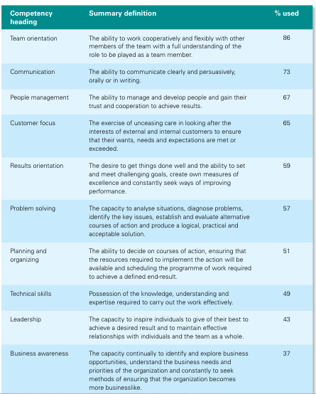
Figure 3: Incidence of different competency headings.
[Source: Armstrong and Taylor, 2020].

Personnel management strategies refer to processes by which manifestos, implementation of these strategies, appraisal and review are done to facilitate the organisation in its mission to effectively manage the staff. This emphasis includes recruitment, worker training, appraisal, and communication with employees. The human resource management techniques that are acknowledgeable in the business, are among the most formidable, planting a fruitful working environment, instigating employee engagement and development, and aligning employee objectives with organisational objectives (Forbes, 2023). It further ensures fairness and transparency in all operational processes. When organisations invest in their personnel they cannot only achieve efficiency but also innovation and long-term success.

3.1 Environmental Adversities
Bolt Taxi UK
Due to internal and external factors, People Management tactics by Bolt Taxi UK are shaped constantly. Externally, obstacles such as the type of organisation, its culture, and the workforce demographics determine the pathway to target, recruit and train and decide on how to manage performance. Technological breakthroughs, regulatory changes, and the dynamics in competitors of the market change talent acquisition, pay and reward, and employee engagement strategies which are internal. The adequacy of these trend shifts can be observed in combination with e-hailing services (Wireko-Gyebi et al., 2024). There had always been a business that had played very active roles in the initial stage of the innovations through the redefining of the markets as well as the business environment following such an influx of technology. Bolt allows individuals from diverse backgrounds to join its company by encouraging the cab drivers to be brought together to share their experiences. In addition, the organisation ensures that drivers acquire specialized knowledge by organizing driver development programs. Also, it relies on cutting-edge technology to enable efficient work.
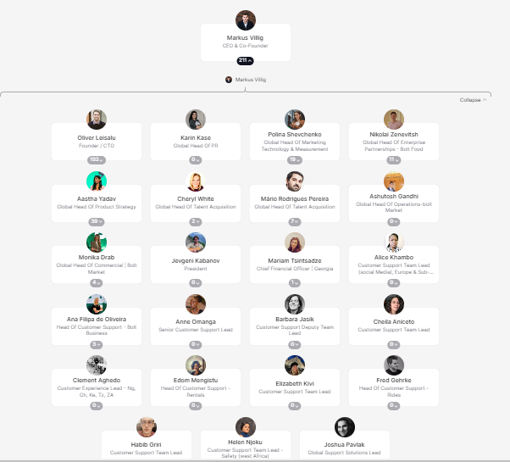
Figure 4: Organigram of Bolt UK
[Source: Bolt, 2023].

Uber Taxi UK
Through the People Management strategies adjusting to the dynamic internal and external factors, Uber Taxi UK enables a knowledgeable and committed crew up to the standards associated with the evolving needs of customers in the competing taxi industry. Internally the most powerful factors in the shape of organisational culture, structure, and workforce size affect recruitment, professional growth, and employee performance. Technological processes, rules, and the market situation outside have effects on position recruitment, payroll policies and employee engagement formulation as the foremost services of the HR’s of the company (CIPD, 2024). People management strategies are among the most considerable strategies, use them, whether business corporations, to level resistance as different variables could undermine the business proficiency of the company. These have been what the organisation’s focus on with the differing kinds of innovative practices for their employees, the things that the HRM probably does the best organisational functions. These strategies are also being prioritized by the top management of the company while making the policies as well as taking any initiative in context to the people management strategies for the business enterprise.

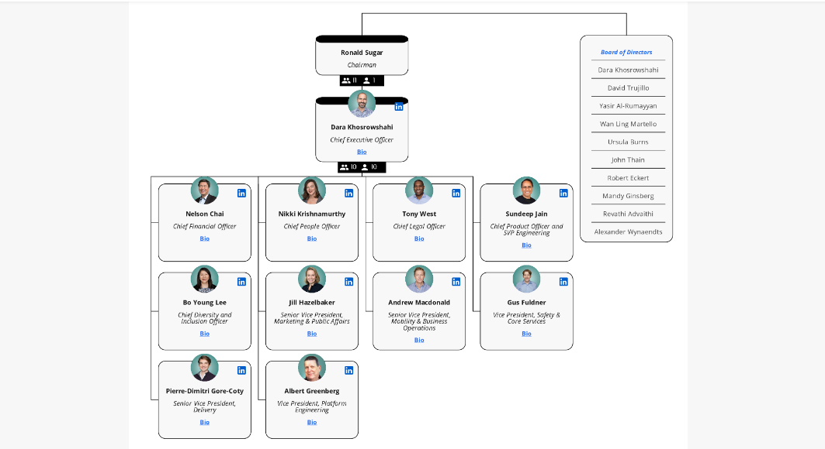
Figure 5: Organigram of Uber UK
[Source: Uber, 2024].

3.2 People Management Approaches
Bolt Taxi UK
Bolt Taxi UK places people at the forefront with a non-discriminating atmosphere, a tailored training program for its drivers, and a technology line that optimizes its operations. The foremost priority area for the company is to provide adequate training to their employees to make them capable of coping with the rapidly changing technological transitions. There is a focus on driver’s behavior, there are prizes for performance, and the company supports communication with transparency. The company’s employees are highly skilled and highly motivated, can provide quality services, engage with the customers, and boost their satisfaction. It is none other than the progressive nature of its market, which has proven the viability of its operations within a ten-year period and has founded a customer base of over 45 million worldwide (Kriukelyte et al., 2024). This also extends to the field of operational competency which is greatly enhanced using the organisation’s talented and skilled personnel.
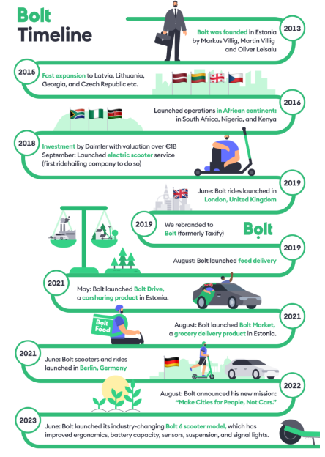
Figure 6: Bolt UK Timeline
[Source: Bolt, 2023].
Uber Taxi UK
The human resource management of Uber Taxi UK puts driver safety as a top priority, work arrangements flexible and incorporates data-driven strategies for workers' optimization. Invest in driver training, create new programs infusing employees with positive internal compliments and hold regular employee calls. Uber strongly strives to keep a winning team and motivates its skilled drivers to make them attain the highest standards of servicing to satisfy the clientele. To this end, these considerations are a measure of the fact that Uber offers lots of on-site jobs in the form of ride-hailing as well as delivery services where such employees are required to execute the tasks indicating how the business manages the operations as well (Koivusalo et al., 2024). Furthermore, the services streamlining is linked to the subsector of urban transport marking the success of the people management system in the context of the addressed sector where the services such as motivation and skilled labour coverage are addressed.

3.3 People Management Concerns
Diversity and inclusion (D&I) have emerged as the major issue in the field of People Management for the time of now. Rapid development considers equity and representation, so companies in this area increase the space of inclusion culture and practice a diverse workforce. Thus, the main goal of this system is to create an atmosphere where diversity and inclusion are the basis for all practices (Dawsons et al. 2024). Thus, they strive to eradicate discrimination, open the doors of the company for everyone, not distinguishing them by race, gender, ethnicity, sexual orientation, or background; and establish a workflow, where people of different views are respected and heard. Organisations now offer D&I training, form diversity hiring strategies and develop a commitment to inclusive policies and procedures to constitute a workplace where everyone is supported and feels an intrinsic part of the team. Through recognizing diversity and undertaking proper inclusion measures in the workplace, employers in the UK currently not only improve employee engagement and morale but also drive innovation and creativity which has a positive impact on organisational success in a multicultural world (BBC, 2024).

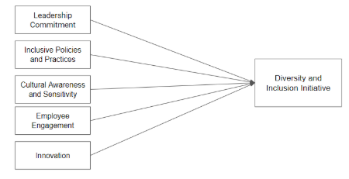
Figure 7: Theoretical Framework for Diversity and Inclusion
[Source: Anggoro and Anjarini, 2024].

Bolt Taxi UK
The core people management concerns for the company (Bolt) can be understood through the following heads-

Employee Engagement: Bolt Taxi UK strongly recognizes the value of company culture that is built based on support, respect, and equal partnership within its workforce. Bullet Point Logistics always stresses the establishment of open communication channels, offers the drivers chances to provide feedback and reward the best performances. In this manner, Bolt develops employee satisfaction and devotion by putting drivers in decision-making processes and those concerns are met. Moreover, the employers further emphasise the employee's development and increment their level of engagement by giving the employees a certain degree of freedom to tackle their matter in return for total ownership like in the description of the price of individual rides mode of transportation.

Performance Management: There are a total drivers (about) 65,000 people who work in almost 14 cities in the employment of this company in the United Kingdom (BBC, 2021). Bolt applies technology-assisted systems to gauge and scale performance, data for instance the passenger feedback and the ride success rate, and to provide current results. They give training & development that causes drivers to step forward to pursue safety and service quality goals. Bolt's performance assessment is structured around proximity to overall company targets, enabling them to keep high standards and encourage further progress.

Diversity: Bolt Taxi UK Vows to Harmonize Diversity and Covert Workforce. Training programs aim at the inclusion of topics of cultural sensitivity and diversity awareness. Thus, getting a friendly feeling to all drivers and passengers. Bolt, which allows for diversity, stimulates innovation, and improves creativity, and overall efficiency, is an example. This has been because if the opportunity to equip the employee with the required skills and other skills and other abilities is not provided by the organisation, then the organisation might come across the competency gap, which is the preparedness of the employee and the organisation in terms of their abilities and already put skills (Bolt, 2020). Thought is the vision is being further enacted for passengers including them also.

Uber Taxi UK
The main people management concerns for Uber are as follows-

Employee Engagement: The main areas that Uber cares about in that respect are flexible scheduling, means of communication with the drivers, as well as recognition programs. They promote the involvement of drivers in decision-making processes and respond accordingly to their feedback quickly enough, to meet drivers' expectations for positive work-life experience and professional contentment. Besides, such assessment aspects can also be implied from the decision of the senior management team of the organisation to compensate its employees with GBP 178 million (BBC, 2024)

Performance Management: Uber uses the data to measure and assess driver efficiency by determining their customer rankings and trip completion rates. They train drivers and provide them with support throughout their service, assisting them to increase the quality of their service and enhancing performance. Periodically, the individuals would be assessed to look out for possibilities of development or to also acknowledge those who work above expectations.

Diversity: Uber Taxi has a clear focus on equality and work efficiency which is achieved through workforce diversity and inclusion. These regulatory agencies enact policies and programs in order to provide equal driving opportunities for drivers with different backgrounds. In that regard, training assets emphasise cultural awareness and sensitivity to create a welcoming and inclusive environment for both bus operators and the riding public (Forbes, 2022).

3.4 Technological Adversities

Bolt Taxi UK
Chat bots driven by AI tackle messages and queries bringing about results and improving communication for customers. Nevertheless, whereas AI augments its own operational procedures, the UK is the Uber taxi that states they enrich the humane approach, where the drivers benefit and relate more with their customers. The inclusion of AI gives the UK Uber Taxi the sort of flexibility to adjust to crucial market changes at ease, optimize resource distribution, and strengthen employee collaboration for creative innovations, which in the long run boosts the quality of services as well as customer satisfaction. They highlight the fact that the galaxy has changed and they the company to compete with the new technological leaders such as the Imperium Drive (Euronews.com, 2022).

Uber Taxi UK

Technological advances, which include Artificial Intelligence (AI), are so instrumental in mapping the people management approaches that Bolt gets in the UK. AI software helps in driver recruitment, by making the system of driver assignment more efficient and effective and reducing the staffing requirements to the minimum. AI-fueled analytics generate a wealth of information on the performance of their drivers and allow for custom-tailored training and development programs based on this. Chat bots along with AI lead tools are very effective in reducing the important communication volume, and the overall efficiency of the employees. AI, on the other hand, increases efficiency and decision-making but focuses our attention on making lives delightful through intelligent technologies, smartphones, and apps (Taxi Butler, 2023).

4.0 Conclusion
In conclusion, it can be said that these issues are not only a task but an obligation for the Uber Taxi UK leaders, as maintaining the motivation and engagement of their drivers, providing high-quality services, and doing work which is socially responsible is the right thing to do. The Bolt Taxi, in achieving their goal of technological dominance for their company's sake, emphasises their staff with up-to-date technical knowledge needed to cope with the present circumstances. Bolt's engagement with employees through performance management and diversity as indispensable is one reason this organisation is so well-known for its social and customer-centric accountability. Machine learning models search through the performance metrics of a driver, providing the necessary information to undertake personalized training and development.

5.0 Recommendations
The workers stand for themselves and respect everyone's diversity in terms of identity, perspective, and background (Forbes, 2022). The company must emphasis free exchange, mutual respect, and openness so that others can feel respected and valuable, and then because of that such diversity will become richer, and the organisation's culture will become better.

Bolt Taxi UK should consider the challenging environment presented by the rapid technological shifts within the transportation sector as an important factor. In view of the fact that innovation keeps changing the face of the industry, the need for workforce skill enhancement and adaptation also arises. The absence of training and development programs nowadays leaves people without the means to take advantage of the potential of new technologies to the full, thus lagging behind the rest of the world in terms of efficiency and competitiveness.

Without continuous investment in human resources and talent management systems, Bolt Taxi UK is likely to stay behind competitors and fail to fulfil the changing customer interest. It is vital for the organisation to tackle this problem to maintain stability and relevance for a long time in an ever-changing market (Bolt Technology, 2024). As a result, HR management should focus on training and development along with gamification processes within an HR department so that a culture of continuous learning and skill enhancement is created which will put Bolt Taxi UK in a position to manage the ever-changing tech-savvy market.

The lake of training and skills related to technological advancement for Bolt Taxi UK can be a consequence of the Training Program that is not so accurate. The Uber is one of the recognized organisation of the UK, but Bolt required the various types of the upgradations where as the report focuses more on Bolt following recommendations that can be taken into consideration by the company-

Bolt Taxi UK
The main recommendations for Bolt based on their findings from the conclusion are the
- Gamification
Implementation of Gamification needs effective communication of objectives, procedures, results, and awards to the workforce to enable better understanding and involvement (Armstrong and Taylor, 2020).

- Human resource management systems
For implementing efficient human resources management systems for streamlining HR activities, expertise in EIS software (enterprise information system) is essential for managing and maintaining the data of the employees and their performance appropriately (Atkinson, 2023). Acquaintance and hands-on digital tools used for HR functions are another crucial requirement for smoothly operating activities like selection, recruitment, onboarding, training, wellbeing, and performance management.

and the

- Providence of the training sessions.
For executing the training and development of the HR personnel, knowledge of information and communication technology and tools is needed; it involves accessing training platforms and communication mediums.

Reason: Spare the use of game elements in Human Resource Management Systems (HRMS) to motivate, engage and increase employee productivity (Personnel Today, 2023). Influence this through using incentives, challenges, and leader boards for good behaviors such as attending training sessions and showing performance improvement, which will be more engaging and enjoyable below the main head of the gamification (People Management, 2018). The workforce training sessions bring about the improvement of the technical skills of their staff that were established to gauge the progress and the professionalism of the staff members (Bolt, 2022).

Word count: 2.515

References
- Anggoro, A. and Anjarini, A.D. (2024) Building an Organizational Culture that Supports Diversity and Inclusion. Management Studies and Business Journal (PRODUCTIVITY), 1(1), pp.190-197.
- Armstrong, M. and Taylor, S. (2020) Armstrong's handbook of human resource management practice. Kogan Page Publishers.
- Atkinson, C.L. (2023) Student-driven research in human resources management: Developing skills and capacities. SAGE Publications Inc.
- BBC (2021)Bolt: Ride-hailing app to let London drivers set their own fares.BBC [online]. Available from: https://www.bbc.com/news/uk-england-59267592 [Accessed 06/04/2024].
- BBC (2024)More ethnic minority chief executives at top UK firms.BBC [online]. Available from: https://www.bbc.com/news/business-68530034 [Accessed 06/04/2024].
- BBC (2024)Uber agrees to $178m payout to Australia taxi drivers.BBC [online]. Available from: https://www.bbc.com/news/business-68594134 [Accessed 06/04/2024].
- Bolt (2020)Everything you need to know about Bolt Ride Insurance for drivers and riders. Bolt [online]. Available from: https://bolt.eu/en-ng/blog/everything-you-need-to-know-about-bolt-ride-insurance-for-drivers-and-riders/ [Accessed 06/04/2024].
- Bolt (2022)How to become a Bolt driver in the UK? Bolt[online]. Available from: https://bolt.eu/en-gb/blog/how-to-become-a-bolt-driver-in-the-uk/ [Accessed 06/04/2024].
- Bolt (2023) The story of Bolt. Bolt[online]. Available from: https://bolt.eu/en/blog/the-story-of-bolt/ [Accessed 06/04/2024].
- Bolt (2024) Explore Bolt services - The all-in-one mobility app.Bolt[online]. Available from: https://bolt.eu/ [Accessed 06/04/2024].
- Bolt (2024)People & Workplace. Bolt [online]. Available from: https://bolt.eu/en/careers/teams/people/ [Accessed 06/04/2024].
- Bolt Technology (2024) Bolt Business. Bolt Technology [online]. Available from: https://bolt.eu/en-ng/blog/category/bolt-business/ [Accessed 10/04/24].
- CIPD (2024) HR shared services. CIPD [online]. Available from: https://www.cipd.org/uk/knowledge/factsheets/shared-services-factsheet/ [Accessed 06/04/2024].
- CIPD (2024) Strategic human resource management. CIPD [online]. Available from: https://www.cipd.org/en/knowledge/factsheets/strategic-hrm-factsheet/ [Accessed 06/04/2024].
- Dawson, N.E., Parker, S.L. and Okimoto, T.G. (2024) Profiles of diversity and inclusion motivation: Toward an employee‐centred understanding of why employees put effort into inclusion and exclusion. Human Resource Management, 63(1), pp.45-66.
- Euronews.com (2022) The driverless race: Imperium's remotely driven car sharing service in UK to compete with Uber. Euronews.com [online]. Available from: https://www.euronews.com/next/2022/01/19/the-driverless-race-uber-to-compete-with-imperium-s-remotely-driven-car-sharing-service-in[Accessed 06/04/2024].
- Forbes (2022)The Importance of Diversity and Inclusion For Today’s Companies.Forbes [online]. Available from: https://www.forbes.com/sites/forbescommunicationscouncil/2022/03/03/the-importance-of-diversity-and-inclusion-for-todays-companies/?sh=666a857949df [Accessed 06/04/2024].
- Forbes (2022)Why Feeling a Sense of Belonging At Work Matters And How To Cultivate It.Forbes [online]. Available from: https://www.forbes.com/sites/adigaskell/2022/10/01/the-modern-employee-increasingly-wants-to-belong/?sh=6d8b0bbc12e5 [Accessed 06/04/2024].
- Forbes (2023)Companies Want People Impact, But Managers Are Often Flying Blind: Breaking the Cycle In 2024.Forbes [online]. Available from: https://www.forbes.com/sites/forbestechcouncil/2023/12/20/companies-want-people-impact-but-managers-are-often-flying-blind-breaking-the-cycle-in-2024/?sh=bd44c7a33058 [Accessed 06/04/2024].
- Forbes (2024) Key HR Statistics and Trends In 2024. Forbes [online]. Available from: https://www.forbes.com/advisor/business/hr-statistics-trends/ [Accessed 06/04/2024].
- Forbes (2024)Strategic Human Resource Management (2024 Guide).Forbes [online]. Available from: https://www.forbes.com/advisor/business/strategic-human-resource-management/#:~:text=After%20you've%20brought%20new,not%20least%20is%20performance%20management. [Accessed 06/04/2024].
- Koivusalo, M., Svynarenko, A., Mbare, B. and Perkiö, M. (2024) Globalization, platform work, and wellbeing—a comparative study of Uber drivers in three cities: London, Helsinki, and St Petersburg. Globalization and Health, 20(1), p.18.
- Kriukelyte, E., Sochor, J. and Kramers, A. (2024) Actualizing sustainable transport: the interplay between public policy instruments and shared mobility providers’ business models. European Transport Research Review, 16(1), p.11.
- People Management (2018) How gamification can improve employee engagement. People Management [online]. Available from: https://www.peoplemanagement.co.uk/article/1741101/how-gamification-can-improve-employee-engagement [Accessed 06/04/2024].
- Personnel Today (2023) Five approaches for HR to drive productivity. Personnel Today [online]. Available from: https://www.personneltoday.com/hr/how-can-hr-improve-productivity/ [Accessed 06/04/2024].
- Taxibutler (2023) How AI can change the taxi industry.Taxibutler[online]. Available from: https://www.taxibutler.com/blog/how-ai-can-change-the-taxi-industry/ [Accessed 06/04/2024].
- Uber (2024) Drive when you want, make what you need.Uber[online]. Available from: https://www.uber.com/gb/en/drive/ [Accessed 06/04/2024].
- Uber (2024) Ride with Uber - Request Rides 24/7- Official Uber Site . Uber[online]. Available from: https://www.uber.com/in/en/ride/ [Accessed 06/04/2024].
- Uber (2024)Company info.Uber[online]. Available from: https://www.uber.com/in/en/about/?uclick_id=07b6cacd-c211-41f0-9502-e8e961b348df [Accessed 06/04/2024].
- Wireko-Gyebi, S., Baah, N.G., Nustugbodo, R.Y., Zaazie, P., Senya, E.K., Bosomefi, V. and Amankona, S. (2024) Service quality, satisfaction, and loyalty among sharing economy vehicle users. Cogent Social Sciences, 10(1), p.2327130.

