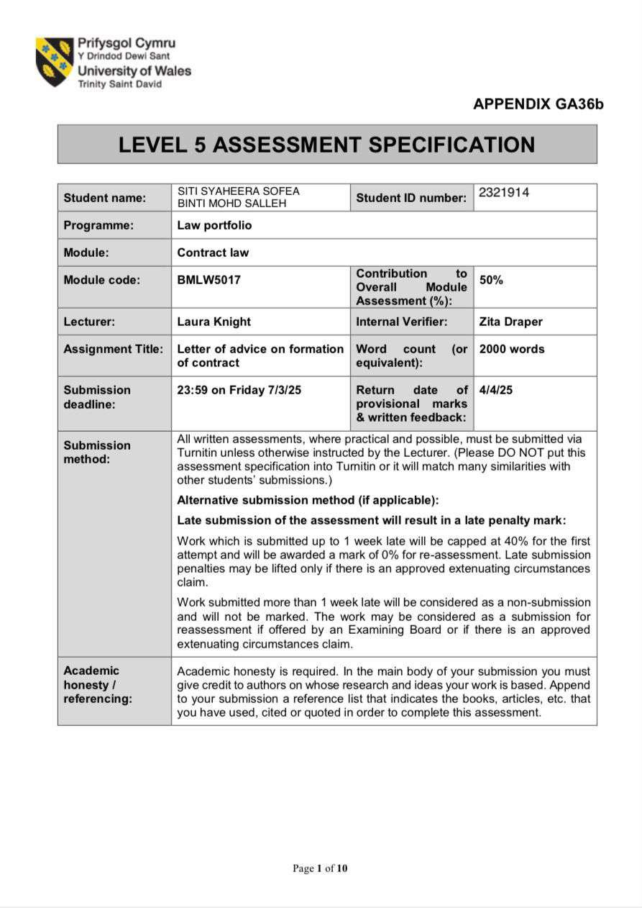

Letter of Advice to Mr. Smith

Jane
66 Alexandra Road SA1 1AA, Swansea 21/5/2025
Mr. Smith

Flat 31, Hitherwood Court 28 Charcot Road
NW9 5YW, London Dear Mr. Smith,

Re: Legally Binding Contract for the Rental of Your Flat

I am writing to address the situation regarding the tenancy agreement for your flat, which I had agreed to rent for the upcoming academic year 2025/2026. Based on our interactions, I wish to clarify whether the legally enforceable agreement between us has been established and the potential legal implications of your decision to rent the flat to another individual.

Elements of Contract Formation

Under English contract law, a legally binding contract requires the presence of the following elements:
- Offer – A clear expression of willingness to contract on specific terms.
- Acceptance – Unqualified agreement to the terms of the offer.
- Consideration – Something of value exchanged between the parties.
- Intention to Create Legal Relations – An intention by both parties to be legally bound.
- Capacity to Contract – The legal ability of both parties to enter into a contract.

The validity of a contract depends on all three elements that can be interpreted in various ways. This section explains each element with specific details about their application in our situation.

Offer

An offer stands as a certain promise between an offeror who directs their promise to an offeree for the promise to create binding legal obligations upon acceptance. A valid offer needs to contain clear statements that a recipient offeree can understand and delivers to the intended person. A legal binding promise through an offer offers clear differences from an invitation to treat serving only as a starting point for discussions between parties. The significance of this distinction was emphasized in Partridge v Crittenden [1968] 1 WLR 1204, where it was held that advertisements for the sale of goods are generally considered invitations to treat rather than offers unless the wording suggests otherwise.
In our case, you verbally offered to rent the flat to me for £500 per month, starting from September 1, 2025. This was a clear and specific promise regarding the property, rent amount, and start date. Unlike an invitation to treat, this statement was made with the intention of securing a tenant, meaning it was a valid offer rather than an invitation to negotiate further terms.
Additionally, the offer was later confirmed in writing, strengthening its legal standing. In your email, you explicitly stated:
"Sure, the rent is £500 per month, and you can move in on September 1, 2025. Please confirm if you agree."
This written confirmation meets the criteria for a valid contractual offer because:

  - It specifies essential contractual terms (property location, rental price, and move-in date).
  - It demonstrates an intention to be bound by the agreement if I accepted.
  - It was communicated directly to me, the offeree, creating the possibility of a legally enforceable agreement.
The enforceability of conditional acceptance through offers depends heavily on the decision made by the courts in Storer v Manchester City Council [1974] 1 WLR 1403. Based on the judgment made in Storer v Manchester City Council [1974] 1 WLR 1403 the court determined that clear contractual terms make an offer enforceable without requiring a signed formal document. Manchester City Council sent a letter to the defendant which explained that house sale after the plaintiff signed the document would proceed with the agreement. A binding contract existed according to court decision even though policy changed since the offer was unambiguous and clearly presented with subsequent acceptance.

Similarly, in Gibson v Manchester City Council [1979] 1 WLR 294, the court clarified that an offer must be distinct from preliminary negotiations. While the wording in Gibson was deemed insufficiently clear to constitute an offer, the wording in your email explicitly stated “Sure, the rent is £500 per month, and you can move in on September 1, 2025”, indicating a firm and clear offer rather than a mere negotiation.
The court established in Carlill v Carbolic Smoke Ball Co [1893] 1 QB 256 that uncertain offers do not hold legal value. The stated terms for monthly rent and start date demonstrate offer clarity because they do not need further approval or negotiation to become binding.
A clear offer stands as an essential factor as demonstrated through this particular case example Harvey v Facey [1893] AC 552, Price statements serve as offers only when the speaker shows a willingness to be bound under Privy Council laws. However, in our case, your email did not merely state the rental price but explicitly asked me to confirm my agreement, reinforcing its nature as a genuine contractual offer.
The development of our verbal discussions into a written agreement through your email email establishes beyond doubt that this was an actual offer as opposed to a negotiation invitation. Your email search for agreement confirmation demonstrates a strong intent to be legally bound which surpasses the standard of an invitation to treat as shown in Fisher v Bell [1961] 1 QB 394 about shop window displays.
Given these considerations, your email qualifies as a legally valid offer under contract law. The next crucial step is acceptance, which I provided in response, further solidifying the contract’s enforceability.

Acceptance

Acceptance is the unqualified agreement to the terms of an offer. For acceptance to be legally valid, it must meet the following criteria:
  - It must be unequivocal – The offeree must accept the offer in its exact terms without modifications (known as the mirror image rule).
  - It must be communicated to the offeror – The law considers silence to become acceptance only when both parties have previously agreed that silence would equal agreement.
  - It must be made within a reasonable timeframe – If an offer specifies a deadline for acceptance, the offeree must respond within that period. If no deadline is set, acceptance must occur within a reasonable time.

In response to your email, I replied:

"I agree to the terms. I will arrange the deposit payment by the end of this week."

This response clearly and unequivocally indicates my acceptance of your offer. My acceptance matched the terms of your offer without proposing any modifications, thereby satisfying the mirror image rule, which states that acceptance must exactly correspond to the offer for a contract to be formed. The importance of this principle was affirmed in Hyde v Wrench [1840] 3 Beav 334, where a counteroffer was considered to reject original offers which blocked the creation of contracts. Since my response did not alter any of the offered terms but instead expressly agreed to them, my acceptance was valid and binding.

Communication of Acceptance

For a contract to form both parties must deliver effective acceptance notifications to each other. Entores Ltd v Miles Far East Corporation [1955] 2 QB 327 established acceptance made through instant communication methods like email and fax and telephone will create a binding contract at the instant and location of offeror receipt. The email sent through instant communication led to prompt reception of my acceptance by you. The effective communication requirement becomes fulfilled with my acceptance email delivery to your position which marks the exact time when the contract was established.
Additionally, in Brinkibon Ltd v Stahag Stahl und Stahlwarenhandel GmbH [1983] 2 AC 34, the court confirmed that the time and place of acceptance are crucial in determining when a contract comes into effect. Since email communication is considered instantaneous (unlike postal communication), acceptance is effective when it reaches the offeror's inbox, not when it is sent. Therefore, my acceptance email fulfilled this requirement, solidifying the contract’s validity.

Silence as Acceptance?

In some cases, one party may argue that acceptance was not validly communicated. However, it is a well-established principle in English contract law that the silence of an individual does not carry legal implication of acceptance. as demonstrated in Felthouse v Bindley [1862] EWHC CP J35, where the court ruled that an offer cannot be accepted simply by failing to reject it. However, my case is fundamentally different. I did not remain silent but actively communicated my acceptance in writing, making it legally enforceable.

Conditional vs. Unconditional Acceptance

One could argue that my statement, "I will arrange the deposit payment by the end of this week," introduces a condition that might delay contract formation. However, in Manchester Diocesan Council for Education v Commercial and General Investments Ltd [1970] 1 WLR 241, the court held that a contract can still be formed even if certain administrative steps, such as payment, are yet to be completed, provided that the key terms have been agreed upon. Since my acceptance was not contingent on the deposit being paid but rather stated my intention to make the payment later, the acceptance remains unconditional and legally binding.
Under the legal ruling made in Carlill v Carbolic Smoke Ball Co [1893] 1 QB 256 the court established that acceptance in unilateral contracts does not necessarily need direct confirmation from the offeree to the offeror. According to the principles established by Carlill v Carbolic Smoke Ball Co [1893] 1 QB 256 the act of executing a bilateral contract requires both parties to make mutual promises yet my agreement is valid because I demonstrated my willingness to perform my obligations by paying the specified deposit.

Timeliness of Acceptance

For an acceptance to be valid, it must also be made within a reasonable time. The duration of performing obligations depends both on the characteristics of the agreement together with standard practices in the industry. Since you did not specify a deadline for acceptance, contract law dictates that acceptance should occur within a time period that would be considered reasonable for rental agreements. My prompt email response falls well within this standard, further solidifying the validity of my acceptance.

Conclusion

Based on the principles of contract law and supporting case law, my acceptance was valid, clear, and effectively communicated. The mirror image rule was satisfied, and the contract was formed the moment you received my acceptance email. Therefore, at that point, a legally binding contract was created between us for the rental of your flat under the agreed-upon terms.

Consideration

Consideration is a fundamental requirement for a legally enforceable contract. Under English contract law, consideration is defined as something of value exchanged between the contracting parties, forming the basis of a binding agreement.

Consideration ensures that a contract is not merely a promise but a legally enforceable obligation.

Definition and Legal Principles of Consideration

For consideration to be valid, it must satisfy the following criteria:

- It must have value – Consideration must be something of economic or tangible worth, The transfer of money along with goods, services and promises of actions or abstention falls under the category of contracts.
- It must move from the promisee – Only those who provide consideration can enforce the contract.
- It must not be past consideration – Consideration must be given in return for a promise, meaning past actions do not constitute valid consideration.
- It need not be adequate, but it must be sufficient – According to law there is no need for equal consideration value yet worth must be demonstrable in any agreement.
In this case, my agreement to pay £500 per month in rent together with the payment of the deposit establishes valid consideration between the parties. The exchange of money completes the legal requirement for consideration by providing the flat tenant's right to occupy the property.
Deposit payments have a well-recognized status as valid consideration within legal contracts. A deposit investment functions beyond its payment status as it creates a legally binding promise for the agreement. Your bank transfer of the deposit shows both my contractual commitment and establishes a financial responsibility through which our agreement becomes stronger.

Relevant Case Law

The principle that consideration must be present for a contract to be enforceable was firmly established in Dunlop Pneumatic Tyre Co Ltd v Selfridge & Co Ltd [1915] AC 847, where the court emphasized that every contract must involve a mutual exchange of value. In this case, my financial commitments—agreeing to pay rent and transferring a deposit—constitute valid consideration, reinforcing the legally binding nature of our agreement.
The definition of consideration according to Currie v Misa [1875] LR 10 Ex 153 explains it as a benefit received by one party together with a corresponding detriment for another. Both parties entering into the rent obligation and promise to lease the

property satisfy the consideration requirement which demonstrates valid contractual agreement.
Furthermore, in Thomas v Thomas [1842] 2 QB 851, the court ruled that even nominal consideration is sufficient to enforce a contract, as long as something of real value is exchanged. The fact that my deposit and rent payments are significant financial commitments makes the consideration in our agreement strong and indisputable.

Conclusion on Consideration

Based on well-established legal principles and case law, my deposit payment and monthly rent obligation constitute valid, enforceable consideration. This element of contract formation is therefore clearly satisfied, reinforcing the legally binding nature of our tenancy agreement.

Intention to Create Legal Relations

For a contract to be legally binding, both parties must demonstrate an intention to create legal relations. The law distinguishes between:
- Social or domestic agreements, which are presumed not to be legally binding unless proven otherwise.
- Commercial agreements, which are presumed to be legally binding unless there is clear evidence to the contrary.
The property rental agreement belongs to the commercial contract category where enforceability stems from automatic application.

Presumption of Intention in Commercial Agreements

In Edwards v Skyways Ltd [1964] 1 WLR 349, business contracts made in professional environment automatically hold legal force according to court decisions unless explicitly stated otherwise. Our rental agreement, involving a landlord-tenant relationship, clearly falls within this category.
Additionally, in Esso Petroleum Ltd v Commissioners of Customs and Excise [1976] 1 WLR 1, the court reinforced that transactions with financial implications are presumed to have legal intent. Since our agreement involves monthly rental payments and a deposit, the existence of financial commitments strongly supports the presumption of legal enforceability.

Express Statements and Conduct

Intention to establish legal ties can be constructed through analyzing how parties act and speak during communication processes. Your email stating:

"Sure, the rent is £500 per month, and you can move in on September 1, 2025. Please confirm if you agree."
demonstrates a clear willingness to be bound by legal obligations. Similarly, my acceptance email and deposit payment further reinforce the seriousness of our agreement.

Conclusion on Intention to Create Legal Relations

Through both their commercial nature and judicial presumptions it becomes evident that all parties naturally intended to establish legal relationships within their landlord-tenant agreements. The enforceability requirement of the contract is satisfied through its application.

Capacity to Contract

To create a valid enforceable contract each party must have enough legal capacity to maintain legal agreements. A person needs the required capacity to comprehend both the legal clauses of a contract and their ability to become bound by what they agree to.

Legal Principles of Capacity

Under English contract law, individuals over the age of 18 and of sound mind have full contractual capacity. Those lacking capacity include:
- Minors (under 18 years old) – Contracts involving minors are generally voidable unless for necessities (e.g., food, housing).
- Persons lacking mental capacity – Contracts may be void if a party cannot understand the terms due to mental impairment.
- Intoxicated individuals – A contract may be voidable if a party was so intoxicated that they could not understand the agreement.

Application to Our Case

Being older than 18 years old while attending university gives me the legal ability to create a tenancy agreement. Every landlord requires full legal capacity to negotiate property leases due to their mandatory authority to rent properties.

Relevant Case Law

In Nash v Inman [1908] 2 KB 1, the court decided minor participation in contracts remains unenforceable except when it deals with essential items. However, since I am an adult with full legal capacity, this principle does not apply to our situation, reinforcing the enforceability of our agreement.
Furthermore, in Hart v O’Connor [1985] AC 1000, the court emphasized valid agreement happens when a person with a healthy mental state enters into a contract legally binding unless proven otherwise. As both parties in our case are legally capable, this requirement is clearly satisfied.

Conclusion on Capacity to Contract

The agreement holds legal validity due to the full legal capacity both parties have. Law establishes no obstacles for enabling the enforcement of this agreement.

Legal Precedents Supporting Contract Formation

Several key cases reinforce the argument that a binding contract was formed:

- Carlill v Carbolic Smoke Ball Co [1893] 1 QB 256 – This case defined that a valid contract requires three elements: an offer combined with acceptance supported by consideration which matches our current agreement.

- Gibson v Manchester City Council [1979] 1 WLR 294 – This case emphasized that negotiations alone do not constitute a contract. However, since our agreement included a firm offer, acceptance, and payment, it meets the criteria for a legally binding contract.

- Parker v Clark [1960] 1 WLR 286 – A party's reliance on contractual promises that include financial commitments combined with altered residential plans hardens the enforceability of their promises. Quick Pay of my deposit together with my rental agreement show my reliance on the property agreement.

- Spencer v Harding [1870] LR 5 CP 561 – This case clarifies that invitations to negotiate do not form contracts, but once an offer is made and accepted, as in our case, a binding agreement arises.

Implications of Breach of Contract

Since all the essential elements of contract formation are present, a legally binding contract exists between us. Your decision to rent the flat to another tenant despite our agreement constitutes a breach of contract. The legal implications of this breach may include:

Damages

I may be entitled to claim financial damages for losses incurred due to your breach, including:
  - Additional costs of securing alternative accommodation.
  - Financial hardship caused by the sudden cancellation of the agreement.

In Anglia Television Ltd v Reed [1972] 1 QB 60, the court ruled that a party suffering losses due to a breach of contract can claim damages for financial loss.

Specific Performance

I could seek a legal remedy compelling you to honor our agreement and proceed with the tenancy. The remedy of specific performance is often awarded in cases involving land transactions, as real estate is considered unique.

Conclusion

A legally binding contract was formed when you made the offer, I accepted, and I provided consideration through the deposit payment. Your subsequent decision to rent the flat to another person despite our agreement constitutes a breach of contract.
I strongly urge you to reconsider your decision and uphold our agreement. If this matter is not resolved amicably, I may have no choice but to pursue legal action.
I look forward to your prompt response. Yours sincerely,
Jane

References

- Carlill v. Carbolic Smoke Ball Company [1893] 1 Q.B. 256.
In this landmark case, the court ruled that an advertisement offering rewards for using the smoke ball constituted a unilateral contract, binding the defendant to pay once the condition was fulfilled.
Citation: Carlill v. Carbolic Smoke Ball Company [1893] 1 Q.B. 256, Court of Appeal.

- Beta Computers (Europe) Ltd v Adobe Systems (Europe) Ltd [1996] FSR 367, 1996 SLT 604, 1996 SCLR 587, (1995) IP & T Digest 28.
This intellectual property dispute addresses copyright infringement and the proper application of the law regarding software licensing agreements.
Citation: Beta Computers (Europe) Ltd v Adobe Systems (Europe) Ltd [1996] FSR 367, 1996 SLT 604, 1996 SCLR 587, (1995) IP & T Digest 28.

- Entores Ltd v Miles Far East Corporation [1955] 2 Q.B. 327.
The court in this case examined the issue of when a contract is considered to be accepted in cases of instantaneous communication such as telex or telephone.
Citation: Entores Ltd v Miles Far East Corporation [1955] 2 Q.B. 327, Court of Appeal.

- Currie v Misa (1875) LR 10 Exch 153, 44 LJ Ex 94, 23 WR 450.
This case is seminal in the study of consideration in contract law, establishing the concept of consideration as a benefit to one party or a detriment to another.
Citation: Currie v Misa (1875) LR 10 Exch 153, 44 LJ Ex 94, 23 WR 450, Exchequer Court.

Chappell & Co. Ltd and Another v Nestlé Co. Ltd and Another [1960] A.C. 87.
The court examined the necessity of consideration within contracts involving goods transfers through this particular case. A simple chocolate bar wrapper proved to be acceptable enough consideration based on this ruling.
Citation: Chappell & Co. Ltd and Another v Nestlé Co. Ltd and Another [1960]

A.C. 87, House of Lords.

RTS Flexible Systems Ltd v Molkerei Alois Müller GmbH & Co KG (UK Production) [2010] 1 WLR 753.
This case clarified the need for a formal agreement in long-term supply contracts and the extent to which a party is bound by an agreement if the contract's terms are not formalized.
Citation: RTS Flexible Systems Ltd v Molkerei Alois Müller GmbH & Co KG
[2010] 1 WLR 753, Supreme Court.

- Esso Petroleum Ltd v Commissioners of Customs and Excise [1976] 1 All ER 117, [1976] 1 WLR 1, 120 Sol Jo 49.
This case addressed the classification of petrol discount tokens and whether they could be considered as an “advertisement” under UK VAT law.
Citation: Esso Petroleum Ltd v Commissioners of Customs and Excise [1976] 1 All ER 117, House of Lords.

- Harris v Nickerson (1873) LR 8 QB 286.
This case discussed the enforceability of advertisements offering goods for sale in a particular manner, marking the distinction between offer and invitation to treat.

- Carbolic Smoke Ball Co v Carill [1892] 2 Q.B. 484.
Another pivotal case involving unilateral contracts, where the Court of Appeal held that an advertisement promising rewards for using a product constituted an enforceable contract.
Citation: Carbolic Smoke Ball Co v Carill [1892] 2 Q.B. 484, Court of Appeal.

- L'Estrange v F Graucob Ltd [1934] 2 K.B. 394.
The case is a critical example of the court's treatment of exclusion clauses and the enforceability of terms in signed contracts.
Citation: L'Estrange v F Graucob Ltd [1934] 2 K.B. 394, Court of Appeal.

- Partridge v Crittenden [1968] 1 WLR 1204.
This case confirmed the legal principle that advertisements are generally seen as invitations to treat, rather than offers.
Citation: Partridge v Crittenden [1968] 1 WLR 1204, Court of Appeal.

- Smith v Hughes (1871) LR 6 QB 597.
This case involves the issue of whether a contract can be valid if both parties were under different assumptions about its terms.
Citation: Smith v Hughes (1871) LR 6 QB 597, Queen's Bench.

- Felthouse v Bindley (1862) 11 CBNS 869.
In this case, the court ruled that silence or failure to object does not amount to acceptance in contract law.
Citation: Felthouse v Bindley (1862) 11 CBNS 869, Court of Common Pleas.

- Harris v Time Inc [1985] 2 All ER 290.
The case discussed issues around defamation and the publication of misleading information, impacting the enforcement of certain contractual terms.

- R v Thompson [1981] 2 All ER 51.
This case was pivotal in the development of UK law on the construction and enforcement of contracts involving illegal activities.
Citation: R v Thompson [1981] 2 All ER 51, Court of Appeal.



