Note from tutor James Williams: Assignment submitted On-time. Due to upload problems, assignment was submitted via email on-time. And uploaded to Turnitin by tutor on 03/01/21.
-

Module name: Learning in the Digital Era
Assignment Title : Assignment 1: E-Portfolio.

Student Name: Julia Bronowska

Student Number : 2008157

Course Title:

Table of contents
E-Portfolio
Task 1 – Written summary
Task 2 – Mind Map
Task 3 – Video presentation
Task 4 - Academic poster

E-Portfolio
Link to E-Portfolio homepage
https://squishysquidart.wixsite.com/website

Screenshot of e-Portfolio Homepage
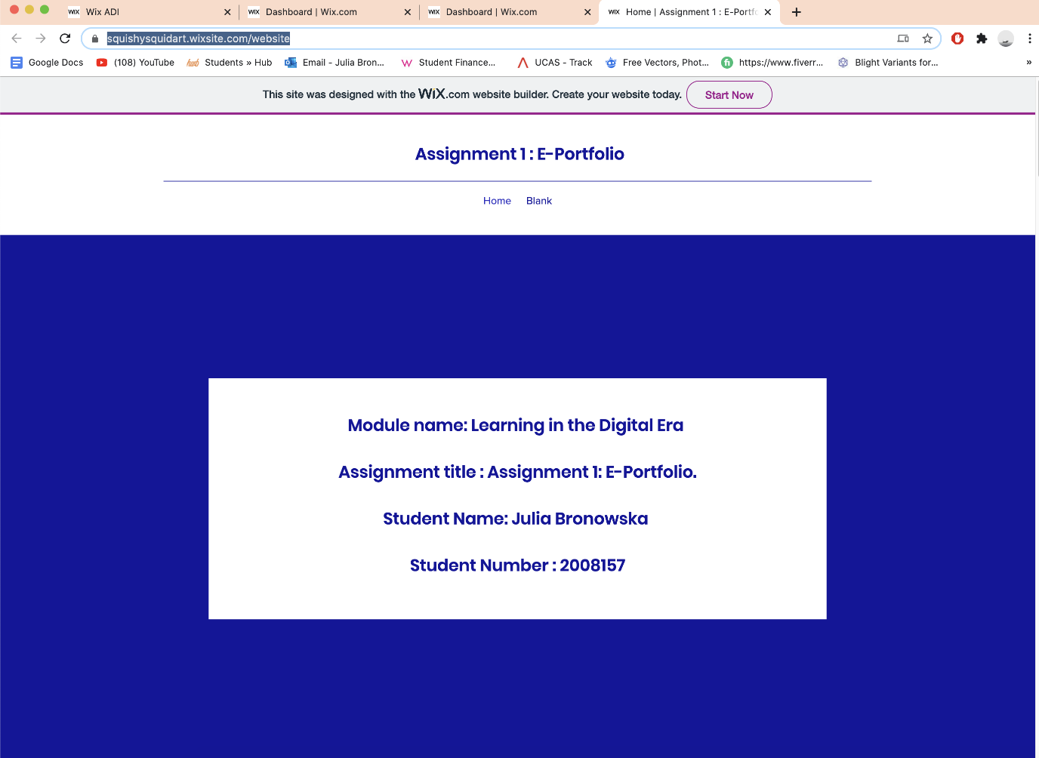

Unit 1 – Written Summary
https://squishysquidart.wixsite.com/website

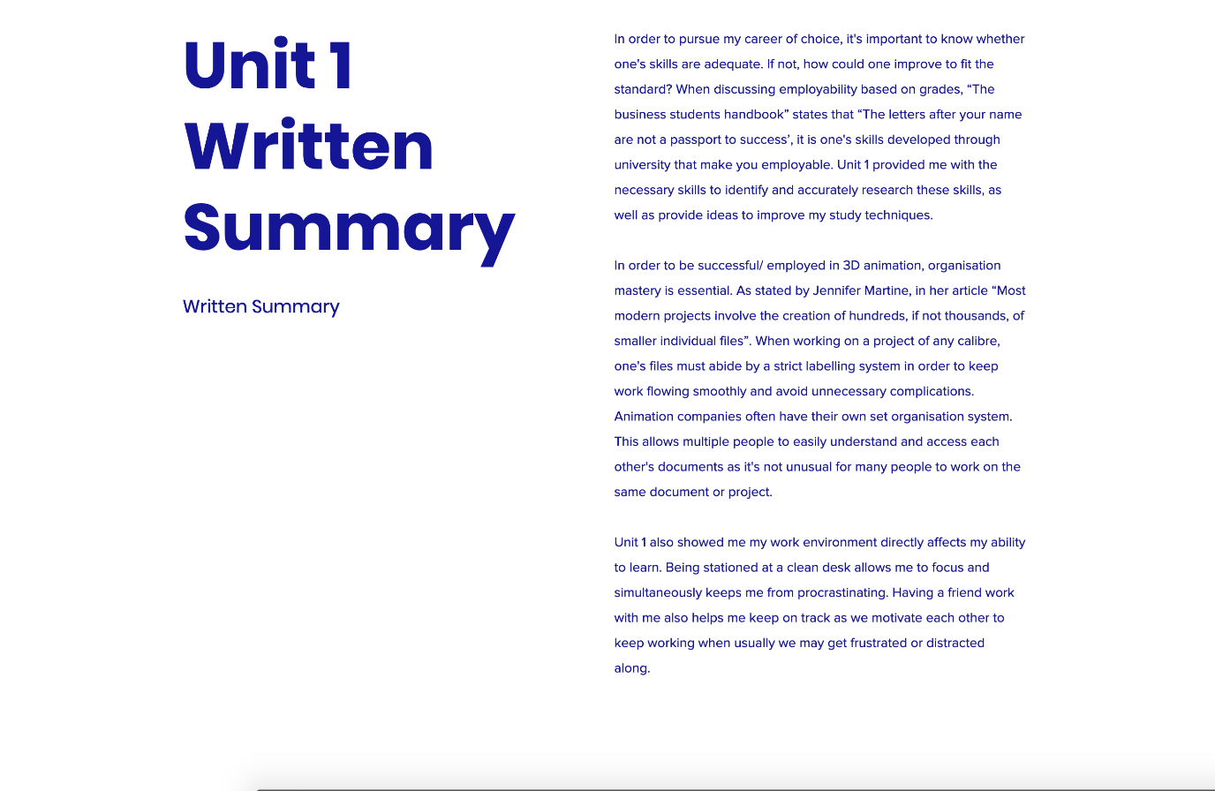
In order to pursue my career of choice, it's important to know whether one's skills are adequate. If not, how could one improve to fit the standard? When discussing employability based on grades, “The business students handbook” states that “The letters after your name are not a passport to success’, it is one's skills developed through university that make you employable. Unit 1 provided me with the necessary skills to identify and accurately research these skills, as well as provide ideas to improve my study techniques.
In order to be successful/ employed in 3D animation, organization mastery is essential. As stated by Jennifer Martine, in her article “Most modern projects involve the creation of hundreds, if not thousands, of smaller individual files”. When working on a project of any calibre, one's files must abide by a strict labelling system in order to keep work flowing smoothly and avoid unnecessary complications. Animation companies often have their own set organization system. This allows multiple people to easily understand and access each other's documents as it's not unusual for many people to work on the same document or project.
Unit 1 also showed me my work environment directly affects my ability to learn. Being stationed at a clean desk allows me to focus and simultaneously keeps me from procrastinating. Having a friend work with me also helps me keep on track as we motivate each other to keep working when usually we may get frustrated or distracted along.

References:

Textbooks

The business student's handbook: skills for study and employment
Author: Cameron, Sheila
The study skills handbook
Cottrell, Stella

Articles

https://usv.edu/blog/7-skills-needed-to-be-a-successful-3d-animator/
7 SKILLS NEEDED TO BE A SUCCESSFUL 3D ANIMATOR
BY JENNIFER MARTIN | MAY 27, 2020
https://www.skillsyouneed.com/general/employability-skills.html
Employability Skills: The Skills You Need to Get a Job
https://www.simplilearn.com/why-are-employability-skills-important-article
Reflection
Having reviewed my similarity score through Turnitin, I'm fairly satisfied with my results of 16%. I have no similarities in the main body of writing, with similarities occurring only in the references.
For this task I would mark myself around 85 as I feel I approached it well and applied my skills fully to accomplish my best. I believe my literary skills were good however I feel I could have been more mindful of the word limit and reduced unnecessary rambling.

Task 2 – Mind Map
https://squishysquidart.wixsite.com/website
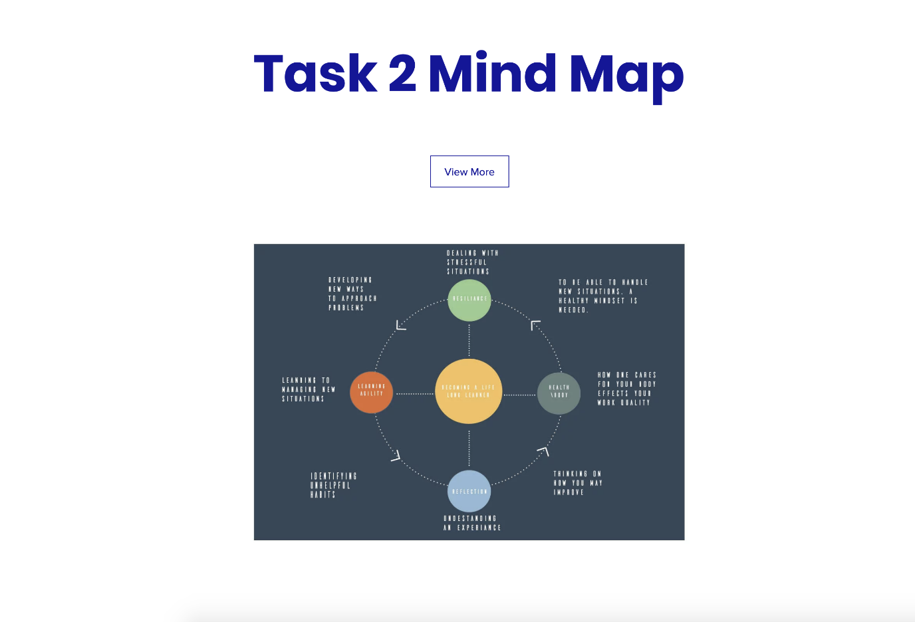
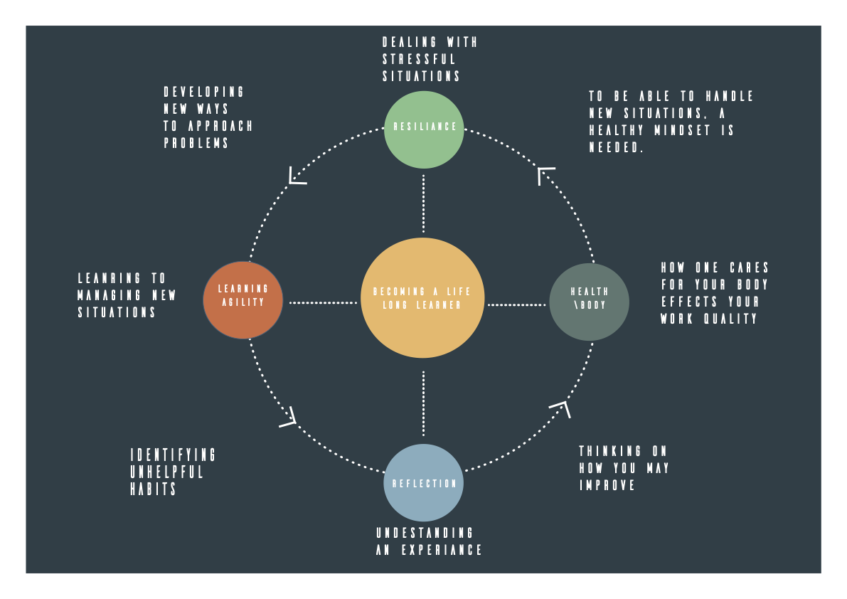

Task 3 – Video presentation

https://spark.adobe.com/video/OqpHMYpiDlUJd

https://squishysquidart.wixsite.com/website

Task 4 - Academic poster
https://squishysquidart.wixsite.com/website



