Gavin Owen Stefan Williams
P146704
Electric and Hybrid Propulsion Control Part a
Module Code: M3X8668

1.0 Abstract
2.0 Introduction
3.0 Problem identification
4.0 Vehicle of Choice
5.0 Additional Information
6.0 Offroad Course
7.0 List of Calculations
8.0 Spread sheet
9.0 Graphs
9.1 Power overtime
9.2 Velocity Overtime
9.3 Rolling Resistance Surfaces
9.4 Areodynamic Resistance Overtime
9.5 Gradient Resistance overtime
9.6 Total Resistances overtime.
10.0 Conclusion

1.0 Abstract
For this report an engineering director from a corporate entertainment events company approched us to find choose a suitable offroad buggie and make a suitable offroad course. A Excel spreadsheet will then be made to find the buggy`s typical duty cycle for a lap of the course. The performance of the vehicle will have to be suitable enough to go around the track with two people inside the buggy. A suitable track will then be made with an elevation of 20m with a lap time of 2 minutes (120 seconds).
2.0 Introduction
The main purpose of this report is to pick a suitable vehicle and write a typical duty cycle for a buggie avaliable off the blitzworld buggy supplyer website. The typical duty cycle will be designed from scratch for this assignment and must include multiple variables to test the performance of the vehicle and also be exciting for potential customers. Aswell as that the terrain of the course will be taken into consideration for future calculations.
The spreadsheet which will be made will collect data from the vehicle such as the weight, power and wheel radius, the type of surface the vehicle is run on, the gradient percentage, the garadeablity of the vehicle and the forces that act upon the vehicle while travelling.
A list of equations will be compiled which will be used for the spread sheet. These will include convertions from one unit to another and equations to find resistances.
3.0 Problem Identification
Before any calculations take place a number of problems will have to be identified. These include problems with the type of driver, the surface of the track and the overall speed of the vehicle which will be taken into consideration. The problems that may occour with the person driving the vehicle is that they could weigh more or less than the uk average weight and also that the way they drive the buggy could possibly be slower or faster depending on their off road driving experience. The next problem that could occour could be from the surface of the track not being fully consistant with what the overall rolling resistant will be for the type of surface. Aswell any type of weather changes could affect times, speeds and resistances applied to the vehicle. Finally when the vehicle is being driven up or down a gradient the person behind the wheel may use less or more brake and throttle for the section meaning the consistancy for the velocites on the slopes could vairy.

4.0 Vehicle of Choice
From the use of the website Blitsworld.co.uk a suitable offroad buggy was picked for the use of this project. The vehicle itself is a Quadzilla Z8 4x4 2017. Below shows a graph of information which the buggie:
Quadzilla Z8 | Specifications
Engine | V-Twin, 800cc, 4 stroke 8 valve
Power | 62.2BHP(46.38kw) @6200rpm
Torque | 72Nm @6200rpm
Fuel Capacity | 27 Litres
Dimensions | 2870 x 1510 x 1830mm (L X W X H)
Ground Clearance | 310mm
Cooling | Liquid cooled
Fuel System | Electronic fuel injection
Suspension | Independent adjustable double wishbone
Transmission | CVT automatic gearbox
Wheels | 14” Allow with block tread tyres
Differential | On demand diff lock
Price | £8,995.00
Weight of Vehicle | 500kg (5 Litres of fuel with all fluids)
Seats | Two seats
Warranty | 12 months parts and labour

From these specifications given from the blitzworld site the vehicle chosen due to the fact its lightweight, inludes two seats, uses a suitable engine which can be restricted power wise and also an automatic CVT gearbox. Below is a picture of the buggy.
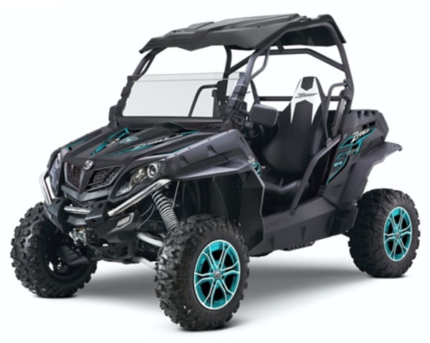
Blitzworld 2017

5.0 Additional information
Before any of the calculations begin for the spredsheets aditional information must be gathered and tabled below:
Air Density | 1.2
Average Mass of a male in the UK (Kg) | 83.6
CD of this type of vehicle | 0.6
Rolling resistance Co-efficient on Conrete | 0.013
Rolling Resistace Co-efficient on Mud | 0.225
Gravity | 9.81
Vehicle mass with fuel tank full. | 516.476

6.0 Offroad Course
Below shows a likely verson of the offroad couse which will be suitable for the vehicle and calculations. The track itself uses a section of strights, low, medium and high speed corners and a section in which has a 20m inclimb and 20m decent. The track itself will have to last around 120s long.
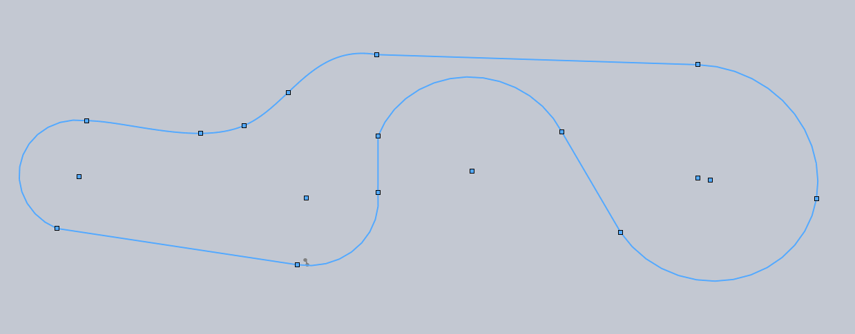
From this base map a split up the track into 30s sections and highlighted each section accordingly to the data in the spreadsheet. Sections 1 and 4 are on tarmac and section 2 and 3 are on mud.
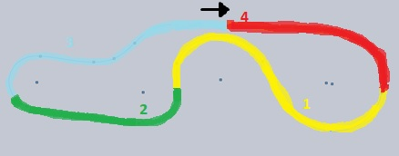
As this is a concept offroad course it is open to interpritation and changes to make it more suitable for the buggy.

7.0 List of Calculations used for the spread sheet
Power
Tractive Force x Velocity
Coefficient of Drag
2 x m.g ÷ (density of air x (velocity ^2) x area of vehicle)
Gradient Resistance
m.g x SIN(Theta)
Rolling Resistance
m.g x Rolling Resistance Coefficient
Tractive Effort
m.g x Coefficient of fiction
Tractive Force
Tractive Effort – Rolling Resistance
Grade ability
100*((Tractive Force/Weight) - Rolling Resistance Coefficient)
Meters Per Second Equation
MPH x 0.44704
Acceleration (m/s²)
(Current velocity – previous velocity) / 1
Distance
M/s velcity x 1
Length
Current distance + previous length
Total Resistances
(Mass x accelertaion) + all resistances
Watt to kilowatt equation
Watt x 0.001
Angle of gradient in degrees
Sin^1(height / distance)

8.0 Spread sheet
Below shows the completed spreadsheet which was made. The colums include time (s), height (m), Acceleration (m/s²), Vehicle Velocity in MPH, Vehicle Velocity in m/s, Gradient (%), Rolling Resistance (N), Areodynamic Resistance, Distance, Length,Gradient Resistance (N), Total Resistance (N), Power(W), Power (Kw), Average Power (w), Average Power (Kw). As the amount of time was 120 seconds I split up the track into 4 sections. The first section used tarmac as its road surface, the second and third section uses a road surface of a muddy field with the final section going back to tarmac.
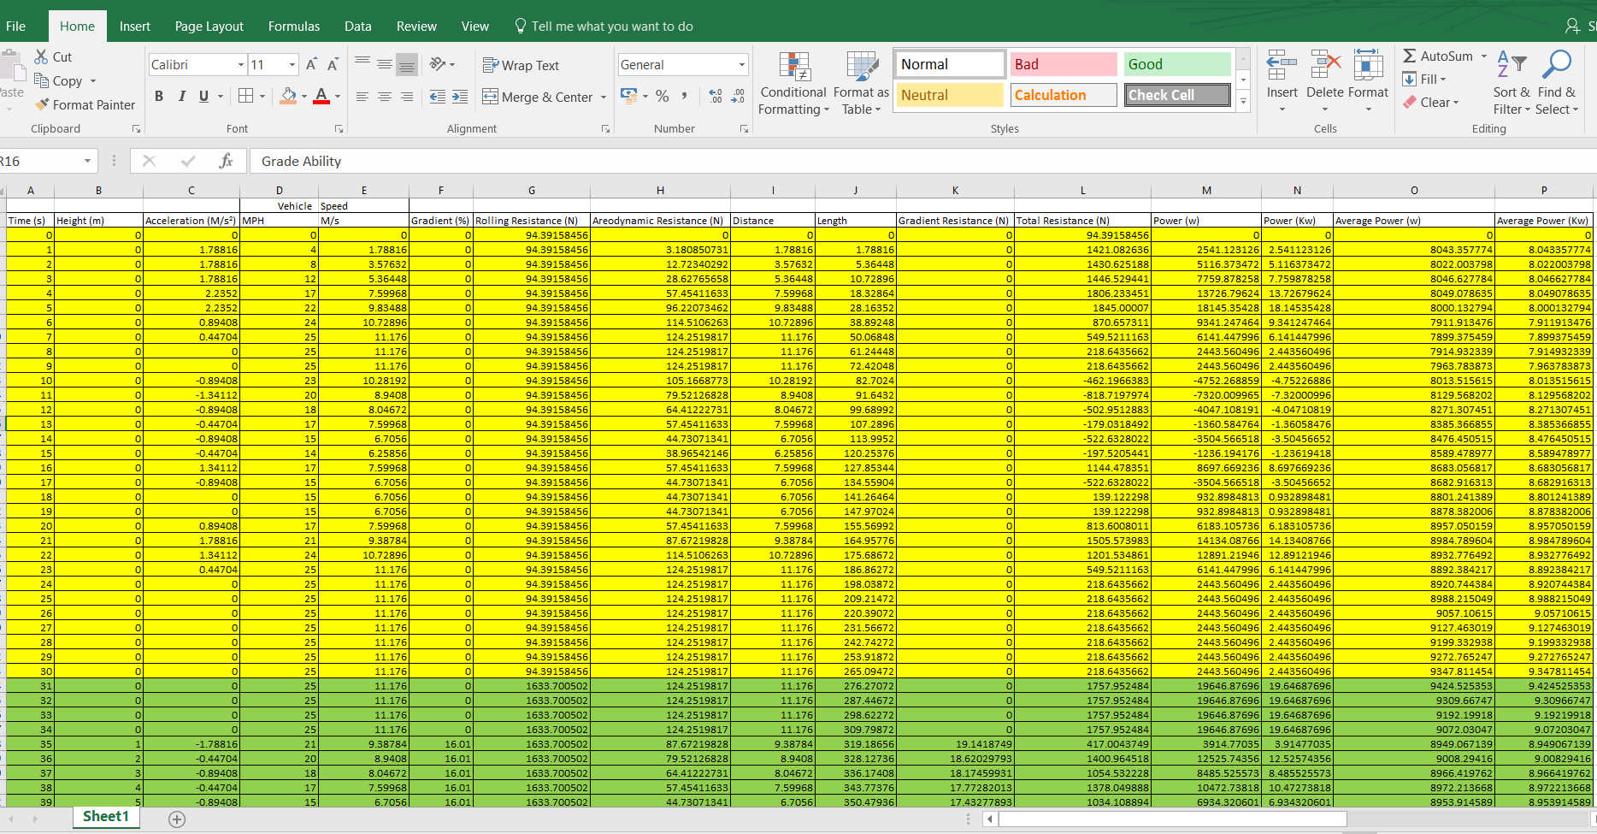

Aswell as that atable was made which includes other valuable information needed for the spread sheet which is shown below:
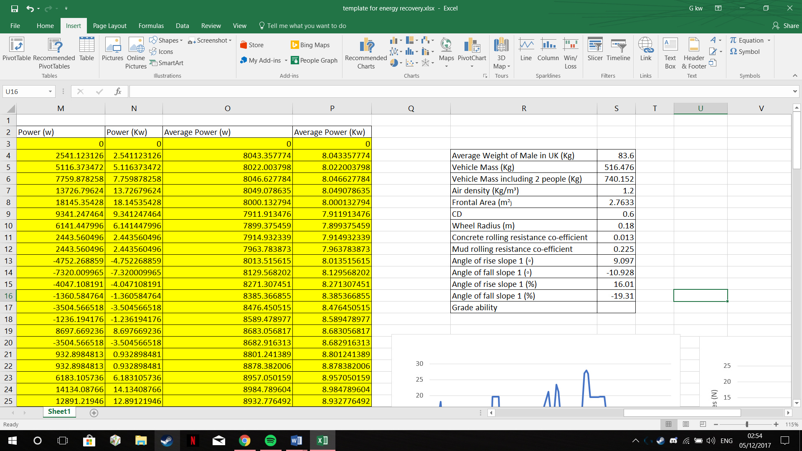
From the use of this spread sheet It was possible to find an overall length for the track whch happened to be 970m long.

9.0 Graphs
From the use of the spreadsheet a number of graphs were created. All the graphs were plotted against time in seconds for comparison.
9.1 Power overtime
The graph shown below shows the power of the vehicle in kw. The graph fluctuates every few seconds due to the change of throttle.

9.2 Velocity Overtime
The graph below uses the velocity in m/s. when the vehicle is accelerating the gradient of the graph increases. While at a constant speed it will then begin to flatten out and when decelerating the graph will then show the line decreasing.

9.3 Rolling Resistance Surfaces
For this graph it shows the change of surface resistance is. As you can see between the 30s to the 90s mark the vehicle is on a surface with has a higher resistance compaired to what is seen between 0s to 30 seconds and between 90s to 120s.

9.4 Areodynamic Resistance Overtime
The graph below shows the amount of areodynamic resistance in which the vehicle faces while travelling along the corse. The higher the graphs peak the more forces are being appled to the vehicle.

9.5 Gradient Resistance overtime
The gradient resistance graph below shows the newtons that effect the vehicle while travelling up the slope. The 34s mark of the graph theres a large peak of 20N of force that’s being appled to the vehicle due to the change of gradient. Once the gradient is then smoothed outh the resistances settle back down to 0. While going back down the slope the gradient resistances will then go into the negative.

9.6 Total Resistances overtime.
The graph belows the total resistaces from the areodynamic resistances, gradient resistances and rolling resistances.

10.0 Conclusion
In conclusion a suitable course has been created which fits the requirements needed for the tasks along with a vehicle which is in a suitable specification for the created course. An excel speadsheet was created using multiple calculations along with multiple graphs showing the duty cycle of the buggy. Due to the nature of the equations certain values used were estimated so the results may have some discrepancies.

References
Blitzworld.com. (2017). Cite a Website - Cite This For Me. [online] Available at: http://blitzworld.com [Accessed 2 Dec. 2017].
Quadzillaquads.com. (2017). Official home of Quadzilla Quads - Road Legal Quads and Buggies, Kids Quads & Farm Quads. [online] Available at: http://www.quadzillaquads.com/ [Accessed 5 Dec. 2017].

