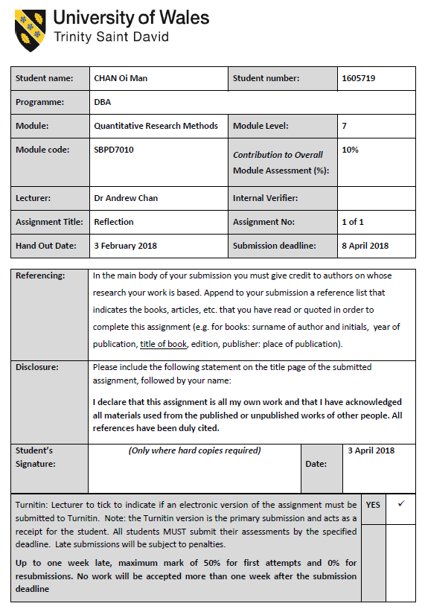
Building Innovation Culture in the Traditional Fashion Retail Business in Hong Kong
Reflection
After the data analysis of the information gathered in the pilot, the primary conclusion is one out of four hypothesis is rejected:
 | Relationship | Primary Conclusion
H1 | Transformational leadership is positively and significantly related with employees’ attitude towards innovation | Accepted
H2 | Organizational innovation is positively and significantly related with human capital innovation | Rejected
H3 | Organizational innovation is positively and significantly related with process innovation | Accepted
H4 | Transformation leadership and organizational innovation are correlated in building innovation culture | Accepted

From the primary conclusion, there are mainly two lessons learnt from the findings:
- Conceptual information digged out from literature review may not be necessary valid, i.e. some writers believe human capital factors are important for organizational innovation and innovation culture building (Rejection of H2).
- Information gathered from people of Senior executive may not be true for general staff (including managers and supervisors). During the interviews, the majority of the Senior Executive stressed that human capital is vital important for organizational and innovation culture building.
Nonetheless, the pilot result indicates that what the senior executive believes are not agreed by the general staff. The possible explanation is their views are influenced by their own interests and position. For example, the senior executive believe staff with innovation work should be with higher status in their organization. However, the general staff does not agree with their point. Possibly, the general staff thinks all staff should be equal regardless their type of work.
With the concurrence from the pilot test result, the conceptual framework is amended as the following Figure 1:
This is an interesting but difficult exercise. I was required not only to build up the concept through literature review but to verify it by quantitative pilot survey. The result from the pilot is out of my expectation.

