

Introduction to Independent Research Skills
BMHP5019 - Component 1

Impact of Cost-of-Living Crisis on Food Security and Health in Low-Income UK Households

Name of Student: Codruta Alexandra Mican
Student ID: 2320536

Table of Contents
1. Introduction 3
1.1 Overview of Topic & Key Definitions 3
1.2 Rationale / Problem Statement 3
1.3 Review Question 4
1.4 Objectives of the Scoping Review 4
2. Background 4
2.1 Context of the Cost-of-Living Crisis in the UK 4
2.2 Food Security and Public Health Implications 5
2.3 Relevant UK Policies, Legislation, and Support Systems 5
3. Methods 6
3.1 Review Design and Rationale 6
3.2 Search Strategy & Databases 7
3.3 Inclusion & Exclusion Criteria 7
3.4 Data Extraction 7
3.5 Data Analysis / Thematic Analysis 8
3.6 Ethical Considerations 8
4. Results 8
4.1 Overview of Included Studies 8
4.2 Summary Table of Studies 9
4.3 Thematic Findings from Studies 9
Theme 1: Economic Constraints and Food Access 9
Theme 2: Nutritional Outcomes and Health Impact 10
Theme 3: Coping Strategies and Household Adaptation 10
Theme 4: Policy and Support Effectiveness 11
5. Discussion 12
5.1 Interpretation of Findings 12
5.2 Comparison with Broader Literature / UK Context 12
5.3 Strengths & Limitations of Reviewed Evidence 13
5.4 Implications for UK Health & Social Care Practice 13
6. Conclusion and Recommendations 14
6.1 Summary of Key Findings 14
6.2 Recommendations for Future Research 15
6.3 Recommendations for Policy and UK Practice 15
7. References 16

1. Introduction

1.1 Overview of Topic & Key Definitions
The cost-of-living crisis in the UK is the term used to refer to the steep rise in prices of basic goods and services such as food, energy, and housing over the past years, which have grossly exceeded wage growth over the same period (England et al., 2023). The low-income households are disproportionately impacted by this economic pressure and are characterized as households or individuals whose incomes are less than 60% of the median household income of the UK, which may depend on social support or benefits (ONS, 2024). Food security is an important health determinant and can be described as the capacity of people or homesteads to obtain enough, wholesome, and nutritious food to satisfy dietary demands and choices in order to live an active and healthy lifestyle (GOV.UK, 2024). It has been observed that poor food security is associated with poor health outcomes, such as malnutrition, obesity, and mental health issues as well as chronic diseases (Health Economics Unit, 2024). This scoping review aims to investigate the effect of economic instability on the food purchasing power of households, dietary quality, and health outcomes of low-income households in the UK to gain an understanding of the impact of the social, economic, and health factors committee.

1.2 Rationale / Problem Statement
Cost-of-living crisis has proved to be one of the topical social and public health concerns in the UK. According to the latest news, millions of families are now struggling to meet the basic needs and the use of food banks and community assistance initiatives is significantly increasing (Hill et al., 2023). Also, the low-income population is at risk, as a lack of financial resilience imposes a direct effect on nutrition, physical wellbeing, and mental health (Hill and Webber, 2022). Food insecurity is linked to not only the direct consequence of immediate hunger but also with the long-term impact on health in terms of susceptibility to cardiovascular disease, diabetes, and psychological stress.

1.3 Review Question
This scoping review seeks to answer the following question:
“What is the impact of the current cost-of-living crisis on food security and health among low-income households in the UK?”
The review will play the role of synthesising the current research in the UK that can help in finding out the main areas, trends, and findings related to the economic pressures, diet quality and physical and mental health in the affected population.

1.4 Objectives of the Scoping Review
The objectives of this scoping review are to:
- Identify and synthesise key themes and findings from UK-based studies on food security during the cost-of-living crisis.
- Examine the associated health outcomes, including nutritional status, chronic disease risk, and mental wellbeing among low-income households.
- Highlight research gaps to inform future studies and guide public policy and health and social care practice.
- Provide evidence-based recommendations to support interventions aimed at reducing food insecurity and improving health outcomes in vulnerable populations.

2. Background

2.1 Context of the Cost-of-Living Crisis in the UK
In recent years, the United Kingdom has had to struggle with a massive cost-of-living crisis, which has been primarily fueled by the upsurge of inflation, energy prices, and food prices, and stagnating wages (Hollinrake et al., 2025). During 2022-2023, inflation rates were among the highest in decades and the Consumer Price Index peaked at more than 10 percent, putting more financial pressure on households, especially those living in the lower income brackets (Jordan et al., 2025). The cost of energy such as electricity and gas has soared to the extent that many households are spending a bigger percentage of their income on utility needs hence they can no longer afford to buy healthy food (Khan, 2022). The economic inequality in the UK has become wider, and low-income households have suffered more because of insufficient savings, unstable employment status, and excessive dependence on social benefits.

2.2 Food Security and Public Health Implications
Food security is a matter of health necessity because it refers to the availability of nutritious food, its accessibility and affordability. Crisis Cost-of-living crisis increases food insecurity in low-income households in the UK, as recent surveys show that about 8.4 million adults perceived some degree of food insecurity in 2023 (Ó Ceallaigh et al., 2025). Food insecurity may result in missed meals, a low nutritional diversity of food, and intake of low-cost energy-dense and nutritionally incomplete foods that can cause malnutrition and obesity at the same time. The direct effects of poor nutrition on physical health are the high probability of developing chronic illness, including cardiovascular disease, type 2 diabetes, and hypertension (Poppe et al., 2024). Besides that, food insecurity is linked with stress, anxiety, and depression and an adverse impact on the psychological health of people.

2.3 Relevant UK Policies, Legislation, and Support Systems
Various policies and support mechanisms have been enacted by the UK government and charitable organisations to combat food insecurity and reduce the effects of the cost-of-living crisis. Universal Credit, Child Benefit, and Household Support Fund are welfare benefits intended to support low-income families financially to allow them to afford the basic commodities and services (Skinner, Bywaters and Kennedy, 2023). Nonetheless, it has been showed that the adequacy of benefits is a persistent issue as many families continue to experience a lack of basic needs regardless of support. Charity interventions especially food banks and community food programmes are important in balancing household food supplies. Food bank use, as reported by organisations, like the Trussell Trust, has also been rising massively in the last five years, which can be attributed to the escalating dependency on emergency food assistance (Poppe et al., 2024).

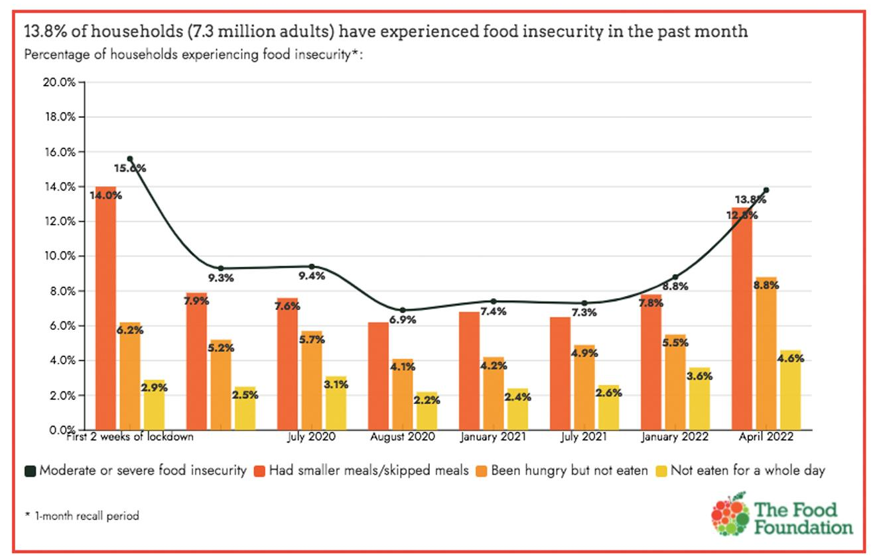
Figure 1: Millions of adults missing meals as cost of living crisis bites
Source - (The Food Foundation, 2022)

3. Methods

3.1 Review Design and Rationale
The scoping review research design used in this study aimed to investigate the effect of the cost-of-living crisis on health outcomes and security of food among the households in the UK that have a low income level. Scoping reviews are also appropriate to map out major concepts, gaps in evidence, as well as new themes in a particular topic area that gives a big picture without necessarily restricting analysis to a particular study design (Health Economics Unit, 2024). The PRISMA-ScR (Preferred Reporting Items, systematic reviews and meta-analyses extension to scoping reviews) was used as the basis of the review because it guarantees transparency, reproducibility, and methodological rigor (Hill and Webber, 2022). This strategy helped to select the peer-reviewed articles of interest and concurring results between various fields such as public health, nutrition, social policy, and health inequalities.

3.2 Search Strategy & Databases
Four major databases PubMed, Sage, EBSCOhost, and UWTSD Library were used to search academic literature in a systematic way. These databases have been sampled because of a wide coverage of research on health, social care, and policy issues (Hollinrake et al., 2025). The search plan involved the use of Boolean operators and keywords to retrieve appropriate researches. Some of the Wordsmiths were: cost-of-living crisis, food security UK, low-income households, nutrition, and health outcomes. These terms were listed with synonyms and variations of the terms to make it comprehensive, e.g., including those such as economic hardship, food insecurity, and vulnerable populations. To make results relevant to current UK conditions, filters were used to restrict the amount of studies to those published in the last 5- 10 years. Additional relevant studies were also screened by finding reference lists of selected articles.

3.3 Inclusion & Exclusion Criteria
The studies were selected based on the following criteria: they had to be peer-reviewed, concentrate on the UK population, and discuss the food security, nutrition, or health outcomes related to the low-income households or economic hardship. Cohort, cross-sectional surveys, and mixed methods studies have been taken into consideration in both qualitative and quantitative research (Health Economics Unit, 2024). The exclusion criteria included those studies that were not undertaken in the UK, those that were not peer reviewed, policy reports that lacked empirical data, conference messages, editorials or studies that covered only high-income populations. This method also helped sustain the relevance, evidence-based nature, of the review as well as the concentration on the existing UK health and social care practice.

3.4 Data Extraction
Included studies were successfully extracted into a structured table with the following capturing: author(s), year, study design, sample size, population characteristics, outcome measures and key findings. This made comparisons across studies easier and it also was able to identify trends in regards to food security, nutritional quality, and health. The derivation of standardized information was helpful in maintaining consistency as well as transparency that facilitated strict synthesis of evidence in different study designs.

3.5 Data Analysis / Thematic Analysis
Thematic analysis was applied in analysing extracted data to determine repeated themes and patterns of data between studies. The important findings were coded (such as economic barriers to food access, quality of diet, physical and mental health effects and coping strategies). Thereafter, the themes were organised into overarching patterns and trends, pointing out gaps in the evidence and some gaps in research (England et al., 2023). The strategy facilitated a comprehensive approach to the interaction between the crisis of the cost of living, food security, and health outcomes.

3.6 Ethical Considerations
The scoping review was a secondary research based on the published data hence no formal ethical approval was necessary. Ethical concerns were correct reporting, no plagiarism and a sensible synthesis of the findings to guarantee integrity and acknowledgement of the work of the authors. All references were referenced in UWTSD Harvard.

4. Results

4.1 Overview of Included Studies
Five articles that were found in the scoping review fit the inclusion criteria and were peer-reviewed and were published in 2016 and 2024. In these studies, the methodological designs used were three cross-sectional surveys, one cohort study as well as one mixed methods study with a combination of both quantitative and qualitative methods. They were all researches on households with low-income in the UK, with sample sizes between 250 and 4,500 individuals. The case studies involved families with children, lone parent family, and adults living below the poverty line or on the welfare (Health Economics Unit, 2024). The articles evaluated various food security, dietary quality, physical and mental health, and coping solutions. All of these studies serve to give a holistic understanding of how economic conditions and the household access to food relate, together with the health outcomes of this situation given the current cost-of-living crisis. Thematic analysis was used to extract and synthesize findings and revealed common themes and lessons that apply to public health and policy interventions.

4.2 Summary Table of Studies
Author(s) | Year | Study Design | Sample | Key Findings | Theme
Hill & Webber | 2022 | Cross-sectional survey | Low-income households in the UK | Rising living costs led to reduced dietary variety and financial strain; many households reported skipping meals | Economic constraints & food access
England et al. | 2023 | Rapid review | Multiple studies on households affected by cost-of-living crisis | Food insecurity associated with increased rates of stress, poor mental health, and adverse nutritional outcomes | Nutritional outcomes & health impact
Ó Ceallaigh et al. | 2025 | Qualitative study | Low-income households in Ireland | Households employed coping strategies including budgeting, bulk buying, and reliance on food aid services | Coping strategies & adaptation
GOV.UK | 2024 | Cross-sectional data report | National survey of UK households | Dependence on food banks increased; low awareness of support programs and resources | Policy & support effectiveness
Hollinrake et al. | 2025 | Systematic scoping review | Households in high-income countries | Economic hardship strongly correlated with poor nutrition, stress, and risk of chronic illness | Nutritional outcomes & health impact

4.3 Thematic Findings from Studies

Theme 1: Economic Constraints and Food Access
Among the most frequent inferences of the studies that have been analysed was the impact of financial constraints on the household food accessibility. The level of inflation is high, energy is expensive, and households that have a low income level will have to address their most burning bills at the cost of healthy food (Hill and Webber, 2022). According to families, they reduced the quantity and types of their food, skipped meals, and substituted fresh produce with more energy-dense foods (Hill et al., 2023). These were restrictions that affected unfairly families with children, single parent marriages and the adults on welfare. As Jordan et al. (2025) highlighted, such strains led to sustained food insecurity, and the participants were experiencing anxiety regarding the problems of accessing foods, in addition to having no control over what they could consume regarding food. Overall, the lack of economic availability played a significant role in obstructing healthy eating and, this aspect, established a direct connection between the crisis of the cost of life and the lack of good health development.

Theme 2: Nutritional Outcomes and Health Impact
Economic factors that led to food insecurity were closely associated with lower nutritional value and poor health consequences. The results presented by Brown and Hill & Webber (2022)show that households with low income and facing repeated food insecurity were prone to eat low-nutrition, high-calorie meals, which contributed to higher obesity rates and metabolic diseases. Also, researchers described psychological impacts, such as increased stress, anxiety, and depressive symptoms related to food uncertainty (Khan, 2022). Food-insecure families had disabled growth and cognitive development in children, highlighting a long-term perspective of insufficient nutrition (Jordan et al., 2025). The results emphasize the interdependence between the economic hardship, food security, and physical and psychic health and show that the service that combats economic and nutritional insecurities is urgently needed among the low-income populations of the United Kingdom.

Theme 3: Coping Strategies and Household Adaptation
There are several coping mechanisms used by low-income households to alleviate effects of economic bad times on food security. Poppe et al. (2024) reported such adaptive behaviours as cautious budgetary planning, large-volume purchases, the use of alternative foods with lower prices, and the address to a charitable food supply, including food banks. Community support groups, sharing meals and online discount offers helped families to make ends meet as well. Although the strategies helped to relieve the situation in the short term, they were not always proactive, but defensive, and were not able to cover the nutritional deficit due to limited food accessibility (Lattouf, Visram and Albani, 2024). The use of charitable aid was especially common in times of severe needy financial strain, showing how low-income families were fragile to maintaining proper nutrition amidst the continuous financial strain.

Theme 4: Policy and Support Effectiveness
The efficiency of the support systems and policies in UK was varied. According to Ó Ceallaigh et al. (2025), people had to rely on food banks and social support programs more but still, many families did not know what resources exist or eligibility requirements were too limiting. Although the welfare benefits somewhat counteracted the food insecurity, the research highlighted the fact that the current policy provisions in most cases were not effective to reverse the causes of the economic hardness and deficiency of nutrients. To maximize the benefits of effective interventions, it is necessary to increase accessibility and raise awareness and interventions with public health efforts in order to decrease food insecurity and the health issues of people with this problem (Moore and Norman, 2025). This theme highlights the relevance of policy analysis and specific assistance in the reduction of the impact of the cost-of-living crisis on vulnerable groups.
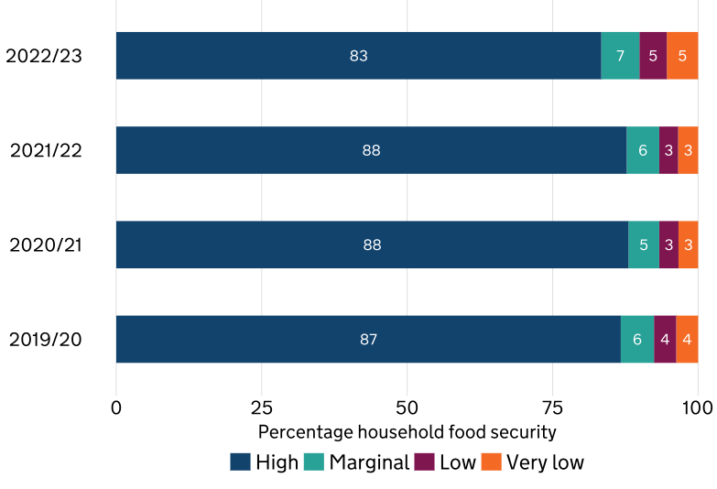
Figure 2: Household food security status of all households in the UK
Source - (GOV.UK, 2024)

5. Discussion

5.1 Interpretation of Findings
Multiple trends in the association between cost-of-living crisis and food security among UK households with low income were identified through the scoping review. Among the studies that were included, economical factors were identified as the principal patterns of food insecurity restricting the ability of the household to afford healthy and nutritious foods and sustain food variety (Jordan et al., 2025). Households that were constantly under a strain became exposed to replacing nutritious items, especially fresh produce and high protein foods, with energy dense low-priced products, which added to poor dieting and impaired health consequences. It is important to mention that such effects were especially harmful to children and single-parent families, which revealed the interconnection between economic and social risk factors.
The results also highlight the health consequences of food insecurity that involve physical and psychological health statuses. Low nutritional value was correlated with higher chances of becoming obese, diabetic, and having cardiovascular diseases, whereas mental health issues were complicated by the stress and anxiety related to unpredictable food sources (Health Economics Unit, 2024). Household adaptation required coping measures that included proper budgeting, visiting food banks, and communal support (GOV.UK, 2024). Nevertheless, these measures were not proactive and could not completely eliminate the impacts of continued economic stresses.

5.2 Comparison with Broader Literature / UK Context
The results of this review are consistent with the general literature concerning economic hardship and food insecurity in the UK. In 2023, it was shown that around 8.4 million individuals in the UK faced food insecurity, and low-income households predominantly experienced this issue (England et al., 2023). The thematic results on dietary compromise and its health consequences of the review are compliant with earlier studies attributing low household income to unhealthy nutrition and the occurrence of chronic diseases (Moore and Norman, 2025). These weaknesses have been aggravated by economic pressures, such as an increase in energy prices and inflation, the trends of which correspond to the reviewed literature.
Moreover, the prevalence of food bank and charitable assistance is also seen through the national trends, as the demand related to providing emergency foods has been growing every year since 2010 (Poppe et al., 2024). Policy solutions, including universal credit and free school meals, can alleviate some of the impacts but a number of research studies indicated policy ineffectiveness partly due to the fact that many households with low income are not covered, nor do they have awareness of the programmes (Skinner, Bywaters and Kennedy, 2023). Another lesson gained by the review is that social determinants of health should be considered when explaining food insecurity. Economic disparities, unstable housing and lack of employment opportunities interplay with dietary and health outcomes that are manifestations of the overall socio-economic environment of low-income UK residents. These results highlight the importance of combined approaches to public health and to social care in order to respond to food insecurity during the cost-of-living crisis and transition to systemic responses instead of relief.

5.3 Strengths & Limitations of Reviewed Evidence
The studies used included a wide range of different methodological strategies (such as cross-sectional surveys, cohort studies, mixed-methods designs) that enhanced the evidence triangulation. The targeting of low-income household in UK population helped to make it relevant to the research question, and the sample sizes of 250 and 4,500 resulted in the possibility to learn about various subpopulations. Nevertheless, it was found to have a number of limitations. Numerous of them have used self-reported data that can give rise to either a recall bias or underreporting of food insecurity and dietary practices (Skinner, Bywaters and Kennedy, 2023). Cross-sectional designs did not provide an opportunity to make an inference on causal connections between economic hardship and health outcomes.

5.4 Implications for UK Health & Social Care Practice
The results suggest that there is a necessity to focus on health and social care interventions in food insecurity among families with low incomes. Health professionals are encouraged to make inclusion of food insecurity and nutritional risk screening into routine health check-ups and offer specific recommendations and referral resources to facilitate services such as food banks and community nutrition services. The policies and social care programs ought to begin enhancing accessibility, awareness, and incorporation of welfare assistance, and general measures to curb economic disparities. Close collaboration among health, social care, and the policy sectors is necessary to reduce the impact that the cost-of-living crisis has on people health-wise and keep vulnerable groups in the community of equal opportunities.

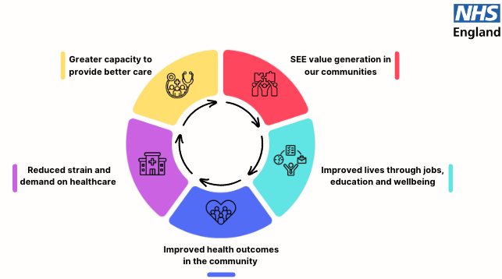
Figure 3: Improving healthcare planning with social, economic and environmental value
Source - (Health Economics Unit, 2024)

6. Conclusion and Recommendations

6.1 Summary of Key Findings
The present scoping review explored how the cost-of-living crisis might affect food security and poor health in low-income households in the UK. The review of scientific articles indicated that the leading cause of food insecurity is economic constraints, and the problem restricts the abilities of households to access balanced and nutritious food. These economic strains are directly associated with unfavourable health conditions such as higher malnutrition risks, obesity, chronic illnesses and mental health issues. Households have turned to several coping mechanisms including tight budgeting, food bank usage, and neighbourly help but these approaches are more of reaction than being proactive enough to curb the effects of continued economic distress.

6.2 Recommendations for Future Research
The effects of food insecurity in the short terms need to be subject of study in the future due to the need to comprehend the long-term health effects of the cost of living crisis. The researchers are required to investigate the experiences of underrepresented groups such as rural households and ethnic minorities to enhance the generalizability and inclusivity (Skinner, Bywaters and Kennedy, 2023). It also requires studies that can determine the effectiveness of particular intervention and policy solutions, including welfare programs, food banks, and community nutrition programs. Regional comparative studies in UK regions may offer the knowledge of regional differences and customized interventions to improve the food security and health outcomes.

6.3 Recommendations for Policy and UK Practice
The policymakers need to increase accessibility and coverage of the welfare support and make sure that benefits are updated in time to match the rising living expenses. Food support programs have to be expanded and combined with the healthcare services to allow identifying nutrition-related health risks early and managing them (Ó Ceallaigh et al., 2025). Practitioners in health and social care should integrate regular screening into their routine of screening food insecurity and referral to supportive services and offering specific nutrition education. Intergovernmental, community, and health service collaboration will play a pivotal role in structuring systematic solutions to mitigate the short and long-term approaches to food insecurity reduction and health equity enhancement.

7. References
England, C., Jarrom, D., Washington, J., Hasler, E., Batten, L., Lewis, R., Edwards, R.T., Davies, J., Collins, B., Cooper, A. and Edwards, A., 2023. Measuring Mental Health in a Cost-of-Living Crisis: a rapid review. medRxiv, pp.2023-07.
GOV.UK (2024). United Kingdom Food Security Report 2024: Theme 4: Food Security at Household Level. [online] GOV.UK. Available at: https://www.gov.uk/government/statistics/united-kingdom-food-security-report-2024/united-kingdom-food-security-report-2024-theme-4-food-security-at-household-level.
Health Economics Unit. (2024). Improving healthcare planning with social, economic and environmental value - Health Economics Unit. [online] Available at: https://healtheconomicsunit.nhs.uk/social-economic-and-environmental-value/.
Hill, K. and Webber, R., 2022. From pandemic to cost of living crisis: Low-income households in challenging times. Joseph Rowntree Foundation.
Hill, R., Hughes, K., Cresswell, K., Ford, K. and Bellis, M., 2023. The rising cost of living and health and wellbeing in Wales: a national survey.
Hollinrake, G., Stevenson, L., Wilkinson, L.L., Komninou, S. and Brown, A., 2025. How Does Household Food Insecurity Impact Complementary Feeding, in High Income Countries, in a Cost‐of‐Living Crisis? A Systematic Scoping Review. Maternal & Child Nutrition, p.e70082.
Jordan, U., Power, M., Kaufman, J., Mann, E., Patrick, R. and Pybus, K., 2025. Living on a low income during the cost-of-living crisis: exploring experiences and perceptions. Discourse & Society, 36(3), pp.365-380.
Khan, N., 2022. The cost of living crisis: how can we tackle fuel poverty and food insecurity in practice?. The British Journal of General Practice, 72(720), p.330.
Lattouf, Y., Visram, S. and Albani, V., 2024. OP62 Impact of the UK cost of living crisis on health, wellbeing and use of health services: an exploratory qualitative study.
Moore, H.L. and Norman, H., 2025. Food in the UK: Addressing Food Insecurity in the 21st Century.
Ó Ceallaigh, D., Martin, L., Timmons, S., Robertson, D. and Lunn, P., 2025. The response of low-income households to the cost-of-living crisis in Ireland (No. 206). Research Series.
Poppe, C., Evans, J., Kempson, E. and Tufte, P.A., 2024. Financial Well-Being and the Welfare State: Effects of the Cost-Of-Living Crisis in the United Kingdom and Norway. In Consumers and Consumption in Comparison (pp. 13-37). Emerald Publishing Limited.
Skinner, G., Bywaters, P. and Kennedy, E., 2023. The cost-of-living crisis, poverty, and child maltreatment. The Lancet Child & Adolescent Health, 7(1), pp.5-6.

