Alexandru Florin Gabunea

ORGANISATIONAL CONSULTANCY: HOTEL TRAVELODGE

Table of Contents
Executive Summary 3
Introduction 5
Analysis 6
Recommendations and Change Management 17
Action plan 25
Conclusion 27
Reference List 29

Executive Summary
The report had analysed or inspected and introduced the operational context of Travelodge Hotels. It is a well-known United Kingdom (UK) hotel chain with a rich history and extensive presence. It is the first budget hotel band in the UK and currently it has over 600 hotels across Spain, Ireland, and the UK. The consultancy firm so has applied its expertise to help the hospitality sector achieve operational efficiency and sustainable growth. By blending industry insights or information, innovative strategies or plans, and analytic tools, it has so provided efficient recommendations for change management that align with the hospitality sector. A thorough inspection has so suggested that the company is facing the primary issue of lack of training of employees. This challenge has mostly raised due to the financial issue, staffing crisis, persistent threat from the external environment as well as degraded quality of services. The report so had presented the aim to combine the procedure in management as well as consultancy. It had a focus to generate effective change management strategies. Thus, it has adopted an active, reflective as well as the positive approach. It had further analysed the aspect of development of professional confidence is strategic action and a management of change as well as addition of value through initiation of change. Such correlation brings a practical application to the operating world and so the demand for a business to undertake creative and innovative notions. It further provided a deeper apprehension of the role of management of organisation so to initiate and carry Change Management with the help of different strategies. A thorough analysis so had been undertaken for the report to produce data or other critical analysis of the hospital industry. Along with the analysis it has evaluated assumptions, arguments and appropriate conclusions that relate to generate recommendations for challenges.
The primary findings of the analysis is indicates that the UK has a stable economy and it mostly depends on spending by consumers and the hospitality sector. Furthermore, the UK's hospitality sector is growing at a rate of over 2.53%, with an estimated 57.39 billion dollars in development. In the UK its hospitality sector is so a sizable one. The tax laws have a direct impact or effect on the level of profitability in the hotel industry greatly. The following so enhances the financial sustainability of hotels, restaurants, as well as other industrial enterprises. With a market capitalisation of over 50 billion pounds, UK's digital and technology industry is seeing tremendous growth. The analysis section so stated that Travelodge has a significant issue of inadequate employee training. It had so led to negative customer perceptions and poor service quality. This lack of training so resulted in inconsistencies or negative reviews. It affected the brand reputation, guest loyalty, and so increased the expenditures. Seasonal employment fluctuations impacted the training programs of the employees too. It so led to high turnover rates and cost constraints. The absence of qualified trainers have posed challenges or threats in the industry. Communication barriers impact employee training for future growth greatly. Management of the company faces the challenge because of different cultural variation and styles of learning or acknowledgement. Lack of proper training so is a significant issue that affects the company's operations or the overall success. There is so a need to address these issues to boost or help the long-term success and growth of the company.
The report has recommended the organisation to adopt different strategies or practices so to imply change management. It has been suggested that the company adopts technology change management through the application of the ADKAR model. Though it is a cost intensive method it would be beneficial for the company in the long-run. In order to address the issues of organisational service quality, it is important for the company to deploy training programs, workshops, and simulated games, and this change has been depicted in the study with the help of Lewin’s change management model. Alongside this, the study has also provided an estimate regarding the metrics and budget that the company could utilise to effectively inculcate the change in the organisational operations. With the help of Kottler’s change management model, the study has illustrated how the company can address issues related to understaffing, and the metrics that Travelodge can utilise to fix this problem. Lastly the report has concluded that analysis of Travelodge's operations through SWOT, PESTLE, and TOWS reveals the drawbacks and benefits of the internal and external environment. The conclusion so analysed that a process-driven transformation would be important. Implementation of specific strategies would include practices to capitalise opportunities. The plan so established a foundation to train or manage.

Introduction
The report will analyse the operational context of Travelodge Hotels. It has distinctly applied frameworks of change management on the company’s landscape. Travelodge is a well-known hotel chain based in the United Kingdom (UK) (Travelodge, 2024). It has a wide presence and also holds a rich history. It is technically the first budget hotel band that was launched in the UK. In 1985, Trusthouse Forte owned Travelodge and it opened the first hotel. Currently the brand is operating with more than 600 hotels across the regions of Spain, Ireland and UK (Travelodge, 2024). Rooms in Travelodge are designed specifically to be functional and comfortable. Standard rooms in the hotel have a king size Dreamer bed. Family rooms easily accommodate two adults with two children with king size as well as pull out bed. With more than 30 years of experience the hotel has expanded and is also planning to extend further its operation globally (Travelodge, 2024). By analysing the scenario, the consultancy firm will apply its wealth of experience and expertise. Through its evaluation it will help the organisation of the hospitality sector to achieve operational efficiency and sustainable growth (Joneset al., 2022). With the adoption of the procedure of blending the insights of the industry, innovative strategy as well as analytic tool it will also efficient recommendations of Change Management that are entirely aligned to the hospitality sector.
The landscape of the hospitality industry is extremely dynamic globally. Every form of organisation including hotels that operate in this industry faces multifaceted challenges. To overcome these challenges, an organisation has to have strategic insights as well as a set of actionable solutions (El-Gohary, 2020). The report so will undertake an in-depth analysis of the current market position in the hospital industry. It will also provide recommendations, so to address the pressing issues that are hindering the performance of the organisation. The hotel businesses of the hospital industry are extremely competitive in that every organisation has to follow strategic rules and regulations so that they can provide efficient and substantial customer satisfaction. In the ever-changing landscape of business operation Change Management acts as an efficient tool that provides viability and profitability to organisations (Penget al., 2021). Different frameworks will be applied to analyse the internal as well as external environment of the hospitality organisation. The PESTLE framework will be used with the intention to apprehend the external environment factors that impact Travelodge. This framework is known to depict the political, economic, social, technology and environment as well as legal context that impact the hotel industry of the UK. The report so will also undertake a SWOT analysis (Verawatiet al., 2023). This tool will be applied to the context of the organisation to analyse its internal strength and weaknesses as well as external opportunities and threats that prevail in the industry. Evaluation of the SWOT factors thus will provide an impactful platform to make better decisions. The analysis of the SWOT would be taken a step ahead by developing the TOWS matrix. It will depict the strategies of change management that Hotel Travelodge will adopt by using its strength to counter the threats and use opportunities to overcome weaknesses.

Figure 1: Hotel Travelodge
(Source: Travelodge, 2024)

Analysis
Description of the issues
Travelodge Company has faced the issues of lack of training among their employees. The issues of lack of training among travelodge employees could have significance to the company’s operations and guest satisfaction (Ulfa, 2021). In March 2024, Travelodge hotels (UK) had a lack of training as a negative aspect of working there. This has resulted in a negative perception from the customers as they are facing severe problems with employees and their quality of services. Due to these issues, the company is dealing with major losses in the hospitality industry (Mathew, 2023). Without the adequate training, employees may lack the skill and knowledge to deliver high-quality service to guests. This leads to the inconsistency to the poor customer services and naive review about the company.
The lack of training makes an impact in the business consistency in the hotels and brings bad reputations towards their services. As per the company’s standpoint, this diminishes the brand's reputation and erodes guest loyalty (Depierraz, 2023). The process led to instances of poor customer service and negative reviews and affecting the company's reputation in damage of financial problems. The company also faces lack of business operations to focus on the productivity of the services. The process of lack of training brings bad impact in the safety system in the hotels to precede services
The impact of employee morale makes them ill equipped to perform their roles leading to staffing crisis. The process makes a higher turnover rate to investing in training demonstrates a commitment to employees professional development and job satisfactions. The impact of inefficiency and errors makes employees understand their roles and responsibilities and perform their tasks efficiently (Valentini and Woods, 2022). A shortage of training might result in greater business threats from rival companies. This might include expenditures for compensating visitors for bad service, recruiting and training new personnel for replacing those who quit due to unhappiness, and losing income from unsatisfied guests who do not return.
The cause of the lack of training in companies rises due to the seasonal employment experience fluctuations in demand based on holidays. This can bring the result in the workforce composed of the employees to minimal training due to their short-term employment status and service quality management (Koranne, 2023). This creates a hospitality industry with high turnover rates with employees frequently leaving their jobs for various reasons such as low pay, long hours. This build cost constraints make employees tight budgets to operate business in the competitive market.
The criticism of quality and comfort makes lack of qualified trainers bring a bad impact in the business operation due to the hospitality operations. The approach makes industry specific best practices to find on the trainers to conduct training sessions can be challenging. It will also hamper bad impact in the employees training for future growth (Ali, 2023). Communication barriers can impact employees of training programs in varied hospitality workplaces with staff from a variety of cultural and language backgrounds. Employers have also faced the struggle to provide training materials in numbers language to modify training techniques to fit varied cultural conventions and learning styles.
PESTEL analysis

Factors | Analysis | Impact
Political | - In the UK, government regulation needs to be followed for developing health and safety standards to focus on employment regulation and food safety. The UK is politically stable in business practices for hospitality establishments.  - The taxation policies are directly related to the profitability of the hospitality business. This also makes effective financial viability of restaurants, hotel and industry establishments (Mathew, 2023a).  - The hospitality has tourism promotion which attracts visitors to the UK and brings significance in marketing campaigns to inbound tourism.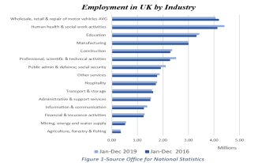  Figure 2: Employment rate of Hospitality industry  (Source: Polizzotto , 2022) | - The political factors make a good opportunity for everyone to respond in the hotel business. This is also related to constructing financial assistance to mitigate the impact of the hospitality business.  - The approach of the Travelodge Company has provided financial assistance to mitigate the impact of Brexit implications. This also focuses on the trade agreement that may affect their operations and profitability.  - The political landscape plays a crucial role in shaping the operational environment for hospitality business and workforce dynamics (Asmoro, 2021).
Economic | - The UK is an economically stable country and mainly focuses on consumer spending and is related to the role of the hospitality industry. The company makes good tourism trends to focus on domestics and international places (Hossin, 2023).  - The economic growth of the hospitality industry in the UK is 57.39 billion dollars and its growth rate is almost 2.53%. The hospitality industry in the UK is a substantial sector.  - Hospitality in the UK focuses on the supply chain cost to build economic factors to connect with decisions within the industry.  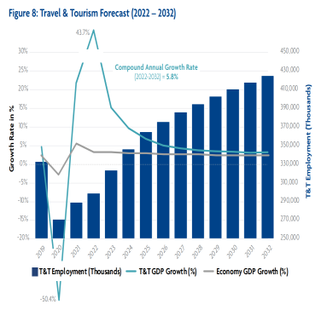  Figure 3: Financial growth rate of Hospitality industry In UK  (Source: EHL Insights, 2023) | - The company has to follow economic factors which are anticipated to build good marketing trends to hotels and tourism sectors. This brings good opportunities to focus on the investment and financing towards the hospitality sectors.  - Travelodge has effective economic stability and favourable financing conditions to stimulate investment in the business profits.  - The company also attracts international tourists to contribute to the industry growth and revenue generation (Suri and Narendra Kumar, 2022).
Social | - Hospitality industry makes demographic changes which are considered increasing diversity to help the company for marketing growth (Berry, 2022). This makes good travel trends to influence sustainability tourism and its offerings for services.  - The industry has consumer expectations to focus on affordability and personalisation. The industry must understand the evolving consumer preference to focus on environmentally sustainability practices.  - The hospitality industry has good technological innovations which mainly focus on the affordable options for short getaways or family vacations. | - The impact brings threats to the company for high technological adoptions. This makes an effective impact towards the services.  - Travelodge's social responsibility includes its engagement with local communities. Participating with communities through charity projects, preservation of the environment efforts, and collaborations with local companies improves Travelodge's image and develops compassion among inhabitants.  - The analysis makes effective cultural sensitivity which is mainly related to the behaviours of diverse markets like the UK and other countries (Hasan, 2022).
Technology | - The hospitality industry has an online booking platform which makes user-friendly booking interfaces and optimises its websites for mobile devices and digital marketing channels (Shabani, 2023).  - Tourism makes a good advance property management system to focus on the streamline operations to help tracking guests and connect with personalised services. This will also help to automate the process.  - Tourism has to build data analytics to gain insights into booking patterns and market trends. This also builds good tools to optimise revenue in management strategies. | - The approach of the technological factors makes a good opportunity for companies to focus on technological advancement to stay in industrial trends (Beldona, 2023).  - The company’s technological factors are related energy efficient solutions to connect with minimises utility costs. This also related to the investing in sustainability practices aligns with Travelodge’s corporate social responsibility goals.  - Travelodge monitors and manages its online reputation through review platforms, social media channels.
Environmental | - Hospitality companies have an effective environmental impact by implementing energy-efficient practices in the hospitality industry. These environmental factors help the company to focus on the smart heating and cooling systems for the rooms (Chen, 2023).  - This makes effective sustainability sourcing which prioritises environmentally sustainable sourcing practices for its products and suppliers. This includes sourcing locally produced goods to reduce transportation emissions.  - The industry has to analyse the carbon emission reduction to focus on the carbon offset programs to mitigate emission from unavoidable sources. | - This impact makes opportunities for the company to attract customers from international fields. This makes a good transportation impact for staff and vehicle charging stations.  - Travelodge makes good community engagement which supports environmental conservation initiatives to environmental sustainability.  - Travelodge can lower the company's ecological footprint, improve its status as a culturally responsible firm, and market to environmentally aware customers in the UK and beyond (Hartwell, 2021).
Legal | - Hospitality industry in the UK has health and safety regulations which ensure the occupational health and safety laws which are connected to the fire safety standards for customers (Mathew, 2023b).  - The industry has to introduce licensing laws to focus on the sales and services of alcoholic beverages. This includes ensuring responsible alcohol service practices.  - The industry has the employment laws which make good employment contracts and build good employee rights. | - The legal factors make threats to the company to data protection and privacy laws. The company makes an impact in collecting, storing.  - This includes obtaining consent for data collection and protecting personal data from unauthorised access (Raju, 2020).  - This brings good consumer protection laws which govern the rights and responsibilities of guest. This includes providing accurate information about accommodations, services.  - The company also focus on the contract obligations towards business partners.

SWOT analysis

Strengths  - The company has strong tourist attractions which focus on attracting millions of tourists annually.  - The approach of the hospitality industry needs diverse accommodation options to different traveller preferences (Richard, 2021).  - The company has innovation in technology to leverage advances in booking platforms.  - The company focuses on enhancing guest convenience and operational efficiency to enhance the overall guest experience. | Weakness  - The UK hospitality has built the business in seasonal demand in low occupancy throughout the years.  - The industry has labour shortages in food services and front-line customer service.  - The company has regulatory burdens which navigate health and safety regulations, and licensing laws.  - The company has dependency on tourism which makes it vulnerable to external factors such as economic downturns and political instability (Malgapo, 2023).
Opportunity  - The company has rising demands in the tourism industry and focuses on innovative services.  - The company has a growing business travel market which focuses on the services of corporate exploration (Sebastian, 2023).  - This brings effective expansion into emerging markets to support high customer segments and diversify revenue streams. | Threats  - The company faces economic uncertainty in the business investment in the hospitality industry.  - Hospitality industry has competitive landscapes which focus on the various segments to connect with alternative accommodations (Purnomo Wibowo et al., 2023).  - The company has disruptive technology which poses threats to traditional hospitality business models.  - The company has issued health and safety concerns to operational challenges for hospitality business.

TOWS analysis

Internal factors/external factors | Strengths  - Strategic locations  - Heritage values  - Technological innovation  - Staff services  - Hygienic and safety | Weakness  - Old fashion building  - Limited capacity  - Low business foundation  - Economic downfall
Opportunities  - Technological innovation  - High business trends  - Growth of travel business | (SO)  - Offer healthy experience package  - Practise contactless service  - Collaborate with travel and tourism agents | (WO)  - Enhance Hotel brand image through digital marketing strategies.  - Innovation in the economic factors
Threats  - High hotel competitions  - Declining of travel motivation  - Political regulation | - Develop flexible cancellation policy  - Develop loyalty programs  - Tenant program | - Enhance attractive education tourism  - Offer location for hybrid events.

Recommendations and Change Management
- Adopt Digital Up-gradation
To counter the criticism regarding comfort and quality by visitors, the brand is recommended through digital upgradation. The management of Travelodge is so recommended to adopt digital inclusions such as artificial intelligence, data driven insights as well as Internet of Things. The digital sector of the UK is a booming concept. Its value was more than 50 billion British pounds (Taylor, 2024). Implementation of digital check-in will allow guests to skip the front desk operations. Integration of mobile device applications will offer convenience and also reduce wait times. Application of artificial intelligence will further streamline the operation of the company. It would generate creative content for its marketing approaches (Limna, 2023).
Technology Change management would be best suited to the operative structure of the hotel because the current landscape of the hospitality industry is extremely dynamic. However, the management has to keep in mind the cost included in this strategy of change management (Limna, 2023). This form of change management practices will be applied through predictive analytics. It is greatly useful to anticipate and address the issues of maintenance before it negatively impacts the guest experience. Technology adaptation rate KPI will help the company to measure the effectiveness of the decision. This adaptation might cost nearly $ 20000. The ADKAR model of change management is the best suited framework in this scenario. By applying if the management will take the first step to create awareness among the staff of the hotels and also other stakeholders regarding the need to change. Secondly, they will support a desire to participate in the process of technology upgradation. Training regarding technological upgradation can help employees to adapt to the change better. Required resources would be provided to support the use of new technology to boost the ability of employees. Furthermore, to sustain the change the hotel authority has to implement a mechanism of reinforcement through continuous monitoring and support programs.
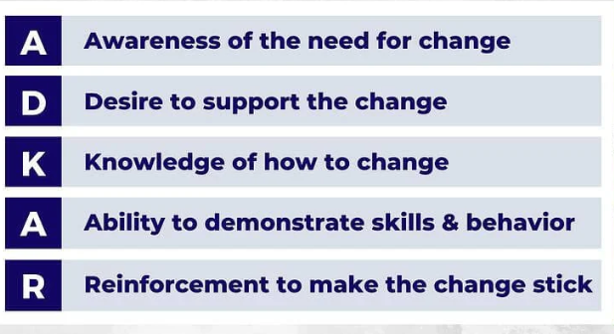
Figure 4: Elements of the ADKAR Model of Change Management
(Source: Johnson-Woods, 2023)
- Extensive utilisation of mentorship programs, workshops, and simulated situations
The implementation of the change management model proposed by Lewin in regards to the formulation of training programs for employees in a reputed hotel like the Travelodge Hotels, operating in the UK. The implementation of such a model involve a structured and thoughtful approach directed towards the facilitation of a meaningful change, which in this case is the enhancement of performance of the workforce (Ali, 2023). The Lewin’s model of change is depicted in three stages, which comprise of the unfreezing, changing, and refreezing phases. With the deployment of this model, the necessary change can be showcased in the following way:
- Unfreezing
The initial stage of unfreezing prepares the individuals and the management of Travelodge Hotels by disrupting the current mindset with a newer readiness to learn. Considering the deployment of appropriate training programs directed towards the enhancement of the performance of the workforce, the need for the implementation of the training program is required to be communicated to the employee-base (Bedford, 2022). Such an initiative would be highlighting the importance of the program, and any kind of resistance or grievance regarding the incorporation of such program would be addressed swiftly by the management of the company.
From the perspective of evaluation analysis of the situation, it is necessary for the company to examine and comprehend the current level of skills of its workforce, the identification of gaps, alongside comprehending the requirement of training of its employees prior to the implementation of any training program (Bedford, 2022). In order to do this, Travelodge can utilise approaches such as performance evaluations, discussions, and surveys with the team-leaders to garner necessary insights pertaining to the areas that call for improvement of the workforce such as improving several aspects of room-services or meeting the quality standards of catering.
Alongside this, it is also necessary to create awareness regarding the occurrence of the problem and the necessity of implementation of the workshops and training programs. As a consequence, it can be implied that communication will be playing a major role in the phase of unfreezing. Leaders should be capable of explaining the reasons for the deployment of these training initiatives and workshops, in addition to the emphasis on how the organisational goals should be made with the enhancement of performance by the workforce (Ali, 2023). This might involve communication with the help of mailing and carrying out simulation games and workshops to make the workforce understand the rationale for these upcoming changes.

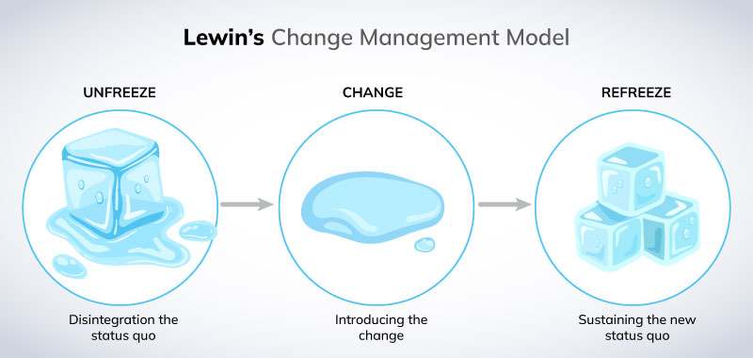
Figure 5: Lewin’s change management model
(Source: Miller, 2022a)
- Changing
This stage would involve the implementation of the actual training program alongside the facilitation of garnering new insights, skills, and attitudes. This stage revolves around Indian playing the workforce to embrace and understand the change and engage actively in the process of learning (Miller, 2022a). In order to address the issue, it is necessary for the company to develop tailored training programs that not only would address the issues regarding operations and catering but should be moulded by considering diverse styles of learning. Whether through online programs, workshops, simulated situations, or mentorship programs, it is important for Travelodge to deploy various types of learning in order to promote engagement and make the programs a success (Miller, 2022a).
Alongside this, it has also become a necessity for the company to encourage active participation so that the overall performance of Travelodge is enhanced. This could be done by carrying out group activities, interactive sessions, and simulated incidents, which if expected to enhance the application and retention of knowledge by the participants.
In order to comprehend the success of the program, there are several metrics that the management of the company can utilise to understand their Return on Investment. With the help of Key Performance Indicators or KPIs such as occupancy rates, guest satisfaction scores, and employee productivity, the company could track the success of the program (Bedford, 2022). Alongside this, employee engagement is an aspect that is to be noticed by the company. It would involve tracking employee motivation and morale, and satisfaction of the job, which, in turn is a major factor pertaining to the overall performance enhancement of Travelodge.
- Refreezing
In the last stage of Lewin’s change management model, the focus will be shifted towards the stabilisation of the change and incorporating it in the organisational operations and culture. This phase is about the reinforcement of new attitudes and operational adjustments that would be considered as the new norm moving forward. With the help of proper reward and recognition programs, the company should be celebrating achievements and milestones, which would be acknowledging of the improvement in operations by the company’s workforce (Ali, 2023). Training outcomes should also be instilled in the organisational operations and systems to make sure that the reputation of Travelodge is not jeopardised. This might involve updating procedures and policies, alongside the alteration of criteria of performance evaluation to reflect the effect of the newly acquired competencies and skills of the workforce.
As of 2022, the revenue of Travelodge was reported to be approximately $222 Million in the 3rd quarter of the financial quarter of 2022-23 (Ali, 2023). In regards to the facilitation of appropriate training programs, 10% of this revenue can be utilised by the company to hire suitable experienced trainers for its branches in the UK. 5% of the revenue can be utilised to rent suitable space of training alongside the purchasing and distribution of appropriate equipment. Alongside this, 10% of the revenue can be disbursed for handouts, training materials, and tools. 15% of this revenue can be compensated for the time of employees who partake in these programs. Lastly, in order to invest in appropriate software and online learning platforms, 5% of the total amount generated in the financial year of 2022-23 could be utilised.
- Implementing effective staff hiring and retention strategies
With the help of Kotter’s change management model, Travelodge can address issues pertaining to stuffing with the incorporation of a structured approach:
a. Establishing a sense of urgency
It is necessary for the company to highlight the consequences of reduced staffing on the aspects of operation and guest satisfaction. It is important for the company to present data on decreased productivity, increased guest complaints, and increased turnover costs to make sure that a sense of urgency is created among the stakeholders (Ulfa, 2021).
b. Developing a guided coalition
In order to lead the change efforts, it is important for the management of Travelodge to formulate a coalition of the primary stakeholders comprising of department heads, upper management, frontline employees, and the organisation’s HR. The coalition developed with these stakeholders should possess appropriate expertise and showcase required authoritative power to address the issues of stuffing effectively.
- Develop a suitable vision and strategy
it is important for Travelodge to come up with a strategy and vision to improve staffing practices. This might comprise of initiatives that not only focus on the aspect of increased recruitment, but also significantly consider the quality of talent, alongside the provision of quality training and developmental opportunities. The management should also make sure that employee retention becomes the key aspect in the overall HR strategy of Travelodge (Bedford, Speklé and Widener, 2022).
- Relaying the vision
With the help of multiple channels such as via emails, hosting bi-weekly meetings, and organising training sessions, the vision and strategy of the management are to be communicated to the workforce. It should be done to make sure that everyone understands that the company is experiencing staffing issues, and how the workforce could help the company overcome this situation.

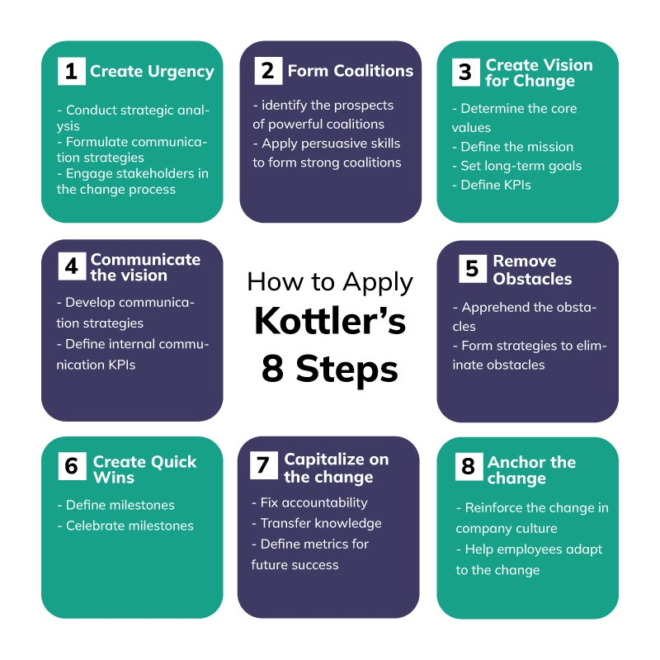
Figure 6: Application of Kottler’s Change Management Model
(Source: Miller, 2022b)
- Taking empowering actions
It is necessary for the upper management to empower employees for carrying out the desired action regarding employee recruitment with the utilisation of appropriate resources, in addition to asking the experienced frontline workers to assist the management in this regard (Ulfa, 2021).
- Producing short-term wins
It is important for Travelodge to celebrate the immediate improvements regarding the hiring of experienced staffs, which would result in minimised turnover rates, increased employee morale, and increased effectiveness in the process of recruitment (Bedford, Speklé and Widener, 2022).
- Consolidating gains
It is important for the management to integrate the changes into the culture and procedures of Travelodge. In order to reflect the new staffing practices to ensure organisational sustainability in the long-run, the procedures and policies should be updated.
- Capitalising on the change
In order to utilise the impact of increasing experienced staffs in the workforce, the company should immediately deploy them in the areas where most customer grievances have been observed, such as catering and room-servicing, because of which the organisational reputation is being currently jeopardised (Beldona, 2023). It would also address the annual turnover of the company from a long-term perspective if the image of Travelodge is restored.
One of the major metrics that the company can utilise to observe employee retention and recruitment is employee turnover rate, where the company can keep records of the percentage of staffs who leave Travelodge within a particular time-period. Higher rates of turnover would imply that the company’s workforce is disgruntled because of underlying issues of staffing or the company had continued the implementation of poor recruitment standards and practices (Ulfa, 2021). Alongside this, Travelodge can utilise feedback mechanisms or surveys to evaluate the levels of employee satisfaction. Lower scores might imply disgruntlement, and dissatisfaction regarding compensation and/or working conditions.
Approximately, 15% of the organisational revenue should be invested in recruitment costs by Travelodge, which would involve advertisements regarding job-vacancies, carrying out interviews and organise background checks to hire and attract qualified staffs. A major chunk of the organisational revenue (30%) should be utilised for addressing expenses such as providing competitive salaries, healthcare benefits, and bonuses, coupled with staffing technology to optimise Travelodge’s recruitment system.

Action plan

Number | Problem | Solution | Desire outcomes | Time Scale | Completion date | Planned budgets ($)
1 | Financial Problem | The company needs to implement cost control measures to reduce wastage and optimise energy uses. The analysis also focuses on the revenue management to connect with dynamic pricing and maximise revenue from existing resources. | This will help to reduce operating expenses and lead to improved profitability. This makes good revenue per available room and higher overall revenue. It will improve operational efficiency to better guest experiences and reduce labour costs (Gupta, 2021). | 2 months | 6 July, 2024 | 10000
2 | Staff Crisis | The company needs to offer competitive wages which benefits in transportation assistance can make hospitality positions more attractive. The flexible work arrangement provided opportunities to the employees to focus on the diverse needs and preferences in the company. | This improves employee satisfaction and reduces turnover rates and increases loyalty. The approach of flexible work arrangement enhances work-life balance to generate higher job satisfaction and better retention rates. This improves employee engagement and increases productivity in the workforce (Bedford, Speklé and Widener, 2022). | 1 months | 8 June, 2024 | 5000
3 | Threat of rival company | The company needs to focus on the unique selling points which build market differentiation to innovate amenities and specialised experiences. This also gathers customer data and personalised services for allowing strong relationship with guests. | This will build good brand loyalty and focus on the competitive advantages to generate customer satisfaction. The process makes higher repeat bookings and focuses on the positive word-of-mouth referrals. This also attracts new customers and in cares high market share and staying ahead of competitors (Bedford, 2022). | 3 months | 10 August, 2024 | 15000
 | Quality and comforts | The company needs to focus on implementing comprehensive quality assurance programs to establish services and staff training processes. This will provide ongoing training and development opportunities for staff to enhance their skills in customer service. | The process of consistent delivery makes a higher-quality experience which leaves a positive review. This also improves service quality and interactions to the culture of excellence among employees (Bedford, 2022). | 2 months | 9 July, 2024 | 20000

Conclusion
The overall analysis helps to focus training staff and their safety for the workplace in the Travelodge Company. This analysis mainly focuses on the foundational concept of the company which makes effective understanding is related to the issues of the company. As per the research analysis this also focuses on the factors of specific recommendation which will help to improve external factors of the research. The approach of the analysis needs a good foundational concept about business operations to focus on the training and employee management in the company. This will help to focus on the opportunities for the business foundation.
The analysis of SWOT, PESTLE and TOWS analysis makes good help to docs on the evaluation process and build effective nature to construct proper understanding related to the coursework. The approach makes good help for developing opportunities to enhance desired outcomes and generate proper knowledge about the business operations. It brings good brand credibility and favourable location relaxation which are considered as the strengths of the business. It will focus on the integrated action of the business in the hospitality industry. Staff and stakeholders implemented restructuring procedures to enable a seamless transition and reduce opposition to the guidelines.
The recommendation of the analysis makes proper desired outcomes to focus on the business growth in future. This also helps to understand the desired output of business operations to connect with the future perspective of business in the Travelodge Company. The hotel will implement a process-driven transformation to gain expertise in change management. Implementing a strategy for action may help firm address problems, capitalise on opportunities, and achieve goals, including employee training before the end of the year and these factors help the company to focus on problem solving.
The action plan makes a good establishment to focus on the strategy proposed to the company growth. The process of the action plan brings a good foundation to focus on the aspects of training and management to issues resolved. This also brings good understanding to access proper analysis of the research to connect with company financial growth

Reference List
Ali, B. (2023). IJEBM | Hotel Service Quality: The Impact of Service Quality on Customer Satisfaction in Hospitality. [online] aipublications.com. Available at: https://aipublications.com/ijebm/detail/hotel-service-quality-the-impact-of-service-quality-on-customer-satisfaction-in-hospitality/. [Accessed 11 May 2024].
Asmoro, A.Y. (2021). (PDF) PESTLE Analysis In the Hospitality & Tourism Industry. [online] ResearchGate. Available at: https://www.researchgate.net/publication/349139288_PESTLE_Analysis_In_the_Hospitality_Tourism_Industry. [Accessed 11 May 2024].
Bedford (2022). Budgeting and employee stress in times of crisis: Evidence from the Covid-19 pandemic. [online] Available at: https://www.researchgate.net/publication/358370672_Competitive_Strategies_in_The_Lodging_Service_Sector_Five_Porter_Analyses_And_Case_Study_SWOT_Analysis. [Accessed 11 May 2024].
Bedford, D.S., Speklé, R.F. and Widener, S.K. (2022). Budgeting and employee stress in times of crisis: Evidence from the Covid-19 pandemic. Accounting, Organizations and Society, 101, p.101346. DOI: https://doi.org/10.1016/j.aos.2022.101346.
Beldona, S. (2023). Evaluating hotel guest technologies: does home matter? [online] Available at: https://www.emerald.com/insight/content/doi/10.1108/IJCHM-03-2017-0148/full/pdf. [Accessed 11 May 2024].
Berry, C. (2022). MASTERS FINAL WORK PROJECT EQUITY RESEARCH: WHITBREAD PLC. [online] Available at: https://www.repository.utl.pt/bitstream/10400.5/27132/1/DM-CTPB-2022.pdf. [Accessed 11 May 2024].
Chen, H. (2023). An environmental performance assessment of the hotel industry using an ecological footprint. [online] Available at: https://www.researchgate.net/publication/228426260_An_environmental_performance_assessment_of_the_hotel_industry_using_an_ecological_footprint. [Accessed 11 May 2024].

Depierraz (2023). Training is the Answer to High Turnover Rates in Hospitality. [online] hospitalityinsights.ehl.edu. Available at: https://hospitalityinsights.ehl.edu/training-high-turnover-rates-hospitality. [Accessed 11 May 2024].
EHL Insights (2023). Hospitality Industry: All Your Questions Answered. [online] hospitalityinsights.ehl.edu. Available at: https://hospitalityinsights.ehl.edu/hospitality-industry. [Accessed 11 May 2024].
El-Gohary, H., (2020). Coronavirus and halal tourism and hospitality industry: Is it a journey to the unknown?. Sustainability, 12(21), p.9260. Available at: https://www.mdpi.com/2071-1050/12/21/9260
Gupta, K. (2021). Financial challenges in the Indian hospitality industry. [online] Available at: https://www.researchgate.net/publication/241828934_Financial_challenges_in_the_Indian_hospitality_industry. [Accessed 11 May 2024].
Hartwell, H. (2021). Environmental Management in the Hospitality Industry. A Guide for Students and Managers. [online] Available at: https://www.researchgate.net/publication/249449498_Environmental_Management_in_the_Hospitality_Industry_A_Guide_for_Students_and_Managers. [Accessed 11 May 2024].
Hasan (2022). Market Analysis to Discover New Restaurant Business Opportunities in Imatra Region. core.ac.uk. [online] Available at: https://core.ac.uk/reader/38124140. [Accessed 11 May 2024].
Hossin (2023). (PDF) A comparative analysis of internal and external environments. [online] ResearchGate. Available at: https://www.researchgate.net/publication/312320719_A_comparative_analysis_of_internal_and_external_environments_between_Hotel_Hyatt_UK_and_Hotel_The_Cox_Today_Bangladesh. [Accessed 11 May 2024].
Johnson-Woods, C. (2023, March 16). What is the ADKAR Model of Change Management. Resonance Global. Available at: https://www.resonanceglobal.com/blog/what-is-the-adkar-model-of-change-management
Jones, K., Mosca, L., Whyte, J., Davies, A. and Glass, J., (2022). Addressing specialization and fragmentation: product platform development in construction consultancy firms. Construction management and economics, 40(11-12), pp.918-933. https://www.tandfonline.com/doi/pdf/10.1080/01446193.2021.1983187
Koranne, S. (2023). Study of Service Quality Management in Hotel Industry. [online] Available at: https://www.researchgate.net/publication/347946243_Study_of_Service_Quality_Management_in_Hotel_Industry. [Accessed 11 May 2024].
Limna, P., (2023). Artificial Intelligence (AI) in the hospitality industry: A review article. International Journal of Computing Sciences Research, 7, pp.1306-1317. https://stepacademic.net/ijcsr/article/download/337/136
Malgapo (2023). SWOT Analysis of Hospitality Management and Tourism Services: A Basis for Tourism Development Road Map. [online] Available at: https://www.ijerm.com/download_data/IJERM0801001.pdf. [Accessed 11 May 2024].
Mathew (2023a). Detailed PESTEL Analysis of Hotel Industry | EdrawMax Online. [online] Edrawsoft. Available at: https://www.edrawmax.com/article/hotel-industry-pestel-analysis.html. [Accessed 11 May 2024].
Mathew (2023b). Hospitality Laws BHM-504T. [online] Available at: https://www.uou.ac.in/sites/default/files/slm/BHM-504T.pdf. [Accessed 11 May 2024].
Mathew (2023c). How the Lack of Training Affects Your Organization. [online] www.linkedin.com. Available at: https://www.linkedin.com/pulse/how-lack-training-affects-your-organization-talent-point-inc-riqbc [Accessed 11 May 2024].
Miller, K. (2022) Description and application of Lewin’s Change Management Model, Crowjack. Available at: https://crowjack.com/blog/strategy/change-management-models/lewins-model (Accessed: 11 May 2024).
Miller, K. (2022b) Detailed description of Kotter’s Change Management Model, Crowjack. Available at: https://crowjack.com/blog/strategy/change-management-models/kotters-model (Accessed: 11 May 2024).
Peng, J., Li, M., Wang, Z. and Lin, Y., (2021). Transformational leadership and employees’ reactions to organizational change: evidence from a meta-analysis. The Journal of applied behavioral science, 57(3), pp.369-397. https://www.researchgate.net/profile/Jian-Peng-5/publication/341413982_Transformational_Leadership_and_Employees'_Reactions_to_Organizational_Change_Evidence_From_a_Meta-Analysis/links/615b1f494a82eb7cb5ff3adf/Transformational-Leadership-and-Employees-Reactions-to-Organizational-Change-Evidence-From-a-Meta-Analysis.pdf
Polizzotto , G. ed., (2022). Time to say goodbye: Brexit, employment and the hospitality sector | Birkbeck Perspectives. [online] Available at: http://blogs.bbk.ac.uk/bbkcomments/2021/02/01/time-to-say-goodbye-brexit-employment-and-the-hospitality-sector/. [Accessed 11 May 2024].
Purnomo Wibowo, R., Sadalia, I., Syahfitri, I. and Erisma, N. (2023). The Analysis and SWOT Strategic Development of Tourism Sector in Samosir Regency. [online] Available at: https://www.atlantis-press.com/article/125967916.pdf. [Accessed 11 May 2024].
Raju (2020). Performance Evaluation Techniques in Hospitality & Tourism Industry. [online] Available at: https://www.researchgate.net/publication/371538629_Performance_Evaluation_Techniques_in_Hospitality_Tourism_Industry. [Accessed 11 May 2024].
Richard (2021). 10 tips to suceess in hotel Management. [online] Top Hotel Management College in Hyderabad | Regency College. Available at: https://rchmct.org/the-10-most-important-strengths-for-success-in-the-hospitality-industry/. [Accessed 11 May 2024].
Sebastian, V. (2023). A Swot Analysis Of The Global Hospitality Industry. Revista Economica, [online] 69(6), pp.105–119. Available at: https://ideas.repec.org/a/blg/reveco/v69y2017i6p105-119.html. [Accessed 11 May 2024].
Shabani, N. (2023). Technology in the Hospitality Industry: Prospects and Challenges. [online] ResearchGate. Available at: https://www.researchgate.net/publication/332789931_Technology_in_the_Hospitality_Industry_Prospects_and_Challenges. [Accessed 11 May 2024].
Suri, M. and Narendra Kumar, M. (2022). Tourism and Hospitality Industry Sustainability in Competition In India (Strategic Study of Tiger Tourism). Amity Research Journal of Tourism, Aviation and Hospitality, [online] 01. Available at: https://amity.edu/arjtah/pdf/MonikaSuri_NarendraKumar.pdf. [Accessed 11 May 2024].
Taylor, P. (2024). Digital Economy in the UK. Available at: https://www.statista.com/topics/7208/digital-economy-in-the-uk/
Travelodge. (2024). Company Overview. Available at: https://www.travelodge.co.uk/our-business/about-us/company-overview/
Travelodge. (2024). Upgraded customer experience drives record year. Available at: https://www.travelodge.co.uk/press-centre/press-releases/Upgraded-customer-experience-drives-record-year
Ulfa (2021). Analysis of The Factors that Affect Employee Turnover Intention at Travelodge Hotel Batam. [online] Available at: https://www.researchgate.net/publication/357584140_Analysis_of_The_Factors_that_Affect_Employee_Turnover_Intention_at_Travelodge_Hotel_Batam. [Accessed 11 May 2024].
Valentini and Woods, R. (2022). Identifying Training Challenges in Hospitality Industry: An Exploratory Approach. Hospitality Review, [online] 29. Available at: https://digitalcommons.fiu.edu/cgi/viewcontent.cgi?article=1500&context=hospitalityreview. [Accessed 11 May 2024].
Verawati, D., Yudhanto, W., Giovanni, A., Ikhwan, K. and Hartono, B., 2023. Strategic Leadership Model in the Hospitality Industry: SWOT Analysis. JurnalIlmiahManajemenKesatuan, 11(2), pp.477-486. https://jurnal.ibik.ac.id/index.php/jimkes/article/download/2117/1336

