

Learning Journal Guidance
- Student teachers and Class / Subject Mentors are expected to complete the Journal after each taught session, including informal comments, reflections and queries
- Wider reflections (over and above reflecting on taught lessons) can be recorded daily (as appropriate) and may include; conversations with parents/carers, observations of other members of staff, interactions with colleagues/peers, reflections on wider reading, personal targets, planning considerations etc.
- The Learning Journal must be available to Class / Subject Mentors and other staff members at all times – but not accessible to the pupils in class
- As the Journal is a professional document, although not ‘formal’, student teachers and Class / Subject Mentors need to ensure that the language used is appropriate and that staff and children are not named
- The Journal should act as a two way document in which the Class / Subject Mentor and student teacher engage in reflective and purposeful dialogue
- Student teachers should use the Journal as an opportunity to note any reflective conversations with mentors/other staff
- Mentors may add comments/suggestions whilst the student teacher is teaching. Student teachers are expected to engage with these and check understanding if they are not sure
- Queries/questions that student teachers may want to ask their mentor relating to their professional progress may be recorded in the Journal
- Reflections should focus on children’s progress, as well as standards of teaching
- The Learning Journal is NOT a ‘To Do List’ – if student teachers or mentors need to make lists, this is to be done elsewhere
- The Learning Journal will be periodically inspected by University tutors, Network Leads and Senior Mentors
- The contents of the Learning Journal should be discussed during the Weekly Reflection Meeting
Reflection Questions and Prompts to support Reflections in the Learning Journal

Class/Senior Mentor reflective questioning | Student-teacher reflection prompts
How do you know that strategy was effective? | This was an effective strategy because…
What was the impact on the children’s learning and how do you know? | This impacted upon children’s learning because…
What was the impact? | The impact has been…
Now that you have done… what have you realised? | Looking back now I realise…
What do you need to do next to inform your practice? | To inform my practice I will…
What will you aim to do next? | On reflection I will aim to…
What have you been able to do because of this? | Consequently, I was able to…
What have you previously identified in your practice or the pupils learning that has benefited your practice? | Having previously identified…
What did you find useful and why? | I found this useful because…
How has this enhanced your practice? | My practice has been enhanced because…
What will your next focus be? | My teaching practice will now focus on…
What has this impacted on and how do you know? | I believe this impacted upon… I know this because…
What will you do in the future/moving forward? | For future reference I will ensure…
Looking back what would you do differently? | In hindsight…
What have you discovered from doing this and how will it impact on your practice/pupils learning? | This has shown that… and a consequence…
How could this have been more effective? | On reflection it would have been more effective if…
How will what you have learnt/read/observed inform your practice? | This knowledge will be applied through my practice by…
What do you now know from …? | This has helped me to see…
How do you know this was not effective and how do you plan to amend/change/develop this? | I know this was not effective because… in the future I intend to develop this by…

Some student teachers and Class / Subject Mentors have made use of a key to illustrate who is writing, what (as below):
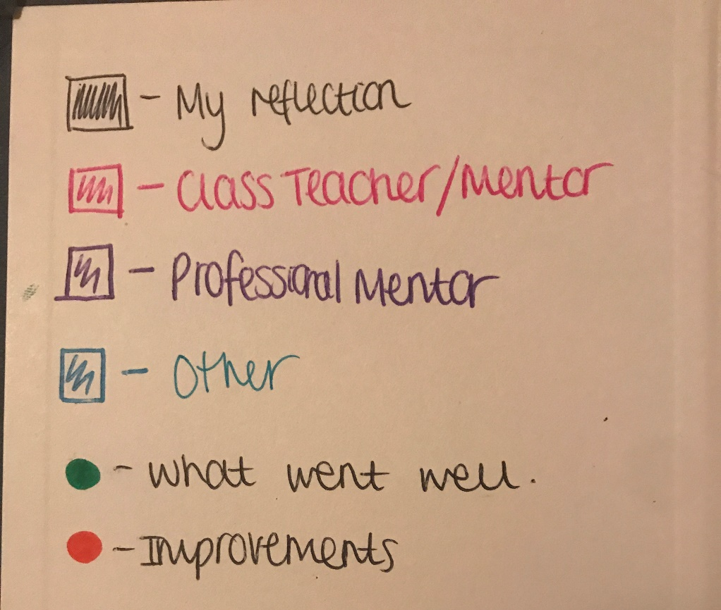

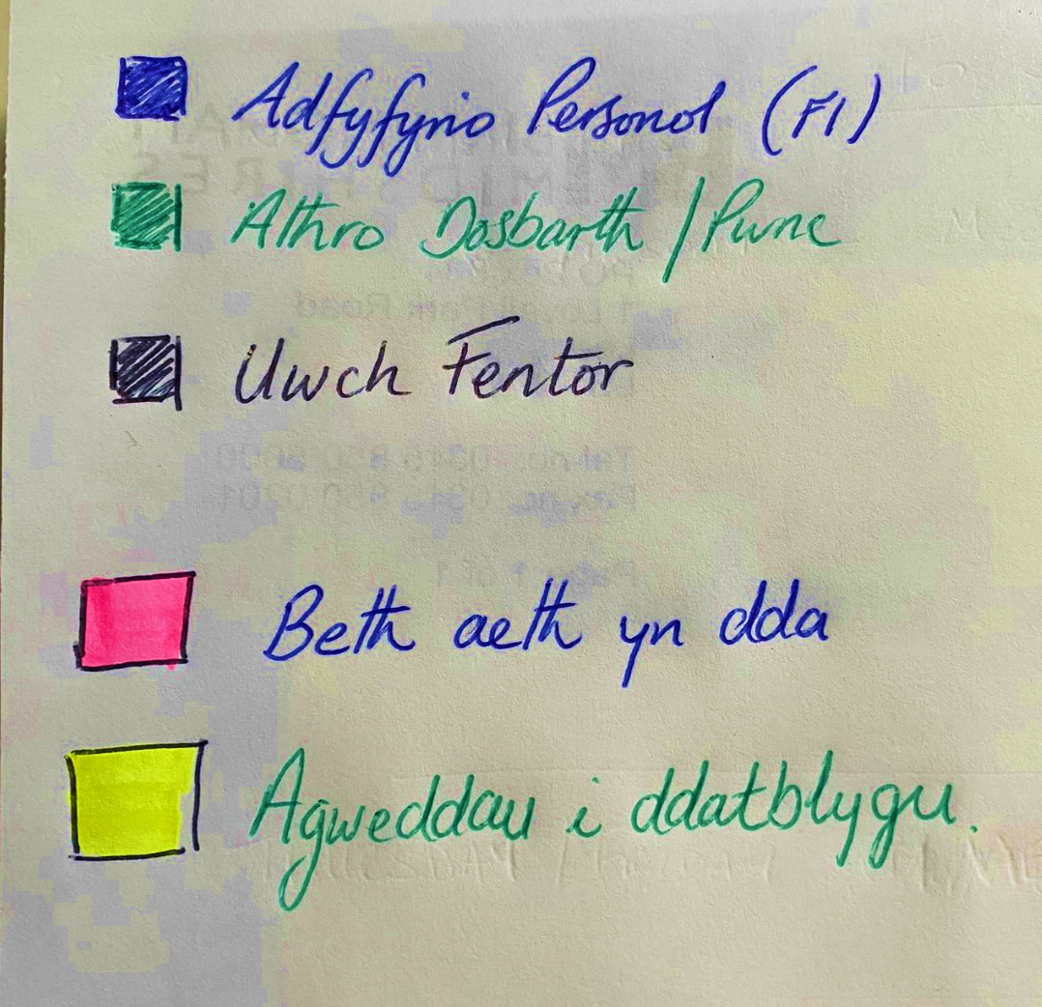

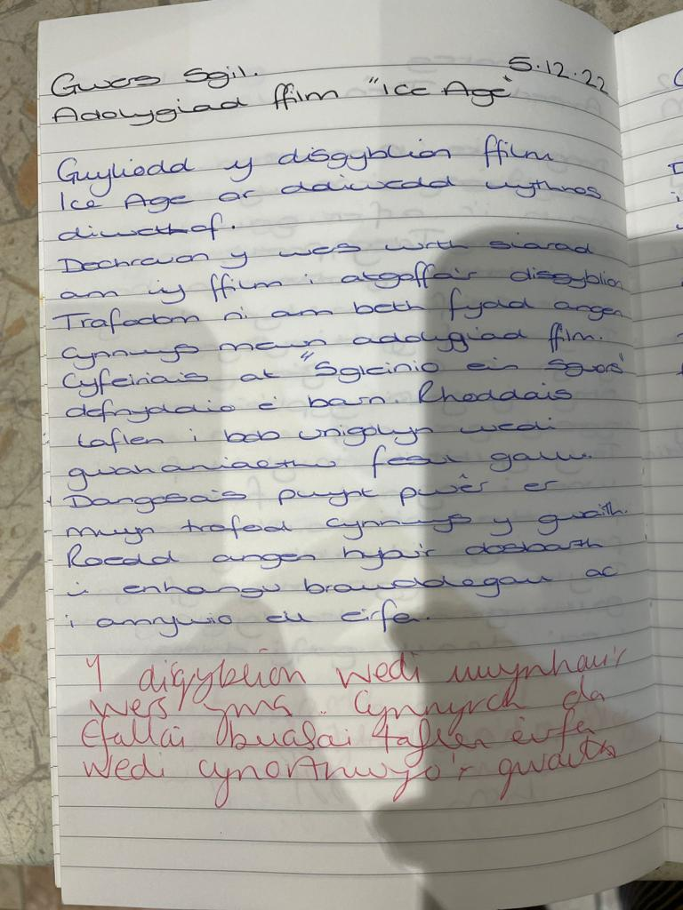
Please see the below examples taken from Learning Journals which have been used to good effect, previously:
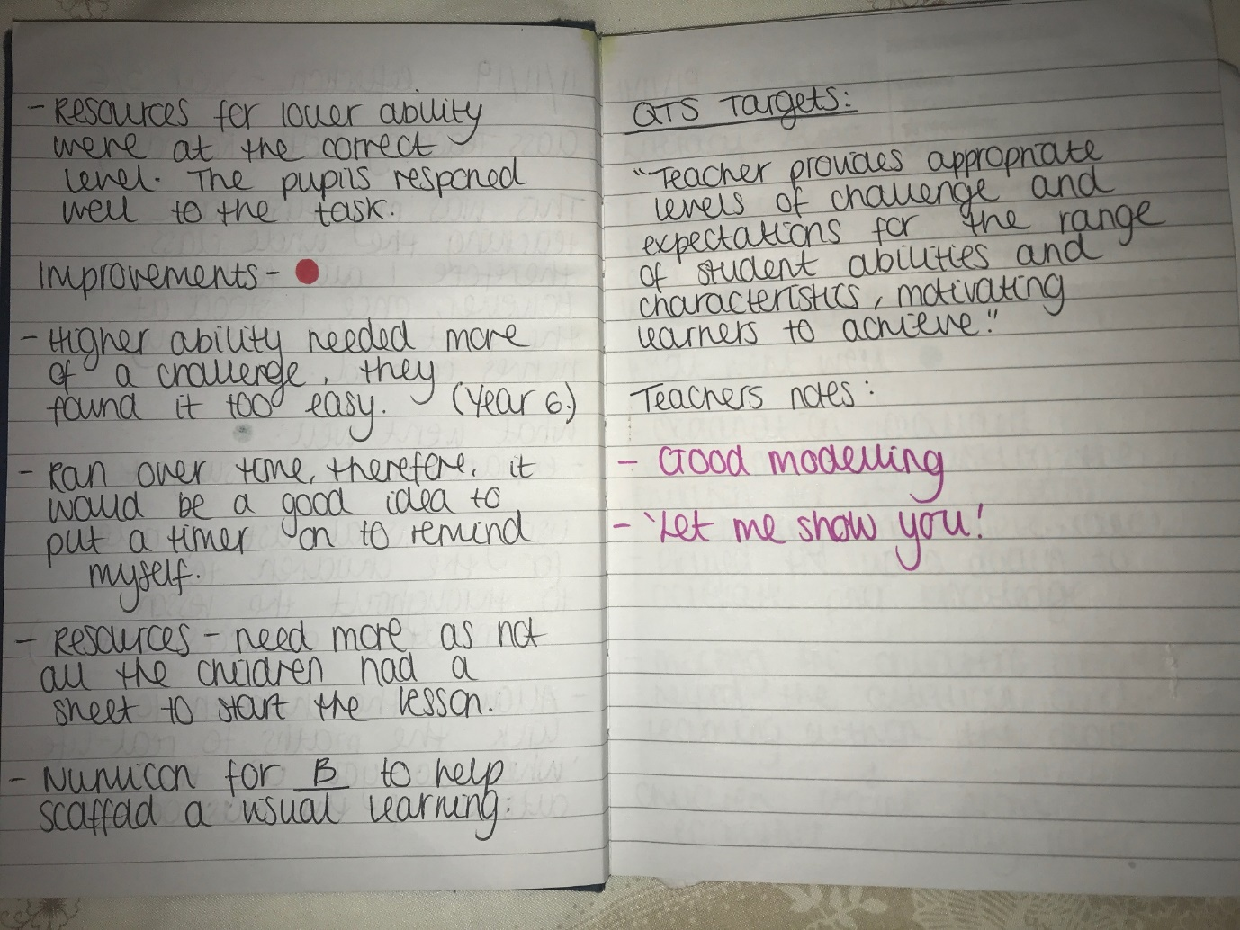
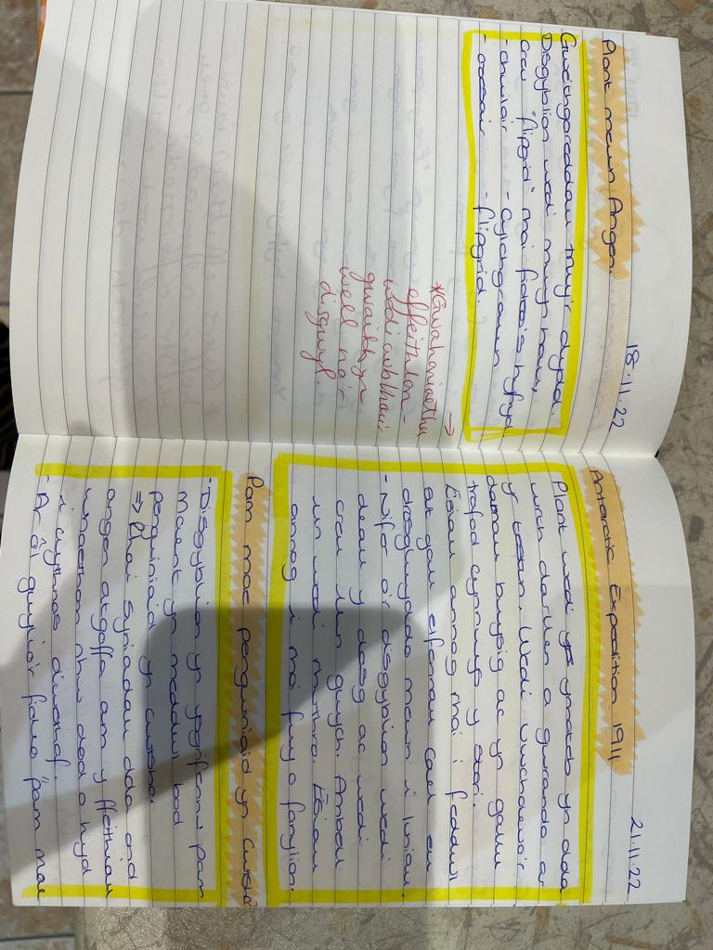
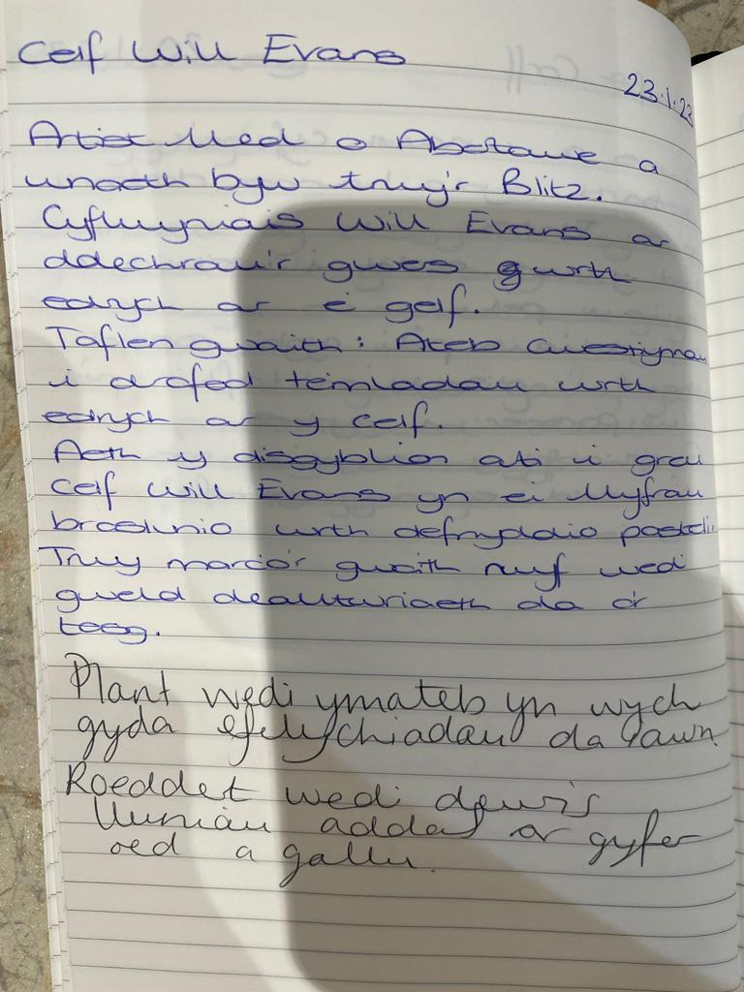

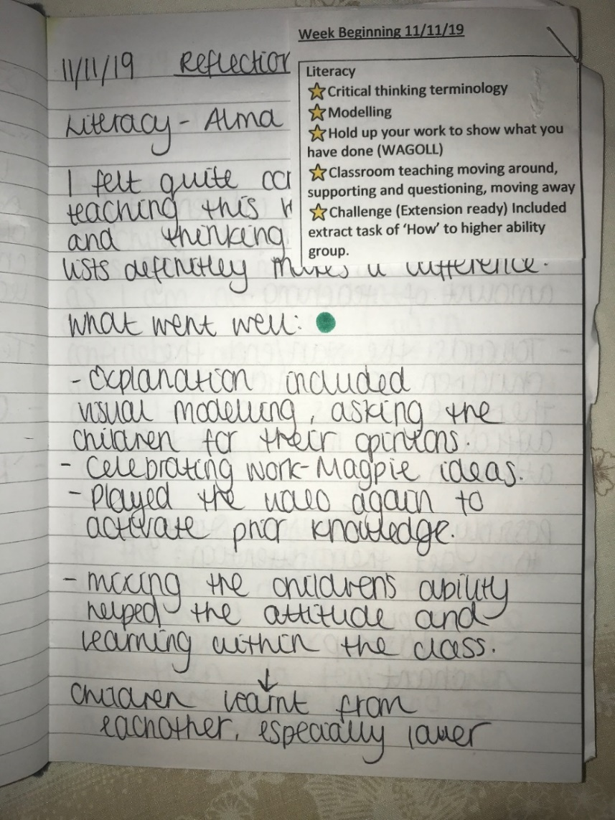

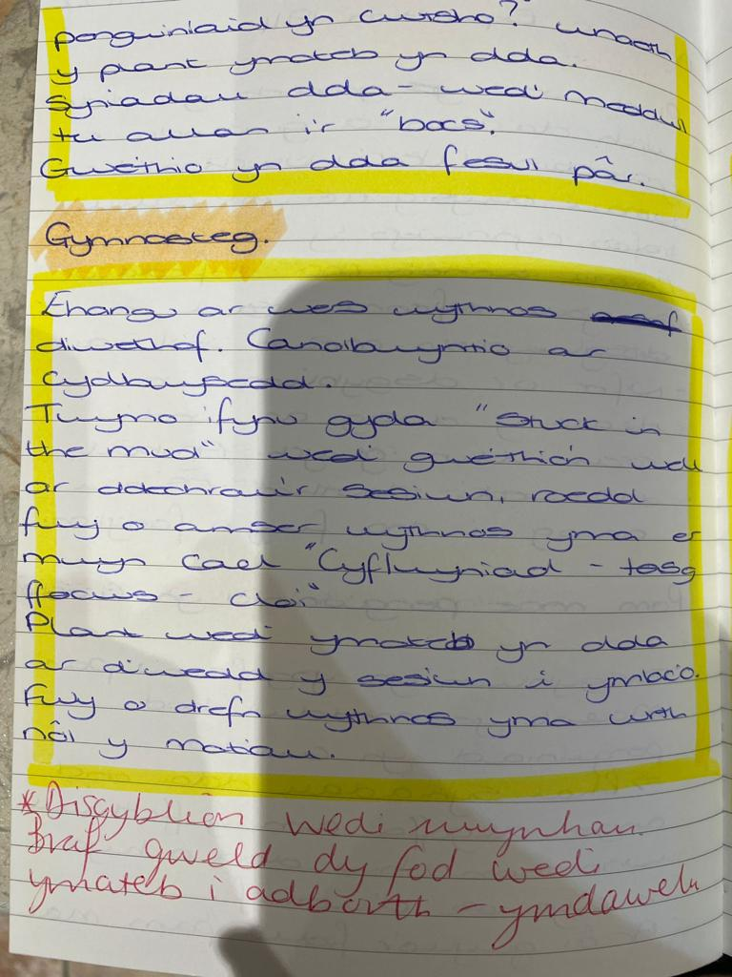
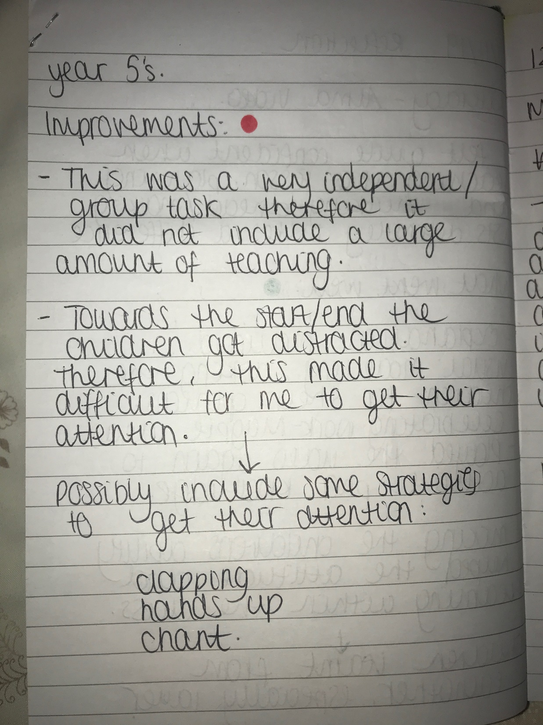
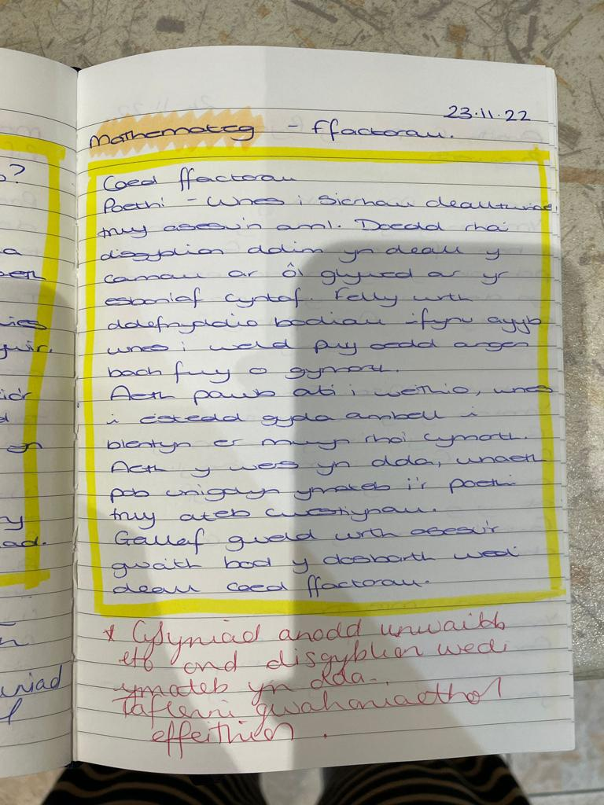

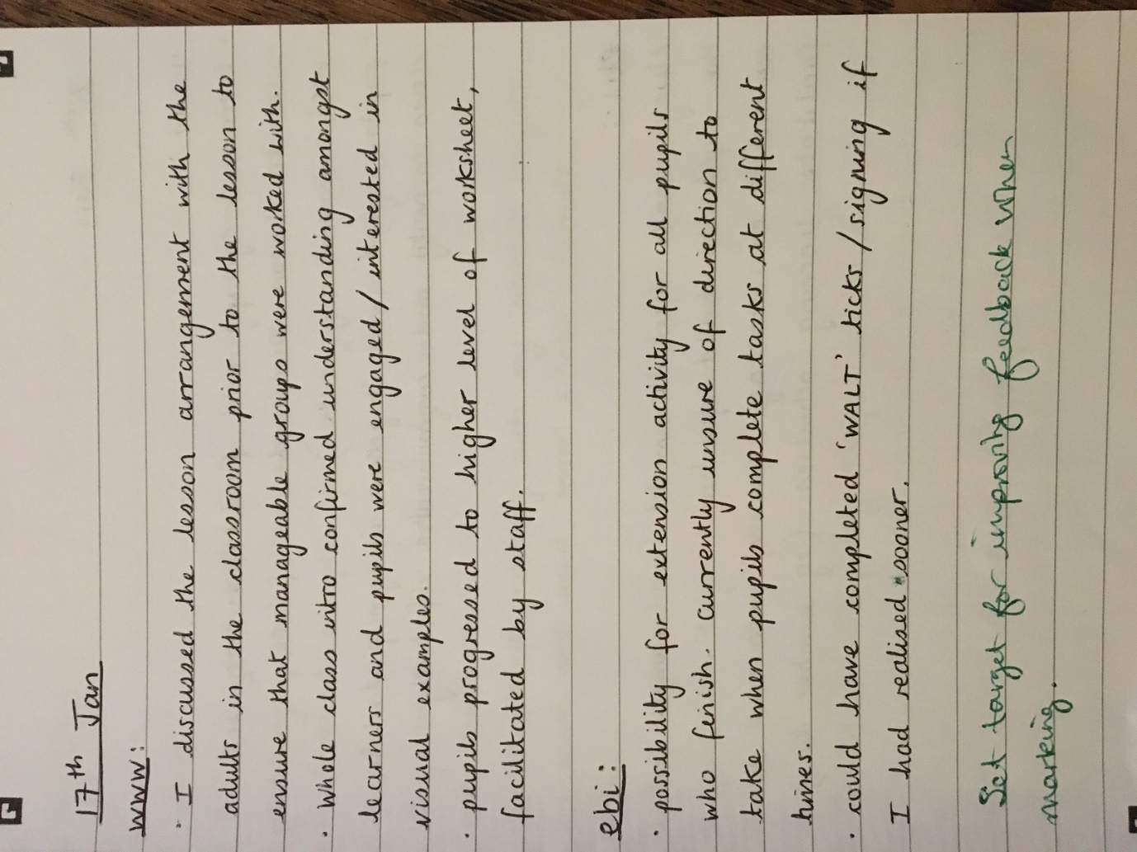
Please note that the class mentor has written in green in this example
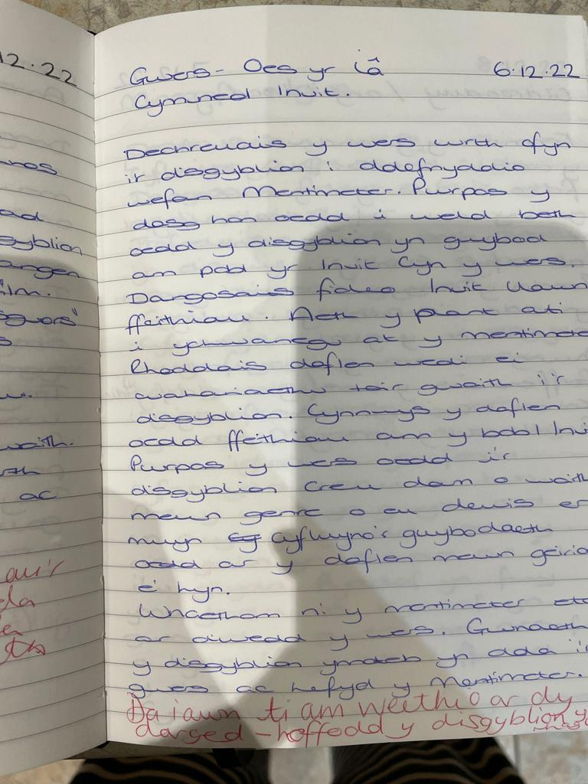
Please note that the class mentor has written in red in this example

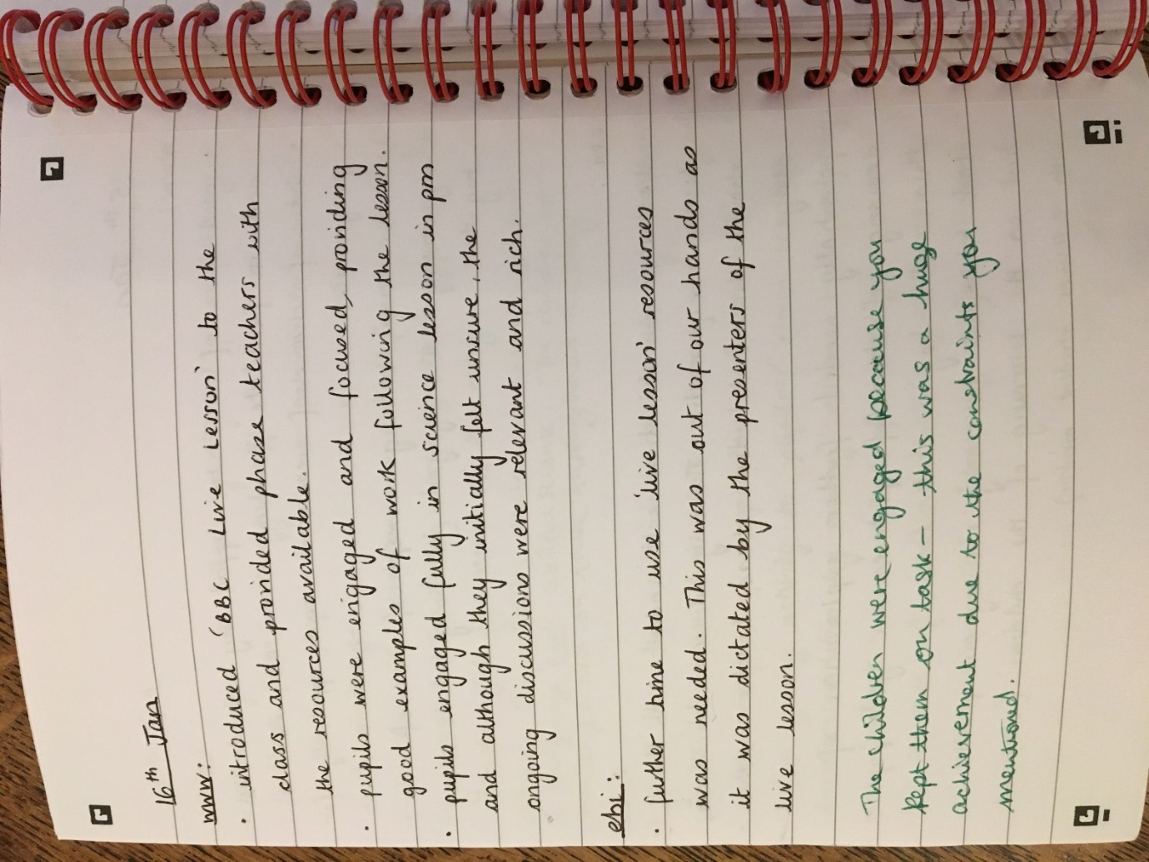
Please note that the class mentor has written in green in this example

