Destination Management: Solimar International, United Kingdom

Contents
Introduction 2
Tourism destination of Solimar International, United Kingdom 2
Solimar International's sustainable tourism guiding principles (in view of economic, socio-cultural, and environmental) 2
To ascertain the stages Solimar International has gone through or is presently in, Butler's life cycle model and Doxey's Irridex model were used 4
Future development of destination management of Solimar International 7
Conclusion 7
Reference 8

Introduction
UK-based Solimar International A great destination for tourists is one with great management and sustainable goals. They do maintain a set of organized rules and laws here. In addition, the economic, sociocultural, and environmental pillars of sustainability help them go far. Again, good facts about stages in that hotel may be given in Butler's life cycle model and Doxey's Irridex model. (Solimar International, n.d.)

Tourism destination of Solimar International, United Kingdom
The act of guiding all facets of a destination, such as its attractions, amenities, accessibility, marketing, and price, is called as destination management. For better management of a destination, Solimar helps destinations in rationally merging these occasionally extremely disjointed elements.
It covers a range of subjects, including Measured Tourism Impacts.
Change is brought on by our tourism-related projects in a variety of different industries and development areas. Agriculture, construction, transportation, and the export sector are all benefited by a thriving tourism industry. (Zagere, Zagere and Zagere, n.d.)
The tourism information center is responsible for providing visitors with information about local attractions and services. Solimar has built these centers in popular tourist destinations, serving as a central hub for visitors to access local shops and services. The center has the authority to provide information and assist visitors in their travels. (Solimar International, n.d.)

Solimar International's sustainable tourism guiding principles (in view of economic, socio-cultural, and environmental)

Environmental
Global warming and climate change are having a significant impact on the tourism industry. As the environment continues to be affected by these issues, the tourism sector will continue to feel the effects. Agricultural connections, such as the increasing number of travelers visiting rural areas, are also being impacted by climate change. The cultural landscapes and rural lifestyles that attract many tourists may be altered by the effects of global warming. It is important for the tourism industry to be aware of these issues and take steps to mitigate their impact.
Social
The development of local artisanal crafts can greatly benefit both the culture and economy of a nation. Traditional crafts such as textiles and paintings can enhance the tourist experience and provide a unique glimpse into the local culture. By hiring and supporting local artisans who preserve cultural treasures, the informal sector of the economy can contribute to the growth of the GDP. This not only benefits the artisans and their families, but also the local economy and the tourism industry. (Solimar International, n.d.)
Effective planning is crucial for the success of any organization or destination. Solimar can work with key stakeholders to develop a strategic plan that outlines a common vision and the steps needed to achieve it. This process involves identifying goals and objectives, conducting market research, and creating a detailed plan of action. By implementing well-thought-out plans, Solimar can develop its tourism industry in a way that benefits the town, local businesses, and visitors. It is important to consider the long-term effects of these plans and strive to create sustainable tourism that does not harm the environment or the local community. Workforce development is essential for promoting sustainable tourism growth in developing countries. In these areas, tourism can provide the money and jobs needed to develop the local economy and tax base. However, many destinations lack the trained workforce necessary to provide the level of service needed to attract and retain visitors. Solimar can help by providing training and support for local workers to develop their skills and knowledge. This can include both theoretical and practical training, as well as opportunities for hands-on experience. By investing in the workforce, Solimar can help destinations reach their full potential and support sustainable tourism development.
Economic
Destination management involves overseeing all the elements that make up a tourism destination, including attractions, amenities, access, marketing, and pricing. Solimar can assist with this process by helping destinations link these often-fragmented entities in a strategic manner. This can help to protect the natural environment and celebrate the local culture while also making the destination economically viable. By effectively managing the destination, Solimar can help to ensure that it is successful and sustainable in the long term.
Marketing is an essential part of the tourism industry, as it helps to inspire travelers and encourage them to visit a particular destination. With the rapid growth of the tourism sector, there are many opportunities for businesses to attract visitors. However, many destinations fail to capitalize on these opportunities. Solimar can help by providing a comprehensive destination management and marketing system that combines the power of technology with expertise in green tourism. This can help destinations to effectively market themselves and attract tourists, while also ensuring that their activities are sustainable and have a positive impact on the local environment. (encyclopedia.pub, n.d.)

To ascertain the stages Solimar International has gone through or is presently in, Butler's life cycle model and Doxey's Irridex model were used

Solimar International follows the Tourism Area Life Cycle (TALC) model, also known as Butler's Destination Management Life Cycle model. This model, developed by Professor Richard Butler, is widely used in the tourism industry and is a key part of many travel and tourism management curricula. It provides a framework for understanding the different stages of tourism development in a destination and the factors that influence its growth and success. Solimar International uses this model as a guide to help destinations move through the different stages of the TALC and achieve sustainable, successful tourism development. (Stainton, 2020)
In the engagement stage of the Tourism Area Life Cycle (TALC), destinations begin to focus on the potential benefits of tourism and how they can capitalize on them. This may involve developing infrastructure and services to support the growing tourism industry, such as guest houses, hospitals, airports, and transportation systems. Local governments and businesses may also start to think about how they can attract foreign investment to support tourism development. At this stage, tourism seasonality may also become more apparent, with certain times of the year seeing higher levels of visitor activity. Overall, the engagement stage marks the beginning of tourism development in a destination. (Ku.edu, 2015)

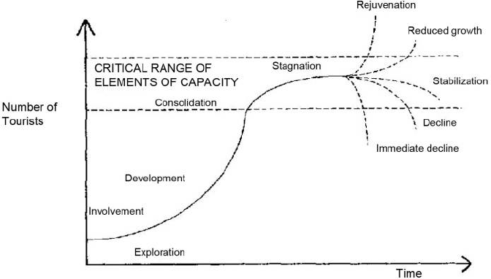

As a place develops and grows, it is natural for there to be changes in the way things are run and managed. In the case of tourism, this can involve the development of new infrastructure, such as highways, train stations, and airports, to accommodate the influx of visitors. Additionally, the growth of tourism in an area can led to the development of new attractions and accommodations to cater to the needs of tourists. (Barcelona Field Studies Centre, 2019)
During the consolidation phase of tourism development, there may be a deliberate effort to limit the number of tourists in an area or to make tourism-related goods and services more exclusive. This can be done for a variety of reasons, such as to prevent over-tourism or to maintain the quality of the tourist experience. (Google.com, 2014)
Locals' dissatisfaction may start to show at this stage. One of the negative effects of tourism on society is this. Thus, a decline in the tourism sector is only getting started. At this point, it's likely that tourist numbers peaked, and a lot of limits were reached. Simply, the area is no longer desirable. We can now see just how much harm tourism does. It's probable that society, the ecology, and the economy will all lose.
Finally, decline or revival A range of potential outcomes for the destinations along the spectrum between rejuvenation and decline are shown in Butler's tourism area life cycle model's final stage. The result of this will depend on the intents and actions of the affected parties in the aforesaid tourism development project. Major redevelopments can lead to complete rejuvenation. A change in the target market, the inclusion of new attractions, the adoption of sustainable tourism tactics, etc. With a few minor alterations and improvements to the total services and infrastructure for tourism, there may be a small rejuvenation.

Doxey's irridex destination management model for Solimar International
The model used is Doxey's Irridex model (1975), which exhibits a clear visual trend between levels of tourism growth and shifts in the host community's attitudes. The concept holds the main steps of tourism development are linked to various levels of stress in the local community. More specifically, levels of annoyance, which vary from exhilaration to antagonism, rely on the number of outsiders and the pressures they put on locals' living standards. (Akdu and Ödemiş, n.d.)
The Irridex model is a widely accepted model that describes the stages of resident attitudinal shifts in response to tourism growth. As per this model, residents typically go through a series of stages as tourism grows in their area, starting with initial acceptance and moving through phases of opposition, tolerance, and eventually acceptance again. However, the specific stages and their duration can vary depending on the destination and other factors, such as the local economy and culture.

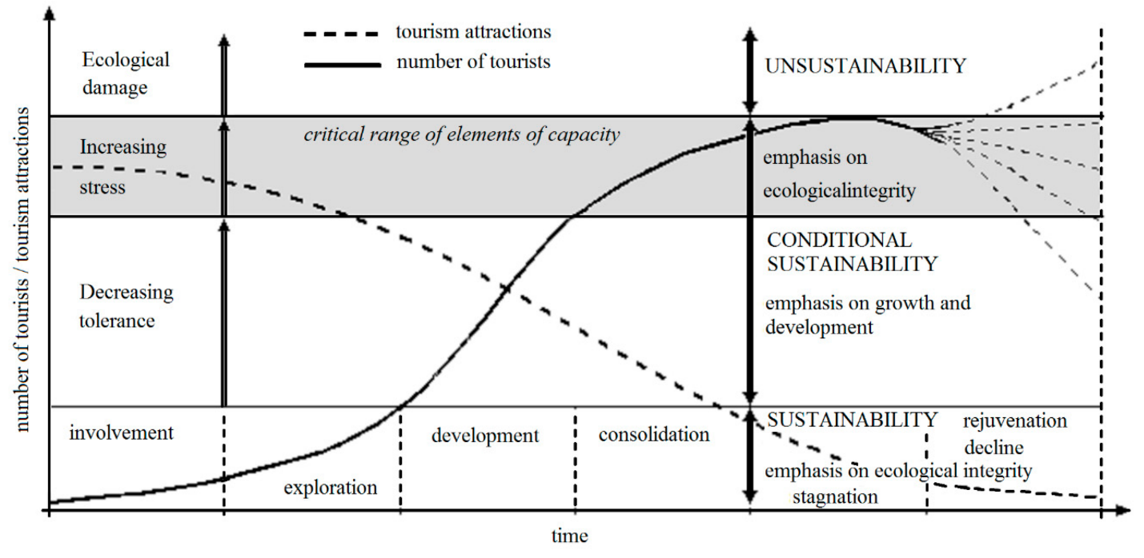

The strength of the euphoria during the initial stages of tourism growth can vary depending on the destination and the specific circumstances. In general, however, people are likely to be happy and excited about the growth of tourism in their area, as it can provide opportunities for locals and bring in money from visitors.
As the market grows, people may become more passive and begin to take tourists for granted. At this stage, interactions with visitors may become more formal and transactional, as locals may see tourists as a source of profit rather than as individual people.
As the industry continues to grow, there may come a point at which the number of tourists becomes overwhelming for the local population and infrastructure. At this stage, locals may begin to feel irritated and frustrated by the influx of visitors, leading to increased tension and potentially even conflict.
As tourism growth continues and the number of visitors becomes overwhelming, the level of disharmony between locals and tourists may increase. At this stage, locals may begin to express their frustration and anger openly, and may blame tourists for a variety of problems, such as rising taxes and the degradation of the local environment.
Eventually, people may come to the realization that the very things that initially drew tourists to their area are the same things that they valued and cherished. However, in their haste to capitalize on the growth of tourism, they may have neglected these things and allowed the local environment to change. As a result, they may recognize that their ecology will never fully recover and that they are now attracting a different type of visitor than they did in the past. Ultimately, the success of a destination in terms of tourism growth will depend on its ability to handle the influx of visitors and maintain a high level of quality and enjoyment for both locals and tourists.

Future development of destination management of Solimar International
Solimar International may need to complete various tasks and documents to manage and promote tourism in the area effectively. This can include completing a weekly career assessment sheet to track staff progress, developing materials for a DMO such as a marketing plan, creating a DMO Board Policy Document, developing a budget, researching visitor services laws, creating a branding strategy, and marketing plan, developing a visitor guide and website, implementing a voluntary contribution fee, developing a communications and content marketing strategy, and producing an annual DMO report. These tasks and documents can support Solimar International in effectively managing and promoting tourism in the area. (Oxfam Policy & Practice, n.d.)

Conclusion
Solimar International's success as a tourist destination can be evaluated by using Doxey's Irridex model and Butler's life cycle model. These models can help to determine the current stage of tourism development in the area, as well as identify any potential challenges or opportunities. By combining these two models, it is possible to gain a comprehensive view of the state of tourism in Solimar International and take steps to ensure that the destination remains safe and enjoyable for both locals and visitors. This can help to promote the continued success of tourism in the area and contribute to the overall economic and social well-being of the community.

Reference

Solimar International. (n.d.). Solimar International | Tourism Marketing & Sustainable Tourism Consulting. [online] Available at: https://www.solimarinternational.com/.
Zagere, E., Zagere, E. and Zagere, E. (n.d.). Emilija Zagere, Author at Solimar International. [online] Solimar International. Available at: https://www.solimarinternational.com/author/emilija/ [Accessed 28 Nov. 2022].
Solimar International. (n.d.). Marketing Strategies. [online] Available at: https://www.solimarinternational.com/what-we-do/strategic-planning/marketing-strategies/ [Accessed 28 Nov. 2022].
Solimar International. (n.d.). Artisan Development and Linkages. [online] Available at: https://www.solimarinternational.com/what-we-do/destination-management/artisan-development-and-linkages/ [Accessed 28 Nov. 2022].
encyclopedia.pub. (n.d.). Influence of Technologies on Sustainable Tourism. [online] Available at: https://encyclopedia.pub/entry/16440 [Accessed 12 Nov. 2022].
Stainton, H. (2020). Butler’s Tourism Area Life Cycle Model: A simple explanation. [online] Tourism Teacher. Available at: https://tourismteacher.com/butlers-tourism-area-life-cycle-model/.
Ku.edu. (2015). Chapter 26. Changing the Physical and Social Environment | Section 13. Enhancing the Built Environment through Design | Main Section | Community Toolbox. [online] Available at: https://ctb.ku.edu/en/table-of-contents/implement/physical-social-environment/neighborhood-design-and-zoning/main.
Barcelona Field Studies Centre (2019). Butler Model of Tourist Resort Development. [online] Geographyfieldwork.com. Available at: https://geographyfieldwork.com/ButlerModel.htm.
Google.com. (2014). Butler’s Tourism Area Life Cycle - 5 Star Tourism Consultancy. [online] Available at: https://sites.google.com/site/5startctl1088/blackpool/butler-s-tourism-area-life-cycle.
Akdu, U. and Ödemiş, M. (n.d.). Examining the Impacts of Tourism on Gumushane Residents According to the Doxey Index Examining the Impacts of Tourism on Gumushane Residents According to the Doxey Index. [online] Available at: https://dergipark.org.tr/tr/download/article-file/599129.
Oxfam Policy & Practice. (n.d.). Faith is Not Enough: Ensuring that aid donor-private sector partnerships contribute to sustainable development. [online] Available at: https://policy-practice.oxfam.org/resources/faith-is-not-enough-ensuring-that-aid-donor-private-sector-partnerships-contrib-620839/ [Accessed 28 Nov. 2022].
.

