Michele CHIARELLO
Student id: 1805745
MODULE TUTOR: terry walcott

ACCC5003
NETWORK OPERATING SYSTEMS AND SECURITY
assignment 1 - screenshots
April 18, 2020
Contents
TABLE OF FIGURES 1
NETWORK TOPOLOGY 3
SCREENSHOTS 4
WORKSHEET 1 5
WORKSHEET 2 6
WORKSHEET 3 10
WORKSHEET 4 19
WORKSHEET 5 25

TABLE OF FIGURES

Figure 1. Network Topology 3
Figure 2. IP addressing scheme 4
Figure 3. Domain Controller installed 5
Figure 4. Client computer creation 5
Figure 5. Client1 after the connection to the domain 6
Figure 6. Task 1 - Creating OU hierarchy 7
Figure 7. Task 2 - Defining Account Lockout time 7
Figure 8. Task 2 - Create user accounts 8
Figure 9. Task 2 - Create Department Managers accounts 8
Figure 10. Task 2 - How to manage individual accounts 9
Figure 11. Task 2 - Error message after account disabled 9
Figure 12. Task 3 - Create user groups 10
Figure 13. Task 3 - Create managers group 10
Figure 14. Task 1 - Creation of the shared folder and file 11
Figure 15. Task 1a (Share and NTFS Permissions) 12
Figure 16. Task 1b (Share and NTFS Permissions) 13
Figure 17. Task 1c (Share and NTFS Permissions) 14
Figure 18. Task 1d (Share and NTFS Permissions) 15
Figure 19. Task 1e (Share and NTFS Permissions) 16
Figure 20. Task 2a (Group Policy setup) 16
Figure 21. Task 2b (Group Policy setup) 17
Figure 22. Task 2c (Group Policy setup) 17
Figure 23. Task 2d (Group Policy setup) 18
Figure 24. Task 2e (Group Policy setup) 18
Figure 25. Task 2f (Group Policy setup) 19
Figure 26. Task 1 Part A - DHCP Service installation 20
Figure 27. Task 1 Part B - Client IP before DHCP 20
Figure 28. Task 1 Part B - Client IP after DHCP 21
Figure 29. Task 1 Part C1 21
Figure 30. Task 1 Part C2 22
Figure 31. Task 1 Part C3 22
Figure 32. Task 1 Part D – (DHCP Lease and scope) 23
Figure 33. Task 1 Part D – (DHCP Lease and scope) 23
Figure 34. Task 1 Part D – (DHCP Lease and scope) 24
Figure 35. Task 1 Part D – lease renew from client 24
Figure 36. Task 1 Part D after renewing 25
Figure 37. Task A - Server1 hostname 26
Figure 38. Task A - Server2 hostname 26
Figure 39. Task B - Server1 DNS installed 26
Figure 40. Task 2 - Record verification for the hosts on the network 27
Figure 41. Task 3 - IISS installation 27
Figure 42. Task 3 - Virtual directory creation and permissions 28
Figure 43. Task 3 – web page creation 28
Figure 44. Task 3 - Web server test from Server1 29

NETWORK TOPOLOGY

The scope of the following diagram and tables is to represent the network topology used for the achievement of the tasks required by the first paper.

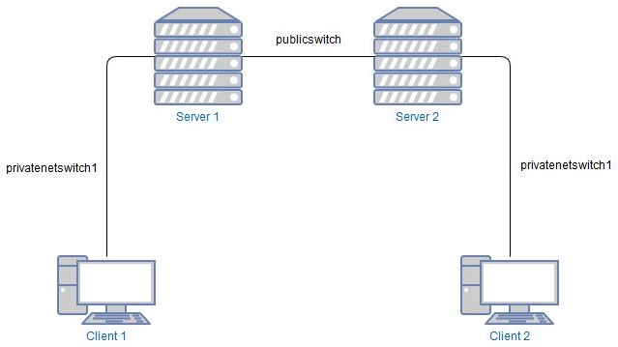
Figure 1. Network Topology

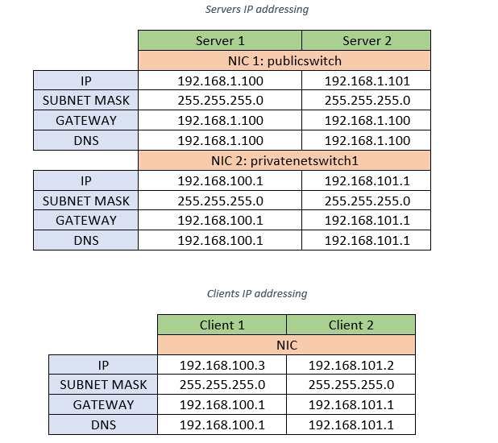
Figure 2. IP addressing scheme
As visible in the first picture, the network is composed of 2 servers and 2 clients. Each client is connected to a server through a private network connection, called privatenetswitch1.
The servers are then interconnected using another network called publicswitch.
In the tables above is possible to see which IP addresses have been used to configure the various NICs (Network Interface Controllers) to allow the various devices to communicate with each other.
The used addressing scheme does not allow the 2 clients to communicate with each other, but allows the 2 servers to exchange data, through the puclicswitch network.

SCREENSHOTS

WORKSHEET 1

The following screenshots show the results of the accomplished tasks required in the Worksheet 1.
The aim was to give to Server1 the role of Domain Controller, create an AD Domain and adding client computers and object in the AD.
After the creation of the Client computer in the AD, was required to connect the physical one, Client1, to the domain.

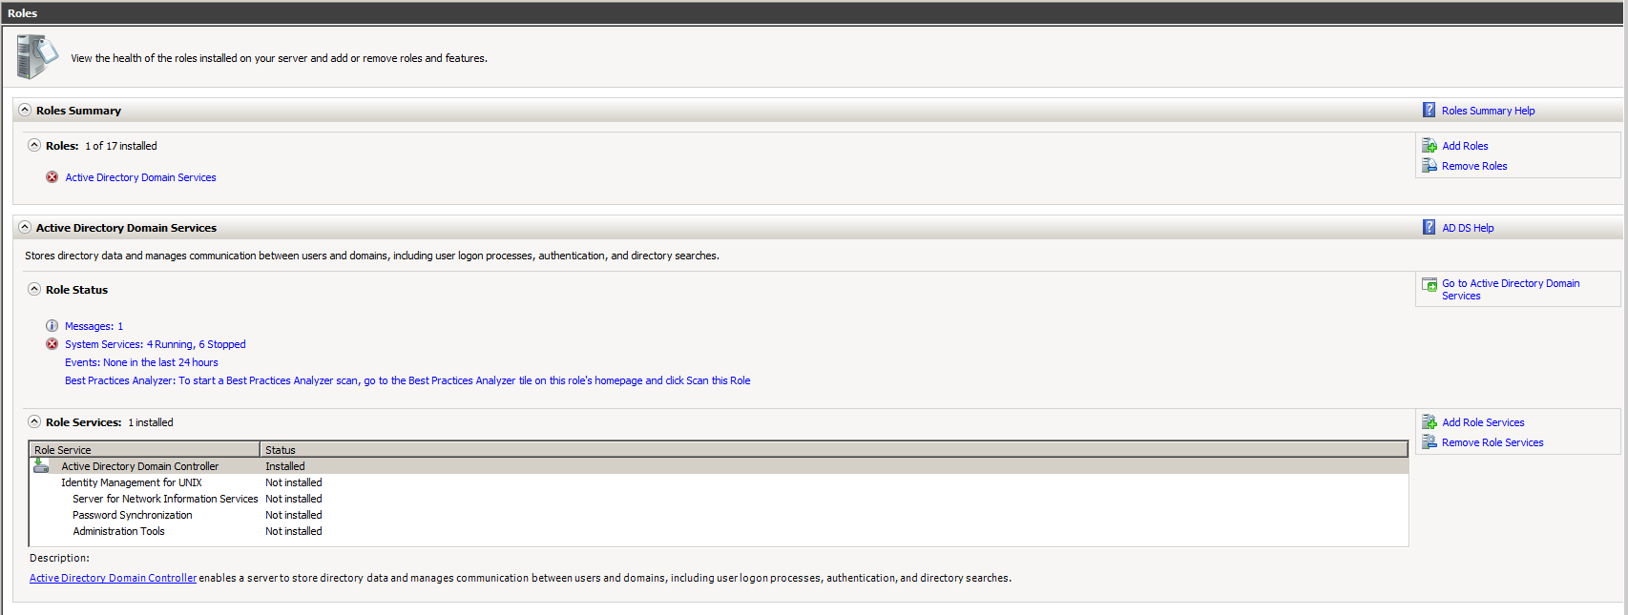
Figure 3. Domain Controller installed
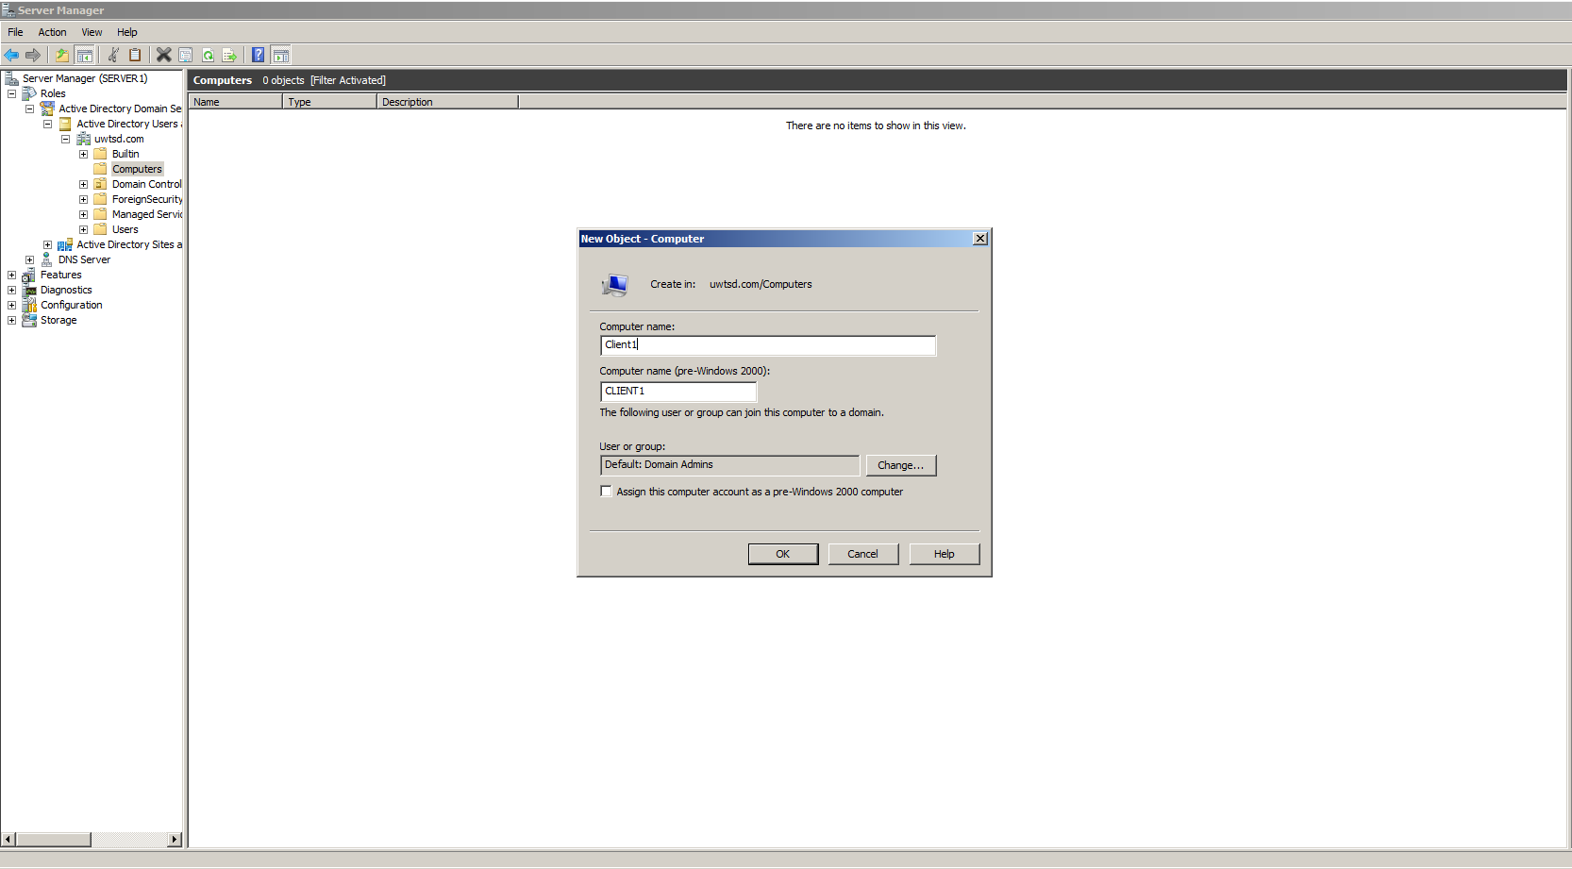
Figure 4. Client computer creation
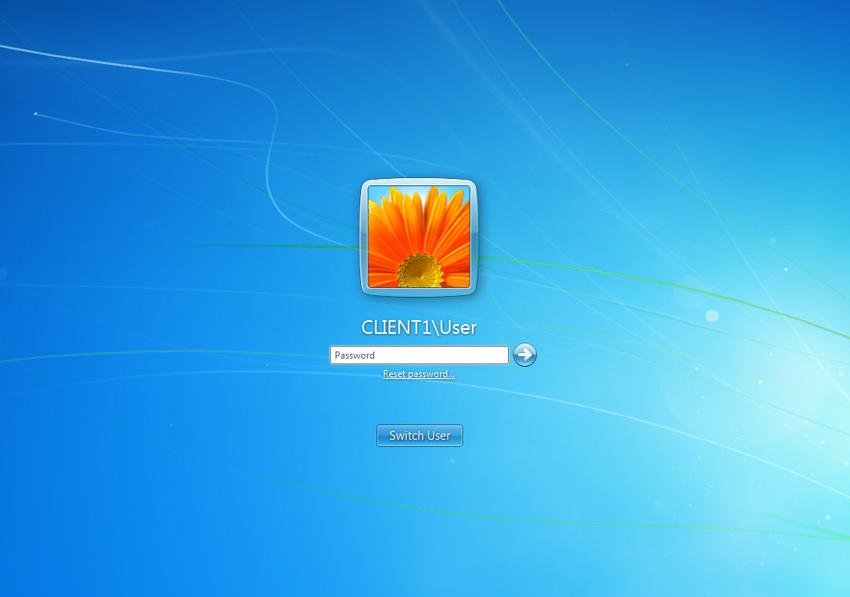
Figure 5. Client1 after the connection to the domain

WORKSHEET 2

In worksheet 2 was required to create an OUs, in this case, the various departments of the domain created before and define policies to apply to users.
Once defined these, was required to create groups objects to assign different privileges to the users of the different departments.
The screenshots below, represent the steps followed to achieve the goal.
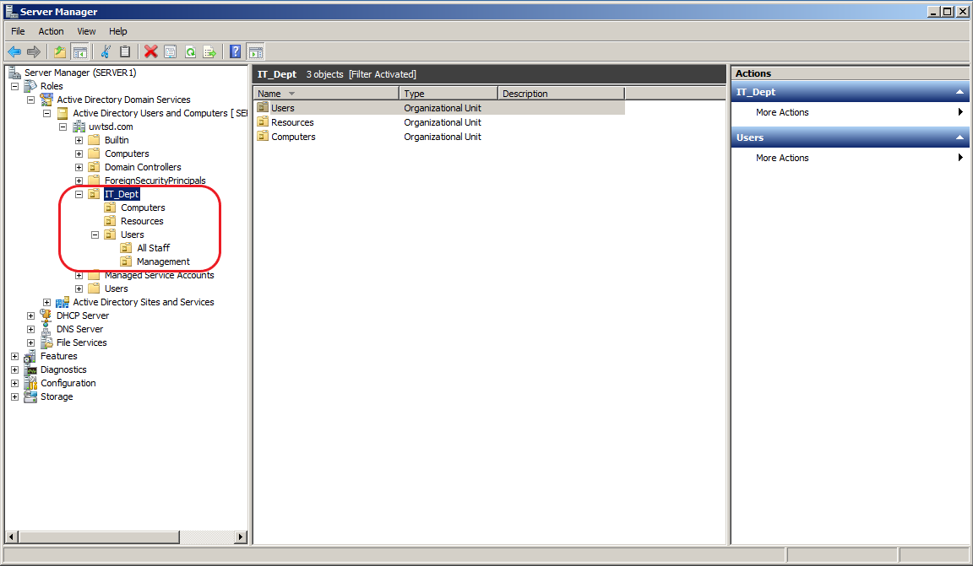
Figure 6. Task 1 - Creating OU hierarchy
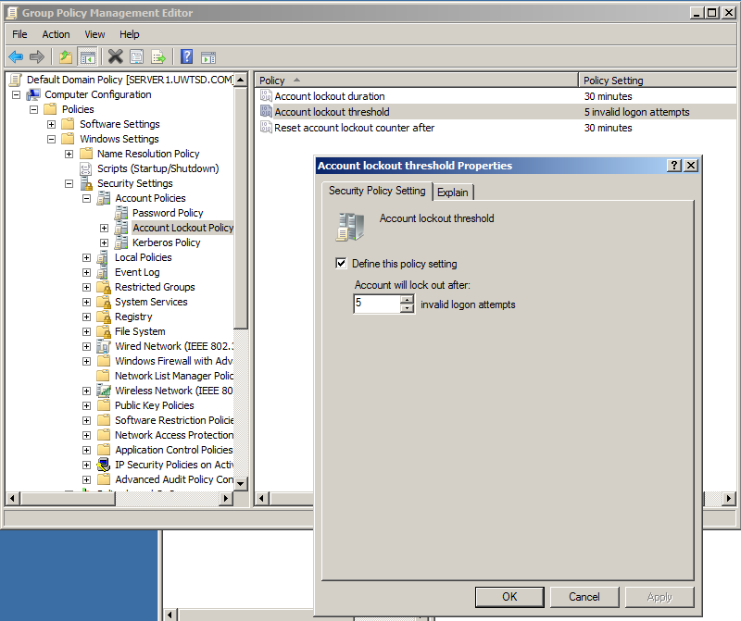
Figure 7. Task 2 - Defining Account Lockout time
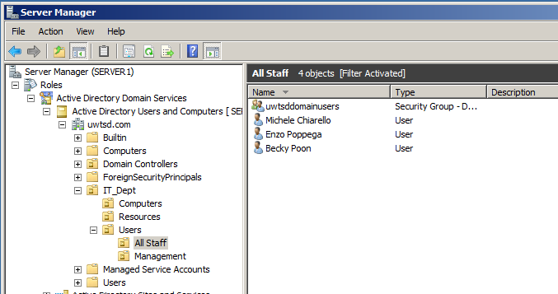
Figure 8. Task 2 - Create user accounts

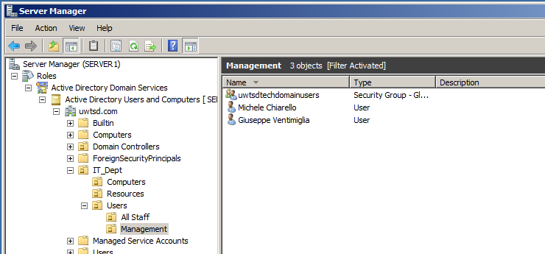
Figure 9. Task 2 - Create Department Managers accounts

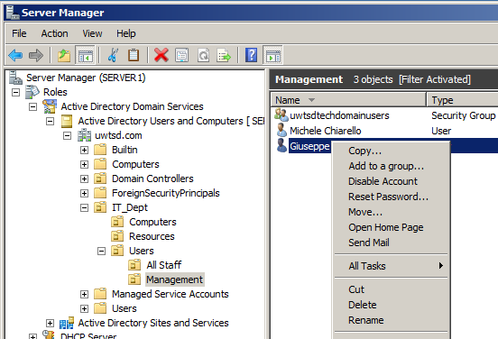
Figure 10. Task 2 - How to manage individual accounts

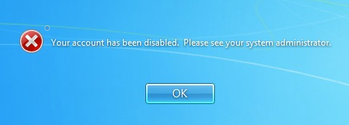
Figure 11. Task 2 - Error message after account disabled

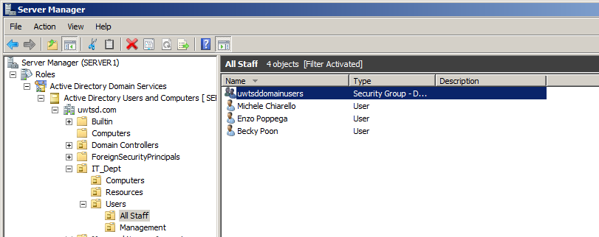
Figure 12. Task 3 - Create user groups

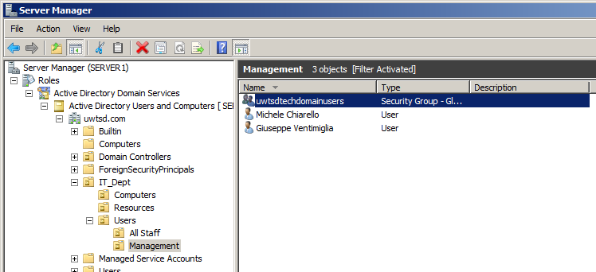
Figure 13. Task 3 - Create managers group

WORKSHEET 3

In the 3rd worksheet was required to create a shared folder with different access permission from the users. Also, was required to set up policies for the management of the Clients for the domain used.
To accomplish this was required to set up Share and NTFS Permissions.
The pictures below, show the various steps and the results of the steps used to complete the worksheet.
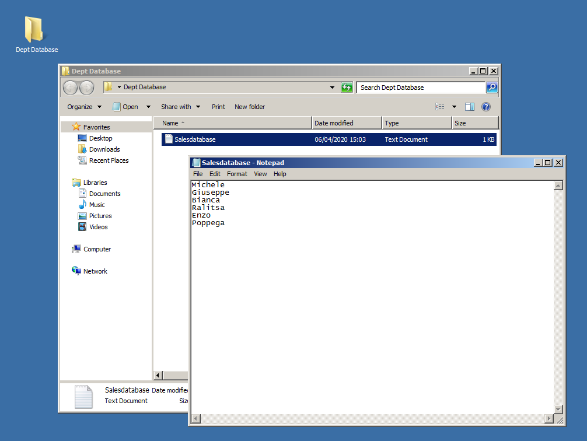
Figure 14. Task 1 - Creation of the shared folder and file

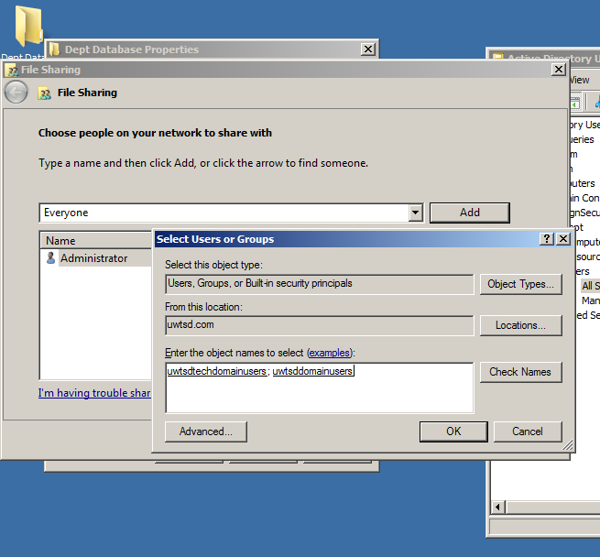
Figure 15. Task 1a (Share and NTFS Permissions)
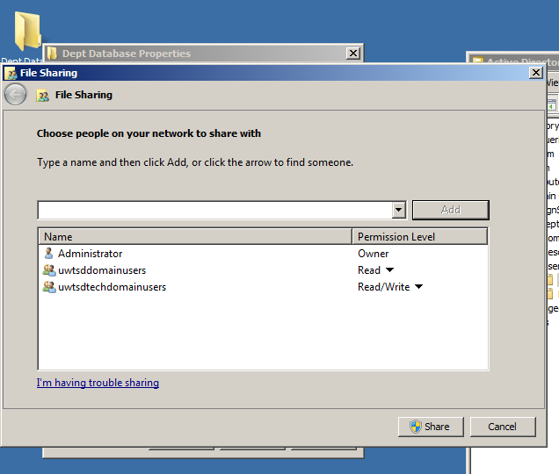
Figure 16. Task 1b (Share and NTFS Permissions)
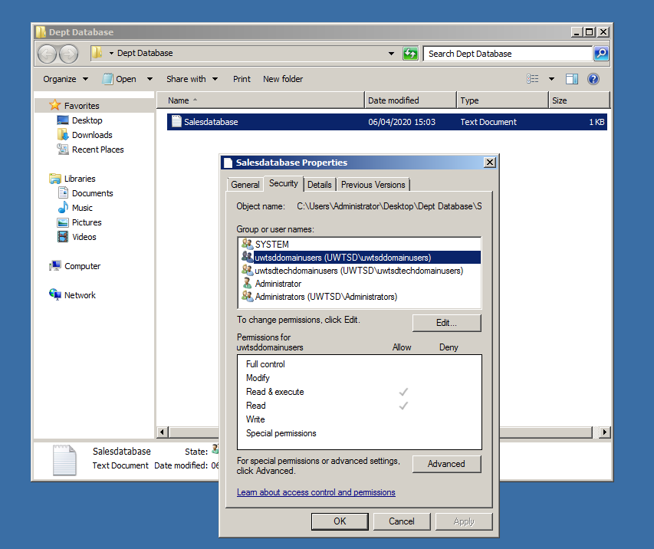
Figure 17. Task 1c (Share and NTFS Permissions)
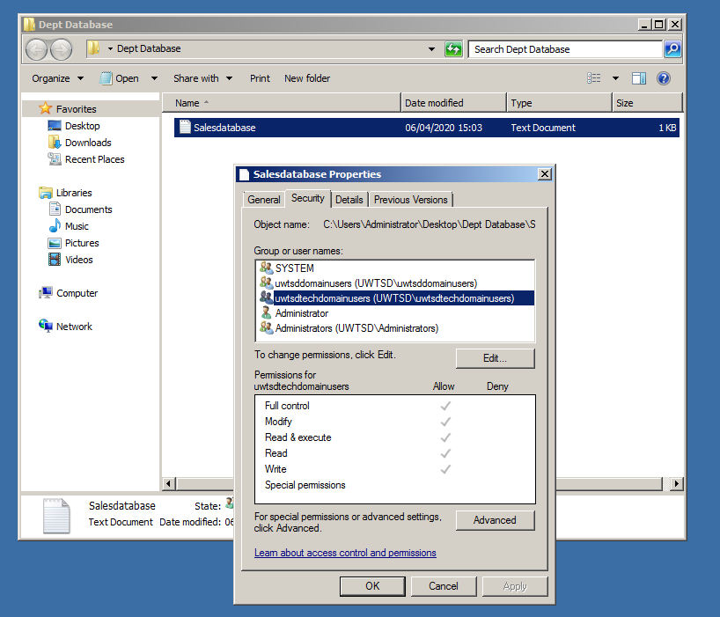
Figure 18. Task 1d (Share and NTFS Permissions)

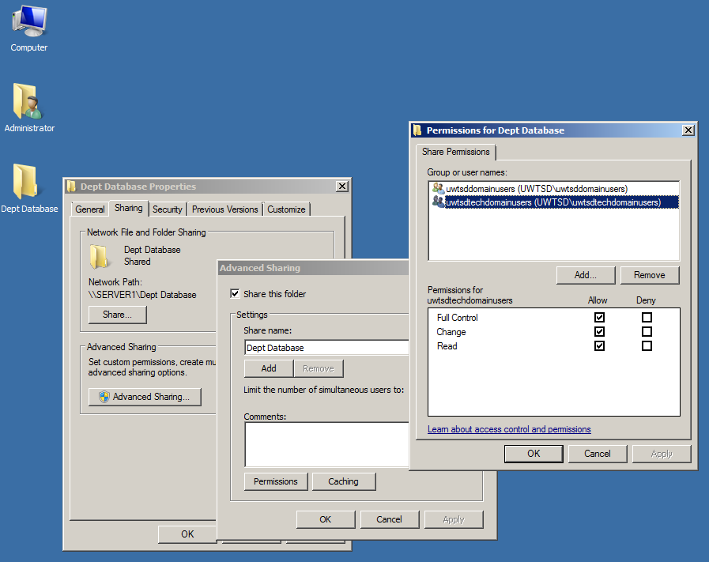
Figure 19. Task 1e (Share and NTFS Permissions)
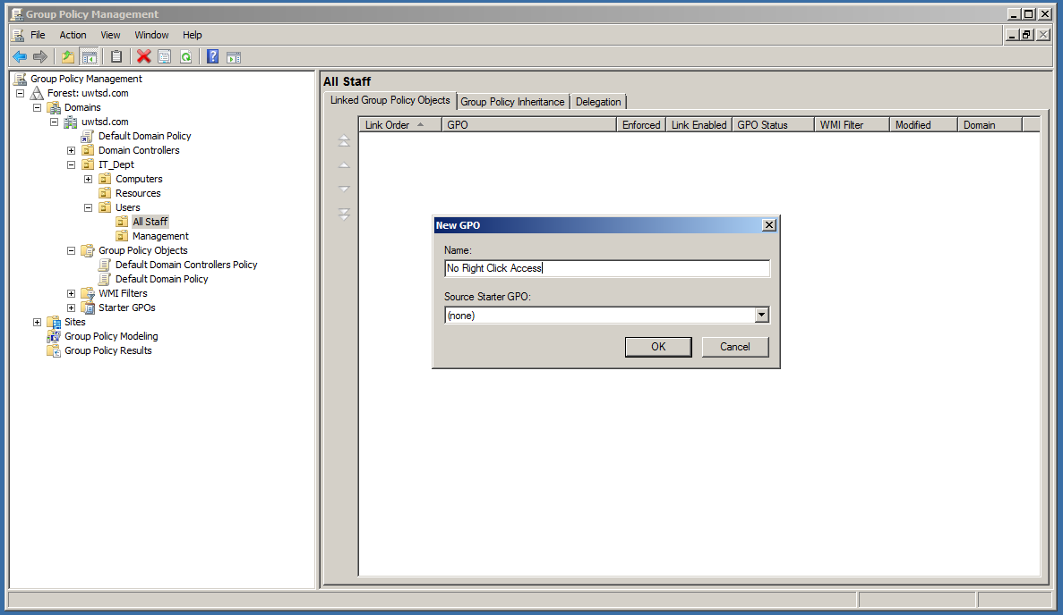
Figure 20. Task 2a (Group Policy setup)
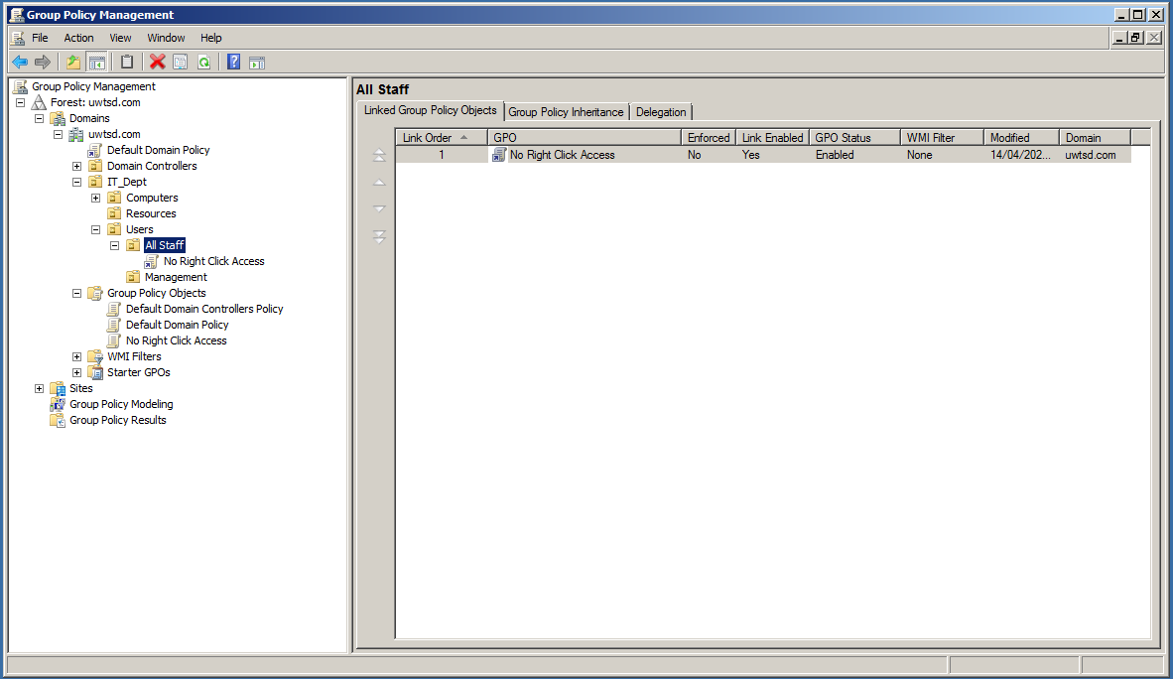
Figure 21. Task 2b (Group Policy setup)
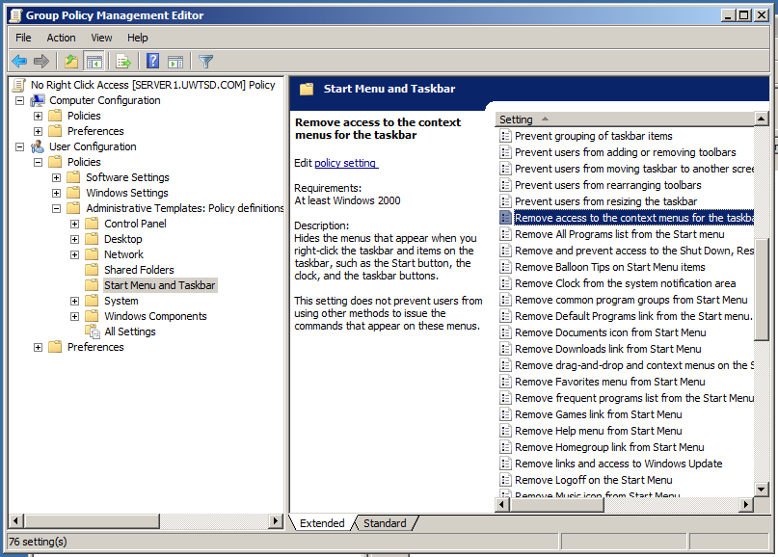
Figure 22. Task 2c (Group Policy setup)
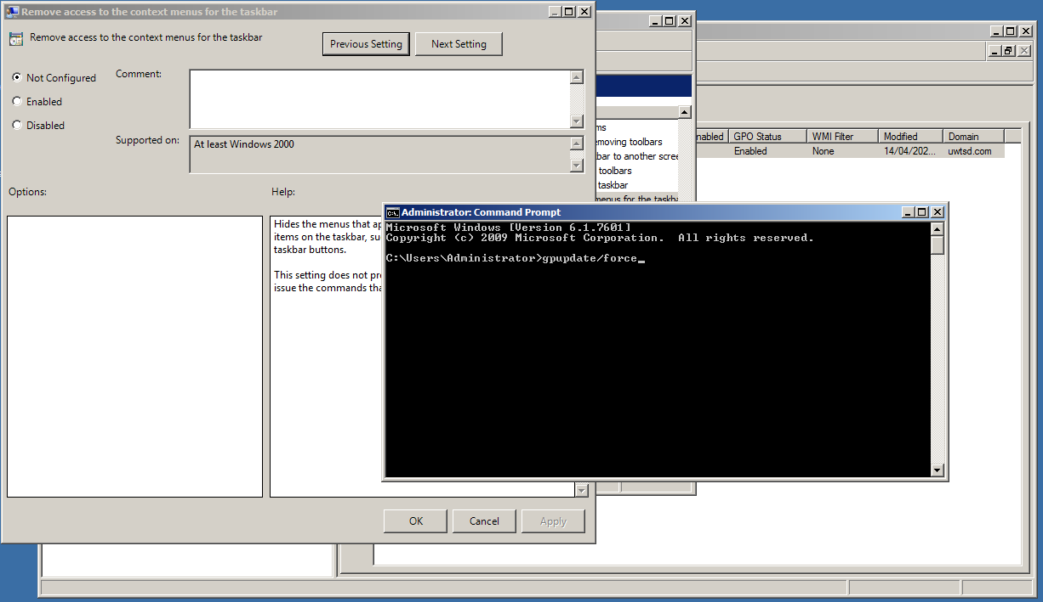
Figure 23. Task 2d (Group Policy setup)
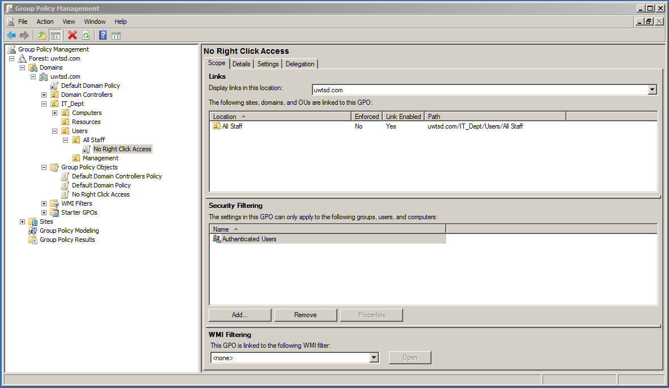
Figure 24. Task 2e (Group Policy setup)
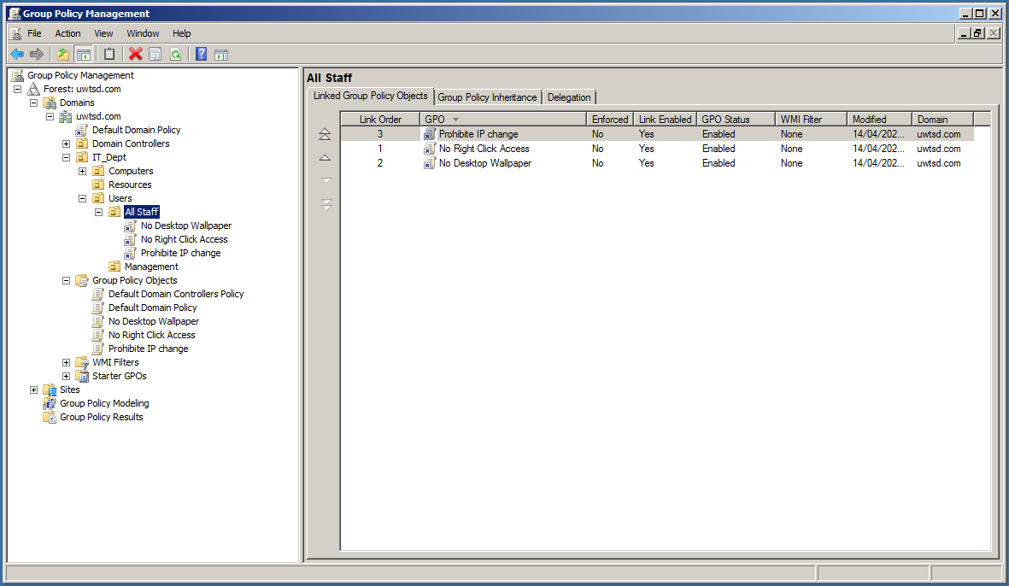
Figure 25. Task 2f (Group Policy setup)

WORKSHEET 4

The Worksheet4 was related to the DHCP service.
In the following screenshots, it is possible to see how this has been implemented and how it looks on both server and client-side.
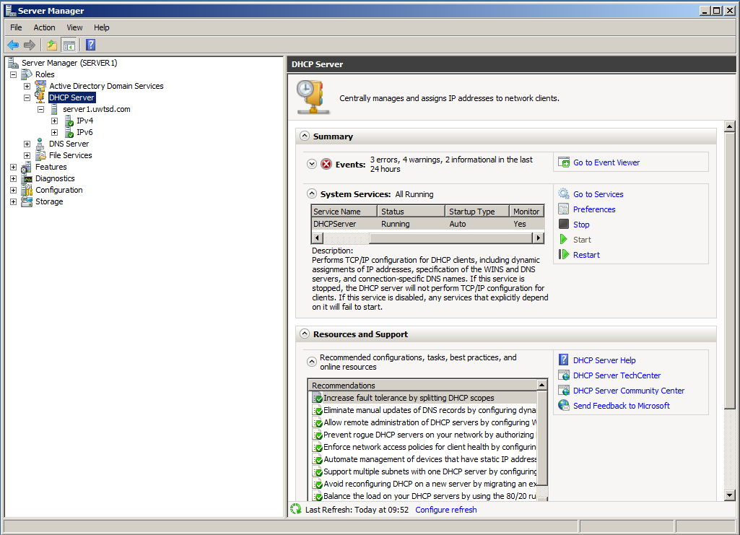
Figure 26. Task 1 Part A - DHCP Service installation
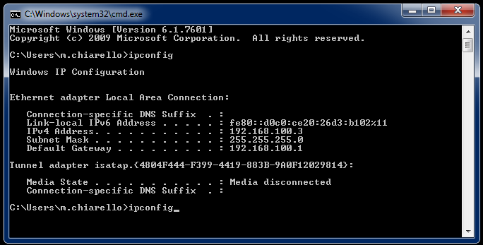
Figure 27. Task 1 Part B - Client IP before DHCP
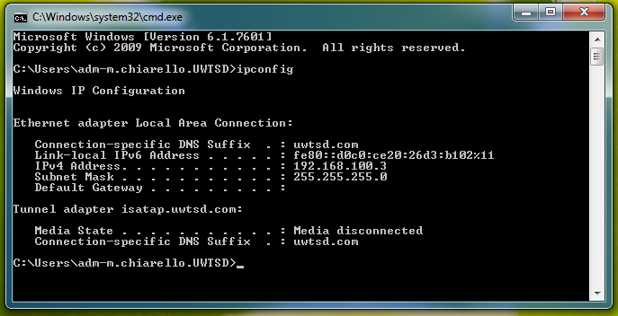
Figure 28. Task 1 Part B - Client IP after DHCP
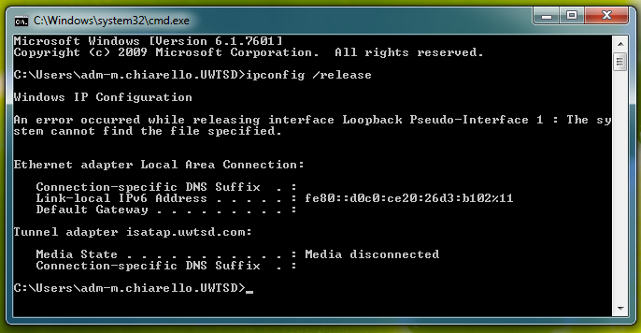
Figure 29. Task 1 Part C1
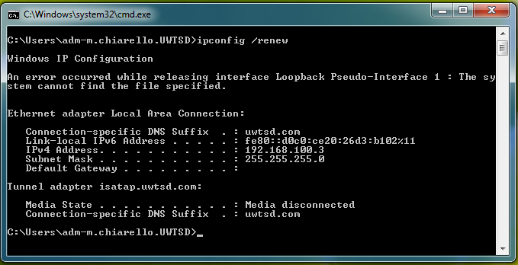
Figure 30. Task 1 Part C2
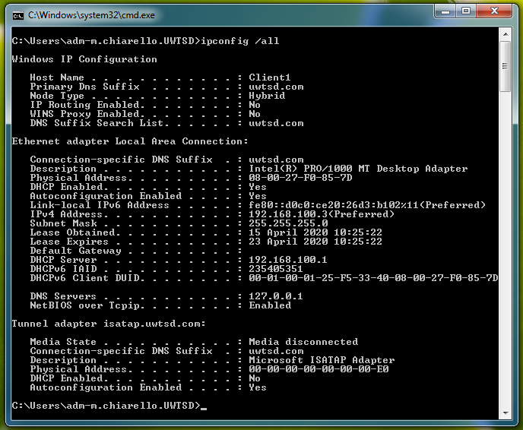
Figure 31. Task 1 Part C3
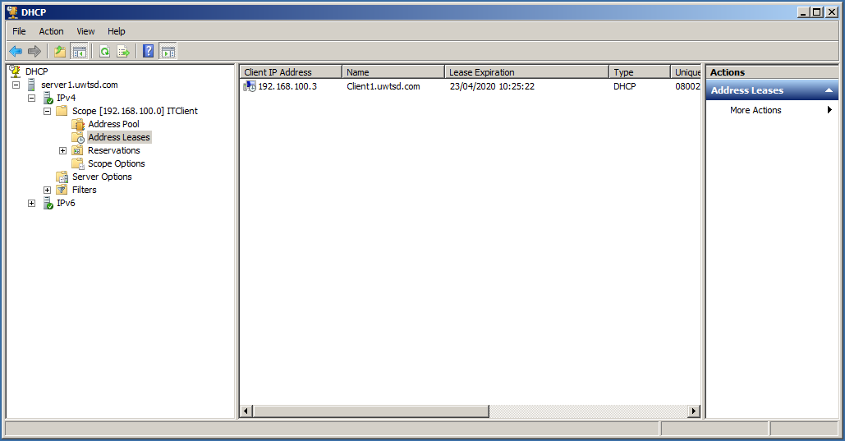
Figure 32. Task 1 Part D – (DHCP Lease and scope)
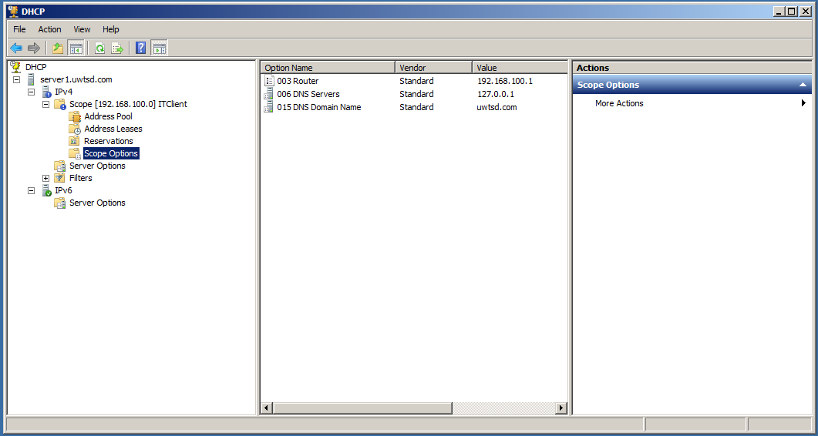
Figure 33. Task 1 Part D – (DHCP Lease and scope)

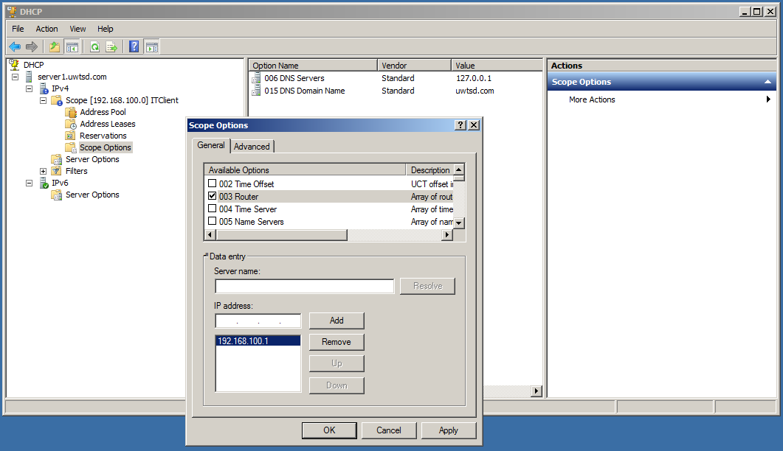
Figure 34. Task 1 Part D – (DHCP Lease and scope)
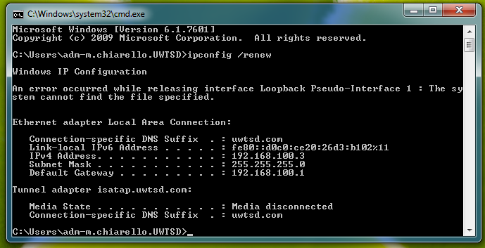
Figure 35. Task 1 Part D – lease renew from client
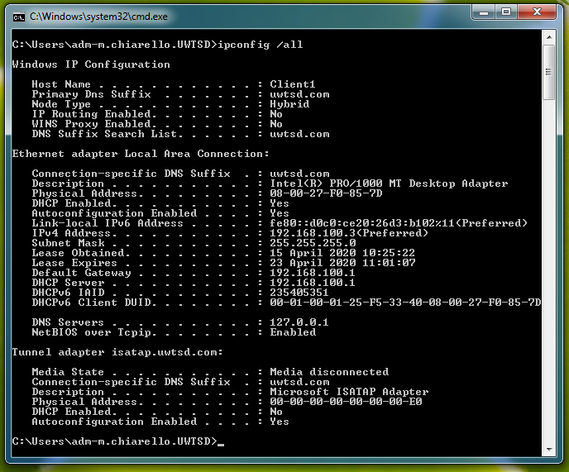
Figure 36. Task 1 Part D after renewing

WORKSHEET 5

In the final worksheet, was required to deploy a DNS on the Server1 and to install the Web Server functionality on Server2, in order to test one of the services that rely on the correct DNS configuration.
The pictures below, aim to show how the DNS is implemented and how the IISS server is configured to allow the services it hosts to be reachable.
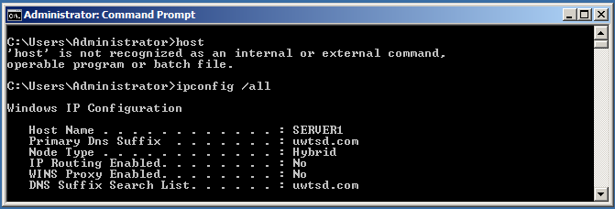
Figure 37. Task A - Server1 hostname
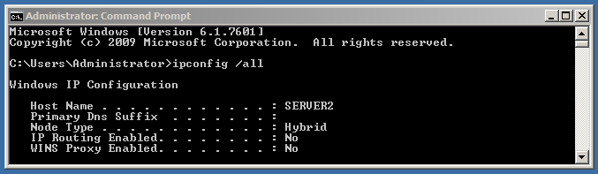
Figure 38. Task A - Server2 hostname
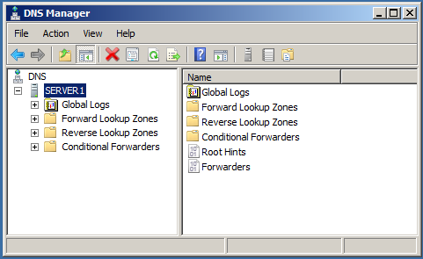
Figure 39. Task B - Server1 DNS installed
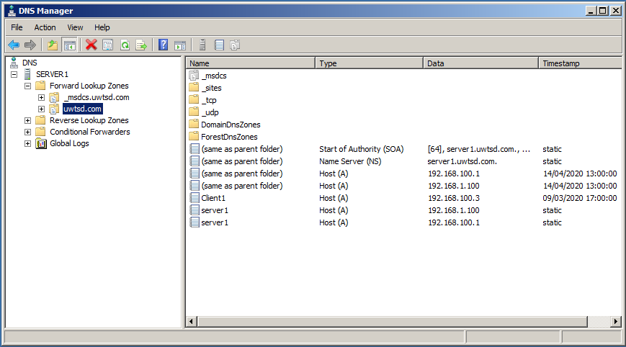
Figure 40. Task 2 - Record verification for the hosts on the network
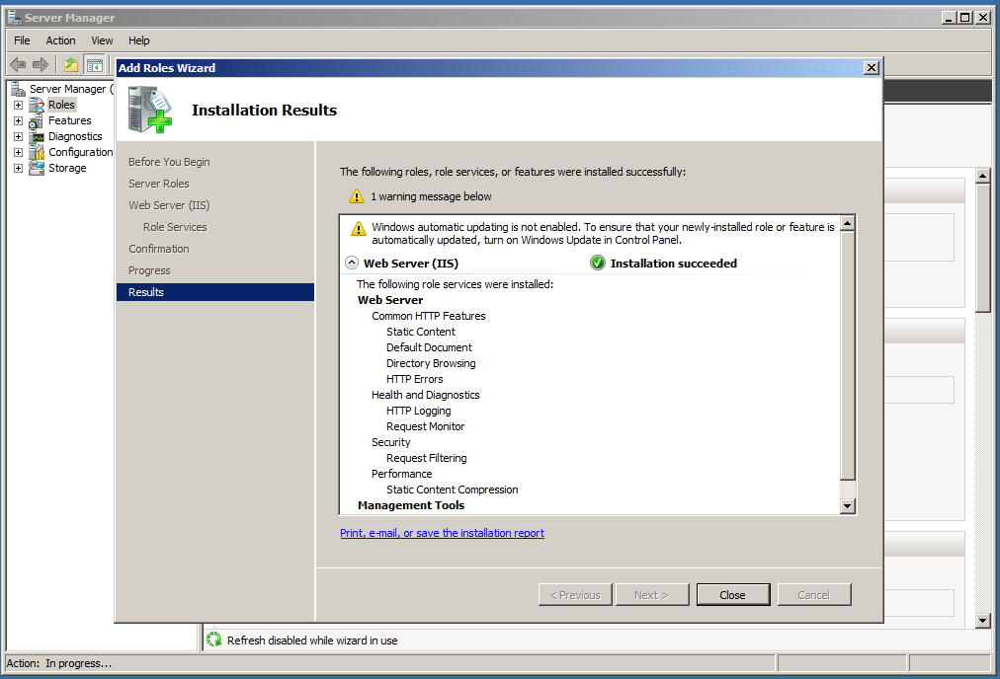
Figure 41. Task 3 - IISS installation
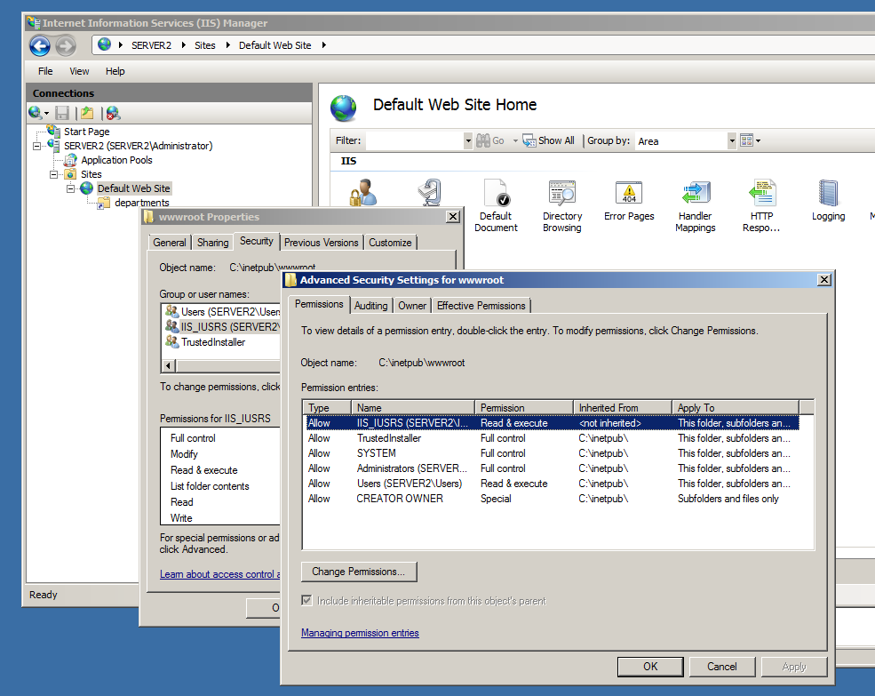
Figure 42. Task 3 - Virtual directory creation and permissions
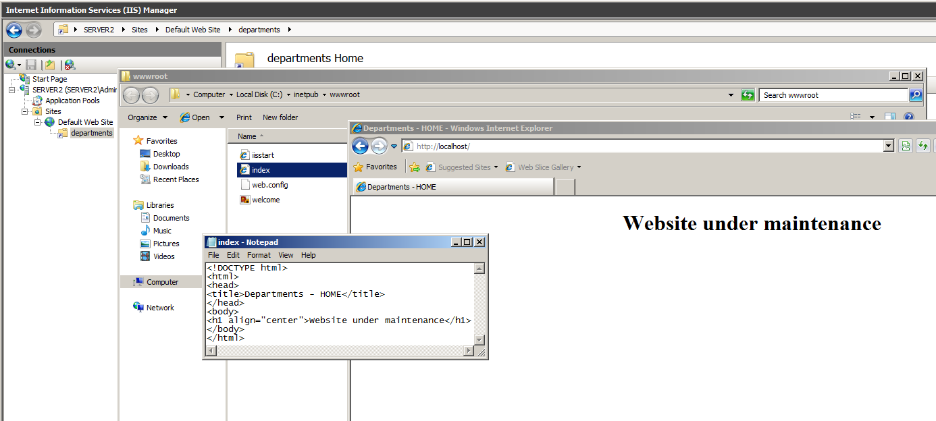
Figure 43. Task 3 – web page creation
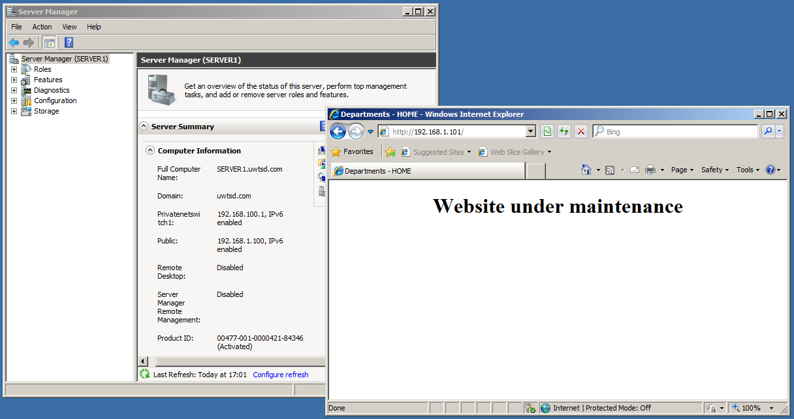
Figure 44. Task 3 - Web server test from Server1

