HTML & CSS Web Development

Student Name: Lloyd Johnson
Student Number: 1802820
Module Code: ACCA4018
Module: Internet Technology and Security
Date: 1/5/2019

Contents
Introduction 3
Requirements 3
Validation 7
Evaluation 7
Bibliography 9

Introduction
This report will include a requirements section that will include a brief introduction to the website that has been built for a small gym in the Neath Area. The first section will also include what is required to be in a website for a small gym business.
This will include:
- Target audience
- Is all the information displayed relevant to the website?
- The purpose of the website
The next section in this report will include a screenshot of all the completed pages on the website. This section will also describe any errors that occurred when designing the website and discuss how they were corrected.
The home page code will then be validated at http://validator.w3.org/.
Finally, the report will include an evaluation of the finish website which will discuss if the website met all its requirements. The usability of the website which will include disability access and describe if the overall look suited the purpose of the website.

Requirements
The webpage is a local gym website. The target audience for the gym is all ranges as it will have different types of memberships that will suit 16-70-year olds. Therefore, all the text on the page should be easily understandable as elderly people may have vision problems. Also, any text that is included on the website should be consistent. This means all the important headings should be the same size and all text relating to those heading should be consistent through all the webpages making sure to maintain the flow between pages.
Since most younger people will have a respectable understanding of the internet the website should follow what most websites look like, this is so there will be a degree of familiarity when designing the web pages. But since elderly people will also be viewing the webpage then it should be easily navigated by them. To do this the website will include large buttons and images that the viewers can click on to navigate around the site.
To keep the website accessible to people with vison problems all images should have alternative text so their screen readers can tell them that there is an image there and a small description saying what the image is.
The colour scheme of the website should be consistent all the way through and the colour blue has been chosen after researching other gym websites.

  - Screenshots
Home Page
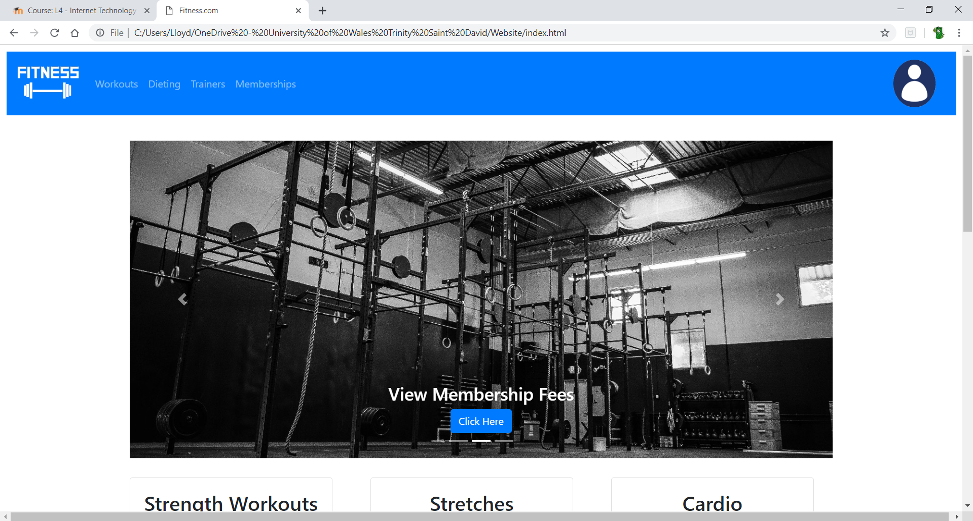

Workouts
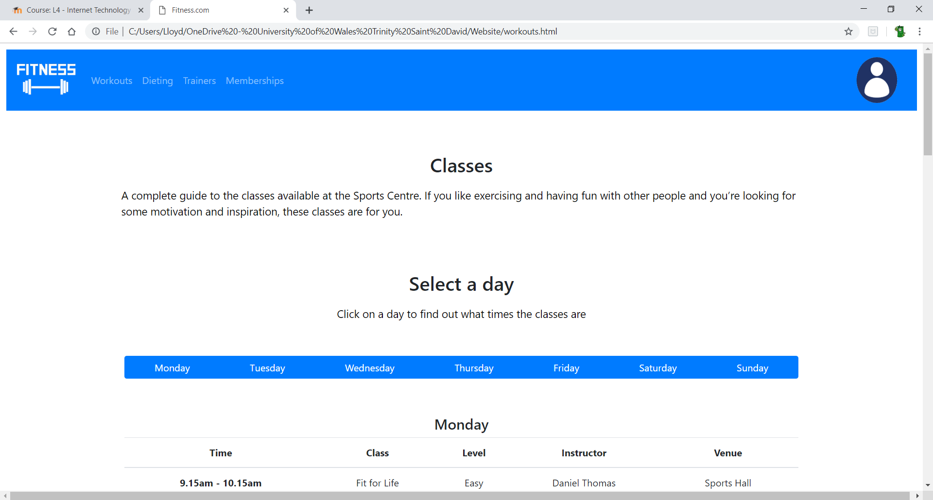

Dieting
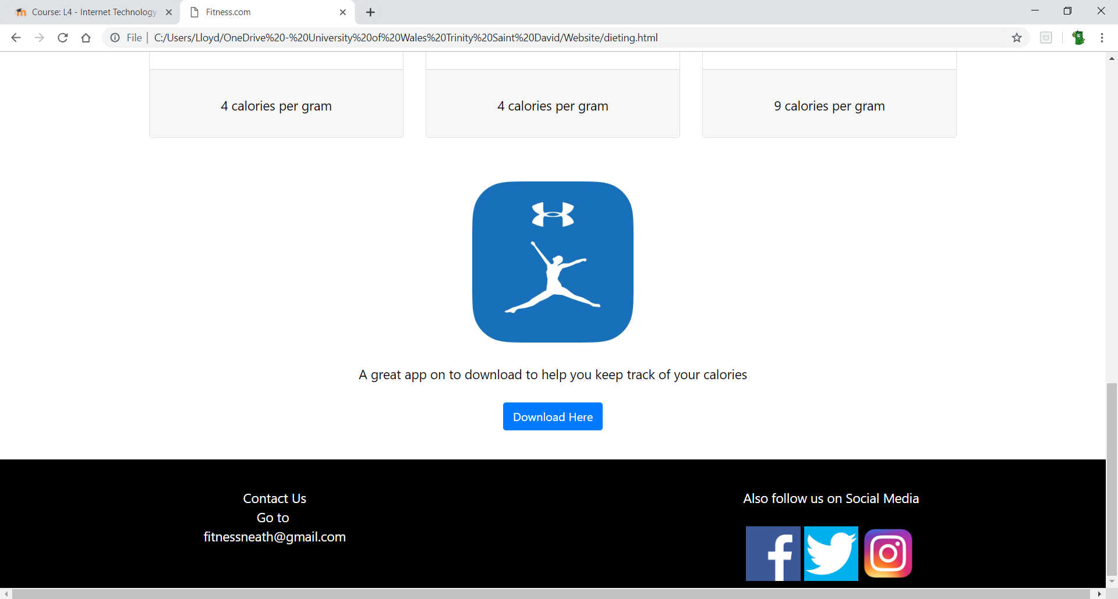

Trainers
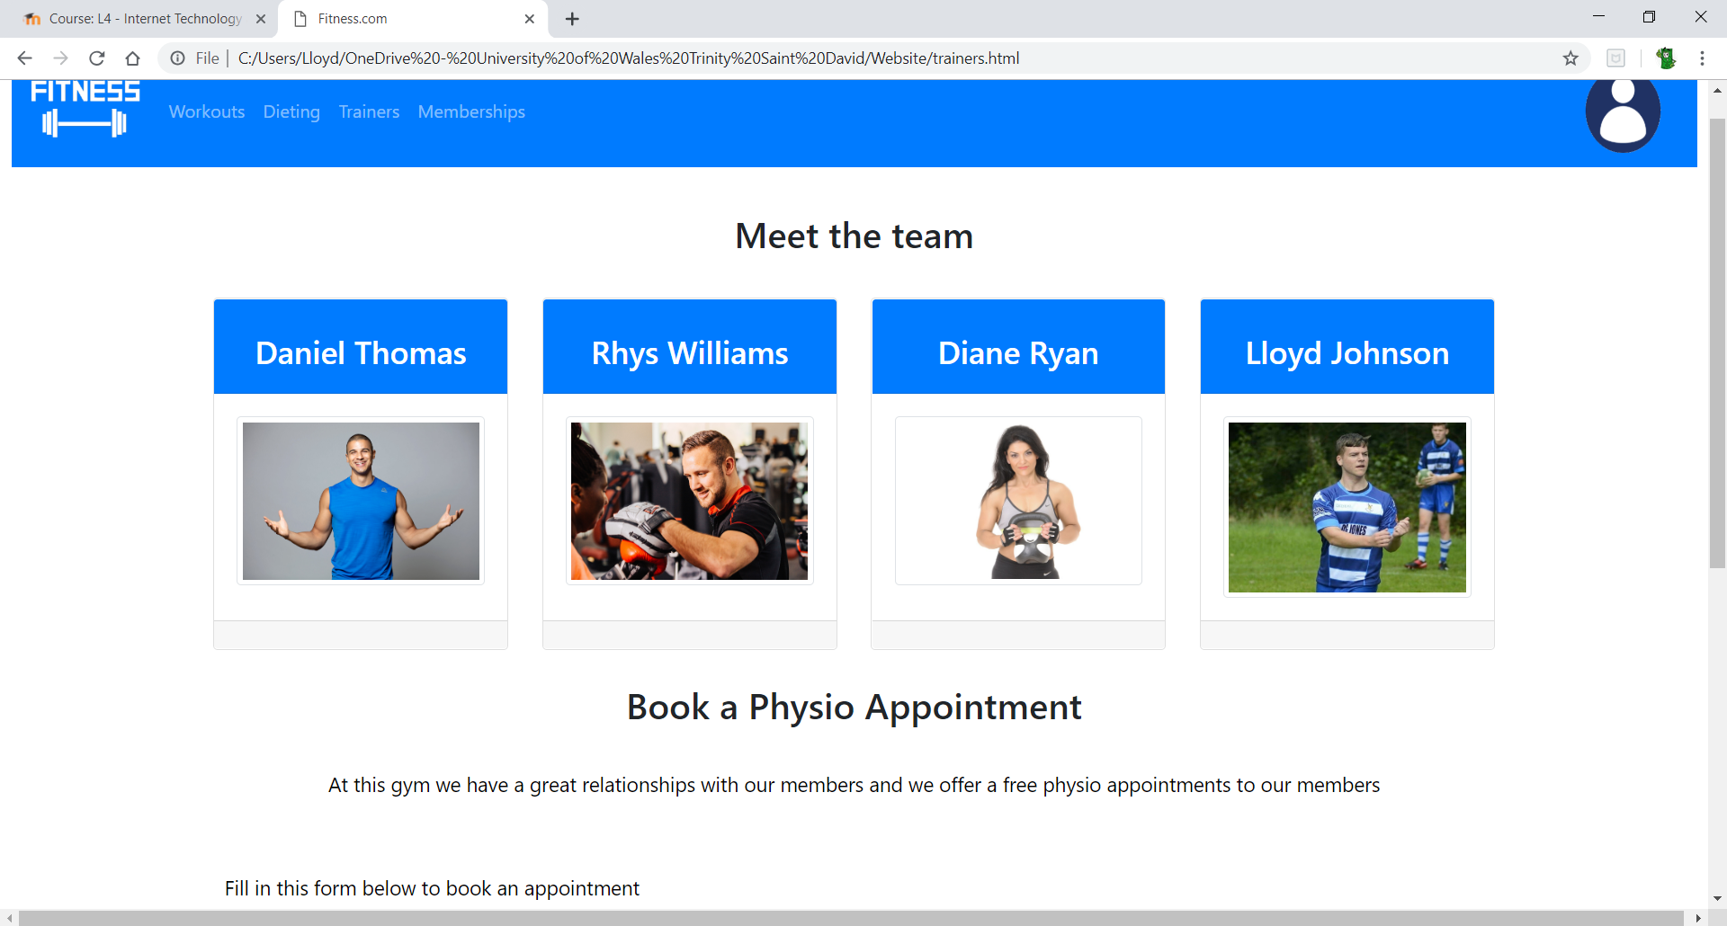

Memberships
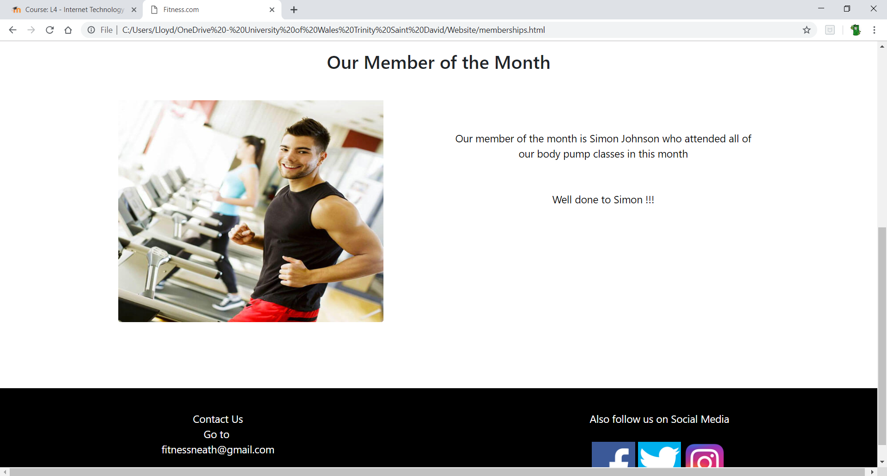
Login
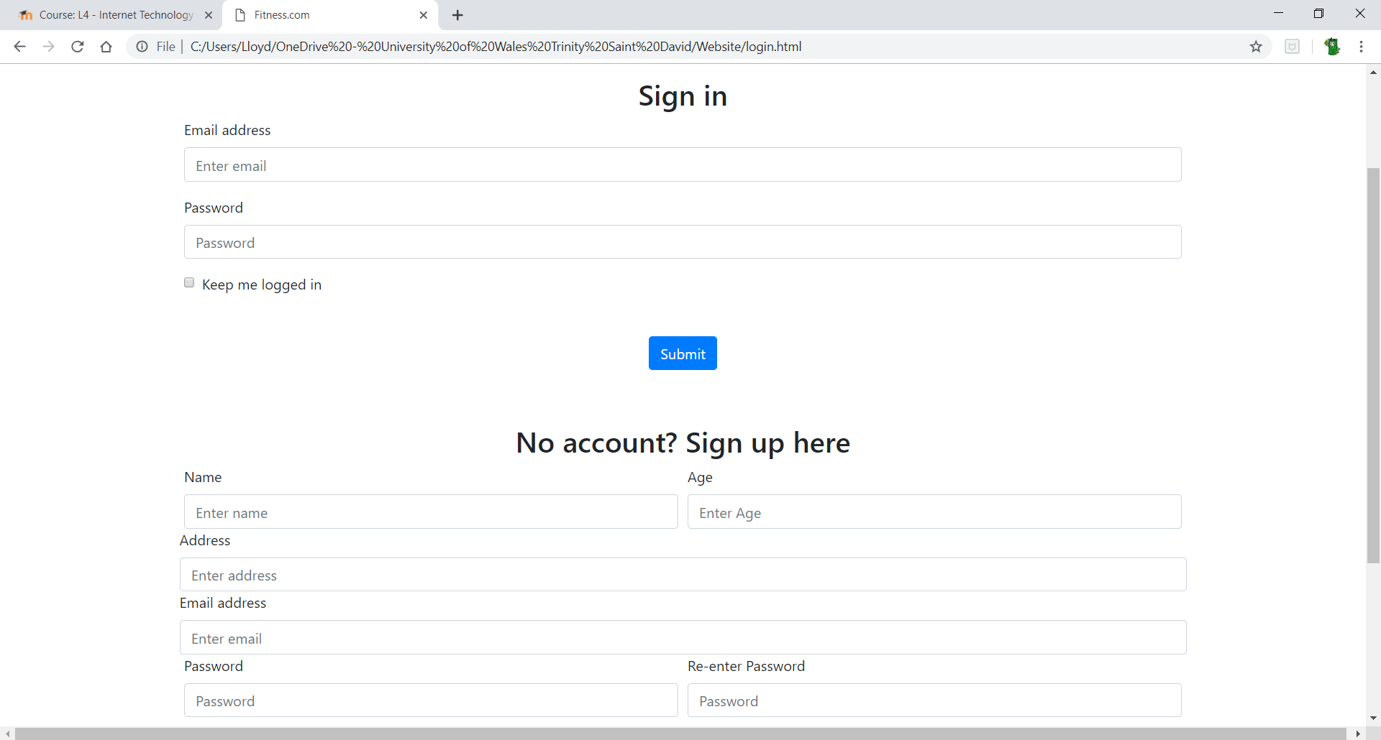

Validation
Next the website html code and the css code were validated using https://validator.w3.org/nu/#file. The errors that the validator displayed was, where the login icon image code was the validator stated that " Attribute href not allowed on element img at this point.” The reason for this error is because the attribute was duplicated as it was already in the “a” tag. Once I removed the extra attribute the error was solved. Another error that was on most html code pages is there would be no spaces between some attributes, if left along this would make it harder for programmers to read the code and make changes so spaces should be added to the attributes.
The final error that I was seen was repeating IDs. However, these were left as the website was designed using columns and the only instance the IDs duplicated was if they were in different columns. I used the IDs to style them and since I wanted them to be in the same style, I let them have duplicate IDs.
When the style sheet was validated it contained no errors.

Evaluation
Since it is a gym website then all the text on the website should relate to health and fitness and it does. This is the most important thing as if the content does not match the website then viewers are not going to stay on it.
The website followed a basic layout with a header, main and footer sections. Since most websites that are running on the internet today. A health and fitness website that uses this layout is https://uk.bodybuilding.com/store/ . Using a layout that most other websites use is smart as when a person comes to view the webpage, they will already have a small understanding on where certain elements are, such as having the contact information at the bottom of the screen. Therefore, making the website easily accessible to the average person.
The text on the page is easily read as it has a good contrast from the background so even people with forms of colour blindness will not be left out when reading the website. The text also all relates to the webpage that it is on such as all the dieting and food information belonging to the dieting page and all membership information belonging to the membership page keeping the website constituent all the way through.
When displaying text on a screen there are some suggestions. In WCAG 2.1 you must distinguish titles and smaller text with a 3:1. [1] This has been followed making it very easy to understand what is a main point or heading and what is the text that goes along with the heading. Another Suggestion by WCAG 2.1 is to make sure that there is a suitable space between paragraphs that discuss different subject matters. This has been followed, when looking at the workouts page the two paragraphs are suitably separated making it clear to the viewer, they do not link. Within the workouts page, there are workout class tables that just have a name of the class. This is not giving enough information to the viewer. In WCAG 2.1 [2] it says there must be a mechanism to explain text and at the bottom of the workouts page there is a small key to explain what each class does however, I feel there should be more information describing the class in the key.
The colour scheme of the website has been kept consistent all the way through. The reason the colour blue was chosen is because health websites that were researched most contained blue. All the headings have been kept the same size and all the colours of the buttons are the same. This is important to do as it makes the website flow together. [3] The colours used when trying to get the viewers’ attention are also bright and in contrast to their background which will help draw their attention to that one area. This is a beneficial design move as more important areas can be highlighted which they have been on this website. [4]
All the images on the website are well used and well placed. If there is an image that relates to a piece of text on the page, it is either held in a “card” or it will be in the same container. This is a good design idea as it means there are no random images on the webpages which will be confusing to a viewer. [5]
The website feels like most websites, it has the navigation bar on the top and follows a column system. Since the website feels like most others, the users will know how to use it making the navigation around the website easier. This is important as you don’t want the website to feel foreign to them because then they will have to take time to learn it which they will not do making them not stay there long. [6]
All the images on the website have alternative text tags. This is for people who cannot load the images or people with vision problems. This is important to have as it makes the website accessible to mostly everyone.
The first improvement that would be made to the website is to add more images to some of the web pages. The reason this would be done is to add more colour to the webpages which will make it more attractive. Most people would rather look at images then read text so if text can be replaced with images then hopefully users will stay on the website longer and increase traffic to the website.
The next improvement that would be made is adding a search bar to the navigation bar. The reason this would be done is to further increase the ease of navigation. So, when users want to find something on the website, they do not need to go through the pages to find it. At the moment, it isn’t needed as there are no subpages to the main pages but when the website expands it would be smart to add a search bar.
Another improvement would be to create social media accounts for the contact us section in the footer so when the viewer selects the social media platform, they want to view it will take them to the fitness social media page.
The final improvement that would make to the website is to add a store function. The store function would be used by the viewer selecting what membership they would like then they would be redirected and must fill out a form to attain a membership to the gym.

Bibliography

[1] | 5 June 2018. [Online]. Available: https://www.w3.org/WAI/WCAG21/Understanding/resize-text.html. [Accessed 1 May 2019].
[2] | W3Schools, 5 June 2018. [Online]. Available: https://www.w3.org/TR/WCAG21/#abbreviations. [Accessed 1 May 2019].
[3] | “TOP 10 WEB DESIGN TIPS,” Alchemy, [Online]. Available: https://www.alchemyinteractive.co.uk/design/top-10-web-design-tips. [Accessed 1 May 2019].
[4] | “Web Content Accessibility Guidelines (WCAG) 2.1,” W3Schools, 5 June 2018. [Online]. Available: https://www.w3.org/WAI/WCAG21/Understanding/use-of-color.html. [Accessed 1 May 2019].
[5] | W3Schools.org, 5 June 2018. [Online]. Available: https://www.w3.org/WAI/WCAG21/Understanding/info-and-relationships.html. [Accessed 1 May 2019].
[6] | O. Sellers, “10 Web Design Best Practices for Greater Business Success,” LYFE Marketing, 25 July 2018. [Online]. Available: https://www.lyfemarketing.com/blog/web-design-best-practices/. [Accessed 1 May 2019].
[7] | “https://uk.bodybuilding.com/store/,” BodyBuilding.com, [Online]. Available: https://uk.bodybuilding.com/store/. [Accessed 2 May 2019].
[8] | Celtic Leisure, [Online]. Available: https://celticleisure.org/. [Accessed 2 May 2019].

