A research report on Data centre

SCHOOL OF APPLIED COMPUTING ASSIGNMENT SPECIFICATION
Student name- Priyank Patel
Program - BSc (Hons) Cloud Computing
Lecturer: Koushik Modak
Internal Verifier: Renuga Jayakumar

Table of content
Case study and the organisation requirements……………………………………………………2
Data virtualisation…………………………………………………………………………………….3
Key promoting factors for virtualization……………………………………………………………5
Creating a virtual data centre……………………………………………………………………….6
Virtualization technology…………………………………………………………………………….8
Data centre architecture of UWTSD………………………………………………………………13
Scalability ……………………………………………………………………………………………14
Load balancing ……………………………………………………………………………………..14
Risk and control involved in virtualization………………………………………………………..16
SAN(storage area network)………………………………………………………………………..17
Energy consumption………………………………………………………………………………17
Conclusion ………………………………………………………………………………………….18
references…………………………………………………………………………………………..19

Scenario 1(task B)
Case study and the requirement for the organisation
UWTSD (University of Wales Trinity Saint David) has thought of bringing data virtualisation to its central operating IT systems and they are trying to rebuilt the virtualised data centre in order to centralise UWTSD’s servers and services. It is being subjected for an expert opinion and the organisation needs a thorough understanding, implementation and execution of data virtualisation pertaining to the organisation’s needs. The aspects relating to the designs of software, their external conditions. Scalability and any physical limitation are to be tapped and taken care of in order to convert the traditional data centre into a virtualised and more efficient place of network with more sustainable and secure supplies of energy and networks. The organisation needs a proposal for their perusal of how the service structure will look like once implemented, it is also needed to rectify and present whether it is beneficial for the organisation to go for its own data centre or work along with the outsources solutions.

Proposal report
Before moving ahead with implementation of data virtualisation, it is important to understand why there is so much fad for such a technical jump.
Data virtualisation
Data virtualisation is a process in which software-based or virtually represented forms of applications, storage devices, servers and networks are created. It isn’t any game to play off, but the simplest way to reduce the cost and IT expense and not just it affects the cost but also boosts up the efficiency of business irrespective of their size. Data visualisation is a typical use of software in order to create an abstract over hardware of computers that helps the hardware to function as multiple virtual computer which is typically known as virtual machines (VMs). Not just a new virtual setup, every virtual machine tends to have its own operating system and starts behaving like an independent entity despite of the fact that it is running on the same integrated single [hardware computed system.
Visualisation is efficient in enabling the utilization of a single physical computer hardware to allow its virtual extension to the whole organisation thus cutting short on the hardware investment to a greater extent. [1]
The impact of virtualisation has been quite significant in the previous years, from strong and robust networking to huge cost saving and increased investment returns, virtualisation has given a stronger back to IT services within organisations. What makes virtual systems work so efficiently is the question. They are typically multi-tenancy drivers used for better utilization of servers, consolidation of data centres and to provide relatively easy and speedy provisions for the server settings. [2] It becomes easy for cloud service providers in order to achieve high density to translate it into better margins. For an enterprise, it is easy to shrink upon the capital expenditure on setting up different hardware’s and it increases the operational efficiency to multitudes.
The reasons why virtualisation environment can be more sophisticatedly secure and safer than the traditional ways-
- It isolates the virtual machines using a hypervisor
- Hypervisors are known to be free from attacks as it needs secure source codes and ability to implement hypervisors
- Network switches and fireballs become efficient as virtual appliances so it delivers core infrastructure and secure technical solutions
- It allows an easy quarantine of a single system from the rest for recovering if any incident takes place.
The security breaches [3] an organisation can face with traditional computing methods are as followed-
- Breach of data
- Loss of data
- Hijacking
- Service denial
- Insecure APIs and interfaces
- Cloud service abuse
- Insufficient diligence
- Vulnerability to the shared technology
Creating data centres- construction and experimentation of data centres helps enabling businesses and organisations to maintain their IT operations and Kee them up to date without being considerate about the reach and size of their working capital. Data centres are important a crucial aspect for any organisation to function with efficiency. For every organisation, data centres are the heart of a business and are very intimidating when it comes to uphold with the routine operations. [4]
Virtualisation can make an organisation an IT powerhouse as with a crunch and shrink in IT budgets and expanding expectations to have desirable, smart and efficient businesses, its extremely important to deploy virtualization in order to bring down the capital and this makes the operation more agile, aligned and appropriately fit with the needs of the business. It makes it easy to operate in challenging and diverse environment for organisations. Not just the cost cutting bit also a smooth and improved service to the users makes an organisation more responsive and proactive depending on the fats pacing and Changing business environment. Through virtualization, IT resources can be shared and pooled in order to meet the organisation’s expectations and bringing it closer to the dynamic IT.

Key promoting factors of Virtualization
It transforms the company’s way of examining and delivering IT services in their organisation. Virtualization transforms how organizations in the industry consider or execute ITservices — whether technology is operated, acquired, implemented and strategized. In addition to centralized management, virtualization helps IT to view the programs they deliver as resources rather than separate servers and operating systems. In the datacentre, for example, businesses focus on how best to offer services to suit each other. [5]
Creating a virtual data centre
Virtual data centres are nothing but a cluster or collection of all the cloud infrastructure resources that are designed in order to help and organisation grow and meet its requirement. The mandatory traditional tools for data virtual centres are central processing unit (CPU), RAM, storage disks and bandwidth for networking. This means that the physical data can now be represented into a virtual space with servers in the form of storage clusters and with different network components which are eventually hosted by a single or two data centres. It is fundamentally a product of creating a robust infrastructure as service delivery model for cloud computing. Data centres help in providing computing, storage and network demands and it integrates all of the existing intrastate pertaining to IT within the organisation. It is not a physical entity but a whole cloud stored formulation of the data patterns. This being the most beneficial part of cloud computing, it allows even the relatively small organisations to have an access to strong IT infrastructure as in the form of creating virtual data centres and in a cost cut matter which could have been used in construction go an avital data centre. [6]
To understand virtualisation of a data centre is very important for a managed facility for data visualisation. With benefits, there are few challenges that are involved with data virtual centres. These virtual methods can be managed easily with sheer expertise.
Manage data centre virtualisation- as there was development in computing technology and its advent, a rapid increase in innovative and responsible ideas for data centre were computed, to make better transistorized and efficiently integrated circuits. With development in computing technologies, ability od data storage, its manipulation and recoding also took a leap.
For an organisation as big as UWTSD, having more than 500 servers in their data centre there is usually found that they have unused storage capacity which allows growth but considering modern and efficient ways to deal with that unused memory storage sounds more efficient. This problem found its resolution by pooling the disks and making them accessible through networks. It can help in drawing one capacity pool from many devices and gradually increasing the utilization within the enterprise. This also helps in decreasing the load on management for their storage systems. These storage arrays can be connected using a network segregate from local area network. This segregated form of network is known as SAN, storage area network. This networking type uses different protocols for networks which are eventually better for storage networking, typically called as fibre channel protocol. The deployment of SAN served a great purpose which is to direct and store data and thus it decreases the loss of transmission
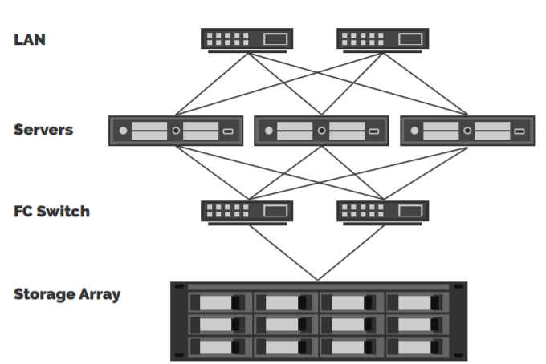

Figure -1: a typical SAN structure
SAN is found to provide specific access to all the storage arrays and thus its name started to be used as “a storage array providing block-level storage.”
Virtualization technology
with lesser and fewer physical servers in order to manage, the administration servers became easy to manage and tolerate. With few firmware updates, hardware updates during new cycles and a fraction of repairs in motherboards. The virtualisation has a great impact on the organisation in terms of changing their networking game completely. This can be served with an example as before virtualisation, there could have been two data cables foe each server that is under operation but as post virtualised environment is seen and portrayed, only two data cables for hypervisor works well. Hypervisor has many virtual machines attached to it to utilize all the physical links. This intern create oversubscription in links of networks as compared to the traditional legacy model
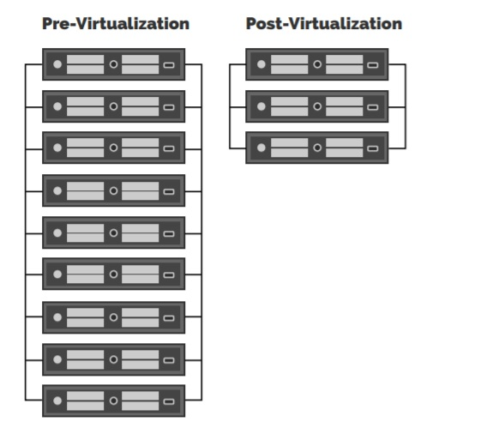
Figure-2- The image showing lesser network load using virtual machines and hypervisor
With the use of hypervisors and virtual machines, performance of the network setup enhances to manifolds.
Virtualisation basically is nothing but a set of software as discussed above, it runs on virtual hardware’s ((virtualization using virtual machines and hypervisor).
Virtual machines basically are a virtual operating system which can also be known as virtual machine or guest machine. It performs the basic tasks of providing a platform to the hardware that eventually provided virtual environment to operate for any guest operating system. This works along with the hypervisor as hypervisors are nothing but monitors for efficient working models of virtual machines, it is also known as virtual machine monitor (VMM) and is a specially designed software which runs on the host hardware platform and it finally performs the task of supervising the virtual machine execution.
There are two types of virtualisation using any virtual machine depending on the type of hypervisor used for them. [7]
- A type 1 hypervisor, it is called as a native or bare metal hypervisor and is directly hosted on the underlying hardware.
- A type 2 hypervisor, it is also called as a hosted hypervisor and is hosted on top of a host operating system.
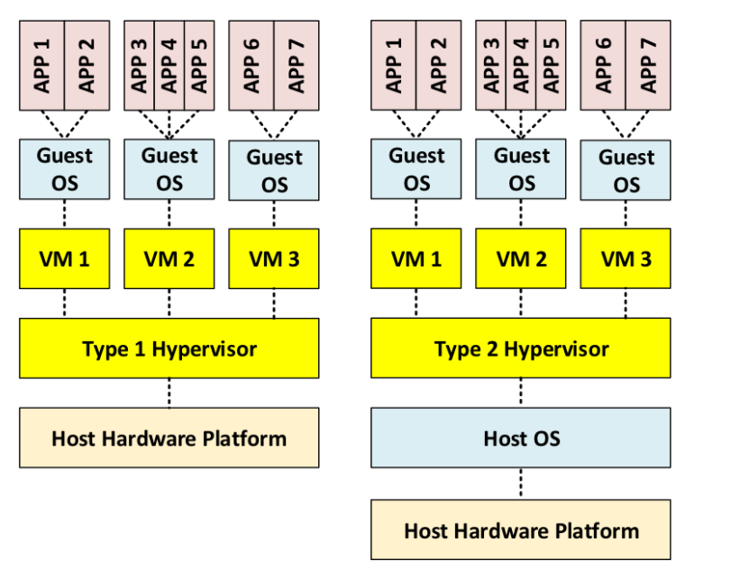
Figure- Virtual machine virtualization through hypervisor 1
There is notional diagram below that exabits the implementation of 14 software that are running on guest OS and are basically deployed on only 7 virtual machines which are currently running on Hypervisor 1.

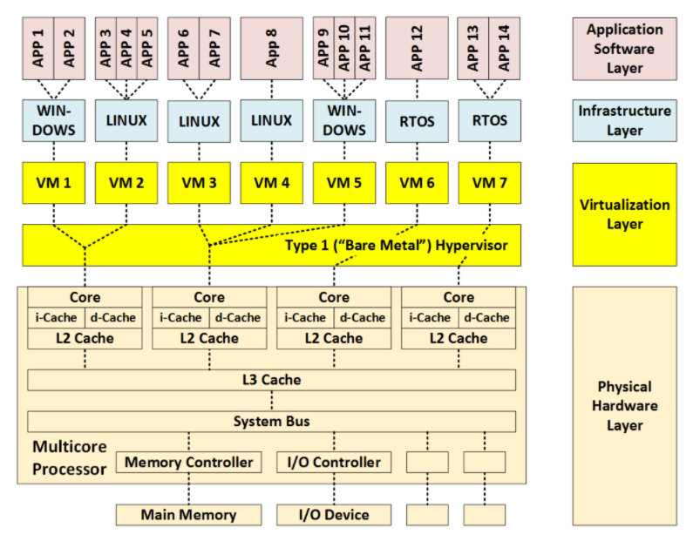
Figure-3- hypervisor type 1
With hypervisor 1 there are basic advantages that can be seen in the given diagram
- Additional virtual layer is added which consists of two sub layers
- Simulated hardware environment is created
- This enables the use of different operating systems
- It provides a measure for physical and temporal isolation.
Virtual machine Virtualization using a Type 2 Hypervisor
As in a similar scenario with the previous diagram, the given figure shows a hypervisor type 2 and how it is different from hypervisor 1. Apart from just providing virtualisation layer, hypervisor 2 provides two new infrastructure layers. One considering to be the host operating system layer and other one be the guest operating system layer. Though the approach is somewhat similar to the previous approach but has a more complex structural built and it prices the usage of operating system as a single point of failure and source.

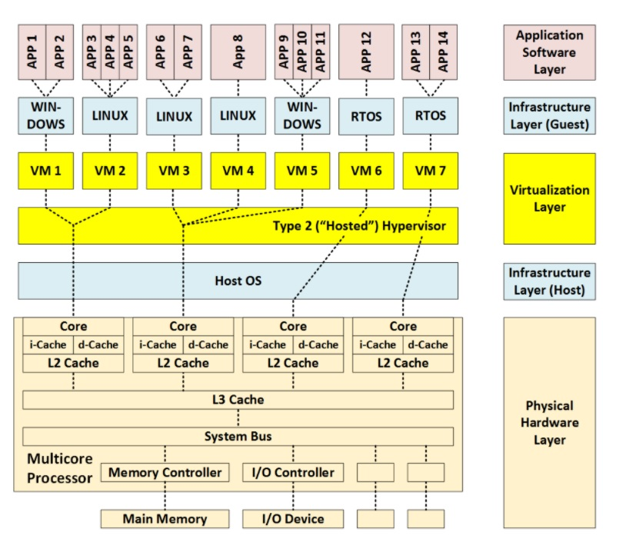
Figure-4- hypervisor type 2
Virtualization through the use of virtual machines has become extremely common for IT applications, data centres, and data storage at cloud server. Likewise, VM virtualization is progressively seen in processing (mass storage), virtualization, and portable devices (particularly for virtual smart phone evaluation).
On the other hand, virtualization through Virtual machines has considerable limitations regarding their overhead time / space and the volatile nature of the effect of the hypervisor on scheduling. Cloud computing mostly through virtual machines could therefore be improper for several kinds with real-time, safety-critical as well as safety-critical structures, including such industrial software, Internet of Things (IoT) as well as active combat operating systems.
Data centre architecture for UWTSD
- Overall scenario -As the overall scenario for what the UWTSD thinks of the current system and why the implementation of a virtual data centre is needed has been discussed in the case study. It is mostly important to understand why the data virtualisation is needed in the origination in terms of its architectural requirements. The overall scenario to be discussed for data virtualisation, we understood the needs depending on the server size campus requirement and the usage of data processes within the organisation. As mentioned, and subjected by the organisation. The server connectivity is needed for all the campuses involving a construction of an integrated server system that can virtually provide data network solutions throughout.
- As UWTSD has three campuses so an integrated SAN network and individual servers are needed to equip and interknit such a vast virtual network zone.
- Physical limitations- There can be many physical limitations to the virtualisation of data centre in UWTSD or any organisation in general-
- The major limitations of a running internet service which integrates the clustered and a huge network zone as when it goes offline, all the websites which are hosted within the network goes off. To overcome this, a larger cluster of servers are needed to be created.
- Managements of the virtual environment needs regular instantiation, monitoring, configuration and savings throughout.
- It becomes physically difficult to have an indirect access to the hardware’s in such a vast infrastructure.
- To manage the performance of the virtual network, there has been no such consolidated approach in order to scale and measure the performance as such
- As not all infrastructures can be changed and rectified, it becomes difficult to run all the virtual machines on the same host as it hinders if the host computer is lacking sufficient power.
- Multiple links require a chain that works together.
- RAM consumption occupies a great space
- Scalability- it will help in making the infrastructure more affordable and efficient as it trades the physical servers for the virtual machines. This increases the options for scalability. [8]
- Load balancing- refers to the efficient distribution of incoming traffic across a team of backend servers, also recognized as data centre or server pool. Contemporary high-traffic webpages should represent hundreds of millions, if not thousands, of concurrent requests from users and customers as well as revert back the correct text, images, video or application data in a fast and reliable manner. [9]
Load balancer behaves as just a traffic cop lounging next to your data centres as well as forwarding service request throughout all data centres able to respond to certain queries in such a manner that optimizes velocity as well as greater stability and guarantees that no database is overstressed, that could present problems. When a singular server is down, the task scheduling device reroutes congestion to a surviving dedicated server. Whenever a new server is introduced to a server group, this same load balancer would then simply send queries to a server group.
In this manner, the load balancer provides the following steps:
• allocates user request or system loads effectively along all various computers;
• guarantees optimum stability and performance by requesting access to dedicated server only.
• allows ease to add or remove servers as dictated by the demands
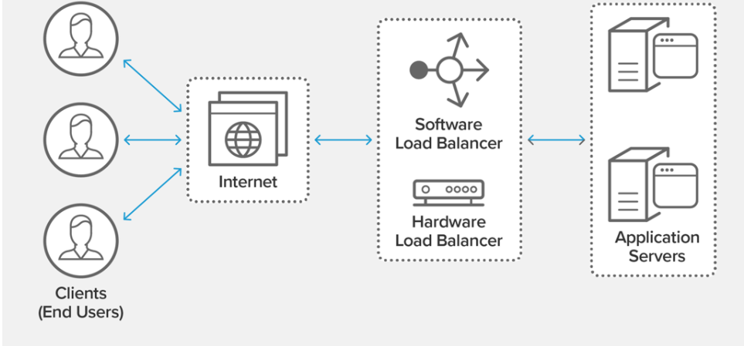
Benefits of using load balancing
- It reduces downtime
- Makes the server more scalable
- Redundancy
- Makes the system efficient
- Increases flexibility
- Global load balancing
- Security and reliability- Data virtualisation needs reliability and security in order to monitor its framework. To guide the design of Hyper Tap, a hyper visor-level framework that effectively supports both types of monitoring in virtualization environments, we identify the commonalities between reliability and safety. In Hyper Tap, device events and state logging are standard across monitors, and is the centre of the framework.
- Risk and control involved in virtualization
Various risks and control measures are analysed by cloud security alliance, these recommendations are very important to be undertaken for smooth functioning of an organisation so must be taken care of while designing a data virtual system for UWTSD, including all its interknitted campus servers. [10]
These risks involve-
- Virtual machine sprawls- there is a chance of proliferation of unpatched and obsolete servers within the server environment
- Within a virtual machine, there is a possibility of compromise of sensitive data
- If virtual machine remains offline for long, it can lead to deviation from the secure baseline
- If approp4riate security isn’t there, there is a possibility of unauthorized access to the VM
- Excess movement in the environmental may lead to lack of visibility and control
- Resources may get exhaust due to over-allocation
- Compromise in hypervisor security as it is just a software that is always on risk of getting compromised easily.
- Service and account hijacking are quite possible in such cases where self-service portals are there
- Workload on different trust levels as located on same server leads to exhaustion
- There is always a risk due to cloud service provider APIs
- Storage area networks- as discussed above, as and when it is implemented along with SAN, virtualisation provides a single source management point for all the storage sources. Virtualisation pools down all the physical storages from different networks to present it in a set of virtual storage.
- Energy consumption- virtualization is usually performed so that it is worked on an x86-based server that are consistent enough instead of working on the already arranged hardware that’s been manufactured and a specifically devoted device by the manufacturer. By working in a few consistent servers, it can diminish the wastage of equipment and adapt with the alter much appreciated to fast equipment improvement. This ponder makes it possible to propose a more effective setup and framework of decreasing taken a toll in arrange server operation utilizing such NFV innovation and found that the fetched was diminished by 24% compared to existing arrange hardware. The strategy proposed in this ponder is anticipated to be an establishment innovation for future maintainability computing.

Conclusion
From the whole summary provided for the university needs and requirements, it can easily be summarised that data virtualisation is the best possible way to enhance the organisation’s IT department and to implement the technology with prompting benefits that includes zero replication, integrated view of data from all the campuses without any movement if the robust structures or any kind of replication done to the infrastructures. Data virtualisation has emerged as a solution which has been allowing the organisations to present their data in a virtual manner with more safer network setup. In conclusion to all, data visualisation can enhance the data progression in the organisation and thus is recommended as the best solution for integration, implementation and security of data.

References

[1] | Y.-P. A. L. K. a. B. Z. Tsaur, “ "Application and file system data virtualization from image backup.",” august 2013.
[2] | A. R. T. a. T. N. kasoju, “ "Method and apparatus for data virtualization and display.",” pp. 12/945,399., 2012.
[3] | M. A. I. H. T. B. M. &. A. A. Karpathiotakis, “Just-in-time data virtualization: Lightweight data management with ViDa. In Proceedings of the 7th Biennial Conference on Innovative Data Systems Research (CIDR) (No. CONF).,” 2015.
[4] | A. B. Fokoue-Nkoutche, “"Data virtualization across heterogeneous formats." U.S. Patent Application No. 14/467,640.,” 2016.
[5] | M. F. bari, “"Data center network virtualization: A survey." IEEE Communications Surveys & Tutorials 15.2 (2012): 909-928.,” 2012.
[6] | C. Guo, “"Secondnet: a data center network virtualization architecture with bandwidth guarantees." Proceedings of the 6th International COnference,” 2010.
[7] | A. Blenk, “"Survey on network virtualization hypervisors for software defined networking.",” 2015.
[8] | D. Talia, “"Clouds for scalable big data analytics." Computer,” 2013.
[9] | A. M. K. a. D. M. Singh, “"Server-storage virtualization: integration and load balancing in data centers.",” 2008.
[10] | J. a. J. G. Helfman, “"Data visualization techniques." U.S. Patent No. 8,640,056. 28 Jan. 2014.,” 2014.

Data Center Virtualization-Scenario 2

Introduction

Swansea Data LTD which has three physical data centre and one virtual data centre is successfully managing their business data. Two types of services are being offered by this company who pays a fee for it- Cloud storage and virtual service. Hardware and software systems are carefully established at Swansea for safe and secure browsing for the premium customers. The high-end fibre connection is connecting all the data centres and establishing a secure connection to every customer and developer. Although security policy and organization design play a crucial role for the company like Swansea Data ltd. To run a virtual data centre without any interruption it is required to implement a disaster recovery plan along with security policy to cope up with any kind of security or production risk. Along with this, it is required to focus on strengthening the security of this virtual service hosting company because it has the bulk of confidential data all the time. To protect confidential data from corruption it is required to use SAN so that only authorized users could make changes to the data and storage [6].

Importance of information security policy in data centers
To maintain quality and security in data center resources it is required to make information security policy that can restrict unauthorized users from access and manipulation of data. The data center always stores and hosts enterprise data and application and maintaining its security is the critical requirement of a company like Swansea Data ltd. As of now, the company has three data centers and they are located from some distance to one another. Due to any disturbances in form of Storms com of flats or any serious cyclones that can destroy the connectivity between these data centers can cause productivity loss for the business and it is required to set up a class study covering plan along with the information security policy to maintain the uptime 24/7 [3]. In these key areas, there is a need to analyses the physical condition and environment also along with data safety because maintaining uptime is the primary requirement of any physical or virtual data center. Apart from this if a security policy is generated and implemented by the company then it can help to prevent unauthorized access to the sensitive data as well as cybersecurity risk could be mitigated on the exact timing. Data centers should always function like they include a hierarchy of validated structure so that even the visitors could be asked for verification every time they log into the system [1].

Importance of disaster recovery planning

The data protection method is defined as the safeguarding process of information from corruption, compromise, and losses. Data protection is an important parameter for any company because as fast as data grows in company with increased rates and handle such growing data is so difficult and challenging [5].

1. It is also important to discuss security surveillance devices so that not any user carries hardware or storage devices or outside data centers. This can result in loss of sensitive data if anyone carrying disk containing confidential data takes out from the security. Apart from virtual security, there is a need to set up physical security also for the physical data center because data break and criminal activities could cause use loss for the Enterprises who are the premium members of the company.

2. There could be some legal standards and guidelines for the company and the user who gives ATI physical data center for those who are logging in the virtual data center because I doubt any restrictions there are more chances of getting caught of risk and threat activities.

3. It is very important to protect the equipment because power outage or natural disaster can also result in downtime of the business and that does not guarantee that if the system fails how long it will take to resume.

4. There are more than one premium users for Swansea data limit and if redundant data which is stored in physical and virtual data center lost then that can be the reason for weak security policy. There should always be backup for the company because due to lack of backup there can be a complete disaster for the company. For power outage or power failure, there should be the availability of alternate solutions to resume power as early as possible.

Importance of SAN in Swansea Data Ltd

Storage Area Network is the high-end network and subnetwork that allows the sharing of storage devices and it works in the interconnection of multiple servers. This type of high-end network allows users to reorganize their common shared resources in a more secure independent network so that high performance can be achieved. In short, SAN is known as a tightly combined network where it works like a block-based network, it is difficult to manage and also complex to set up. Due to complexity, it is hard to be hacked, and also, there are multiple layer restrictions to block unauthorized users in the network. If Swansea data ltd use such type of network that can help in protecting sensitive data of the premium users. SAN works on the mechanism of Internet Engineering Taskforce and internet protocol suite, which has a set of standard rules and policies to use such types of shared resources. Premium based cloud storage and virtualization service can be more secure if, SAN protocol is being installed in the current infrastructure [2].

.

Conclusion
In this report, the discussion of Swansea Data ltd has been presented along with the importance of security policy, disaster recovery plan, and implementation of the SAN network. Virtual space and virtualization are the high-end technology that allows users to share the same hardware and software so that network operating cost can be reduced, and enterprise can easily store their data on virtual space. Every day there is a bulk generation of data, and to manage high volume data, it is required to set up some safe and secure environment. Cloud and virtualization are the primary requirement of many businesses today and to make it secure, data center companies like Swansea should always focus on spreading strong information security policy.

REFERENCES

- Linux Foundation, T. (2013). How To Build Your Virtualized Datacenter Using Open Source, Linux, KVM and Xen, Part 1 - Linux.com. Retrieved 18 July 2020, from https://www.linux.com/training-tutorials/how-build-your-virtualized-datacenter-using-open-source-linux-kvm-and-xen-part-1/

- Parlinska, M. (2017). CLOUD COMPUTING AND ITS BENEFITS. Information System In Management, 6(4), 309-317. doi: 10.22630/isim.2017.6.4.5

- Services, P. (2020). Distributed Virtual Data Center for Enterprise and Service Provider Cloud. Retrieved 18 July 2020, from https://www.cisco.com/c/en/us/products/collateral/ios-nx-os-software/ios-xr-software/white_paper_c11-694882.html

- Sharma, S., & &rarr;, V. (2020). Should You Outsource or Set Up Your Own Data Centres? | Ricoh Data Center. Retrieved 18 July 2020, from https://www.ricohidc.com/kb/should-you-outsource-or-manufacture-data-centres/

- Tsugawa, M., & Fortes, J. (2009). Characterizing user-level network virtualization: performance, overheads and limits. International Journal Of Network Management, 20(3), 149-166. doi: 10.1002/nem.733

- WEN, Y., MENG, D., & ZHAN, J. (2014). Request Behavior Characterization for Data Center Application. Chinese Journal Of Computers, 36(5), 1004-1014. doi: 10.3724/sp.j.1016.2013.01004

