From Digital Battlefield Warriors to Young Leaders :

A Critical Literature Review
Table of Contents
Introduction 3
What are Esports? 3
Evolution of Esports 4
History and Growth of Esports 4
Different games and genres 5
Video game culture 8
Esports as an Extra Curricular Activity 10
Leadership in Esports 10
Social interactions and Team Dynamics 10
What is leadership in the context of Esports 11
Types 11
What it might look like in 16 to 18 year olds – Youth Leadership 11
Case study 12
Empirical Studies on Adolescent Leadership Development 12
Psychological Aspects of Esports 13
Resilience and Emotional Intelligence in Competitive Gaming 13
Player Development and Coaching 13
Impact of Esports on Collaboration and Task Completion 14
Importance of leadership in esports 14
Strategies in Esports Team Management 14
Gender Differences in Esports 14
Positionality theory 15
Conclusion of the Critical Literature Review 15
References 17

“There is a field called ‘Game theory’ which has something to do with games, a lot to do with psychology, even more to do with math, and not a lot to do with game design” (Koster 2005, p12)

Introduction

What are Esports?
Since Esports is a developing term, and a keyword used throughout this paper an explanation is needed to fully comprehend what it is and to explain the study in more context. Hamari & Sjoblom (p.211 2016) explain that Esports are electronic versions of sports arrangements, and declare that it is “a form of sports” where there are arrangements made, rules to follow, and organisations set up that permit game players to compete against each other. These competitions can be local or LAN and similar to the ‘grass roots’ form of regular sports, but can also be nationwide and involve sums of money as an incentive to win (see image below).


Figure 1 UK based Esports Team Tundra wins £7.4m (Malvern 2022)
In their own right these video game players involved in Esports become celebrities, and national treasures and there is a career available for the best players, and to give it a context in 2022 the Esports audience amounted to approximately 532 million (Geyser, 2023). Here we are focussing on the primary aspects of Esports, Hamari (p.211 2016) allows us to develop a conceptual understanding based on how we may already view sports that there are professionals involved, league tables and an audience. These competitions can be LAN games that are locally set up in players houses, or can also be organised events such as the Insomnia Gaming Festival that takes place in the Birmingham NEC each year and is attended by some 40,000 people. As Esports gains in popularity, the games with the required speed of internet connection can be played online with gamers from different countries.
So there is already a significant audience, and participants involved in the gaming. But how exactly did Esports start and become so popular?

Evolution of Esports


History and Growth of Esports
Whereas the term Esports seems to be something quite unfamiliar to most people, the competitive playing of Computer, Video and Arcade Games has been a popular pastime since the 1950’s (Larch, 2023). The first popularised computer game ever made was Spacewar! (Martin, 1981) which allowed players to battle against each other by controlling a spaceship around the screen trying to hit each other – effectively a space based ‘dogfight’ (Collins, 1991)
Figure 2 Spacewar! the first popularised computer game 1962 AniGIFs (n.d.)
Significant changes took place in Competitive Video gaming during the 1960’s, 1970’s, 1980’s with Arcades and home video gaming. In 1979 when dial up modem access allowed gamers to connect to shared computer a primitive form of network based game play in the form of Multi-user Dungeons (LivingInternet, n.d.).
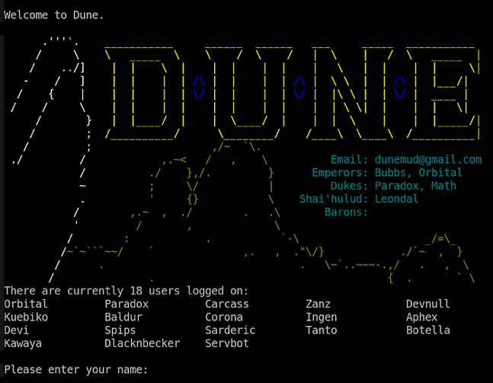
Leadership development skills began to emerge in digital gaming with the introduction of Multi User Dungeons, or MUDs (Andruid, 2023). MUDs allowed users to engage in a real time interactive world where they could type commands as shown to to move around the world, interact with story characters and communicate with one another. This ultimately led to the forming of alliances and teams to help each other in the mission, collaborate and combat one another. This early form of online gaming was revolutionary in that it introduced complex social interactions, as well as creating a level of cooperation and strategy that had not been seen in gaming before.
Figure 3 Multi User Dungeon Andruid (2023)

Within these digital landscapes leadership skills began to develop, as players were required to negotiate and collaborate on decision making which ultimately led to a gaming outcome not just for themselves but also their teammates. This is clearly a rudimentary form of digital interaction that is seen in leadership dynamics that can be observed in modern esports competitions today. The communication abilities required in a group to move towards a common goal laid what could be called as the groundwork for leadership skills seen in competitive gaming successes.
From the engagement and interaction of these text based adventures, leadership skills started to form and in the 1990’s when the Internet now allowed computers to connect to each other; games which were becoming much more graphical ultimately became more immersive and allowed gamers to connect to each other in another form. So as computing systems became more powerful and games more engaging a new level of entertainment was developed which now became Esports as we see it today.
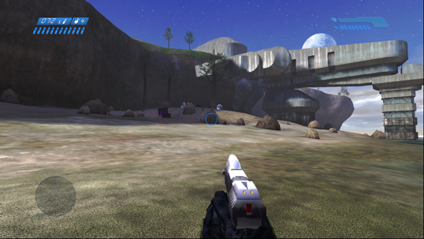  Figure 4 Halo 1 Jerasunder (2021) | 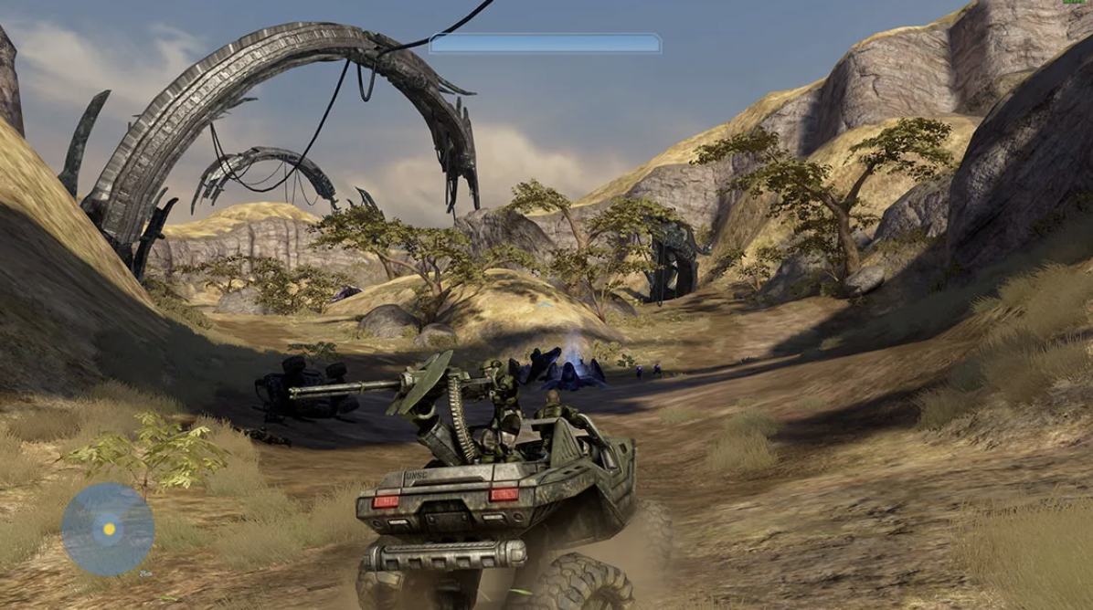  Figure 5 Halo 3 Clayton (2020)
To develop a sense of awareness, it is necessary to take one game that has been around for quite some time “Halo” and is constantly being re-released with newer and up to date graphics to make use of the additional Computing power. This meant more guns, more vehicles to drive and different game play all within a space world.
Halo generations (Halo 2001, Halo 2 2004, Halo 3 2007, Halo 4 2012, Halo 5 2015, Halo 6 2021)
This example is a sort of cycle of events, new computing power is developed, the games are written to take advantage of this and then in turn Esports ecosystem is also continually changing (Scholz p.3 2020). Whereby the players will purchase the games, the popularity increases and consequently the organised events and audience that surround the game playing becomes more lucrative, with bigger wins and bigger prize money specially if games have only recently been released and audiences wish to see how to complete certain levels.

Different games and genres
Esports itself is an organised version of computer game playing, each game will fall under a specific genre that will define the gameplay an possible strategic aims (Wirtz, 2023). Is a brief overview of each genre, supported by an illustrative screenshot in an attempt to exemplify gameplay dynamics:
A First Person Shooter is where the player is seeing through the eyes of the character they are playing, and effectively have two arms in front of them holding whatever weapon they are carrying.
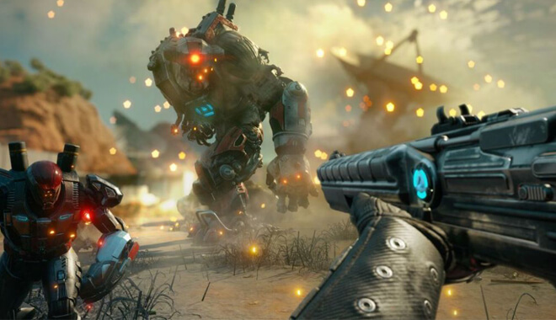
Figure 6 Rage 2 Musa (2018)

Real-Time Strategy involves the management of resources, troops, trains to accomplish an objective, this is usually controlled via a mouse click.
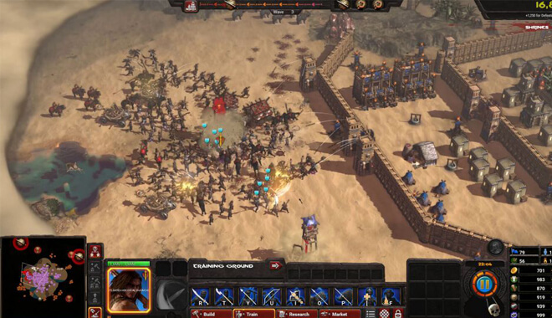
Figure 7 Conan Unconquered Skiffington (2019)
Role Playing Games are often from a third person perspective, and allow the player to see the whole of the character and control them around the world in which they reside. The game play is based on the character having an adventure, fighting something, looking for artefacts.
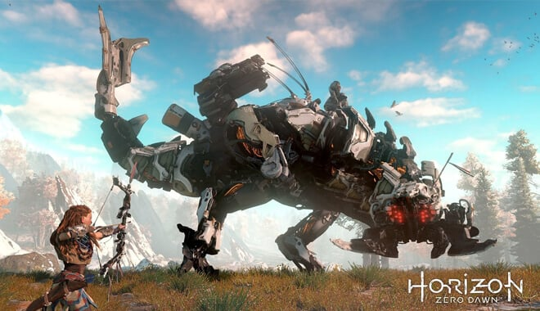
Figure 8 Horizon : Zero Dawn Higton (2017)

Massively Multiplayer Online Role Playing Games
These types of games are played from a top down perspective, and the characters are part of a large story and can be played over many months, or years even. The players can upgrade their characters as stories unfold and continue to add artefacts including better armour, better weapons and such like to make missions easier to complete and players to last longer in the game.
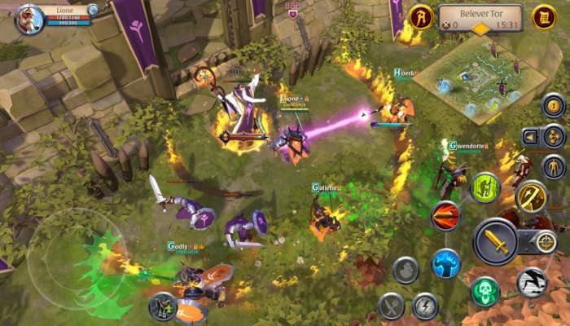
Figure 9 Mobile MORPGs Fanelli (2023)
Multiplayer Online Battle Arena
Originated as a MOD for an MMORPG (Wikipedia Contributors, 2023) which allowed players to continue one aspect of an otherwise larger game like that shown in the previous game type. This type of game is driven by strategy, and allows the players to engage is just the one aspect and play a game for 40 minutes to 2 hours at a time in Battle Arena but with no character progression.
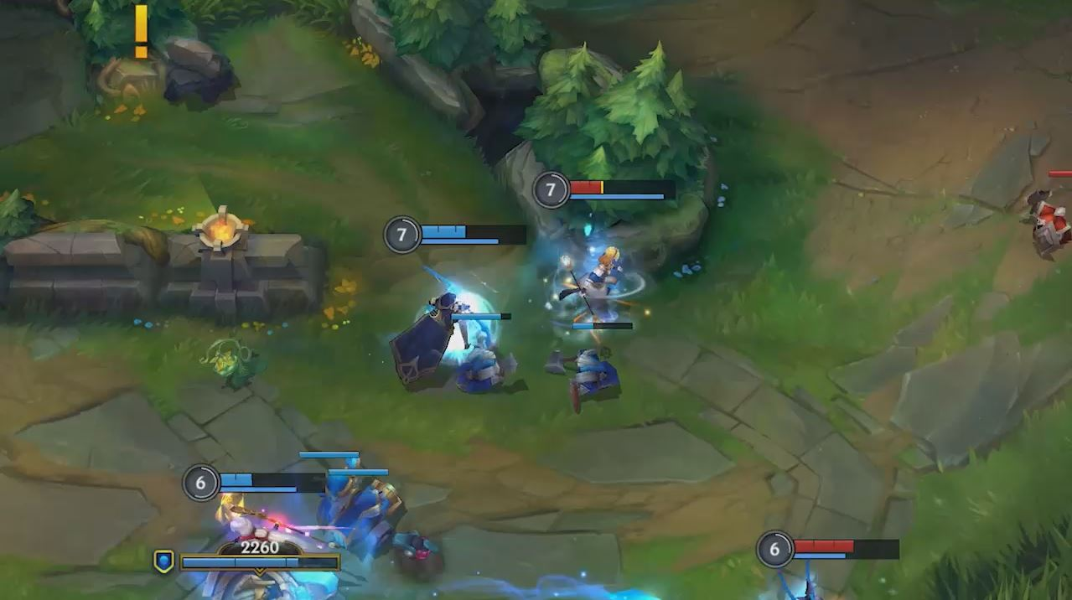
Figure 10 League of Legends Fisher (2022)

Video game culture
Understanding the point of view how the Gaming Industry is so popular (see history and growth of esports) the developers of games have created concepts, worlds, activities that people want to play. To make a great game developers will spend some considerable time searching their own interests and making something they themselves want to be involved in as is the case of Shigeru Miyamoto the creator of Pokemon (Rouse, p.12 2005). The reasons why Players want to play (see table 1) is a mixture of different aspects of Psychology and will initialise this study by reflecting on how when a group of people are put into an environment of free will, a natural leadership will ensue which is very reminiscent of the 1954 book “Lord of the Flies” by William Golding and much like in the novel with no parental guidance the leadership position had no inhibitors and ran completely out of control.

Table 1 Why Players Play (extracted from Rouse 2025 p.2-8)
Players want a Challenge | When a person faces a challenge and then overcomes it, that person has learned something.
Players want to Socialise | Play games to have a social experience with friends or family
Players want a Dynamic Solitary Experience | Contrary to the previous point, not all gamers want the social experience and like the solitude invited to them
Players want Bragging Rights | Winning a game often ends in winning respect from fellow gamers
Players want an Emotional Experience | Games can be an exciting experience with an adrenaline rush, and will afford great satisfaction
Players want to Explore | Exploring new spaces and seeing new environments
Players want to Fantasize | Digital storytelling is an art form, and players want to immerse themselves within this form of art
Players want to Interact | To talk to one another and to discuss, and engage is where leadership comes in

The term play has a general definition attached to it in some academic circles, whereby play can be associated with free movement within a more rigid structure Zimmerman (p.159 2008). There are some games that allow this sort of free form, allow players to explore strange new virtual worlds, interact with characters and game situations too allow them to progress further into the game’s story.
Transformative play Back et al. (p.18:3 2017), which can develop over time as the players are working their way through the game allow a chance to increase skills, and further progress into the game. For example, they may be adopting one of a number of different strategies in order to meet a particular aim, but the rules of Transformative play suggest that in order to accomplish a mission it would be better to adapt a new approach if the previous one did not succeed. Thus, forming a new approach and the result of a collaborative effort in understanding how to proceed. With each of the transformation happening multiple times, and with multiple teams that could be involved in Competitive video gaming, it means that each of the transformations that occur within the game play will be the result of a leadership element involvement. Therefore competitive play is the ideal environment to present a natural occurrence on the interactions required, and each team will adopt a strategy to surpass the opponents and ultimately win the round.

Esports as an Extra Curricular Activity
Since video gaming is usually an outside interest, there are opportunities afforded to students that allow them to be ear marked as leaders by those that are delivering the Esports courses and arranging the competitions. When I started the Esports Academy, I noticed that students would not speak to each other much within the classroom environment, and there were pockets of students who had formed friendships outside of the classroom in these games. This meant that I looked for a means to allow students to form those friendships on a wider scale. The Esports Academy was an effort to form friendships and bring people closer together.
An extra curricular activity has the potential to increase and individuals outlook on life (Buckley, 2018), and the academic abilities as well as the application of their knowledge. As is the case with Esports the individuals that are taking place can practice this several different things which are not obvious at first glance. The arrangement and commitments of the students may differ but would probably benefit from a weekly competition, with training opportunities in between. As noted by Buckley (2018) the only clear indication of there being an improvement through an extracurricular activity is via those that are dedicated to the cause. This allows the generation of cognitive connections and understanding how to put this in place in future.

Leadership in Esports
Leadership in Esports should be seen a naturally occurring facility, with a trained professional observing exactly what is occurring within a team dynamics, and observe how the game is played from beginning to end. This development will be reinforced, developed, and reflected on as the games are being continued to play. It is therefore crucial to focus on the social interactions and team dynamics (Tang, 2018) of the Esports players and how they are collaborating together. This in itself is a social interaction, a communication within the Team in order to relay complicated information very quickly.

Social interactions and Team Dynamics
In the interim, it must be said that a group of people that are working together to complete a common aim will often “sort themselves out” with the more alpha type personalities taking overall control off the situation at hand, and each problem as it arises to look for the best outcome. Which ultimately means winning the game, an winning the competition. Seeking naturally occurring, embedded type social interactions the conversations will be scrutinised and understood. There is much to be said about choosing a team, but in this context the team selection may not actually be possible so it is the interactions that are paramount to understand what is going on, without previous history. A significant point that draws these concepts together is suggested by Sousa et al. (2019):
“Games can be designed to potentiate the training process through a virtual world promoting the
social interaction and competencies development.”
Which relates to games that are played with a storyline, so that the actors (the players) can develop their leadership skills and the decision making processes that coincide with it. The relationship between Game Based Learning, focusing on pre-determined and defined activities to encourage the set leader to look at making the correct decision. This is a useful notion in terms of this critical literature review, as it delves into the idea that Virtual Worlds are an effective place to learn leadership skills Chrino-klevans (p.11 2017) but introducing the possibility of a naturally embedded environment. The learners are not positioned within the game to learn the skills, but rather the educated facilitator will look for scenarios, situations and interventions that would encourage the 16 to 18 year olds to develop those skills used later in life to lead.

What is leadership in the context of Esports
That said in terms of leadership in the context of Esports, what leadership qualities are being observed, throughout the duration of the Competition series, since this will not be able to be evidenced in just one game as the personalities will take time to develop and reveal themselves through the gameplay. There will be opportunities whereby other players will take on board the leadership role, and develop that in a sense themselves.
Since each game, and even each game section will have a Teamwork effort or a collaboration there will emerge a leader amongst them. It has been noted before that even in such cases as harder upbringing will equal a life long resilience – Gurkhas as a prime example of this whereby they have grown up in a particular harder lifestyle and as a result be ferocious warriors when placed in front of an enemy with a task to complete. This so called up bringing could result in the development of a family history of environment, maybe the team workers were the younger siblings and therefore did not have experience of being so called “in charge” at any point. Stanford University in 1971 set up environments (Texier, p.1 2019) were set up whereby volunteer students took on the role of either a Prisoner, or a Warden it was at this stage that the personalities started to reveal themselves and become those leading, those managing, and even those bullying the Prisoners. Reflecting on this self directed, and self arranging model of Leadership is agreed by Logan et al. (p.4 2011) which states that the “leader upgrades the tribe, as the tribe embraces the leader” in a circle of events that are socially constructed. Additionally, they state that “Tribal Leaders know how to nudge language” and state that there can be such a thing as a natural leader. So the opportunity to observe this in development in the context of Esports is an exciting one in having a tribe set up that has those naturally occurring, and naturally embedded skillsets.

Types

What it might look like in 16 to 18 year olds – Youth Leadership
In order to apply a cross sectional analysis between the two elements; Esports and Leadership, I have taken the initiative to investigate and report on what Leadership in its own right may look like in the same age group outside of the Esports “Arena”, this way the same sort of social interactions can be observed and commented on in a like for like basis. Sousa et al. (p.362 2019) suggest both Transactional Leadership and Transformational Leadership being the most appropriate for Game Based Learning (GBL) and most applicable to this study.
Transformational Leadership is developed by a charismatic individual, whose “vision, respect and trust” (Sousa et al. p.362 2019) is followed by those individuals that are lower down in the hierarchy of command. Transformation of leadership is defined as a leader who has charisma, and is an inspiring and engaging individual. This type of leader has the ability to develop trust, respect, and admiration which in turn influences those under their care. They have the ability to but their own self interests aside, in order for the organisation or team to succeed. These types of leaders challenge and encourage creativity, and will even create and foster an environment where followers/team members feel valued and empowered to make decisions. They are often aware of the needs and development of team members, transformational leaders keep a close eye on developments and aim to elevate and improve standards throughout. As Menon (p2. 2021) states that this form of leadership is effective in times of change, the Esports arena is any state of continual change and well suited.
Transactional Leadership (Antonakis, 2014) however is based on what can be termed as a favour exchange, whereby those under the leaders care are rewarded for their efforts and given some sort of roles and responsibilities later on. Leaders who make use of this style can set clear objectives, establish those standardised procedures and monitor performance very closely. The achievement and compliance is typically rewarded, and a figure results in corrective action. This form of leadership may not be well suited to youth development.
Those highlighted above dictate what Leadership Model may be present in Game Based Learning; on the other hand Sheriff (p.2 2017) suggested that Youth Leadership does not fall into a mould. That Leadership in Youth does not come with an understanding of businesses, for want of a different expression manipulation, coercion and control. Youth live mostly in the social constructs of their world, and so when considering applying a GBL Model to it what emerges is lack of experience in the Youth and even a possible resentment for being placed under the direction of someone they do not understand.

Case study
The following case studies represent those ideas that sit outside of the context of Esports but can be applied since they are within the same age group, and have demonstrated some similarities in terms of how the same theoretical approach can be applied:
Foroige is a national youth organisation based in Ireland, which in 2009 developed and run the Leadership for Youth Programme which engages some 750 people annually (Redmond et al. p.262 2016). The paper also describes and confirms that Adult Leadership can be taught, but Youth Leadership should be learned by doing, and a fitting experience whereby the students will engage and interact with one another is in Esports. This leadership for youth programme engages and emphasises “learning by doing” which is a particularly relevant and dynamic interactive environment of Esports. This approach support that leadership skills which are taught to adults, are most effectively learned through practical experience among the younger subjects. Taylor et al. (p.7 2019) posited that experiential development is evident in Esports as players collaborate and compete which effectively practises leadership skills, therefore having leadership development practises in esports could very well serve as the next avenue for youth leadership education.

Empirical Studies on Adolescent Leadership Development
Tackett et al. (p.829 2023) announced in their 2023 paper that there is a lack of empirical evidence for Adolescent Leadership and have asked for research to be conducted and empirical evidence gathered in this age group. They have stated very early on in the paper that leadership among youths is “poorly understood” so with a main focus on seeking to understand what is happening during these conversations there does not appear to be an agreed leadership methodology. There are several points of interest to note as Tackett et al. (p.830 2023) there are “missed opportunities for the youth to recognize” this leadership potential. Engaging in Esports is one such opportunity for development, as I am looking for communication to be used in order to help achieve an aim. For the students to be able to understand and recognise the process for themselves means that the development of these leadership skills should in fact be a naturally embedded method and not one whereby leadership Education is delivered entirely using gamification.
Furthermore in understanding how to develop Leadership in students Tackett et al. (p.830 2023) suggest that the development of leadership in this age group is compatible with adolescent development. Which presents a scope opening in seeking further information, and adding wider reading in and around the subject and adding more value to the field to understand the leadership development. They have also suggested that leadership in itself starts at an early age and “emerges in childhood” Tackett et al. (p.830 2023), and has the potential to develop into key skills amongst other things such as social dominance and self-control.
Higher Education establishments have already made a move into developing leadership through extra-curricular activities. Eva et al. (p.15 2021) make reference to adventure learning which is an aspect of experiential learning and applicable to this study, and also study abroad programmes so that the students can immerse themselves into an event or learning scenario and develop the skills there. This is a step away from the formal classroom engagement for leadership development, and more towards the unconventional style of leadership development that I am seeking.

Psychological Aspects of Esports

Resilience and Emotional Intelligence in Competitive Gaming
Manley (2023) is quoted as saying that for students to develop resilience they must be prepared to fail and be ok with it. This helps them to adjust, reflect, come up with a plan of action and move on. Declaring that failure is an option, which is contrary to the often quoted “Failure is not an option” it is the development of what the individual does after the failure is key. This is the mark of the individual and is a key element to the development of an individual first to lead themselves but further more to be placed into the position of leadership.
Resilience in itself seems to be a key word, a buzz word of late that means in order for someone to be able to deal with difficult situations and opportunities that present themselves from time to time. If someone has resilience they are able to handle these situations and still be able to get the job done. This is not often a situation whereby an individual can cope with multiple stresses at the same time.
Emotional intelligence supports the resilience part as mentioned by allowing students of this age group to manage other members stress levels, and ability to complete a task. Competitive gaming can be a high stress event, especially when there are high stakes and monetary value involved. Audrin et al. (2023) state that emotional intelligence is about self-control, emotionality and social-ability which has an influence for others in the team. If the whole situation is turning bad and others in the team are struggling to ‘keep it together’ then the one person who is ‘keeping it together’ will be a positive influence on the outcome. This sort of influence is not just restricted to one particular game event, but needs to be throughout the competition tournament and an ongoing development. This may be an opportunity for intervention to occur, to develop those leadership skills in the students as a trained professional will be able to see when a good leader will dramatically changed the outcome. Willink (p.41 2017) states that “there are no bad teams only bad leaders”, so if one of the leadership individuals start to ‘crack under pressure’ then there should be significant support within the team for a quick switch over to a new leader and change the potential outcome.

Player Development and Coaching
The coach will inevitably be somebody of a trained position, such as a tutor or teacher who will then provide support to the leader and the team, as well as intervention at appropriate time. Christina et al. (2023) suggest that coaching is most effective when done on an ad hoc basis as the event is unfolding which means real time development will encourage the leadership to develop efficiently. The whole aspect behind coaching is to look for opportunities for improvement in the individual as well as the team. In the context of Esports the role of the coach is critical to help develop the leadership capabilities within the team. Coaching is not just about direct instruction, it is a holistic process aimed at recognising opportunities and seizing the moment to help with improvement, this comes for both the individual and the team. Effective coaching is there for the ability to give immediate feedback and direction to help but the development of the team, and the leadership qualities.

Impact of Esports on Collaboration and Task Completion

Importance of leadership in esports
Aside from the fact that a successful Esports team will benefit from a strong successful leader (Happonen, p2. 2023), who is experienced in playing the game in question there is also the factor but the more intervention that occurs to develop those leadership skills the better the team will become. Each individual member of the team will also develop those leadership skills, which is seen as responsibility for one's own self also seen as autonomy. The team dynamic will be influenced by this strong leadership position, I have seen in my own Esports Academy the development of strong yet subtle personalities in the individuals in those leadership positions “team captain”. And even outside of class the team members have been referring to their team captain, not by name but by team position (e.g. our captain). This has spread itself into other aspects of their studies whereby a trust is built up between the team captain and the other team members untaken this sort of dynamic with them. Garrett (p.85 2023) corroborates this by stating that leadership can be seen in all walks of life.
The actual importance of leadership in Esports is crucial since without a trusted key member in the team the team is simply a group of individuals running around with their own agenda, which may in certain instances work but without a strategic aim to complete the task. Watson (2023) explains what is unusual about Esports and other team based activities, is the way that the players communicate via headsets so at any point during the game messages can be relayed information can be updated and the leaders can make new decisions. For example a previous section that was left open, is now being overrun by the opposition no needs a new tactic to defend and overcome the opponent.
Martes et al. (p.20 2023) states that coaching is one of the key elements where intervention will be most useful, and have the biggest impact on those leadership development skills. The gameplay is very frantic, so there will not be an opportunity to pause and discuss, so therefore recordings should be made and then reflected upon later, it is then down to the leadership to take on board the comments and enhance their team leadership skills. To make those difficult decisions amongst and certainty, with a potential good outcome (this may mean a game that is won, or just time to reflect on how successful that task was under those circumstances).

Strategies in Esports Team Management

Gender Differences in Esports
The differences neurologically between adolescent males and females, is a well documented fact. Peters (L.424 2012) reviews this in terms of the brain make up and how the brain is developed. The female brain multitasks efficiently, and the male brain is task based. Eva et al. (p.4 2021) states that for both male and female leadership development, there should be a motivational aspect which may come from their history and backgrounds, for example a strong parental figure. Furthermore Eva et al. explain that most previous studies, and the emergence of leadership and management development has been predominantly male based. In this instance for Esports, which is a male dominated activity – approximately 95% of gamers who engage in Esports are male (Sports Initiative 2019) there are opportunities to focus on female leadership skills development, as the gamers are available and can still be evidenced as there will be information accessible. Pizzo (p.603 2023) states that in one competition league namely Overwatch, there were 250 male players and no female players - this would suggest at this stage that Overwatch being a first person shooter game is less suited to female players. Other games that are more social in context, are not just action games, that involve this strategy thinking that I have mentioned and the communication that goes with it for example League of Legends will also reveal some interesting insights.
Through my observations, which is in conjunction to Peters (2012) that due to the nature of a competitive game being played and the fast pace of stimuli, the female mind will be able to take on board the full picture and make quick decisive decisions for a better outcome. Even in this light it would appear that games that require strategy thinking would be most suited to female players. During adolescence the gender divide can become an issue, and therefore communication will not be as efficient as is required in this fast-paced environment. It is therefore crucial to this study, that female players are sought out and their participation carefully observed. Since that is no existing literature to date, related content has been located in terms of understanding the difference between the male mind and the female mind.

Positionality theory
Positionality theory, is a strand of social science that looks at the development of personalities identities, experiences and perspectives based on their experiences in those environments (Donovan, 2015). Since Esports brings together people from all walks of life, with different kinds of experiences it is the team that allows the game to be played, completed, missions successful. So even though this critical literature review is regarding Esports and leadership / management development it is related to the cause and effect of conversation and how social skills play a part Weekes (2023). What is particularly useful in this context is that the physical barrier has been removed, since gamers are playing games possibly in the same room but could also be at other locations. This makes the communication even more paramount to understand how leaders could be developed.
Again in relation to the resilience aspect of Esports competitions, Manley (2023) stated that since this may be the first time that those that are involved have experienced some sort of resilience development it becomes a steep learning curve. The age group that I am concentrating on is 16 to 18 year olds and so to immerse these individuals into an experience of high stress, managing teams, handling pressure, and managing teams will ultimately be beneficial not just in the leadership and management development but also for those that may not necessarily have the leadership quality to understand how leadership works, and to be a good team player in order to complete missions as set in the game.

Conclusion of the Critical Literature Review
Esports as a significant cultural and economic force seems to be changing entertainment, there are some good opportunities to develop leadership dynamics within this arena. The review has scrutinised the importance of leadership in Esports for adolescent students aged 16 to 18 (UK college age). In this digital environment, leadership has transcended the traditional physical and social boundaries, and offers a unique opportunity to develop leadership and team enhancement whilst engaged in these challenges.
The psychological aspects of competitive gaming, Esports tournaments, particularly resilience and emotional intelligence central to effective leadership in Esports. These particular skills which are critical in managing in game strategies and team engagement, also play a role in handling pressures, challenges, stressful situations evident in competitive play. The review highlights how leaders in Esports should be balancing technical ability and prowess with emotional control, and awareness. And be able to adapt to the demands of a virtual environment.
The application of positionality theory provides a viewpoint in understanding various factors such as gender, cultural background and age in shaping leadership dynamics. Leaders should be aware of these different positionalities not only to manage their teams effectively but also to encourage and inclusive environment, and one that embraces diversity.
This critical literature review presents findings that suggests several avenues for future research. A longitudinal study could offer further insights into how leadership skills evolve among esports players, particularly in relation to their engagement in this competitive game in nature over a period of time. Additionally, an examination of the specific training programmes on developing leadership abilities in Esports may in fact provide useful and valuable data for educational and professional settings and environments. As there is a current under representation of women in this field the exploration of gender differences any sports is paramount, such research could contribute significantly to efforts at achieving gender equality through Esports.
These programmes should emphasise not only gaming skills, but also the development of emotional intelligence, resilience, and effective communication. Meaning that professional teams, educational settings, and Esports academies could enhance the leadership capabilities of young players to help them in their future careers.
In the broader scope, understanding leadership itself in Esports has implications beyond the gaming world. The concept and idea of being able to transfer these skills across domains is the ultimate aim of a large scale project such as the one that can be suggested from this critical literature review. Being the leader of an esports team, is not the ultimate aim of this critical literature review but to be able to employ those skills into a business sense. Taking what has been learned with them on into their careers, that can be applied to businesses since it is a case of managing people, managing time, and use of communication, to achieve a task that everyone understands that is on the team.
To further extend this conclusion, it is useful to emphasise the transformative potential of Esports in relation to leadership development. Skills can be nurtured in this environment such as strategic thinking, team coordination, and adaptability under pressure which are key elements for in game success and could even be redeployed and redeveloped to be outside skills, or even as a learned process that can be applied by the individual in future.
In conclusion, the critical literature review on Esports and leadership development offers some valuable insights into the complexities of leading in a modern digital, virtual environment. It highlights the need for adaptive, emotionally intelligent individuals and ultimately a new era of leadership development that combines the virtual world and the real world; helping shape the leaders of tomorrow.

Word count : 6079

References
AniGIFs (n.d.) Spacewar MIT 1962, accessed from https://gifs.com/gif/spacewar-mit-1962-vqrQ9b on 21/01/2024https://www.rockpapershotgun.com/halo-3-makes-its-pc-debut-with-limited-testing-next-month
Andruid (2023) Multi-User Dungeons: 10 games still serving text based fun in 2023, accessed from https://medium.com/@the_andruid/multi-user-dungeons-10-games-still-serving-up-text-based-fun-in-2023-1e3951d3bf43 on 10/12/2023
Back, J., Segura, E.M. and Waern, A., 2017. Designing for transformative play. ACM Transactions on Computer-Human Interaction (TOCHI), 24(3), pp.1-28.
Buckley, P., & Lee, P. (2021). The impact of extra-curricular activity on the student experience. Active Learning in Higher Education, 22(1), 37-48. https://doi.org/10.1177/1469787418808988
Chirino-Klevans, I. (2017) ‘Virtual Reality in Global Business: Using Technology for Leadership Skills Development’, ISM Journal of International Business, pp. 11–15. Available at: https://search.ebscohost.com/login.aspx?direct=true&db=bth&AN=127780740&site=ehost-live (Accessed: 21 January 2024)
Clayton, N (2020) Halo 3 makes its PC debut with limited testing next month, accessed from https://www.rockpapershotgun.com/halo-3-makes-its-pc-debut-with-limited-testing-next-month on 21/01/2024
Collins English Dictionary (1991) Definition of Dogfight, accessed from https://www.collinsdictionary.com/us/dictionary/english/dogfight on 10/12/2023
Ceaser, D. (2015). Significant life experiences and environmental justice: positionality and the significance of negative social/environmental experiences. Environmental Education Research, 21(2), 205–220.
Eva, N. Cieri, HD. Murphy, SE. Lowe, K (2021) Leadership development for adolescent girls : State of field and a framework for moving forward, The Leadership quarterly
Fanelli, J. (2023) 10 Mobile MMORPGs To Dive into on the go 2023, accessed from https://www.mmorpg.com/columns/10-mobile-mmorpgs-to-dive-into-on-the-go-in-2023-2000124081 on 21/01/2024
Fisher, C (2022) Game Review : League of Legends, accessed from https://www.gbhbl.com/game-review-league-of-legends/ on 21/01/2024
Garrett, J. (2023) Leadership and Culture, accessed from https://journal-gehu.com/index.php/gehu/article/download/53/120 on 21/01/2024
Geyser, W (2023) The Incredible Growth of eSports [+ eSports Statistics], Influencer Marketing Hub, accessed from https://influencermarketinghub.com/esports-stats/ on 10/12/2023
Graetz, M (1981) The Origin of Spacewar” Creative Computing, Vol6 no8 p.56-67
Horobin, D (2019) The Best PS4 Exclusives, accessed from https://www.truetrophies.com/n17294/the-best-ps4-exclusives-available-in-2019 on 21/01/2024
Koster, R (2005) A Theory of Fun, Plaraglyphpress
Larch, F (2023) Esports History : How it all began, ISPO, accessed from https://www.ispo.com/en/sports-business/esports-history-how-it-all-began#! On 10/12/2023
Logan, D. King, J. Halee F-W (2011) Tribal Leadership Leveraging Natural Groups and Build a Thriving Organization, Harper Collins
Malvern, J. (2022) UK Esports team wins £7.4m for playing video games, The Times Newspaper, accessed from https://www.thetimes.co.uk/article/60933350-5954-11ed-9b1f-f7c251e9dfdc?shareToken=300f37d05179285b1a6b153bc36c49d9 on 10/12/2023
Manley, C. (2023) Resilience Training using the Raspberry Pi, Digifest Birmingham ICC
Menon, ME (2021) Transformational Leadership at Times of Crisis: The Case of School Leaders in Greece, accessed from https://files.eric.ed.gov/fulltext/EJ1302373.pdf on 21/01/2024
Redmond, S. Dolan, P. (2016) Towards a Conceptual Model of Youth Leadership Development,
Rouse III, R (2004) Game Design Theory and Practice, Wordware Publishing
Sousa, MJ. Rocha, A (2019) Leadership styles and skills developed through game based learning, Journal of Business Research 94 360-366
Happonen, L. (2023) Leadership in Esports Teams, Metropolia
Higton, I (2017) Watch: Ian murders robot dinosaurs in 90 minutes of Horizon Zero Dawn, accessed from https://www.eurogamer.net/watch-ian-challenges-robo-dinos-to-a-fight-to-the-death-in-90-minutes-of-horizon-zero-dawn-gameplay on 21/01/2024
Hilbert, J (2019) Gaming gender how inclusive are Esports, Sports Initiative, accessed from https://www.sportsintegrityinitiative.com/gaming-gender-how-inclusive-are-esports/ on 21/01/2024
Jerasunder (2021) Recreating Halo 3 Viewmodels in Halo 3, accessed from https://twitter.com/Jerasunder/status/1433850543378767883 on 21/01/2024
Musa, T (2018) Rage 2 Hands on e3, accessed from https://www.thesun.co.uk/tech/gaming/6541036/rage-2-preview-hands-on-e3/ on 21/01/2024
Peters, S (2012) the Chimp Paradox, Random House Books
Sarah Taylor, K. Anh Do, Shen Qin, Yan Ruth Xia, & Maria Rosario T. De Guzman. (2019). Youths’ Perspectives of Experiential Learning Delivery: Findings from a Multistate 4-H Youth Program. Journal of Human Sciences and Extension, 7(1), 1–13. https://doi.org/10.54718/HOFV4911
Skiffington, D (2019) Conan Unconquered looks to add the Burgeoning Survival RTS Genre, accessed from https://www.fanbyte.com/legacy/conan-unconquered-preview on 21/01/2024
Tackett, JL. Reardon, KW. Fast, NJ. Kang, SK. Lang, JW. Oswald, FL (2023) Understanding the Leaders of Tomorrow : The Need to Study Leadership in Adolescence, Perspectives on Psychology Science
Tang, W (2018) Understanding Esports from the Perspective of Team Dynamics, accessed from https://thesportjournal.org/article/understanding-esports-from-the-perspective-of-team-dynamics/ on 21/01/2024
Weekes, AP (2023) Being intentional about intersectionality and positionality, https://doi.org/10.1080/02615479.2023.2273259
Willink, J. Babin, L (2017) Extreme Ownership: How U.S. Navy SEALS Lead and Win, St. Martin’s Press
Wikipedia contributors. (2023, November 21). Defense of the Ancients. In Wikipedia, The Free Encyclopedia. Retrieved 18:16, January 4, 2024, from https://en.wikipedia.org/w/index.php?title=Defense_of_the_Ancients&oldid=1186109800
Wirtz, B (2023) The Complete Guide to Computer Video Game Genres accessed from https://www.gamedesigning.org/gaming/video-game-genres/#:~:text=Multiplayer%20Online%20Battle%20Arena%20games,genres%2C%20namely%20RTS%20and%20RPGs. On 30/12/2023
Zimmerman, E., 2008. Gaming literacy: Game design as a model for literacy in the twenty-first century. In The video game theory reader 2 (pp. 45-54). Routledge.

LAN is a Local Area Network, meaning that computers are connected via cables and devices that are in the same location

