BA – Business Management
Module – Community Engagement
Module Code – LCBB4002
Module Lecturer – Dr Gregory Cowan
Student Name – Valentina Georgieva Pencheva
Student ID – 2023164
Group 1 / Term 2

Assessment 1
Part A: Plan and Coordinate a Community Engagement Event

British Heart Foundation
  - Event idea and strategies for increasing community engagement

Table of Contents
Introduction 3
Discussion and analysis 3
The proposed event 3
Approaches and practices for community engagement 5
Conclusion 8
References 9

Introduction
The British Heart Foundation is one of the biggest non-government organisations (NGOs) in UK which funds more than £100 million of research per year, focused on all heart and circulatory diseases, as well as the factors which leading to their development (BHF, 2021a). It is believed that UK community is not fully aware of this problem and its potential prevention. At the same time, despite the medical advances, technological development and lifestyle changes, many are still suffering from these diseases and the consequences are significant. According to recent research, conditions of heart and circulatory diseases kill one in four people in UK; thereby, contributing to approximately 160,000 deaths every year – representing 460 deaths per day (BHF, 2021b). Nearly 7.6 million people currently live with a heart of circulatory disease in UK (BHF, 2021b). More than 900,000 people in the country are living with a heart failure (BHF, 2021b). In addition, more than 4.1 million people in UK have been diagnosed with diabetes and tens of thousands have it without being diagnosed (BHF, 2021b). These key findings demonstrate the seriousness of the problem and the need to take collective action to restrict this problem and increase awareness of its causes and consequences.
This assignment focuses on the planning and coordinating an event organised by the British Heart Foundation, aiming to contribute to its goals. The event idea is presented alongside an analysis of the theoretical framework related to the subject, best practices and principles of community engagement and assessment of different approaches and channels of communication used for higher involvement of stakeholders.

Discussion and analysis

The proposed event
The British Heart Foundation works with many partners, including Tesco. During the five years of partnership between the two organisations, millions of shoppers have adopted a healthier lifestyle and donated to the causes supported by the foundation (BHF, 2021c). The three main goals of the partnership include the adoption of healthier lifestyle and shopping habits, raising funds to support research initiatives and accelerating progress towards national and international health goals (BHF, 2021c). Many campaigns have been organised since the beginning of this cooperation. For example, in September 2020, more than £3 million has been raised by a two-week campaign hosted by Tesco, in which customers were offered the chance to round up their shopping bills and have a matching donation by the grocery retailer (BHF, 2021c).
The idea of the current event reflects the goals of the partnership mentioned above. The idea is to organise an online contest for a healthy substitute of a traditional meal. The candidates have to record their shopping experience in Tesco, their recipes of a healthy meal, the ingredients they use, how they find it in the store and the final result. Participants can make a whole video, post different stories or a combined post with pictures/videos and tag British Heart Foundation and Tesco. They also have to use hashtag #HealthyIsWealthyAtTesco. The winners will win vouchers for shopping at Tesco on the amount of £10,000. In return, Tesco will receive a significant promotion which can be a source of competitive advantage against rivals. The British Heart Foundation will also be promoted and, in this way, it can attract more supporters and raise awareness of the issues of heart and circulatory diseases.
The degree to which people maintain a healthy lifestyle is one of the determinants of the risk of heart and circulatory diseases. Currently, there is a post-COVID trend towards healthy eating and improving of daily routine in terms of exercise, priority on health and lifestyle changes (Cancello et al., 2020). Despite that, though, the majority of population is still not fully aware on the small changes it can make, such as eating habits. At the same time, the interest towards functional foods and healthier alternatives is increasing, especially since the outbreak of the pandemic, and more and more innovative recipes for meals are popping out as alternatives of traditional plates (Askew, 2021).
Due to all this, it can be claimed that such an event would definitely increase awareness and interest towards healthier lifestyle and would encourage shoppers to change their behaviour towards consumption of certain products. The campaign will also be combined with provision of information regarding heart and circulatory diseases. For example, the nutritional qualities of some ingredients will be shared with target audiences and their impact on health will be explained alongside potential consequences of heart and circulatory problems and the need to mitigate these risks. The campaign will also share how every person can support the British Heart Foundation – donations, participation of events, voluntary work and many other alternatives. This is expected to lead to more sustainable engagement with the foundation’s activity and sustainable development of both its performance and local community.

Approaches and practices for community engagement
In order to be successful, the event needs to be planned and organised on the basis of six core principles. The first one states that engagement should focus on the best interests of society (State of Queensland, 2017). Considering the statistics of heart and circulatory diseases presented previously, it is evident that the consequences of these problems on community are catastrophic. Improving awareness of the public and changing consumption habits can have a significant positive impact nation-wide and if people understand the importance of their contribution and health preservation, they tend to be more likely to engage with the campaign (State of Queensland, 2017).
The second principle stands for open, honest and meaningful engagement (State of Queensland, 2017). This is achieved through providing genuine opportunities to participate and contribute to the achievement of pre-set goals, as well as keeping community continuously informed (State of Queensland, 2017). This will be achieved by the provision of informative related content.
The third principle stands for inclusive and appropriate approaches to reach audiences and choosing the ‘right’ communication channels (State of Queensland, 2017). This will be achieved through adopting a mixed approach combining online and offline channels, mainly focusing on Tesco’s resources (stores, web platform, e-store, social media platforms) and the social media platforms of the British Heart Foundation. Further justification for emphasising on social media is presented below.
The fourth principle stands for providing timely and relevant information through selected channels (State of Queensland, 2017). This is achieved through allowing community members enough time to process information and deliver input. For example, this may be achieved through their own recipes and meal ideas for healthy eating) (State of Queensland, 2017).
The fifth principle stands for accurate, easy to understand and accessible information provided to community members (State of Queensland, 2017). This will be achieved through the development and communication of easy to understand and comprehend information regarding the importance of healthy lifestyle, potential causes and consequences of heart and circulatory diseases and other relevant content, such as avoiding heavy medical terminology and using simple explanations which can be understood by non-experts.
The sixth principle stands for transparency and clear decision-making process (State of Queensland, 2017). This will be achieved through opening the content for vote by the public (in regard to the content) and communicating the annual reports of the foundation to the audience, emphasising on its transparent philosophy of operations. The annual reports of the British Heart Foundation include a lot of details regarding its operations, investments, supported research projects, criteria for decision-making and many more, as the extract shown below.
Figure 1 – Investment of British Heart Foundation 2019-2020
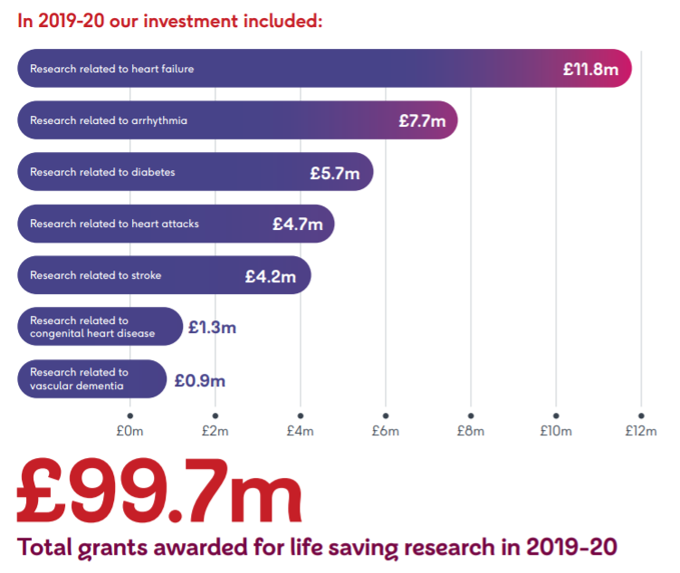
Source: BHF (2021d)
The value of social networking for achieving inclusive, effective and multi-cultural community engagement for projects is undisputable nowadays. Social networks are tools with high importance for providing easily comprehensive information and reach large audiences aiming at their active involvement and engagement in certain projects. Recent research also reveals that social networks also play a significant role in improving population’s health and consumption attitudes (NIH, 2011). They are also considered to be an effective tool and appropriate strategy to be used to reach nation-wide communities and encourage them to participate in collective action to address a certain problem (NIH, 2011).
As stated by Kemp (2021), approximately 53 million people in UK are active social media users as of January 2021. This shows an increase of 4.4% compared to the same period in 2020 and currently represents 77.9% of the total population of the country (Kemp, 2021). This high penetration rate is also an argument for using social media as a main channel to promote the proposed event and engage community in it. The three proposed social media channels, which should be prioritised for promoting this campaign, include Facebook, Instagram and Twitter. Facebook is the most popular platform and has more than 2.18 billion users on a global scale (Avocado Social, 2021). Instagram already reached more than 31 million users in the UK (Avocado Social, 2021). Twitter has 16.5 million users in the country which also makes it a preferred channel.
As already mentioned, hashtag #HealthyIsWealthyAtTesco will be created and promoted through the three platforms, using the profiles of Tesco and British Heart Foundation. This is expected to lead to the creation of viral content which is also interesting for users and, through this, the interest towards healthier lifestyle and the risks of heart and circulatory diseases will significantly increase, encouraging people to take actions to prevent them. Through the use of already established audiences of the two organisations, it is believed that the campaign will have a successful initial start and reach. On Facebook, posts can also be promoted with a pre-defined budget, so that they reach look-alike audiences with similar interests to already established ones. On Instagram and Twitter the hashtag use is expected to lead to viral sharing of the campaign and related content will be visible to more people, triggering their interest. The vote will be organised with likes on Facebook, voting polls on Instagram tweet likes on Twitter. The combined effect from the three platforms will then be shortlisted and final winners collecting most votes will be selected following the same approach.
During the time of the campaign, the organisers will also provide extensive nutritional information. For example, they can pick some ingredients from participants’ recipes and explain about their nutritional qualities, the impact they have on human health, the way they support healthy lifestyle and how they mitigate the risks of heart and circulatory diseases. This will increase awareness of the public and would encourage to try proposed products and meals.
The campaign can be the starting point of a long-term project which can, at a later point include TikTok and encourage the “Recreate it till you make it” function, where people can try proposed meal recipes and share their own results.

Conclusion
To sum up, heart and circulatory diseases impact a vast number of people and households in the UK and this problem should be addressed. The British Heart Foundation works for decades to improve research and awareness related to this problem and cooperates with many partners, including Tesco to achieve these goals. The proposed event also has the objective of improving community understanding and engagement in this regard. The collaboration between the two organisations is considered to result in greater transparency and trust, leading to higher engagement rates. Proposed channels of communication are established means owned by Tesco and British Heart Foundation, with an exclusive focus on social media – Facebook, Instagram and Twitter. This is expected to contribute to higher interest of local community, the development of viral content which is spread across social media and increasing engagement with the campaign. All this is perceived to be a driver of campaign effectiveness, increased awareness of the problem and changed consumption habits and lifestyle of UK population.

References
Askew, K. (2021) Functional Food is no COVID Fad: ‘Consumers Have Fundamentally Changed Their Attitudes to Health and Wellness”, [online] Available: https://www.foodnavigator.com/Article/2021/03/24/Functional-food-is-no-COVID-fad-Consumers-have-fundamentally-changed-their-attitudes-to-health-and-wellness [Accessed: 26 August 2021]
Avocado Social (2021) The UK Social Media Statistics for 2021, [online] Available: https://www.avocadosocial.com/the-uk-social-media-statistics-for-2021/ [Accessed: 29 August 2021]
BHF (2021a) About the British Heart Foundation, [online] Available: https://www.bhf.org.uk/what-we-do/who-we-are [Accessed: 27 August 2021]
BHF (2021b) Facts and Figures, [online] Available: https://www.bhf.org.uk/what-we-do/news-from-the-bhf/contact-the-press-office/facts-and-figures [Accessed: 27 August 2021]
BHF (2021c) Tesco, [online] Available: https://www.bhf.org.uk/how-you-can-help/corporate-partnerships/our-corporate-partners/tesco [Accessed: 28 August 2021]
BHF (2021d) Our Annual Report and Accounts 2020, [online] Available: https://www.bhf.org.uk/what-we-do/annual-report-2020 [Accessed: 28 August 2021]
Cancello, R., Soranna, D., Zambra, G., Zambon, A. and Invitti, C. (2020) Determinants of the Lifestyle Changes During COVID-19 Pandemic in the Residents of Northern Italy, International Journal of Environmental Research and Public Health, Vol. 17(1), pp. 6287-6300.
Kemp, S. (2021) Digital 2021: The United Kingdom, [online] Available: https://datareportal.com/reports/digital-2021-united-kingdom [Accessed: 29 August 2021]
NIH (2011) Principles of Community Engagement, [online] Available: https://synergy.dartmouth.edu/sites/default/files/docs/Principles_of_Community_Engagment_NIH_2ndEdition.pdf [Accessed: 29 August 2021]
Ringer, J. (2021) Post-COVID-19 Lifestyle Tips to Stay Healthy as the Pandemic Eases, [online] Available: https://news.llu.edu/health-wellness/post-covid-19-lifestyle-tips-stay-healthy-pandemic-eases [Accessed: 28 August 2021]
State of Queensland (2017) Community Engagement Toolkit for Planning, [online] Available: https://dilgpprd.blob.core.windows.net/general/community-engagement-toolkit.pdf [Accessed: 29 August 2021]

