CIPD Membership Number: 55478700

Qualification: CIPD Diploma in Applied Human Resources (CIPDL5)

Module: Employee Engagement

Word Count: 3, 300

By signing below, I confirm that the work/evidence presented is my own, unaided work. I understand the regulations pertaining to candidate malpractice and the action that may be taken as a result.

Signed: Emma Carrington

Date: 8th January 2020

Employee Engagement (EE)

Kahn (1990) suggests that EE is complex and individuals employ and express themselves in a physical, cognitively and emotional way which is depicted as three different dimensional concepts; Physical engagement through high levels of energy and mental resilience, and the willingness to invest effort in their work; Cognitive engagement is expressed by an employee when they’re fully concentrated in work and they have trouble detaching themselves; Emotional engagement is expressed through strong involvement in work where employees experience a sense of significant enthusiasm, pride, inspiration and challenge.

In contrast, CIPD (2015) proposes EE goes beyond job satisfaction and motivation and is something an employee has to offer (which cannot be required as part of the employment contract). This is evident within new CIPD Professional map which has moved from EE to Employee Experience (CIPD, 2020; CIPD, 2017; 2018; Peakon, 2020; Gallup, 2020; Mercer, 2019; People Insight, 2020; Sage, 2020).
The UK Government initiated a review of EE in 2008 which culminated in the publication of the Macleod Report (2009) which built on David Guests idea of constructing an EE model as a work place approach designed to ensure employees are committed to organisational goals and values, motivated to contribute to organisational success and enhance their own wellbeing (Taylor, 2016). MacLeod (2009) suggests “This is about how we create the conditions in which employees offer more of their capability and potential”; EE is a workplace approach resulting in the right conditions for all members of an organisation to give of their best each day. Suggesting EE goes to the heart of the workplace relationship between employer and employee. He further suggests it can be a key to unlocking productivity and transforming the working lives of many people.
Both Kahn (1990) and CIPD (2014;2012) conceptualise EE as a three-dimensional concept which can occur at two different levels. Both definitions suggest that an employee express more discretionary effort and are more engaged within an organisation. However, the consequence of this is employers must recognise the drivers of engagement within different parts of an organisation as one size does not fit all.

Utrecht University group hold a narrower, more specific view that defines EE as a state of mind in which and therefore rather than displaying burnout employees show vigour, dedication and absorption.

CIPD commissioned a report (Alfes et al 2010, p5) which identified engagement as having three dimensions: Intellectual engagement, thinking about the job and how it might be done better; Affective engagement, positive feelings about doing a job well; Social engagement, an employee actively seeks opportunities to discuss work related issues (Rees & French, 2016). The authors claim that engaged employees are more likely to perform better that those who are not. This is supported by survey respondents claiming to be willing to take on additional work, have good levels of social skills and had a tendency to score high with their PA’s. Secondly engaged employees are more likely to be innovative at work e.g. generating innovative ideas and alternative productive ways of working. Thirdly, engaged employees are more likely to stay with their employer. Towers Perrin (2007,2008) review identified the top five drivers of EE (appendix 1).
It’s evident that organisations define engagement differently however, it could be debated EE is underpinned by the ten pillars of EE (Shriar, 2015; Mansfield, 2018; Deloitte, 2015). The more an employee feels engaged the more probable they are to stay with their organisation and deliver excellent job performance. Software giant Intuit, for example, found that highly engaged employees are 1.3 times more likely to be high performers than less engaged employees. They are also five times less likely to voluntarily leave the company (Ramsay & Finney, 2006).
HR, Leadership and Cultural elements
Our UK Working Lives survey (2020) found that the quality of relationships and managerial support is consistently related to various aspects of EE, including job satisfaction, enthusiasm, effort and intention to quit. However, different aspects of engagement are most closely related to different factors of job quality e.g. job complexity is most closely related to enthusiasm and effort and terms of employment.
This can be supported by Purcell (2010) fundamental EE building blocks of employee trust in management, job changes, satisfaction with the sense of achievement from work, pay received and involvement in decision-making etc. all of which can have several HRM policy and practice implications. Underpinned by trust, conditions of service and an employee’s ability to contribute and fulfil, the building blocks emphasises the importance of policies and practices. It could be suggested that these form a good relationship between an employer and employee, which encourages an employee to demonstrate discretionary effort that is associated with EE (Taylor, 2016). The Macleod (2009, p6) asserts that engagement can universally benefit an employee at work, the organisation and for the whole country (appendix 2). It furthermore identified four enablers of engagement; A strategic narrative, leadership; Engaged managers, who motivate, empower and support their employees; Employee voice, throughout the organisation, to involve employees in decision making; Organisational Integrity, that stated values are reflected in the actual organisational culture (CIPD, 2019; 2020;HEIW, 2018; Wilkinson & Taylor, 2016; Bersin, 2015 ); what organisations say is what they do (appendix 3).
Both MacLeod (2009) and Purcell’s (2010) research demonstrates the importance of a manager’s role in EE i.e. promoting an engagement culture within an organisation. Herzberg (1959, 1968) would agree and advocate that managers can enrich an employee’s job by providing them with a complete unit of work, having a periodic reporting system rather than tight inspection and control, and giving an employee responsibility and accountability. He also suggested giving a specific task to enable them to become experts in that field plus occasionally introducing new and more challenging tasks to aid self-development, which also fits with the motivation theory (Pink, 2009; Keating, 2015).
The key to a successfully engaged organisation is to have a culture based on a strongly held and widely shared set of beliefs that are supported by strategy and structure (Horizontal and vertical integration) (Woodham et al, 2016).
EE can help organisations achieve mission, execute its strategy and generate important business results. HR practices, including job design, recruitment, selection, training, compensation and performance management can enhance employee engagement. Strategy provides employees with clarity regarding organisational goals and helps employees focus on collective action and decision-making. Groysberg et al (2018) suggest it relies on a set of choices to motivate employees and can be enforced by reward for achieving a goal or consequences for not. It’s also reliant on changing environmental factors, which need to be managed to ensure organisational continuity and growth. Leadership is an important factor in strategy.

Culture expresses goals through values and beliefs and guides activity through shared assumptions and group norms, however its more elusive as most is secured in unspoken behaviours, mindsets and social patterns. HR has a dynamic role in preserving a strong culture from the beginning, starting with recruiting and selecting applicants that share the organisation's beliefs and thrive in the culture. HR develop training and performance (appendix 4) management programs that outline and reinforce an organisation's core values and ensures that appropriate rewards and recognition go to employees who truly embody the values.
When an organisation has a strong culture, three things happen: Employees know how top management wants them to respond to any situation, employees believe that the expected response is the good one, and employees know that they will be rewarded for demonstrating the organisation's values and are therefore more engaged (SHRM). This can be supported by Robinson and Hayday (2009) research on behalf of IES.
HR Strategy and Practice
The presence of an EE business case which aims to increase organisational EE, with an investment return is essential to create a genuinely engaged workforce, lower turnover, improve performance and customer retention along with enhanced employee creativity and innovation. Jenkins & Delbridge (2013 p2671) suggest contingent factors inhibit managers ability to deliver engagement i.e. Private sector operate in a competitive environments and face pressure to cut costs and increase efficiency. Public sector is governed by Government costs to increase efficiencies’ (Government Comprehensive Spending Review). WERS, 2013 highlights barriers to organisations securing discretionary effort from their employees along with the importance of interoperating engagement within the context of the organisation and external environment (Taylor, 2016).

Holbech and Matthews (2012) suggest there are four ‘drivers’ to generate EE; Connection, Voice, Support and Scope (appendix 5).
CIPD supports this belief and suggests that ‘employers want engaged employees as they deliver improved business performance and are usually more fulfilled and therefore happier and healthier, which reduces sickness rates. West and Dawson (2015, 2018) found clear evidence that trusts with higher engagement levels have lower levels of sickness absence among staff and have lower spend on agency and bank staff. Mental health problems in the UK workforce cost employers almost £35 billion a year in sickness absence, reduced productivity at work, and staff turnover (Parsonage & Saini, 2017). The financial implications suggests that NHS leaders should investigate the importance of nurturing positive, trusting cultures within which staff have high levels of wellbeing; where they feel valued, respected and supported; where they have high levels of influence in their workplaces; and where they are consequently more highly engaged (Tan et al., 2014; Hamberg van Reenen et al, 2012; Centre for Mental Health).

Towers Perrin 2007/8 Global workforce research of 50 global organisations over a year (2009) also demonstrates the link between high engagement and high performance. High EE benefited from 19% increase in operating income compared with a 32% drop in those with low EE levels. The report also demonstrated a 28% growth in earnings compared to an 11% decrease in low levels.
High levels of EE are associated with employee loyalty, profitability, safety, productivity, customer satisfaction (Harter et al 2002) and organisational commitment (Saks, 2006).
In contrast to non-engaged employees, those who are engaged characteristically experience greater job satisfaction (irrespective of role) and a greater wellbeing (Schaufeli et al 2008, 2010; Alfes et al 2010). They also have a role in promoting their organisational brand and act as an organisational advocate.
It could be debated that the link between EE and profitability cannot be proved as crucial information is not made public (Taylor, 2016) However, Gallup organisational study evidenced that 25% of engaged employees produced 1% to 4% higher profitability and an average of 80-120k higher monthly revenue than those in the bottom 25%. The study also found together EE and customer produced organisational benefits such as better profit margins than those that focused on one objective at a time.
Gallups report emphasised that stores which score high in both customer satisfaction and EE had much higher conversation rates than those who don’t. The study also emphasised the importance of a bottom up leadership approach which encourages employees to have autonomy and respond to customer need as top-down approaches do not benefit customer experience (Hutchinson & Purcell, 2003; SHRM, 2010). This can be supported by companies such as John Lewis, who empower employees and refer to them as partners. By calling them partners, the company is clearly expressing that there is a shared responsibility for the customers and the outcomes of the company. So, they focus on involving their partners in decisions and solutions, empowering them to create the best customer experience (Flint & Vinberg Hearn,2015) (appendix 6).
Google encourages transparency, creativity and collaboration, to facilitates a creative culture, break down barriers as a result employee feel engaged and empowered. Informed employees feel valued and engagement typically follows. In contrast, Virgin demonstrate EE through Listening and valuing its employees

Key sources of employee engagement related data

The CIPD 2009 national research (undertaken by Kingston University and IPSOS / MORI) looked at employee’s attitudes and the extent of EE within the UK workforce (CIPD, 2010), which resulted in a benchmark which organisations can use to measure their EE. The research confirmed that overall a third of employees were actively engaged; when assessed against the three dimensions of engagement. 60% were emotionally engaged with their work; 60% were cognitively engaged, although only 40% were physically engaged and willing to go the extra mile. The research also found that more women than men were engaged with their work and only a quarter of under 35 felt engaged compared with 40% of those over.
Employees on flexible contracts were more engaged, satisfied with work, speak highly about their organisation and less likely to quit, than those on alternative contracts.
Public sector employees had less trust and confidence in their organisation as they felt senior managers did not have clear vision. They were also less likely to believe in the content of organisational communications.
In contrast, Buckingham (2001) national sample of UK working population research used the Gallup Q12 index and found that more than 80% of employees in the UK are not engaged with their organisation (SHRM, 2010). Three different employee categories’ were identified within the research; Engaged employees: Those who are devoted, reliable, trustworthy and productive are retainable and are more likely to recommend their place of work; Non-engaged employees: Are not psychologically bonded to their organisation although they are productive they may defect other employees and the organisational brand; Disengaged employees: are physically present but psychologically not which can be damaging to the employee brand. Based on classification the study demonstrated that only 17% of British workers were engaged, 63% were non-engaged and 20% were disengaged.
Gallup furthermore investigated attendance and absence figures which indicated that engaged workers missed 4.67 days at work compared to non-engaged that missed 10.68 days. The report highlighted turnover levels of engagement amongst the engaged work groups were lower than actively engaged employees.
The research results suggested the longer the employees stay with an organisation the less engaged they become as they do not feel valued. This result is counterintuitive and contradicts the human capital advantage model (Bell, 2012) i.e. employee skills, knowledge and experience become more valuable to an organisation over time.
Potential reasons for low levels of EE in the UK
Taylor and Woodham (2016) suggest that low levels of EE may be due to difficulties, limitations and approaches used to measure it. Purcell (2010) proposes that engagement surveys are limited as engagement is treated in isolation and as a tick box exercise. He furthermore suggests that engagement index scores which measure organisational engagement may be used to punish managers within performance review and does not fully explain engagement levels. Mclead & Clake (2009) support this and additionally suggest an engagement strategy has more clout than “simply doing a survey and publishing results”. In contrast Cattermole (2014, p31) suggest that organisations should use the surveys as a tool to meet specific business needs rather than organisations placing too much emphasis on external benchmarking. He describes the surveys as transactional rather than transformational (in order to overcome the limitations identified by Purcell 2010, p89). He suggests engagement surveys benefit from being “interpreted” together with organisational indicators such as productivity, absence and turnover rates.
Silverman (2014) recommends that compared to traditional methods of engagement social media offers organisational opportunity to gain insight in a more open and transparent manner (CIPD, 2013; Engage for Success, 2020)
Research indicates low engagement can be linked to work intensification, burnout and lack of work-life-balance (WLB).
Wellbourne (2011, p97) suggests that employees may resist engagement due to its association with burnout and health problems which could explain low levels of engagement in the UK. CIPD (2017) highlight the significance of burnout in relation to Health and wellbeing. They identified that 22 % of employees say they often or always feel exhausted in their jobs, or under excessive pressure. They also highlight serious concerns regarding the demands of work and the impact it can have on people’s health. Furthermore 66 % say they have experienced a work-related health condition in the last 12 months, with anxiety and sleep problems being two of the most common issues reported (McDonald et al 2005; CIPD 2016, 2020; NHS Workforce Trends 2017, 2019; Mercer, 2016).
Rees et al (2012, 2013) proposes a link between engagement and work intensification perceiving that engagement can drive work intensification as employers may expect an employee to go the extra mile with no additional benefits i.e. over-time pay. Kelliher & Anderson (2010) report evidence of work intensification being experienced by those who work reduced hours and those who work remotely. Therefore, employees respond to WLB by entering additional effort to return benefits to the employer. They reported that those employees who work flexibly, record higher levels of job satisfaction and organisational commitment (French, 2016). They conclude that employees adopt the social exchange theory to respond to the ability to work flexibly by exerting additional effort, to return benefit to the employer. However, research indicates employees don’t always respond negatively to intensification, especially whereas a consequence they believe they will gain some benefits (psychological theory) (ibid p99).

Evidence supports and highlight the importance of engaging employees, creating flexible working opportunities and family friendly policies (ibid, p326). There’s significant evidence within organisations that adopt and implement WLB, FW and special leave policies, improve employee commitment, staff recruitment and increase performance, and are business cost effective thus, reduce absenteeism and turnover (Lyonette & Baldauf, 2019).

Research study North Bristol NHS Trust (NBT) Improving performance and engagement by improving staff wellbeing
Recent study to improve performance across the board through improved employee engagement saved hundreds of thousands of pounds by prioritising and enhancing staff wellbeing. NBT improved performance across the board and saved hundreds of thousands of pounds by prioritising and enhancing staff health and wellbeing. During January 2018 NBT launched a new staff wellbeing programme. Results were obtained through surveys and listening events. Two themes emerged: workload and staff health and wellbeing. NBT created comprehensive plans to address both issues concurrently. Since the beginning of the programme NBT have moved from below average to above average in staff engagement and wellbeing and was recognised as one of the most improved organisations for Health and wellbeing in the 2019 survey. There was a tangible shift to staff health and wellbeing being considered as important as patients’ health and wellbeing, which put NBT in a good place to look after its staff during the response to COVID-19. Furthermore, these changes to improve staff health and wellbeing has reduced overall occupancy by 4% and caring for 6% more patients with 38 fewer beds in 2018/19. Additionally, almost 4,000 working days were saved due to reductions in sickness, equating to £301,015 saved on sickness costs in one year (NHS Employers, 2020). This research demonstrates that employees need to create a climate of trust in EE which adopts opportunities for both a collective and individual voice. Furthermore, effectively communicating and listening to their workforce will create the conditions for them to have a voice to make suggestions and assure them, they can be confident they will be acted on, to lead to effective change (NBT, 2020; Rees et al, 2013).
Towers Perrin (2007, 2008, 2009) report compared engagement levels between various demographics, from various job levels i.e. s. executives to hourly and salary employees to industry non-profit organisations, service sector and heavy manufacturing etc. Most respondents were moderately engaged and only a small number were highly engaged. Disengaged respondents were slightly larger than highly engaged respondents. The research highlighted s. executives were found more engaged than other groups (and less likely to be disengaged) however, the report outlined the link between income and employment. In contrast role characteristics such as authority, challenge, autonomy and stimulation, access to information, resources and opportunity for growth were linked to high levels of work engagement amongst hourly workers, who have almost no or less control or influence over their jobs and work experience (appendix 7).
Millennials and Generation Y top priority is a healthy WLB.

Companies report that their younger workers expect a better work-life balance and faster career progression (appendix 8). (People Management, 2018). There’s an increasing need to build roles that are flexible and allow a WLB (Deloitte, 2014, 2019; People Management, 2018, 2019; Independent 2016; CIPD 2015; KPMG, 2017; INC 2018). The spread of ages across the workforce now covers up to four generations as older workers retire later (Focus on age report,2017; Future trends 2015). WLB policies are imperative to support the ageing workforce (Chemistry Report, 2019). Employers that support a WLB philosophy are more likely to engage their workforce and have a competitive advantage within the labour market particularly the new generation of employees (appendix 9).

Gender

Avery et al (2007), Gallup and Johnson (2004) reported that women tend to find more fulfilment and satisfaction in their job and are therefore more engaged than men. It could be argued employees’ lives are becoming more complex and demanding. More parents are raising children alone and need to work as they are the only source of income in the family (Daniels, 2019). Due to a lack of flexible options, large numbers of mother’s step back from their careers (CIPD, 2019). Schaufeli et al (2006) and Sprang et al (2007) suggest that females are at higher risk of stress due to competing work culture and therefore at risk of burnout and as a consequence may report lower levels of engagement (Elkhof et al, 2007; Halbestebn, 2011). The research also suggests that married employees were more settled and engaged than unmarried. However, Kong (2009) debates that single employees are more engaged due to less responsibilities. Insight survey indicates men currently have low expectations of securing WLB it identified a variety of perceived cultural barriers in the workplace holding men back from greater involvement at home. 85 % of men think they should be as involved as women in caring for children (Eltringham,2018).

Link to Health and Wellbeing
During 2018, 37% of organisations saw a rise in stress-related absence and 55% an increase in mental health problems (CIPD, 2017). It’s been documented that staff engagement results in better patient outcomes and the most significant impact on staff engagement is staff health and wellbeing.

Conclusion
CIPD Employee outlook survey indicated that EE levels are stable at 33-39% amongst UK employees (Taylor, 2016). However, this report has highlighted ways in which different HR practices, including job design, recruitment, selection, training, compensation and performance management can enhance EE. Nevertheless, these examples also show that EE is more complex than it may appear.
Engaged employees give organisations competitive advantage; higher productivity and lower
employee turnover. It is therefore essential that all organisations regardless of size and type invest in policies and practices that foster engagement and commitment of their employees.
It is clear the EE continues to evolve within the ever-growing context of change and uncertainty, and there is arguably a need for EE more than ever. Taylor (2016) highlights the remaining debate is a factual definition of EE, the cause and the outcomes of EE and barrier and unintended consequences associated with EE. EE is likely to be one of the main organisational future priorities, especially in light of COVID-19 (McKinsey, 2020).

The following elements, however, will continue to be key to developing, embedding and benefiting EE:

  - Good quality management at levels: coherent, consistent and continuous role modelling from the rep managers who lead, encourage their teams to perform well, who take an interest in their employees and provide opportunity for development (CIPD, 2019; Hutchinson & Purcell, 2003; Gallup Q12;SHRM, 2010; West, 2012, 2013, 2018).
  - Open two-way communication that encourages an employee voice (Rees et al, 2013; CIPD, 2013; Alfes et al, 2010)
  - Collaborative working between departments and functions; avoiding silo working and stereotypes (Roper, 2017; Bento et al, 2020)
  - Commitment to employee wellbeing (Mental Health at Work, 2020; NICE, 2016; Thrive, 2020)
  - Clear accessible HR policies and practices in place i.e. Communication and Engagement plan that focuses on motivation, organisational behavior/commitment and job satisfaction (Vance,2006)
  - Strong emphasis on performance (Takeuchi et al., 2007, p. 1069; Becker & Huselid, 1998; Guthrie, 2001; Huselid, 1995; Way, 2002; Zhang et al 2014)

A lack of WLB within organisations can have a negative impact on employees with an increase of absenteeism, productivity, staff engagement etc. Making flexible and sustainable roles more widely available will allow employees a WLB and improve EE, recruitment and retention (Kelliher & Anderson, 2010, Grimshaw et al 2016; CIPD, 2017; Timewise, 2014).

References

Alfes, K., Truss, C., Soane, E. C., Rees, C. I. and Gatenby, M. (2010) Creating an Engaged Workforce. London. Chartered Institute of Personnel and Development.
Avery, D.R., P F. McKay, D.C. Wilson, S. Tondidandel (2007) Unequal attendance. The relationship between race, organisational Diversity cus and absenteeism. Personnel psych 60 (4) 875-902.
Bell, J (2012) Human Capital Advantage. SHRM. Available at: https://blog.shrm.org/blog/the-human-capital-advantage [Accessed 14/09/20]
Bento, F., Tagliabue, M., Lorenzo, F (2020) Organizational Silos: A Scoping Review Informed by a Behavioural Perspective on Systems and Networks. Available at: file:///C:/Users/em021016/AppData/Local/Microsoft/Windows/INetCache/IE/MYMEG95U/societies-10-00056.pdf [Accessed 14/10/20]
Brooks, S. M., Wiley, J. W., & Hause, E. L. (2006). Using employee and customer
perspectives to improve organizational performance. In L. Fogli (Ed.), Customer
service delivery: Research and best practices (pp. 52 – 82). San Francisco, Calif.:
Jossey-Bass.
Buckingham, M. (2001) What a waste. People Management. 11 October. pp19-22.
Bursin, J (2015) Becoming irresistible: A new model for employee engagement Deloitte Review Issue 16. Available at: https://www2.deloitte.com/us/en/insights/deloitte-review/issue-16/employee-engagement-strategies .html [accessed 29.09.20].

CIPD (2009-2017) Employee Outlook Published between Spring 2009 and Spring 2017 this survey of UK employees identified their opinions of and attitudes towards working life, produced in partnership with Halogen Software. Available at: https://www.cipd.co.uk/knowledge/fundamentals/relations/engagement/employee-outlook-reports [Accessed 17/09/20]
CIPD (2013) Social media and employee voice. Available at: https://www.cipd.co.uk/knowledge/work/technology/employee-voice-report#_ga=2.55391912.2076890705.1602861887-129707373.1602000613 [accessed 01.09.20].
CIPD (2014) Developing Managers to manage sustainable employee engagement, health and wellbeing. Research Report. Available at: www.cipd.co.uk/hr-resources/research/developing-managers.aspx [Accessed 16/09/20]
CIPD (2019) Organisational culture and cultural change. Available at: https://www.cipd.co.uk/knowledge/culture/working-environment/organisation-culture-change-factsheet [Accessed 15/09/20]
CIPD (2020) Ethical practice and the role of HR. Available at: https://www.cipd.co.uk/knowledge/culture/ethics/role-hr-factsheet [Accessed 16/09/20]
CIPD (2020) CIPD Good Work Index (The CIPD Good Work Index provides an annual snapshot of job quality in the UK, giving insight to drive improvement to working lives). Available at: https://www.cipd.co.uk/knowledge/work/trends/goodwork [Accessed 15/09/20]
CIPD (2020) Work making our wellbeing worse – even before COVID-19 crisis started. Available at: https://www.cipd.co.uk/about/media/press/good-word-index-2020 [Accessed 15/09/20]
CIPD (20202) Specialist knowledge: Employee experience. Available at: https://peopleprofession.cipd.org/profession-map/specialist-knowledge/employee-experience [Accessed 06/03/20].

Deloitte (2014) Big Demands and High expectations: The Deloitte Millennial Survey. London. Deloitte. Available at: http://www2.deloitte.com/al/en/pages/about-deloitte/articles/2014-millennial-survey-positive-impact.html [Accessed 06/03/20].

Deloitte (2019): The Deloitte Global Millennial Survey. Available at:
https://www2.deloitte.com/global/en/pages/about-deloitte/articles/millennialsurvey.html [Accessed 06/03/20].

Engage for Success (2020) Available at: https://engageforsuccess.org/what-is-employee-engagement
Eikhof, D.R. Warhurst, C. and Haunschild, A. (2007) Introduction: what work? What life? What balance? Critical reflections on the work-life balance debate. Employee relations. Vol29, No4. pp325-3333.

Focus on Age report (2015). Available at:
https://weds.heiw.wales/assets/Uploads/4cdf2f75d8/Focus-On-The-Age-of-the-NHS-Wales-Workforce-2015.pdf [Accessed 5 May 2020]
Frampton, A., Fox, F., Hollowood, A., Northstone, K., Margelyte., Smith-Clark, S., Redwood, Sabi (2016) Using real-time, anonymous staff feedback to improve staff experience and engagement. BMJ. Vol 6, Issue 1. Available at: https://bmjopenquality.bmj.com/content/6/1/u220946.w7041 [accessed 10.08.20].

Future Trends (2017). Available at:
https://gov.wales/future-trends-2017 [Accessed 5 May 2020]
FUTURE CHEMISTRY 2019: Getting the elements right for the workforce of tomorrow. Available at:
https://sites-burness.vuturevx.com/74/800/uploads/future-chemistry-burness-paull.pdf [accessed 10.08.20].

Flint, M., & Vinberg Hearn, E. (2015). 6 companies that get employee engagement and what they do right. CMI. Available at: https://www.managers.org.uk/knowledge-and-insights/case-study/6-companies-that-get-employee-engagement-and-what-they-do-right/ [accessed 10.08.20].

Gallup (2020) Employee Experience (2020) Available at: https://www.gallup.com/workplace/242252/employee-experience.aspx [accessed 20.08.20].
Gallup Q12: No. 1 employee engagement survey and all the strategic advice that goes with it. Available at: https://www.gallup.com/access/239210/employee-engagement-survey.aspx [accessed 20.08.20].
Gallup Q12: Fortune 500 Employee Engagement Tools for Your Size Company. Available at: https://q12.gallup.com/ [accessed 20.08.20].
Groysberg,B., Lee, L., Price, J., J, Yo-Jud Chen (2018) The Leader’s Guide to Corporate Culture. Harvard Business Review. Available at: https://hbr.org/2018/01/the-culture-factor
Harter, J.K., Schmidt, F. L and Hayes, T. L. (2002) Business-unit level relationship between employee satisfaction, employee engagement and business outcomes: a meta-analysis. Journal of applied Psychology. Vol 87. Pp268-79.

HEIW (2018) Values and behaviours. Available at: https://heiw.nhs.wales/about-us1/values-and-behaviours/ [accessed 10.08.20].

Herzberg, F. (1968) One more time: how do you motivate your employees? Harvard Business Review. January-February. Pp109-120.

Herzberg, F., Mausner, B., & Snyderman, B. (1959). The motivation to work (2nd ed.). John Wiley. by F Herzberg.

HR Central (2018) Employee Relations: The Importance of Feedback in the Workplace. Available at: https://hrcentral.com.au/blog/feedback/ [accessed 10.08.20].

Holbeche, L. and Matthews, G. (2012) Engaged: Unleashing your Organisation’s potential through employee engagement. Chichester: Wiley/Josey Bass.

Huselid, M.A. (1995) The impact of human resource management practice on turnover, productivity and corporate financial performance. Academy of Management Journal. Vol 38. Pp635-672.

Hutchinson, S. and Purcell, J. (2003) Bringing policies to life: the vital role of front-line managers in people management. London: Chartered Institute of Personnel and Development.

Jenkins, S. and Delbridge, R. (2013) Context matters: Examining ‘soft’ and ‘hard’ approaches to employee engagement in two workplaces. International Journal of Human Resource Management. Vol 24, No 14. Pp2670 – 2691.

Kahn, W. A. (1990) The psychological conditions of personal engagement and disengagement at work. Acadamy Of Management Journal. Vol33. Pp692-724.

Lyonette & Baldauf (2019) Family friendly working policies and practices: Motivations, influences and impacts for employers. Government Equalities Office. Available at: https://assets.publishing.service.gov.uk/government/uploads/system/uploads/attachment_data/file/840061/Warwick_Final_Report_1610.pdf [accessed 10.07.20].

Macleod, D. and Clarke, N. (2009) Engage for Success: enhancing performance through employee engagement. A report to government. London: Department for Business, Innovation and Skills.

Mansfield, T (2018) The 10 Pillars Of Employee Engagement. Zest. Available at: https://zestmeup.com/blog/the-10-pillars-of-employee-engagement/ [accessed 01.09.20].
Mercer (2019) Building a better employee experience. Available at: https://www.mercer.com/our-thinking/career/voice-on-talent/building-a-better-employee-experience.html [accessed 01.09.20].
Mental Health at Work (2020) Workplace wellbeing: showing your commitment. Available at: https://www.mentalhealthatwork.org.uk/toolkit/workplace-wellbeing-showing-your-commitment/
McKinsey (2020) COVID-19 and the employee experience: How leaders can seize the moment. Available at: https://www.mckinsey.com/business-functions/organization/our-insights/covid-19-and-the-employee-experience-how-leaders-can-seize-the-moment [Accessed 28 September, 2020]

NICE (2016) Workplace health: management practices. Available at: https://www.nice.org.uk/guidance/ng13/chapter/recommendations [accessed 10.10.20].

NHS Wales’ Workforce Trends Report. Available at:
https://weds.heiw.wales/assets/Uploads/a8c0b0c31d/NHS-Wales-Workforce-Trends-as-at-31-March-2017-v2.pdf [Accessed 1 May 2020].

People Insight (2020) Employee Experience vs Employee Engagement: What’s the Difference? Available at: https://peopleinsight.co.uk/employee-experience-vs-engagement/ [accessed 01.09.20].
People Management (2018) I'll tell you something: The NHS can't afford to ignore the demand for FW. Available at:
https://www.peoplemanagement.co.uk/voices/comment/nhs-afford-ignore-demand-flexible-working [Accessed 23 September 2020]

People Management (2019): The time to start engaging millennials is now - To inspire trust and loyalty, businesses need to demonstrate. Available at: https://www.peoplemanagement.co.uk/voices/comment/time-start-engaging-millennials [Accessed 22 September 2020]

Pink, D (2009). TED Global. The Puzzle of Motivation Available at https://www.ted.com/talks/dan_pink_the_puzzle_of_motivation [Accessed 5 August, 2020]

Ramsay, C. S., & Finney, M. I. (2006). Employee engagement at Intuit. Mountain
View, CA: Intuit Inc.

Rees, C., Alfes, K. and Gatenby, M. (2013) Employee voice and engagement: connections and consequences, International journal of Human Resource Management 24, No14. pp2780-2798.

Rees, G & French, R. (2016) Leading, Managing and Developing People (5th Edition). London CIPD.

Roper, J (2017) The five key collaboration challenges. HR Magazine. Available at: https://www.hrmagazine.co.uk/article-details/the-five-key-collaboration-challenges [accessed 10.08.20].

Rumbles, S., & Adam-Smith, D. (2010). Managing the employment relationship. In G. Rees, & R. French (Eds.), Leading managing and developing people (3rd ed., pp. 222-243). CIPD Publications.
NHS Employers (2020) Improving performance by improving staff wellbeing. Available at: https://www.nhsemployers.org/case-studies-and-resources/2020/08/improving-performance-by-improving-staff-wellbeing [accessed 10.08.20].
NHS Employers (2020) North Bristol NHS Trust. Available at: https://www.nhsemployers.org/-/media/Employers/Documents/Retain-and-improve/Health-and-wellbeing/North-Bristol-NHS-Trust-August-2020-(002).pdf [accessed 10.08.20].
Parsonage, M. & Saini, G. (2017) Mental health at work: the business costs ten years on. London: Centre for Mental Health.
Peakon (2020) The Four Phases of Employee Experience. Available at: https://peakon.com/resources/library/the-four-phases-of-employee-experience/ [accessed 22.09.20].
Purcell, J. (2014), Disengaging from engagement. Human Resource Management Journal, 24:3, 241-254.
Sage (2020) The importance of employee experiences in HR tech selection. Available at:https://www.sagepeople.com/Ventana2020-employee-experience/?gclid=EAIaIQobChMIoszD0bO57AIVS9iyCh2cMwr9EAMYAiAAEgJcMPD_BwE[accessed 21.09.20].
Saks, A.M (2006) The antecedents and consequences of employee engagement. Journal of Managerial Psychology. Vol 21, No 7. PP600-19.
Schaufeli, W.B. and Bakker, A. B. (2010) The conceptualization and measurement of work engagement. In Bakker, W.B.and Leiter, M.P. (eds). Work engagement: a handbook of essential theory and research. New York: Psychology Press.
Schaufeli, W.B., Taris, T. W. and Van Rhenen, W, (2008) Alcoholism, burnout and engagement: three of a kind or three different kinds of employee wellbeing. Applied Psychology. An International Review. Vol 57. Pp173-203.
SHRM (2010) The Gallup Q12 Employee Engagement Questionnaire. Available at: https://www.shrm.org/hr-today/news/hr-magazine/pages/0510fox3.aspx [accessed 10.08.20].
Silverman, D. (2014) The Future of Engagement. Research Report. CIPD. Available at: www.cipd.co.uk/hr-resources/research/future-engagement.aspx [Accessed 10.08.20].

Shriar, J (2015) 10 Essential Pillars of Employee Engagement. Available at: https://www.business2community.com/infographics/10-essential-pillars-employee-engagement-infographic-01124922 [accessed 10.08.20].
Sisson, K. (2010) Employment relations matters. Available at www2.warwick.ac.uk/ac/soc/wbs/research/irru/ [Accessed 28 April 2020].
Tan L., Wang M.J., Modini, M., Joyce, S., Mykletun, A. et al. (2014). ‘Preventing the development of depression at work: a systematic review and meta-analysis of universal interventions in the workplace’. BMC Med. 12:74
Takeuchi, R., Lepak, D.P, Wang, H., & Takeuchi, K. (2007) A empirical examination of the mechanisms mediating between high performance working systems and the performance of Japanese organisations. Journal of applied Psychology, 92 (4), 1069. Available at:
https://psycnet.apa.org/doiLanding?doi=10.1037%2F0021-9010.92.4.1069

Taylor, S. (2016) Improving Organisational Performance in Taylor and Woodham (2nd Edition) Studying Human Resource Management. London: CIPD.

Thrive at work (2020) Thrive at Work Wellbeing Commitment: Growing healthier,
happier workplaces. Available at: https://www.wmca.org.uk/media/2563/thrive-at-work-commitment-framework.pdf [Accessed 28/09/20].
Towers Perrin (2009) Global Workforce study 2007/2009: closing the engagement gap- a road map for driving superior business performance. London. Towers Watson.
Vance, R. (2006) Employee Engagement and Commitment A guide to understanding, measuring and increasing engagement in your organization. Available at: https://www.shrm.org/hr-today/trends-and-forecasting/special-reports-and-expert-views/Documents/Employee-Engagement-Commitment.pdf [accessed 01.09.20].

WERS (2013) The 2011 Workplace Employment Reslations Study (WERS): first findings- updated May 2013. Available at: www.gov.uk/government/publications/the-2011-workplace-employment-relations-study-wers [accessed 01.09.20].
West, M. A. Dawson, J.F. (2012) Employee Engagement and NHS performance: Lancaster University & University of Sheffield. The Kings Fund. Available at:
https://www.kingsfund.org.uk/sites/default/files/employee-engagement-nhs-performance-west-dawson-leadership-review2012-paper.pdf [Accessed 21 September 2020].

West, M. A. Dawson, J.F. (2018) “Employee engagement, sickness absence and agency spend in NHS trusts”. The King’s Fund. Available at: https://www.england.nhs.uk/wp-content/uploads/2018/03/wres-engagement-absence-agency-spend.pdf [Accessed 20 September, 2020].

Woodham C, Perkins G & Wilkinson K (2016) Developing the knowledge and skills of the HR Professional in Taylor and Woodham (2nd Edition) Studying Human Resource Management. London: CIPD.

The Kings Fund (2015): Six building blocks for harnessing the creativity and enthusiasm of NHS staff. Available at:
https://www.kingsfund.org.uk/sites/default/files/field/field_publication_file/staff-engagement-feb-2015.pdf [Accessed 7 May 2020].
Zhang, M., Difan, D., & Zhu, C.J. (2014). High Performance Working Systems, Corporate social performance and employee outcomes: Exploring the missing links. Journal of Business Ethics, 12 (3), 423-435. Springer Netherlands.

Appendix 1
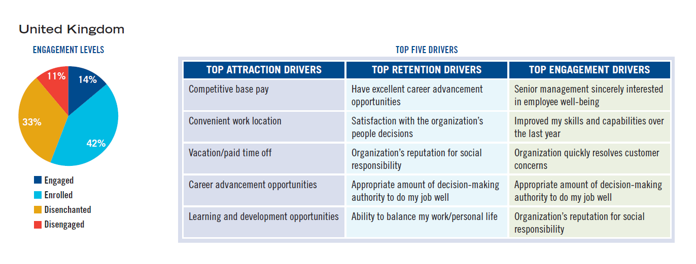

https://engageforsuccess.org/wp-content/uploads/2015/10/Closing-the-engagement-gap-TowersPerrin.pdf

Appendix 2
Enablers of Employee Engagement

Enabler | Definition
A strategic narrative | Defined as a strong transparent and explicit organisational culture which gives employees a line of sight between their job and the vision and aim of the organisation (MacLeod and Clarke 2009, p31)
Engaging managers | Defined as managers who offer clarity, appreciation of employees’ effort and contribution, who treat their people as individuals and who ensure that work is organised efficiently and effectively so that employees feel they are valued, and equipped and supported to do their job’ (Macleod and Clarke 2009, p80).
Employee voice | This refers to when ‘Employees’ views are sought out; they are listened to and see that their options count and make a difference (Macleod and Clarke 2009, p75)
Integrity | Integrity is defined as ‘A belief among employees that the organisation lives its values, and the espoused behavioural norms are adhered to, resulting in trust and a sense of integrity (MacLeod and Clarke 2009, p33).

Appendix 3
Benefits of EE for employees, organisations and individuals

Benefits of Employee Engagement for Employers and Organisations
For the employer, the benefits of employees and teams who are actively engaged with the organisation where they work include:
- enhanced commitment, loyalty and performance
- higher levels of discretionary effort
- the development of employees’ skills and abilities
- fresh and innovative ideas and suggestions
- greater synergy and productivity from the team as a whole
- a positive and productive working environment.

Benefits of Employee Engagement for Individuals
For individuals, the benefits of engagement include:
- a sense of personal fulfilment and well-being in their work
- increased morale and job satisfaction
- the feeling that they are valued and that their efforts are appreciated
- a sense of pride in individual and team achievements
- the realisation of their personal potential
- enhancement of their promotion and career prospects

https://www.managers.org.uk/knowledge-and-insights/resource/employee-engagement/

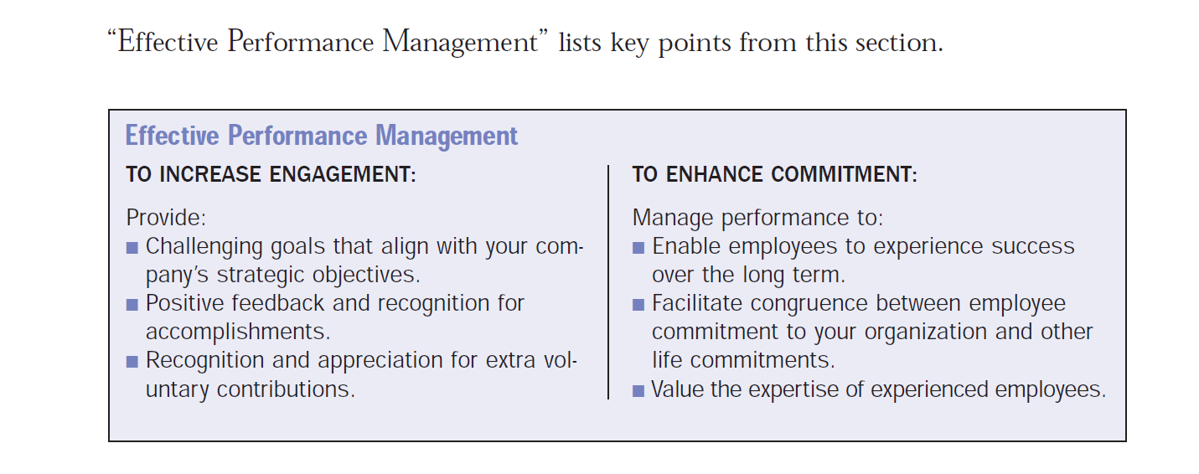
https://www.shrm.org/hr-today/trends-and-forecasting/special-reports-and-expert-views/Documents/Employee-Engagement-Commitment.pdf

Appendix 4
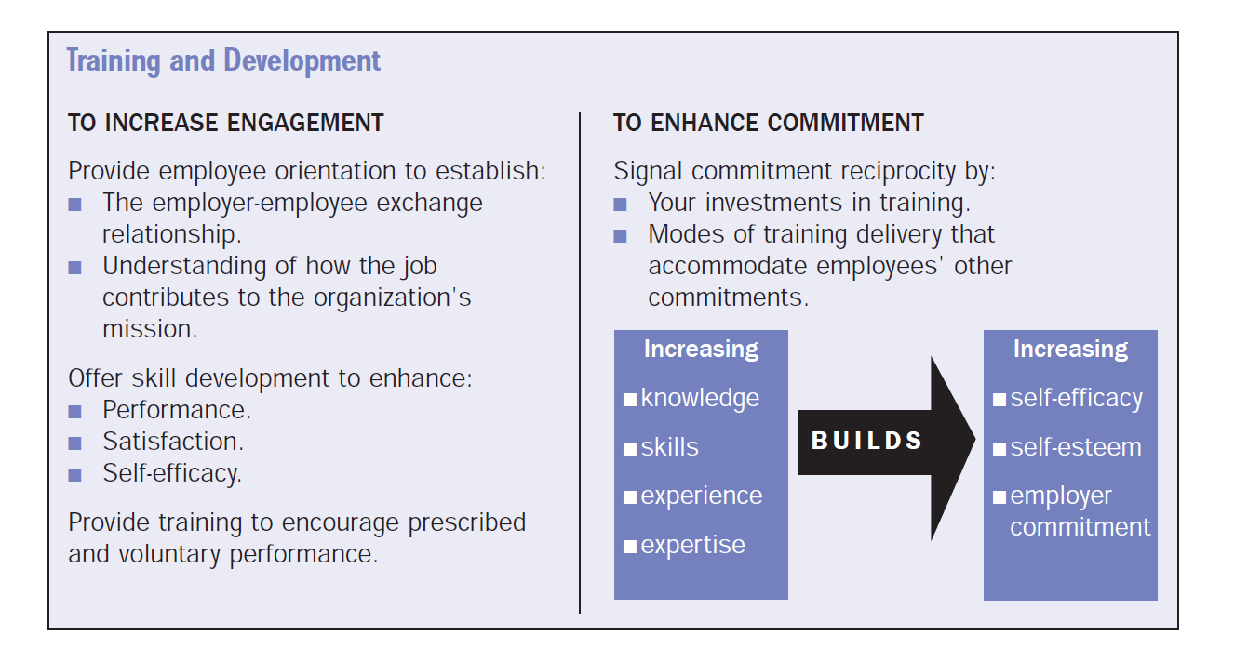

Appendix 5 : Holbeche and Matthews (2012)
Enabler | Definition
Connection | Employees need a sense of identification with, and pride in working for, the employing organisation; there has to be a common purpose and shared values.
Voice | Managers need to keep employees informed of organisational progress and of organisational change and listen to employees’ views so that they feel involved in the business.
Support | Employees need to be treated as individuals and enabled to do their job; they should feel they are valued and receive a fair deal from their employer, and believe their employer is concerned with their wellbeing.
Scope | Work should be purposeful and provide employees with the opportunity for growth and accomplishment; it should allow for autonomy and be underpinned by mutual trust.

Appendix 6: High Performance Model

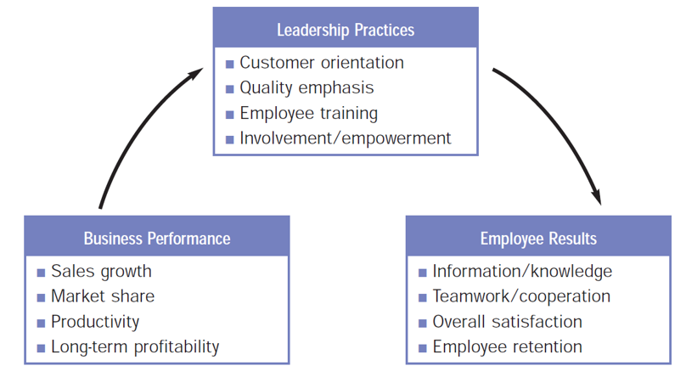
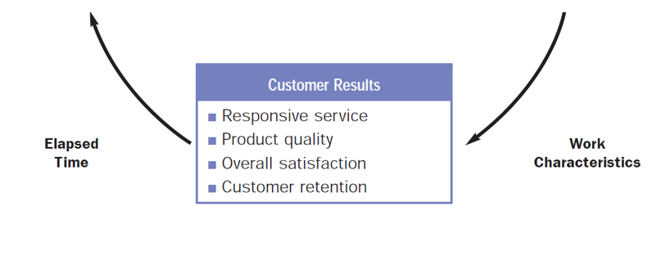
A summary model by Jack Wiley, cofounder of Gantz Wiley Research (now
part of Kenexa) shows how employer leadership practices, employee results of those
practices, customer results of leadership and work practices and business performance are interrelated (Brooks et al, 2006). The model is cyclical, showing that, over time, business performance also influences leadership practices. In addition, this model suggests particular variables within each factor that may affect employee engagement.


Appendix 7

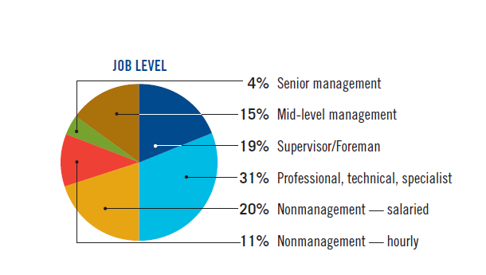

Appendix 8

Top Five Retention Drivers Across the Generations in the Workplace (Towers Perrin, 2007/2008)

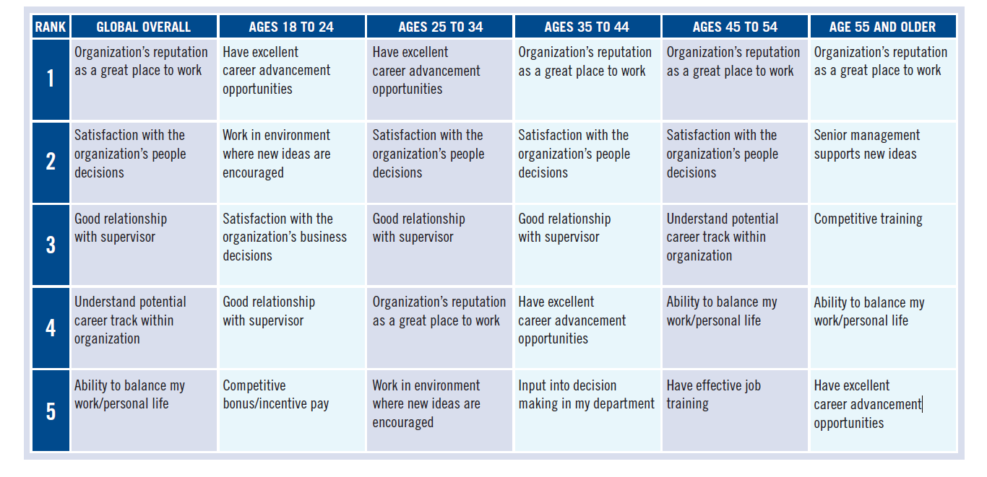

Top Five Attraction Drivers Across the Generations in the Workplace

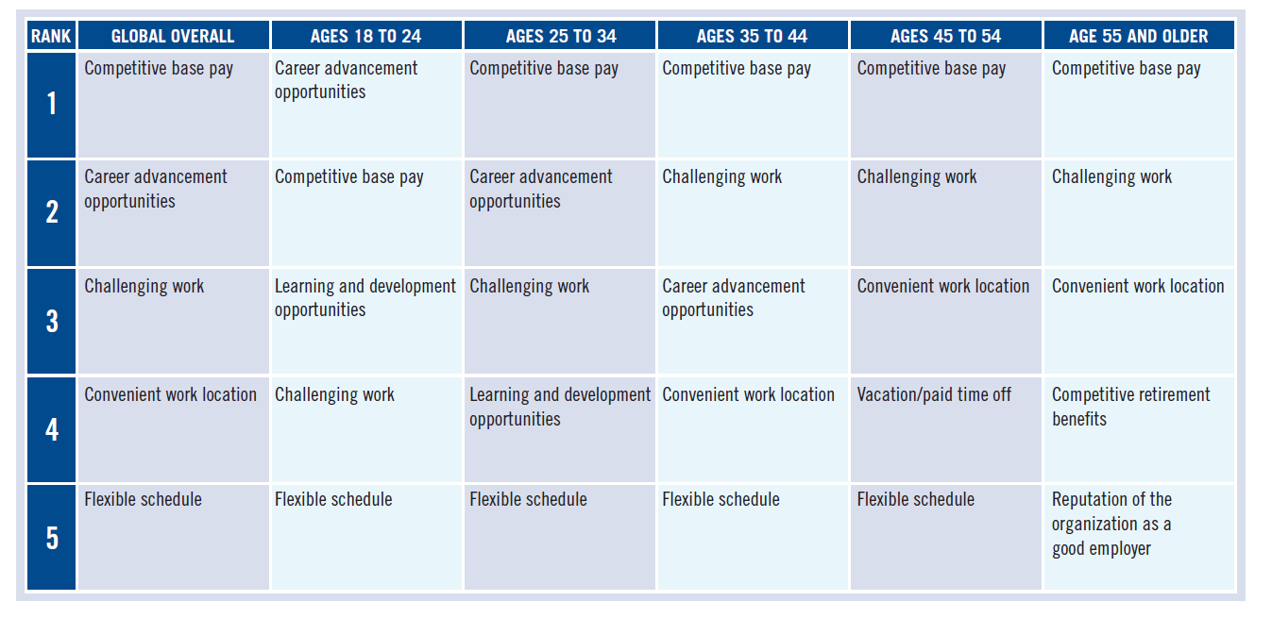

Top Five Engagement Drivers Across the Generations in the Workplace

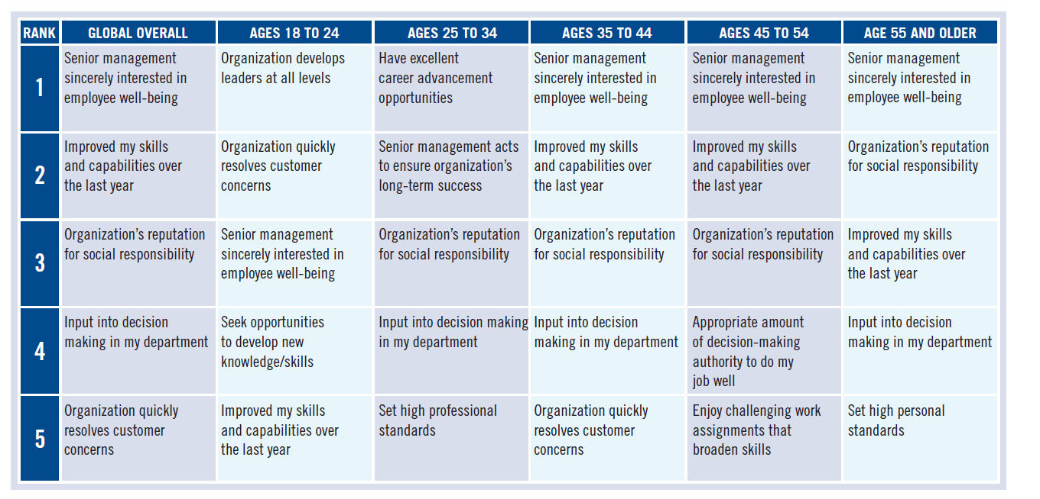

https://engageforsuccess.org/wp-content/uploads/2015/10/Closing-the-engagement-gap-TowersPerrin.pdf

Appendix 9: Link to competitive advantage:

Reaping Business Results at Caterpillar
Construction-equipment maker Caterpillar has garnered impressive results from its employee
engagement and commitment initiatives, including:
- $8.8 million annual savings from decreased attrition, absenteeism and overtime (Europeanplant)
- a 70% increase in output in less than four months (Asia Pacific plant)
- a decrease in the break-even point by almost 50% in units/day, and a decrease in grievances by 80% (unionized plant)
- a $2 million increase in profit and a 34% increase in highly satisfied customers (start-up plant)

