

Arron Simpson

ACDA5022 Work-Based Group Project

University of Wales Trinity Saint David
Ordnance, Munitions and Explosives Professional Degree Apprenticeship

Academic Year: 2026 – 2027

Supervisor: Dave Holley
Date: July 2026

Table of Contents

Abstract 3
Introduction 4
Project Progress and System Engineering Approach 4
Role within the Team: Breakdown and Disposal 5
Interaction Between Roles 5
Communication and Decision Making 6
Output to the Team and Design Solution 6
Presentation and Feedback 7
Reflection and After-Action Review 7
Conclusion and Recommendations 7
Annex A – Breakdown and Disposal Slides 1
Annex B – Presentation Feedback 1

Table of Tables

Table 1 – Presentation Pack 2
Table 2 – Presentation Feedback 2

Abstract
This report reflects on a work-based group project to develop a conceptual Explosive Ordnance Disposal capability using systems engineering principles. The project required a multi-disciplinary apprentice team to interpret an Ordnance, Munitions and Explosives problem, develop a viable design solution, and present the proposal for assessment. The report focuses on the Breakdown and Disposal role, which examined how energetic materials, lithium batteries, electronics, composites and other system components could be safely broken down, segregated and disposed of during testing, operation and end of life activity. The project demonstrated that disposal planning is not a standalone end of life task, but a design consideration that must be integrated from the outset. The report concludes that future designs should include clear requirements traceability, modular features that support safe removal and segregation, justified disposal routes, and auditable evidence to support safety, compliance and assurance.

Introduction
- This report outlines the development of a group design project undertaken to produce a conceptual Explosive Ordnance Disposal capability using systems engineering principles. The project required a multi-disciplinary team of apprentice engineers to interpret a designated Ordnance, Munitions and Explosives (OME) problem, develop a viable design solution, and present the final proposal to a panel for assessment and feedback. The design brief required the team to work largely unsupervised after the initial tasking, apply the learning from the concurrent systems engineering module, and produce a viable solution to an OME related problem.
- The team consisted of apprentices from Defence Nuclear Organisation (DNO), Defence Equipment & Support (DE&S), BAE Systems (BAES) and QinetiQ. This breadth of organisational experience provided a useful mix of operational, safety, manufacturing, test and assurance perspectives. My allocated role was the Breakdown and Disposal phase, which required me to consider how the proposed system could be safely broken down, disposed of, or recovered at the end of life, during test activity, and under emergency conditions. This required understanding of disposal requirements, design for disposal deliverables, candidate disposal techniques, critical analysis of disposal design data, feedback into the design process, and preparation of a waste stream management plan.
- The task was particularly relevant to my professional background. As an experienced OME engineer, with previous Royal Air Force (RAF) weapons preparation and management experience and eight years working on complex Air-to-Air missile projects, I was able to contribute practical understanding of OME lifecycle management, safety constraints, configuration control, stakeholder assurance and the importance of traceability. However, the value of the project was not limited to technical output. It also tested the team’s ability to communicate effectively, allocate responsibility, make decisions collaboratively and integrate specialist contributions into a coherent system design.

Project Progress and System Engineering Approach
- The project developed through a staged systems engineering process. The initial phase focused on understanding the customer requirement and translating it into system level functions. The design brief required the team to use outputs from systems engineering lectures to propose a viable solution, with a mid-point design review used to confirm progress and resolve specific design questions. This encouraged the team to avoid jumping directly to a preferred technical answer and instead consider the wider lifecycle, including requirements, architecture, design trade-offs, test, manufacture, safety and disposal.
- The final Breakdown and Disposal presentation defined a single top level disposal requirement: that the system should enable safe, compliant breakdown and disposal of all system components, including explosive payloads, electronic subsystems and structural elements, in accordance with applicable environmental, explosive safety and hazardous waste regulations at end of life. This requirement was described as the driver for disposal related design, documentation and verification activity. This was important because it prevented disposal from being treated as an afterthought. Instead, disposal considerations were introduced into the design process early enough to influence architecture and component selection.
- The system was broken down into key elements, including the UAV/UGV elements, shaped charge payload, control station, electronics and lithium-ion power systems. The disposal focus areas were energetic materials, batteries, composites, electronics and marking chemicals. This decomposition helped the team identify hazards, applicable legislation, disposal routes and key dependencies between roles.
- The team’s systems engineering approach linked requirements, architecture, integration and test, manufacture, in-service use and end of life disposal. It identified modular explosive interfaces, separable battery modules and accessible electronics as important design considerations, and showed that safe to dispose procedures and disposal documentation should be validated for both routine and emergency contexts.

Role within the Team: Breakdown and Disposal
- My role was to provide the Breakdown and Disposal input to the wider system design. The role required me to understand the disposal requirements for the selected system area, identify legal and procedural deliverables, select candidate disposal techniques for article and explosive disposal, critically analyse disposal design data, provide feedback into the design process and prepare a waste stream management plan.
- The Breakdown and Disposal workstream initially focused on understanding what would need to be disposed of. This required close interaction with the manufacturing, safety, environmental and test roles because disposal routes could not be defined until the system architecture, materials, energetic content and test assumptions were sufficiently understood.
- The disposal requirements were driven by four main considerations: transportation of equipment, safe breakdown of equipment, safe disposal of equipment, and no threat to the operator throughout. These considerations were reflected in the final slide pack, which identified safety, compliance, segregation, operational flexibility and traceability as key disposal requirement themes. From my perspective, the most significant of these was traceability. For OME systems, disposal cannot be treated simply as waste management; it also requires control of energetic items, chain of custody, evidence of certified disposal, and assurance that no residual explosive hazard remains.
- The Breakdown and Disposal presentation separated disposal deliverables into test and production environments. Test activity required risk assessment, hazard classification, safe maintenance information and hazardous material data, while production required an end of life disposal plan, demilitarisation procedure, waste stream register, certified disposal routes and traceability documentation. This distinction recognised that prototype and mature systems require different levels of disposal control.

Interaction Between Roles
- The project required continuous interaction between roles because each discipline’s output affected the others. Manufacturing decisions influenced material selection, assembly methods and whether components could be separated at end of life. Safety decisions influenced hazard controls, operator protection, render-safe assumptions and acceptable design constraints. Test and evaluation decisions influenced what evidence would be required to verify disposal assumptions, particularly for damaged or unsafe energetic items. Environmental safety influenced waste categorisation and the selection of appropriate disposal routes.
- The Breakdown and Disposal function was dependent on system level information from other team members. Disposal routes for electronics, lithium batteries, energetic components and composite structures depended on final architecture and material choices. Candidate routes included recycling or secure destruction for non-explosive items, and licensed facility return, EOD handover or demilitarisation for energetic items.
- This interdependency meant that communication was essential. If the manufacturing lead selected a material that was difficult to recycle or hazardous to process, this changed the waste stream. If the safety lead identified a credible hazard during breakdown, this affected the disposal procedure. If the test lead identified additional evidence requirements, this affected the disposal verification plan. The team therefore had to operate as an integrated design group rather than a set of isolated discipline leads.
- In practice, the group worked effectively because individuals took ownership of their allocated roles while remaining open to challenge from others. Concerns were raised for discussion rather than retained within individual workstreams. This was particularly important for disposal because disposal decisions could not be made solely on convenience or cost; they needed to balance safety, legal compliance, practicality, operator exposure, environmental impact and system availability.
- A further challenge was recognising when to step back and allow less experienced apprentices to work through problems independently. Although this was sometimes frustrating where discussions took longer than expected, it reinforced the need to guide rather than direct and to create space for others to develop confidence and judgement.

Communication and Decision Making
- The team communicated through a combination of group discussions, weekly Teams meetings, allocated actions and presentation development and in person rehearsal. This style of working was suitable for a mixed experience team because it provided regular opportunities to align assumptions, review progress and identify dependencies between roles.
- Decision making was based on collective discussion, with the systems engineering process providing structure. The team decomposed the system, considered options, and used role specific analysis to feed the final design. The approach reflected the brief’s expectation that the team would work unsupervised, use systems engineering output, and develop a viable OME solution.
- For Breakdown and Disposal, decision making centred on selecting disposal routes that were credible, compliant and traceable. Key trade-offs included recyclability, hazardous waste, dismantling difficulty and lithium battery fire risk. These issues showed why disposal decisions should be considered early, as they can influence system architecture.
- One of the main lessons from the project was that decisions should be explicitly traceable to requirements and design constraints. Panel feedback specifically asked how requirements influenced the design, how the modular design concept was driven, how candidate disposal means were chosen, and where design traceability was shown. This was valid feedback. Although the design logic was understood by the team, it needed to be presented more clearly so that the assessment panel could follow the rationale from requirement to design feature, disposal route and verification evidence.

Output to the Team and Design Solution
- My main output to the team was the Breakdown and Disposal strategy. This included identifying disposal requirements, candidate disposal techniques, routine and emergency disposal considerations, critical disposal design data, and a waste stream management plan. The final presentation summarised the waste stream management plan by categorising explosives, lithium batteries, PCBs and electronics, metal chassis and structures, and plastics and composites into corresponding disposal routes (Annex A – Breakdown and Disposal Slides).
- The design solution also included a lifecycle flow from manufacture and configuration capture through use, removal of hazardous items, system disassembly, segregation and certified disposal. This showed that disposal assurance depends on evidence captured throughout the lifecycle, not only at end of life.
- A key design implication was the need for modularity. Explosive modules, batteries and electronics should be separable to support safe removal, segregation and disposal. This output helped turn disposal requirements into practical design features.

Presentation and Feedback
- The team delivered the final design to a panel and received both group and individual feedback. The overall group presentation was marked strongly, with scores of 27 out of 30 for response to questioning, 27 out of 30 for presentation of design, 17 out of 20 for demonstration of understanding, 8 out of 10 for presentation style and 8 out of 10 for presentation quality, giving a total of 87 out of 100 (Annex B – Presentation Feedback).
- Feedback recognised that the presentation was professional and that the Breakdown and Disposal section appropriately addressed legislation, routine and emergency disposal, and component-specific disposal methods.
- Areas for improvement included clearer requirements layout, stronger design traceability, better explanation of how disposal options were selected, and clearer presentation of the waste stream management plan. The panel also noted that some slides were too text heavy and that the presentation overran.
- This feedback showed that the technical analysis was credible, but the reasoning needed to be more visible. In future, requirements, assumptions, decisions, risks and mitigations should be linked more explicitly to strengthen the assurance argument.

Reflection and After-Action Review
- Overall, the team worked effectively together. The mix of experience across DNO, DE&S, BAES and QQ provided a useful range of perspectives, and individuals took ownership of their areas while raising issues for group discussion. This reflected how OME engineering problems are solved in practice: through informed challenge, stakeholder engagement and integration of specialist evidence.
- The team collaborated well and developed a broad requirement into a coherent concept with identifiable subsystems, disposal routes, risk controls and lifecycle governance. The Breakdown and Disposal workstream influenced the design by identifying the need for modular explosive interfaces, separable battery modules, accessible electronics and waste stream segregation.
- The main weakness was presentation clarity. The team included too much detail for the available time, so future presentations should be simplified with supporting evidence retained separately.
- If repeated, I would establish a requirements traceability matrix earlier, use a decision log, and conduct a focused dry run to improve timing and clarity.

Conclusion and Recommendations
- The project demonstrated the value of applying systems engineering principles to an OME design problem. By considering requirements, architecture, manufacture, safety, test, disposal and lifecycle governance together, the team developed a more complete and defensible EOD capability concept. The Breakdown and Disposal role contributed by ensuring that end-of-life, test and emergency disposal requirements were considered as part of the design rather than as a late stage activity.
- The main conclusion is that disposal planning must be integrated from the start of the design process. For systems containing energetic materials, lithium batteries, electronics and composite structures, disposal is not simply an environmental activity; it is a safety, compliance, configuration and assurance issue. The final design therefore needed to support modular removal, segregation of hazardous materials, certified disposal routes and traceable evidence from manufacture through end of life.
- The key recommendations are as follows. First, future projects should adopt explicit requirements traceability from the outset. Second, disposal methods should be compared and justified rather than only selected. Third, design for disposal principles should be used to influence architecture, particularly modularity, access and segregation. Fourth, presentation material should be simplified for mixed audiences, with acronyms explained and detailed evidence retained in supporting documentation. Finally, the after action review should be treated as part of the engineering process, ensuring that feedback from the panel is translated into design improvement, clearer assurance arguments and improved professional practice.
- Overall, the task was a valuable exercise in technical engineering, communication and teamwork. It reinforced that successful OME design is not achieved by technical knowledge alone, but by the ability to integrate diverse inputs, challenge assumptions, communicate clearly, and produce a traceable design argument that can withstand scrutiny from suitably qualified reviewers.

Annex A – Breakdown and Disposal Slides
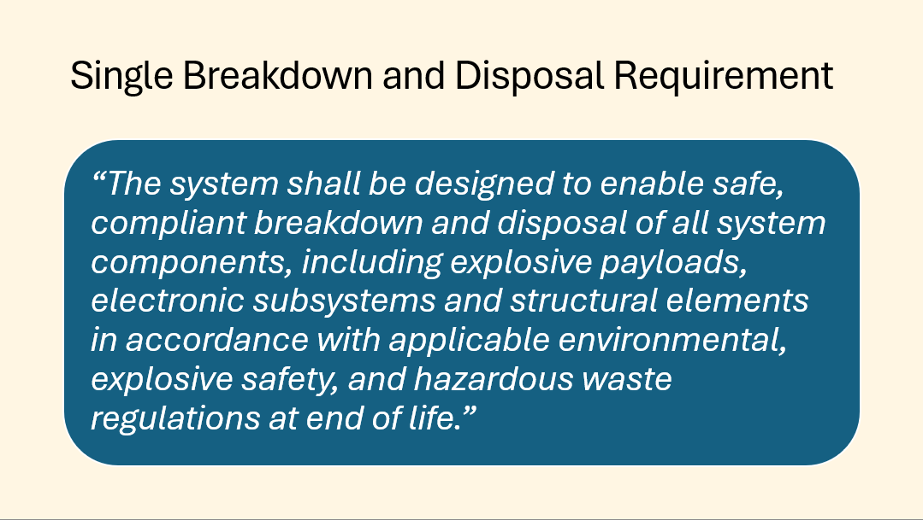 | 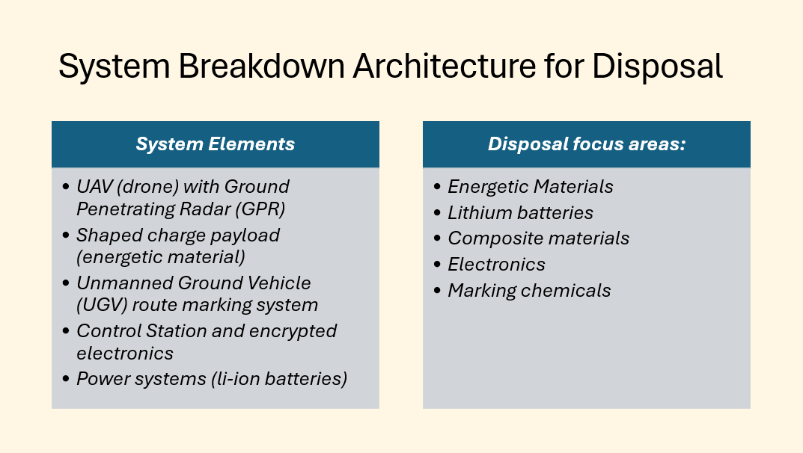
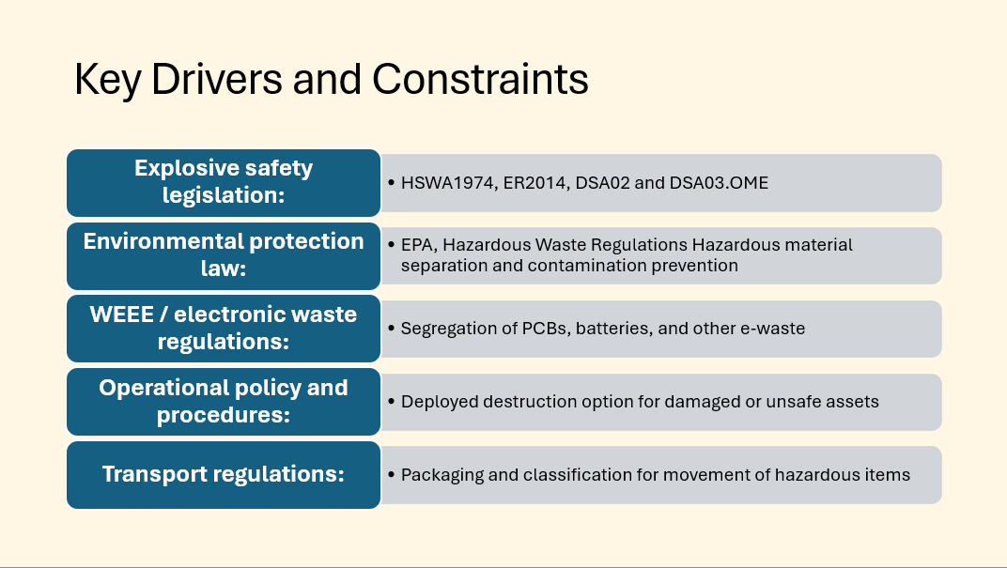 | 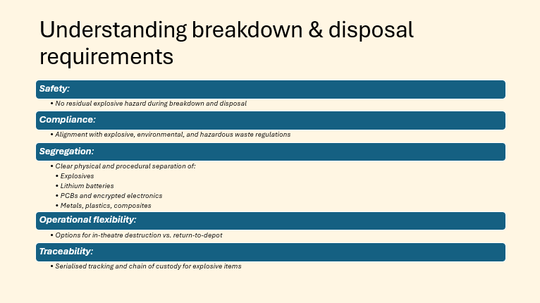
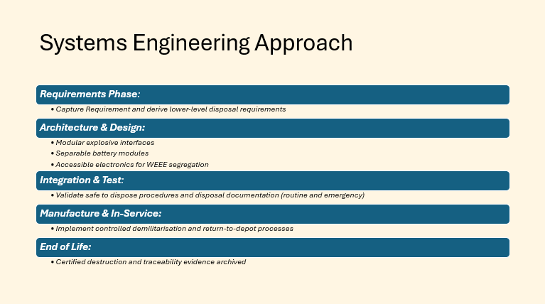 | 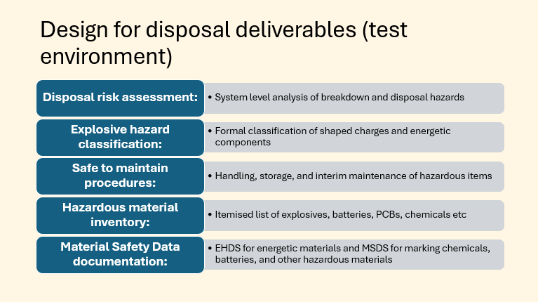
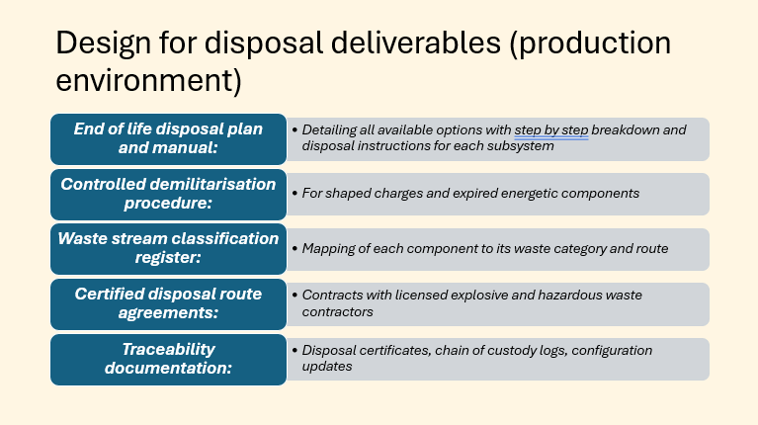 | 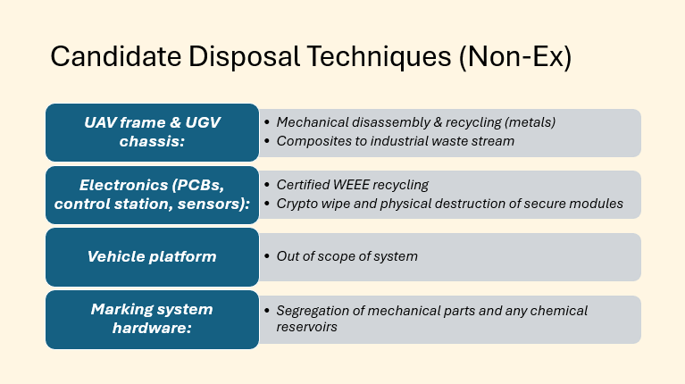
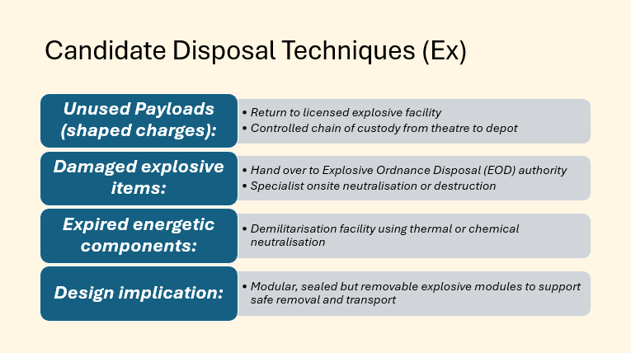 | 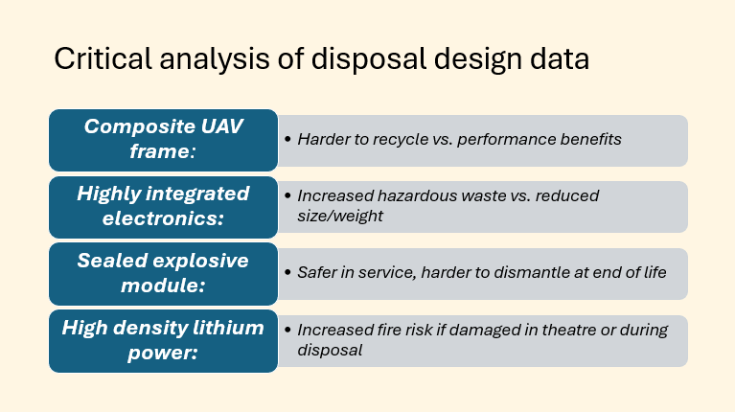
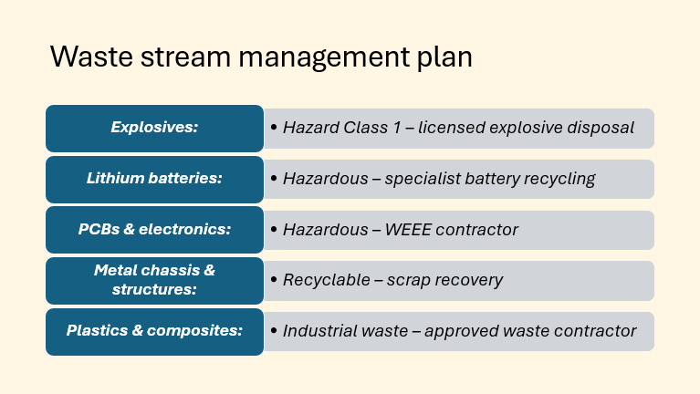 | 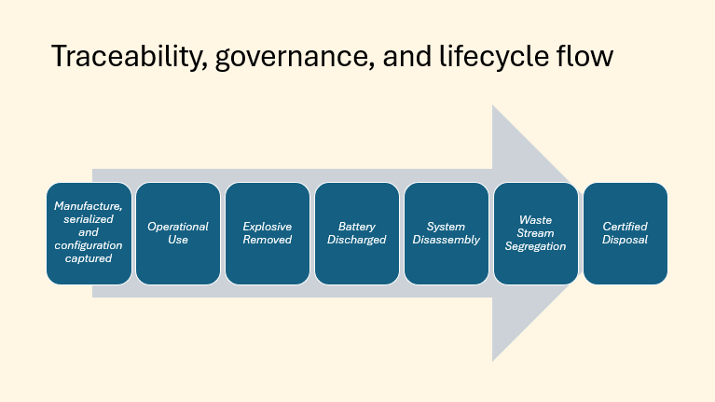
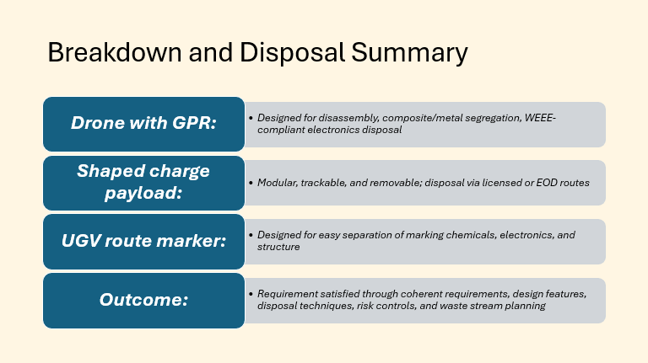
Table A1 – Presentation Pack

Annex B – Presentation Feedback
Arron Simpson | Team 1
Group Presentation Overall
1. Response to Questioning | /30 | 27
2. Presentation of Design | /30 | 27
3. Demonstration of Understanding | /20 | 17
4. Presentation Style | 10 | 8
5. Presentation Quality | /10 | 8
TOTAL | /100 | 87
Team feedback / Questions
Jenni. Cost of the system.
Gareth. Shaped charge (PE-8) notoriously bad. Complicated filling process.
Dave. Human factors assessment
Jacko:- Legislation when using drones. Programming etc.
Placement of the charge again. Balancing forces when the charge, how are ensuring it’s all gone?
EWA. Taggant? What is it?
All suitably professional in appearance. Simplistic and effective slide design, good use of visual images to help with audience understanding throughout. Many slides have a lot of writing on, this could make it difficult for audience to read, try practicing from the back of a large room to ensure your text is an appropriate size. Some very limited areas (it final square on trials safety slide) have a low text to background contrast making it very difficult to read, consider a darker text on a light background or lighter text on dark background as you have done well in the rest of the presentation. Try and avoid using acronyms where possible in the slides as not everyone who will be seeing these will be an expert, whilst you articulate very well in the presentation itself (well done!), it could be that not everyone who needs to see the slides will be present at the time. References slides included, this pleases Jenni! Overran by about 8 minutes.
Feedback / Comments Dave
Requirements laid out
Ensure requirements laid out in the report
Did any of these requirements influence the design (Do they check out)
For instance, how did the requirements drive the modular design concept.
Through life view taken
Candidate disposal means selected (How chosen? Where is the design traceability)
Waste stream management plan presented.
Feedback / Comments Jenni
Good volume and pace. Nice open body language. Some fair attempts at interacting with the audience, however there was a lot of reading from the slides or the screen. This could come across as being unprepared or unfamiliar with the material which is clearly not the case. Identification of various legislations relating to disposal. Consideration of routine and emergency disposal, good. Suitable disposal methods for each component of the design setup.
Individual Mark
Role
Breakdown and Disposal | Understanding of the breakdown and disposal Requirements for the area selected | Understanding the deliverables for design for disposal in test and production arenas | Identification of candidate disposal techniques for article and explosive disposal | Critical analysis of disposal design data | Feedback into the design process | Preparation of the waste stream management plan
 | 8 | 8 | 7 | 6 | 7 | 8
Total mark = |  |  | 60 | 100 | 44 | 73
 |  |  |  |  | 2 | 160
 |  |  |  |  |  | 80.17
Table 2 – Presentation Feedback

