Student name: Cristina-Elena Enache
Student code: 2026057
Module name: BMHP5014_BIRM
Module code: Changemakers: Creativity and value Creation
Lecturer name: Azora Hurd
Assignment name: E-Portfolio evidence of learning comprising of 2 separate artefact items

Contents
Introduction 3
Elevated pitch 3
Conference poster 4
Reference 6

E-Portfolio evidence of learning comprising of 2 separate artefact items

Introduction
Domestic violence refers to any behaviour—physical or verbal—by a family member against another member of the same family that results in or may result in physical, mental, sexual, emotional, or psychological harm or suffering. It also includes the threat of such behaviour, coercion, or deprivation of liberty. (NCDV) Below I will present an elevated pitch and a conference poster where I present what domestic violence means, what effects it can have in everyday life and how we can make it no longer take place.

Elevated pitch
My name is Cristina Enache, the founder of The Hope Foundation and today I am with you to talk about domestic violence. Nowadays, many women and children are subject to domestic violence, which is not normal for the society we are in, where women have equal rights with men, and men must in no way show their power through violence, in all its forms.
The impact of gender-based violence on children, especially domestic violence, is very damaging. Children are always affected by the abuses committed against mothers and can also become victims of the aggressor who, in most situations, is their natural father or stepfather. Moreover, children can be directly affected by domestic violence by subjecting them to a similar act of violence. Their personality can undergo profound changes as a result of domestic violence experienced in childhood: boys are more likely to become aggressors, and girls are victims. It is essential that they receive support to deal with experiences of violence and understand that living together in terror and abuse is not normal. (Women’s Health) Children raised in families where verbal or physical violence manifests themselves learn that, through violence, you can get everything you want, you can impose your point of view and make yourself listened to. Males who punish females are presented as real males, who know how to be confident, who do not express their feelings, and are always listened to and respected. In a family affected by aggressive behaviours, children live in an atmosphere where the need for safety, emotional security are deeply altered. Instead of parental authority, in such a home, terror is installed that does not educate, does not form a balanced adult and that can hinder the normal mental and affective development of the child. (Women’s Aid)
From a social point of view, the victim is isolated from his family of origin, friends, co-workers or social assistance services. The social isolation of the victim is one of the most severe factors of failure in their failure to get out of the abusive relationship in which they find themselves. According to statistics, annually in the UK over one million women are victims of domestic violence, in 2018 estimating 1,316,000 aged between 16-59 were assaulted by a family member or partner. (NimbleFins, 2021)
Thank you for being with us tonight and for listening to us. I invite you all to join our cause to help as many women and children as possible get out of this situation. If you have acquaintances who are victims of domestic violence please do not hesitate and guide them to come to us to ask for help and to help them.

Conference poster

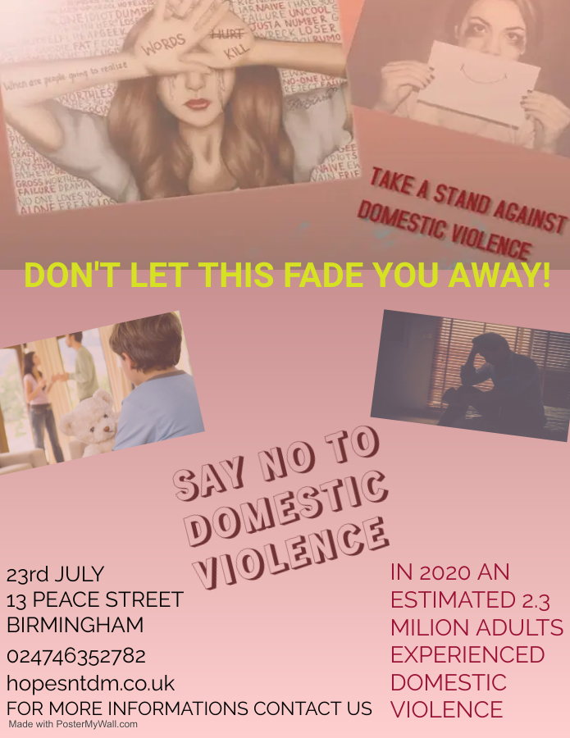
The first step in receiving treatment is realising that you are being abused; domestic violence frequently escalates from verbal and written threats. Even if physical harm is the most evident and serious risk, the emotional and psychological effects might be noticeable as well. Abuse and domestic violence are used to take and keep complete control over an individual. The aggressor seeks to force his authority on the victim using unnatural and improper methods and controls them through fear, guilt, shame, intimidation, and humiliation. The abuser typically causes harm or makes threats of harm. On an emotional level, abusive relationships can devastate one's sense of self-worth, cause anxiety and melancholy, and make the victim feel helpless and abandoned. Nobody should have to endure this kind of suffering and realising that an abusive environment exists is the first step towards getting out of it. Once this reality is acknowledged, assistance can always be gotten.
Hope is a foundation that supports and reintegrates domestically abused people into society, helping them to regain their self-confidence and motivation to move forward. This foundation was founded in 2015 out of the pleasure of helping other people, who need someone to support them. The Hope Foundation responds to the complex needs faced by people affected by domestic violence. The team of specialists working in the Hope Foundation supports the assisted persons to understand the abusive situation, to adapt to the life "outside" of the relationship, to regain their self-respect and to improve their relationship with the children and the extended family. Thus, both the social problems that are associated with the phenomenon of domestic violence, as well as the psychological and legal aspects are considered. Within the foundation we have doctors and psychologists specialized in domestic violence, mental or physical abuse, depression, anxiety, post-traumatic stress, individual psychotherapy, a counselling centre, a legal counselling and representation in court for obtaining the protection order. The counselling centre offers specialized assistance to survivors of domestic violence, consisting of free social, legal and psychotherapy counselling services, offered by professionals with over years of experience in intervening in these cases. Beneficiaries are supported to regain their confidence and self-esteem, to discover new resources in themselves and new mechanisms to deal with violent incidents. The provision of these services both by phone and online allows us to support people from all over the country or who cannot reach the counselling centre for various reasons. Besides this we also have houses and apartments, schools and playing areas for abused people and children, located in safe places where abusers cannot access. We also want to make sure that abused people can reintegrate into society, trusting people again, so we will help them find a job. We want to make ourselves heard and we hope that on July 23rd we will be joined by as many people as possible at our meeting. With us will be one of our psychologists who will tell us what the impact on our lives of domestic violence is.

Reference

https://www.bing.com/images/search?view=detailV2&ccid=abkDU5N3&id=C8F81EB904F70142C76E07E5E2232FF8A89F76CC&thid=OIP.abkDU5N3Bumuzh3X8PLeRQHaE8&mediaurl=https%3a%2f%2fnewportbeachchristiancounseling.com%2fwp-content%2fuploads%2f2019%2f02%2fsydney-sims-519706-unsplash-1500x1000.jpg&cdnurl=https%3a%2f%2fth.bing.com%2fth%2fid%2fR.69b90353937706e9aece1dd7f0f2de45%3frik%3dzHafqPgvI%252bLlBw%26pid%3dImgRaw%26r%3d0&exph=1000&expw=1500&q=Mental+Abuse+&simid=608013734206139441&FORM=IRPRST&ck=59944D17ACA38F23E94DE5DBB06F1CAC&selectedIndex=20&ajaxhist=0&ajaxserp=0

https://www.bing.com/images/search?view=detailV2&ccid=OjHBwGZn&id=AB0AD14D548E8EBCA27275E7A46ECE19B3A130F7&thid=OIP.OjHBwGZnAzOOLFvZDX4N8AHaHa&mediaurl=https%3a%2f%2fi.pinimg.com%2foriginals%2fcb%2f32%2f4c%2fcb324c515f5c4a31494b73e9ff54ca22.jpg&cdnurl=https%3a%2f%2fth.bing.com%2fth%2fid%2fR.3a31c1c0666703338e2c5bd90d7e0df0%3frik%3d9zChsxnObqTndQ%26pid%3dImgRaw%26r%3d0&exph=500&expw=500&q=WHEN+ARE+PEOPLE+GOING+TO+REALISE+WORDS+KILL&simid=608024140915962824&FORM=IRPRST&ck=CB2BB201827CE0E82392404492084352&selectedIndex=1&ajaxhist=0&ajaxserp=0

https://www.bing.com/images/search?view=detailV2&ccid=cWZA8RXv&id=2458AA043EE164B2BD8BC3E0B456723B78C0D96D&thid=OIP.cWZA8RXvEk8czw6lM2UCaAHaEL&mediaurl=https%3a%2f%2fwww.gannett-cdn.com%2f-mm-%2f4b705fec2884e9b709dc703f8a6efd784cce1fd0%2fc%3d0-185-3873-2370%2flocal%2f-%2fmedia%2fUSATODAY%2ftest%2f2013%2f09%2f12%2f1379005022000-D01-FLAG-YL-09.jpg%3fwidth%3d3200%26height%3d1806%26fit%3dcrop%26format%3dpjpg%26auto%3dwebp&cdnurl=https%3a%2f%2fth.bing.com%2fth%2fid%2fR.716640f115ef124f1ccf0ea533650268%3frik%3dbdnAeDtyVrTgww%26pid%3dImgRaw%26r%3d0&exph=1806&expw=3200&q=abuse+child&simid=608019979114865997&FORM=IRPRST&ck=31EF05D8EB1A5AF05F2515478729F943&selectedIndex=0&ajaxhist=0&ajaxserp=0

https://www.bing.com/images/search?view=detailV2&ccid=o68%2bEi4N&id=CE04356DAA4DF11B8926DB42991512FC855768D2&thid=OIP.o68-Ei4N8UhCbWZgAZUP1gHaE1&mediaurl=https%3a%2f%2fimg2.thejournal.ie%2farticle%2f3734811%2friver%2f%3fheight%3d400%26version%3d3734891&cdnurl=https%3a%2f%2fth.bing.com%2fth%2fid%2fR.a3af3e122e0df148426d666001950fd6%3frik%3d0mhXhfwSFZlC2w%26pid%3dImgRaw%26r%3d0&exph=400&expw=613&q=MEN+ABUSE&simid=608055683184162361&FORM=IRPRST&ck=C4F66B95385EF53B0267C9B93CE5BF6E&selectedIndex=91&ajaxhist=0&ajaxserp=0

- Domestic Violence, Org
Available at https://domesticviolence.org/definition/, accessed on 26.06.2022

- What is domestic violence, National Centre Domestic Violence A Community Interest Company
Available at https://www.ncdv.org.uk/what-is-domestic-violence/ , accessed on 27.01.2022

- The impact of domestic abuse on children and young people, Women’s Aid
Available at https://www.womensaid.org.uk/information-support/what-is-domestic-abuse/impact-on-children-and-young-people/, accessed on 28.06.2022

- Effects of domestic violence on children, Women’s Health
Available at https://www.womenshealth.gov/relationships-and-safety/domestic-violence/effects-domestic-violence-children, accessed on 29.06.2022

- Violence Against Women Statistics UK, 2021, NimbleFins
Available at https://www.nimblefins.co.uk/violence-against-women-statistics-uk, accessed on 01.07.2022

- C S Stover, 2005, Domestic Violence Research: What Have We Learned and Where Do We Go From Here?, accessed on 30.06.2022

