Module: Research Practices
Module code – M5X01571

- Assignment title -
Dissertation Proposal (Exploration of three Keywords) 2000 words.

For this assignment Three key words and Three key images will be chosen that will develop into a question that will be developed in next terms dissertations. Research will be undertaken to show development of the idea and how it can be taken forwards in the dissertation stage and developed further. After exploring the keywords and images a final question will be presented that will be taken forwards and developed as the main talking point of the dissertation.
Keyword – loss
Loss is the absence of something or someone that the owner previously possessed or knew (1). For the first keyword loss will be discussed and its meaning and context to the dissertation. The great thinker Plato ones said ‘’Death is one of two things -- either death is a state of nothingness and utter unconsciousness, or, as men say, there is a change and migration of the soul from this world to another ‘’ (2) in context loss is about the disappearance of an object or person. Everything dies or gets destroyed over time and people want to keep holding on to it as long as they can what creates this strong attachment in our lives that keeps us obsessing over things we have no control over? Could it be that people are greedy and just want to keep holding onto something as long as possible or something far more phycological that each person has deep down in their hearts. When talking about the loss of an object people are simple attached to things and hate the idea of losing something they owned or earned. Ryan Martin Ph.D. a Doctor of Psychology (3) states that each person has a Trigger event that sets offer certain emotions and actions in everyone and can be activated from something as small or severe. Loss must be tied into this trigger event as people can react in extreme ways when something or someone is take away from them for example notice how a child acts when a toy is taken away from them they scream and cry but if they get back the lost object they stop crying and go back to normal. In the context of loss when talking about a person its far more phycological and individual based the great thinker plato states that ‘’ that death is most definitely not an eternal sleep but rather the moment at which the soul is finally released from the body’’(4) (5) with this way of thinking no one dies but they simple move onto a new journey in their life it could be argued that this is offensive to tell someone that lost a loved one but it keeps the hope that they are still alive in some way even if not physically.
By the Deathbed by 15) Edvard Munch (1893)
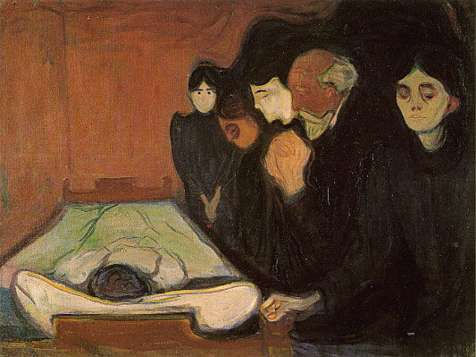
This painting by Edvard Munch titled By the Deathbed (7) depicts a family morning the loss of a loved one and really depicts the feeling of loss that Edvard was feeling at the time it was painted to commemorate the death of his mother that died very early on in his life (6). Just through a simple painting like this many emotion are conveyed to the viewer and tales you the story without you needing a description with the small boy’s face giving off the feeling of loss without you needing understand the context. If applied to the concept of a video game maybe using this technique would be useful as well using simple art style but applied the same technique to express to the player, the story or objective without fancy graphics or gameplay.

Keyword – denial

Denial ‘’an assertion that something said, believed, alleged is false’’(7) is a powerful emotion that people experience in a time of loss or pain. When attributing the concept of denial when talking about a person or persons it usually takes place when a close family member or loved one has died and the person will not admit to themselves that there gone. Steven Novella states that that ‘’ At the heart of all denial is a motivation to deny the specific claim or science, a motivation that has nothing to do with the truth’’ (8) this would link back to the fact that people don’t want to accept the truth of a hard subject. When going back to the subject of video games the emotion of denial is not that often explored in the medium and the times that it is very rare. For example, in the video game series gears of war one of the main characters Dom is searching for his lost wife and throughout the story its stated many times that she is probable dead and he should stop his reckless search. But he never stops and keeps looking and ignores the main character this complicated plot is one of the best examples of denial in a video game to date (9). There are other examples of denial in video games, but they are few and far between but the few examples that are out there are well made and don’t make it obvious to the player. If the idea of denial was taken forwards into the dissertation stage and a subject was chosen, the concept of death and denial could be used to interesting effect and many concepts could be talked about regarding this emotion. Not just games explore this concept through there are many other examples of denial in different mediums that could be explored for example a dissertation on a subject like life and death in movies could be explored or depression in famous books could also be an interesting concept to explore. Movies such as the godfather explore the concept of Denial well with one of the main plots of the movie based around the death of a son and how the family deals with it. One of the best examples of denial in a media in recent years came out of the comic book the walking dead with the story talking about the struggles of people after a zombie plague many emotions are explored in the book and offer a good insight in the characters minds. Rick the main character loses his Wife and child early on but throughout the story he blames himself and doesn’t except their deaths and believes that they are still alive but are missing (10)(14). denial and death could be an interesting subject to look at and it could incorporate many subjects and themes and media examples that could be studied

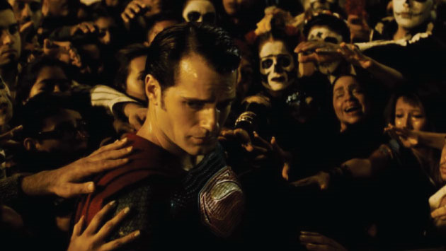
This was a screenshot from the recant movie batman v superman dawn of justice and really offers a good example of denial in recent years. In the movie superman is seen as a god to the people of earth and they believe that he can protect them from anything but superman himself knows this isn’t true, but the people are so in denial that they can’t accept that he can’t be everywhere at ones. This screenshot really shows you the conflicted nature of superman and how the people view him as a sort of god, this could be a really good movie to reference if denial is taken forwards into the dissertation
Batman v Superman: Dawn of Justice. (16) (2016

Keyword – representation

Representation ‘’a usually formal statement made against something or to effect a change’’(11) the word representation is used when talking about a way an object or person/people are seen in public life for example when a person of Chinese decent is shown in a movie or video game the developer will want to show that person in a correct way and not make fun of them in any way shape or form. when relating to the two other keywords of loss and denial the three words could be used in a way to talk about people of different ethnic groups and how they are seen in video games or movies. This would be an interesting subject to look into and explore and see how different types of media portrays people in a good or bad way. Joseph Campbell states in his book (The Hero with a Thousand Faces) that Every story follows something called the (heroes journey) 10 steps that he has found to take places in most western story’s and how this inspires story’s even today (12). His other books The Power of Myth (1988), and the mythic image (1974) explores the fact that every culture on earth has the same story’s and legends and how this shapes story’s today Campbell states ‘’ A hero ventures forth from the world of common day into a region of supernatural wonder: fabulous forces are there encountered and a decisive victory is won: the hero comes back from this mysterious adventure with the power to bestow boons on his fellow man’’(12)(18). this common link every culture on earth shares could be a really interesting subject to look at for the dissertation and the question how culture’s and legends are represented in video games/movies could be explored if chosen. instead of looking at people maybe a dissertation on the question of , how is religion represented in video games could be explored this is a very common plot in video games for example in final fantasy 10 the main bad guys are the religion of that world and how they treat the people as insects to be controlled .This plot is recycled in mostly all of the final fantasy games and is a recurring theme that the storylines are based on and usually focuses on the main character and his friends trying to stop a religion from taking over the world (13). For the dissertation question the concept of how organised religions or other large organisations are represented like in games or movies could be a good idea to look into that would have many interesting concepts linked to it that could be explored further.
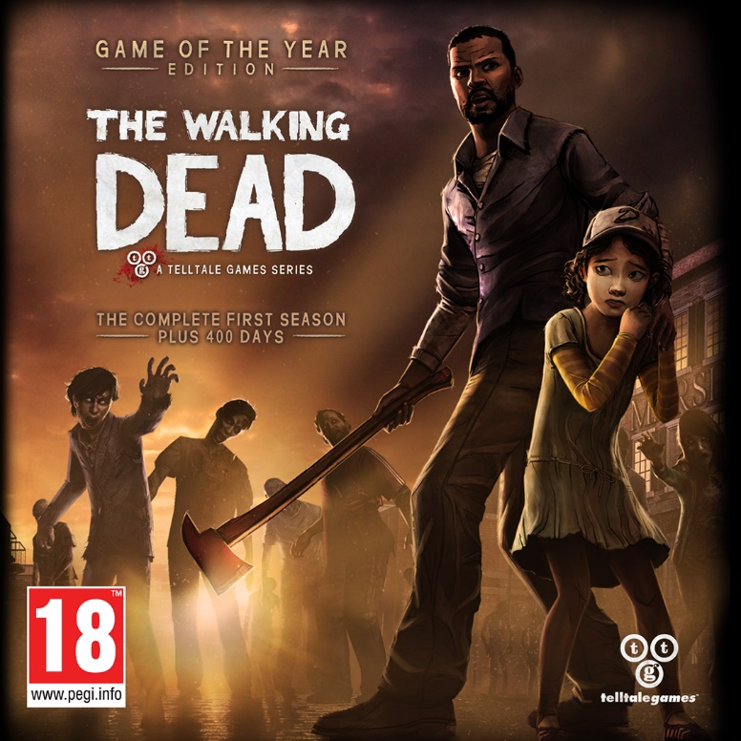
The walking dead the telltale game (April 24, 2012,) (17)
One of the most critically acclimated games of 2012 was the walking dead game from telltale games. It received awards for its deep story and characters but one of its best aspects was its representation of black characters in video games its main character lee was a likeable and interesting character that wasn’t a stereotype on black culture but stood on his own merits. If the question is based on representation of race in games lee would be an interesting character to look into and analyse. Also, in the game the characters deal with many loved one’s deaths and suffering this could tie into the keyword of loss and denial and make for a really interesting Dissertation question and idea (14).

Outcome/ Dissertation question - how video games treat death and loss

Throughout looking at the three keywords of Loss, denial, and representation many concepts and ideas have been formulated that could create for an interesting range of ideas that could make up the main body of the dissertation question. The main theme has been death overall and how people cope with it that’s why it would make sense to have the question be related to this subject in some way or at least have some aspect of it therefore the question that will be taken forwards next year will be how video games treat death and loss. This is the question that will be taken forwards and explored because it has a wide range of subjects and concepts that can be look at and compared with for an interesting study. some other questions that where considered where how people of different cultures are represented in games and also how is religion is represented in video games. These ideas are still an option that is open to explore but could 5000-6000 words be written on these subjects and also would there be a wide range of research and studies/references to look at as well. More research will be done on the chosen question to prepare for it in the next term and a list of talking points will be written up to get feeling for what’s in store.

Bibliography
Section 1 – loss
N.A. (2018). Definition of loss. Available: https://www.merriam-webster.com/dictionary/loss. Last accessed 24/3/2018. (1)
roangelo.net. (27 July 2016). Philosophy and Death. Available: https://www.roangelo.net/logwitt/logwit37.html. Last accessed 25/3/2018. (2)
Ryan Martin Ph.D. (Posted Oct 19, 2011 ). Why We Get Mad. Available: https://www.psychologytoday.com/us/blog/all-the-rage/201110/why-we-get-mad. Last accessed 25/3/2018 (3)
deathreference. (N.A). Philosophy, Western. Available: http://www.deathreference.com/Nu-Pu/Philosophy-Western.html. Last accessed 25/3/2018. (4)
Edman, Irwin, ed. The Works of Plato. New York: Modern Library, 1930 (5)
Dana Sitar . (September 27, 2015). Art on Death by Edvard Munch. Available: http://blog.sevenponds.com/soulful-expressions/art-on-death-by-edvard-munch. Last accessed 25/3/2018. (6)
Section 2 – denial
dictionary.com. (2018). denial. Available: http://www.dictionary.com/browse/denial. Last accessed 26/3/2018. (7)
Steven Novella, MD. (April 2002). Skepticism and Denial. Available: https://theness.com/index.php/skepticism-and-denial/. Last accessed 26/3/2018. (8)
Jorn Pedersen. (October 5, 2016). Gears of War plot summary. Available: https://4onegaming.com/gears-of-war-plot-summary/. Last accessed 26/3/2018.(9)
walkingdead.wikia. (October 2003 ). Themes:_Denial. Available: http://walkingdead.wikia.com/wiki/Themes:_Denial. Last accessed 26/3/2018. (10)
section 3 – representation
merriam-webster. (2018). representation. Available: https://www.merriam-webster.com/dictionary/representation. Last accessed 27/3/2018. (11)
Craig Batty . (June 25, 2014 ). Are you monomythic? Joseph Campbell and the hero’s journey. Available: http://theconversation.com/are-you-monomythic-joseph-campbell-and-the-heros-journey-27074. Last accessed 28/3/2018.(12)
Toby McCasker. (25 May 2014 ). Final Fantasy X’s War on Organised Religion. Available: http://uk.ign.com/articles/2014/05/26/final-fantasy-xs-war-on-organised-religion. Last accessed 27/3/2018.(13)
Emily Gaudette. (March 28, 2017). The Best 'Walking Dead' Is the Video Game, By a Mile. Available: https://www.inverse.com/article/29582-telltale-walking-dead-season-3-episode-3-above-the-law-review-guide. Last accessed 28/3/2018.(14)
Images

by the deathbed (15)

https://www.wikiart.org/en/edvard-munch/by-period/european-period
In-text: (by the deathbed, 1893)
: by the deathbed (1893). https://www.wikiart.org/en/edvard-munch/by-period/european-period. [image] Available at: https://www.wikiart.org/en/edvard-munch/by-period/european-period [Accessed 26 Mar. 2018].

Snyder, Z. (16)

Batman v Superman: Dawn of Justice
In-text: (Batman v Superman: Dawn of Justice, 2016)
Batman v Superman: Dawn of Justice. (2016). [film] Directed by Z. Snyder. hollywood: : Warner Bros. · DC Comics.

telltale games (17)

the front cover of the box art depicting lee and clem
In-text: (telltale games, 2012)
telltale games (2012). the front cover of the box art depicting lee and clem. [image] Available at: https://www.euronics.ee/t/57774/mangud-ja-konsoolid/xbox360-mang-the-walking-dead-goty-edition/5060146460934 [Accessed 27 Mar. 2018].
Books

Campbell,J (1990). Joseph Campbell the hero’s journey. . california: new world library. n.a . (18)

Williams, R (2014) Keywords A Vocabulary of Culture and Society (Fourth Estate.)

