MSc Policing (Operational & Strategic Leadership)
Dissertation proposal 2023/2024
BMPO7007D

Student Name: Mark O’Shea
Student Number: 2114092
__________________________________________________________________
Research Question: (1 sentence)
Major Crime and Homicide Investigation: How has South Wales Police addressed the findings outlined in Richard Horwell KC’s report (The Horwell Report) into failings in major investigation disclosure practice?

____________________________________________________________________________________
Research Aim: (Identify the key aim(s) of this study in a sentence or two.)
Is South Wales Police still vulnerable to disclosure failings in a major investigation? What are the emerging areas of vulnerability for South Wales Police in major investigation disclosure practice?

Research Objectives: (Bullet points of what you need to achieve to succeed in your aims)
- To undertake a literature review of the legislative and doctrinal landscape pertinent to the Criminal Procedures and Investigations Act 1996 (CPIA).
- To examine the historical impact on public trust and confidence cases such as R v Mouncher have had on communities.
- To critically examine the strategic and operational leadership response to The Horwell Report at a Force level and at a national level in policing.
- To identify emerging disclosure risks linked to ‘digital crime scenes’ and emerging technologies, such as artificial intelligence and the metaverse.
- To make recommendations regarding future disclosure practice pertinent to the operational and strategic leadership of the Police Service in Wales and England.

__________________________________________________________________
Literature Review: (Explore the current literature around your subject area, provide a rationale for your research)
It is now approaching 6 years since the publication of The Horwell Report into the collapse of a police corruption trial (R v Mouncher and others) where Defendants who were serving or retired Police Officers with South Wales Police. This report is seen by many (Bahra & Ramble 2019,) as a seminal one in the evolution of recent disclosure practice in the Anglo Welsh judicial system. It was a report commissioned by the then Home Secretary Minister Theresa May and was directed to examine the reasons for the collapse of that trial and specifically to examine the handling of unused material on the part of the Police and Prosecutors. Unused material is a legal term to describe material generated during the course of an investigation, that is not ‘used’ or produced as supportive evidence for the prosecution.
Despite ‘disclosure’ being a significant pillar of the criminal justice system in common law there is surprisingly little academic literature devoted to this subject from a police perspective.
It is now nearly 30 years since the enactment of the Criminal Procedures and Investigations Act 1996, and despite the numerous miscarriages of justice and collapsed trials that have occurred due to disclosure malpractice (Bhara & Ramble, 2019, Polykarpou, 2022) policing remains vulnerable to further miscarriages of justice occurring unless disclosure is done correctly. The proposed research will hopefully add a useful policing context to the limited academic analysis currently available.
Many of the texts such as Bhara and Ramble, 2019, approach the practice of disclosure from a lawyer’s perspective. The purpose of the proposed dissertation is to examine the doctrine of disclosure from a strategic police management perspective, by critically examining the impact of Horwell (2017,) upon South Wales Police. The pointed criticism of the police and CPS disclosure practice that contributed to the collapse of the Mouncher case is said by many (Bhara & Robertson 2018, Bhara & Ramble, 2019, Polykarou,2022) to have contributed significantly to the development of the joint National Disclosure Improvement Plan (NDIP.)
The impact of The Horwell Report is commented upon by Bhara and Ramble, (2019) as well as in in the book edited by Innes & Lowe et al, (2023) which examines the history of South Wales Police from its inception in 1969, charting its many leadership challenges over a 50 year period, one of which was the Horwell investigation.
One of the few Police practitioners’ textbooks that touches the subject of disclosure is Tony Cook’s handbook for Senior Investigating Officers, now in its fifth edition. This text is seen as an essential academic reference guide for SIO’s in UK policing. It will be critically examined to establish if it supports the principles outlined in The Horwell Report and subsequently tracked through to the NDIP.
The dissertation will review Brookman’s 2022 book, Understanding Homicide which looks at all aspects of that crime category and the dissertation will try to examine why homicide and major investigations are particularly vulnerable to disclosure failings, as exemplified in the R V Mouncher case.
Government reports and House of Commons committee reports, such as the 2019 Making it Fair report which was published by the joint inspectorates of constabulary and the Crown Prosecution Service will be critically examined to ascertain if their conclusions or observations have been effectively implemented by the police service.
Rationale:
The doctrine of disclosure will be examined to explain the legal paradigm that exists in Anglo-Welsh criminal law related to the rules of disclosure. Further literature research will be undertaken to examine the strategic impact of the R v Mouncher case on Anglo Welsh criminal justice and police disclosure practice. A critical evaluation of the impact on public trust and confidence in the justice system will be undertaken to assess the continued threat posed, particularly by digital disclosure practice.
The Mouncher case is a significant factor in the establishment of a joint National Disclosure Improvement Plan. It was first published in 2018 with later iterations being jointly published by the Crown Prosecution Service and the National Police Chief’s Council in 2020 and 2022. The research proposal is to examine the impact of The Horwell Report and the consequent National Disclosure Improvement Plan upon the leadership of South Wales Police and consider how it has changed the doctrinal norms in the service and how its recommendations have been implemented strategically. The research will consider if the findings and observations in the Horwell report have translated into operational change in South Wales Police and pose the question as to how vulnerable South Wales Police remains to significant disclosure failings in a Major Crime or Homicide investigation.
The research may become more refined following further consultation with key strategic practitioners in South Wales Police using Delphi discussions (Saunders et al 2016.)

____________________________________________________________________________________

Methodology:
Literature research will be conducted to evaluate the academic and legal authorities that have examined disclosure practice and doctrine since 1996.
Research will also be conducted at an in person workshop being planned for February 2024. This workshop will utilise Hive or SLIDO electronic questionnaire surveys to gather data from around 80 police officers and Crown Prosecutors on their perception of current disclosure risk prevalent in investigative practice within South Wales Police. A series of questions will be formulated to evaluate the progress made to address some of the key tenets of The Horwell Report.
Quantitative research will be conducted utilizing publicly available data dashboards made available by the Ministry of Justice, such as the Directors Guidance Assessment Framework (DGA) to evaluate progress in Force level performance as measured against the Director of Public Prosecutions Assessment Framework for case file quality.
Ethical considerations in undertaking this research will include a transparent declaration that the surveys are voluntary despite being undertaken in a work based environment and will form part of academic research that will be published in a Masters dissertation report accessible via the University of Wales, Trinity St Davids at the conclusion of the grading exercise.
Ethical considerations that have been considered includes the impact of the police discipline code and the police code of ethics. The lead researcher is a senior officer within South Wales Police and the Police Discipline Code requires junior officers to comply with lawful orders and instructions. The lead researcher in theory, could instruct junior officers to complete the academic research surveys, but that would not be in line with the police code of ethics or the academic ethics of the University of Wales. In order to maintain transparency, and in accordance with the police code of ethics a written declaration will be included in all briefings making it clear that contributions to the surveys will form part of an academic research paper. An option to not participate in the academic research will be incorporated in the survey and workshop preamble. Participation in the surveys will be voluntary and this will be made clear in the declaration.
The research has translatable value into the operational development of South Wales Police toward the objectives of the National Disclosure Improvement Plan.

_________________________________________________________________
Proposed timeline: (not included in your word count)
(Insert table or figure/flow chart to depict your proposed project timeline of key events.
A project planning document has been developed to outline the key milestones and this will be further developed and maintained throughout the span of the project to complete a dissertation.
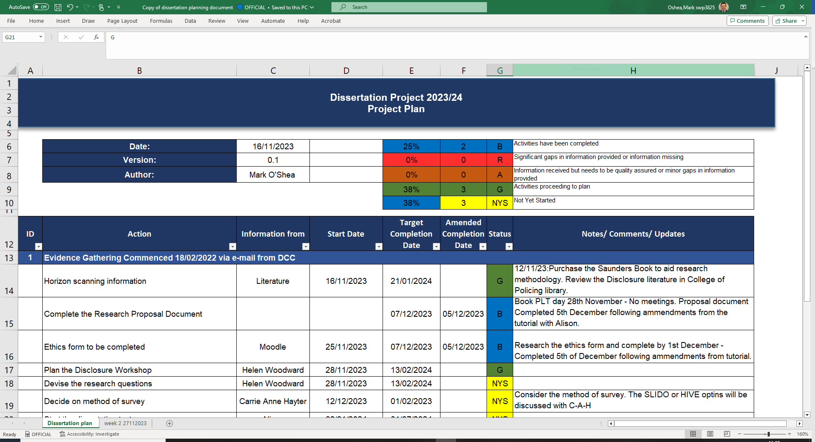
Table1 : Planning document
__________________________________________________________________
Anticipated Outcomes: Briefly explain what you hope to achieve with this research project (i.e. could your findings influence practice, policy or training?).
This research will be an opportunity to critically evaluate the effectiveness of the strategic leadership thus far taken by South Wales Police in addressing the findings of The Horwell Report, whilst also attempting to identify continued areas of vulnerability in maintaining the trust and confidence of the public and judiciary in disclosure practice across the service, but more precisely, in the area of major and homicide investigation.
History has taught us that signal crime cases (Brookman 2022, Innes et, 2023) which are investigated as a Major Crime and are later quashed or overturned on appeal have long standing impact on the reputation of a police service, and many miscarriages of justice have been attributed to a failure in disclosure practice (Bhara & Ramble, 2019.) The research will therefore seek to focus particular attention on major and homicide investigative disclosure practice. The research will also aim to assess the current risk posed by emerging technologies and make recommendations for improving disclosure practice in South Wales Police.

__________________________________________________________________
References
Use Harvard referencing (see Moodle for instructions).
Nahrita Bahra KC & Don Ramble, 2019, Tackling Disclosure in the Criminal Courts, A Practitioners Guide, Law Brief Publishing, Somerset.
Nahrita Bhara KC & Fiona Robertson, 2018, Achieving sea-change: criminal disclosure failures, Counsel Magazine, Achieving sea-change: criminal disclosure failures | COUNSEL | The Magazine of the Bar of England and Wales (counselmagazine.co.uk)
Innes, Lowe & Madge, 2023, Policing Yesterday, Today, Tomorrow, The View from South Wales Police, University of Wales Press, Cardiff.
Richard Horwell KC, 2017, Mouncher Investigation Report, Crown Copyright.
Tony Cook, 2019, Senior Investigating Officers’ Handbook, Oxford University Press.
HMCPSI & HMIC, 2017, Making it Fair, A joint Inspection of the disclosure of unused material in volume crown court cases, Crown Copyright.
House of Commons Justice Committee, 2018 Disclosure of Evidence in criminal cases, 11th Report of session 2017-19, Crown Copyright.
Fiona Brookman, 2022, Understanding Homicide, Sage Publishing.
Maro Polykarpou, 2022, Prosecutorial and Police Disclosure Ethics in Criminal Evidence Review in the UK and the US. A Comparative Account, Criminal Justice Ethics, Routledge.

