
University of Wales Trinity Saint David
School of Engineering

3 Jaw CoBot end Effector
Manufacturing Design & Technology
ACHA5002

Gwydion Gwyn Clement
Student ID: 1804252
27/5/21

Contents
1 Introduction 4
2 Background 5
3 Concept Design Appraisal 7
3.1 Root Cause analysis 8
3.2 QFD 9
3.3 Discussion 10
4 Manufacturing Process Proposal 11
4.1 Injection Moulding 12
4.2 Material Selection 13
4.2.1 Thermoplastic Materials 13
4.2.2 Thermosetting Plastic Materials 13
4.3 Design considerations for injection moulding 14
5 Design and Development Work Undertaken 17
5.1 DFA 17
5.2 Failure Modes and Effects Analysis 18
5.3 Lucas Manual Handling and Fitting Analysis 20
5.3.1 Manual Handling Analysis 20
5.3.2 Manual Fitting Analysis 21
5.4 Design for Manufacture considerations 22
5.5 Suggested Alterations 23
5.5.1 Jaws 23
5.5.2 Joins 24
5.5.3 Drive plate 24
5.5.4 Cylinder 25
6 Manufacturing Process Design 27
6.1 Production Process Plan 28
7 Conclusion 29
8 References 30
9 Appendices 32
9.1 QFD ‘Blown up Attic View’ 32
9.2 OFD Blown up ‘Characteristics & Quality View’ 33
9.3 QFD Blown up ‘Basement’ View 34

Figure 1 - Ishakawa for Pick and Place End Effector 8
Figure 2 – FMEA on Fin Ray effect gripper (Anwar, 2019) 10
Figure 3 - Injection Moulding Process (RNA, 2019) 12
Figure 4 - Over the Wall Approach (Robert A, 2010) 14
Figure 5 - Design for Assembly appraisal 17
Figure 6 – End Effector Pick and Place Process 18
Figure 7 – Revised Jaw concept 23
Figure 8 – Revised Join Concept 24
Figure 9 - Revised Drive plate Concept 25
Figure 10 – Revised Cylinder Concept with Horizontal Parting Line 26
Figure 11 – Base view with vertical Parting Line 26
Figure 12 - Revised Cylinder Concept with vertical Parting Line 26
Figure 13 - Manufacturing Process Plan 28

Introduction

This report will detail the steps taken in creating a design study to develop a 3- jaw gripper. It will identify the key uses of CoBot arms, primarily within the pick and place function. An outline will be presented regarding the public perception and implementation of CoBots within the manufacturing industry.

Following this, a design appraisal will be conducted to gain a grater understanding of the requirements of an end effector. This will be implemented through Ishikawa techniques and the use of a Quality Function deployment table. The results from this will then be later used in the creation of modified concepts.

A proposed manufacturing process will then be presented, this will outline how best to decide on process for manufacturing the product. Explanations will then be presented discussing the needs that must be considered when implementing such a process.

With the research complete, various ‘Design for x’ techniques will be used to show what changes need to be implemented, not only to improve the current design but to also facilitate its ability to be manufactured. These changes will then be shown through relevant CAD models and discussed.

Finally, a manufacturing design process will be discussed and presented alongside a proposed production process.

Background

Before reviewing the proposed design, the operating conditions of the end effector should be considered. Any task in which a workpiece is picked up and moved to a new location is referred to as a pick and place task. This may be a packaging or sorting mechanism from a tray or conveyor. End-effectors that can comprehend the object are typically needed for pick and place functions (Gonzalez, 2018). While picking and placing items by hand being one of the most routine activities performed by humans today, the repetitive physical movements can cause strain or injury. Equally the mundane nature of the job can lead to mistakes (Gonzalez, 2018). The advantages are not only limited to labour considerations. Lower construction costs due to the absence of safety cages (Allowing for space saving); more simple programming, which decreases commissioning time and costs while allowing rapid adaptation to new tasks; facilitating lower capital costs (Bogue, 2016).

These advantages are particularly appealing to small and medium-sized manufacturing and assembly businesses (SMEs), which have historically viewed robots as too expensive and complicated (Bogue, 2016). For this reason, CoBot systems exist, not to eliminate current work positions but to assist their human counterparts.

Before humans may consider the CoBot as a team member, they must learn to work with it. CoBots are quickly becoming a common sight on the factory floor, and they are changing the way we work. This is only one of hundreds of situations in which humans would have to learn to work with their robotic partners (Ana M. Djuric, 2016). (Table 1) Represents some consideration of a CoBot within the workplace.

Table 1 – Systems perspective summary matrix (Ana M. Djuric, 2016)
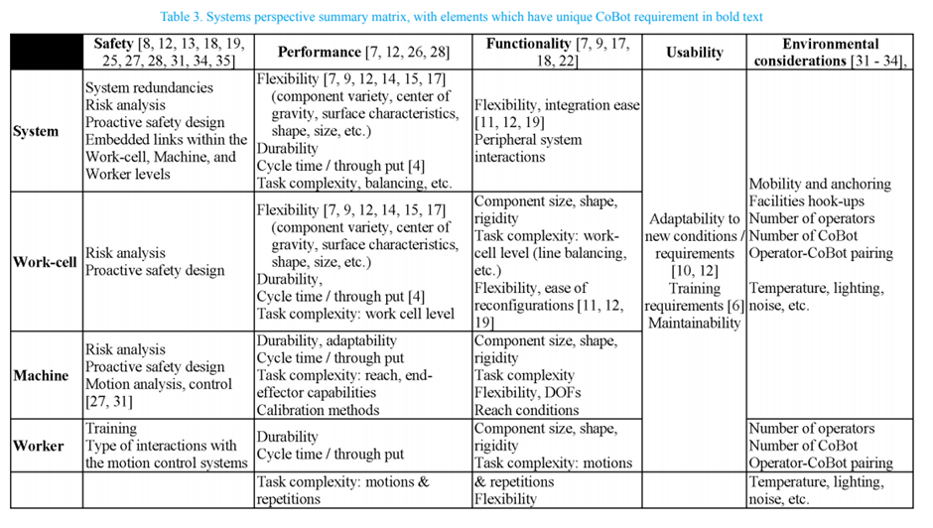

There have been notable concerns identified with this new integrated approach to manufacture. With fears that these solutions would lead to massive rises in income inequality, millions of citizens who are essentially unemployable, and social breakdowns (Davis, 2015). However, Davis goes on to state, that the creators of the latest generation of CoBots claim that humans have little to fear from their new co-workers. With the CoBot continuing with the ‘grunt work’ it allows for the humans to concentrate in more important tasks, in turn this would aid in lowering production cost an allow for a business to potentially recruit more employees. An observation was also made that people who work with the robots daily are the ones that discover new applications for them (Davis, 2015). Meaning that advancements can be made to achieving a leaner and more efficient workplace.

Concept Design Appraisal

While Industrial and collaborative robot arms have made slow but steady progress, the end effector evolution has accelerated in recent years. Demand for dexterous manipulation in pick-and-place operations like e-commerce order fulfilment is part of the reason for this (COBOTTRENDS, 2020).

End-effectors are a critical component of industrial robot value. Industrial robots would struggle to achieve their central goal of automating manual processes for greater profitability if they do not have the right end-effectors (Systems, 2018). The wrong End Effector will result in substantial downtime, lowering overall productivity. CoBots that use the incorrect end-effector can be disabled or too sluggish to keep up with modern production lines, resulting in even more inefficiencies (Systems, 2018). (COBOTTRENDS, 2020) Identifies the increasing need for End Effector providers to be compliant with many brands of robots, given how frequently new players are entering the CoBot market it is now common practice to incorporate compatibility with multiple robot brand in their new designs (COBOTTRENDS, 2020).

When approaching the design consideration will be made to working stresses, payloads, speeds, tooling lengths, component specifications, space constraints, and budget constraints (Systems, 2018). Ultimately the aim should be to keep the confusion under the surface as the consumer will not be unconcerned with the ‘how’s’ and ‘why’s’ and would simply desire the robot to complete the task at hand with limited complications (COBOTTRENDS, 2020).

Given these finding a root Cause Analysis has been drawn out alongside a QFD to identify these needs more clearly.

Root Cause analysis

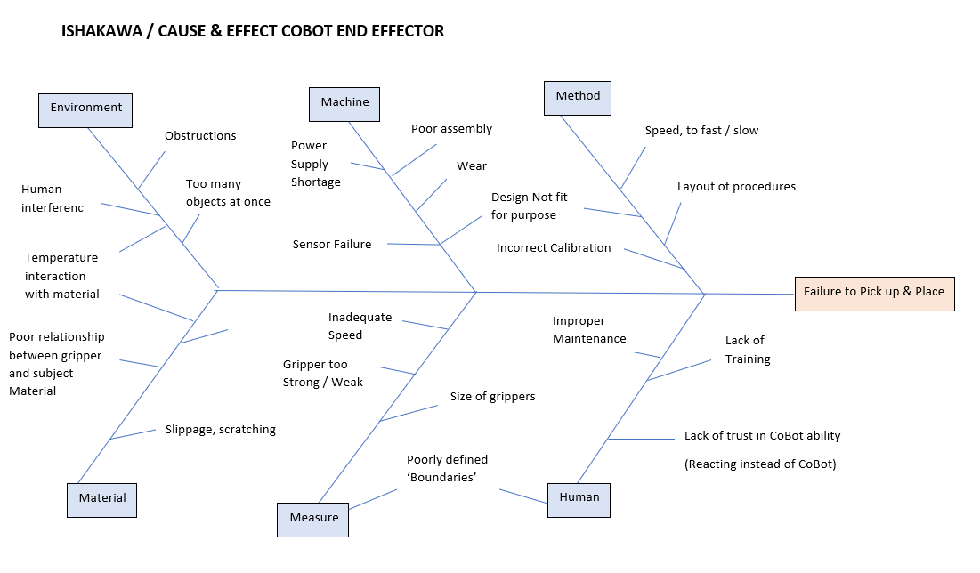
Figure 1 - Ishakawa for Pick and Place End Effector

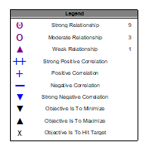
QFD

Table 2 - 3 Jaw Gripper QFD

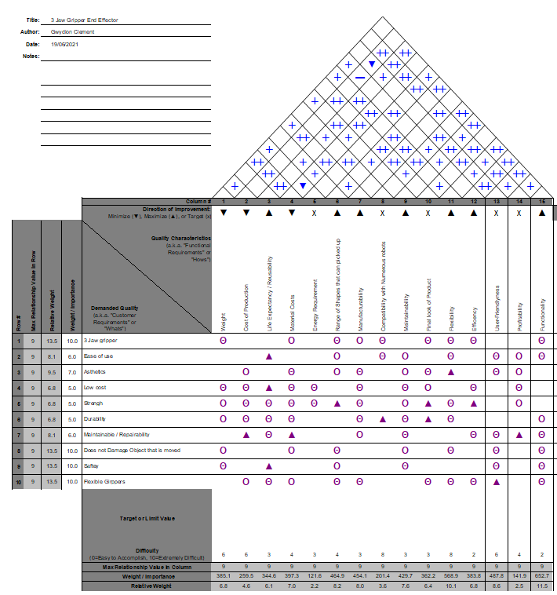

Discussion

From (Table 3) the data shows that importance has been placed both on Flexibility and Functionality. Functionality scored highly due to unclear specification as to how the gripper would be attached to the drive plate and cylinder, this would also raise issues when in service adjustments would need to be made. The range in shapes of the objects that can be picked up were considered when approaching the flexibility, this also had a high synergy with user friendliness. Having the ability to engage with a wide range of shapes would not only allow for more efficiency in the workplace but would also generate greater customer satisfaction eliminating a higher range of potentially mundane and dangerous jobs as highlighted in section (2).

Following the findings of (Table 3) further research was conducted to find potential flexible end effectors currently available. Functional fingers for robot grippers used in pick-and-place operations are complicated to design and are usually customised to requirements for each application (Anwar, 2019). In the report (Anwar, 2019) focused on the strengths of a gripper design based on a Fin Ray effect which is derived from the physiology of a fish. The proposed gripper was designed with unidirectional enforcement that allows them to adapt to the form of the grasped object (Anwar, 2019). (Figure 2) Shows the unloaded (a) and Loaded (b) transformation such a gripper would take.

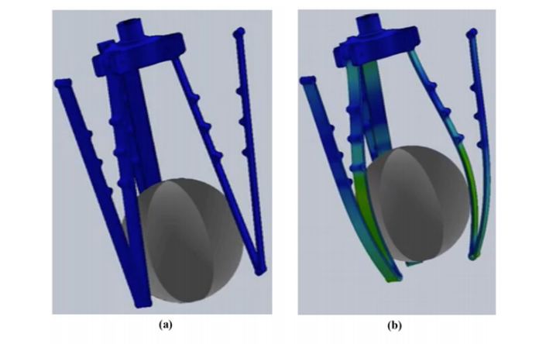
Figure 2 – FMEA on Fin Ray effect gripper (Anwar, 2019)

Although drastic redesigns should not be taken lightly when approaching the concept design an appreciation to emerging developments should be considered when selecting manufacturing processes. It should also be noted; that with the growth that the end effector market has seen (2) such re-designs should undergo a thorough patent search in accordance with The Intellectual Property Act 2014 (GOV.UK, 2014).

Manufacturing Process Proposal

When choosing a production process, the look and feel of the product must be thought of as much as the needs to meet the desired functionality (Antonio, 2019) With not all materials being compatible with all methods (DeGarmo, 2008), a clear understanding of how the finished product should be presented needs to be realised. DeGarmo also states that a material's overall appeal is determined not only by its physical and mechanical properties, but also by our ability to form it into usable components in a cost-effective and timely manner (DeGarmo, 2008).

The production process is not final until the finishing touches are applied. Finishing a product properly not only improves its appearance, but it also improves its durability and efficiency (Antonio, 2019). DeGarmo notes secondary processes, such as machining, grinding, and polishing, all necessitate the handling, placement, and processing of individual parts, as well as the use of additional tooling, and thus can greatly increase manufacturing costs (DeGarmo, 2008). In most cases, it is preferable to reach the target with the fewest operations possible. Some processes necessitate preheating or heat treatment afterward. Other factors to consider include the rate of production, the volume of production, the desired level of automation, and the amount of labour needed, especially if it is skilled labour. (DeGarmo, 2008)

Both Injection Moulding and Die Casting were considered for the manufacture of the end effector with both being able to accommodate production volumes of between 1000 and 2000 per week.
Withing both processes the technique is essentially the same, although there are some differences in method. The most significant distinction between die casting and injection moulding is that die casting employs a metal as the raw material, usually an aluminium alloy, whereas injection moulding uses plastic or polymers (PremierEngineeredProducts, 2019).

The decision to select Injection Moulding was ultimately made upon the production being quicker due to more flexibility in the moulding process and the benefit of being able to accommodate different plastic or polymer materials (PremierEngineeredProducts, 2019) that allowed for more flexibility when considering material selection. Thought was also given to the payload capabilities of the CoBot. Despite aluminium being a lightweight metal, a fully plastic end effector could allow for heavier object to be manouvered.

Injection Moulding

Injection moulding is the most common method for mass-producing relatively complex thermoplastic parts in large quantities. (Figure 3) depicts one approach to the procedure, in which raw material granules are fed into a cavity ahead of a moving plunger by gravity from a hopper (DeGarmo, 2008). The material is pushed through a preheating chamber and then into a torpedo section, where it is combined, melted, and superheated as the plunger advances. The superheated material is then injected into a mould through a nozzle. (DeGarmo, 2008)

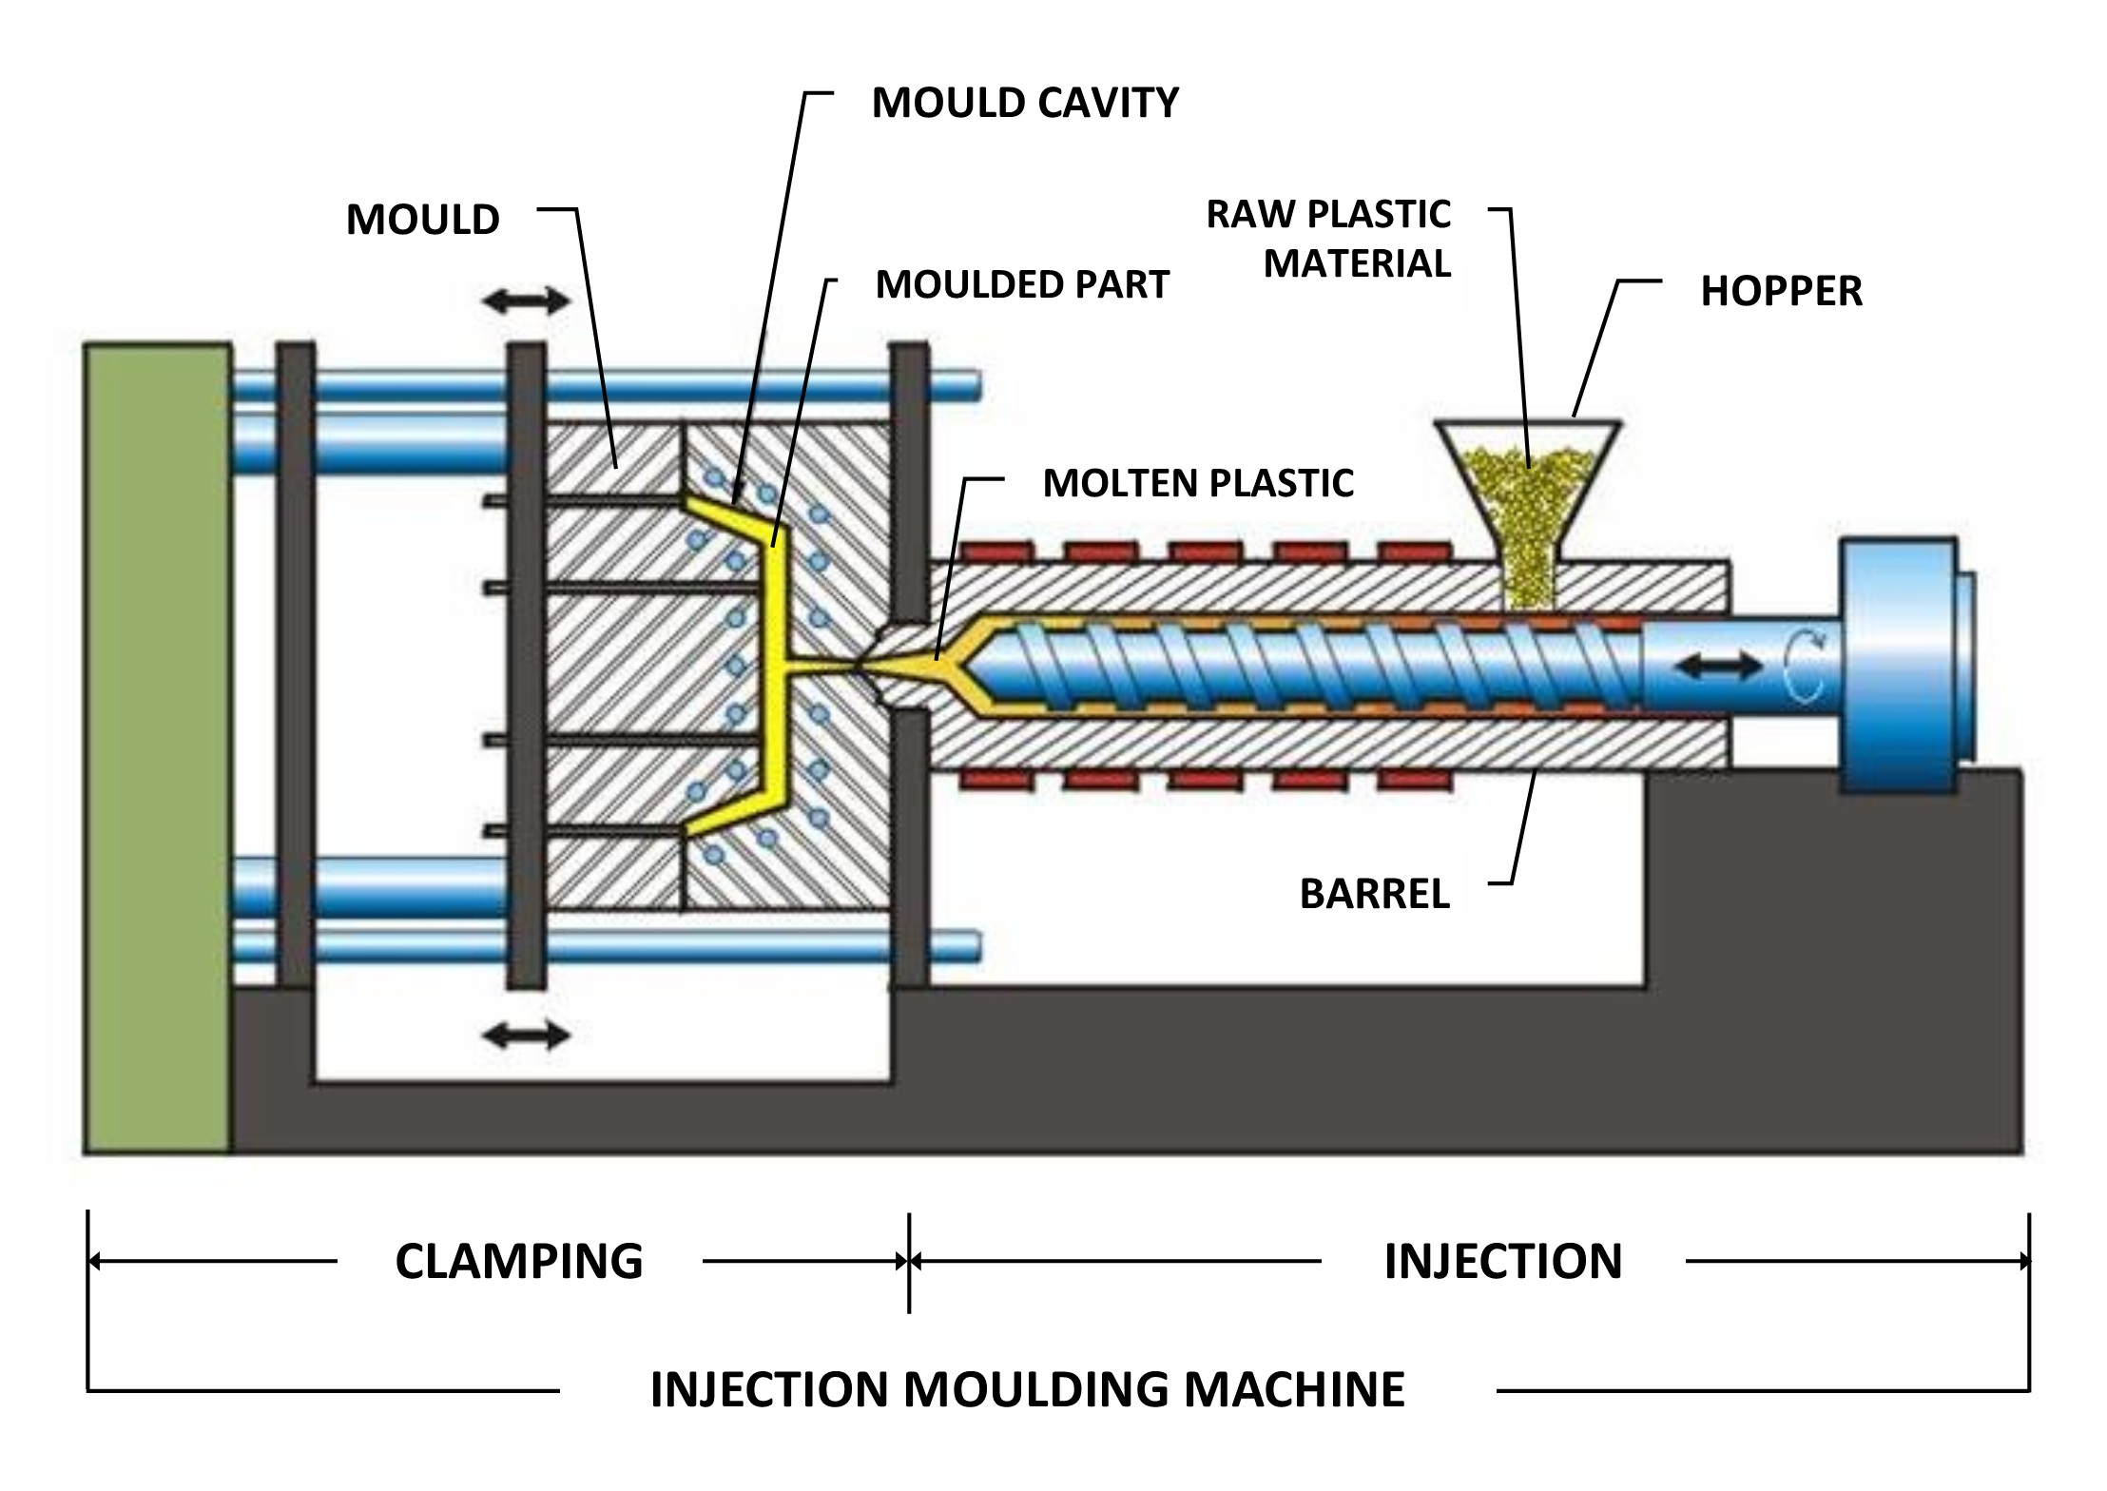
Figure 3 - Injection Moulding Process (RNA, 2019)

During moulding, the mould halves must be firmly clamped together and then quickly removed for component ejection. During die closing, impact forces should be kept to a minimum because they can shorten die life. Various clamping designs, such as toggle, hydraulic, and hydromechanical, have been developed. The result is normally a finished product that requires no further assembly or use (DeGarmo, 2008).

Material Selection

With Injection moulding being used to manufacture plastic objects with complex geometries, the adaptability of plastic materials is, without a question, their single most essential feature (Robert A, 2010). Most plastics are made up of monomeric building pieces that are combined to form high molecular weight polymers. Depending on the material chemistry, these high molecular weight polymers are classed as thermoplastic or thermosetting (Robert A, 2010). A variety of end-use criteria should be considered when selecting either of these materials.

Thermoplastic Materials
The thermoplastics category encompasses most plastic polymers used in injection moulding. Thermoplastics are polymeric materials with a linear or branching structure that soften when heated and "resolidify" when chilled (Robert A, 2010). Thermoplastic materials come in several forms and grades, ranging from rigid to elastomeric in characteristics (Robert A, 2010). The processing of thermoplastic materials, in theory, only includes physical changes (e.g., phase transitions), therefore the materials can be recycled easily. However, it is highly likely that some chemical change (e.g., oxidation, thermal degradation) will occur during processing, and the properties of the second-generation material may not be identical to those of the virgin polymer (Robert A, 2010).

Thermosetting Plastic Materials
Thermosetting plastics are polymers that chemically react to generate a cross-linked polymer chain network during processing. The chemical reaction cannot be reversed. Thermosets, unlike thermoplastics, are not directly recyclable. Thermoset moulding involves a chemical reaction, with several extra reaction-related process variables are introduced into the process (Robert A, 2010). Due to this, Thermoset materials can be difficult to work with and require specialised moulding equipment and techniques; yet, they have several impressive features, including high creep resistance, dimensional stability, and chemical resistance (Robert A, 2010).

Design considerations for injection moulding

Designers must address a variety of aesthetic, functional, and manufacturing challenges when creating plastic parts. The final part design must meet the criteria of each of these distinct regions, which frequently conflict (Robert A, 2010).

While the actual time and cost to design a product may be less than 5% of the overall time and cost, the impact on the final fabricated moulded product's performance and cost is immense (Rosato, 2020). Almost all malfunctions are caused by a lack of understanding of the properties and potentials of plastics, which leads to incorrect application, rather than by flaws in the material or process itself. To achieve cost-property performance, one must use the proper design, material, and fabrication technique (Rosato, 2020). Furthermore, fabricators and mould designers should offer product designers advice on material actions and how to make manufacturing easier. The designer should not be limited by just knowing one process or system and should avoid concentrating on a single narrow feature of a design or process (Rosato, 2020). When creating a new product, there are a few various ways that can be used. New parts or products have traditionally been developed through a sequential engineering or "over-the-wall" technique (Robert A, 2010)(Figure 4).

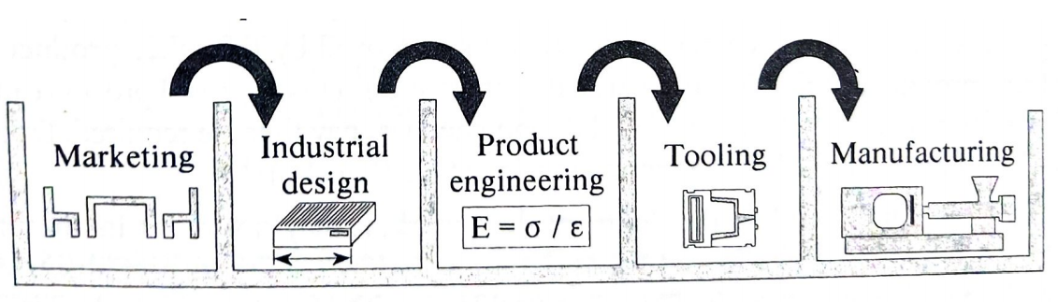
Figure 4 - Over the Wall Approach (Robert A, 2010)

(Robert A, 2010) Describes over-the-wall design process by starting with a new product concept being developed by marketing teams, who have identified a demand and specified the product's end-use requirements. The project is subsequently sent over the wall to the next stage of development, which is usually handled by the industrial design team. Industrial designers define the product's overall shape, appearance, and feel, and are more concerned with the ergonomics and aesthetics of the design than with its manufacturability. They send the design to product engineering after they have finished developing the basic models. The project engineering group oversees the selection of the materials and procedures that will be used to build the item in the end, as well as ensuring that the result meets all the end-user specifications (Robert A, 2010).

Following guidance from ‘Plastic Part Design for injection molding’ and the ‘Injection Molding Handbook’ a table was created (Table 3) to help analise the concept design for section (5).

Table 3 – Design Considerations

Design and Development Work Undertaken

DFA

The various components were viewed individually and considered according to the DFA appraisal chart (Figure 5). The finding of these can be found in (Table 4).

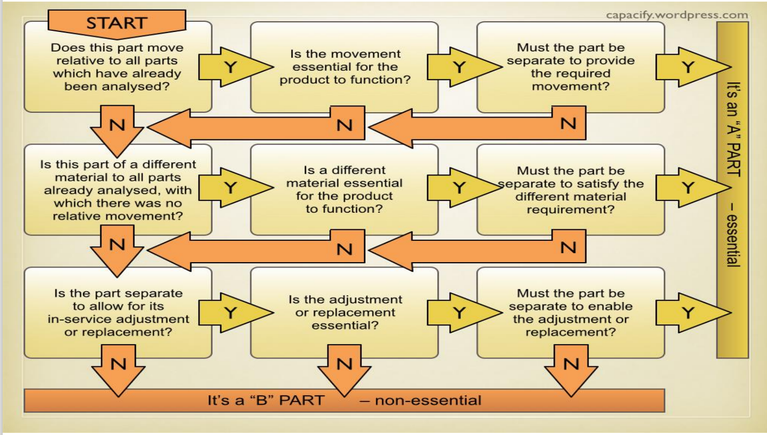
Figure 5 - Design for Assembly appraisal

Table 4 – Essential Non / Essential Parts
Part A | Part B
Motor / Shaft | Worm
Cylinder | Jaws
Drive plate | Joins

Within column ‘B’ (Table 4) the Worm, Jaws and Joins have been considered non-essential. The view here was that the worm could potentially be integrated into the drive plate design. Despite the jaws and joins requiring separate movement based upon the research from (Table 3) consideration be made to include snap joints into the design.

Using the results from (Table 4) a design efficiency of 50% has been calculated.

$$Design Efficiency=\frac{A}{A+B}×100=50\%$$

Failure Modes and Effects Analysis

From the research conducted (3) a process plan for the function of the end effector was created (Figure 6) to facilitate the use of Failure Modes and Effects Analysis (FMEA) (Table 5)

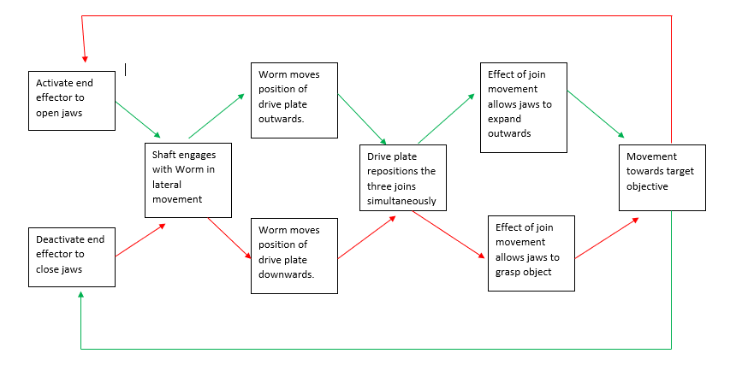
Figure 6 – End Effector Pick and Place Process

Table 5 - FMEA

From (Table 5) the RPN numbers show that the processes that should take priority in approaching the design. The processes that need to be addressed are; the assembly of the joints and jaws, this is due to lack of specification as to how connections will be made. The lack of tolerancing is also highlighted. With the assumption that the components will be connected via bolts correct specifications should be drawn out to facilitate the use of them, alongside any bearing and press fit inserts that that will be required.

Lucas Manual Handling and Fitting Analysis

The Lucas DFA method has been utilised to analyse the components and their assembly process, to find any adjustments that could be improved upon to help facilitate a leaner assembly line. Due to no physical handling of the concept design, assumptions have been made based upon the supplied Solidworks files.

Manual Handling Analysis

Table 6 – Manual Handling Analysis
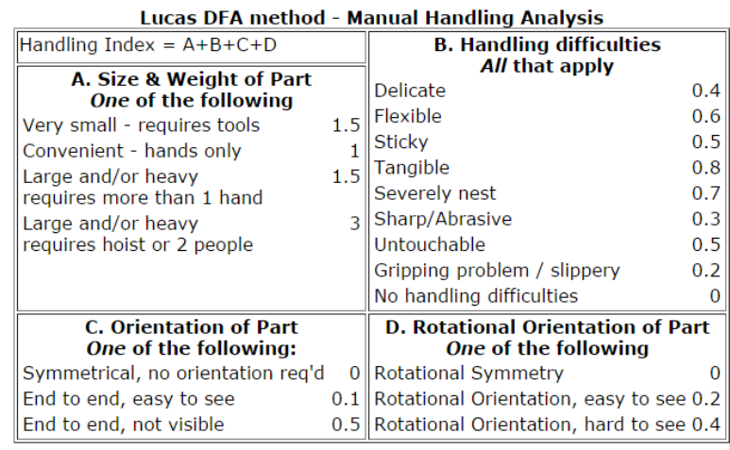

Table 7 – Manual Handling Results
Components | A | B | C | D | Total:
Jaws | 1 | 0.3 | 0.1 | 0.2 | 1.6
Cylinder | 1 | 0.3 | 0.1 | 0 | 1.4
Drive plate | 1 | 0.3 | 0.5 | 0.4 | 2.2
Motor | 1 | 0 | 0.1 | 0 | 0.1
Joins | 1 | 0 | 0 | 0 | 1
Shaft | 1 | 0 | 0 | 0 | 1
Worm | 1 | 0.3 | 0.5 | 0.2 | 2
 |  |  |  | Overall: | 10.5

In general, all components were found to be easy to handle except for the drive Plate. Due to having numerous features that would be sharp to handle.

Manual Fitting Analysis

Table 8 – Manual Fitting Analysis
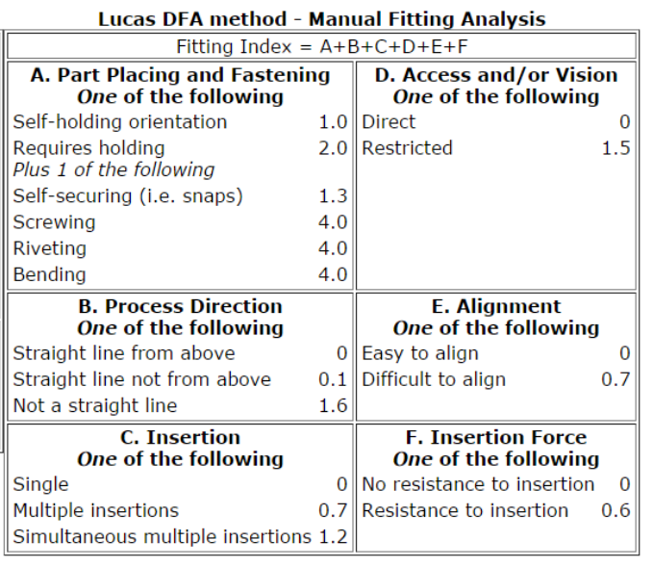

Table 9 – Manual Fitting Results
Assembly Process | A | B | C | D | E | F | Total:
1. Shaft placed in Motor | 1 | 0 | 0 | 1.5 | 0 | 0 | 2.5
2. Cylinder Placed over motor shaft | 1 | 0 | 0 | 0 | 0 | 0 | 1
3. Worm connected to shaft | 6 | 0 | 0 | 1.5 | 0 | 0.6 | 8.1
4. Drive plate attached to worm | 6 | 0 | 0 | 1.5 | 0 | 0.6 | 8.1
5. Join fitted to Jaw x 3 | 6 | 0 | 0.7 | 0 | 0.7 | 0 | 7.4
6. Jaw fitted to Cylinder | 6 | 0.1 | 0.7 | 1.5 | 0 | 0.6 | 8.9
7. Join fitted to drive plate | 6 | 0.1 | 0.7 | 1.5 | 0 | 0 | 8.3
 |  |  |  |  |  | Overall: | 44.3

Primary considerations here will need to be placed upon the means of fixing the components mainly between the Drive Plate, Jaw, and Joins. (Table 9) also shows that the orientation of the Drive Plate could prove problematic in assembly, causing it to be attached incorrectly.

Design for Manufacture considerations

Following the research (4:3) (table 10) Was created to formulate some design considerations for each of the components.

Table 10 – Design for Manufacture Considerations

Suggested Alterations

Jaws

The main alterations made to the jaw reflect DFM comments made in (Table 10). (Figure 7) shows that all the sharp edges have been filleted, this in turn will not only reduce stress concentration at these sections (Table 10) but also enable the component to be handled more easily as in consideration to the results found (Table 7). To maintain uniform wall thickness coring has been introduced while maintaining the same symmetry as the concept design. An effect of this meant that bosses were included following the guidance of (Table 10). From the data in (Table 2) the general shape of the jaw has remained the same. Consideration was also given to how to fix the jaw to the Cylinder and the join. The proposed method would be to utilise a standardised shoulder screw, to enable this, a transition fit would be required for the holes, so that a press fit bearing could be inserted.

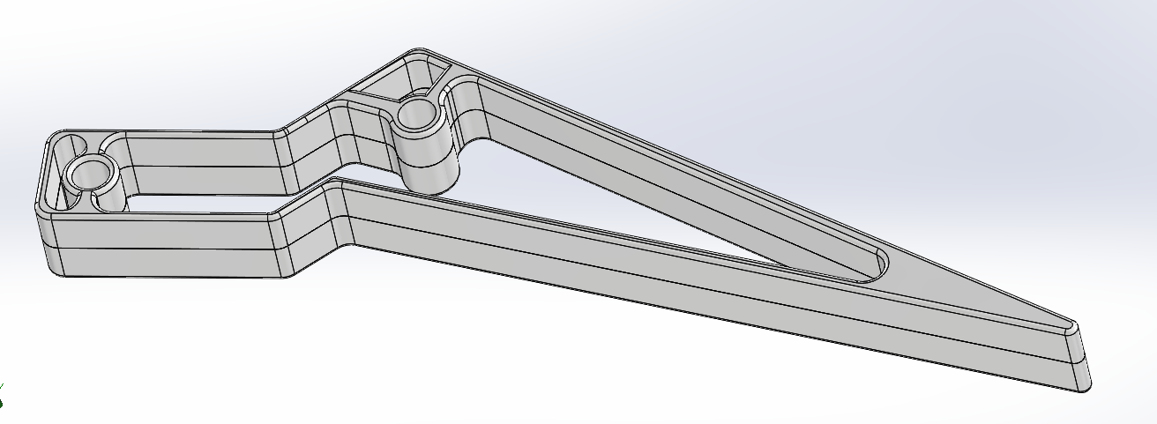
Figure 7 – Revised Jaw concept

Joins

The joins have experienced similar alterations to the jaws, with the main emphasis on change coming from the necessity to adjust for manufacture (Table 10). The main consideration here was to allow for enough material to flow around the blind holes. This meant that a sufficient flow pattern needed to be incorporated to allow the plastic to centre itself. Further development could be utilised here to find a means of having a snap join connection as shown in (Table 3).

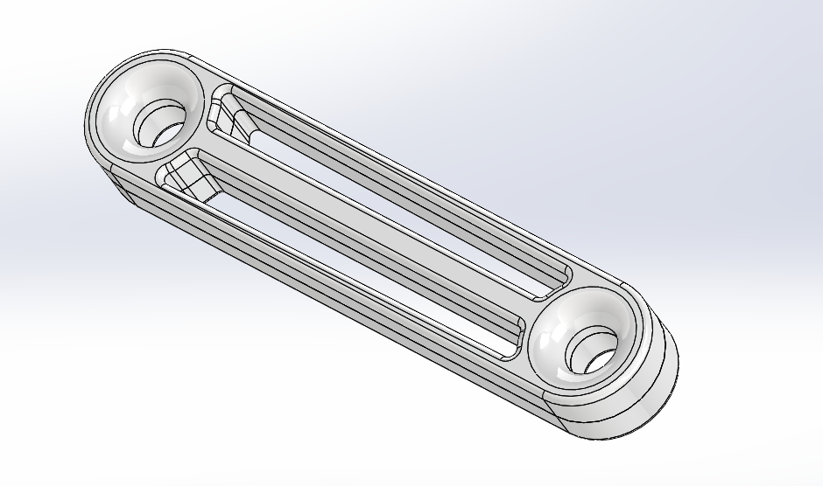
Figure 8 – Revised Join Concept

Drive plate

The Drive place would require the largest alterations in accordance with (Table 2) (Table 10). The necessity to eliminate the friction of the joins on the drive plate has been removed by positioning the connection points parallel to the drive plate itself (Figure 9). In turn this will aid the assembly process by leaving the component with a clearer orientation. Uniform wall thickness has then been achieved by coring the component, and consideration has been given to the blind holes by allowing a sufficient flow pattern. The centre hole should have an interference fit to accommodate a press fit insertion. This would also limit the wear the drive plate would experience.

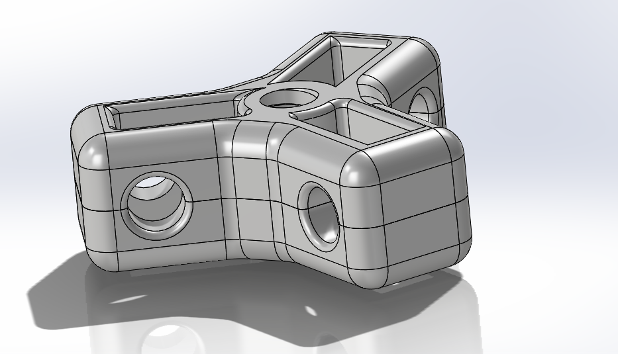
Figure 9 - Revised Drive plate Concept

Cylinder

Within the cylinder uniform wall thickness has been implemented through having the fastening points to the jaw extruded to the base of the cylinder. The overhang of these fastenings has also been removed to allow for easy removal from the mould (Table 10). Key considerations here should be given to the parting line, as it will dictate where weld lines will occur. If the parting lines of (Figure 10) were considered, then weld lines would appear at the top of the mounting holes, this could lead to damage when press fit inserts are installed. The parting lines of in (Figure 11, 12) would prove a more suitable approach, however sufficient cooling time must be met to ensure the strength of the component.

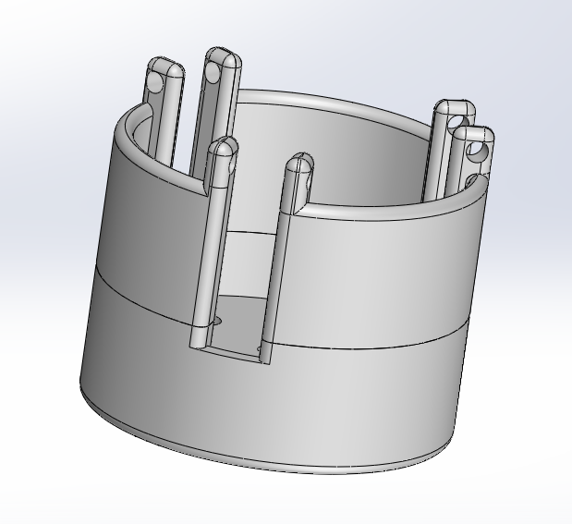
Figure 10 – Revised Cylinder Concept with Horizontal Parting Line
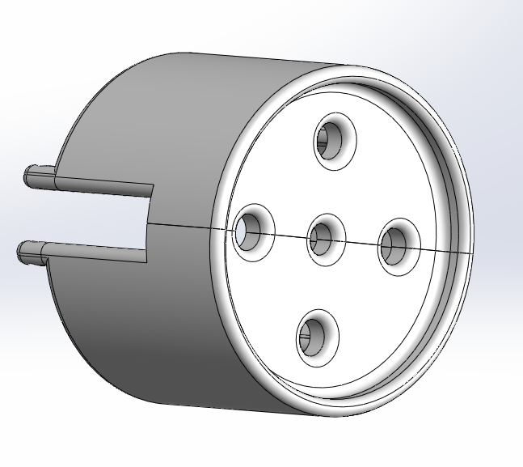
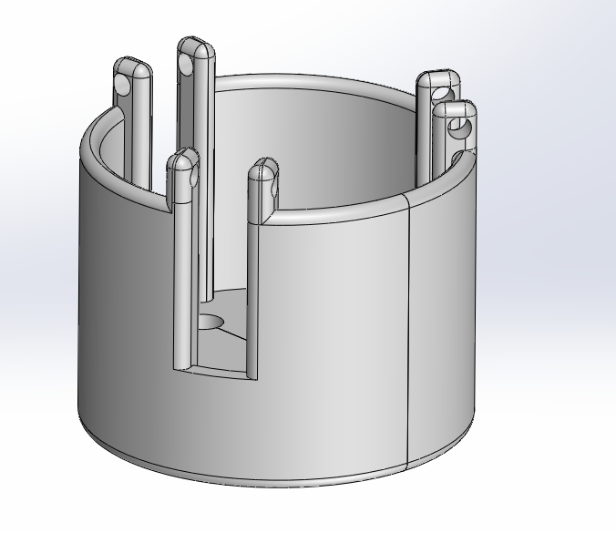
Figure 11 – Base view with vertical Parting Line
Figure 12 - Revised Cylinder Concept with vertical Parting Line

Manufacturing Process Design

A manufacturing process is normally carried out as a unit operation, which means it is a single step in the process of transforming a raw material into a finished product. There are two sorts of manufacturing operations (Groover, 2014):

- Processing activities and
- Assembly operations

A processing action takes a work material from one stage of completion to the next, bringing it closer to the ultimate desired result. It adds value to the basic material by altering its geometry, qualities, or appearance (Groover, 2014). Regarding Injection moulding, this would be the acquisition of materials to the moulding process through to the ejected final part (Figure 13).

Processing activities are typically performed on components that require further work (Groover, 2014). This would be via the means of securing any relevant press fits into the components. Groover also notes that some processing processes can also be applied to assembled goods, when an assembly operation unites two or more components to form a new entity (Groover, 2014).

It is also recommended to closely follow the developments made within the manufacturing process itself. Digital technologies have begun to have make an impact on corporate performance across industries, and businesses are now noticing the disruptive and productive effects of digitisation on their operations (Capgemini, 2017). While manufacturing organisations were once thought to be oblivious to the impact of digitization, this perception has drastically altered in recent years, with most manufacturing firms now acknowledging the need for digitization. It is seen as critical to ensuring long-term competitiveness and a significant driver of profitable growth (Capgemini, 2017).

Production Process Plan
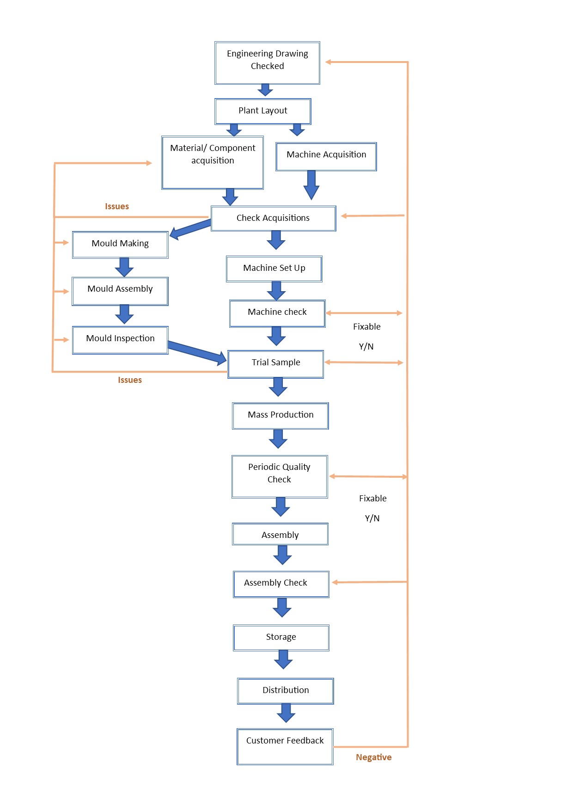
Figure 13 - Manufacturing Process Plan

Conclusion

With industry developing as it is, the need for future proofing is essential. For this reason, Injection moulding has been presented to allow for as much flexibility in the manufacturing process as possible. However, the lengthy process of mould creation should always be considered, also when approaching any new design current patents should be thoroughly researched to avoid any legal concerns. Conscious decisions should also be made regarding material selection. With increasing awareness of environmental concerns, the decision of utilising thermoplastic or thermosetting polymers could detract customers.

Regarding the proposed concept alterations further research and development should be investigated in the use of snap joints. In turn this would increase the design efficiency of the concept and mean fewer moulds would have to be created. This would lead to a leaner assembly, and limit process steps significantly.

Finally, continuous monitoring of the advancements within digitisation of manufacturing could lead to much leaner processes, it is therefore recommended that the process in place is reviewed regularly to allows for these potential adjustments.

References
Ana M. Djuric, R. U. (2016). A Framework for Collaborative Robot (CoBot) Integration in Advanced Manufacturing Systems. SAE International journal of materials and manufacturing, 9(2), pp.457–464.
Antonio, C. (2019, July 1). how to select a manufacturing process for your product. Retrieved from www.inspirationfeed.com: https://inspirationfeed.com/how-to-select-a-manufacturing-process-for-your-product/
Anwar, M. e. (2019). Modeling and prototyping of a soft closed-chain modular gripper. Industrial robot, Vol.46 (1), p.135-145.
Bogue, R. (2016). Europe continues to lead the way in the collaborative robot business. Industrial robot, 43(1), pp.6–11.
Capgemini. (2017, August). digitizing manufacturing pdf. Retrieved from https://www.capgemini.com: https://www.capgemini.com/consulting-de/wp-content/uploads/sites/32/2017/08/digitizing-manufacturing_0.pdf
COBOTTRENDS. (2020, Feburary 28 28). end effector trends robots watch 2020. Retrieved from www.cobottrends.com: https://www.cobottrends.com/end-effector-trends-robots-watch-2020/
Davis, N. (2015). Will this robot take your job? The Boston globe, The Boston globe.
DeGarmo, E. P. (2008). DeGarmo's materials and processes in manufacturing. Chichester: Wiley.
Gonzalez, C. (2018). 7 Common Applications for Cobots. Machine Design, pp.Machine Design, 2018–01-19.
GOV.UK. (2014, May 15). ukpga/2014/18/contents/enacted. Retrieved from https://www.legislation.gov.uk: https://www.legislation.gov.uk/ukpga/2014/18/contents/enacted
Groover, M. P. (2014). Principles of modern manufacturing. New Delhi: Wiley.
PremierEngineeredProducts. (2019, March 19). die-casting-vs-injection-molding. Retrieved from https:diecasting.com: https://diecasting.com/blog/die-casting-vs-injection-molding
RNA. (2019, October 23). robotics-in-injection-moulding. Retrieved from www.rnaautomation.com: https://www.rnaautomation.com/blog/robotics-in-injection-moulding/
Robert A, M. (2010). Plastic Part Design for injection molding. Munich: Hanser.
Rosato, D. V. (2020). Injection Molding Handbook. Boston, MA: Springer.
Systems, G. (2018, August 23). benefits finding right robotic end effector. Retrieved from www.genesis-systems.com: https://www.genesis-systems.com/blog/benefits-finding-right-robotic-end-effector

Appendices

QFD ‘Blown up Attic View’

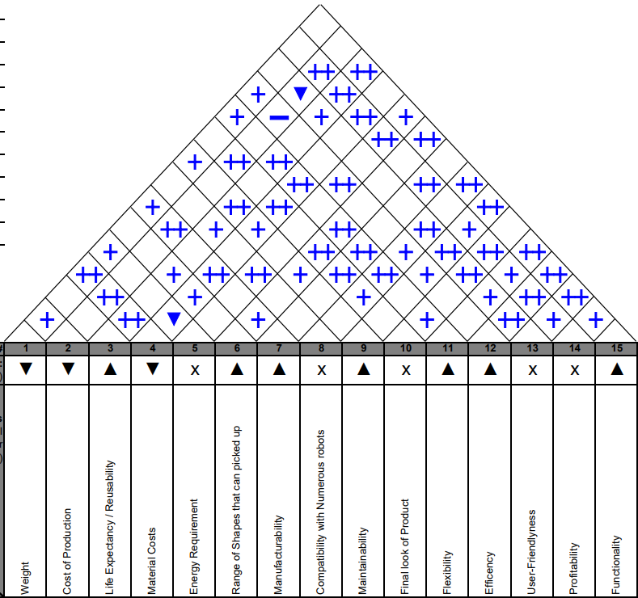

OFD Blown up ‘Characteristics & Quality View’

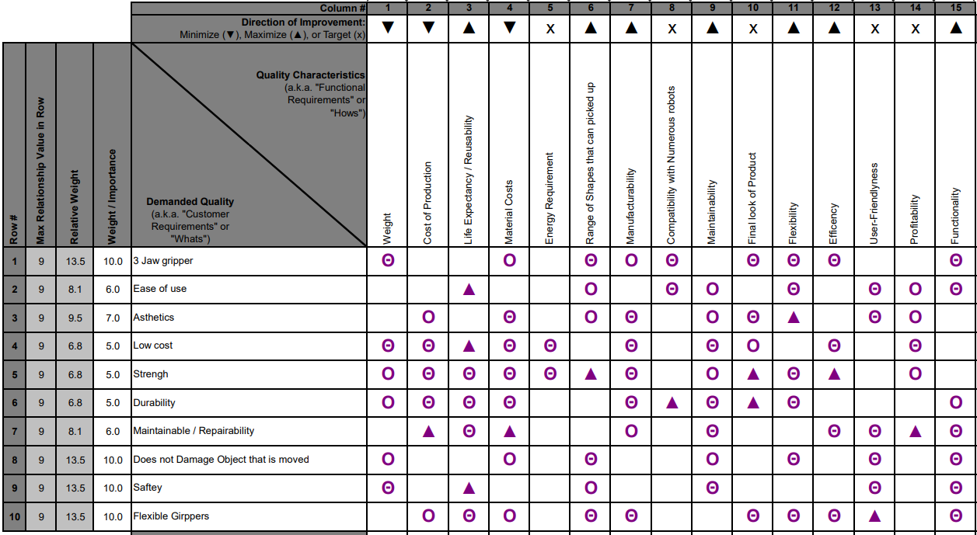

QFD Blown up ‘Basement’ View



