

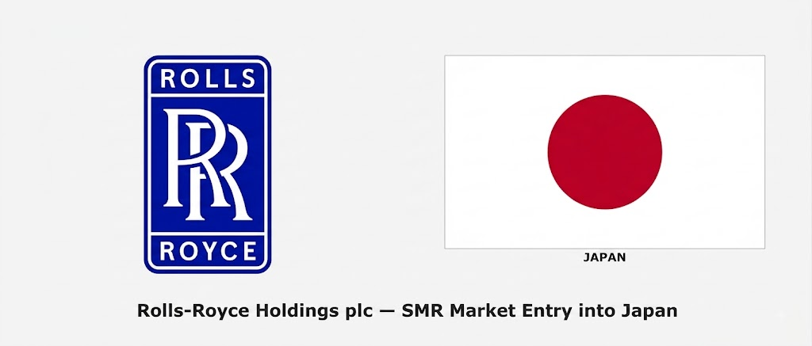
Report Title: Rolls-Royce Holdings plc – SMR Market Entry into Japan
Assessment: Individual report.
Module name: International Business Concepts
Module code: LCMB7034
Lecturer name:

Student name: Ashraful Hoque
Student ID: 2522430

Word count: 5,000 words (±10%)
Submission date: 14th August
University of Wales Trinity Saint David

Acknowledgement of AI Tool Use
In accordance with the UWTSD AI Use Acknowledgement Guidelines (February 2026), the following AI tools were used within the permitted categories of Research and Proofreading as indicated in the assessment brief.
I acknowledge the use of Perplexity AI (https://www.perplexity.ai/) on 15 July 2026 to support my research using the prompt(s):
- What is Rolls-Royce Holdings plc FY2025 revenue by segment, operating profit, margin and key SMR contract updates?
- Summarise Japan’s Seventh Strategic Energy Plan, nuclear targets for 2040 and recent reactor restart developments as of 2026.
I confirm that I have not presented any AI generated text as my own work. I confirm I have copies of my drafts, notes, and other resources I used before, and after the use of AI tools which I may be asked to provide in evidence.

I acknowledge the use of Google Gemini (https://gemini.google.com/) on 17 July 2026 to support my research using the prompt(s):
- Provide current data on Japan’s electricity generation mix, LNG import dependence and nuclear share targets.
- Explain Dunning’s OLI eclectic paradigm with application to high-technology or regulated infrastructure market entry.
- Overview of Japan’s Nuclear Regulation Authority (NRA) licensing process and post-Fukushima requirements for new reactors.
I confirm that I have not presented any AI generated text as my own work. I confirm I have copies of my drafts, notes, and other resources I used before, and after the use of AI tools which I may be asked to provide in evidence.

I acknowledge the use of Claude (https://claude.ai/) on 18 July 2026 to support my research using the prompt(s):
- Summarise Rolls-Royce SMR’s regulatory progress in Europe and analyse the challenges of transferring that experience to Japan’s Nuclear Regulation Authority (NRA) post-Fukushima standards.
- Explain the seismic and tsunami design requirements for nuclear reactors in Japan and their impact on modular reactor economics.
I confirm that I have not presented any AI-generated text as my own work. I confirm I have copies of my drafts, notes, and other resources I used before and after the use of AI tools, which I may be asked to provide as evidence.
I acknowledge the use of Elicit (https://elicit.com/) on 21 July 2026 to support my research using the prompt(s):
- Find and summarise recent academic and industry sources on joint ventures and strategic partnerships between foreign nuclear technology firms and Japanese companies.
- Provide key references on Japan’s energy policy shift towards next-generation reactors and public acceptance issues after Fukushima.
I confirm that I have not presented any AI-generated text as my own work. I confirm I have copies of my drafts, notes, and other resources I used before and after the use of AI tools, which I may be asked to provide as evidence.

I acknowledge the use of Microsoft Copilot (https://copilot.microsoft.com/) on 19 July 2026 to support my research using the prompt(s):
- Summarise Bartlett and Ghoshal’s international business strategy framework and its relevance to a company with multiple divisions like Rolls-Royce.
- What are the main challenges for foreign nuclear technology vendors entering the Japanese market, including public acceptance and seismic requirements?
I confirm that I have not presented any AI generated text as my own work. I confirm I have copies of my drafts, notes, and other resources I used before, and after the use of AI tools which I may be asked to provide in evidence.
I acknowledge the use of ChatGPT (https://chatgpt.com/) on 20 July 2026 to support my research using the prompt(s):
- Detail Rolls-Royce SMR’s existing European contracts and compare them with the Japanese nuclear market structure.
- Summarise key aspects of Japan’s reactor fleet status, decommissioning timeline and new build requirements as of early 2026.
I confirm that I have not presented any AI generated text as my own work. I confirm I have copies of my drafts, notes, and other resources I used before, and after the use of AI tools which I may be asked to provide in evidence.

I acknowledge the use of ChatGPT (https://chatgpt.com/) on 21 July 2026 to support my research using the prompt(s):
- Apply Porter’s Five Forces to the nuclear reactor market in Japan with focus on domestic champions and buyer power.
- Summarise Barney’s (1991) VRIO framework and how it distinguishes temporary from sustained competitive advantage using a technology company example.
I confirm that I have not presented any AI generated text as my own work. I confirm I have copies of my drafts, notes, and other resources I used before, and after the use of AI tools which I may be asked to provide in evidence.

I acknowledge the use of SciSpace (https://typeset.io/) on 22 July 2026 to support my research using the prompt(s):
- Locate recent sources or summaries on joint ventures and strategic partnerships used by foreign firms in Japan’s energy or heavy engineering sectors.
- Provide key references on post-Fukushima regulatory changes and their impact on new nuclear technology adoption.
I confirm that I have not presented any AI generated text as my own work. I confirm I have copies of my drafts, notes, and other resources I used before, and after the use of AI tools which I may be asked to provide in evidence.

I acknowledge the use of SciSpace (https://typeset.io/) on 22 July 2026 to support my research using the prompt(s):
- Find academic papers or summaries on joint venture entry strategies in regulated industries such as energy or infrastructure in Japan or Asia.
I confirm that I have not presented any AI generated text as my own work. I confirm I have copies of my drafts, notes, and other resources I used before, and after the use of AI tools which I may be asked to provide in evidence.

I acknowledge the use of Grammarly (https://www.grammarly.com/) on 24 July 2026 to check my work using the prompt(s):
- Review the full draft for grammar, spelling, academic tone, clarity and flow, focusing on PESTEL, OLI and competitive analysis sections.
- Improve readability and structure of the reflective account while preserving first-person analysis.
I confirm that I have not presented any AI generated text as my own work. I confirm I have copies of my drafts, notes, and other resources I used before, and after the use of AI tools which I may be asked to provide in evidence.

I acknowledge the use of QuillBot (https://quillbot.com/) on 25 July 2026 to check my work using the prompt(s):
- Enhance academic tone in the strategic synthesis, entry mode recommendation and conclusion sections without altering core arguments or data.
I confirm that I have not presented any AI generated text as my own work. I confirm I have copies of my drafts, notes, and other resources I used before, and after the use of AI tools which I may be asked to provide in evidence.
Table of Contents
List of Figures 6
List of Tables 6
Section 1: Strategic Market Entry Analysis 7
1.1 Organisational Classification and Global Strategy 7
2.1 Macro-Environmental Appraisal and Market Attractiveness 11
PESTEL summary, prioritised rather than exhaustive 11
Economic factors: strong, and largely beside the point 11
Political factors: the most favourable they have been since 2011 12
Legal factors: the regulator is the real gatekeeper 13
Competitive context: entering against national champions 14
2.2 Market Entry Synthesis: Dunning's Eclectic (OLI) Paradigm 17
Section 3: Entry Mode Strategy and Strategic Synthesis 19
3.1 Historical pattern recognition 19
3.2 Strategic fit and justification 19
3.3 Conclusion and recommendations 21
Section 2: Reflective Account 24
Description 24
Feelings 24
Evaluation 25
Analysis 25
Conclusion 26
Action Plan 26
References 27

List of Figures
Figure 1: Rolls-Royce Holdings revenue by segment, FY2025
Figure 2: Revenue and operating margin, 2022–2025
Figure 3: Japan's electricity generation mix, 2024
Figure 4: Nuclear share of Japanese electricity, actual and targeted
Figure 5: Japanese reactor fleet status, early 2026
Figure 6: Competitive positioning in the Japanese nuclear market
Figure 7: OLI readiness profile for Rolls-Royce SMR in Japan
Figure 8: Entry-mode trade-off between control and commitment
Figure 9: Materiality weighting of macro factors
Figure 10: Illustrative balanced-scorecard targets for a phased entry

List of Tables
Table 1: PESTEL summary, prioritised (Section 2.1)
Table 2: OLI paradigm assessment (Section 2.2)

Section 1: Strategic Market Entry Analysis
Rolls-Royce is a strange company to write about, because the name attaches to two entirely separate businesses and most people conflate them. This report concerns Rolls-Royce Holdings plc, the aerospace, defence and power group listed on the London Stock Exchange, not the BMW-owned motor car marque with which it shares a name and almost nothing else. Within Holdings, the analysis focuses on Rolls-Royce SMR, the small modular reactor business, and asks whether it should enter Japan. The question is genuinely open, which is why it is worth .
A note on the no-presence claim, since the brief requires it. As at the June 2026 cut-off, Rolls-Royce SMR has no reactor deployment, no site agreement, no Japanese subsidiary and no utility customer in Japan. There is one linkage that must be disclosed rather than glossed over: in June 2026 Rolls-Royce signed two trilateral Memorandums of Cooperation with the UK National Nuclear Laboratory and the Japan Atomic Energy Agency on High-Temperature Gas-Cooled Reactor technology and coated particle fuel (Rolls-Royce, 2026a). Read carefully, though, that agreement runs the wrong way for our purposes. JAEA is supplying safety data to help Rolls-Royce build a demonstration reactor in the United Kingdom by the mid-2030s (UKNNL, 2026). It is Japanese technology flowing into Britain, not Rolls-Royce entering Japan, and it concerns HTGR rather than the SMR product line. So the market entry question stands.

1.1 Organisational Classification and Global Strategy
Bartlett and Ghoshal (1989) sort international firms along two pressures: the pull toward global integration and the pull toward local responsiveness. Multinational firms decentralise and adapt. Global firms centralise and standardise. International firms push the parent's knowledge outward. Transnational firms attempt both simultaneously. Rolls-Royce does not sit in one box, and the interesting part is that its three divisions sit in different ones.
Civil Aerospace is close to a pure global strategy. A Trent XWB-97 is the same engine in Toulouse, Doha or Singapore, because certification economics and engineering scale make variation prohibitively expensive. Defence is more international in Bartlett and Ghoshal's sense, exporting UK-developed capability under government-to-government arrangements. Power Systems is the most locally responsive, adapting to regional grid and data-centre requirements. Rolls-Royce SMR, meanwhile, is trying to be global by design: the entire commercial proposition rests on a factory-built, repeatable reactor that is deliberately not customised per market. That is the whole cost argument for modular nuclear, and it is precisely what Japan will test.
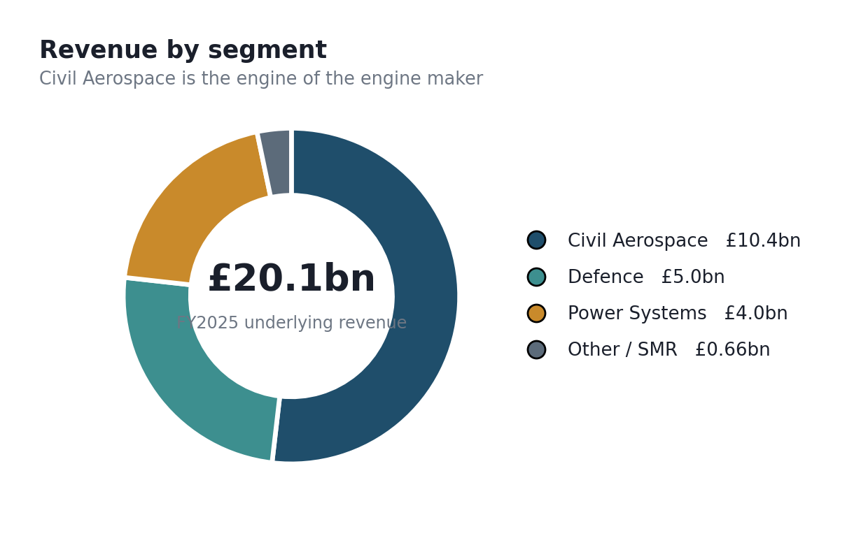
Figure 1: Rolls-Royce Holdings revenue by segment, FY2025 (Rolls-Royce Holdings plc, 2026b).
The financial position matters because it determines what the firm can afford to risk. FY2025 underlying revenue reached £20,059m, up 12.4% on 2024, with underlying operating profit of £3,462m and an operating margin of 17.3%, up 350 basis points year on year (Rolls-Royce Holdings plc, 2026b). Civil Aerospace delivered £10.4bn of segment revenue at a 20.5% margin. This is a company three years into a successful turnaround, generating cash, with a large-engine order book up 20% to 2,207 engines. It has the balance sheet to fund a Japanese entry. Whether it has the strategic appetite is a different question, and the answer is less obvious.
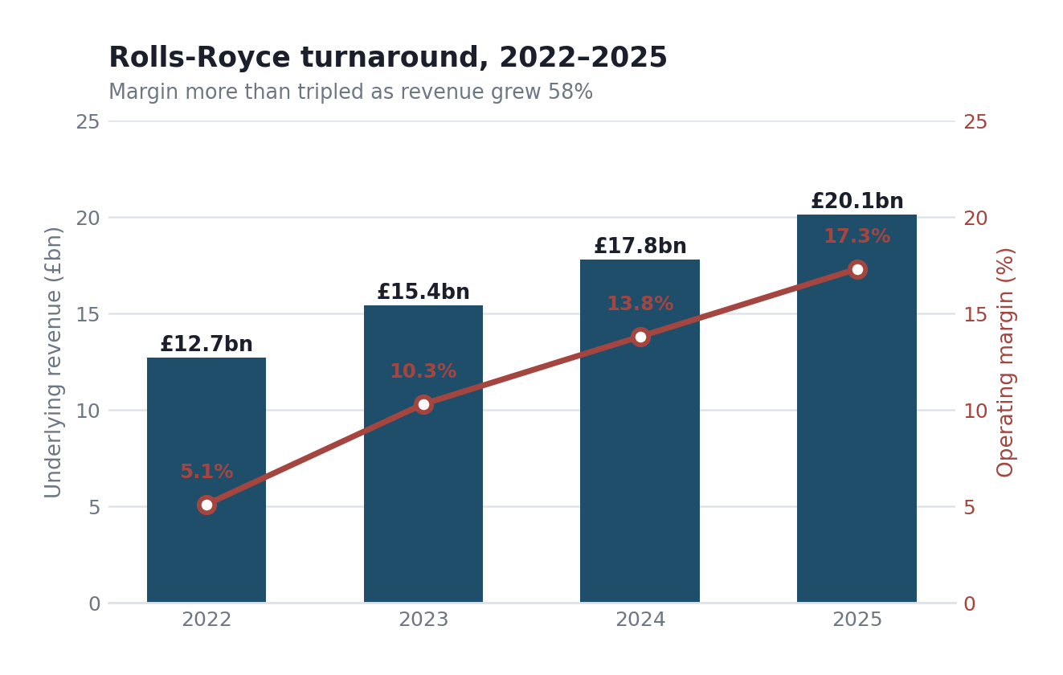
Figure 2: Revenue and operating margin, 2022–2025 (author's compilation from Rolls-Royce Holdings plc annual results, 2023–2026).
Where does competitive advantage actually come from? Not from the reactor design alone. Applying the resource-based view (Barney, 1991) with some honesty produces a mixed picture rather than a clean moat. The regulatory position is genuinely rare: Rolls-Royce SMR has been successful in every competitively tendered SMR selection in Europe and holds multiple contractual commitments in the UK, Czechia and Sweden, which no competitor can currently claim (Rolls-Royce, 2026c). That is valuable and hard to imitate quickly, because regulatory approval takes years. The naval nuclear propulsion heritage is rarer still, and effectively inimitable, since it derives from decades of UK submarine reactor work. But the modular manufacturing capability, while valuable, is imitable over time by GE Vernova, Hitachi or Mitsubishi Heavy, both of which have deep nuclear engineering bases. So the VRIO conclusion is one sustained advantage, one durable advantage, and one that erodes. Forcing all three into the sustained column would be tidier and wrong.
Value creation across the group follows a razor-and-blade logic that is worth stating because it explains the SMR strategy. Civil Aerospace sells engines at thin or negative initial margin and earns over decades through long-term service agreements tied to engine flying hours, which rose 8% in 2025 to 111% of 2019 levels (Rolls-Royce Holdings plc, 2026b). The installed base is the asset. Rolls-Royce SMR is being built on a deliberately similar premise: the first units are expensive and the economics only work if a fleet follows, which is why management targets the SMR business reaching profitability and positive free cash flow by 2030 (Rolls-Royce Holdings plc, 2025). This matters enormously for Japan. A single Japanese reactor would not justify entry. Entry only makes sense as the first unit of a fleet, and that raises the bar on how confident the firm must be about the market before committing.
The global configuration point is worth making bluntly. Rolls-Royce SMR's footprint is European and Atlantic. The UK, Czechia, and Sweden are contracted; Poland and the Netherlands are at the agreement stage; and US regulatory entry is underway. There is no Asian deployment. ČEZ Group's strategic investment during 2025 deepened the European tilt further by putting a Czech utility on the shareholder register (Rolls-Royce Holdings plc, 2026b). A firm with an established Asian nuclear business would treat Japan as an incremental market decision. Rolls-Royce would be treating it as a bridgehead into a region where it has no operating history, and that difference should shape everything that follows.

2.1 Macro-Environmental Appraisal and Market Attractiveness
The temptation in a country analysis is to march through every PESTEL letter with equal weight, which produces a neat table and a weak argument. A real entry decision turns on two or three factors capable of sinking it. For Rolls-Royce SMR in Japan those are, in order: the regulatory licensing regime, public and local government acceptance, and competition from entrenched domestic champions. Economic factors, which dominated when this module's earlier cases involved emerging markets, barely register here, and saying so explicitly is part of the analysis rather than an omission from it.

PESTEL summary, prioritised rather than exhaustive

Factor | Effect on a Rolls-Royce SMR entry | Weight
Legal / regulatory | NRA licensing is among the world's most demanding post-Fukushima. No foreign SMR design has been licensed. This is the single largest barrier, and it is measured in years, not months. | Critical
Social | Public acceptance remains fragile fifteen years after Fukushima; prefectural governors hold effective vetoes over restarts and new builds. | Critical
Political | Strongly favourable at the national level. The Seventh Strategic Energy Plan targets ~20% nuclear by 2040 and explicitly promotes next-generation reactors. | High (positive)
Economic | AI and data centre demand growth is the commercial pull. Financing, currency and sovereign risk are effectively non-issues in a G7 economy. | Medium
Technological | A world-class domestic nuclear engineering base is both a partnership opportunity and a competitive threat. | Medium
Environmental | Seismic siting requirements add engineering cost and constrain locations; decarbonisation targets support the case. | Low-Med

Economic factors: strong, and largely beside the point
Japan is the world's third-largest economy with deep capital markets, and this removes an entire category of risk that would dominate an emerging-market entry. There is no currency convertibility problem, no sovereign credit concern, and no question about whether the counterparty can fund a multi-billion-pound commitment. Utilities such as TEPCO, Kansai Electric and Kyushu Electric have genuine balance-sheet capacity. That said, the honest analytical point is that financial strength is a hygiene factor here rather than a driver: it removes reasons not to enter without supplying a reason to enter.
The actual economic pull is electricity demand and import dependence. Natural gas accounted for 33% of Japan's electricity generation in 2024, and Japan remains the world's second-largest LNG importer after China (EIA, 2026). Each restarted reactor displaces roughly a billion dollars a year in LNG imports; Kashiwazaki-Kariwa Unit 6 alone could displace approximately 1.3 million tonnes of LNG annually (EIA, 2026). Layered on top is demand growth from AI and semiconductor capacity, which is the stated justification for the government's policy reversal. So the commercial logic is real. It is worth noting, though, that Japan's own transmission coordination body has found demand forecasts have consistently overestimated consumption since 2015 (Nippon.com, 2026a), which is a genuine caveat that an uncritical analysis would skip.
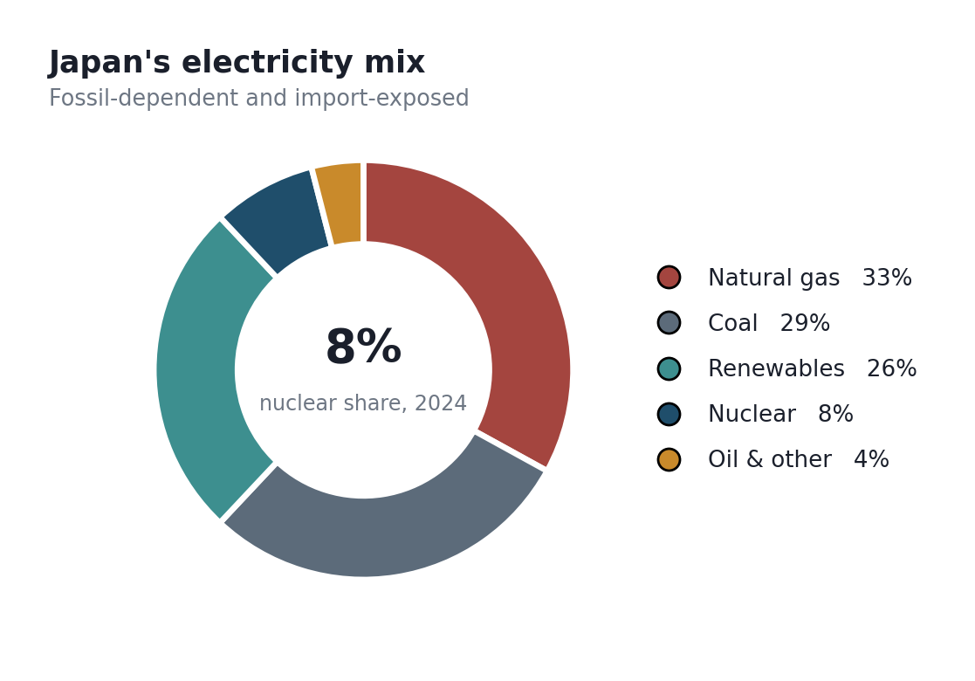
Figure 3: Japan's electricity generation mix, 2024 (EIA, 2026).

Political factors: the most favourable they have been since 2011
Government policy has reversed comprehensively, and this is the strongest pull factor in the analysis. The Seventh Strategic Energy Plan, approved in February 2025, targets nuclear supplying around 20% of electricity by 2040, up from under 10% currently, and commits to maximum use of existing plants alongside development of next-generation reactors (World Nuclear Association, 2026a; Nippon.com, 2026b). The GX Decarbonisation Power Supply Bill supports the same direction. Prime Minister Takaichi's administration has been vocally supportive, and the February 2026 restart of Kashiwazaki-Kariwa Unit 6, the world's largest nuclear plant by capacity, after fourteen years offline, is the clearest signal yet (EIA, 2026).
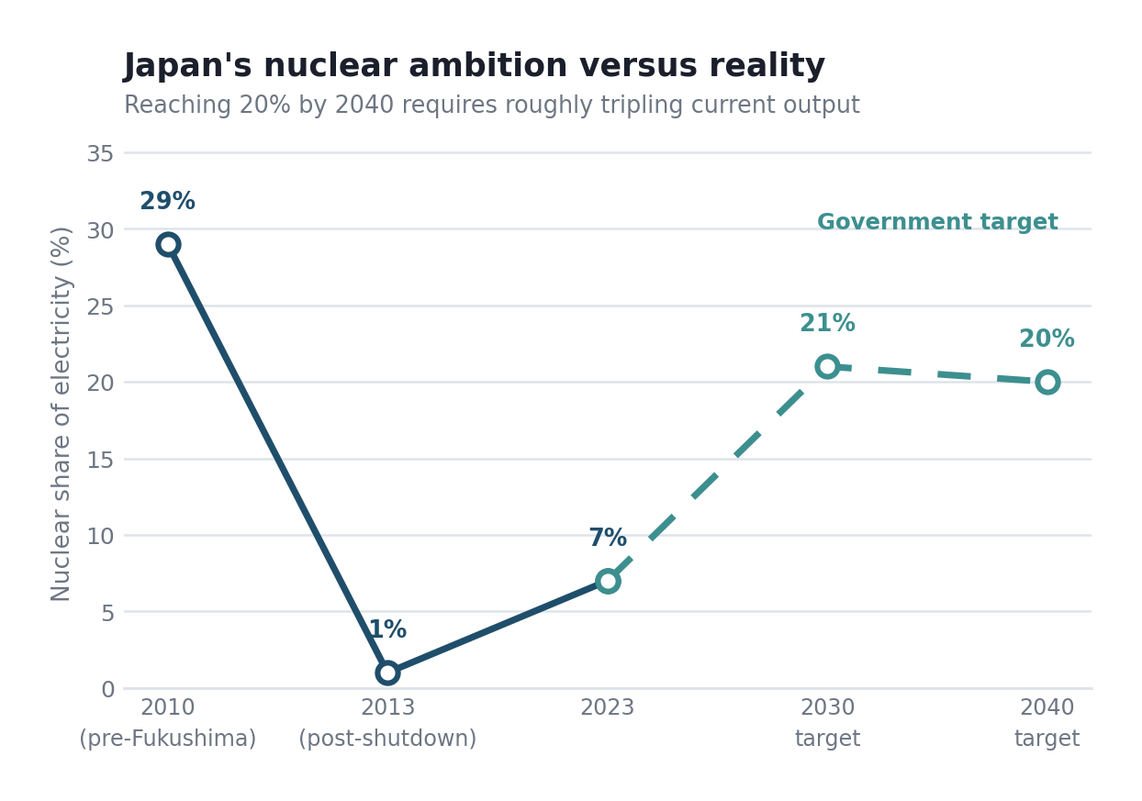
Figure 4: Nuclear share of Japanese electricity, actual and targeted (World Nuclear Association, 2026a; Nippon.com, 2026b).
National support does not equal local support, and this is where the analysis has to be careful. A restart requires prefectural governor approval, which gives regional politicians an effective veto. Niigata's governor approved the Kashiwazaki-Kariwa restart only in November 2025, after years of hesitation. Public response to the maximisation push has been described as lukewarm, with the decision viewed as driven by a narrow set of stakeholders rather than national consensus (Nippon.com, 2026a). For a foreign vendor proposing new construction rather than the restart of an existing asset, that acceptance problem is harder, not easier.

Legal factors: the regulator is the real gatekeeper
The Nuclear Regulation Authority, created after Fukushima, applies some of the most demanding safety standards anywhere, and no foreign SMR design has been through its process. The practical implication is a licensing timeline measured in years with no certainty of outcome, during which capital is committed and revenue is zero. Seismic qualification adds a further layer that European designs do not routinely address. Rolls-Royce SMR's European regulatory record, impressive as it is, transfers only partially, because NRA acceptance is not a rubber stamp on foreign approval. This is the factor most likely to determine whether entry succeeds, and it is largely outside Rolls-Royce's control.
One physical constraint deserves more attention than a PESTEL table gives it. Japan sits on four converging tectonic plates, and seismic qualification is not a box to tick but a design problem that reshapes cost and siting. Reactors must withstand ground motion far exceeding European design-basis assumptions, which affects foundation engineering, component mounting and containment specification. For a modular reactor whose entire economic argument rests on building identical units in a factory, this is a pointed challenge: every Japan-specific modification erodes the standardisation that makes the product cheap. Rolls-Royce would face a genuine trade-off between a compliant design and an economic one, and there is no evidence in the public record that the firm has resolved it. Coastal siting compounds matters, since tsunami protection post-Fukushima demands defences that add cost and constrain viable locations. None of this is fatal. Domestic vendors design for the same conditions profitably. But it does mean the cost advantage Rolls-Royce carries into European tenders may not survive translation, and an entry case that assumes European unit economics would be building on sand.

Competitive context: entering against national champions
A macro-scan without naming competitors is incomplete, because attractiveness depends on who else is in the room. Mitsubishi Heavy Industries is developing the SRZ-1200 with four major utilities as partners, alongside a 300 MW SMR, HTGR and micro-reactor programme aligned to Japan's GX policy. Toshiba and IHI have deep nuclear capability. GE Vernova Hitachi has the BWRX-300 already under construction in Ontario. US-Japan cooperation announced during 2026 envisages substantial support for Westinghouse AP1000 and SMR construction with possible partnerships involving Mitsubishi Heavy, Toshiba and IHI (ANS, 2026). Rolls-Royce would therefore be a British entrant competing against Japanese national champions who are themselves partnering with American vendors backed by state financing.
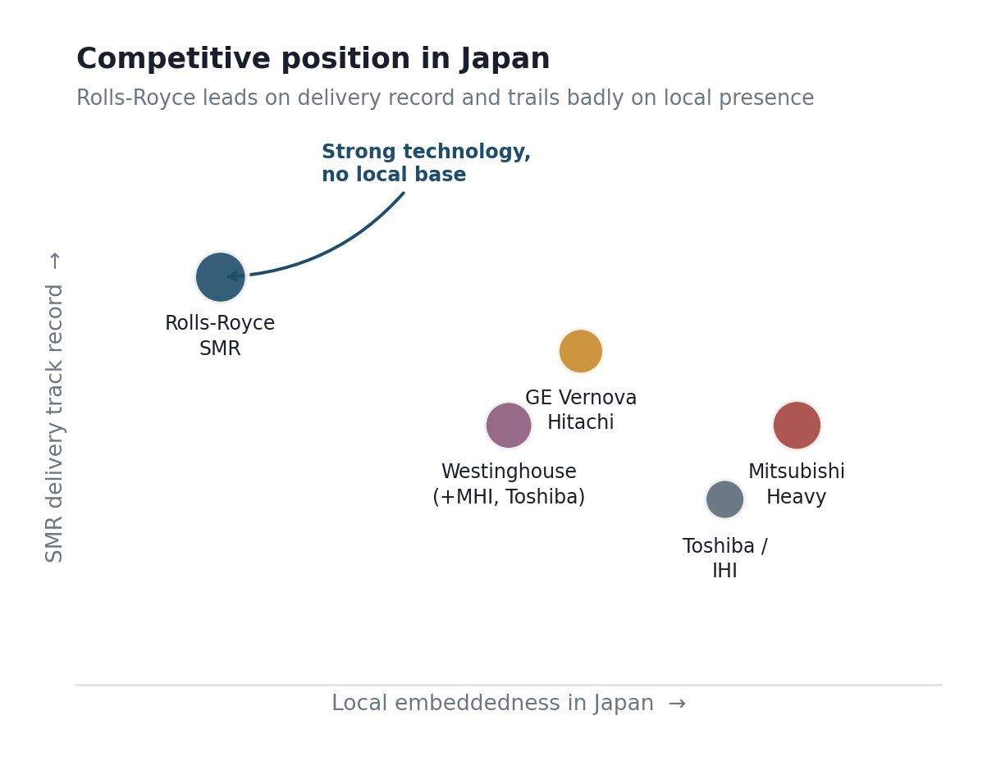
Figure 6: Competitive positioning in the Japanese nuclear market (author's assessment).
The strategic implication is uncomfortable and clarifying at once. Rolls-Royce's advantage is its delivery track record and regulatory momentum; its deficit is local embeddedness, and in Japanese infrastructure procurement, local embeddedness is not a soft factor. It determines access to utilities, prefectural relationships and supply chains. A firm that is technically superior and institutionally absent will lose to one that is adequate and present. That asymmetry is the crux of the entry-mode question in Section 3.
Reading the same market through Porter's (1985) five forces sharpens where the pressure actually sits. Rivalry among established vendors is intense and, more importantly, politically structured rather than purely commercial. Supplier power is moderate, though seismic-qualified component supply in Japan is concentrated among firms who are themselves aligned with domestic reactor vendors, which is an awkward dependency for an outsider. Buyer power is high and concentrated: a handful of regional utilities and the state effectively constitute the entire customer base, and they are not price-takers. The threat of substitutes is real and often understated in nuclear analyses, since offshore wind, grid-scale storage and continued LNG all compete for the same decarbonisation capital. Barriers to entry, finally, are the highest of any industry in this module, and they cut both ways: they protect Rolls-Royce once inside, and they are precisely what makes getting inside so expensive.
The fleet data illustrates why replacement rather than restart is the commercial opening. Fourteen reactors have restarted under enhanced post-Fukushima standards, with roughly two dozen either decommissioning or unlikely to return, and TEPCO has already delayed Kashiwazaki-Kariwa Unit 7 to 2029–2030 (EIA, 2026). Restart is therefore slow and finite. If Japan is serious about roughly 20% nuclear generation by 2040, arithmetic alone says a restart cannot deliver it, and a new build must. That is the gap an SMR vendor would be selling into, and framing the opportunity this way is more defensible than pointing at headline policy targets.
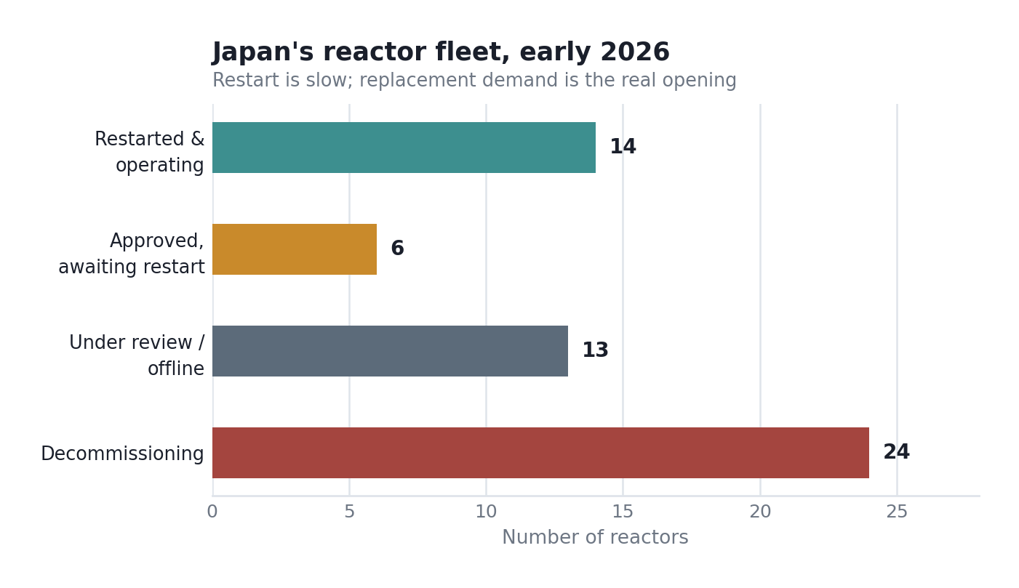
Figure 5: Japanese reactor fleet status, early 2026 (author's compilation from EIA, 2026 and World Nuclear Association, 2026a).

2.2 Market Entry Synthesis: Dunning's Eclectic (OLI) Paradigm
Dunning's (2000) eclectic paradigm asks three questions before a firm commits abroad. Does it possess ownership advantages worth exploiting elsewhere? Do location advantages make the target country worth operating in rather than serving from outside? And are there Internalisation advantages that justify doing it in-house rather than licensing or partnering? A confident entry needs three affirmative answers. Rolls-Royce gets a strong yes, a qualified yes, and a fairly clear no. The asymmetry is the finding.
OLI element | Assessment for Rolls-Royce SMR in Japan | Verdict
Ownership | Proven SMR design, unmatched European regulatory record, naval nuclear heritage, modular manufacturing capability. Genuinely strong and transferable. | Strong
Location | Policy support, demand growth and import dependence pull hard one way; NRA licensing, public acceptance and entrenched domestic competition push the other. Net moderate. | Moderate
Internalisation | Regulatory navigation, utility relationships, prefectural consent and supply-chain access are all supplied far better by a Japanese partner than by Rolls-Royce alone. Weak case for going it alone. | Weak

Ownership is the straightforward leg. Rolls-Royce SMR's advantages travel: a factory-built reactor design with a demonstrated ability to clear rigorous regulatory processes is exactly the firm-specific asset Dunning envisages. The European contract record is verifiable evidence rather than assertion.
Location is genuinely contested, and I want to resist resolving it too neatly. Japan needs low-carbon baseload; has stated policy commitment; and faces demand growth. Those are real. But the market is not short of capable suppliers, the licensing pathway is unproven for foreign SMRs, and local consent is fragile. On balance the location advantage is moderate rather than strong, which means it cannot carry a high-commitment entry on its own.
Internalisation is where the analysis turns, and the answer is the opposite of what Rolls-Royce's history would suggest. Almost everything that determines success in Japan, NRA engagement, utility procurement relationships, prefectural politics, and seismic-qualified local supply chains is done better by an incumbent Japanese firm. Rolls-Royce cannot buy those capabilities and would take a decade to build them. Meanwhile, the thing Rolls-Royce must not surrender is the reactor design and its regulatory dossier, because that is the entire ownership advantage. So the internalisation question is not whether to internalise but what to internalise: keep the technology and licensing position in-house or externalise the market-facing capabilities. That distinction points directly at the recommendation.
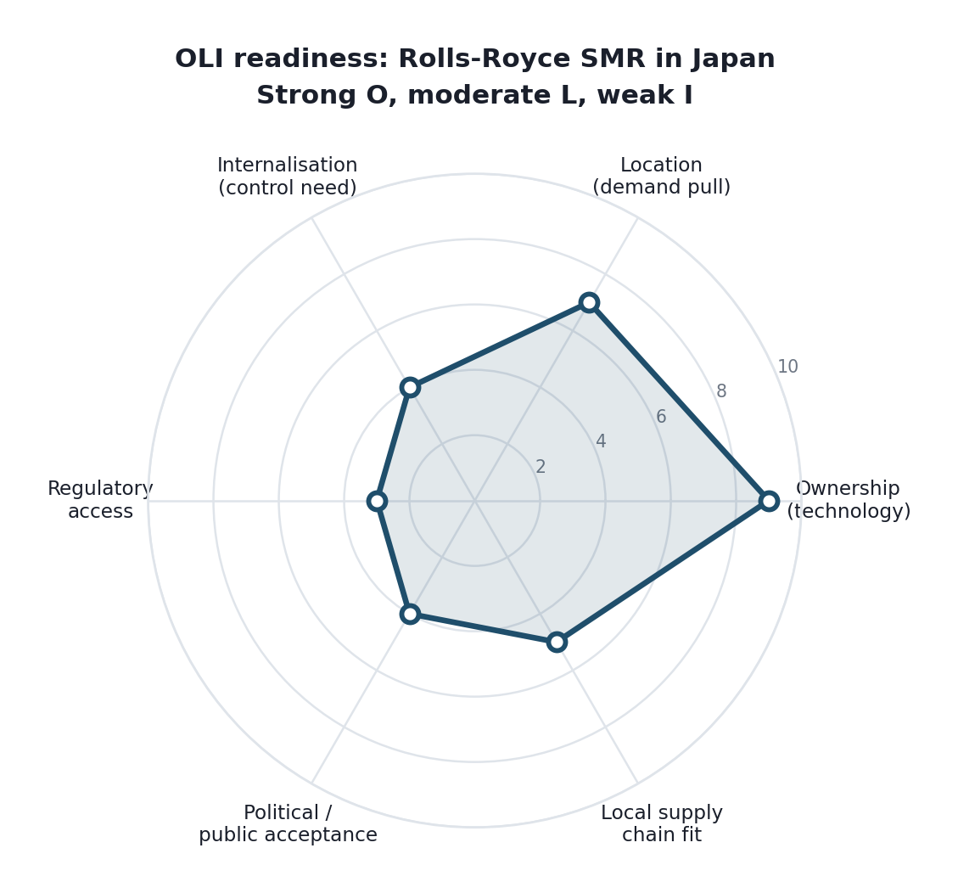
Figure 7: OLI readiness profile for Rolls-Royce SMR in Japan (author's assessment).
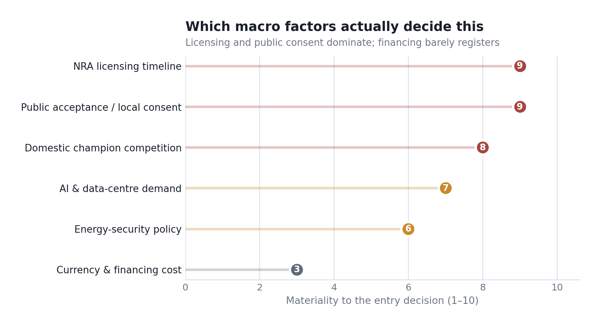
Figure 9: Materiality weighting of macro factors (author's assessment).

Section 3: Entry Mode Strategy and Strategic Synthesis

3.1 Historical pattern recognition
Rolls-Royce's expansion history reveals two distinct patterns, and knowing which applies is half the analysis. In civil aerospace, the firm has used risk-and-revenue-sharing partnerships and joint ventures extensively, particularly for MRO capacity. The Beijing Aero Engine Services joint venture with Air China, opened in December 2025, will support up to 250 Trent overhauls annually by the mid-2030s (Rolls-Royce Holdings plc, 2026b). MRO capacity was added in Derby, Dahlewitz and Singapore during 2025. The pattern is partnership where local access matters.
Rolls-Royce SMR's pattern is different and much shorter. Every entry so far has been direct contracting with a state or utility counterparty following a competitive tender: Great British Energy-Nuclear in the UK, ČEZ in Czechia, and Videberg Kraft in Sweden. The one structural variation is equity: ČEZ took a strategic stake in Rolls-Royce SMR itself, which is a partnership at the shareholder level rather than the project level. There is no franchising, no licensing, and no local joint venture in the SMR portfolio. The dominant mode is winning the tender, contracting directly, and retaining full technology control.
There is a second, quieter pattern worth naming, because it bears directly on strategic fit. Every SMR market Rolls-Royce has entered so far shares three institutional features: an open competitive tender, a government actively sponsoring the procurement, and a regulator either already familiar with the design or working within a European framework. The UK, Czech and Swedish wins were all competitive selection processes the firm entered on equal terms and won on merit (Rolls-Royce, 2026c). That record is genuinely impressive, and it is also narrow. It tells us Rolls-Royce SMR is excellent at winning open competitions. It tells us nothing about whether the firm can build a position in a market that does not run on them, which is exactly the question Japan poses.

3.2 Strategic fit and justification
Applying the direct-contracting model to Japan fails, and the OLI analysis explains precisely why. Direct contracting works where a competitive tender exists, where the regulator has an established pathway for the design, and where the customer can commit without political intermediation. Japan currently offers none of these. There is no open SMR tender comparable to Sweden's or the UK's; the NRA has never licensed a foreign SMR; and utility procurement is embedded in prefectural politics that no foreign firm can navigate alone. Rolls-Royce would be applying a mode designed for open European competitions to a market that does not run them.
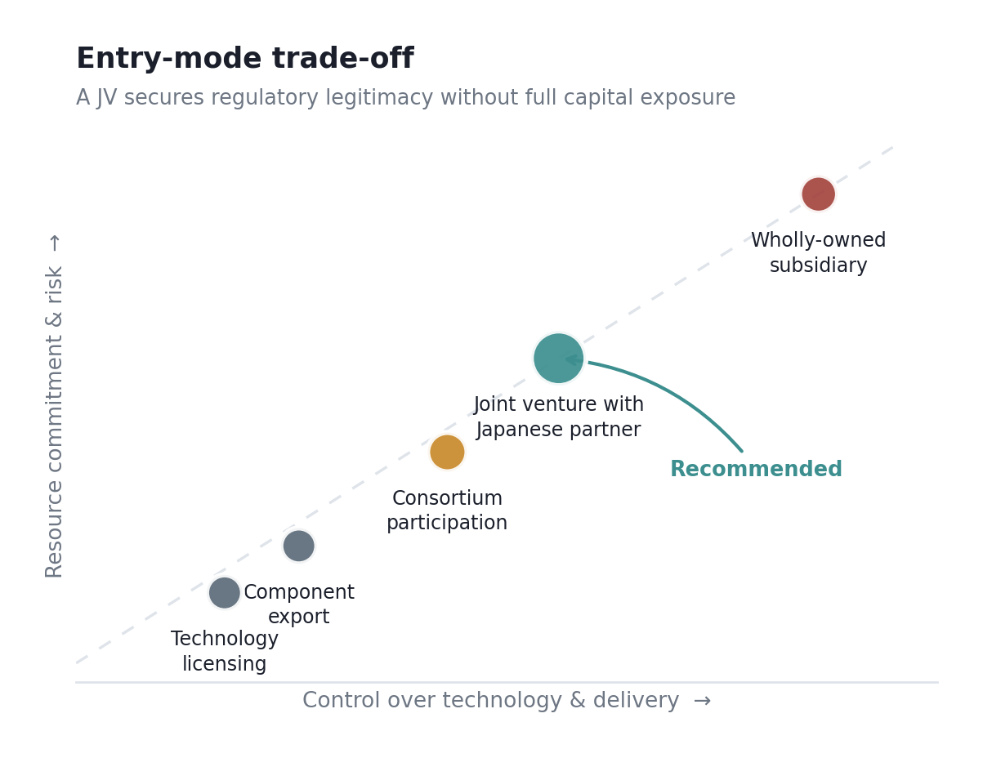
Figure 8: Entry-mode trade-off between control and commitment (adapted from Hill, Hwang and Kim, 1990).
A wholly-owned subsidiary sits in the top-right corner of Figure 8 and is the wrong answer for the same reason it usually is in unproven markets. Maximum control, maximum capital exposure, and no solution to the problems that actually bind: licensing and legitimacy. Buying a Japanese entity is not realistically available either, since the relevant capability sits inside Mitsubishi Heavy, Toshiba and IHI, none of which is acquirable.
Pure technology licensing sits at the opposite extreme and fails differently. Licensing the design to a Japanese firm would generate royalty income with minimal risk, but it surrenders the ownership advantage that constitutes the entire strategic asset, and it hands a capable competitor the means to compete globally. Given that Mitsubishi Heavy is already developing its own 300 MW SMR, this would be arming a rival. Low risk, unacceptable strategic cost.
The mode that fits the analysis is a joint venture with an established Japanese industrial partner, and the reasoning maps directly onto the OLI split rather than splitting the difference for its own sake. A partner such as IHI or Toshiba supplies exactly the weak legs: NRA engagement experience, utility relationships, prefectural credibility, and a seismically qualified supply chain. Rolls-Royce contributes the design, the regulatory dossier and the modular manufacturing method, retaining ownership of the intellectual property through the JV structure rather than transferring it. Crucially, the partner absorbs much of the political and licensing risk that a foreign firm cannot manage, while Rolls-Royce's capital exposure stays proportionate to a market that has not yet proven it will buy.
There is precedent for this being the sane route into Japanese infrastructure. Foreign entrants into regulated Japanese sectors have routinely used joint ventures to acquire legitimacy that cannot be purchased directly, and Rolls-Royce's own Civil Aerospace division has used exactly this logic in China through BAESL (Rolls-Royce Holdings plc, 2026b). The mode is not new to the group; it is only new to the SMR business, whose short history has been shaped by European tender competitions that happen not to exist in Japan. Applying a familiar mode to an unfamiliar institutional context is a common way for capable firms to lose money abroad (Johnson et al., 2023).

3.3 Conclusion and recommendations
The recommendation is a phased, joint-venture-led entry, conditional on regulatory progress rather than committed up front. Phase one: establish a JV with a Japanese industrial partner and open a formal pre-application dialogue with the NRA, with capital exposure deliberately limited while the licensing pathway is tested. Phase two, contingent on regulatory milestones, develops a reference site with a utility partner and builds local supply-chain qualification. Phase three, deployment at scale, only if phases one and two demonstrate both licensing feasibility and public acceptability. This structure buys Rolls-Royce an option on a large market without betting on an outcome it cannot control.
Three risks require explicit mitigation rather than acknowledgement. Intellectual property leakage to a partner who is also a potential competitor is the first, and it is managed through JV structure, licensing terms that restrict the field of use, and retescaling of the regulatory dossier in Rolls-Royce's name rather than the JV's. Second, licensing timeline risk, which is mitigated by staging capital against regulatory milestones so that a stalled NRA process caps losses rather than compounding them. Third, public acceptance, which cannot be contracted away and must be addressed through the partner's local standing and sustained prefectural engagement from the outset rather than at the point of site selection.
On Ansoff's matrix this is market development: an existing product taken to a new geographic market. That classification is correct but not very illuminating, and it is worth saying why rather than describing all four quadrants. Ansoff tells us the direction of growth and is silent on the institutional mode of getting there, which is the only question that actually matters in a market gated by a regulator and a set of prefectural governors (Johnson et al., 2023). The framework's silence here is a fair criticism of it in this application.
A balanced scorecard keeps the phasing honest against evidence rather than optimism. Figure 10 sets illustrative targets across regulatory, partnership, supply-chain and public-sentiment dimensions, with the deliberate point that phase gates depend on licensing milestones and measured public favourability rather than on commercial enthusiasm (Kaplan and Norton, 1996).
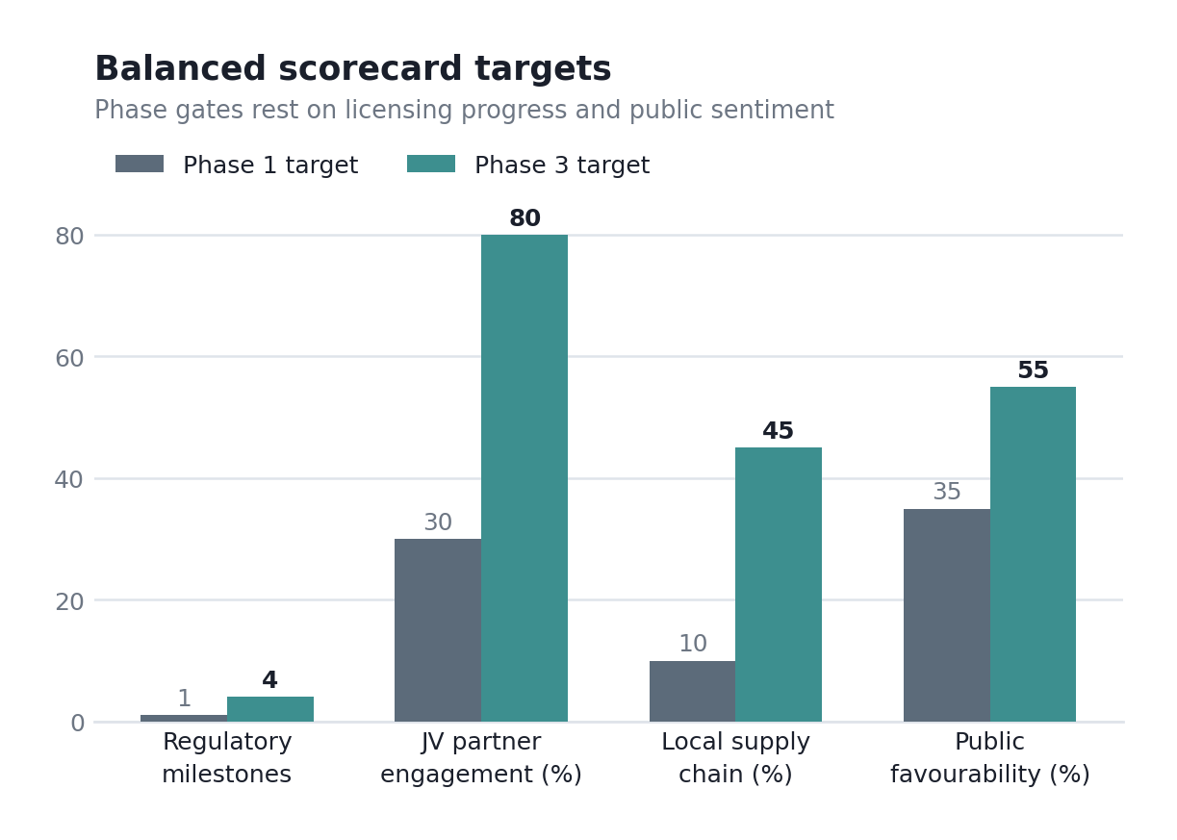
Figure 10: Illustrative balanced-scorecard targets for a phased entry (author's construction; framework after Kaplan and Norton, 1996).
Two conditions should gate the decision entirely. First, a credible partner must be securable on terms that protect the intellectual property; if the only available partners demand technology transfer, the entry should not proceed, because the ownership advantage is the business. Second, NRA pre-application engagement must indicate a viable pathway within a defined period; an open-ended regulatory process with no timeline is not a risk to be managed but a reason to wait. Meet both, and the downside is a capped, recoverable investment in a market that could matter substantially by the 2040s. Meet neither, and no entry structure rescues it.

Section 2: Reflective Account

Description
I chose Rolls-Royce and Japan because the obvious version of this assignment looked too easy, and the real version turned out to be harder than expected. The work ran in three passes. Establishing which Rolls-Royce I was analysing came first, since the aerospace group and the motor car marque are unrelated companies. Reading the group's FY2025 results took an evening. The Japanese market data took considerably longer, across two sessions, because nuclear policy is fast-moving and sources disagreed. Only then did I apply the frameworks: Bartlett and Ghoshal, PESTEL, OLI and entry-mode analysis. I worked mostly evenings over a fortnight at home, with the framework analysis done across two weekend sittings.
On method, I worked from primary company disclosure outward rather than secondary commentary inward. Rolls-Royce's investor relations material gave segment revenue, margins and the SMR contract position as stated figures rather than analyst inference. For the host market I triangulated the World Nuclear Association, the US Energy Information Administration and Japanese sources, and where they disagreed, I said so rather than picking the convenient number. The university library discovery service and Google Scholar were my routes to the academic entry-mode literature.

Feelings
The moment that unsettled me was discovering the JAEA agreement after I had already decided Japan was a clean no-presence market. My first reaction was that the whole case had collapsed and I would have to start again. Reading the agreement properly changed that: JAEA is supplying safety data so Rolls-Royce can build a demonstration reactor in Britain, which is Japanese technology flowing into the UK rather than the reverse. The relief was real, but so was the lesson. I had nearly abandoned a workable case on a headline, and I had nearly written an entry analysis without noticing an existing relationship. Both errors would have been mine. The other thing that caught me was the scale gap. Rolls-Royce SMR has swept every European tender it has entered, so I had assumed a globally dominant firm; finding it has no Asian presence whatsoever was a genuine surprise and a useful correction to how I had framed the company.

Evaluation
What went well was prioritising rather than describing. My first PESTEL had six balanced paragraphs and read like a checklist. Forcing myself to say that licensing and public acceptance decide this, and that financing barely matters in a G7 economy, made the section argue something. Dismissing a factor explicitly turned out to be more analytically useful than covering it dutifully.
What went less well was my initial assumption about entry mode. I assumed direct contracting because that is what Rolls-Royce SMR has always done, and I had to catch myself: three data points in Europe is a pattern shaped by European tender processes, not a strategy that transfers. The weakness in my process was source recency. Japanese nuclear policy moved during the period I was writing, and some material was weeks old by the time I used it, which makes parts of the analysis more provisional than the confident tone suggests. I also spent too long on the company before starting the country research, so the two halves of the work felt unbalanced, and I had to compress the Japan analysis under time pressure I had created for myself.

Analysis
Two things from the module reshaped how I worked. The first was the seminar discussion on why firms choose joint ventures over wholly owned subsidiaries, which at the time felt like a dry structural comparison and became the hinge of my recommendation. The argument that stuck was that the choice is not about control in the abstract but about which capabilities a firm can afford to hand over and which it cannot. That let me separate the reactor design and regulatory dossier, which Rolls-Royce must keep, from utility and prefectural relationships, which it cannot build alone. The second was OLI, which did not resolve cleanly. Dunning wants a verdict on each leg; Japan gave me a strong O, a moderate L and a weak I. The imbalance was the insight, because a weak internalisation answer is what points toward partnership rather than either extreme. Dunning’s original 2000 article on the eclectic paradigm was the reading that made this click, precisely because it insists on testing each leg separately rather than reaching an overall verdict.
The assumption I abandoned was that technological superiority determines market outcomes. I began assuming that Rolls-Royce SMR's European regulatory record, unmatched by any competitor, would carry a Japanese entry. Working through the NRA position and the prefectural consent requirement forced me to separate technical merit from institutional access. A firm can hold the better product and still lose to one that is merely adequate and locally embedded. That separation changed my recommendation from confident entry to conditional, partnership-based entry, and giving up the cleaner conclusion was uncomfortable but more defensible.

Conclusion
The skill I improved most was distinguishing what a source actually says from what a headline implies, which the JAEA episode taught me directly. The weakness I have, to be honest about, is reading speed on academic and technical sources. Working through Dunning's original article and the entry-mode literature took far longer than I had allowed, because I read start to finish rather than reading toward a question. The consequence showed elsewhere: I ran out of time to replace weaker secondary sources with primary statistics. That habit of reading a source rather than its headline is the strength I would point to; reading speed on dense material is the weakness I still need to fix.

Action Plan
Next time I would establish the entity boundary before anything else. An hour spent confirming which Rolls-Royce I was analysing would have saved rework, and the general principle, define the unit of analysis before gathering data, applies to any company with subsidiaries or shared branding. I would also check for existing relationships between the firm and target market at the outset rather than mid-way, since that is exactly what nearly derailed this assignment.
The reading problem needs a method rather than more hours. I intend to read journal articles in a fixed order: abstract, then conclusion, then the section answering my question, and read the full text only if those three show the paper is central. To make that stick rather than remain an intention, I will book a session with the academic skills team on reading strategies for journal articles before the next assignment deadline. I will also set myself a fixed cut-off for company research on the next assignment so the country analysis gets equal time.

References
American Nuclear Society (2026) 'New PM, restarts, ongoing cleanup on 15th anniversary of Fukushima accident', Nuclear Newswire. Available at: https://www.ans.org/news/article-7834/new-pm-restarts-ongoing-cleanup-on-15th-anniversary-of-fukushima-accident/ (Accessed: 24 July 2026).
Barney, J. (1991) 'Firm resources and sustained competitive advantage', Journal of Management, 17(1), pp. 99–120.
Bartlett, C.A. and Ghoshal, S. (1989) Managing across borders: the transnational solution. Boston: Harvard Business School Press.
Dunning, J.H. (2000) 'The eclectic paradigm as an envelope for economic and business theories of MNE activity', International Business Review, 9(2), pp. 163–190.
Energy Information Administration (2026) Nuclear reactor restart in Japan will likely displace natural gas electricity generation. Available at: https://www.eia.gov/todayinenergy/detail.php?id=67244 (Accessed: 24 July 2026).
Gibbs, G. (1988) Learning by doing: a guide to teaching and learning methods. Oxford: Further Education Unit, Oxford Polytechnic.
Hill, C.W.L., Hwang, P. and Kim, W.C. (1990) 'An eclectic theory of the choice of international entry mode', Strategic Management Journal, 11(2), pp. 117–128.
Japan Atomic Energy Agency (2026) Accelerating the deployment of Japan's HTGR technology through collaboration with the UK. Available at: https://www.jaea.go.jp/english/news/press/2026/061501/ (Accessed: 24 July 2026).
Johnson, G., Whittington, R., Regnér, P., Angwin, D. and Scholes, K. (2023) Exploring strategy: text and cases. 13th edn. Harlow: Pearson.
Kaplan, R.S. and Norton, D.P. (1996) The balanced scorecard: translating strategy into action. Boston: Harvard Business School Press.
Kolb, D.A. (1984) Experiential learning: experience as the source of learning and development. Englewood Cliffs, NJ: Prentice Hall.
Nippon.com (2026a) 'Japan's energy plan: new policy shifts nuclear power stance from reduction to maximization'. Available at: https://www.nippon.com/en/in-depth/d01195/ (Accessed: 24 July 2026).
Nippon.com (2026b) 'Japan's nuclear power plants in 2025'. Available at: https://www.nippon.com/en/japan-data/h02619/ (Accessed: 24 July 2026).
Nuclear Engineering International (2026) 'Rolls-Royce boosts UK-Japan nuclear push'. Available at: https://www.neimagazine.com/news/rolls-royce-boosts-uk-japan-nuclear-push/ (Accessed: 24 July 2026).
Porter, M.E. (1985) Competitive advantage: creating and sustaining superior performance. New York: Free Press.
Rolls-Royce (2026a) Rolls-Royce, United Kingdom National Nuclear Laboratory and Japan Atomic Energy Agency to co-operate on advanced nuclear technologies. Available at: https://www.rolls-royce.com/media/press-releases/2026/14-06-2026-rr-united-kingdom-national-nuclear-laboratory-and-japan-atomic-energy-agency-to-co-operate-on-advanced-nuclear-technologies.aspx (Accessed: 24 July 2026).
Rolls-Royce (2026c) Rolls-Royce SMR selected to deliver Sweden's first new nuclear power for over 40 years. Available at: https://www.rolls-royce.com/media/press-releases/2026/15-06-2026-rr-smr-selected-to-deliver-swedens-first-new-nuclear-power-for-over-40-years.aspx (Accessed: 24 July 2026).
Rolls-Royce Holdings plc (2025) 2025 half year results. Available at: https://www.rolls-royce.com/media/press-releases/2025/31-07-2025-rr-holdings-plc-2025-half-year-results.aspx (Accessed: 24 July 2026).
Rolls-Royce Holdings plc (2026b) 2025 full year results. Available at: https://www.rolls-royce.com/media/press-releases/2026/26-02-2026-rr-holdings-plc-2025-full-year-results.aspx (Accessed: 24 July 2026).
United Kingdom National Nuclear Laboratory (2026) New international collaboration for advanced nuclear technology. Available at: https://uknnl.com/2026/06/new-international-collaboration-for-advanced-nuclear-technology/ (Accessed: 24 July 2026).
Whittington, R., Regnér, P., Angwin, D., Johnson, G. and Scholes, K. (2023) Fundamentals of strategy. 6th edn. Harlow: Pearson.
World Nuclear Association (2026a) Japan – World Nuclear Outlook Report. Available at: https://world-nuclear.org/our-association/publications/world-nuclear-outlook-report/japan---world-nuclear-outlook-report (Accessed: 24 July 2026).
World Nuclear News (2026) 'Rolls-Royce joins UK-Japan HTGR development agreement'. Available at: https://www.world-nuclear-news.org/articles/rolls-royce-joins-uk-japan-HTGR-development-agreement (Accessed: 24 July 2026).

