 | Student No: | 2408946
 | Module Title: | Business Skills for the International Hotel Industry
 | Module Code: | BMIH4007D
 | Lecturer: | Daniel Payne

Component One: Reflective Journal 1000 words

Introduction
This is a reflective journal, an account of what I have learned and experienced during weeks 2-8 of the Business Skills module (Fahmi and Ali, 2022). I used the ERA model of reflection which includes my experience, reflection, and learning-based action as discussed below:

Week 2
Experience: One of my key experiences during this period was learning about the importance of effective communication skills in the hospitality industry. We were taught verbal and non-verbal communication techniques, conflict resolution, and active listening in this week 2.
Reflection: I realised that I had strengths in the verbal form of communication, although my written communication skills are weak (Fahmi and Ali, 2022). I understood the significance of cultural awareness and sensitivity and its role in customer communication.
Action: Based on this learning outcome and my reflection, I have concluded that I need to work on my writing skills by practicing writing reports and emails. I will seek feedback from my peers and supervisor on my improvement in written communication skills.

Week 3
Experience: I learned about the proper methods of referencing and citation, and different writing styles and techniques. From this week, I started writing a reflective journal entry using proper referencing and citation (Cotton, Cotton and Shipway, 2024).
Reflection: This improved my overall written communication skills, but I haven't become perfect in it as I still need to work on my referencing and citation skills regarding different types of resources.
Action: After learning different methods and techniques, I am always planning to adopt the practice of referencing and citation in my writing (Cotton, Cotton and Shipway, 2024). And, I will practice using different citation styles and techniques.

Week 4
Experience: In digital skills, we learned about Canva, and creating charts and graphs. Along with that, I realised the importance of these digital aptitudes in marketing and analysis functions of the hospitality industry. We worked on many examples and reviewed each other's work in a group.
Reflection: I created a marketing brochure using Canva. Working on it, I realised that my digital skills have become better. However, I am not good at complex data analysis and representation tasks. I found this skill useful in other subjects and areas also (Livingstone, Mascheroni and Stoilova, 2023).
Action: As per my reflection, I need to practice more on my data analysis skills on different software. Also need to practice data representation using different techniques. I will practice on real-life examples and real data sets available on the internet or in digital libraries.

Week 5
Experience: We learned about the relevant transferable skills and the role of time management in the hospitality industry (Livingstone, Mascheroni and Stoilova, 2023). This week, we had to demonstrate teamwork, leadership, and problem-solving skills in practical terms. I enjoyed problem-solving assignments and teamwork.
Reflection: During this week, we received practical lessons and on-time feedback on our performance. I got feedback to improve my time management skills. I agree that I need to work on overall skill development with a focus on time management. I also need to develop influencing skills to master leadership.
Action: Based on my reflection, now I am planning to practice time management skills with the help of an action plan included further (Trentepohl et al., 2022). I will prioritise tasks and practice task division in small achievable steps. I will learn leadership skills after studying it from learning materials from different sources and will practice it during junior projects supervising tasks.

Week 6
Experience: My peers and I learned practical skills this week. We learned more applications of Canva, then we practiced plate delivery, and how to serve a table. We also practiced these skills via role-playing activities (Trentepohl et al., 2022). We did enjoy learning this week and most importantly, we learned valuable lessons of excellent customer service.
Reflection: With practice, I improved my practical skills by the end of the week. However, I lack attention to detail in my performance. Overall, my practice went well. In customer service, my communication, professionalism, and presentation were good but my order delivery lacked perfection.
Action: Based on my reflection, I am planning to double-check the order and table organisation to bring perfection to my practical skills. I will practice these skills via role-playing activities among my peers (Hennchen, 2021).

Week 7
Experience: This week, I learned about legal issues in hospitality management and customer service. The focus was on food safety. Also, the practice of group learning was emphasised. My key learning was the action protocol during the time of customer food emergencies.
Reflection: Reflecting on my experience, I understood the importance of food safety and the seriousness of legal issues. I enhanced my knowledge of these topics and also learned the importance of group learning via group activities. Still, I need to improve my knowledge of the topic via additional learnings and case studies (Hennchen, 2021).
Action: To work on the shortcomings mentioned in the reflection, I plan to study relevant materials and learn the practical application in the work settings.

Week 8
Experience: I learned about reflective models, especially about this ERA model. We were also taught team-building skills. I understood the importance of reflective models in the studies of the hospitality industry and career planning. Reflection is useful to improve performance and achieve goals in my experience (Krapivnyk et al., 2021).
Reflection: Reflecting on my experience, I learned and practiced reflection during this week. And as per the feedback, I improved gradually. As a result, I am writing this reflection, however I observed that I lack in communicating my thoughts properly.
Action: Based on the reflection, I have planned to practice reflection in a practical setting. I will adhere to the lessons that I am deriving from my reflection and will work on the necessary action requirements (Krapivnyk et al., 2021).

Conclusion
This was a reflection on my learning experience from week 2 to week 8 using the ERA reflection model. This activity made me understand my areas of improvement and skills to excel. Based on this, I will create an efficient action plan.
Component Two: Action Plan

Introduction
Using the learning outcomes derived from my reflective journal, I have concluded my lessons in the provided action plan. This action plan addresses my areas for improvement and areas to excel in. This skill development plan focuses on my core strengths enhancement and discusses opportunities for professional practice (Saunders and Bajjaly, 2022).

Identified areas for improvement
Written communication skills: Written communication skills involve a professional way of writing with appropriate citation and referencing in the required academic style.
- Action and Resources: I will practice writing reports and emails. And, I will seek feedback from my peers and tutors on my written communication skills. I will need the resources of online course material and group practice sessions.
- Period requirement: To master the skill, I will need approximately 1 year (Saunders and Bajjaly, 2022).
Time management skills: It involves task division into small achievable steps and prioritisation.
- Action and Resources: I will need to use a planner to stay organised. I won't need additional resources, as I will practice this in my daily life under your guidance.
- Period requirement: To master the skill, I will need approximately 1 year
Attention to detail: This skill is mandatory in hospitality services where customers demand perfection and the best service (Raras et al., 2024).
- Action and Resources: With practice, I can adopt this skill. I will practice the practical in the modules again and again to be perfect in them.
- Period requirement: With the completion of the course, I am expecting improvements.
Knowledge increment regarding legal issues: Laws and protocols in the UK hospitality industry need to be known (Raras et al., 2024).
- Action and Resources: I will read extensively on this subject. I will need case studies, market magazines to stay updated with the changes, and other reading materials.
- Period requirement: Within 6 months, I am planning to cover important topics while the regular reading of industry news will be a habit.
Leadership Skills: To lead the team effectively and align the juniors with common goals, strong leadership is required.
- Action and Resources: I will need an opportunity to practice this skill in group projects. The tutor's feedback will be highly valuable (Pedroso et al., 2023).
- Period requirement: To learn the skill, I will need approximately 1 year.
Digital skill of data analysis and data representation: In hospitality management, employees need to communicate reports and insightful data, at such times digital skills are needed.
- Action and Resources: To learn this skill, I need to register for an online course where assessments should be available.
- Period requirement: To master the skill, I will need approximately 1 year.
Areas to excel in: Verbal communication skills, Teamwork skills, and Use of Canva
- Action and Resources: I need to enrol in the online course on verbal communication skills, where I can practice eloquence tactics. Then, I need to participate in team collaboration activities across various disciplines and need to make regular use of Canva proactively (Pedroso et al., 2023).
- Period requirement: To excel in these skills, I need to engage in the proposed action plans for about 1 year.

Reference List
Cotton, D.R., Cotton, P.A. and Shipway, J.R., (2024). Chatting and cheating: Ensuring academic integrity in the era of ChatGPT. Innovations in education and teaching international, 61(2), pp.228-239.
Fahmi, I. and Ali, H., (2022). Determination of Career Planning and Decision Making: Analysis of Communication Skills, Motivation and Experience (Literature Review Human Resource Management). Dinasti International Journal of Management Science, 3(5), pp.823-835.
Hennchen, B., (2021). What is enough on a plate? Professionals’ practices of providing an “adequate portion” in the food service sector. Food and Foodways, 29(4), pp.355-377.
Krapivnyk, G., Tuchyna, N., Bashkir, O., Borysov, V., Gonchar, O. and Plakhtyeyeva, V., (2021). Modelling the process of reflection in pre-service teacher education.
Livingstone, S., Mascheroni, G. and Stoilova, M., (2023). The outcomes of gaining digital skills for young people’s lives and wellbeing: A systematic evidence review. New media & society, 25(5), pp.1176-1202.
Pedroso, J.E., Sulleza, R.S., Francisco, K.H.M.C., Noman, A.J.O. and Martinez, C.A.V., (2023). Unlocking the power of Canva: students’ views on using the all-in-one tool for creativity and collaboration. Journal of Digital Learning and Distance Education, 2(2), pp.443-461.
Raras, P.N., Oktaria, E.T., Iskandar, A.A., Barusman, A.R.P. and Habiburahman, H., (2024). Hospitality Management Competence. International Journal of Education, Social Studies, And Management (IJESSM), 4(2), pp.613-624.
Saunders, L. and Bajjaly, S., (2022). Direct Instruction and Assessment of Personal and Professional Skills across Disciplines: Faculty Perspectives. International Journal of Teaching and Learning in Higher Education, 33(3), pp.374-384.
Trentepohl, S., Waldeyer, J., Fleischer, J., Roelle, J., Leutner, D. and Wirth, J., (2022). How did it get so late so soon? The effects of time management knowledge and practice on students’ time management skills and academic performance. Sustainability, 14(9), p.5097.

Canva Document

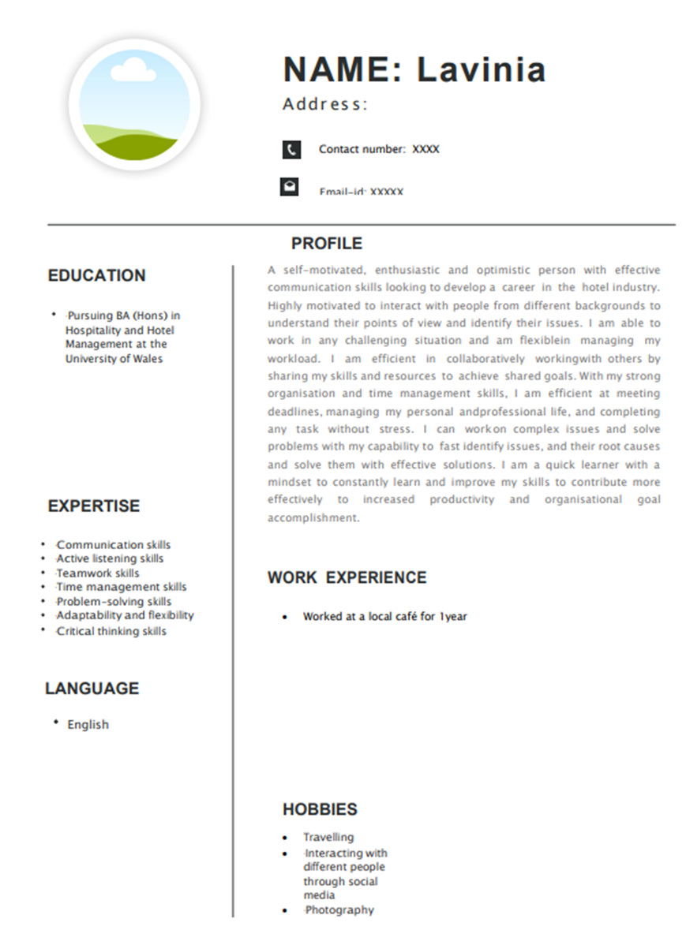

Linkedin Screenshot

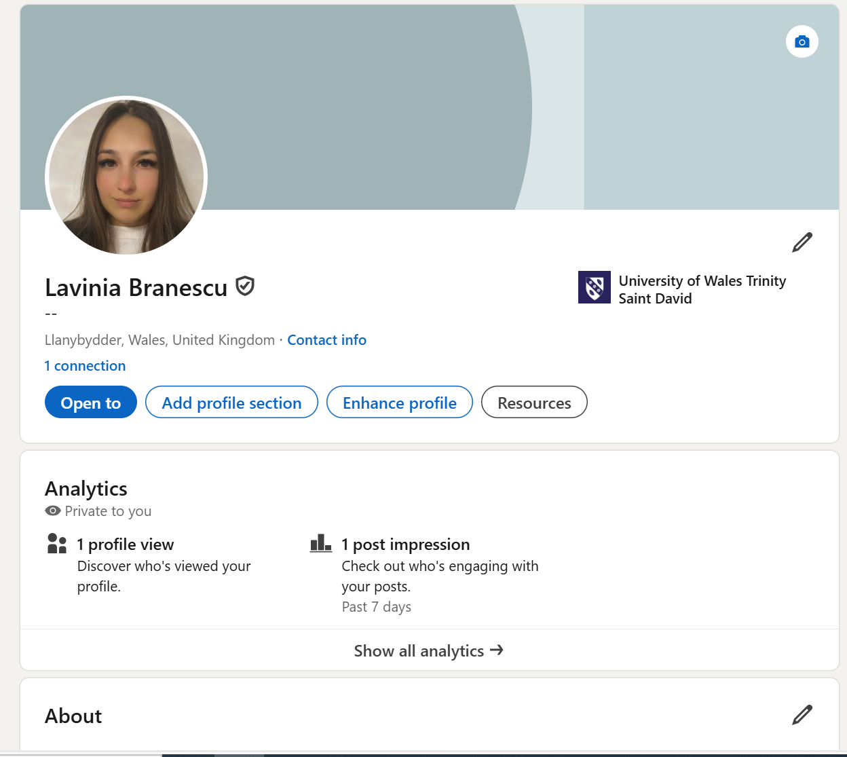

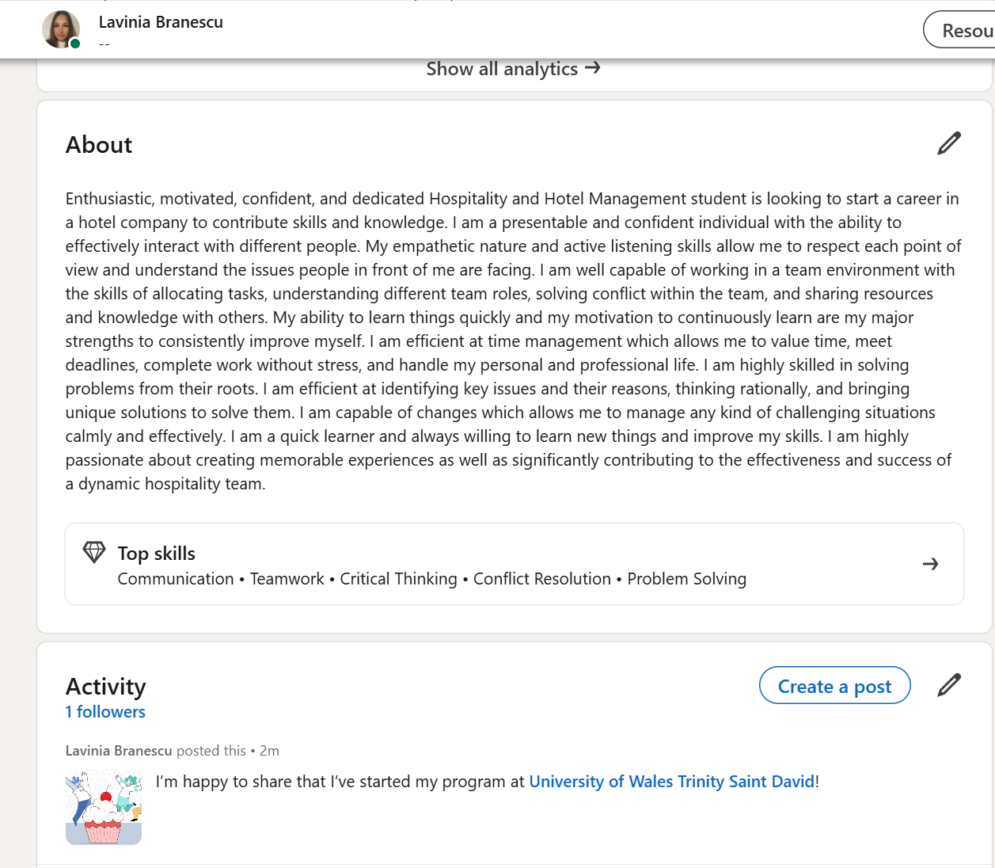

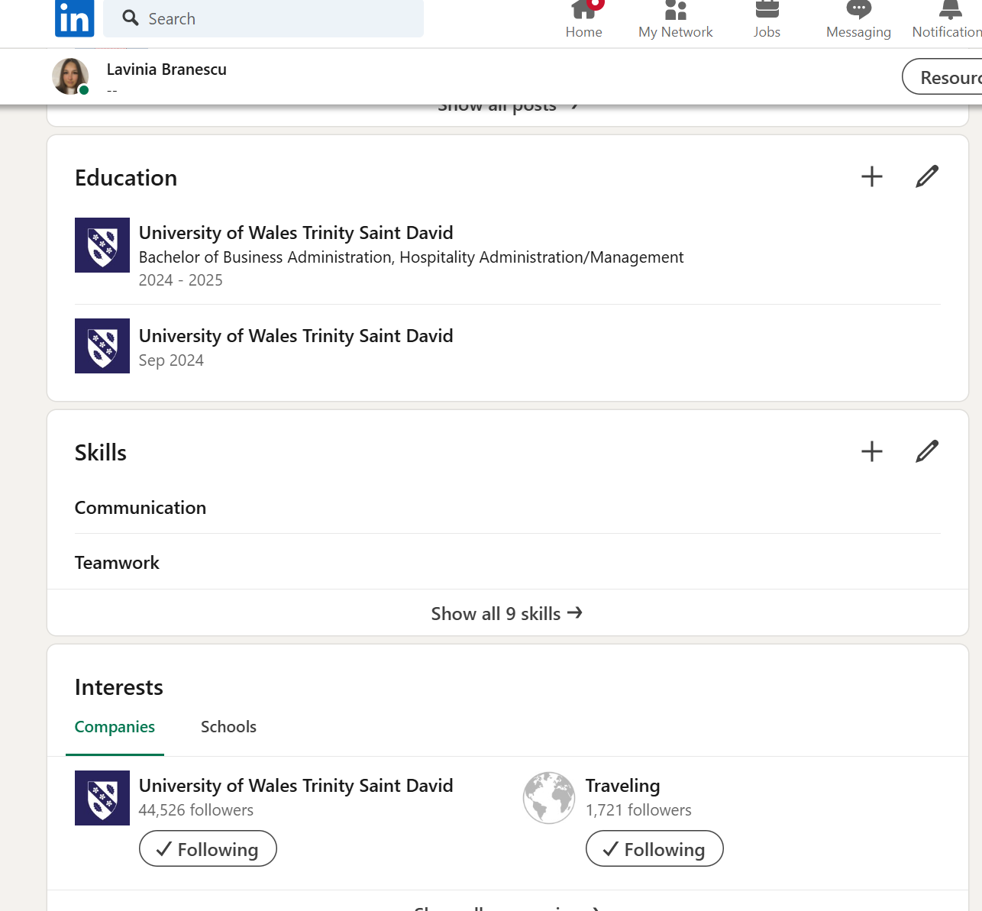

Component Four: Using the information prepared for your CV, present a 5 minute presentation on the key attributes that a person working within the hospitality industry should possess.

This Presentation will be completed in person on site.

Place your presentation time below.

Timeslot: 11:53

