Introduction
Meaning of the term ethics according to Dictionary, (2019) is a principle of morals and the behaviour of what is right or what is wrong actions taken from individuals on an activity. The meaning of sustainability focuses on maintain a certain level or position in the future and can improve the lives of humans will maintaining the change in a balanced environment. Quality means the standard or condition of something against a similar item or object (Dictionary, 2019).
What is business ethics, business ethics is appropriate practices and policies stating moral rules that show how business operate, how business make decisions and how people are treated in the organisations. In every organisation there are many different stakeholders that an organisation needs to answer to regarding the operation of the business, for example customers, shareholders and clients (your Dictionary, 2019).
Ethics, Sustainable marketing
What is sustainable marketing, it is a socially and environmentally responsible marketing which meets the needs of consumers present without compromising the ability of the future generations to meet their own needs. There are three principles which are waste reduction and social engagement, bartering versus purchasing and longevity. Waste reduction and social engagement come in different forms depending in the business being marketed for example from packaging to using no wrapping or using alternatives like using biodegradable for packaging. Bartering versus purchasing is were implementing the principle of bartering in place of buying of social networking and gathering like-minded person open to cross-promotion and information sharing. Longevity is planning marketing efforts which protect the brand from long-term fluctuations in advertising prices which will target long-term returns and long- term social engagement. sustainable marketing helps maintain a better relationship with customers and greater efficiency in pricing goods and the service an organisation provides (Enotes, 2019).
Acting ethically include factors like production, business processes and the organisations behaviour with its customers and communities around it operates. It is also the right steps it takes in everything the organisation does (Business Case Studies,2019). Organisation’s need to understand the importance of marketing ethics in the long-term goal and to achieve long-term gains attached to it such as, customer loyalty, high credibility in the market and in customers minds this will increase market share, higher sales as will as enhance brand value (Marketing 91, 2018).
For example, the business ethics and sustainability in the steel industry a company called Tata Steel they defined the ethics of the company which has five core values integrity, understanding, excellence, unity and responsibility. There values are in everything they do and drive the ethical behaviour of the organisation. Tata steel take responsibility for tackling the issues of sustainability comes naturally from this ethical stance. Tata steel sustainability is to meeting issues that arise now to ensure that future generations can enjoy the same lifestyle people do today this involves looking at it from a long-term perspective on weighing out economic, environmental and social impacts of business. The commitment to ethical behaviour of the organisation is showed in the corporate responsibility policy of an organisation. Organisation are not there to offer goods and services but also to deliver how there doing it and how they impact on society and the environment (Tata steel, 2019).
The ethics and sustainability of tech giant Apple organisation in the electronics industry. Apples ethics are required to provide safe working conditions, treat staff with dignity and respect, act fairly and ethically and use environmentally responsible practices wherever they produce products or perform services for the apple company according to apple supplier code of conduct (Apple, 2019). apples effort in sustainability they have made great efforts in the past few years, towards sustainable growth by advancing renewable energy usage by working with suppliers to create four gigawatts of renewable energy around by 2020 that will assist in powering their facilities (Poplar Network, 2017).
In the retail industry Primark ethics are people and production, setting high standards, partners, newsroom, fair wages they have an ethical trade and environmental sustainability team, they are also members of the ethical trading initiative and have adopted their code of conduct. Primark sustainability they have a lot of good ideas in place which aim to not impact the environment. For example, Primark have been using paper bags instead of plastic bags since 2002 and have introduced initiatives to reduce waste and packaging. Also, in the US stores they donate unsold items to those in need (Good on You, 2018).
Starbucks is also recognized as an ethical company who demonstrate achievements in transparency, integrity, business ethics and compliance, drive to influence positive change in the community and in societies around the world. Starbucks reputation, leadership, and innovation, ethics and compliance program, governance, corporate citizenship and responsibility and culture of ethics (Stories and News, 2018). Starbucks progress in several areas has showed a growth business and commitment to ethical coffee sourcing, environmental responsibility, community involvement and workplace practices like, supporting coffee farmers, fair trade (Starbucks, 2019). As well as organisations being ethical and sustainable they need to have a strategic planning alongside the business as well.
Companywide strategic planning
This is the process of organisation’s developing and maintaining a strategic fit between the business goals and capabilities and the alternative marketing opportunities, every organisation has their own marketing plan.
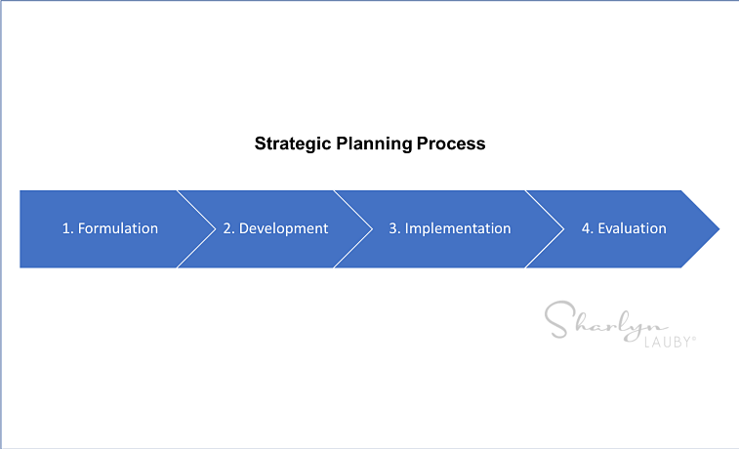
This Photo by Unknown Author is licensed under CC BY-NC-ND
There are four steps in strategic planning, first step is defining marketing’s role; every organisation has a plan for long-term survival and growth in the market. Which all include specific situation, opportunities, objectives and resources focused on strategic planning. This helps organisations to adapting the organisations to take advantages of opportunities in the constantly changing environment. In the corporate level they have different departments focusing on mission overall purpose of business, objective of the organisation. Another section decides on business portfolio, regarding products usefulness and how to support it needs. Marketing managers take the necessary decisions.
The next step is defining a marketing-oriented mission; this states the mission of the organisation and purpose what the business wants, and as an organisation achieve in a larger scale. The mission statement must be market-oriented that satisfy the basic needs of target customers and making a relationship with customer. In return the organisation will be rewarded with profits for creating value for customers (Talk for Biz, 2018).
Setting company objectives and goals the manager of organisation decide on business objectives and goals and will be responsible in achieving it. For example, Apple’s action plan is to offer premium products at premium prices as well as maintaining the large market share and make high profit margins. Apples objects are to continue to create ground-breaking products and always introducing something new and exciting to its customers (Brandon Burnette, 2015).
Designing the business portfolio means the total products or services the organisation that make up the business and analysing the current portfolio. For example, Apple are always looking to improve their existing products and service they provide to keep their customers satisfied and eager when they bring innovative products out (Talk for Biz, 2018).
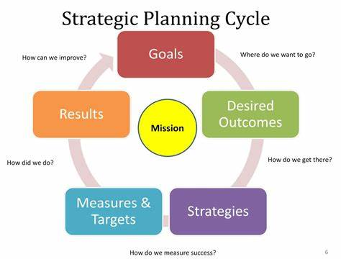
Company-wide strategic planning cycle includes the organisations mission statement which is the organisations purpose, or in other words what it wants to achieve in the business environment as shown in the diagram above the mission statement is in the overall organisation is founded on. Than setting organisation goals, where do we want to go, desired outcome how do we get there, strategies and measures, targets how do we measure success, results how did we do, back to goals how can we improve as an organisation by applying strategic planning the organisation can accomplish the outcomes/results and access the direction in response in the changing environment (Balanced scorecard Institute,2019).
This is an example of Samsung’s organisation mission statement according to Pan more Institute, (2019) mission statement is ‘’we will devote our human resources and technology to create superior products and services, thereby contributing to a better global society’’. Samsung’s vision is to ‘’inspire the world with our innovative technologies, products and design that enrich people’s lives and contribute to social prosperity by creating a new future’ ’Samsung corporate mission and vision states focus on innovation for global societal improvement through technological products and their vision statement is there to make profitable business as well as making customers think their making a difference (Pan More, 2019).
Starbucks mission statement is ‘’our mission to inspire and nurture the human spirit, one person, one cup and one neighbourhood at a time.’’ Their mission statement reflects how the company does to keep its business running (Pan More, 2019).
The quality of customer service is the key differentiator on how organisations delivery good quality customer service, keeps
customers coming back and bad service drives them away (Management for the Rest of Us,2019).
What is meant by ‘Quality?’
Quality is a product or service’s ability to meet the customers’ need or want. Quality is difficult to define, and varies with each consumer, however we can look at some of the components of quality for products and services in the diagram.

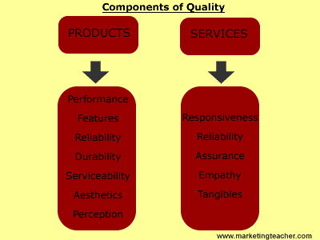
(The Drum, 2018).
When customers look for quality to include all the futures in the components of quality and after service with it. Quality is providing customer with innovative products or services with out defects free and provide fitness for use. Products and services that meet and exceed customer expectations which leaves the customer satisfied and happy to exchange money for the product or service (UCC,2019).
Quality customer service gives organisations an edge over competitors. Attracting new customers cost organisations more than retaining old customers. Organisations need to understand the customers needs and need to meet them by listening and getting customer feedback organisations can improve on customer service that benefits the customer as much as the organisation. Product design and quality of the product is important to maintain customer relationship in the future than sell bad quality product a reason for contact organisation on the first instance a satisfied customer will return to the organisation (Management for the Rest of Us,2019).
For example, Aldi is one of UK top supermarket for customer satisfaction in latest research according to, the drum, (2018) the budget supermarket was recognised by customers for value for money which saw more cost-conscious consumers shopping with them. This put Aldi in top spot with customer satisfaction rating 74 percent marginally ahead of Marks and Spencer and Waitrose. With food cost rising shoppers feeling the pinch and looking for value for money in superstores.
According to DXC Customer experience, (2016) customer experience is an important indictor showing performance and driving revenue to organisation a key competitive differentiator for business success. More than 75 percent of organisations recognize customer experience as a most important strategic performance measure by transforming the ways organisations engage with the customers by giving innovative advisory, technology and digital workforce capabilities and assessing CRM systems in place.
CRM stands for customer relationship management an approach to manage organisations interactions with potential and existing customers. Its analysis data about customers history with the organisation to improve relationships and focusing with customers as well as driving sales for the organisation (Sales Force, 2019).
Improving relationships with internal (employees and suppliers) customers and suppliers assist in providing greater customer service to external customers in increased quality and better communication and motivating as well as retaining employees (Management for the Rest of US,2019). There are theory’s and problem-solving tools to aid organisations to better serve customers and employees.
Problem solving tool fishbone framework (Ishikawa Theory, 1969)
To identifying a likely cause of a problem to service quality in the organisation managers can use the problem-solving analysing tool to find a root cause of a problem. The fishbone is also called the Ishikawa diagram is a tool to recognise potential causes of a problem in order to identify its root causes brainstorming. There are four steps in applying the process identify the problem, work out the major factors involved, identify the causes and analyse the diagram (tech target, 2019). This is example of fishbone diagram in non-manufacturing industry:

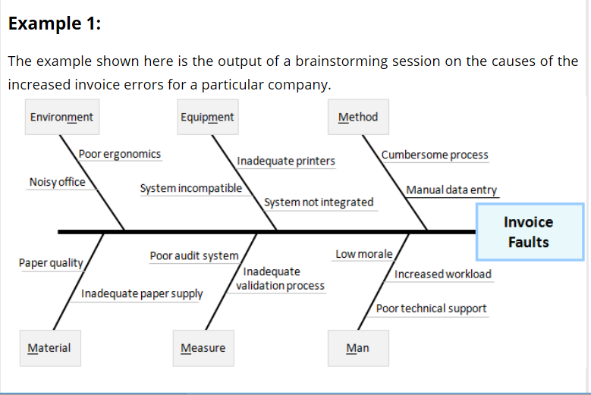

Potential causes in a fishbone diagram are normally grouped into types of causes for easier sharing and reference. These types categories typically include: man, machines, materials, methods, measurements and environment. These are often called the 6 Ms and are used to label the different branches on the diagram:
Man – anyone involved with the process and contributes to the effect.
Methods – how the process is performed and the specific requirements for doing it, such as: the policies, procedures, rules and common practices.
Machines – including the equipment and tools required to do the process.
Materials – including the raw materials, parts, papers, packing and consumables needed to produce the product or provide the service.
Measurements – including the data that are used to evaluate the performance of the process.
Environment (or Mother Nature) – the conditions in which the process operates, such as: the location, time, temperature, and culture
The cause and effect matrix are a tool to find the root cause of problem in the organisation selecting the key causes will help minimize the need to find more statistical evaluation of all the cause that have an unlikely impact on the main cause of outputs problems in the organisation (CI Toolkit,2018). This is a theory that organisations can implement to improve quality in the workplace.
Management by walking around (MBWA)
The Management by walking around (MBWA) is a concept or theory used in organisations to prove quality in the workplace. The theory is getting the management moving about also monitoring the subordinates in their work environment and achieving a more meaningful relationship with them in order to boost the organisations successes. This management theory from 1940s, by management consultants Tom Peters and Robert H. Waterman. The three key objectives are the management must focus in order to implement an MBWA strategy:
- Manager must take time to walk around the organisation.
- The manager must strike up conversations.
- Creating network within the organisation.
By CEO or managers creating an atmosphere of trust and equality and make employees comfortable to approach managers. The MBWA lets managers send a strong sign to employees that there valued in the organisation and first-hand on what is happening in the organisation, breaking the complex hierarchical structure that is seen in most organisations (Work Spirited, 2019). There are different sectors this management theory is used which have been successful for example the banking sectors had a positive impact and good feedback on the service quality, and the other aspects which improved were communication, motivating and creativity on service quality in the banking sector. The MBWA strategy has suggested managers should pay vital and important role in the managing banks and motivating employees have a better relationship and encouraging them to provide the best services to customers. The MBWA theory as supported the development of the banking sectors across the Arab countries (Research Gate, 2018).
According to the Harvard Business School (2013) using the MBWA strategy in the health sectors across hospitals has found that there have been quality improvements programs in the frontline workers suggested by the theory it has benefited in the organisations outcome. The MBWA as resulted in positive organisations change, which lead to successful problem resolutions when seen a problem in context makes the managers aware if the problem and its causes. By working with employees in frontline employees and managers can improve future customer’s experiences. This also enhanced the performance of the organisation by managers presence on the frontline a stronger visible signal that the organisation is serious about solving problems.
How- ever using management theories have their pros and cons does mean one theory might work in one sector doesn’t mean it will work in every organisation. According to Couse hero, (2019) in some environment the MBWA practise has negative outcomes and impact on employees. In many cases employees perceived a presence of managers quite stressful and managers are accused of spaying on employee’s and questioned the lack of trust between managers and employees.
THE CONCEPT OF CORPORATE SOCIAL RESPONSIBILITY
Organisations and their directors find themselves in an uncertain environment. This happens of the ever-changing conditions that occur on the global economic market. Due to the changes and improvements of the new information and communication technologies, the businesses and their directors find it harder to reach and convince their clients or consumers. It is required that these managers use all the potential promoting techniques in order to attract the consumers. It is no longer just about the usage of standard advertising techniques, the marketing specialists must consider several other approaches of advertising like online social networks, viral marketing, corporate social responsibility etc. The importance of the Corporate Social Responsibility from the marketing point of view and especially of using this tool as a brand notoriety increasing factor. We live a world of continuous change, were mankind’s influence on the environment is larger and larger. But Corporate Social Responsibility (CSR) is not just about the environment like many people think. The organizations of the entire world become more and more preoccupied by the necessity and the benefits of a responsible approach to society (The university of Edinburgh, 2017).
The performance of each organization, no matter its type (private, public, economical or NGO), is linked to the degree of development of their communities and in their social environment. Also, the impact of such organizations on the environment has become a vital aspect which reflects the human interest for preserving the natural ecosystems and the pollution. This first aspect is joined by other elements of interests like, social equality and good governance.
In 2001, the European Commission has defined CSR as: a concept whereby companies integrate social and environmental concerns in their business operations and in their interaction with their stakeholders on a voluntary basis (EU Commission, 2001)
Over the years, the concept of Corporate Social Responsibility has become more present in the everyday life of corporations and even public administration institutions. There were numerous efforts to define this concept, but often no clear definition is given, making theoretical development and measurement difficult.
The commitment of business to contribute to sustainable development, commonly understood as sustainable development is the ability of the current generation to meet its needs without compromising the ability of future generations to meet their objectives. (ECRC, 2013).
In 20017, EU Commission definition, the European Commission has defined the concept of Corporate Social Responsibility as the responsibility of enterprises for their impacts on society (EU Commission, 2018). The same paper underline that enterprises should have in place a process to integrate social, environmental, ethical, human rights and consumer concerns into their business operations and core strategy in close collaboration with their stakeholders, with the aim of Maximizing the creation of shared value for their owners/shareholders and for their other stakeholders and society at large; Identifying, preventing possible adverse impacts. In order to create a proper Corporate Social Responsibility Strategy, and to use this important tool in the marketing aspect of the organization, companies must adhere to several important principles that we consider to be of great importance of the companies (Sage Journals, 2018).

Conclusion
Acting ethically, sustainability includes factors like production, business processes and the organisations behaviour with its customers and communities around it operates. It is also the right steps it takes in everything the organisation does (business case studies,2019). Organisation’s need to understand the importance of marketing ethics in the long-term goal and to achieve long-term gains attached to it such as, customer loyalty, high credibility in the market and in customers minds this will increase market share, higher sales as well as enhance brand value (Marketing 91, 2018). Sustainable marketing, it is a socially and environmentally responsible marketing which meets the needs of consumers present without compromising the ability of the future generations to meet their own needs (Enotes, 2019).
This is evident in every organisations code of conduct and the strategic planning their overall goals and business objectives of the organisation their mission, vision statement having strategies in place (Balanced Scorecard Institute, 2019). By recommending using problem solving tools like the fishbone or using the Management by walking around (MBWA) theory to improve quality in the workplace (Work Spirited,2019, Research Gate,2018) The performance of each organization, no matter its type (private, public, economical or NGO), is linked to the degree of development of their communities and in their social environment. Also, the impact of such organizations on the environment has become a vital aspect which reflects the human interest for preserving the natural ecosystems and the pollution. This first aspect is joined by other elements of interests like, social equality and good governance.
In 2001, the European Commission has defined CSR as: a concept whereby companies integrate social and environmental concerns in their business operations and in their interaction with their stakeholders on a voluntary basis (EU Commission, 2001)
.

Apple, (2019), ‘For the Supplier Code of Conduct-Apple’ [online]. Available: https://www.apple.com [accessed on 20/06/2019].
Balanced Scorecard institute, (2019), ‘The Basics of Strategic Planning, Strategic Management and Strategy’ [online]. Available: https://www.balancedscorecard.org [accessed on 23/06/2019].
Brandon Burnette, (2015), ‘Apple Inc Objectives and Strategies’ [online]. Available: https://burnetteb-wordpress-com.cdn.ampproject.org [accessed on 24/04/2019].
Business balls, (2019), ‘CRM (customer Relationship Management)’ [online]. Available: https://www.businessballs.com [accessed on 30/06/2019].
Business Case Studies, (2019), ‘business ethics and Sustainability in the steel industry’ [online]. Available: https://www.businesscasestudies.co.uk [accessed 20/06/2019].
CI Toolkit, (2018), ‘Fishbone Diagram Example’ [online]. Available: https://www.citoolkit.com [accessed on 01/07/2019].
Course Hero, (2019), ‘The Pros and Cons of MBWA many Companies find success when’ [online]. Available: https://www.coursehero.com [accessed on 01/07/2019].
Dictionary, (2019), ‘meaning of Ethics and Suitability’ [online]. Available: https://www.definitions.net [accessed on 19/06/2019].
DXC Customer Experience, (2016), ‘DXC Customer Experience’ [online]. Available: https://www.dxc.technology [accessed on 30/06/2019].
ECRC, (2012), ‘In order to reach sustainable development we need effective policy-ECRC’ [online]. Available: https://ecrc.mn [accessed on 01/07/2019.
Enotes, (2019), ‘Sustainable Marketing’ [online]. Available: https://www.enotes.com [accessed on 19/06/2019].
European Commission, (2001), ‘Corporate social Responsibility & responsible Business Conduct’ [online]. Available: https://ec.europa.eu [accessed 20/06/2019].
European Commission, (2018), ‘The European commission’s strategy on CSR 2011-2014: achievements, shortcomings and future challenges’ [online].
Good on you, (2018), ‘How Ethical is Primark?’ [online]. Available: https://www.goodonyou.eco [accessed on 20/06/2019].
Harvard Business School, (2013), ‘the Effectiveness of Management-By-Walking-around’ [online]. Available: https://wwwhbs.edu [accessed on 28/06/2019].
https://www.dxc.technology [accessed on 27/06/2019].
Management for the Rest of Us, (2019),’ 9 Principles of Quality Customer Service’ [online]. Available: https://mftrou.com/quality/customer/service [accessed on 30/06/2019].
Marketing 91, (2018), ‘Importance of Marketing Ethics’ [online]. Available: https://www.marketing91.com [accessed on 23/06/2019].
Oxford Academic, (2019), ‘impact of corporate social responsibility on the competitiveness’ [online]. Available: https: https://journals.Sagepub.com [accessed on 02/07/2019].
Pan More Institute, (2019), ‘Samsung’s Mission Statement & Vision Statement’ [online]. Available: https://www.panmore.com [accessed on 30/06/2019].
Pan more, (2019), ‘Starbucks Coffee’s Mission Statement and Vision Statement’ [online]. Available: https://www.panmore.com [accessed on 23/06/2019].
Poplar network, (2017), ‘Is Apple a Sustainable Company?’ [online]. Available: https://www.poplarnetwork.com [accessed on 19/06/2019].
Research Gate, (2018), ‘A new model of Ishikawa diagram for quality assessment’ [online]. Available: https://www.researchgate.net [accessed on 01/07/2019].
Sales Force, (2019), ‘What is CRM System: A Beginner’s Guide-salesforce UK’ [online]. Available: https://www.salesforce.com [accessed on 01/07/2019].
Starbucks, (2019),’Mission statement/Starbucks coffee company’ [online]. Available: https://www.starbucks.co.uk [accessed on 30/06/2019].
Stories and News, (2018), ‘Starbucks named one of the world’s most ethical companies’ [online]. Available: https://www.stories.starbucks.com [accessed on 01/07/2019].
Talk for Biz, (2018), ‘four steps of company wide strategic planning with full explanation’ [online]. Available: https://www.talkforbiz.com [accessed on 23/06/2019].
Tata, (2019), ‘Tata Steel Group/business’ [online]. Available: https://www.tata.com [accessed on 21/06/2019].
Tech Target, (2019), ‘Definition fishbone Diagram’ [online]. Available: https://www.techtarget.com [accessed on 27/06/2016].
The Drum, (2018), ‘Aldi named UK’s top supermarket for customer satisfaction’ [online]. Available: https://www.thedrum..com [accessed on 01/07/2019
The University of Edinburgh, (2017), ‘what is corporate social responsibility’ [online]. Available: https://www.ed.ac.uk [accessed 01/07/2019].
The University of Edinburgh, (2017), ‘What is Corporate Social Responsibility’[online]. Available: https://www.ed.ac.uk [accessed on 19/06/2019].
UCC, (2019), ‘Chapter 8: Product/Service and Quality’ [online]. Available: https://jan.ucc.nau.edu [accessed on 25/06/2019].
UCC, (2019), ‘Product/Services and Quality’ [online]. Available: http://jan.ucc.nau.edu [accessed on 30/06/2019].
Work Spirited, (2019), This is How You can Make ‘Management by Walking Around’ Really Work’ [online]. Available: https://workspirited.com [accessed on 02/06/2019].
Your Dictionary, (2019), ‘Business Ethics’ [online]. Available: https://www.yourdictionary.com [accessed on 20/06/2019].

