

Student name: Cristina Apostol
Student ID: 2335890

Module name: Changemakers: Building your Personal Brand for Sustainable Employment
Module code: BMHP5015
Lecturer name: Caroline Salami
Component 2 Assignment

Table of contents

1. Introduction 3
2. Job description of the selected job 3
2.1 Job description 3
2.2 Key responsibilities 4
2.3 Person Specification 4
3. Skill analysis and self assessment 5
3.1 Analysis of required skills (SKA Framework) 5
3.2 Self assessment and tools for reflection 5
3.3 Current qualifications and experience 6
3.4 Areas for improvement 6
4. Development of personal skills and resources 7
4.1 Building a professional identity and brand 7
4.2 Unique Selling Point (USP) and practical value 7
4.3 Future research requirement and skill acquisition 7
5. Action Plan and Timeline 8
6. Communication of skills to potential employers 9
6.1 Professional CV and personal statement 9
6.2 LinkedIn and digital presence 9
7. Conclusion 10
References 11

1. Introduction
The contemporary landscape of UK health and social care, the concept of personal branding has transitioned from the corporate marketing tool to a fundamental requirement for sustainable employment (Kucharska, 2022). For healthcare professionals, Personal brand is considered as a synthesis of skills, core values as well as professional identity which collectively promote trust and credibility with service users as well as multi-disciplinary teams (Welagedara, 2024). The report focuses on understanding this strategic development of a personal brand for the role of Mental Health Support Worker. Building a professional identity in this field is involved with supporting individuals with complex needs (Hu et al., 2022). The report will provide a detailed analysis of the selected job vacancy by outlining key responsibilities and person’s specification. Next, a critical assessment using SKA (Skills, Knowledge and Attitude) and SWOT Analysis will be conducted for evaluating the current competencies against the requirement of the job role. Later, the report will discuss development of personal skills and resources and construct an action plan with a timeline. The report will discuss the communication skills of potential employers and conclude with providing a clear road map for achieing long term career sustainability and excellence in practice.

2. Job description of the selected job

2.1 Job description
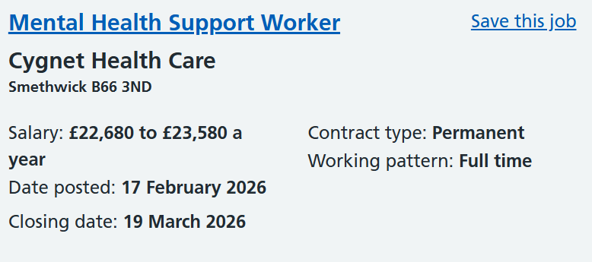
Figure 1: Mental Health Support Worker Vacancy
(Source: NHS, 2026)
The role chosen for this analysis is a Mental Health Support Worker and the organisation “Cygnet Health Care” is hiring for this role (NHS, 2026). The organisation is located in the UK and this position is situated within a high support inpatient rehabilitation service specifically designed for women (NHS, 2026). The role is a critical component of mental health provision in the UK (NHS, 2026). The primary objective of this job role is to facilitate mental health recovery by maintaining an environment that provides priority to personal privacy, independence as well as dignity (NHS, 2026).
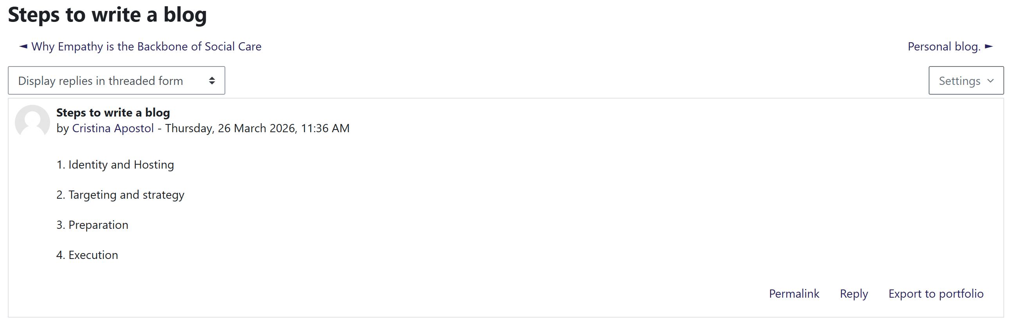

2.2 Key responsibilities
According to this published vacancy, day to day responsibilities are multifaceted and needs balance of clinical observation and emotional support. The key duties includes:
- Enhancement of care delivery by providing physical and emotional support through a flexible learning approach to the recovery journey of individuals (NHS, 2026).
- Assisting the medical and welfare needs of service users through reporting and documentation. This will ensure accurate reporting to the multi-disciplinary team.
- Maintaining a safe, clean and stimulating environment which follows all the safeguarding protocols through effective environment management (NHS, 2026).
- Empowerment by encouraging daily living skills and supporting services users to build independence as they move towards community reintegration (NHS, 2026).
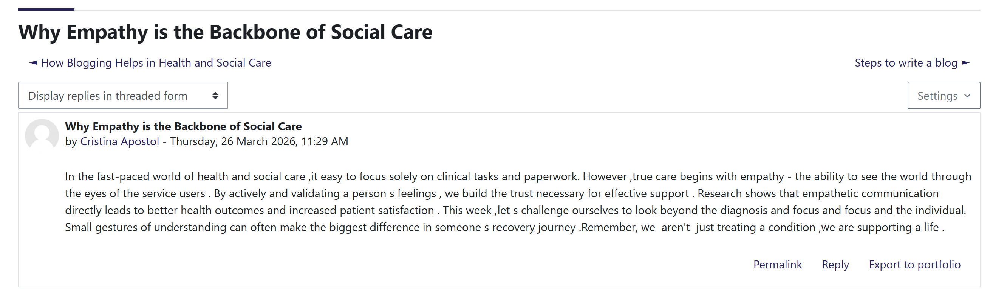

2.3 Person Specification
The person specifications significantly outlines knowledge, skills and attributes which demand to perform effectively in a high pressure environment (NHS, 2026). The vacancy explicitly demands experience with the minimum of 6 months with a mental health setting is essential. The candidate must be an excellent communicator and good team player and capable of working 12 hour shifts with a 42 hours weekly contract (NHS, 2026). The role highly demands someone who is sensitive and intuitive and the processing of energy to provide a trusting and supportive environment to the service users. The candidate must have a genuine passion for making a difference and drive to empower service users are not negotiable requirements for the organisation (NHS, 2026). By analysing this specific vacancy, it is evidence that the role significantly requires a high degree of personal responsibility as well as professional identity. They should be capable enough to manage complex social care situations with sensitivity and integrity (NHS, 2026).

3. Skill analysis and self-assessment
To successfully transition the role of a mental health support worker at Cygnet Raglan House, a comprehensive analysis of the required competencies are essential. The job description demands a blend of both technical efficiency and high level of emotional intelligence (NHS, 2026).

3.1 Analysis of required skills (SKA Framework)
Skills (S) | The role demands practical skills in clinical observation, reporting on medical welfare and safeguarding (Duffy et al., 2025). Additionally, communication skills act as a paramount and the practitioner should maintain a positive connection with the multi-disciplinary team.
Knowledge (K) | The understanding of mental health recovery model, dignity based care and the specific needs of women rehabilitation is mandatory (Anders, 2025).
Attitude (A) | The person specifications significantly emphasize being sensitive, intuitive as well as passionate. This significantly reflects the values required to support service users who have experience of multiple placement breakdowns ( Rajulapati and Berzins, 2026).
Table 1: SKA Framework
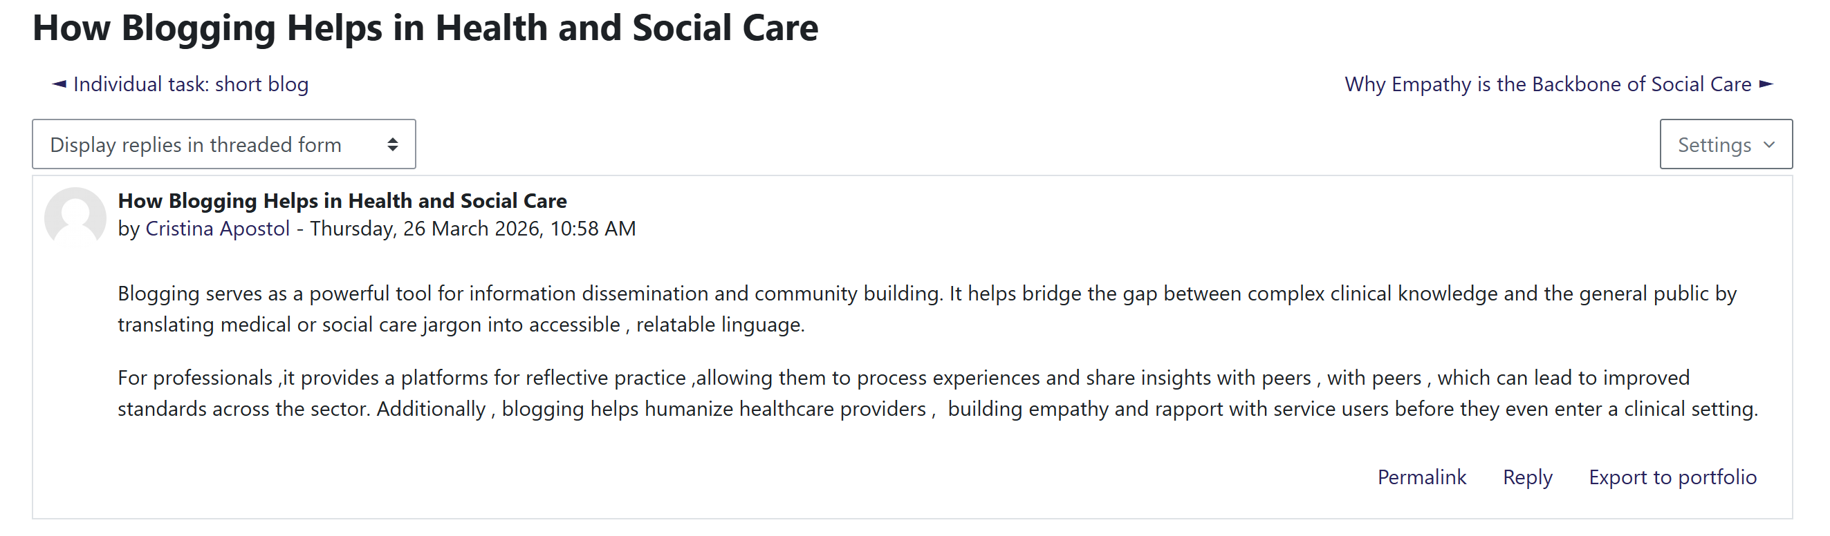
(Source: Self-Generated)

3.2 Self-assessment and tools for reflection
For evaluating my skills, I utilised the SWOT Analysis tool. This effectively provided a structured method of enquiry into my current capabilities.
Strengths | Weaknesses
- Strong academic foundation.  - Excellent communication and team player attitude. | - Lack of 6 months direct experience in a mental health setting.  - Limited exposure to high support inpatient reporting.
Opportunities | Threats
- Apprenticeship and coaching schemes of Cygnet.  - Specialised training about women's mental health. | - High pressure 12 hour shifts affecting work life balance.  - Rapidly changing legislative frameworks in UK healthcare.
Table 2: SWOT Analysis
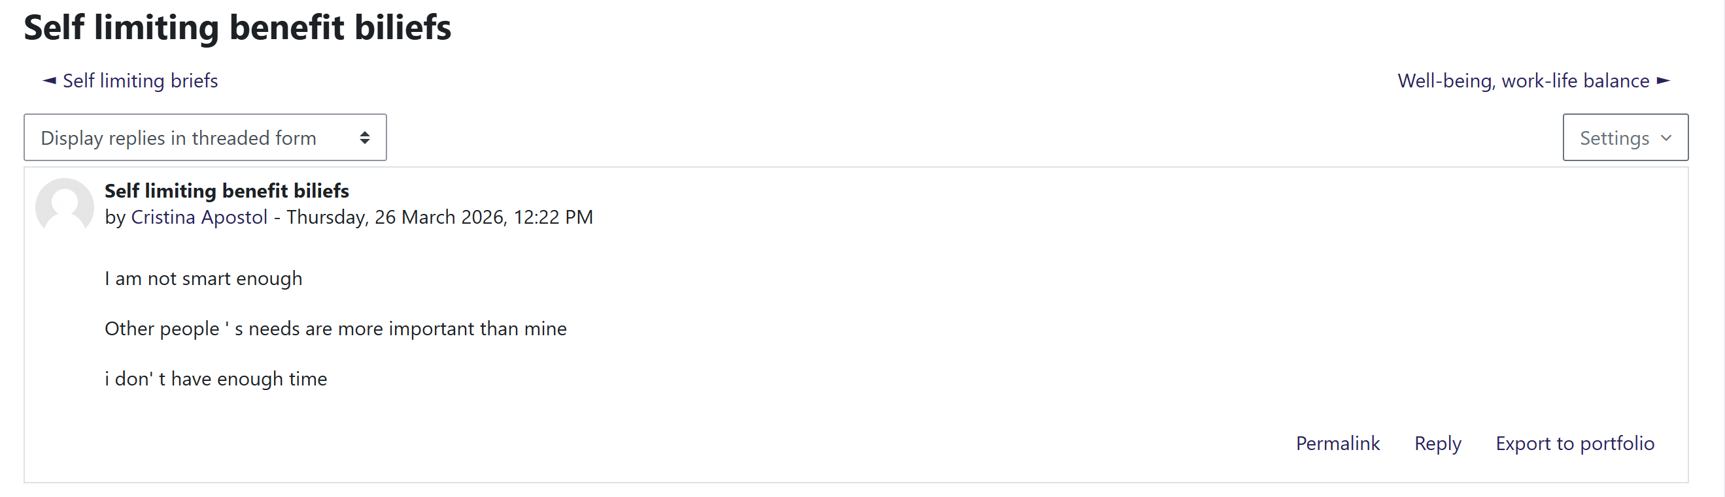
(Source: Self-Generated)

3.3 Current qualifications and experience
My primary qualification is an ongoing diploma in Health and Social care. This significantly provides me with the knowledge of person centred care, safeguarding legislation and ethical practices. My academic training has equipped me with developing my cognitive skills to handle complex information and make sound judgements and decisions. Regarding this experience, I have participated in a 100 hour placement at my local community centre. During this time, I have demonstrated my capability regarding personal responsibility.
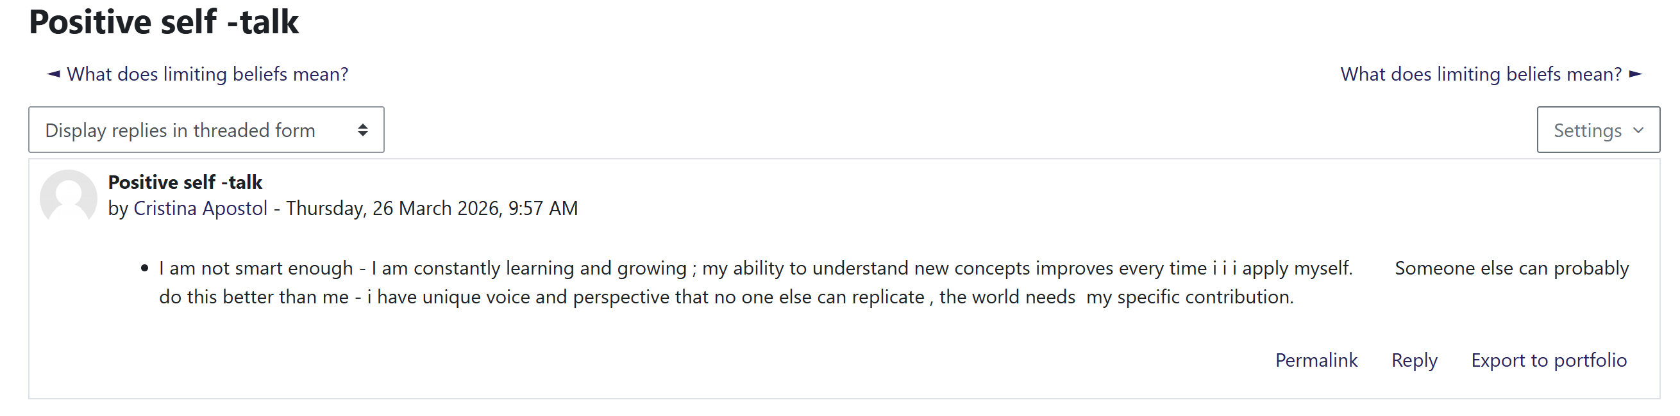

3.4 Areas for improvement
The critical evaluation of my profile significantly reveals the gap in specialised clinical experience. For further improvement, I should focus on gaining practical exposure in a patient rehabilitation setting. Engaging with the professional networks and seeking expert supervision as offered by the alternation will be essential. By proactively addressing these gaps, I am not only preparing for the specific role but also promote occupation and identity that is committed to lifelong learning as well as evidence-based practice.

4. Development of personal skills and resources

Development of a personal brand within the mental health sector demands a strategic alignment between individual values as well as professional standards of the healthcare industry (Huovinen, I., 2025). To build a sustainable brand for the role of Mental Health support worker at Cygnet Raglan House, I must move all the traditional qualifications and focus on value based recruitment principles.
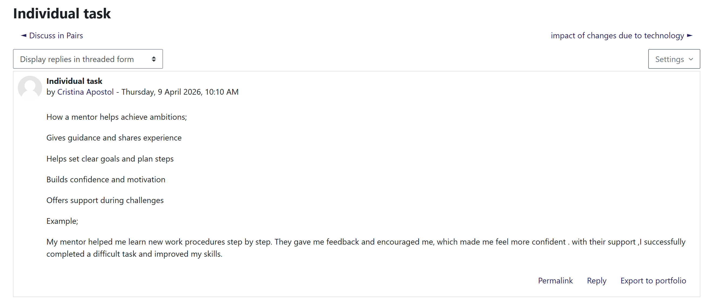

4.1 Building a professional identity and brand
Building my personal brand involves a proactive process of showcasing my commitment of providing high quality person centred care. I can utilise resources like skills for care framework and care certificate centres for ensuring my brand is grounded with the National guidelines of the UK. By engaging with these resources I can present myself not just as a graduate but as a reflective practitioner who stays updated with pioneer services as well as recovery focused outcomes.
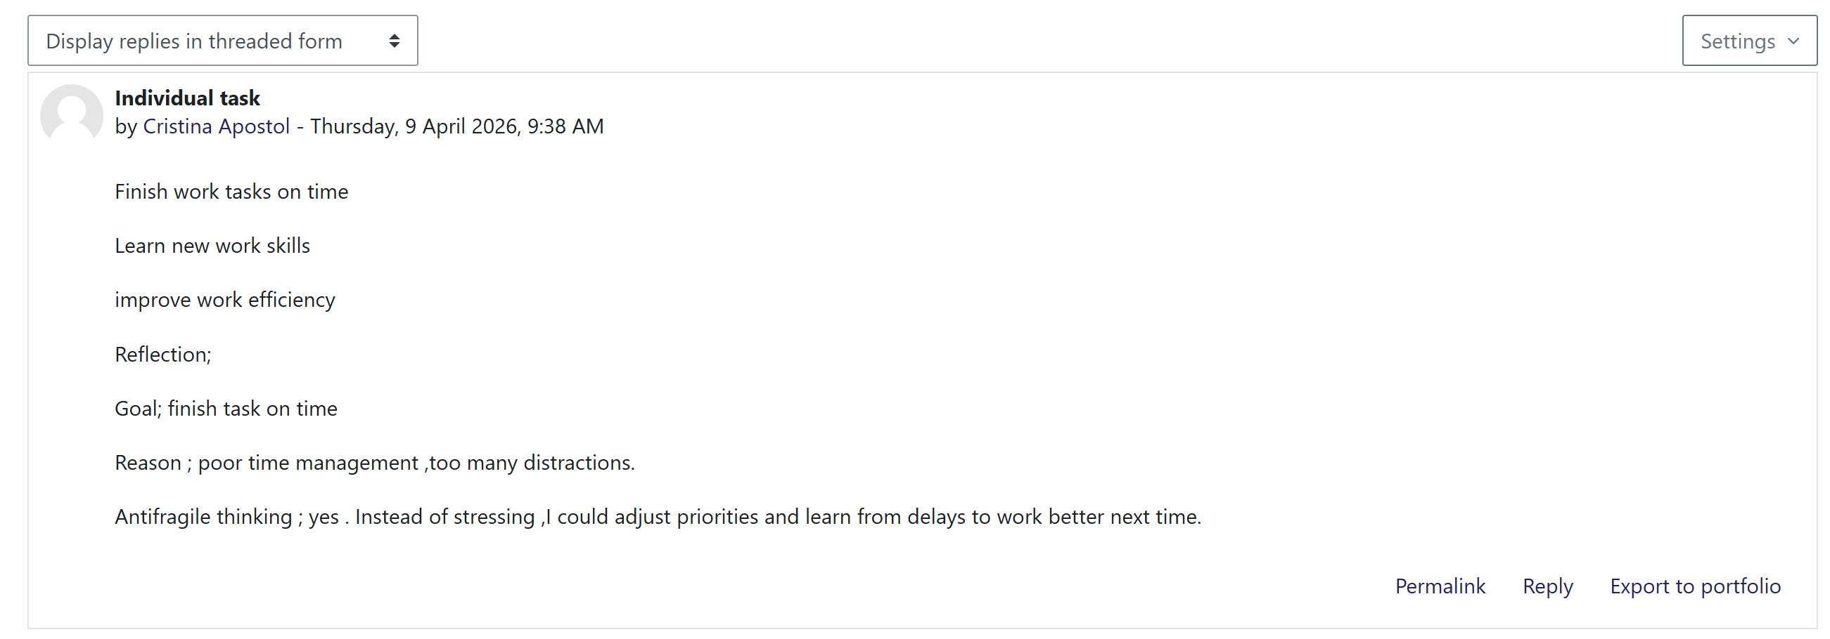

4.2 Unique Selling Point (USP) and practical value
In the context of the vacancy, the Unique Selling Point (USP) is supporting a shift combination of my academic skills and resilience based compassion. Many candidates may have experience, however my USP lies in my ability to translate the conflict psychological series like rehabilitation and recovery into practical application. In practice I added value by facilitating an environment, cultural comfortable and multi-disciplinary contribution. Using my understanding of independence building, contributing to help women at the organisation to move forward their recovery journey. My ability to communicate across diverse backgrounds significantly ensures that personal privacy and dignity are respected even in a high support healthcare environment. My knowledge about critical analysis provides me the benefit of providing high quality medical and welfare reports that assist doctors and nurses in making sound clinical judgments.

4.3 Future research requirement and skill acquisition
- Specialised training
By attending training regarding Complex Resolution and PMVA (Prevention and Management of Violence and Aggression) and Trauma informed care would be beneficial (Wilson et al., 2022). These are essential for working with women who may have experienced placement breakdowns or taking down from a secure environment.
- Volunteering and placements
I will actively seek volunteer opportunities with organisations like Cygnet Health Care or Local NHS Trusts. This practical skills development is essential for gaining hands-on experience demanded by the organisation (Admane and Mondhe, 2021).
- Apprenticeship and mentorship
I plan to utilise the own excellence apprenticeship schemes and regular coaching mentioned in the job advertisement. The potential utilisation now of these internal sources helps in improving expert supervision and peer support which is necessary for refining critical skills in the real world rehabilitation setting (Howarth et al., 2025).
- Digital literacy
Enhancement of ability in using electronic patient records and reporting software key technical resources for improving professional toolkit (Alexiuk et al., 2024).
Effective utilisation of these resources I will successfully make the transition from student to a computer professional. This structured approach contributes to ensuring that the personal brand remains relevant and high performance according to the Health and Social care standards of the UK.

5. Action Plan and Timeline
Strategic Action Plan is necessary for transforming the identified skills gaps into professional competencies.
Time frame | Career milestone and skill development | Key resources and actions
Year 1 | Completion of B.Sc (Hons) Health and Social care | Finalise degree and apply for the certificate program offered by the organisation
Year 2 | Secure entry-level mental health support worker role | Complete mandatory training PMVA, Safeguarding and First Aid.
Year 3 | Specialised in Mental Health and Rehabilitation of women | Enrolling in excellent apprenticeship scheme
Year 4 | Achieve the position of senior support worker or team lead | Pursue leadership and management courses for improving decision making.
Year 5 | Professional sustainability and advocacy | Become a mentor for new staff members and contribute to the pioneer services.
Table 3: Action Plan and Timeline
(Source: Self-Generated)
This timeline effectively ensures that I am not only obtaining employment but also assuming responsibility within the sector. Following this structured path, I demonstrate personal responsibility for my professional growth and this ensures my skills remain aligned with the potential needs of the inpatient rehabilitation service of women.
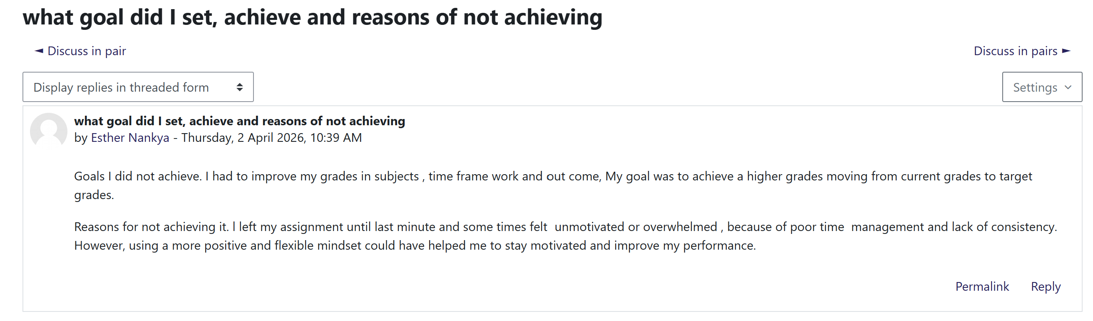

6. Communication of skills to potential employers

6.1 Professional CV and personal statement
My CV will be structured as a skill based CV by highlighting my academic knowledge. I will specifically include a professional profile section which will demonstrate how I am passionate about empowering service users and act as a good team player. I will showcase my transferable skills such as communication reporting with specific examples of my academic placements.

6.2 LinkedIn and digital presence
I will effectively optimise my LinkedIn profile by using professional headlines like Aspiring Mental Health Professional. I will add a post about Mental Health Recovery and Trauma Informed Care and Mental Health Foundation of UK. I will be more connected with relevant professionals within LinkedIn.

7. Conclusion
In summary, the report has provided a critical analysis of the strategic steps by demands to build a sustainable personal brand as a mental health support worker. By identifying the specific needs of high support inpatient service for women, I have been able to manage my skills, knowledge and attitude as per the requirement of HSC standards of the UK. The report has effectively highlighted a unique selling point by combining academic theory with compassion recovery purpose attitude. The report has also utilised SWOT analysis as well as SKA framework. The report has also provided a 5 year Action Plan which can serve as a road map for professional development which ensures a significant improvement in career journey. By effectively communicating my personal identity through optimising CVs and digital platforms, I will deliver high quality and personal centred care for achieving long term success in the HSC sector.

References
Admane, M.R. and Mondhe, P.J., 2021. Skill development of students through hands-on workshop. Journal of Engineering Education Transformations, pp.250-256.
Alexiuk, M., Elgubtan, H. and Tangri, N., 2024. Clinical decision support tools in the electronic medical record. Kidney International Reports, 9(1), pp.29-38.
Anders, R., 2025. Dignity in mental health care: human rights challenges and pathways. Academia Mental Health and Well-Being, 2(2).
Duffy, A., Browne, F. and Connolly, M., 2025. Safeguarding adults: A concept analysis. Journal of Advanced Nursing, 81(1), pp.181-197.
Howarth, S., Ducat, W. and Neary, A., 2025. Twelve Tips to Mastering the Effective Elements of Peer Group Supervision: Practical Guidance from a Narrative Review and Expert Perspectives. The Journal of Practice Teaching and Learning, 23(2), pp.80-100.
Hu, H., Wang, C., Lan, Y. and Wu, X., 2022. Nurses’ turnover intention, hope and career identity: the mediating role of job satisfaction. BMC nursing, 21(1), p.43.
Huovinen, I., 2025. Developing a brand guideline to support employees personal branding.
Kucharska, W., 2022. Personal branding in the knowledge economy: The inter-relationship between corporate and employee brands. Routledge.
NHS (2026) NHS choices. Available at: https://www.jobs.nhs.uk/candidate/jobadvert/E0233-26-0373?keyword=Mental+health+support+worker&language=en (Accessed: 10 March 2026).
Rajulapati, N. and Berzins, K., 2026. Does the Dynamic Support Register Identify the Risk of Early Placement Breakdown in Adults With Intellectual Disabilities? Perceptions of Service Users, Carers and Professionals. Journal of Policy and Practice in Intellectual Disabilities, 23(1), p.e70042.
Welagedara, M.C., 2024. Crafting Your Educational Identity: The Crucial Role of Personal Branding in Modern Pedagogy. Organized by The Department of English, NIE Sabaragamuwa and North Western RESCs, 41.
Wilson, H., de Lima, E.S., Davis, G., Preece, C. and McBride, T., 2022. Understanding the potential of trauma-informed training in Violence Reduction Units. London SW1H 9EA: Early Intervention Foundation.

